ARTIFICIAL INTELLIGENCE
1.Artificial Intelligence.
The term artificial intelligence was coined by john McCarthy in 1956.
Artificial Intelligence (AI) is a branch of computer science that deals with the development of intelligent machines and software that can perform tasks that normally require human intelligence, such as learning, reasoning, problem-solving, perception, and decision-making.
Example: Siri, Alexa, ChatGPT etc…
Advantages and Disadvantages
Advantages:
- Performs well on tasks that uses detailed data.
- Takes less time to perform tasks that needs to process huge volumes of data.
- Generates consistent and accurate results.
- Can be used 24 X 7.
- Optimizes tasks by better utilizing resources.
- Automates complex processes.
- Minimizes downtime by predicting maintenance needs,
- Enables companies to produce new products having better quality and speed.
Disadvantages:
- Involves more cost.
- Technical expertise required to develop and use AI applications.
- Lack of trained professionals.
- Incomplete or inaccurate data may result in disastrous results.
- Lacks the capability to generalize tasks
Machine Learning
Machine Learning is a branch of computer science that analyses data and identifies patterns to teach a machine to deduce results and make decisions without any human intervention
ML algorithms learn from experiences rather than instructions.
They automatically learn and improve by learning from their output. For this, humans do not have to write instructions for them to produce the desired output. They learn by analysing data sets and comparing the final output. In case of any error, they repeat the learning process until the accuracy of the outputs improve.
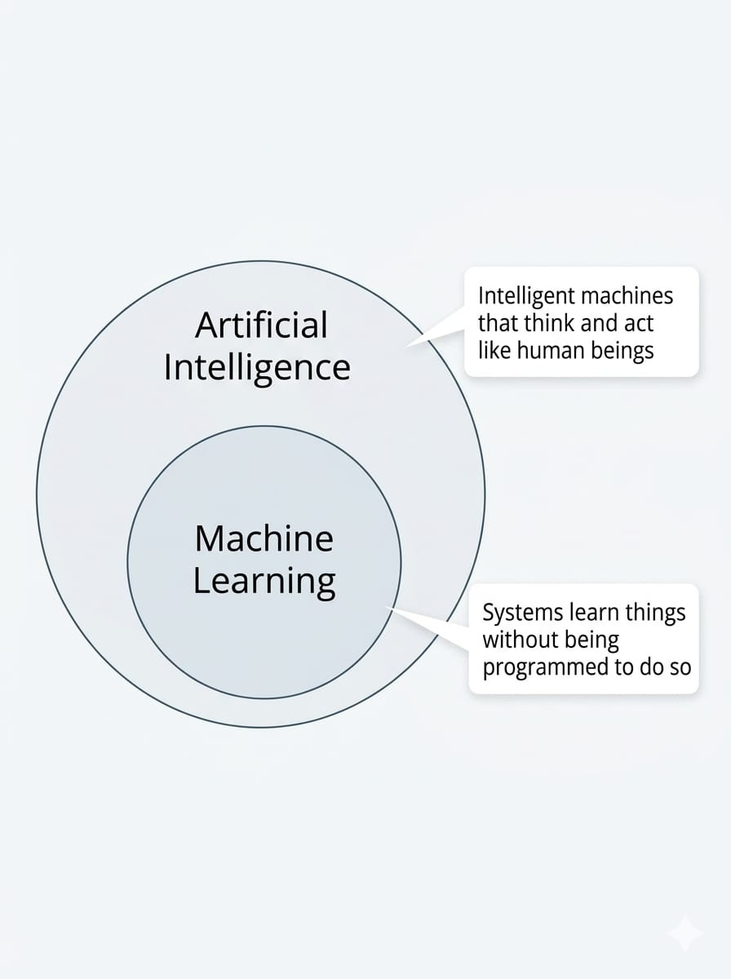

DEEP LEARNING
Deep learning is an advanced machine learning technique that passes data inputs through a biologically-inspired multiple layers of neural network. Such a neural network architecture consists of a number of hidden layers through which the data is processed. Data processed in this architecture allows machines to go 'deep' in its learning, making connections and weighting input for the best results.
Artificial Intelligence vs Machine Learning vs Deep Learning.

Feature | Artificial Intelligence (AI) | Machine Learning (ML) | Deep Learning (DL)
Definition | Technology that enables machines to perform tasks requiring human-like intelligence. | A subset of AI where machines learn patterns from data and improve their performance. | A subset of ML that uses multi-layered neural networks to learn complex patterns.
Relationship | Broadest concept | Part of AI | Part of ML
Main goal | Make machines intelligent. | Enable machines to learn from data. | Enable machines to learn complex patterns automatically.
How it works | May use rules, logic, search, ML, or other techniques. | Learns patterns from data using algorithms. | Uses deep neural networks with multiple layers.
Human involvement | Humans may define rules or provide data. | Humans usually select data/features and the learning method. | Requires less manual feature selection because the network can learn features automatically.
Amount of data | Can work with little or no training data in rule-based systems. | Usually requires a significant amount of data. | Generally requires large amounts of data for complex tasks.
Computational power | Varies depending on the application. | Usually moderate to high. | Usually high, especially for large models.
Examples | Chatbots, expert systems, game-playing systems. | Spam detection, recommendation systems, fraud detection. | Face recognition, speech recognition, image classification.
Common techniques | Rule-based systems, search, ML, robotics, NLP. | Regression, decision trees, clustering, classification. | Neural networks, CNNs, RNNs, transformers.
Simple example | A computer playing chess intelligently. | An email system learning to identify spam. | A system recognizing faces in photographs.
Real-World Applications of Artificial Intelligence
- Healthcare – Helps doctors in disease diagnosis and medical decision-making.
- Education – Provides personalized learning and AI-based tutoring.
- Banking and Finance – Helps with fraud detection and automated customer services.
- Transportation – Supports navigation, traffic management, and intelligent vehicles.
- Robotics – Enables robots to perform tasks intelligently.
- Agriculture – Helps monitor crops and detect plant diseases.
- Cybersecurity – Helps identify suspicious activities and security threats.
- E-commerce – Provides personalized product recommendations and shopping assistance.
- Entertainment – Recommends movies, music, videos, and games.
- Customer Service – Uses AI chatbots to answer questions and provide support.
- Smart Homes – Controls smart devices using intelligent systems and voice commands.
- Manufacturing – Automates industrial processes and quality inspection.
- Virtual Assistants – Understands voice commands and provides useful responses.
- Language Translation – Helps translate text and speech between languages.
- Gaming – Creates intelligent behavior for computer-controlled characters.
Supervised, unsupervised, and reinforcement learning.
1.Supervised Learning
- Definition: The model learns from labeled data — meaning each input has a known output. The algorithm tries to map inputs to outputs by finding patterns.
- Process:
  - Input: Features (e.g., house size, location).
  - Output: Label (e.g., house price).
  - The model is trained on this data until it can predict outputs for new inputs.
- Examples:
  - Predicting house prices (regression).
  - Spam email detection (classification).
  - Credit scoring (classification).
- Analogy: Like a student learning with an answer key — they see the question and the correct answer, then practice until they can solve new questions.
2. Unsupervised Learning
- Definition: The model learns from unlabeled data — meaning there are no predefined outputs. The algorithm tries to find hidden patterns or groupings.
- Process:
  - Input: Features only (no labels).
  - Output: Groups or clusters discovered by the algorithm.
- Examples:
  - Customer segmentation (grouping customers by shopping habits).
  - Market basket analysis (finding items often bought together).
  - Document clustering (grouping similar articles).
- Analogy: Like exploring a new city without a map — you wander around and notice neighborhoods form naturally (clusters).
3. Reinforcement Learning
- Definition: The model (called an agent) learns by interacting with an environment. It receives rewards or penalties based on its actions and adjusts its behavior to maximize rewards.
- Process:
  - Agent takes an action.
  - Environment responds with a reward or penalty.
  - Agent updates its strategy (policy) to improve future decisions.
- Examples:
  - Training robots to walk.
  - Game-playing AI (e.g., AlphaGo beating humans in Go).
  - Self-driving cars learning to navigate traffic.
- Analogy: Like training a dog — when it performs the right action, you give it a treat (reward). Over time, it learns which actions lead to rewards.
Machine Learning Workflow:
1. Dataset
- Definition: A collection of data used for training and testing a model.
- Example: A CSV file containing house sizes and prices.
- Analogy: Think of a dataset as a textbook — it contains all the examples the student (model) will learn from.
2. Features
- Definition: The input variables that describe the data.
- Example: House size, number of rooms, location.
- Analogy: Features are like clues given to solve a puzzle.
3. Labels
- Definition: The output variable we want the model to predict.
- Example: House price (for regression) or “spam/not spam” (for classification).
- Analogy: Labels are the answers in the answer key.
4. Training
- Definition: The process of feeding the dataset into the model so it can learn patterns.
- Example: Using 70% of your dataset to teach the model how house size relates to price.
- Analogy: Training is like studying with practice questions.
5. Validation
- Definition: A separate portion of the dataset used to tune the model and check performance during training.
- Example: Using 15% of the dataset to adjust model parameters (like learning rate).
- Analogy: Validation is like mock exams — you test yourself before the real exam.
6. Testing
- Definition: A final portion of the dataset used to evaluate how well the trained model performs on unseen data.
- Example: Using the remaining 15% of the dataset to check accuracy of predictions.
- Analogy: Testing is the final exam — it shows if the student really learned.
7. Model
- Definition: The mathematical representation of learned patterns from data.
- Example: A linear regression equation: Price = 50,000 + 2000 × Size.
- Analogy: The model is the formula or strategy the student uses to solve problems.
8. Prediction
- Definition: The output the model generates when given new input data.
- Example: Predicting that a 1800 sq.ft house will cost ≈ 180.
- Analogy: Prediction is the student’s answer to a new question.

The machine-learning workflow from problem definition to evaluation.
Machine Learning (ML) is a process in which a computer system learns patterns from data to make predictions or decisions. Developing an ML system involves several important steps, starting from defining the problem and collecting data, followed by preparing the data, training and evaluating the model, and finally deploying and monitoring the model.
The major steps in a Machine Learning workflow are shown below:

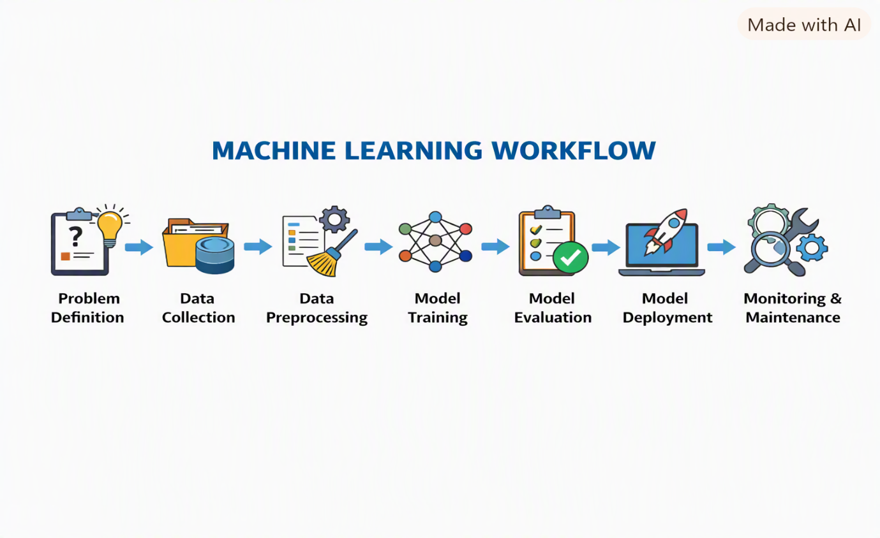
An Algorithm Comparison Table 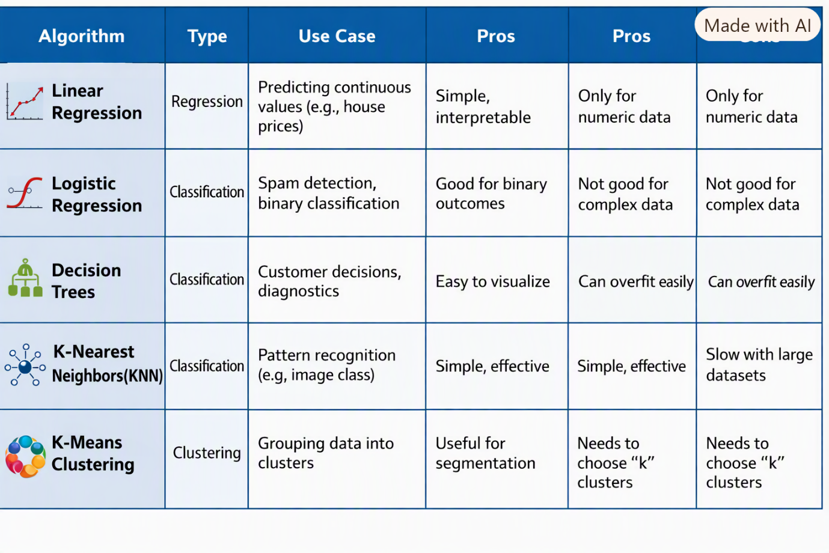
Model Problems in Machine Learning
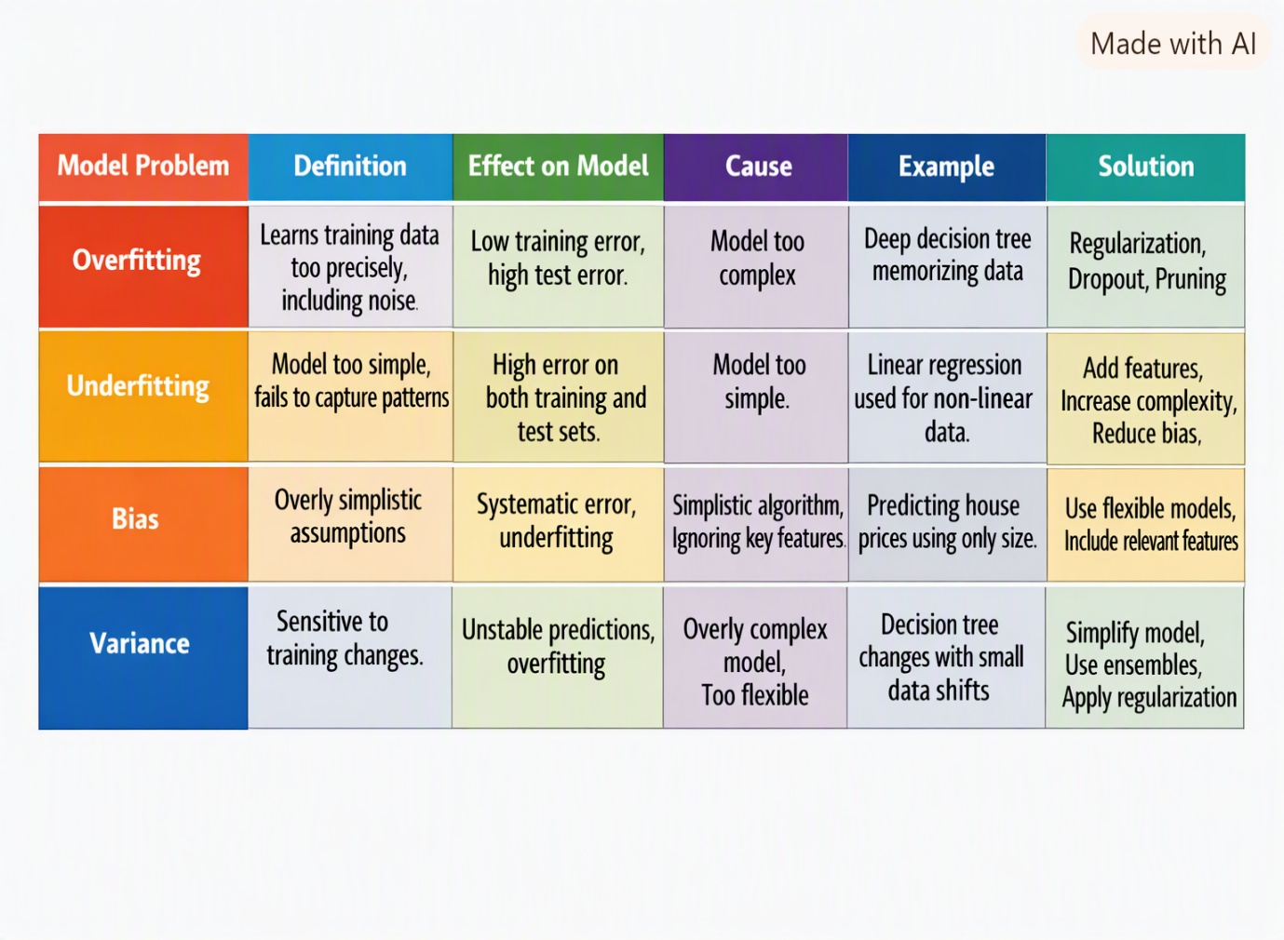
Model Evaluation Metrics
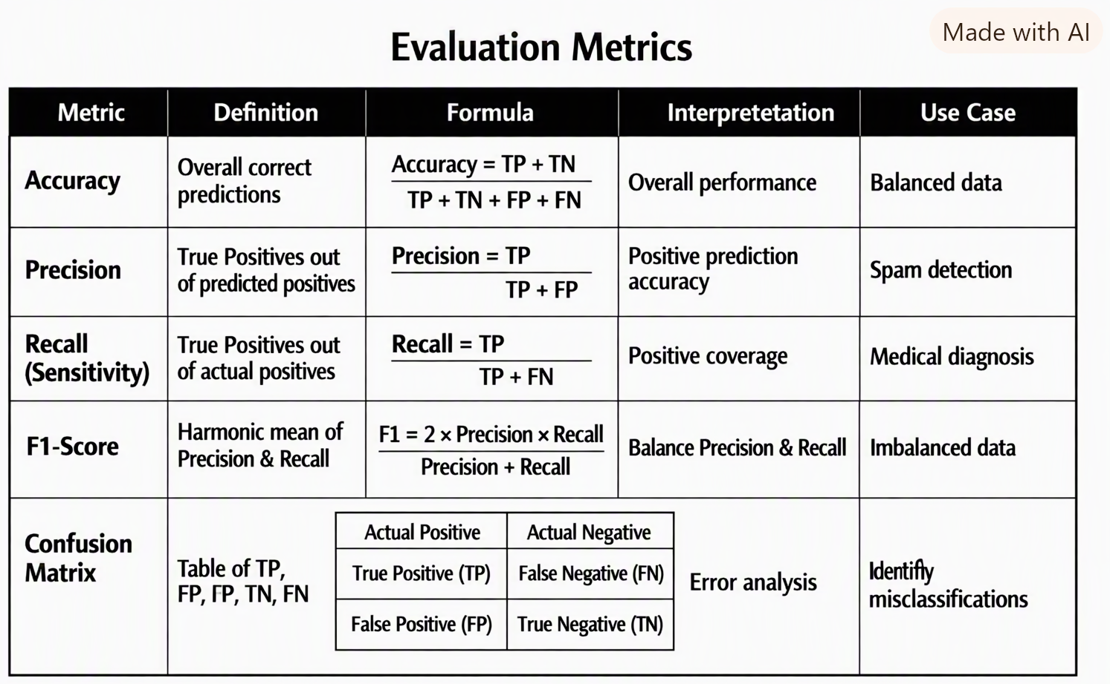
Introduction to Python Libraries for Data Science & Machine Learning
1.NumPy (Numerical Python)
Purpose: Foundation for numerical computing in Python.
Key Feature: Provides support for multi-dimensional arrays and vectorized operations.
Use Case: Fast mathematical computations, linear algebra, random number generation.
Example: import numpy as np
arr = np.array([1, 2, 3])
print(arr.mean()) # Output: 2.0
2. Pandas
Purpose: Data manipulation and analysis.
Key Feature: Provides DataFrame and Series structures for handling tabular data.
Use Case: Cleaning, transforming, and analyzing datasets (CSV, Excel, SQL).
Example: import pandas as pd
df = pd.read_csv("data.csv")
print(df.head())
3.Matplotlib
Purpose: Data visualization library.
Key Feature: Creates static, animated, and interactive plots.
Use Case: Visualizing trends, distributions, and relationships.
Example: import matplotlib.pyplot as plt
plt.plot([1, 2, 3], [2, 4, 6])
plt.xlabel("X-axis")
plt.ylabel("Y-axis")
plt.title("Simple Plot")
plt.show()

4.scikit-learn
Purpose: Machine learning library built on NumPy and Pandas.
Key Feature: Offers tools for classification, regression, clustering, and model evaluation.
Use Case: Building predictive models and evaluating performance.
Example: from sklearn.linear_model import LinearRegression
model = LinearRegression()
model.fit([[1], [2], [3]], [2, 4, 6])
print(model.predict([[4]])) # Output: [8.]

