COMPUTER VISION 👁️
TriNexa Technologies - Collaborative Learning Plan
Domain: Computer Vision | Prepared by: Preethi | Semester 3

1. What is Computer Vision? 🤖
Computer Vision (CV) is the part of Artificial Intelligence that helps a computer "see" and make sense of images or videos - almost like giving eyes and a brain to a machine.
A camera by itself is dumb. It only records light and colour as numbers. It doesn't know what a "dog" or a "car" is. Computer Vision is what turns those raw numbers into actual understanding - like recognising that there is a dog in the picture.
🔥 Real-life example
Think about unlocking your phone using Face ID:
You point the camera at your face
↓
Camera captures the image
↓
CV model compares it with your stored face data
↓
Match found ✅ → Phone unlocks
That whole process, from "camera sees your face" to "phone unlocks", is Computer Vision at work.
Where does CV fit inside AI?
A lot of students get confused between AI, ML, DL and CV. Here's the simplest way I found to remember it:
Term | Meaning | Example
🧠 AI (Artificial Intelligence) | The broad goal - making machines act smart | A chatbot, a self-driving car
📊 ML (Machine Learning) | Machine learns patterns from data instead of fixed rules | Spam filter learning from emails
🔍 DL (Deep Learning) | ML using layered neural networks, good with images/audio | Face recognition, voice assistants
👁️ CV (Computer Vision) | Applying AI/ML/DL specifically to images and video | Face unlock, number-plate reading

So basically:
AI → ML → DL → CV
(CV is a specific application built on top of the other three)
Old CV (before deep learning) used fixed, human-written rules, like "an edge is where brightness changes suddenly." Newer CV mostly lets a neural network learn what an edge or a face looks like on its own, from thousands of examples.
2. Image Representation - Pixels, Resolution, RGB, Grayscale, Channels 🖼️
Here's the one line that made everything else click for me:
"A digital image is just a big grid of numbers."
- Pixel - the smallest dot in that grid. Each pixel holds a brightness value, usually between 0 (pure black) and 255 (pure white).
- Resolution - the total number of pixels, written as width x height (e.g. 1920x1080). More pixels = sharper image = more data to handle.
- Grayscale image - just 1 number per pixel (only brightness, no colour).
- Colour image (RGB) - 3 numbers per pixel: Red, Green, Blue, mixed together to create any colour.
- Channels - the separate colour "layers" stacked on each other.
Grayscale vs RGB - quick comparison
Feature | Grayscale | RGB (Colour)
Numbers per pixel | 1 (brightness only) | 3 (Red, Green, Blue)
Shape in code | (height, width) | (height, width, 3)
File size | Smaller ✅ | Bigger
Used when | Colour isn't needed (edges, text scans) | Colour matters (photos, videos)

⚠️ Something I found surprising
OpenCV (the library we used) loads colour images as BGR, not RGB - Blue first, then Green, then Red! I only found this out after my colours looked completely swapped the first time I displayed an image.
🔥 Real-life example
A small 400x300 colour photo becomes shape (300, 400, 3) in code - meaning 300 rows, 400 columns, and 3 colour numbers per pixel. That is 1,20,000 pixels x 3 = 3,60,000 individual numbers just to store one small picture!
3. Basic Image Operations 🛠️
These are the small "everyday" transformations almost every vision program applies before doing anything clever with an image.
Operation | What it does | Real-life use
Resizing | Changes the pixel dimensions | Making all app photos the same size before upload
Cropping | Cuts out a rectangular region | Zooming into just a face or a number plate
Rotation | Turns the image around a point | Fixing a tilted scanned document
Thresholding | Converts pixels to pure black/white using a cut-off | Separating text from the background in a scanned form
Filtering / Blurring | Smooths out neighbouring pixels | Reducing grainy noise in a low-light photo

🧪 Hands-on Experiment 1
I made a small test picture myself (a square, a circle, and some text) instead of downloading one online, so the whole activity is 100% reproducible and I know exactly what's inside it.
import cv2
import numpy as np
img = np.full((300, 400, 3), (245, 240, 230), dtype=np.uint8)
cv2.rectangle(img, (40, 40), (160, 160), (60, 120, 220), -1)
cv2.circle(img, (280, 100), 60, (90, 180, 90), -1)
cv2.putText(img, "CV Demo", (110, 250),
cv2.FONT_HERSHEY_SIMPLEX, 1.1, (40, 40, 40), 2)
gray = cv2.cvtColor(img, cv2.COLOR_BGR2GRAY) # grayscale
resized = cv2.resize(img, (200, 150)) # resizing
cropped = img[30:180, 20:200] # cropping
M = cv2.getRotationMatrix2D((200, 150), 25, 1.0)
rotated = cv2.warpAffine(img, M, (400, 300)) # rotation
_, thresh = cv2.threshold(gray, 200, 255,
cv2.THRESH_BINARY_INV) # thresholding
blurred = cv2.GaussianBlur(img, (15, 15), 0) # filtering
✅ What actually printed on my screen:
Original image shape (H, W, Channels): (300, 400, 3)
Data type: uint8 | Total pixels: 120000
Grayscale shape (single channel): (300, 400)
Resized shape: (150, 200, 3)
Cropped shape: (150, 180, 3)
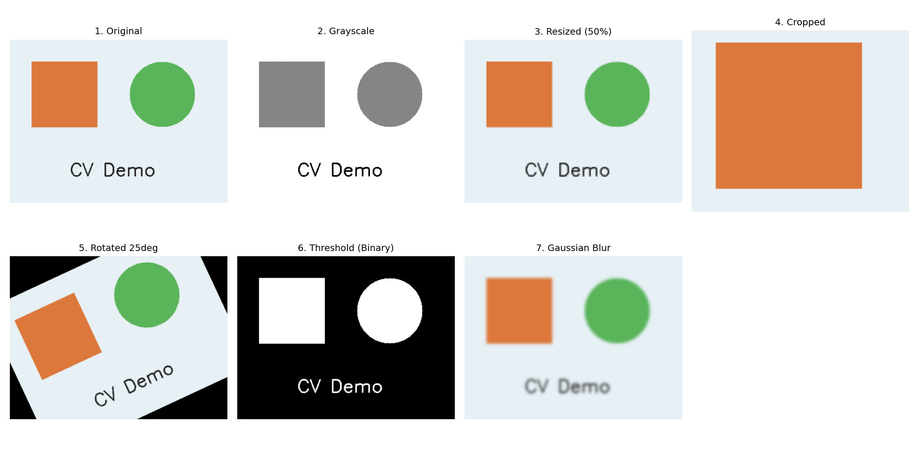
Fig 1: Original -> grayscale -> resized -> cropped -> rotated -> thresholded -> blurred.
💡 Takeaway: none of these operations actually "understand" the picture - resizing, rotating, thresholding etc. are just rearranging or recomputing the same grid of numbers in different ways.
4. Introduction to OpenCV 📦
OpenCV (Open Source Computer Vision Library) is the most widely used open-source library for image and video processing. Built originally in C++ for speed, it has a full Python interface (import cv2), which is why almost every beginner CV course starts here.
Structure of a basic OpenCV program
No matter how big or small the project, an OpenCV program almost always follows the same shape:
ACQUIRE (read image / video frame)
↓
PROCESS (resize, convert colour, blur)
↓
ANALYSE (detect edges, classify, detect faces)
↓
OUTPUT (display, save, or trigger an alert)
import cv2
# 1. Acquire
image = cv2.imread("photo.jpg")
# 2. Process
gray = cv2.cvtColor(image, cv2.COLOR_BGR2GRAY)
# 3. Analyse
edges = cv2.Canny(gray, 100, 200)
# 4. Output
cv2.imwrite("result.jpg", edges)
5. The Image-Processing Pipeline 🔄
Zooming out, this is how a raw image travels through a complete vision system - from the camera to a final decision:
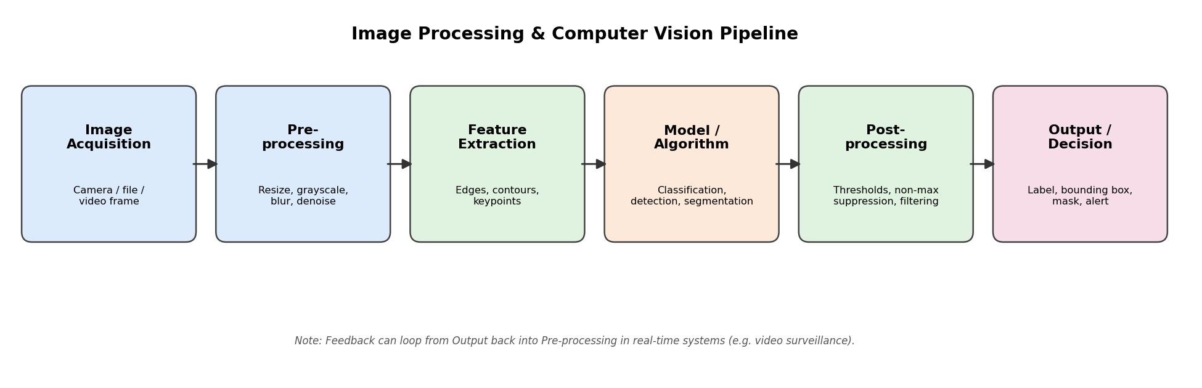
Fig 2: Image Processing / Computer Vision pipeline.
Stage | What happens
1. Image Acquisition | Camera, uploaded file, or a single video frame
2. Pre-processing | Resizing, grayscale conversion, blurring, denoising
3. Feature Extraction | Pulling out edges, contours, corners, key-points
4. Model / Algorithm | The actual classification, detection or segmentation step
5. Post-processing | Cleaning up the result - thresholds, removing duplicate boxes
6. Output / Decision | Final label, bounding box, mask, or an alert

⚠️ Note: in real-time systems like CCTV, the output can loop back and affect the next round of pre-processing - so it isn't always a strict one-way street. Also, deep learning models often skip the "Feature Extraction" box entirely, since the neural network learns to pull out its own features automatically.
6. Classification vs Detection vs Segmentation 🔍
This is probably the most confusing part for beginners, so here's the simplest comparison I could put together:
Task | Question it answers | Output | Example
Classification | What is the main thing here? | One label for the whole image | "This photo has a dog"
Detection | What objects, and roughly where? | Labels + bounding boxes | Box around the dog, box around the person
Segmentation | Exactly which pixels belong to it? | A pixel-level mask | Every pixel of the dog's outline marked

Classification → WHAT
Detection → WHAT + roughly WHERE (a box)
Segmentation → WHAT + exactly WHICH PIXELS
🙂 Face Detection
Face Detection is simply object detection, but trained specifically to find human faces. A classic method here is the Viola-Jones algorithm (a.k.a. Haar Cascade), from a 2001 paper by Paul Viola and Michael Jones.
Scan small windows across the image
↓
Check simple black/white brightness patterns (Haar features)
↓
Reject clearly non-face regions instantly
↓
Keep checking only the promising regions
↓
Face region found ✅
It's fast and still built into OpenCV today, even though modern deep-learning face detectors are usually more accurate on tricky angles or lighting.
7. Edges, Contours, Shapes & Feature Extraction ✂️
- Edge - a pixel location where brightness suddenly changes. The Canny algorithm is a common way to find these.
- Contour - the continuous outline formed by joining connected edge points - basically "tracing" a shape's boundary.
- Feature extraction (classical) - measuring simple numeric properties of a contour (area, perimeter, number of corners) to guess its shape.
🧪 Hands-on Experiment 2a
gray = cv2.cvtColor(img, cv2.COLOR_BGR2GRAY)
edges = cv2.Canny(gray, 60, 160)
contours, _ = cv2.findContours(edges, cv2.RETR_EXTERNAL,
cv2.CHAIN_APPROX_SIMPLE)
for cnt in contours:
if cv2.contourArea(cnt) < 200:
continue
peri = cv2.arcLength(cnt, True)
approx = cv2.approxPolyDP(cnt, 0.03 * peri, True)
if len(approx) == 4:
shape = "Square/Rect"
elif len(approx) > 6:
shape = "Circle"
else:
shape = "Shape"
Number of corners (after approx) | Shape guessed
4 | Square / Rectangle
More than 6 | Circle
Anything else | Unknown Shape

✅ Console output: Number of contours found: 8
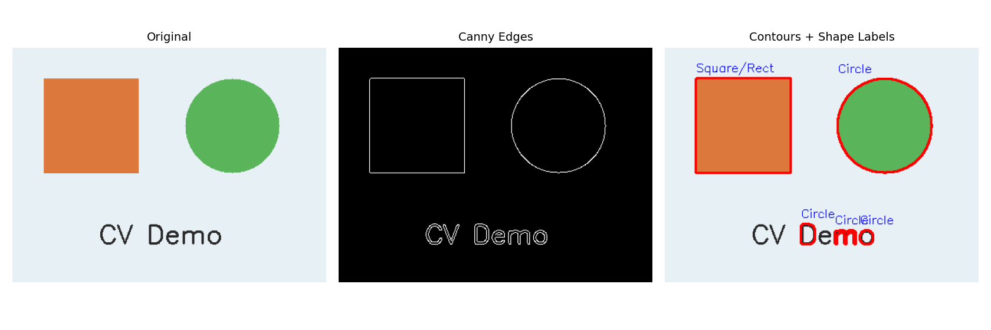
Fig 3: Original image -> Canny edges -> contours with shape labels.
😅 Honest note: the algorithm also picked up a few tiny contours from the letters in "CV Demo", which is why the count came to 8 and not just 2 (square + circle). This is exactly why real programs filter out very small contours - otherwise noise gets treated as a "shape" too.
8. Video Processing & Motion Detection 🎥
A video is really just a fast sequence of images (frames), usually 24-30 shown per second. So video processing mostly means applying the same image techniques to every frame, plus a few tricks that compare frames to each other:
Technique | Basic idea
Frame differencing | Subtract one frame from the next - anything that changed lights up
Optical flow | Estimate direction and speed each pixel/object is moving
Object tracking | Keep the same "identity" attached to an object across many frames

🧪 Hands-on Experiment 2b
diff = cv2.absdiff(frame1, frame2)
gray_diff = cv2.cvtColor(diff, cv2.COLOR_BGR2GRAY)
_, motion_mask = cv2.threshold(gray_diff, 30, 255,
cv2.THRESH_BINARY)
Frame 1 (object at position A)
↓ minus
Frame 2 (object at position B)
↓
Difference image
↓ threshold
Motion Mask ✅ (shows where the change happened)
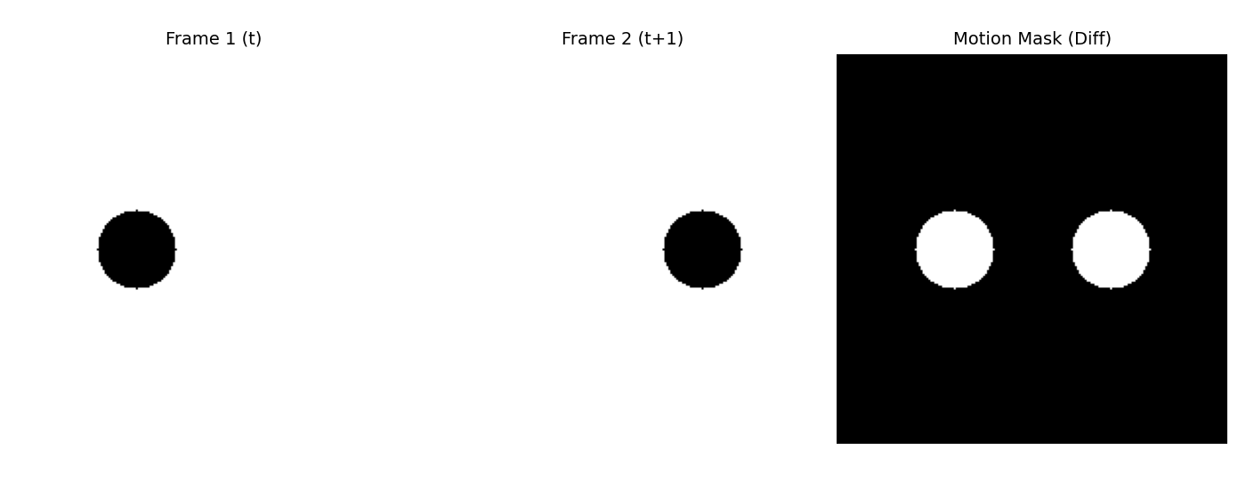
Fig 4: Frame 1, Frame 2, and the resulting motion mask from differencing.
This is a very basic version of the idea behind CCTV motion alerts - real systems add a lot more (ignoring shadows, lighting changes, camera shake) but "compare this frame to the last one" is where it all starts.
9. Real-World Applications 🌍
Domain | How Computer Vision helps
🚨 Surveillance | Motion detection, intruder alerts, crowd counting, spotting unusual behaviour
🏥 Healthcare | Spotting tumours/fractures in X-rays and MRIs, counting cells under a microscope
🌾 Agriculture | Identifying crop disease from leaf photos, estimating fruit ripeness/yield
🚦 Traffic | Reading number plates, catching red-light violations, counting vehicles
👷 Safety | Checking for helmets/masks, detecting falls, spotting fire/smoke early
10. Privacy, Consent, Bias & Responsible Use 🔐
Since Computer Vision usually works with pictures of real people, there's an ethical side to it that matters just as much as the technical side:
Do's ✅ | Don'ts ❌
Collect only the data actually needed | Store recordings forever "just in case"
Inform people a camera/CV system is active | Secretly track or profile people without consent
Test models across diverse faces/skin tones | Assume a model trained on one group works for everyone
Ask "should this be built?" before building it | Deploy mass surveillance without legal/ethical checks

- Privacy - cameras often capture people who never agreed to be recorded or analysed.
- Consent - people should ideally know a vision system is running, and give consent for sensitive uses like face recognition.
- Bias - many face/detection models are trained on datasets that aren't diverse enough, causing lower accuracy for some skin tones, ages or genders.
- Responsible use - vision systems shouldn't be used for mass surveillance or secret tracking without proper oversight.
11. Discussion - Connecting CV to AI and Cybersecurity 🔗
- Link to AI - as covered in Topic 1, CV sits inside AI/ML as one of its main application areas; the same neural network ideas (CNNs) used in CV also show up elsewhere in AI.
- Link to Cybersecurity - this overlap is bigger than I expected:
  - Biometric login (face/iris unlock) uses CV directly, and so does research into breaking it - deepfakes, or holding up a photo/mask to fool a camera (a "presentation attack").
  - Adversarial examples - tiny, sometimes invisible pixel changes that can trick a CV model into misreading an image (e.g. a stop sign read as a speed-limit sign). An active cybersecurity research area.
  - Any surveillance system built with CV also needs to be secured against being hacked itself - a breached camera network is both a privacy problem and a security problem at once.
🔥 This felt like a great discussion point to bring up with the AI and Cybersecurity teammates, since it shows the three domains overlap a lot more than I expected before starting this project.

