

CYBERSECURITY
INTRODUCTION TO CYBERSECURITY

CYBERSECURITY
Cybersecurity is the practice of protecting computers ,networks ,applications, devices and data from unauthorized access , damage , theft or disruption.
- Cybersecurity means keeping digital systems and information safe.
Why do we need Cybersecurity?
Without Cybersecurity attacker may do: data theft , passwords attack , malware, phishing , data modification , service disruption so Cybersecurity aims to reduce these risks.
Cybersecurity
Protects digital systems, devices, applications, networks, and data.
Network Security
A part of cybersecurity focused specifically on protecting networks and the data moving through them.
- Protecting your laptop from malware ~ Cybersecurity
- Securing your college Wi-Fi network ~ Network Security
- Protecting a web application from unauthorized access ~ Application security
CIA TRIAD
CIA Triad is the foundation of information security .
It consists of:
- C – Confidentiality : only authorized people can access data (keeps it secrete)
- I - Integrity : data remains accurate and unaltered (keeps it accurate)
- A – Availability: Systems and data are accessible when needed(keeps it usable)
1 . Confidentiality : Meaning Data marketing– Ensuring that the information is accessible only to authorized people.
How can we protect Confidentiality?
- Strong passwords
- Encryption
- Access control
- Multi – factor authentication

Security failure: an attacker steals your private records
2.Integrity : Meaning – ensuring that data remains accurate , complete and protected from unauthorized modification .
How can we protect Integrity ?
- Hashing
- Access controls
- Digital signature
- Audit logs
Security failure: our data can be modified without permission
A attacker can modify the data without actually seeing it
- Accessing a system : getting permission or an opportunity to interact with it
- Accessing database : actually viewing or extracting the information
*** Sometimes both Confidentiality and Integrity can be violated together at once ***
3.Availability: Meaning - Ensuring that systems and information are accessible when authorized users need them .
Goal: no downtime when critical access is needed
How can we protect Availability ?
- Backups
- Redundant servers
- System maintenance
- Disaster recovery
- Protection against denial-of-service attacks
Security failure : the attacks makes the data / website unavailable
*** Sometimes data might be confidential and integrated but not available
- Confidentiality = Keep it secret.
- Integrity = Keep it correct.
- Availability = Keep it accessible.

Authentication, Authorization & Identification
1 . Identification : identification is the process by which a user claims or states their identity to a system
Ex: entering your username or register number on a college portal
- “I am Chinmayi”
2. Authentication: Authentication is the process of verifying the identity of a user by checking whether the provided credentials or authentication factors are valid.
Ex: Password , OTP , Fingerprint , Face recognition
- “Prove that you are Chinmayi ”
3. Authorization : Authorization is the process of determining what resources or actions an authenticated user is permitted to access or perform.
Ex: Authorization is the process of determining what resources or actions an authenticated user is permitted to access or perform.
- “Now that I know who you are, what are you allowed to do?”
Identification → Who do you claim to be?
↓
Authentication → Can you prove it?
↓
Authorization → What are you allowed to do?
Ex: When you log into your college portal
Username → Identification
Password/OTP → Authentication
Access to student features → Authorization

🔐 Authentication Factors
Authentication factor is a category of information, possession, or characteristic used by a system to verify the identity of a user.
(***An authentication factor is the type of proof you provide to prove that you are really you.***)
Three major authentication factors :
1 . something you know
A knowledge factor is authentication based on information that only the user is expected to know. Ex: Password , PIN , Security question , Passcode Example
You log into your college portal:
Username: Chinmayi
Password: ********
The password is something you know.
So:
🔑 Password = Something you know
(***If someone discovers or steals your password, they may be able to log in as you.
That's one reason we use additional authentication factors.***)
2. Something You Have
A possession factor is authentication based on something that the user physically possesses.
Ex: Mobile phone , Security token , Smart card , Hardware security key
Example
You log into an account and the system sends an OTP to your phone.

Login
↓
Password
↓
OTP sent to your phone
↓
Enter OTP
↓
Access granted
📱 Phone/security token = Something you have
3. Something You Are
A biometric factor is authentication based on a physical or behavioral characteristic of the user.
Ex: Fingerprint ,Face , Iris , Voice , In some systems, behavioral characteristics such as typing patterns
Example
You unlock your phone using your fingerprint.
👆 Fingerprint = Something you are
🔥 Real-life example
Suppose your bank asks for:
Password + OTP
Password:
Something you know 🔑
Phone receiving OTP:
Something you have 📱
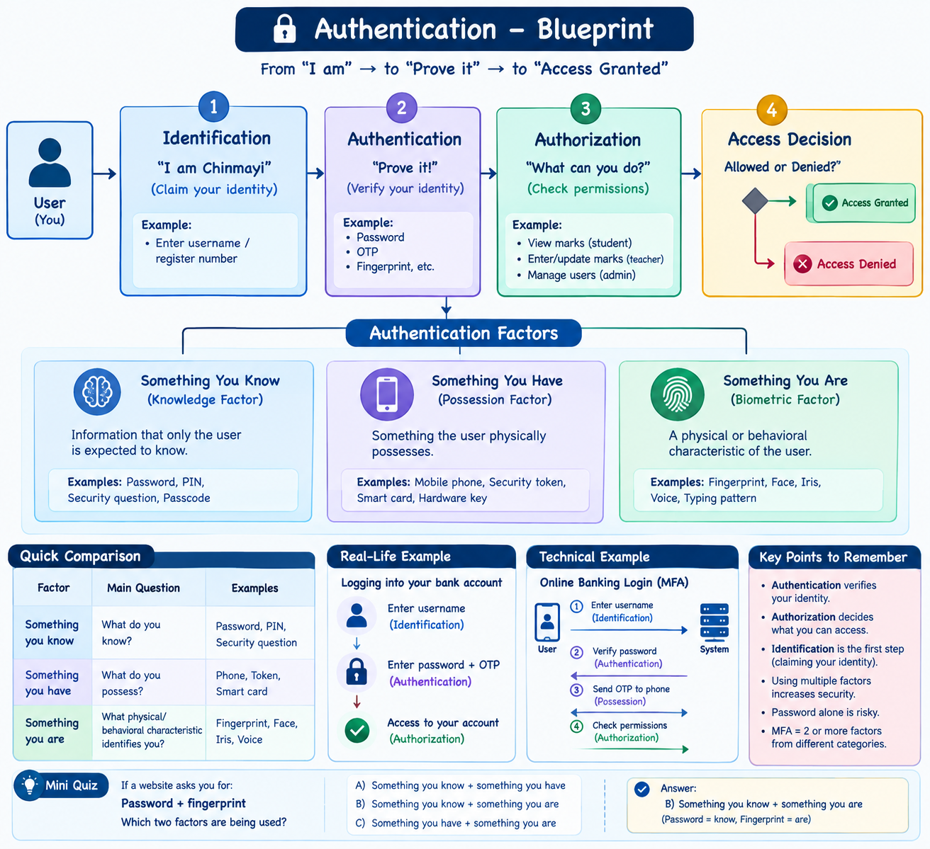
🛡️ Multi-Factor Authentication — MFA
Multi-Factor Authentication (MFA) is an authentication method that requires a user to provide two or more authentication factors from different factor categories to verify their identity.
Factor | Meaning | Examples
🔑 Something You Know | Information only you should know | Password, PIN
📱 Something You Have | Something physically in your possession | Phone, OTP token, security key
👆 Something You Are | A physical or behavioral characteristic | Fingerprint, Face, Iris
Example | Factors Used | MFA?
Password only | Know | ❌ No
Password + OTP | Know + Have | ✅ Yes
Password + Fingerprint | Know + Are | ✅ Yes
OTP + Fingerprint | Have + Are | ✅ Yes

Term | Meaning | Example
1FA | One authentication factor | Password
2FA | Exactly two authentication factors | Password + OTP
MFA | Two or more factors from different categories | Password + OTP + Fingerprint
2FA is a type of MFA, but MFA can involve more than two factors.
Ex: our college portal
LOGIN
▼
Enter Password
(Something You Know)
▼
Enter OTP
(Something You Have)
▼
┌─────────────┐
│ VERIFY │
└──────┬──────┘
▼
ACCESS GRANTED

Password Security
Password Security is the practice of protecting passwords from unauthorized access, disclosure, theft, and misuse through secure password creation, storage, authentication, and management techniques.
1. Strong passwords
A good password should generally be:
- Long
- Difficult to guess
- Unique for each account
- Not based on easily available personal information
For example:
❌ chinmayi123
❌ password123
❌ 12345678
Better:
> Use a long, unique passphrase or randomly generated password.
The key idea is:
Length + uniqueness are extremely important.

2. Never store passwords as plain text
This is a very important cybersecurity concept.
Imagine a website has this database:
Username Password
---------------------------
Alice hello123
Bob cricket123
Chinmayi mypassword
If an attacker gets this database, they immediately know everyone's passwords.
So secure systems should not store the original password directly.
Instead:
User enters password = password
↓
Password hashing = hash
↓
Hash value = “8f3a….91cd”
↓
Database
So saving password using hashing will secure our password

3. Hashing ≠ Encryption
This is something I REALLY want you to remember because it will become important when we study cryptography.
Hashing | Encryption
Generally one-way | Reversible with the appropriate key
Used to verify data/passwords | Used to protect readable data
No normal "decrypt" operation | Can be decrypted
Example: password verification | Example: encrypted communication
Encryption :
Plaintext → 🔐 Encryption → Ciphertext
↓
Decryption
↓
Plaintext
But hashing:
Password → #️⃣ Hash → Hash value
You don't normally take the hash and turn it back into the original password.

4. Salting passwords 🧂
Now we reach an important security technique.
Suppose two users have the same password:
Alice → password123
Bob → password123
If the system simply hashes the password, both could produce the same hash.
A salt is random data added to the password before hashing.
Password + Random Salt
↓
Hash
↓
Stored hash

🔑 PASSWORD SECURITY
│
┌────────────┼────────────┐
↓ ↓ ↓
Strong & Hashing Secure
Unique + Salt Storage
│ │ │
└────────────┼────────────┘
↓
MFA
↓
Stronger Security

Threats
🔐 Password Attacks
A password attack is an attempt by an attacker to obtain, guess, or exploit a user's password in order to gain unauthorized access to an account or system
🧠 Simple meaning
An attacker is basically trying to answer:
“What password will let me get into this account?”
But they don't always simply guess the password. There are several different techniques.

1. Brute-Force Attack
A brute-force attack is an attack in which an attacker systematically tries many possible password combinations until the correct password is found.
Example
Suppose the password is a 4-digit PIN
0000
0001
0002
0003
...
4827 ← Correct password
The attacker keeps trying possibilities
🔧 Technical idea
Possible passwords
↓
Try password 1
↓
Correct? ── No ──→ Try next
↓
Yes
↓
LOGIN
A longer and more complex password generally makes brute-force guessing more difficult because there are more possible combinations.
2.Dictionary Attack
A dictionary attack is an attack in which an attacker tries passwords from a prepared list of commonly used words, passwords, and phrases.
Instead of trying every possible combination, the attacker starts with likely passwords.
password
123456
qwerty
admin
welcome
iloveyou
...

🔥 Brute Force vs Dictionary Attack
Feature | Brute Force | Dictionary Attack
Basic idea | Try many possible combinations | Try likely/common passwords
Uses password list? | Not necessarily | Yes
Can be faster? | Depends | Often, if password is common
Example | aaaa, aaab, aaac... | password, admin, qwerty...
3. Credential Stuffing
Credential stuffing is an attack in which attackers use previously leaked username-password combinations to attempt login to other services. Example:
website A
Username: chinmayi@example.com
Password: abc123
↓
Data breach
↓
Attacker obtains credentials
↓
Tries same credentials on:
Email
Social media
Shopping site
College portal

Three attacks — remember like this
BRUTE FORCE
"Try everything."

DICTIONARY
"Try the common ones."

CREDENTIAL STUFFING
"Try passwords leaked somewhere else.

Attack | What attacker does | Main weakness exploited
Brute Force | Tries many possible combinations | Weak/short passwords
Dictionary Attack | Tries common passwords/words | Common or predictable passwords
Credential Stuffing | Uses leaked credentials on other services | Password reuse

Phishing
Phishing is a type of cyberattack in which an attacker impersonates a legitimate person, organization, or service to deceive a victim into revealing sensitive information, clicking a malicious link, downloading harmful content, or performing an unsafe action.
Ex:
Imagine you receive an email that looks like it's from your college:
Subject: URGENT: Verify your student account
It says:
“Your college account will be deactivated. Login immediately.”
There's a link: gsss-college-login.com
You click it and enter your college username and password.
But the website isn't actually your college's website.
The attacker created a fake login page to steal your credentials.
That's phishing.

Common types of phishing
Type | Description | Example
Email Phishing | Fraudulent email pretending to be legitimate | Fake bank email
Spear Phishing | Targeted attack against a specific person/organization | Fake email specifically targeting an employee
Whaling | Targets high-level individuals such as executives | Fake message to a CEO
Smishing | Phishing through SMS/text messages | Fake delivery SMS
Vishing | Phishing through voice calls | Fake bank-support call

Phishing = deception of the victim.
Malware
Malware is malicious software designed to disrupt, damage, gain unauthorized access to, or perform other harmful actions on a computer system, device, network, or data.
The word malware comes from:
Malicious + Software = Malware
For example, you download what appears to be a useful application. After installation, it secretly starts stealing files or damaging your system.

Main Types of Malware
Type | What it does | Easy way to remember
Virus | Attaches itself to files/programs and can spread when the infected file is executed | Infects files
Worm | Can spread automatically across systems/networks | Spreads itself
Trojan | Pretends to be legitimate software but performs malicious actions | Fake software
Ransomware | Locks/encrypts data and demands payment | Holds data hostage
Spyware | Secretly monitors or collects information | Spies on you
Keylogger | Records keystrokes | Records what you type
Adware | Displays unwanted advertisements; some forms can also track activity | Ads
Technical Example — Ransomware
Original file
↓
Encryption
↓
Unreadable encrypted file
Then the attacker displays a ransom message demanding payment for a supposed decryption key.
This is why ransomware can seriously affect individuals, companies, hospitals, and other organizations

⚔️ Virus vs Worm vs Trojan
Feature | Virus | Worm | Trojan
Needs a host file/program? | Usually yes | No | No
Self-spreads automatically? | Generally no | Yes | No
Disguises itself as legitimate software? | Not necessarily | No | Yes
Main idea | Infects | Spreads | Tricks
Malware is the broad category.
MALWARE
│
┌───────────────┼────────────────┐
↓ ↓ ↓
Virus Worm Trojan
↓ ↓ ↓
Ransomware Spyware Keylogger
Spoofing
Spoofing is an attack where an attacker pretends to be a trusted person, device, website, or system by falsifying identifying information.
Examples:
- Email spoofing → fake sender address
- IP spoofing → fake source IP address
- Website spoofing → fake website resembling a real one
🧠 Spoofing = “I pretend to be someone/something else.”
Sniffing
Sniffing is the process of capturing and monitoring network traffic traveling between devices.
Example:
Device → Network → Server
↑
Attacker
captures traffic
If traffic isn't properly protected, sensitive information may be exposed.
🧠 Sniffing = “I listen to network traffic.”
Man-in-the-Middle (MITM)
A MITM attack occurs when an attacker secretly positions themselves between two communicating parties and intercepts or potentially alters their communication.
You → Attacker → Website
↑
intercepts
Example: An attacker on an insecure public Wi-Fi network intercepts communication.
🧠 MITM = “I secretly stand in the middle.”

DoS — Denial of Service
A DoS attack attempts to make a system, server, or network service unavailable to legitimate users by overwhelming or disrupting it.
Many requests
↓
Server
↓
Resources exhausted
↓
Legitimate users can't access it
🧠 DoS = Make the service unavailable.
DDoS — Distributed Denial of Service
A DDoS attack is a DoS attack launched from multiple compromised systems/devices against a target.
Device ─┐
Device ─┤
Device ─┼──→ Target Server
Device ─┤
Device ─┘

DoS | DDoS
Attack from one source/system | Attack from many systems
Simpler structure | Distributed structure
Goal: disrupt availability | Goal: disrupt availability
🧠 DDoS = Many devices → One target.
SECURITY TOOLS
Security tools are software, hardware, or technologies used to protect computers, networks, systems, and data from cyber threats and unauthorized access.
🔥 Firewall
A firewall is a security mechanism that monitors and controls incoming and outgoing network traffic based on predefined security rules.
Simple:
Internet
↓
🔥 FIREWALL
↓
Your Network
🧠 Firewall = Traffic gatekeeper.
VPN
VPN (Virtual Private Network) is a technology that creates a secure, encrypted connection between your device and a network over the internet.
“A VPN creates a protected tunnel for your network communication.”
Your Device
↓
🔐 Encrypted VPN Tunnel
↓
Internet
↓
Destination
VPN = Secure, encrypted connection over a network
Antivirus / EDR
Antivirus software detects, prevents, and removes malicious software from a device.
🧠 Antivirus = Detect and remove malware.
EDR
EDR (Endpoint Detection and Response) continuously monitors endpoint devices for suspicious activity and helps security teams detect and respond to threats.
🧠 EDR = Monitor + Detect + Respond.
Antivirus | EDR
Mainly protects against malware | Broader endpoint monitoring
Detects/removes threats | Detects suspicious behavior and supports investigation/response
Common on personal devices | Common in organizations
IDS
An IDS is a security system that monitors network or system activity and detects suspicious or malicious activity.
🧠 IDS = Detects + Alerts
IPS — Intrusion Prevention System
An IPS is a security system that detects suspicious or malicious activity and can automatically take action to prevent or block it.
Network Traffic
↓
🔍 IPS
↓
Suspicious?
↙ ↘
YES NO
↓ ↓
BLOCK ALLOW
IDS vs IPS
IDS | IPS
Detects threats | Detects threats
Generates alerts | Can block/prevent
Like an alarm 🚨 | Like a security guard 👮

IDS = “I Detect Suspicious activity.”
IPS = “I Prevent Suspicious activity.”

Proxy
A proxy is a server that acts as an intermediary between a user's device and the internet.
The proxy receives your request and forwards it to the destination.
Proxy = Middleman between you and the internet.
Quick Security Tools Revision
Tool | Main job
🔥 Firewall | Controls network traffic
🔐 VPN | Creates an encrypted connection
🦠 Antivirus | Detects/removes malware
🖥️ EDR | Monitors endpoints and detects/responds to threats
🚨 IDS | Detects and alerts
🛑 IPS | Detects and can block
🌐 Proxy | Acts as an intermediary

Ethical Hacking Principles
Ethical hacking is the authorized process of testing a computer system, network, or application to identify security weaknesses and help fix them
Ethical hacker = Someone who is allowed to test a system to find and fix vulnerabilities.
🔐 Important Principles
1. Authorization
Always get permission before testing a system.
No permission → Don't test it.
2. Scope
Know exactly what you are allowed to test.
Example:
If you're authorized to test example.com, that doesn't automatically mean you're allowed to test every system owned by the same company.
3. Don't cause harm
Testing should avoid unnecessary damage, data loss, or service disruption.
4. Protect sensitive information
If you discover passwords, personal information, or confidential data, don't misuse or disclose it.
5. Report vulnerabilities
Document what you found and inform the authorized organization so it can be fixed.

🧪 Safe Beginner-Level Practice
Never practice attacks on random websites, college systems, Wi-Fi networks, or other people's devices without explicit permission.
Instead, use intentionally vulnerable environments such as:
- Your own computer/VM
- Local test applications
- CTF platforms
- Training labs
- Systems specifically provided for security testing
Safe learning flow:
Learn concept
↓
Build/use a legal lab
↓
Practice safely
↓
Find vulnerability
↓
Understand the impact
↓
Learn how to fix it

