OS PRACTICAL
Q.1
CODE:
#include <stdio.h>
#include <stdlib.h>
#include <unistd.h>
#include <sys/wait.h>
#include <string.h>
int main()
{
char command[100];
char *args[20];
char *token;
int i = 0;
printf("Enter a Linux command: ");
fgets(command, sizeof(command), stdin);
command[strcspn(command, "\n")] = '\0';
token = strtok(command, " ");
while (token != NULL && i < 19)
{
args[i++] = token;
token = strtok(NULL, " ");
}
args[i] = NULL;
pid_t pid = fork();
if (pid < 0)
{
perror("fork failed");
return 1;
}
else if (pid == 0)
{
printf("\nChild Process\n");
printf("Child PID: %d\n", getpid());
printf("Parent PID: %d\n", getppid());
execvp(args[0], args);
perror("exec failed");
exit(1);
}
else
{
printf("\nParent Process\n");
printf("Parent PID: %d\n", getpid());
printf("Child PID: %d\n", pid);
wait(NULL);
printf("\nChild process completed.\n");
}
return 0;
}
OUTPUT:
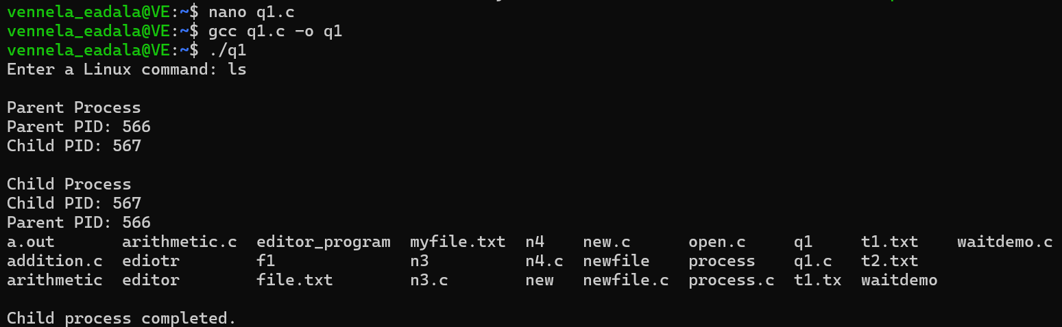
Q.2
CODE:
#include <stdio.h>
#include <stdlib.h>
#include <fcntl.h>
#include <unistd.h>
int main()
{
int source, destination;
char buffer[1024];
ssize_t bytesRead;
source = open("sample.txt", O_RDONLY);
if (source < 0)
{
perror("Error opening source file");
return 1;
}
destination = open("copy.txt", O_WRONLY | O_CREAT | O_TRUNC, 0644);
if (destination < 0)
{
perror("Error opening destination file");
close(source);
return 1;
}
while ((bytesRead = read(source, buffer, sizeof(buffer))) > 0)
{
if (write(destination, buffer, bytesRead) != bytesRead)
{
perror("Error writing to destination file");
close(source);
close(destination);
return 1;
}
}
if (bytesRead < 0)
{
perror("Error reading source file");
}
close(source);
close(destination);
printf("File copied successfully!\n");
printf("Source file: sample.txt\n");
printf("Destination file: copy.txt\n");
return 0;
}
OUTPUT: 