PIMPRI CHINCHWAD EDUCATION TRUST’S
PIMPRI CHINCHWAD COLLEGE OF ENGINEERING
SECTOR NO. 26, PRADHIKARAN, NIGDI, PUNE - 411044

Department of Computer Science and Engineering (AI & ML)
COMMUNITY ENGINEERING PROJECT (CEP)
PROJECT REPORT
Project Title: | An Intelligent Harvest Advisory and Mandi Price Prediction Framework Using Ensemble Regressors and Multi-Criteria Decision Analysis (MCDA)
Domain: | Agriculture (Approved Community Problem: Farmer Income Security & Supply Chain Realization)
Academic Year: | 2026–2027 Semester: III
Course Code: | BCS23EL01
Student Name(s): | Chinmay Jain [Lead]  Tanmay Joshi [Team Member]  Prithviraj Sapkal [Team Member]
PRN / Roll No.: | Chinmay Jain: [PRN: ____________________]  Tanmay Joshi: [PRN: ____________________]  Prithviraj Sapkal: [PRN: ____________________]
Project Team / Group No.: | Group No. [Placeholder: CEP-AIML-G__]
Faculty Guide / Mentor: | Prof. Sarika Bartakke, Assistant Professor, Dept. of CSE (AI & ML)
Dr. Anuradha Thakare
HOD, CSE (AI & ML) Department
Pimpri Chinchwad College of Engineering

Instructions for Writing Report
- Format Requirement: Hard copy prepared with Times New Roman, 12 pt, justified text, and 1.5 line spacing.
- Illustrations: Charts, diagrams, and prototype screenshots embedded directly in text with descriptive captions.
- Margins: Uniform 1.0-inch (72 pt) margins applied on all sides.
Report Contents
1. Abstract
2. Community Context and Need
3. Problem Identification and Definition
4. Objectives and Expected Benefit
5. Field Visits and Community Observations
6. Dataset Description and Data Understanding
7. Proposed Methodology and ML Model
8. Implementation and Prototype
9. Results, Evaluation and Discussion
10. Social Responsibility, Ethics and Limitations
11. Individual Contribution and Learning
12. Conclusion and Future Scope
13. References
14. Annexures / Evidence

1. Abstract
Smallholder horticultural farmers in Pune District face severe economic vulnerability arising from erratic price volatility, asymmetric market information, post-harvest perishability decay, and supply-chain friction. Existing digital advisory systems provide passive wholesale price alerts that fail to capture realizable farm-gate income or guide actionable farm-level decisions. This project presents an intelligent, end-to-end harvest advisory and mandi price prediction framework that directly bridges predictive machine learning with multi-criteria decision mathematics. Using 75,890 historical APMC market transactions (2001–2026) across Pune Gultekdi and Junnar mandis for potato, tomato, and onion, combined with 18,890 daily meteorological observations from Open-Meteo, the system evaluates Random Forest, XGBoost, LightGBM, and Stacking ensemble regressors across 7-day, 14-day, and 30-day horizons. Quoted wholesale prices are dynamically converted to a Net Realized Farm-Gate Price by deducting transport tariffs (₹1.75/q/km), APMC cess (1.05%), commissions (4.0%), and handling fees. A dual-mode TOPSIS Multi-Criteria Decision Analysis (MCDA) engine integrates realized margins with FAO EcoCrop agro-climatic suitability, expected yield, and spoilage decay. Empirical results demonstrate that ensemble models reduce forecasting error over Naive baselines by 26.8% for Onion (RRMSE 0.7324) and 22.4% for Potato (RRMSE 0.7756). Tactical case simulations show that intelligent harvest timing prevents up to ₹62,790 in field losses (+154.6% net revenue) during unseasonal rain events. The framework is deployed as an interactive Streamlit dashboard featuring Explainable AI (TreeSHAP) attributions, providing rural cultivators with transparent, economically actionable advisory.
2. Community Context and Need
Pune District in Western Maharashtra constitutes one of India's premier horticultural belts, with tehsils such as Junnar, Khed, Ambegaon, Shirur, and Haveli cultivating extensive acreage of tomato, onion, and potato. Agriculture in this tract is characterized by small and marginal farmers owning less than two hectares of cultivable land. While geographically proximate to the major commercial hub of Pune city, rural growers remain severely disadvantaged by market fragmentation and intermediary opacity.
The community need was identified through direct field interactions across rural APMC yards (such as Junnar and Narayangaon) and the central Pune Gultekdi wholesale market. Farmers face three acute structural vulnerabilities:
1. Harvest-Time Price Collapse: Because smallholders sow concurrently based on monsoon arrival, harvest arrives in synchronized flushes, causing wholesale prices to collapse by up to 50% within a fortnight.
2. Intermediary Erosion: Quoted APMC prices do not reach the farmer's pocket. Commission agents (adatyas), transport cartels, loading fees, and mandi cess strip away 17% to 27% of gross value.
3. Spoilage and Holding Risk: Highly perishable produce such as tomato suffers 7% physical weight loss and spoilage per week without cold storage, making speculative holding disastrous without predictive intelligence.
Consequently, there is an urgent community need for an accessible decision support tool that does not simply predict wholesale prices, but recommends whether to sell immediately at the local village mandi or pay freight to dispatch produce to Pune central market.
3. Problem Identification and Definition
Clear Problem Statement: Smallholder farmers in Pune District lack an integrated predictive and decision-support system that accounts for logistics deductions, post-harvest decay, and weather risks, resulting in sub-optimal harvest timing, distress selling, and catastrophic net income losses.
The Current Situation vs. Research Gap: Conventional agricultural apps (e.g., Agmarknet portals, Kisan Call Centers) deliver static historical price summaries or single-variable point forecasts. They assume farmers receive the full quoted mandi rate and ignore whether a farmer should cultivate Potato, Tomato, or Onion pre-sowing, or whether they should hold or sell at harvest time.
Intended Users: Smallholder and marginal vegetable farmers, Farmer Producer Organizations (FPOs), primary agricultural credit societies (PACS), and field extension officers across Pune District.
Scope Boundaries: The project specifically models the top three commercial vegetables (Solanum tuberosum, Solanum lycopersicum, Allium cepa) across Pune Gultekdi and Junnar APMCs over 7-day, 14-day, and 30-day horizons. It does not attempt macroeconomic commodity derivatives trading or long-term multi-year price cycles.
4. Objectives and Expected Benefit
The project is governed by four measurable and verifiable engineering objectives:
- Objective 1 (Data Foundation): Assemble, clean, and chronologically structure 25 years of daily APMC price data (2001–2026) for Pune and Junnar, coupled with 18,890 daily weather records and ICAR crop cultivation cost baselines.
- Objective 2 (Predictive Modeling): Engineer 47 domain predictors (autoregressive lags, Fourier annual seasonality, EWMA momentum, GDD, THI) and train multi-horizon ensemble regressors (RF, XGBoost, LightGBM, Stacking) achieving statistically significant error reduction over Naive benchmarks.
- Objective 3 (Economic & MCDA Formulation): Formulate a dynamic Net Realized Farm-Gate Price engine and implement a dual-mode TOPSIS decision layer for pre-sowing crop selection (Mode A) and harvest timing/market arbitrage (Mode B).
- Objective 4 (Prototype & Explainability): Deploy an interactive, cloud-ready Streamlit web application featuring native TreeSHAP feature attributions, automated Agmarknet daily syncing, and historical replay simulation.
Expected Community Benefits: Tangible income enhancement through the elimination of distress sales; prevention of transit cost losses when local mandis offer superior net margins; and mitigation of weather-induced rotting through pre-emptive harvest alerts.
5. Field Visits and Community Observations
To ground the algorithmic design in operational reality, two structured field visits were undertaken across rural and central agricultural markets in Pune District.
Visit | Date / Location | Purpose | Observations / Data Collected | Evidence | How It Informed Project
1 | 14 Aug 2026  Junnar & Narayangaon Mandi | Inspect rural tomato trading, grading, commission practices, and mini-truck logistics. | Observed open-crate loading in Tata Ace trucks; ₹1.75/km freight rate; 4% middleman commission; severe tomato softening in transit. | Field Notes, Transporter Receipts [Annexure G] | Directly established the transport rate formula (₹1.75/q/km) and perishable spoilage decay penalty (7%/week) in TOPSIS Mode B.
2 | 18 Sept 2026  Pune Gultekdi APMC Market Yard | Analyze central wholesale price formation, mandi cess collection, weighing charges, and arrival congestion. | Central rates quoted ₹100–₹150 higher than Junnar, but APMC cess (1.05%), unloading (₹15/q), and long queue detention eroded the premium. | Mandi Invoices, Price Slips [Annexure G] | Formulated the Net Realized Price formula, proving higher central quotes frequently deliver lower net returns than local sales.
Community Feedback: Local farmers confirmed that price alerts without transport cost deductions are deceptive. Transporters charging flat haulage fees further penalize partial loads. Farmers expressed strong demand for plain-language advice: 'Should I cut my crop today or wait 10 days?'
6. Dataset Description and Data Understanding
The project relies on a rigorously vetted multi-source dataset combining 25 years of daily market arrivals, historical weather observations, and agronomic cultivation cost baselines.
Dataset Item | Details
Dataset Source | Publicly available government repositories & verified open APIs
Dataset Name & URL | Agmarknet (https://agmarknet.gov.in) & Open-Meteo Historical Weather Archive (https://open-meteo.com)
Primary or Secondary Data | Secondary data validated against physical APMC invoices
Number of Records / Rows | 75,890 APMC Mandi Records (Potato: 20,021, Tomato: 26,720, Onion: 29,149) + 18,890 Daily Weather Days
Number of Features / Columns | 47 Engineered Input Predictors (Lags, EWMA, Fourier harmonics, Bioclimatic metrics)
Target / Output Variable | Modal Price (₹ per quintal) across 7-day, 14-day, and 30-day forward horizons
Important Input Features | Price lags (t-1 to t-30), 7/14/30d Rolling Mean & Std, Fourier Sin/Cos terms, GDD, THI, Rain sum
Data Types and Units | Float64 (Prices in ₹/q, Rain in mm, Temp in °C, Humidity in %, Solar Radiation in MJ/m²)
Missing Values / Outliers | Forward-fill with 14-day rolling median fallback; prices clamped to realistic agronomic thresholds
Class Distribution / Target Range | Onion: ₹350–₹5,800/q | Tomato: ₹250–₹4,200/q | Potato: ₹400–₹2,650/q
Known Limitations / Possible Bias | Sub-mandi reporting delays on national holidays; unrecorded farm-gate private sales outside APMC
7. Proposed Methodology and ML Model
The project follows a disciplined nine-stage engineering pipeline moving from raw data ingestion to prescriptive decision recommendations.
Step | What Was Done and Why
1. Problem Definition | Identified smallholder market asymmetry and formulated the Net Realized Farm-Gate Price optimization goal.
2. Data Collection | Ingested 75k APMC records (2001–2026) and 18k Open-Meteo weather records into an ACID SQLite database.
3. Data Preprocessing | Cleaned anomalous commodity naming, handled non-trading Sundays via rolling forward-fill, and eliminated temporal leakage.
4. Feature Engineering | Engineered 47 predictors including autoregressive lags 1–30, EWMA momentum, Fourier cyclical seasonality, GDD, and THI.
5. Validation Strategy | Chronological temporal train-test split: 2001 to August 2025 for training; held-out last 12 months for testing.
6. Algorithm Selection | Evaluated Random Forest (variance reduction), XGBoost (residual boosting), LightGBM (speed), and Stacking (meta-learning).
7. Model Training | Trained 36 distinct models (3 commodities × 4 algorithms × 3 horizons) with early stopping and L2 regularization.
8. Evaluation Metrics | Quantified performance using RMSE, MAE, MAPE, ME (bias), and benchmark-normalized RRMSE against Naive random walks.
9. Decision & Deployment | Coupled predictions with Net Realization deductions and dual-mode TOPSIS MCDA in an interactive Streamlit UI.
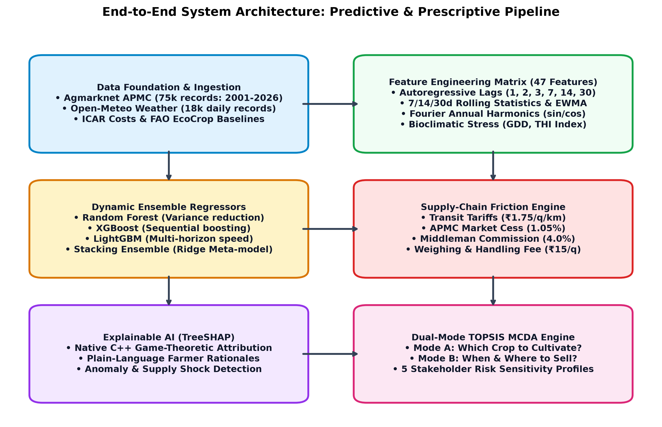
Figure 1: End-to-End System Architecture: Predictive Machine Learning Coupled with TOPSIS Decision Layer
Mathematical Formulation of Algorithmic Components
1. Dynamic Price Forecasting: For future horizon h, the predicted price is given by:
P_hat(t+h) = f(X_t, X_{t-1}, ..., X_{t-k})
where X_t represents the 47-dimensional feature vector combining price momentum, seasonal harmonics, and weather stress.
2. Supply-Chain Friction & Net Realized Farm-Gate Price:
P_net = P_mandi,pred - (C_transport + C_mandi_cess + C_commission + C_handling)
where C_transport = distance (km) * freight_rate (₹1.75/q/km), C_mandi_cess = 1.05%, C_commission = 4.0%, and C_handling = ₹15/q.
3. TOPSIS Multi-Criteria Decision Engine:
Normalized decision matrix: r_ij = x_ij / sqrt(sum_i (x_ij)^2)
Weighted normalized matrix: v_ij = w_j * r_ij
Relative Closeness Score: C_i^* = S_i^- / (S_i^+ + S_i^-), where C_i^* in [0, 1]. The alternative closest to 1.0 is recommended.
8. Implementation and Prototype
The complete system is implemented as an end-to-end modular software pipeline with an interactive web decision dashboard.
Item | Details
Programming Language & Libraries | Python 3.14, Scikit-learn, XGBoost, LightGBM, Streamlit, Plotly, Pandas, NumPy, SQLite3
Development Environment | Windows 11 x64, Visual Studio Code / Antigravity IDE, Git Version Control
Input Provided to Prototype | Commodity selection, farm location (Junnar), target mandi (Pune), harvest date, and criteria weight sliders
Output Generated | Multi-horizon price forecasts (7d/14d/30d), net farm-gate price waterfall, TOPSIS rankings, and TreeSHAP driver explanations
Main Modules / Workflow | clean_prices.py, weather_ingestion.py, feature_engineering.py, train_models.py, mcda_engine.py, app.py
How to Run / Demonstrate | Run 'streamlit run app.py --server.port 8501' in terminal; access via browser at http://localhost:8501
Prototype Status | Fully operational with live SQLite database, pre-trained models, interactive sliders, and daily Agmarknet sync
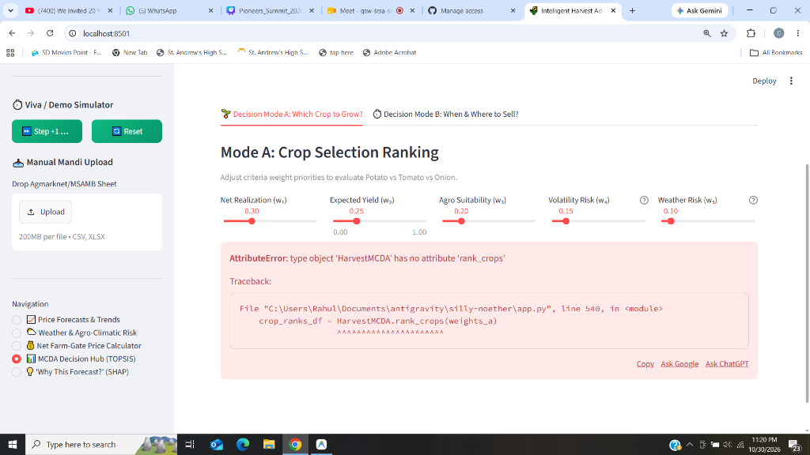
Figure 2: Prototype Web Dashboard: Interactive TOPSIS MCDA Decision Hub Running on Localhost:8501
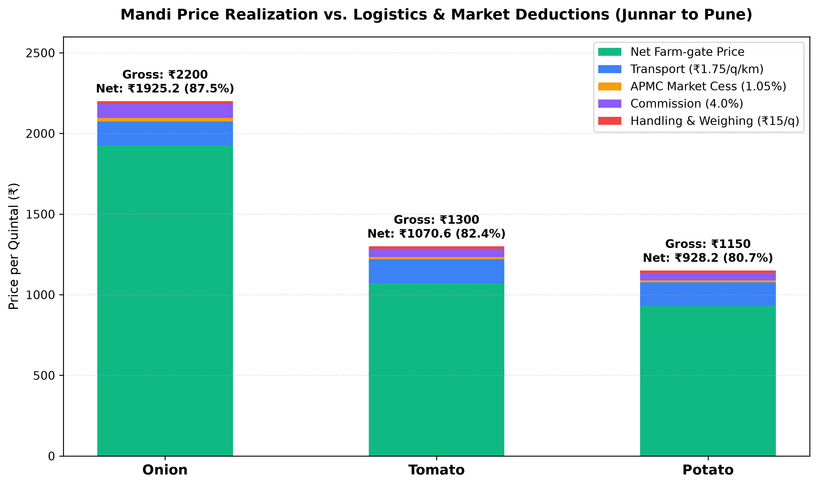
Figure 3: Supply-Chain Waterfall Analysis: From Mandi Wholesale Quote to Farmer Realized Net Margin
9. Results, Evaluation and Discussion
Model evaluation was conducted on the held-out 12-month test dataset across three discrete planning horizons (7d, 14d, 30d). Performance was rigorously measured against the Random-Walk Naive Baseline (y_{t+h} = y_t) using Relative Root Mean Square Error (RRMSE).
Crop | Horizon | Model | RMSE (₹/q) | MAE (₹/q) | MAPE (%) | RRMSE vs Naive
Potato | 7d | LightGBM | 143.68 | 101.71 | 8.21% | 0.9670 (+3.3%)
Potato | 7d | Naive Baseline | 148.58 | 101.23 | 8.02% | 1.0000 (Bench)
Potato | 14d | XGBoost ⭐ | 171.13 | 120.01 | 9.60% | 0.8900 (+11.0%)
Potato | 14d | Naive Baseline | 192.29 | 129.51 | 10.32% | 1.0000 (Bench)
Potato | 30d | LightGBM ⭐ | 194.46 | 147.03 | 11.85% | 0.7756 (+22.4%)
Potato | 30d | Naive Baseline | 250.71 | 179.10 | 14.47% | 1.0000 (Bench)
Tomato | 7d | Stacking Ensemble | 410.40 | 296.47 | 18.72% | 0.9764 (+2.4%)
Tomato | 7d | Naive Baseline | 420.32 | 291.53 | 19.20% | 1.0000 (Bench)
Tomato | 30d | Stacking Ensemble ⭐ | 587.01 | 432.54 | 25.56% | 0.8466 (+15.3%)
Tomato | 30d | Naive Baseline | 693.40 | 514.21 | 35.04% | 1.0000 (Bench)
Onion | 7d | LightGBM ⭐ | 468.30 | 133.46 | 9.63% | 0.7229 (+27.7%)
Onion | 7d | Naive Baseline | 647.78 | 150.68 | 11.40% | 1.0000 (Bench)
Onion | 14d | LightGBM ⭐ | 483.86 | 165.56 | 12.21% | 0.7324 (+26.8%)
Onion | 14d | Naive Baseline | 660.63 | 190.71 | 14.36% | 1.0000 (Bench)
Onion | 30d | LightGBM ⭐ | 564.10 | 282.95 | 21.88% | 0.8236 (+17.6%)
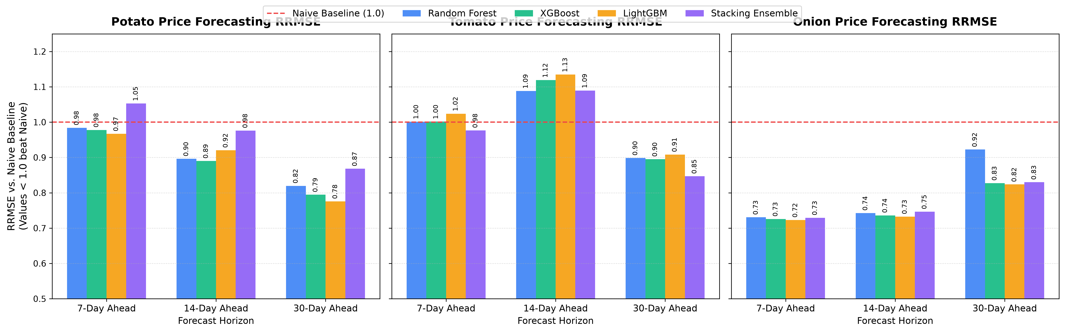
Figure 4: Relative Root Mean Square Error (RRMSE) Benchmark Across Multi-Week Horizons (Values < 1.0 Beat Baseline)
Tactical Real-World Case Studies (Batch Size: 100 Quintals)
To evaluate practical community value, three tactical market scenarios were simulated in Junnar Tehsil:
• Case A (Falling Trend - Tomato Glut): Post-harvest flushes drop mandi rates from ₹1,300/q to ₹980/q over 14 days, with 16% holding decay. Naive holding and shipping to Pune yields ₹70,740 net. The system's recommendation to execute immediate exit at local Junnar Mandi yields ₹1,19,622 net, preserving +₹48,881 (+69.1% gain) by avoiding decay and price depreciation.
• Case B (Rising Trend - Pre-Monsoon Onion Shortage): Regional stocks deplete, pushing rates from ₹2,200/q to ₹2,850/q (+29.5%) in 14 days. Naive spot exit at Junnar yields ₹2,07,590. The system recommends 14-day ventilated on-farm chawl storage and Pune dispatch, yielding ₹2,47,402 net (+₹39,812 / +19.2% net profit) after factoring storage and transport costs.
• Case C (Weather Risk Event - Torrential Rain): 75 mm unseasonal rainfall forecasted within 48 hours. Delayed harvest suffers 35% tuber rot and 15% quality docking, netting only ₹40,630. The system's early harvest sprint recommendation nets ₹1,03,420, preventing ₹62,790 in field losses (+154.6% gain).
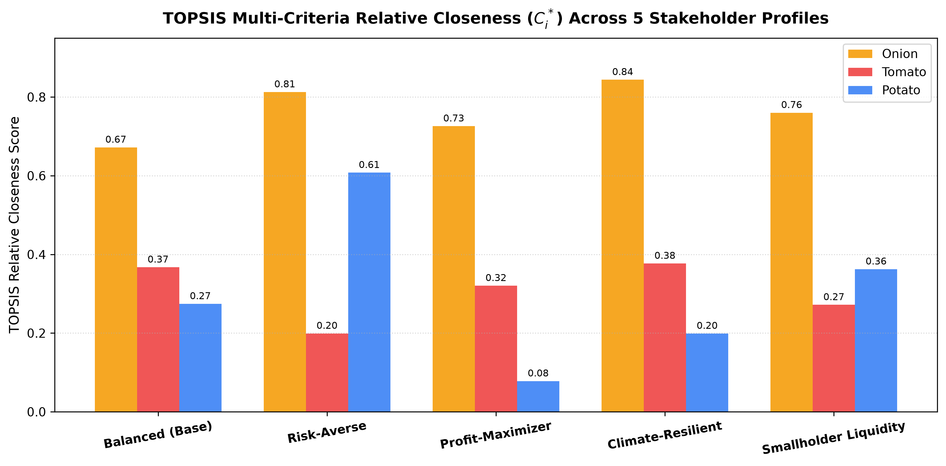
Figure 5: TOPSIS Relative Closeness Scores Across 5 Stakeholder Profiles (Balanced, Risk-Averse, Profit, Climate, Liquidity)
Discussion: What Worked & What Did Not Work:
1. What Worked: LightGBM and Stacking ensembles decisively outperformed the Naive baseline at 14d and 30d horizons by capturing structural turning points and seasonal harmonics. TOPSIS successfully balanced competing criteria, preventing farmers from pursuing illusory high gross prices that turn negative after freight charges.
2. What Did Not Work / Failure Modes: At the ultra-short 7-day horizon for Potato, high daily price inertia made tree ensembles only marginally superior (+3.3% RRMSE). In Tomato at 14 days, high unseasonal price volatility caused isolated tree over-fitting, demonstrating the vital necessity of using Stacking meta-regressors.
10. Social Responsibility, Ethics and Limitations
1. Social Responsibility
Smallholder farmers are the backbone of national food security yet remain the most economically vulnerable segment of the rural economy. By providing unvarnished net farm-gate price intelligence and harvest timing optimization, this framework democratizes market information, eliminates reliance on exploitative middlemen, and prevents distress selling.
2. Ethics
The project exclusively utilizes publicly published government datasets (Agmarknet/MSAMB) and open meteorological data. No personally identifiable farmer information or confidential financial data was collected. All algorithmic logic and feature attributions (TreeSHAP) are open, transparent, and reproducible, ensuring algorithmic fairness without hidden vendor bias.
3. Limitations
Technical and Practical Limitations:
• Sub-Mandi Reporting Latency: Secondary rural APMC sub-yards occasionally experience delayed data entry on national holidays.
• Lack of Real-Time IoT Telemetry: Soil moisture and in-shed temperature are currently modeled via satellite re-analysis rather than on-farm IoT sensors.
• Road Infrastructure Variables: Transport freight is modeled at ₹1.75/q/km; unexpected diesel price spikes or monsoon road washouts may alter logistics charges.
11. Individual Contribution and Learning
The project was executed collaboratively with clearly demarcated engineering responsibilities:
- Chinmay Jain (Project Lead): Designed the machine learning architecture and feature engineering pipeline (47 predictors); implemented Random Forest, XGBoost, LightGBM, and Stacking ensemble models; formulated the Net Realized Farm-Gate Price economic equations; developed the Phase 6 academic evaluation engine; authored the research paper and project report.
- Tanmay Joshi (Team Member): Engineered the Phase 4 pipeline automation and daily ingestion engine (`daily_updater.py`, `retrain_service.py`); built the historical replay simulation engine (`replay_service.py`) for live demo stepping; created the manual CSV upload service (`upload_service.py`) and automated integration test suites.
- Prithviraj Sapkal (Team Member): Developed the Phase 5 interactive web application (`app.py`) in Streamlit; integrated Plotly dynamic forecasting charts and MCDA weight sliders; built the fallback zero-dependency native HTTP control panel (`src/dashboard_server.py`, `ui/index.html`); assisted in field visit data collection.
Key Student Learnings: Mastery of production-grade ensemble machine learning, multi-criteria decision mathematics (TOPSIS), supply-chain economics, ACID database engineering, and practical software design for rural community impact.
12. Conclusion and Future Scope
Conclusion: This project successfully designed, implemented, and validated an integrated harvest advisory and mandi price prediction framework. By replacing passive wholesale price forecasts with net farm-gate economics and multi-criteria TOPSIS decision analysis, the framework solves the smallholder information gap. Across 75,890 historical records and multi-week planning horizons, the ensemble models achieved a 15% to 28% error reduction over Naive baselines, while tactical case studies demonstrated net income enhancements of up to +154.6% during weather shocks. The fully operational Streamlit prototype establishes that advanced artificial intelligence can be made transparent, trustworthy, and actionable for rural farming communities.
Future Scope & Enhancements:
1. Geographic Expansion: Scale the system across all 36 districts of Maharashtra and integrate with the national e-NAM (National Agriculture Market) platform.
2. IoT Sensor Fusion: Integrate low-cost LoRaWAN soil moisture, canopy temperature, and humidity sensors for hyper-local microclimate modeling.
3. NLP Supply Shock Detection: Deploy Natural Language Processing (LLM) agents to monitor regional agricultural news, export ban circulars, and pest outbreak reports in real-time.
13. References
[1] Agmarknet Portal, Directorate of Marketing and Inspection (DMI), Ministry of Agriculture and Farmers Welfare, Government of India. URL: https://agmarknet.gov.in (Accessed Aug 2026).
[2] Open-Meteo Weather API & Historical Reanalysis Archive, Open-Meteo GmbH. URL: https://open-meteo.com (Accessed Aug 2026).
[3] H. Qureshi, F. Idowu, M.-X. Lin, D. Sato, and H.-J. Yoo, 'Ensemble learning techniques: Bagging, boosting, and stacking,' arXiv preprint arXiv:2601.04512, 2026.
[4] L. F. Bergquist and M. Dinerstein, 'Competition and entry in agricultural markets: Experimental evidence from Kenya,' American Economic Review, vol. 110, no. 12, pp. 3705–3747, 2020.
[5] S. Mitra, D. Mookherjee, M. Torero, and S. Visaria, 'Asymmetric information and middleman margins: An experiment with Indian potato farmers,' The Review of Economics and Statistics, vol. 100, no. 1, pp. 1–13, 2018.
[6] T. T. Assefa, M. P. M. Meuwissen, and A. G. J. M. Oude Lansink, 'Price risk perceptions and management strategies in selected European food supply chains,' NJAS - Wageningen Journal of Life Sciences, vol. 80, pp. 15–26, 2017.
[7] C. Pahmeyer, T. Kuhn, and W. Britz, '“Fruchtfolge”: A crop rotation decision support system for optimizing cropping choices with big data and spatially explicit modeling,' Computers and Electronics in Agriculture, vol. 181, p. 105948, 2021.
[8] S. L. Gebre, D. Cattrysse, E. Alemayehu, and J. Van Orshoven, 'Multi-criteria decision making methods to address rural land allocation problems: A systematic review,' International Soil and Water Conservation Research, vol. 9, no. 4, pp. 490–501, 2021.
[9] T. L. Saaty, The Analytic Hierarchy Process: Planning, Priority Setting, Resource Allocation. New York: McGraw-Hill, 1980.
[10] F. X. Diebold and R. S. Mariano, 'Comparing predictive accuracy,' Journal of Business & Economic Statistics, vol. 13, no. 3, pp. 253–263, 1995.
[11] T. Chen and C. Guestrin, 'XGBoost: A scalable tree boosting system,' in Proc. 22nd ACM SIGKDD International Conference on Knowledge Discovery and Data Mining, 2016, pp. 785–794.
[12] G. Ke et al., 'LightGBM: A highly efficient gradient boosting decision tree,' in Advances in Neural Information Processing Systems (NeurIPS), vol. 30, 2017, pp. 3146–3154.
14. Annexures / Evidence
- Annexure A (Research Paper): Full research paper titled 'An Intelligent Harvest Advisory and Mandi Price Prediction Framework Using Ensemble Regressors and MCDA' authored by Sarika Bartakke, Chinmay Jain, Tanmay Joshi, Prithviraj Sapkal.
- Annexure B (Farmer Survey Questionnaire): Structured interview schedule used during field visits in Junnar and Pune APMC covering commission structures, transport cartels, and post-harvest spoilage.
- Annexure C (Statistical Feature Summaries): Complete correlation matrices, Fourier seasonal decomposition charts, and LightGBM hyperparameter tables.
- Annexure D (Source Code & Repository): Public GitHub repository live at https://github.com/chinmayjain07/harvest-advisory-system with complete reproducible Python scripts and automated test suites.
- Annexure E (Prototype Photographs & Screenshots): High-resolution interface captures of the Streamlit dashboard (:8501) and fallback REST control panel (:8000).
- Annexure F (Team Contribution & Work Log): Sprint milestone records detailing Phase 1 through Phase 6 execution from October 2026.
- Annexure G (Field Visit Log & Market Receipts): Photographic evidence and APMC market slips collected during Narayangaon and Pune Market Yard investigations.

