1.What are the two values of the Boolean data type? How do you write them?

Ans: True and False

2. What are the three different types of Boolean operators?

Ans: AND, OR, NOT

3. Make a list of each Boolean operator's truth tables (i.e. every possible combination of Boolean values for the operator and what it evaluate ).

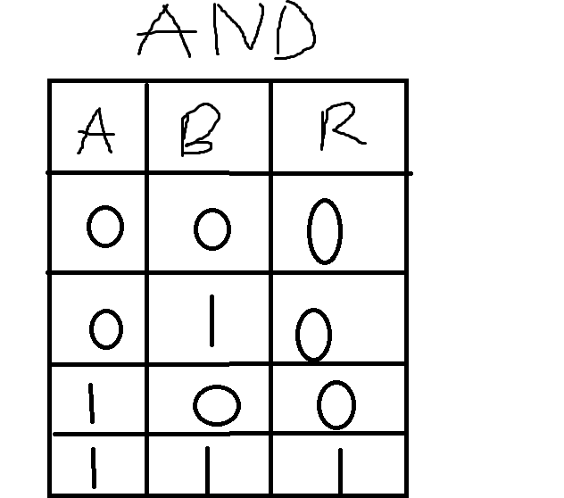

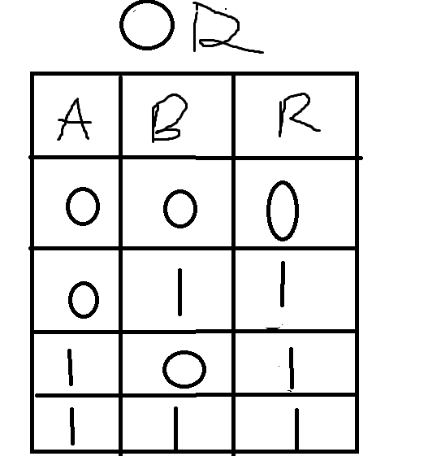

4. What are the values of the following expressions?

(5 > 4) and (3 == 5) -- False

not (5 > 4) -- False

(5 > 4) or (3 == 5) -- True

not ((5 > 4) or (3 == 5)) -- False

(True and True) and (True == False) -- False

(not False) or (not True) -- True

5. What are the six comparison operators?

< ,<=, >, >=, = ,!=

6. How do you tell the difference between the equal to and assignment operators?Describe a condition and when you would use one.

a = 10 -- here assignment operator is used to assign the value to the variable

a=10

if a==10: -- here equal to is used to check whether value of variable a is equal with 10 or not.

print("succes")

else:

print("Fail")

7. Identify the three blocks in this code:

spam = 0

if spam == 10:

print('eggs') -- First block

if spam > 5:

print('bacon') -- Second Block

else:

print('ham')

print('spam')

print('spam') --- Third block

8. Write code that prints Hello if 1 is stored in spam, prints Howdy if 2 is stored in spam, and prints Greetings! if anything else is stored in spam.

spam=input("Enter a value: ")

x=int(spam)

if x == 1:

print("Hello")

elif x ==2:

print("Howdy")

else:

print("Greetings")

9.If your programme is stuck in an endless loop, what keys you’ll press?

Ans: CTRL + C

10. How can you tell the difference between break and continue?

Break – it end the execution of current loop and exit from the loop

Continue – it skips the current iteration and executes the very next iteration in the loop.

11. In a for loop, what is the difference between range(10), range(0, 10), and range(0, 10, 1)?

Range(10) – it is range of values from 0 to 9 increment by default 1

Range(0,10) -- it is range of values from 0 to 9 increment by default 1

Range(0,10,1) -- -- it is range of values from 0 to 9 and increment by 1

12. Write a short program that prints the numbers 1 to 10 using a for loop. Then write an equivalent program that prints the numbers 1 to 10 using a while loop.

For Loop:

for i in range(1,11):

print(i)

While Loop:

i= 1

while i <= 10:

print(i)

i=i+1

13. If you had a function named bacon() inside a module named spam, how would you call it after importing spam?

Ans: spam.bacon()