README:

1. Preprocessing Files:

editCSV.py

featureExtraction.py

imageDownload.py

imageDownloadfromImageNet.py

2. Model:

Model_creation.py

Setup

Download and install Tensorflow, keras, Pillow as PIL, openCV, numpy, pandas, glob

No need to run all the pre processing files:

Download dataset from thin link

link to the dataset 'https://drive.google.com/open?id=1pJl0_06-1Hci7khqScrRy7cg-5UUalMK'

Run only model_creation.py

Before running this file it needs sligh editing for setting the file path:

Set these 2 path names and then run the program

pathofTrainingDataset = 'C:/Users/./CV/AirbnbProject/'

pathofTestingDataset = 'C:/Users/./CV/AirbnbProject/'

Overview of dataset and initial outcome:

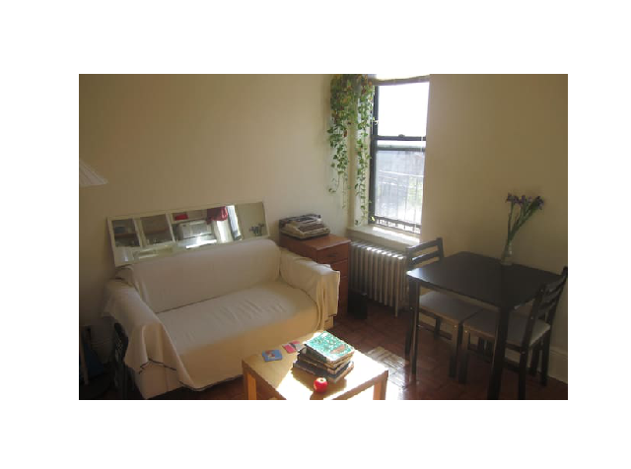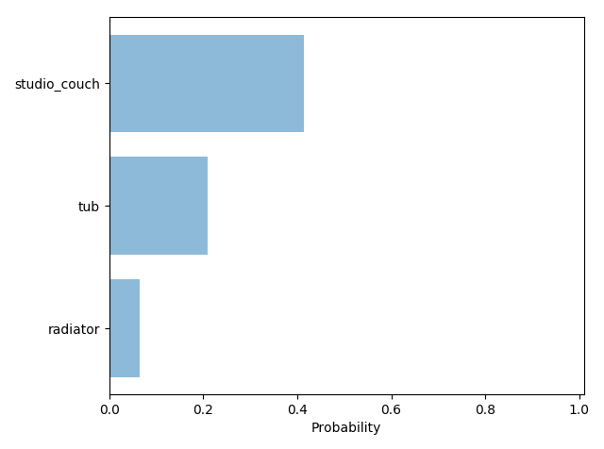

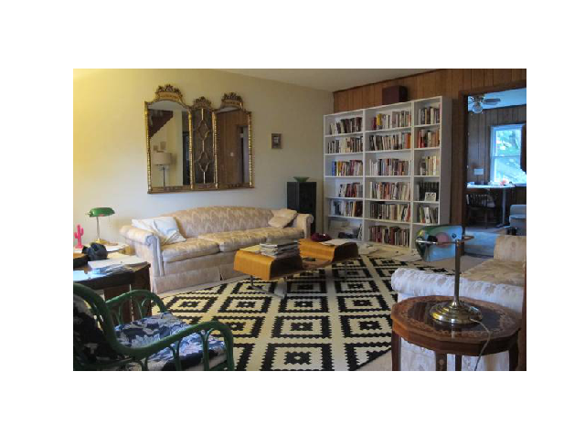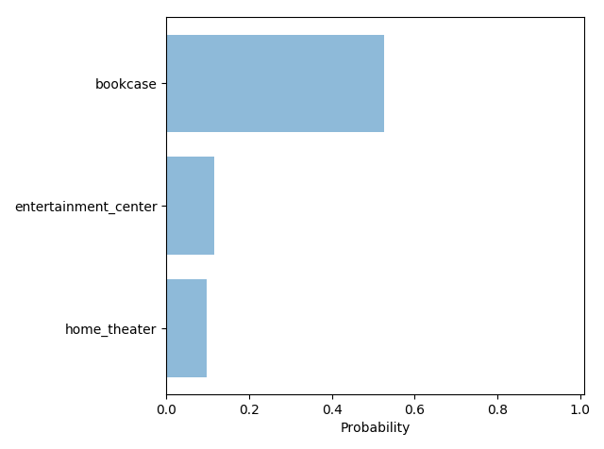

References for this project:

1. https://deeplearningsandbox.com/how-to-build-an-image-recognition-system-using-keras-and-tensorflow-for-a-1000-everyday-object-559856e04699 (Used to impute label)

2 https://machinelearningmastery.com/object-recognition-convolutional-neural-networks-keras-deep-learning-library/ (Referenced for Model build)

https://en.wikipedia.org/wiki/Rectifier_(neural_networks)

https://en.wikipedia.org/wiki/Softmax_function

https://en.wikipedia.org/wiki/Dropout_(neural_networks)