**Service Oriented Computing Assignment**

**Team No. 7 (Team Chinmay)**

Members:

1. Chinmay Kunkikar (Team Leader)
2. Joel D’Souza
3. Shivam Mishra
4. Aakash Vishwakarma
5. Shabbir Doodhwala
6. Sushant Yadav
7. Saurabh T

GitHub URL: [github.com/chinmaykunkikar/bank_soa](https://github.com/chinmaykunkikar/bank_soa.git)

UML diagrams:

1. Architecture Diagram

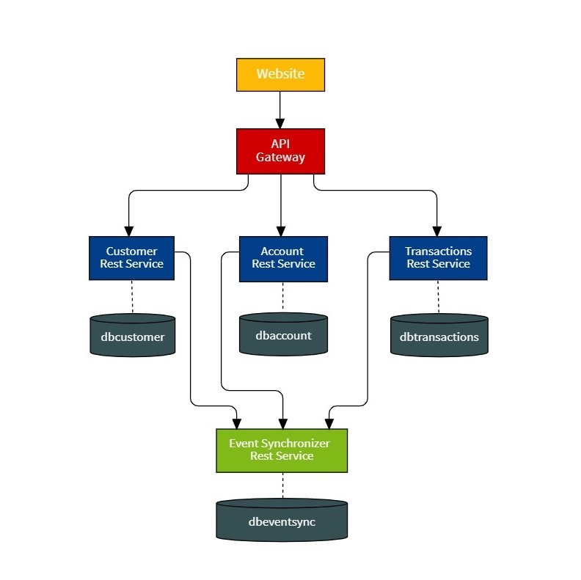

2. Class Diagram

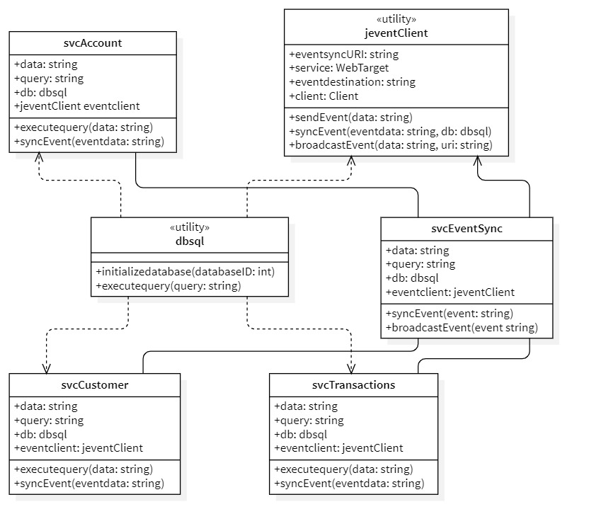

3. Sequence Diagram for Customer

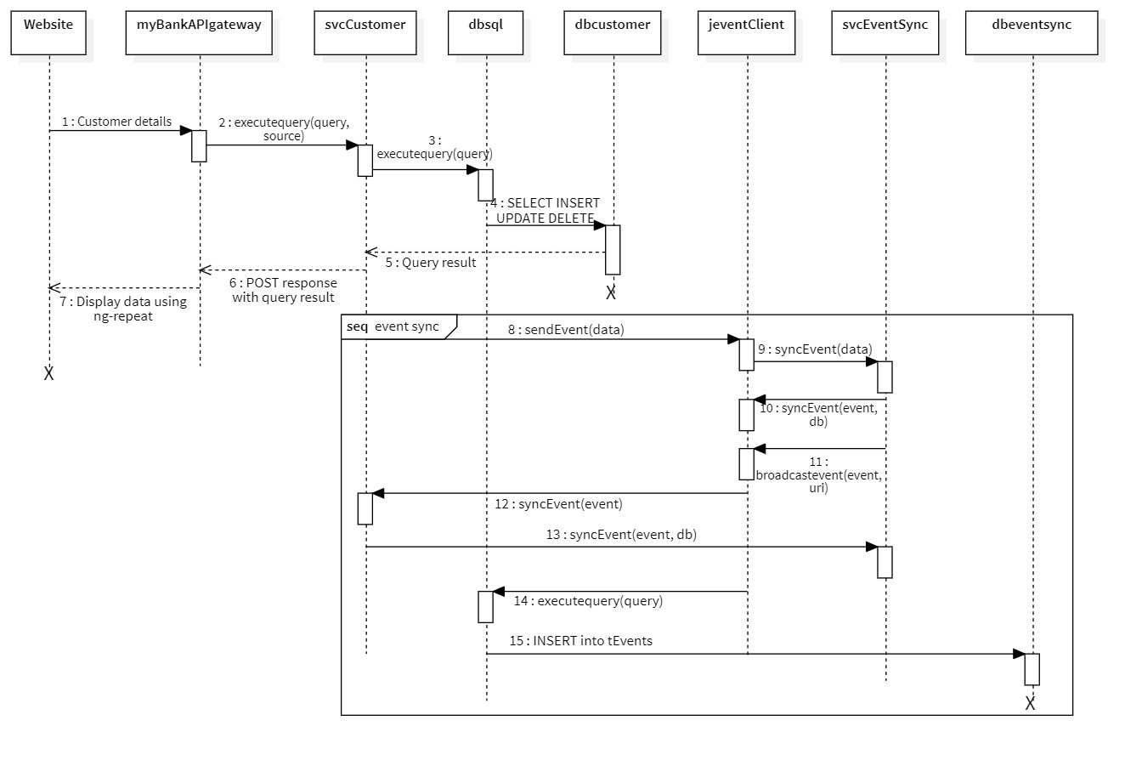

4. Sequence Diagram for Accounts

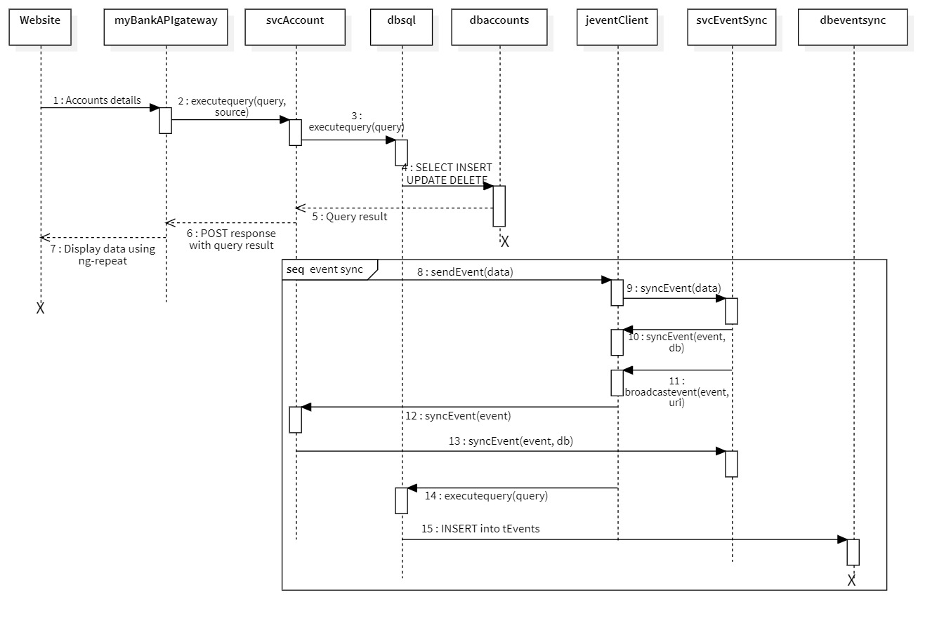

5. Sequence Diagram for Transactions

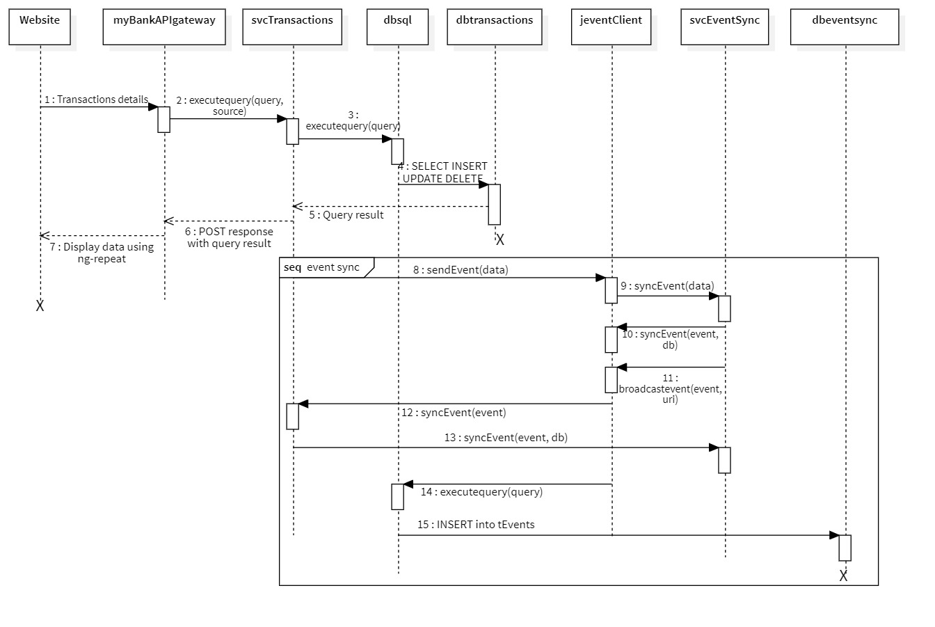

6. Event Lifecycle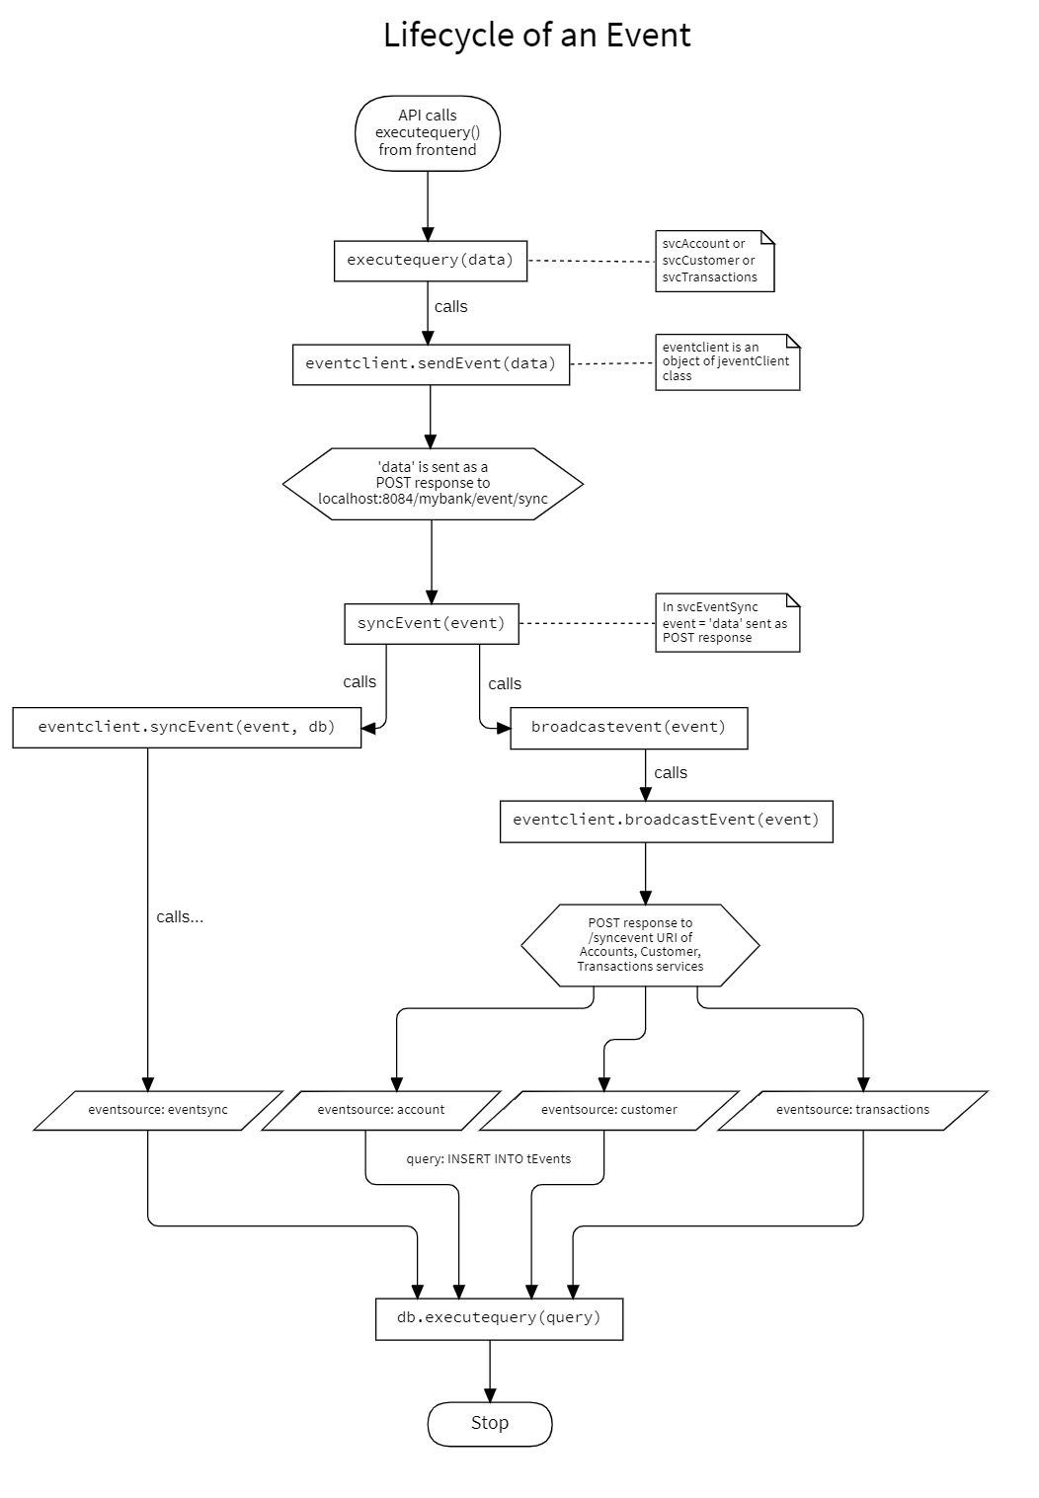

Features:

**Services**

1. Update to latest jersey v2.31.

2. Update packaging of *jdatabase* and *jevent* jars to *'mybank'* in pom.xml.

**Frontend**

1. The website has been redesigned completely using CSS framework *MDBootstrap*.

2. Use minified version (.min.js) of *_mybankAPIgateway.js* to improve performance of js.

3. API gateway supports every input field from the website.

4. Get rid of customer type.

**Database**

1. The database has been worked from ground up to compliment with the improved frontend and services.

2. The *dbsql* utility class no longer needs a query type. It will automatically differentiate between read and write query and return appropriate results.

3. Use of triggers so that any transaction happening at *dbtransactions* will reflect in *dbaccount* database.

4. The tevents table will now know the source of the original query (a.k.a *eventsource*).

**Miscellaneous**

1. Much of the existing codebase was cleaned, formatted, and refactored.

2. Any redundant methods and imports have been removed.

3. The command prompt output is formatted.

4. New and efficient batch files, that will redirect output to a .log file to keep the output on the command prompt clean.

5. The entire work was done using GitHub as version control.