JSPM’s
Rajarshi Shahu College of Engineering, Tathawade, Pune – 33.
Department of Computer Science and Business Systems
AY: 2026-27 Sem: II

Mini Project Report On
CampusCare – College Complaint & Service Management System

Submitted by:
Prathmesh Sadaphule (Roll No: RBT24CB034)

Under the guidance of

Prof. Rutuja S. Bachhav
Course: Skill Development Lab-II

Academic Year: 2026–27 (Semester V)

Table of Contents
1. Abstract 5
2. Introduction 6
2.1 Background / Motivation 6
2.2 Problem Definition 6
2.3 Objectives 6
3. Literature Survey / Existing System 7
3.1 Review of Related Tools or Existing Systems 7
3.2 Gaps Identified 7
4. Proposed System 8
4.1 System Overview 8
4.2 Features / Scope 8
4.3 System Architecture Diagram 8
4.4 Use Case Diagram 10
4.5 Data Flow Diagram (Level 0) 11
4.6 Entity Relationship Diagram 11
4.7 Complaint Life Cycle and System Flowchart 13
4.8 Sequence Diagram – Asynchronous JMS Notification 15
5. Methodology / Implementation 16
5.1 Tools and Technologies Used 16
5.2 Modules Description 16
5.3 Algorithms / Frameworks 17
5.4 Database Design 18
5.5 REST API Summary 19
5.6 Screenshots / Outputs 19
6. Results and Discussion 33
6.1 Outputs Achieved 33
6.2 Testing and Performance 33
6.3 Comparison with Existing Methods 34
6.4 Discussion 34
7. Conclusion and Future Scope 35
7.1 Summary of Achievements 35
7.2 Limitations and Potential Improvements 35
8. References 36
9. Appendix 37
9.1 Source Code Snippets 37
9.2 Build and Deployment Steps 38
9.3 Demo Credentials 38
9.4 Additional Screenshots 38

- Course Outcomes:
CO1: Design and develop the front-end of a web application using HTML5, CSS3, jQuery, and AngularJS for responsive and interactive user interfaces.
CO2: Implement RESTful services using a familiar backend technology (e.g., Java,
Python, or C#) and establish secure database connectivity to manage application data.

- PO Mapped
PO1: Engineering Knowledge: Apply knowledge of mathematics, natural science, computing, engineering fundamentals and an engineering specialization as specified in WK1 to WK4 respectively to
develop to the solution of complex engineering problems
PO2: Problem Analysis: Identify, formulate, review research literature and analyze complex engineering problems reaching substantiated conclusions with consideration for sustainable development.
PO3: Design/Development of Solutions: Design creative solutions for complex engineering problems and design/develop systems/components/processes to meet identified needs with consideration for the public health and safety, whole-life cost, net zero carbon, culture, society and environment as required.
PO5: Engineering Tool Usage: Create, select and apply appropriate techniques, resources and modern engineering &amp; IT tools, including prediction and modeling recognizing their limitations to solve complex engineering problems.

- PSO Mapped
PSO 1: Integrated Technical Proficiency: Ability to analyze, designs, and implement comprehensive software and business systems using modern tools and techniques, ensuring intelligent, efficient, and sustainable solutions.
PSO 2: Data-Driven Decision Making: Ability to apply mathematical and data analytics methods including algorithms, statisticalmodels, and data structures to solve complex computational and business problems and support innovation.
PSO 3: Interdisciplinary Collaboration &amp; Professionalism: Ability to effectively collaborate in multidisciplinary teams, integrating technical and business perspectives, and to communicate and manage projects with professional ethics and societal responsibility.
- SDG Goals Mapped
SDG 4: Quality Education: Develops students’ practical skills in database design, SQL, PL/SQL, NoSQL, and modern database technologies.
SDG 8: Decent Work and Economic Growth: Enhances students’ technical and problemsolving skills required for employment and professional development in the IT industry.
SDG 9: Industry, Innovation and Infrastructure: Promotes the development of technology-based database solutions using SQL, PL/SQL, and MongoDB.
SDG 12: Responsible Consumption and Production: Encourages efficient data management, storage, and utilization of computing resources.

Abstract
Colleges handle hundreds of day-to-day service requests – broken projectors, faulty Wi-Fi routers, power cuts, water-cooler failures, library issues – yet most still rely on paper registers, verbal reports or scattered WhatsApp messages. Complaints are lost, nobody knows who is responsible, and the student never learns what happened. This project, CampusCare, is a full-stack web application that replaces this informal process with a transparent, trackable and role-based complaint and service management platform.
CampusCare is built as an Enterprise Java (Jakarta EE 10) application without Spring. The presentation layer is a responsive single-page application written in HTML5, CSS3 and vanilla JavaScript. It talks over JSON to JAX-RS REST resources deployed on Eclipse GlassFish 7. Business logic lives in stateless EJBs, data is persisted with JPA (EclipseLink) in a MySQL database, and asynchronous notifications are delivered through JMS using a queue, a CDI producer and a Message-Driven Bean. Security is handled with PBKDF2-hashed passwords and HMACSHA256 signed stateless tokens with role-based access control.
Three actors are supported. Students lodge complaints and follow a live five-stage timeline
(PENDING → ASSIGNED → IN_PROGRESS → RESOLVED → CLOSED); staff accept assignments and post progress and resolution notes; administrators view analytics, assign complaints to staff and manage departments. The system was built, deployed and tested end-toend: role access control, validation, status-transition rules and JMS notifications were verified, and API responses were measured at roughly 3–35 ms on a local server.

Introduction

Background / Motivation
A college campus is a small city. Departments such as electrical maintenance, IT labs, civil works, water supply and the library continuously receive requests from thousands of students. In most institutions these requests are collected through complaint boxes, handwritten registers, phone calls or informal chat groups. This approach is slow and opaque: there is no single record of what was reported, no priority ordering, no accountability for who is fixing the issue, and no feedback loop to the student.
Modern enterprise web platforms solve exactly this kind of workflow problem. The Jakarta EE (formerly Java EE) platform provides standardised, battle-tested building blocks – Enterprise JavaBeans for transactional business logic, JPA for object-relational mapping, JAX-RS for REST services, CDI for dependency injection and JMS for asynchronous messaging. Using them to build CampusCare gives both a useful campus tool and practical experience with the technologies that are widely used in industry back-end systems.

Problem Definition
Design and develop a secure, role-based web application that lets students register and lodge categorised complaints, lets the administration route each complaint to a responsible staff member, lets staff report progress and resolution, and keeps every stakeholder informed through notifications – while storing all information reliably in a relational database.

Objectives
- To provide a single online channel for lodging, tracking and closing campus complaints and service requests.
- To implement role-based access for three user types – Student, Staff and Administrator – with secure authentication.
- To model the complaint life cycle (PENDING, ASSIGNED, IN_PROGRESS, RESOLVED, CLOSED) with enforced transition rules and a full audit timeline.
- To deliver asynchronous notifications using JMS and a Message-Driven Bean so that business operations are not blocked by notification work.
- To give administrators analytics (status, category, priority and department summaries) for data-driven decisions.
- To expose clean REST/JSON APIs using JAX-RS and persist data in MySQL through JPA entities with Bean Validation.
- To apply the Course Outcomes of Skill Development Lab-II: front-end development, RESTful services and secure database connectivity.

Literature Survey / Existing System

Review of Related Tools or Existing Systems
Campus grievance handling is generally done in one of the following ways. Each was studied to understand its strengths and the gaps that CampusCare addresses.
Table 1: Comparison of complaint handling approaches
Approach | How it works | Strengths | Limitations
Paper register / complaint box | Student writes the issue; office forwards it manually. | No technology needed. | Easily lost; no tracking, priority or feedback; no analytics.
Phone calls / e-mail / WhatsApp groups | Issue is reported informally to a coordinator or group. | Fast and familiar. | Unstructured, no status, duplicates, no accountability or history.
Generic helpdesk tools (e.g. ticketing SaaS) | General-purpose ticket queue with agents. | Feature-rich workflow. | Paid/licensed, over-complex for a college, not tailored to departments, roles or campus categories.
College ERP grievance modules | Complaint form inside the institute ERP. | Integrated with student records. | Usually one-way submission, little live tracking, rigid and slow to customise.
CampusCare  (proposed) | Role-based web portal with life-cycle tracking and JMS notifications. | Transparent, auditable, free, extensible, tailored to campus departments. | Prototype scope: no file attachments or e-mail/SMS yet.

Gaps Identified
- No visibility: students cannot see who is handling their complaint or how far it has progressed.
- No accountability: complaints are not tied to a department or a named staff member.
- No prioritisation: urgent safety issues are mixed with minor inconveniences.
- No history or analytics: management cannot identify recurring problem categories or slow departments.
- Tight coupling: in simple systems notification logic is mixed with business logic; an asynchronous, queue-based design is more robust and scalable.
CampusCare is designed to close these gaps with structured data, enforced workflow rules, a visual timeline, department-wise routing and dashboards.

Proposed System

System Overview
CampusCare is a three-actor web platform delivered as a single WAR file (CampusCare.war) deployed on Eclipse GlassFish 7.0.18. A student lodges a complaint; it enters the system as PENDING and an asynchronous JMS event notifies the student. The administrator reviews it and assigns it to a staff member (optionally escalating the priority); both parties are notified. The staff member accepts the work (IN_PROGRESS), posts progress notes and finally marks the complaint RESOLVED with repair notes. The student reviews the resolution and confirms closure (CLOSED). Each step is stored in a timeline so that the entire history is auditable.

Features / Scope

Student
- Registration with roll number, branch, year, division; secure login.
- Dashboard with Total / Pending / In-Progress / Resolved counts.
- Lodge complaint with category, priority, department and description (validated).
- Search / filter own complaints and view the life-cycle timeline.
- Confirm closure of resolved complaints; notification bell with unread count.

Staff
- Staff dashboard showing assigned, active and resolved tickets.
- Accept assignment (ASSIGNED → IN_PROGRESS), add progress remarks, mark RESOLVED with notes.

Administrator
- Executive dashboard: status counts, category and priority distributions, department breakdown.
- Assign complaints to staff with optional priority escalation; filter by status, category, priority.
- Create and view departments; browse staff and student directories.

Out of scope (current version)
File/image attachments, e-mail or SMS delivery, and mobile application clients are not part of this version and are listed as future scope.

System Architecture Diagram
The application follows a classic layered Jakarta EE architecture. The browser SPA communicates only through REST/JSON; the REST tier delegates to stateless EJBs; EJBs use the JPA EntityManager for persistence and the CDI-managed JMS producer for events; the MessageDriven Bean consumes those events and writes notifications.
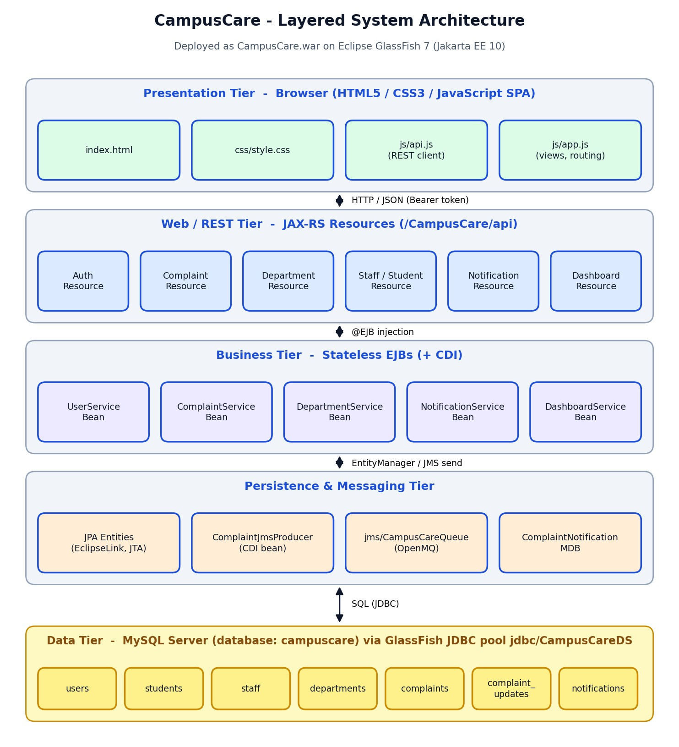
Figure 1: Layered system architecture of CampusCare

Use Case Diagram
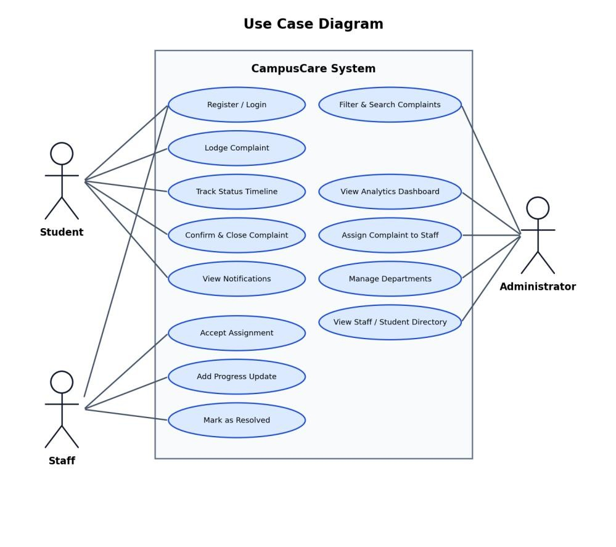
Figure 2: Use case diagram showing Student, Staff and Administrator actors

Data Flow Diagram (Level 0)
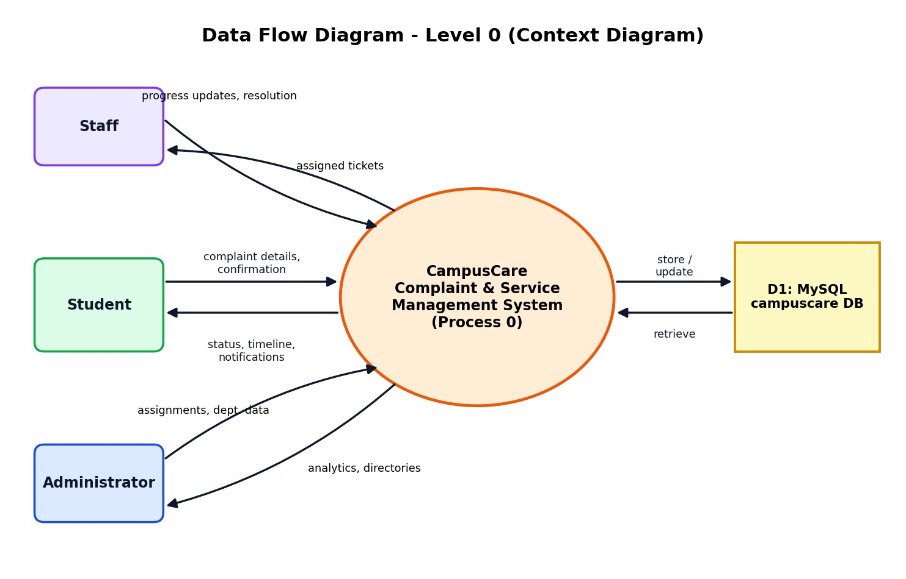
Figure 3: Context-level data flow diagram

Entity Relationship Diagram
Seven tables are generated by JPA/EclipseLink in the campuscare database. A User has a one-toone profile in Student or Staff depending on role; a Department has many Staff and many Complaints; a Complaint belongs to one Student, may be assigned to one Staff member, and owns many ComplaintUpdate rows; each User receives many Notifications.
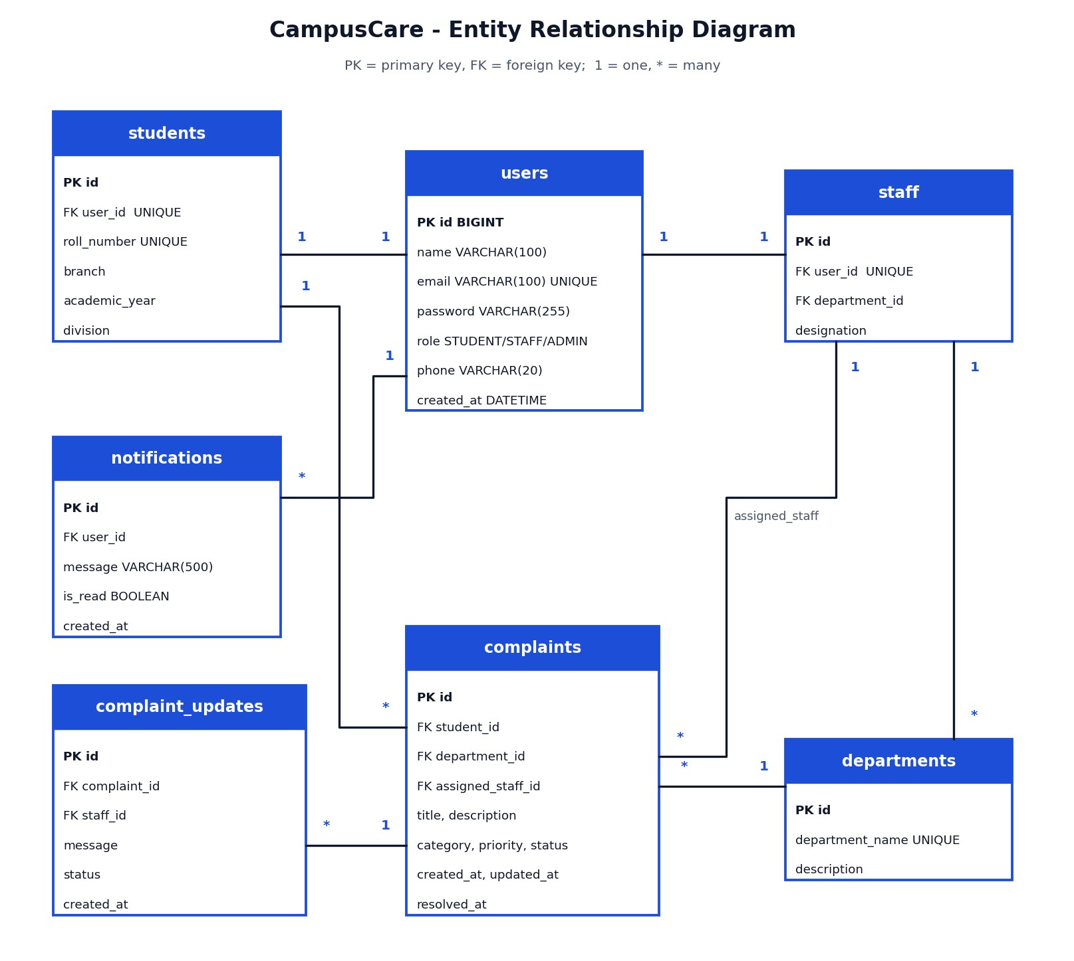
Figure 4: Entity relationship diagram of the campuscare database

Complaint Life Cycle and System Flowchart
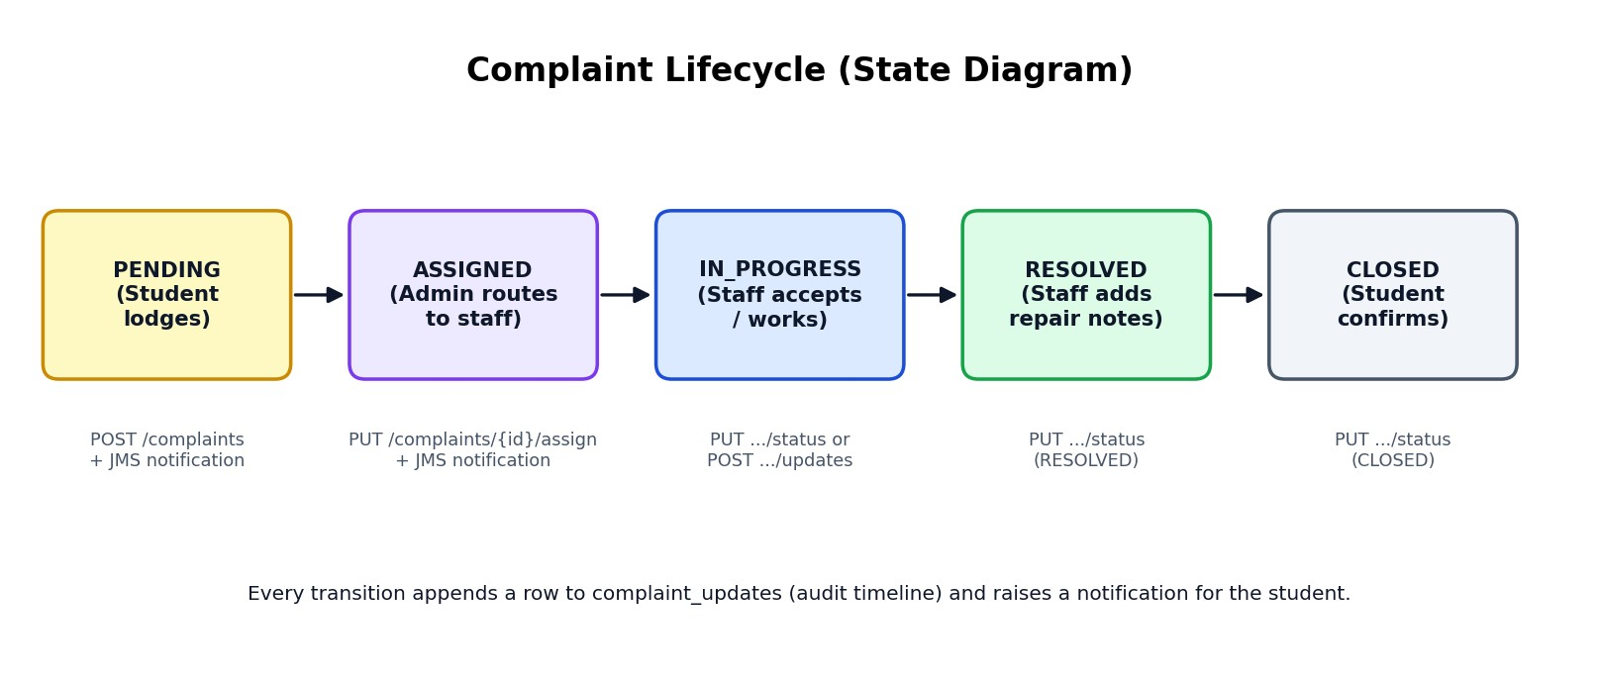
Figure 5: Complaint life cycle (state diagram)
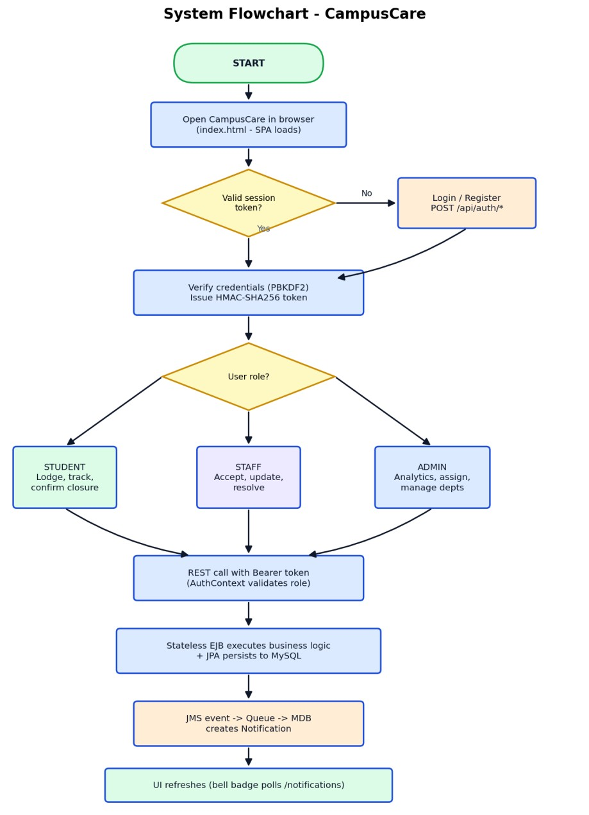
Figure 6: System flowchart – from login to notification

Sequence Diagram – Asynchronous JMS Notification
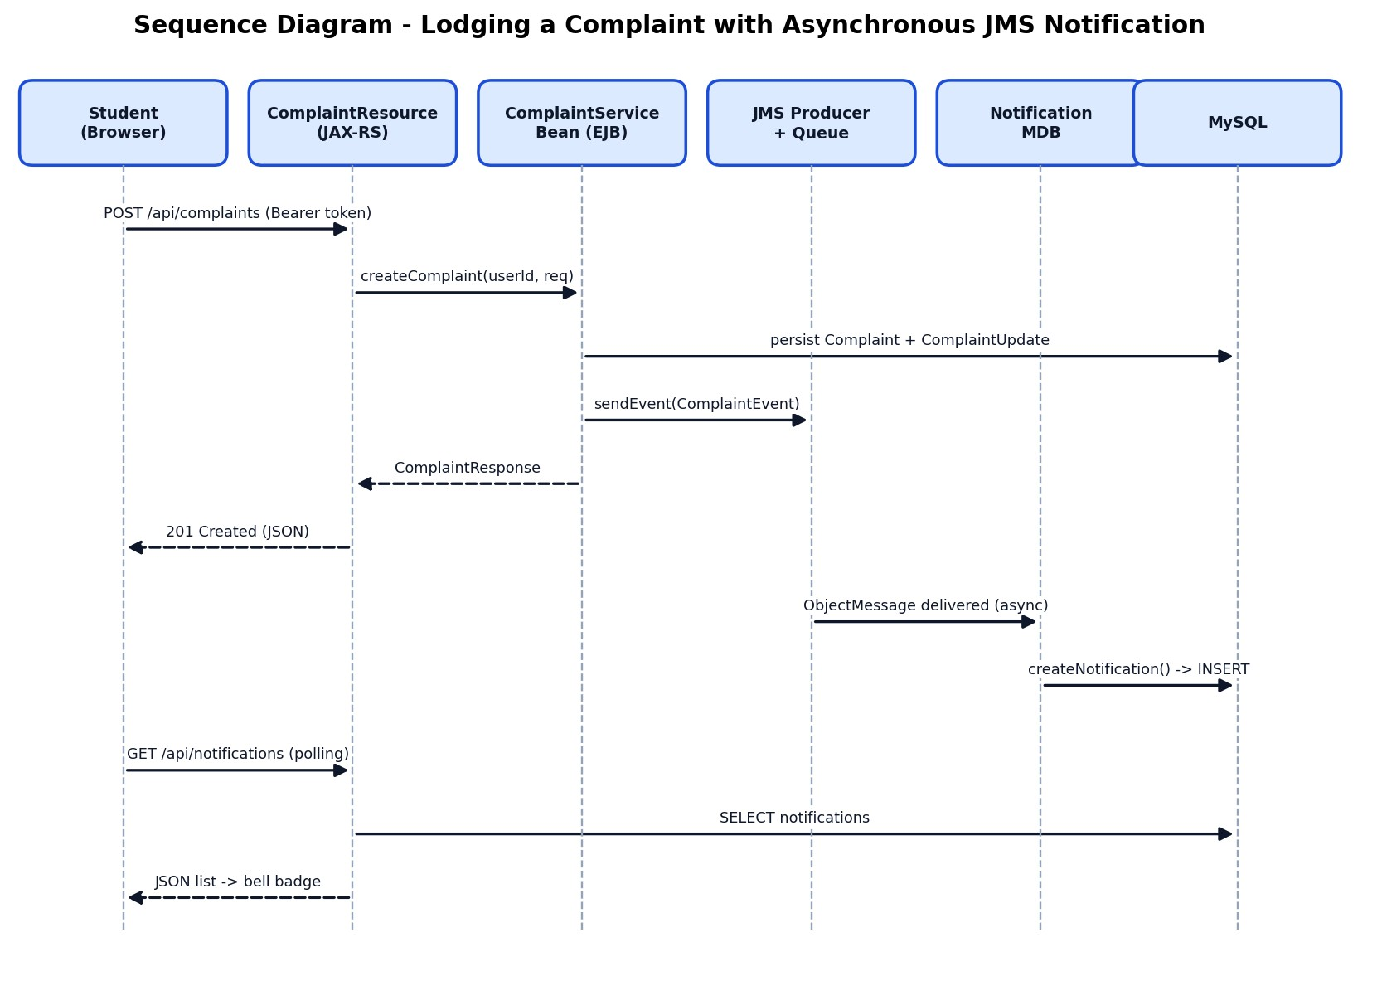
Figure 7: Sequence of lodging a complaint and receiving a JMS-driven notification

Methodology / Implementation
The project was developed iteratively: requirement analysis → database and entity design → business (EJB) layer → REST API → messaging → front-end SPA → integration testing and deployment. Maven was used as the build tool and Apache NetBeans as the IDE; the application is packaged as a WAR and deployed to GlassFish.

Tools and Technologies Used
Table 2: Technology stack
Component | Technology / Version | Purpose
Language | Java 17 (compiled with release 17) | Back-end implementation
Platform | Jakarta EE 10 | Standard enterprise APIs
Application server | Eclipse GlassFish 7.0.18 | EJB, JMS, JTA, JAX-RS runtime
Business layer | Jakarta Enterprise Beans 4.0 (@Stateless, @Singleton @Startup) | Transactional business logic
Persistence | Jakarta Persistence 3.1 + EclipseLink | ORM, JTA data source jdbc/CampusCareDS
REST | Jakarta RESTful Web Services 3.1 (JAX-RS) | JSON API under /CampusCare/api
Messaging | Jakarta Messaging 3.1 (OpenMQ), @MessageDriven bean | Asynchronous notifications
DI / Validation | CDI 4.0, Bean Validation 3.0 | @Inject, @Valid, @NotBlank,  @Size, @Email
Database | MySQL Server, utf8mb4, Connector/J 8.3.0 | Persistent storage (database campuscare)
Front-end | HTML5, CSS3, vanilla JavaScript SPA | Responsive UI, no external framework
Build / IDE | Apache Maven 3 / Apache NetBeans | Project build and development

Modules Description

Authentication and Security Module
AuthResource exposes /auth/login, /auth/register and /auth/me. UserServiceBean verifies credentials and registers users (creating the Student or Staff profile together with the User row). PasswordUtil stores passwords as salt:hash using PBKDF2WithHmacSHA256. TokenUtil issues a stateless token of the form base64(userId:role:expiry).HMAC-SHA256-signature, valid for 24 hours. AuthContext.requireUser/requireRole validate the Bearer token on each request and enforce the role.

Complaint Management Module
ComplaintServiceBean implements creation, search/filter, assignment, status change, progress updates and deletion. Every state change writes a ComplaintUpdate row (timeline) and raises a ComplaintEvent. Status transitions are validated server-side: students may only close RESOLVED complaints; staff may move ASSIGNED → IN_PROGRESS → RESOLVED; administrators may manage any transition.

Department, Staff and Student Module
DepartmentServiceBean and the Department/Staff/Student resources provide department creation and update, staff and student directories and per-user complaint lists. Five departments are seeded: Computer & IT Labs, Electrical Maintenance, Civil & Infrastructure, Water Supply & Sanitation, and Library Services.

Notification (JMS / MDB) Module
ComplaintJmsProducer (a CDI @ApplicationScoped bean) publishes an ObjectMessage containing a ComplaintEvent to jms/CampusCareQueue through jms/CampusCareConnectionFactory. ComplaintNotificationMDB, a @MessageDriven bean, receives the message asynchronously and calls NotificationServiceBean to persist a Notification. If JMS is unavailable the producer falls back to writing the notification directly so no event is lost. The front-end polls /notifications periodically to refresh the bell badge.

Dashboard Module
DashboardServiceBean runs JPQL aggregate queries (COUNT with GROUP BY on status, category, priority and department) to produce DashboardStatsDto for admin, staff and student dashboards.

Start-up Data Initialiser
DataInitializer is a @Singleton @Startup EJB that seeds departments, demo users (1 admin, 2 staff, 2 students) and sample complaints with timelines on first deployment, so the application can be demonstrated immediately.
5.2.7 Front-end Module index.html contains the login/registration views, the portal shell and modal dialogs. api.js is the REST client (adds the Bearer token, handles 401 logout and date parsing). app.js (about 1,480 lines) renders role-specific sidebars and views – dashboards, complaint tables with live search and filters, details modal with timeline, assign/update modals, department, staff and student directories and profile – and drives navigation without page reloads.

Algorithms / Frameworks

Password hashing (PBKDF2)
salt = SecureRandom 16 bytes
hash = PBKDF2WithHmacSHA256(password, salt, 10000 iterations, 256 bits)
store = Base64(salt) + ":" + Base64(hash)
verify: recompute with stored salt, compare in constant time (XOR accumulate)

Stateless token (HMAC-SHA256)
payload = userId + ":" + role + ":" + (now + 24h)
token = Base64Url(payload) + "." + Base64Url(HMAC_SHA256(secret, Base64Url(payload))) validate = recompute signature, compare, check expiry -> TokenClaims(userId, role)

Status transition rule
STUDENT : RESOLVED -> CLOSED only
STAFF : ASSIGNED -> IN_PROGRESS | IN_PROGRESS -> RESOLVED | ASSIGNED -> RESOLVED
ADMIN : any (PENDING -> ASSIGNED on assignment)

Asynchronous notification flow
EJB.createComplaint():
persist Complaint + ComplaintUpdate producer.sendEvent(ComplaintEvent) // returns immediately MDB.onMessage(ObjectMessage): notificationService.createNotification(userId, message)

Database Design
Table 3: Database tables (generated by JPA)
Table | Key columns | Relationships
users | id, name, email (unique), password, role, phone, created_at | 1:1 students / staff; 1:* notifications
students | id, user_id (unique), roll_number (unique), branch, academic_year, division | 1:* complaints
staff | id, user_id (unique), department_id, designation | *:1 departments; 1:* complaints (assigned)
departments | id, department_name (unique), description | 1:* staff; 1:* complaints
complaints | id, student_id, department_id, assigned_staff_id, title, description, category, priority, status, created_at, updated_at, resolved_at | 1:* complaint_updates
complaint_updates | id, complaint_id, staff_id, message, status, created_at | *:1 complaints
notifications | id, user_id, message, is_read, created_at | *:1 users

REST API Summary
Table 4: REST API endpoints
Method | Endpoint | Role | Description
POST | /api/auth/login | Public | Authenticate and receive token
POST | /api/auth/register | Public | Register student / staff / admin
GET | /api/auth/me | Any | Current user profile
GET | /api/complaints | Any | List with status, category, priority, departmentId filters
GET | /api/complaints/{id} | Any | Details with timeline
POST | /api/complaints | Student | Lodge a complaint
PUT | /api/complaints/{id}/assign | Admin | Assign to staff / escalate priority
PUT | /api/complaints/{id}/status | Any (rules) | Change status
POST | /api/complaints/{id}/updates | Any | Add progress note / status
DELETE | /api/complaints/{id} | Student/Admin | Delete a complaint
GET/POST/PUT | /api/departments[/{id}] | Any / Admin | Department management
GET | /api/staff, /api/students | Admin/Staff | Directories
GET / PUT | /api/notifications, /{id}/read, /read-all | Any | Notifications
GET | /api/dashboard/admin | staff | student | Role specific | Dashboard statistics

Screenshots / Outputs
The following screenshots were captured from the running application
(http://localhost:8080/CampusCare/) deployed on GlassFish with the MySQL database.

Authentication
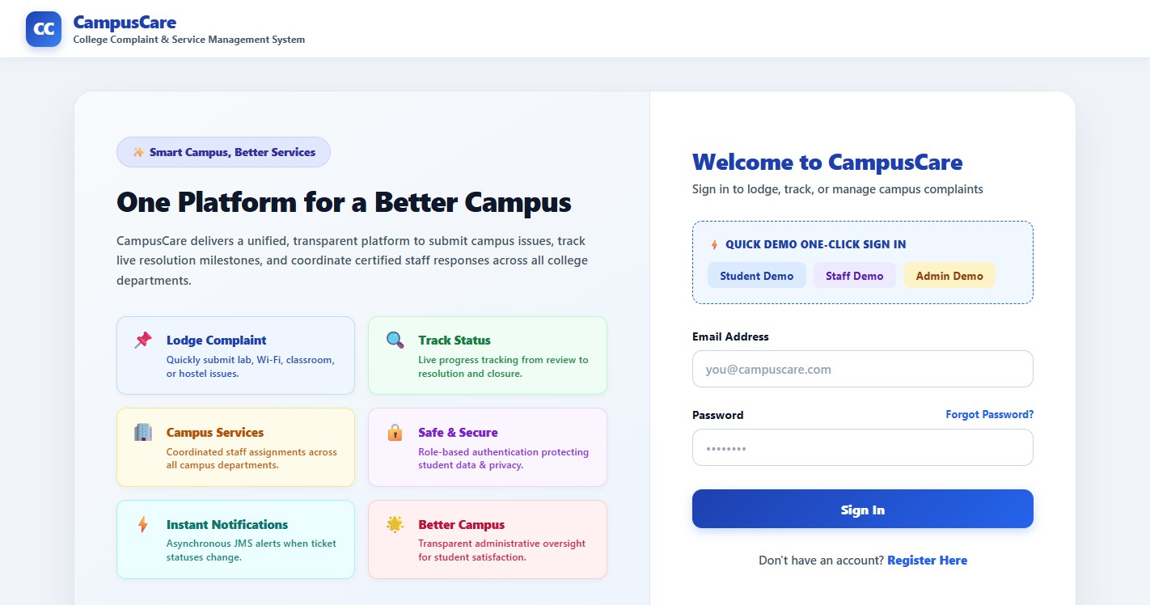
Figure 8: Login page with one-click Quick Demo buttons
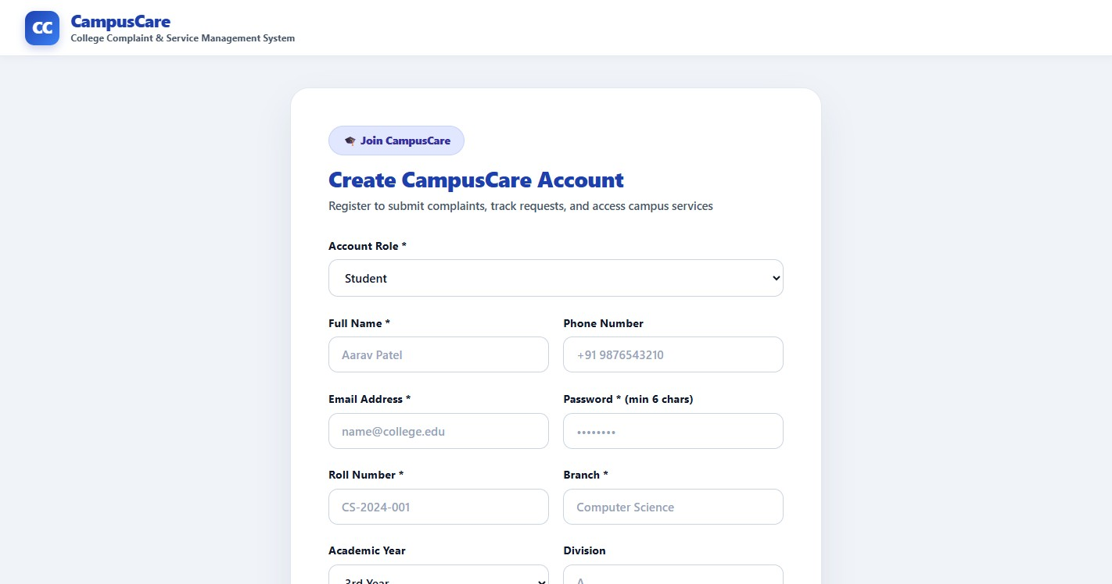
Figure 9: Registration page (student fields)

Student portal
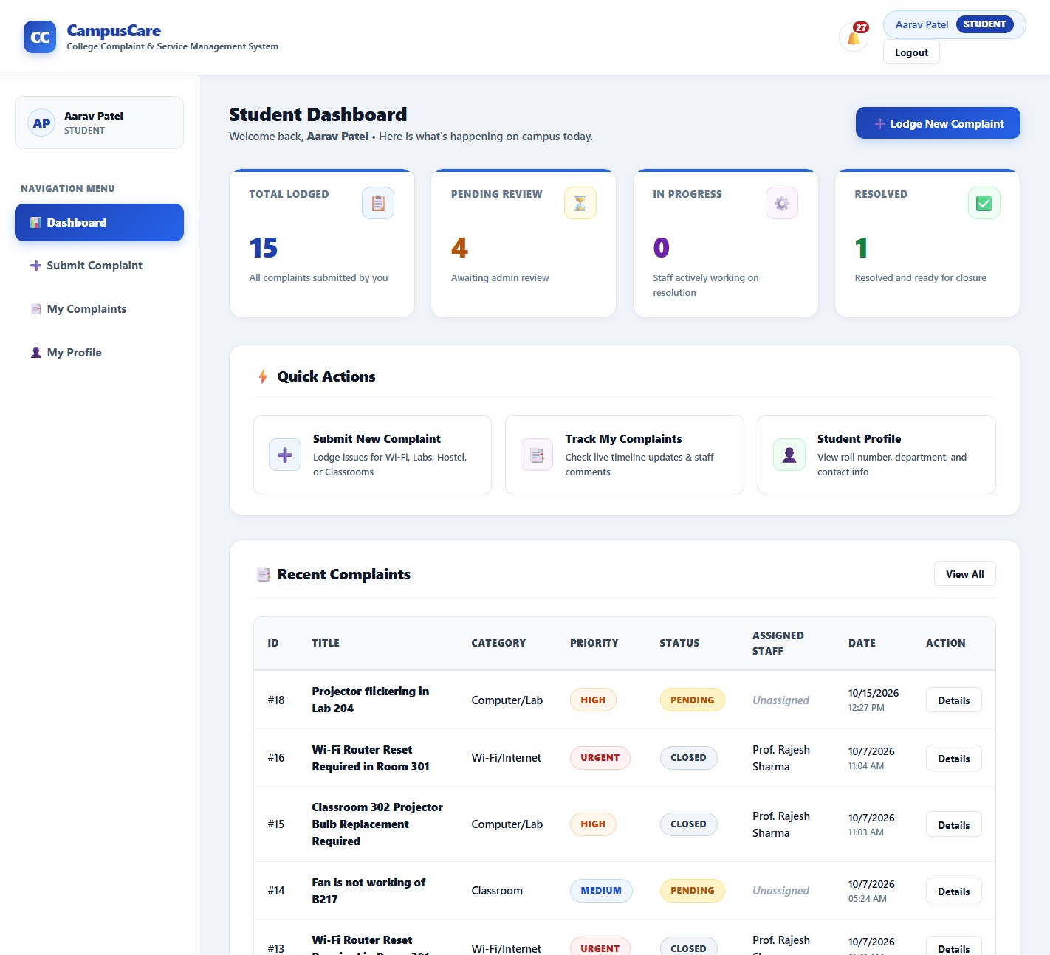
Figure 10: Student dashboard
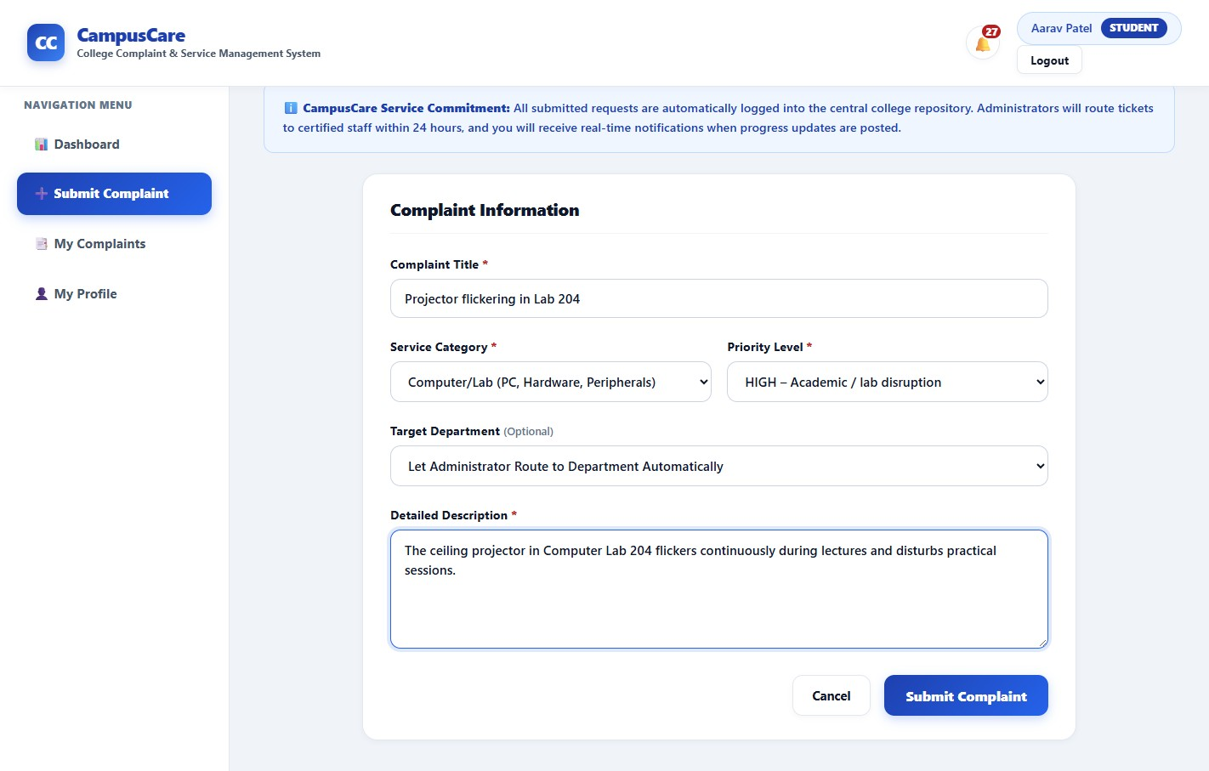
Figure 11: Lodge complaint form with validation
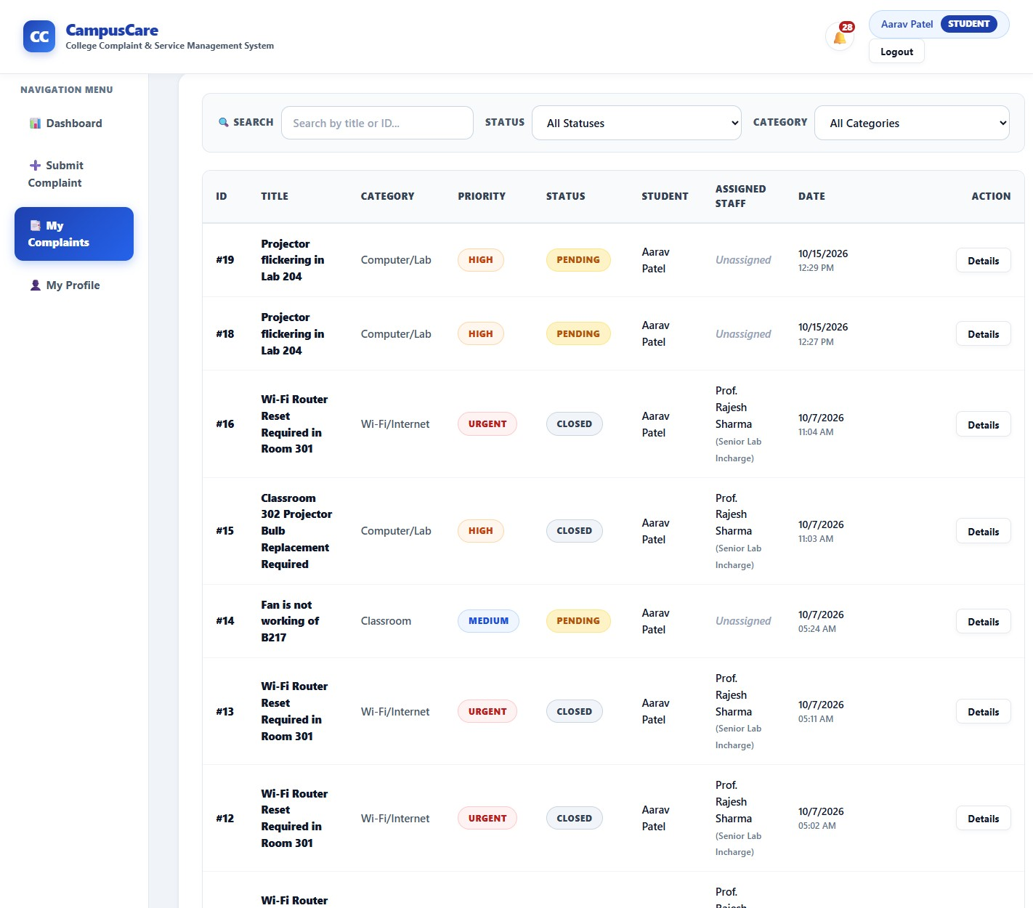
Figure 12: My Complaints list with search and filters
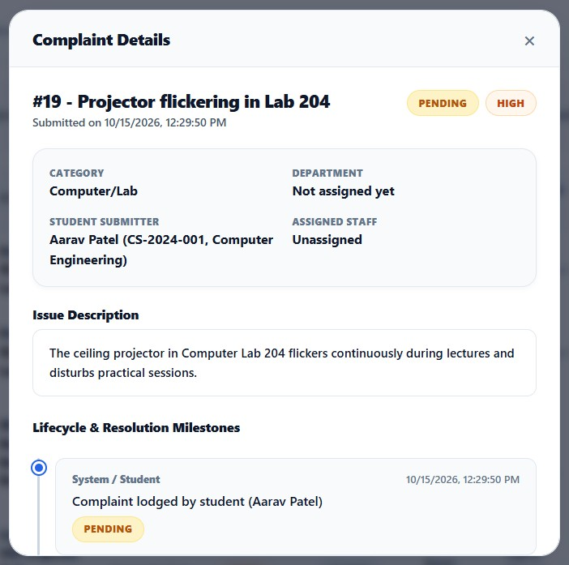
Figure 13: Complaint details with life-cycle timeline
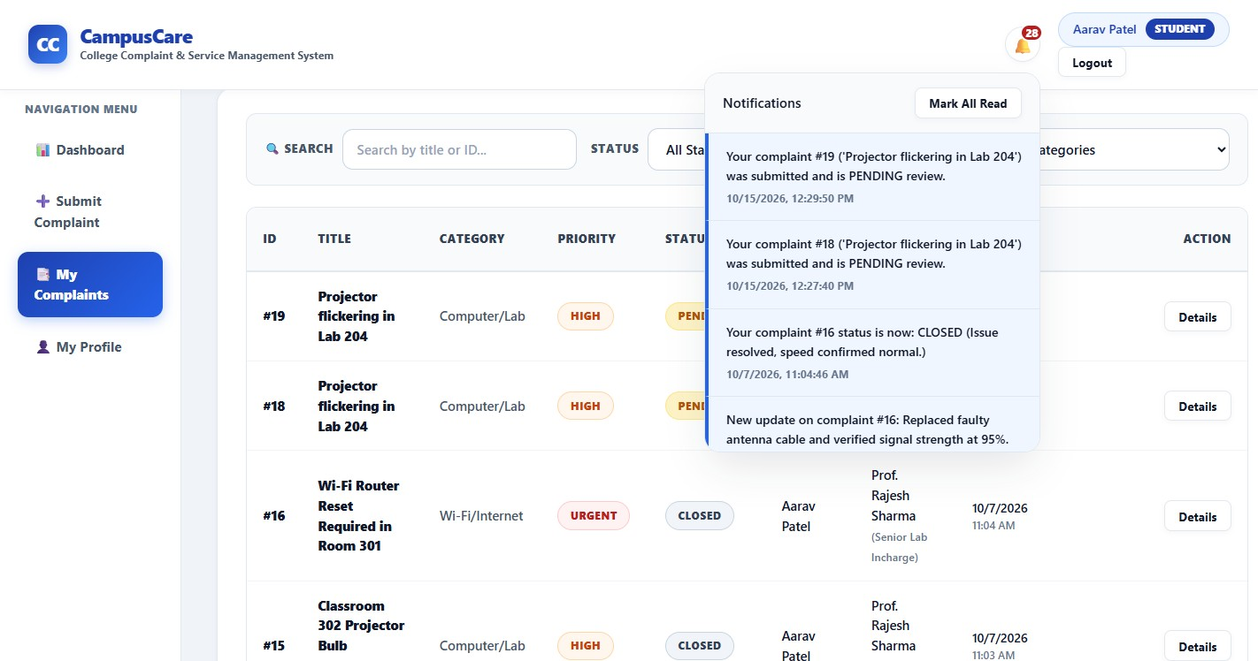
Figure 14: Notification bell showing JMS-generated notifications

Administrator portal
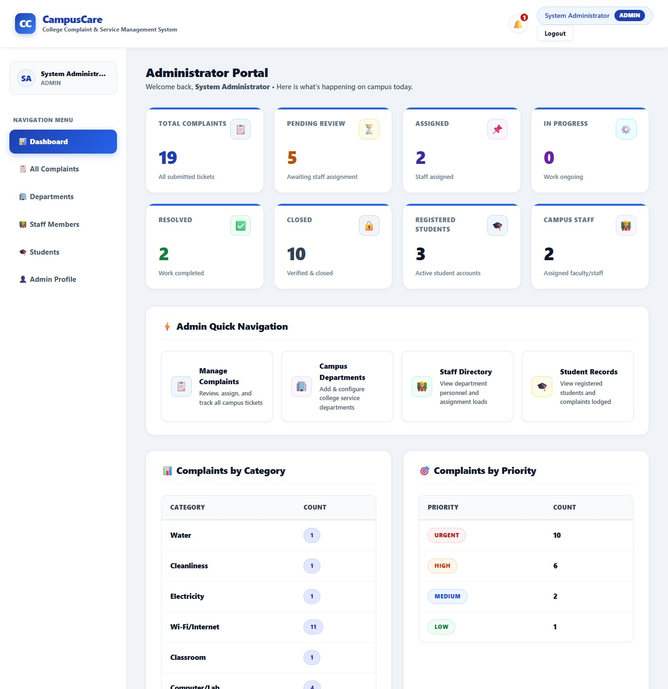
Figure 15: Administrator dashboard with analytics
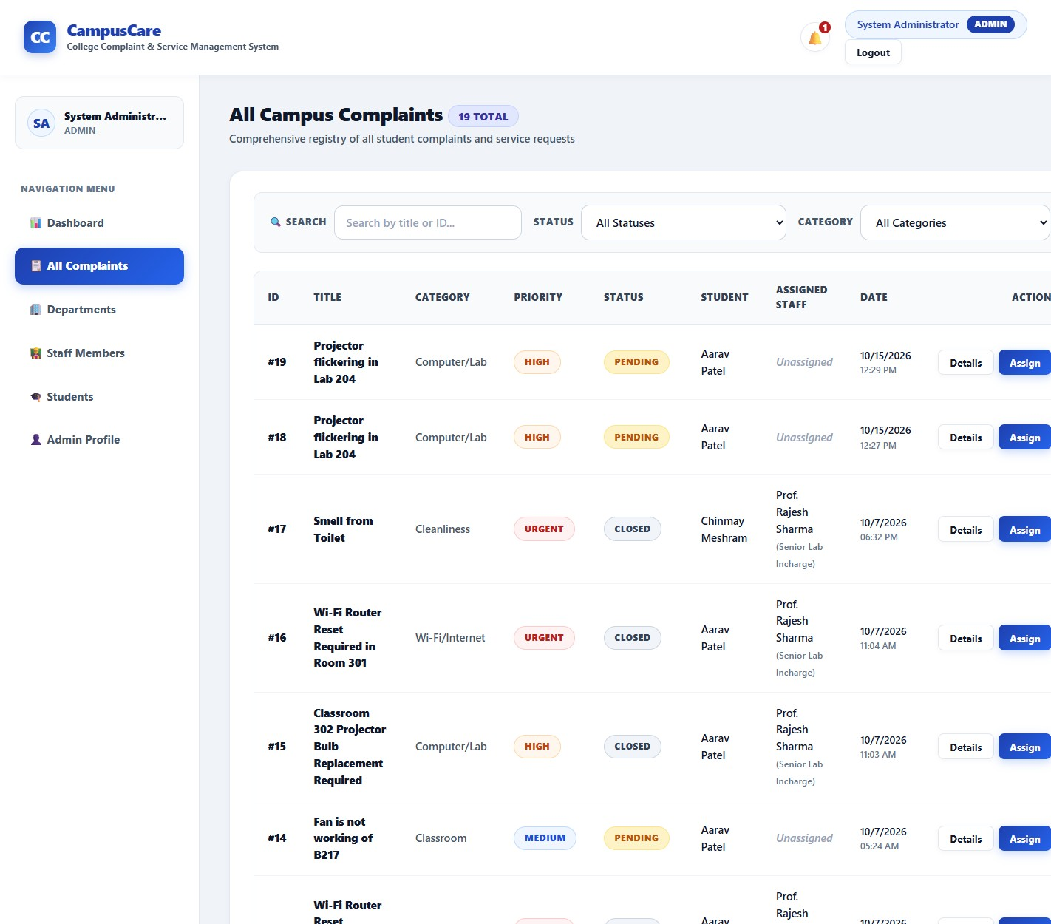
Figure 16: All Complaints (admin) with assign action
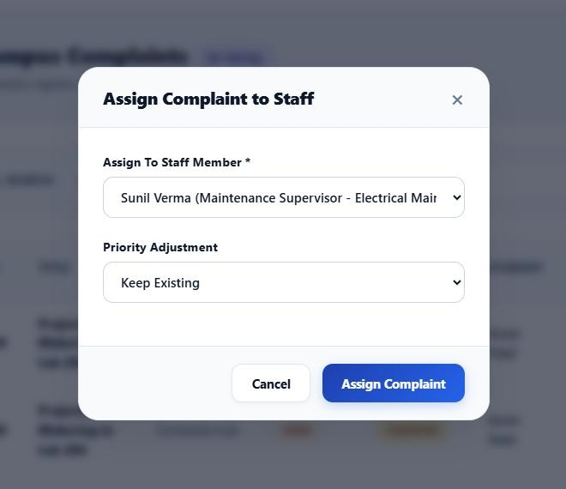
Figure 17: Assign complaint to staff dialog
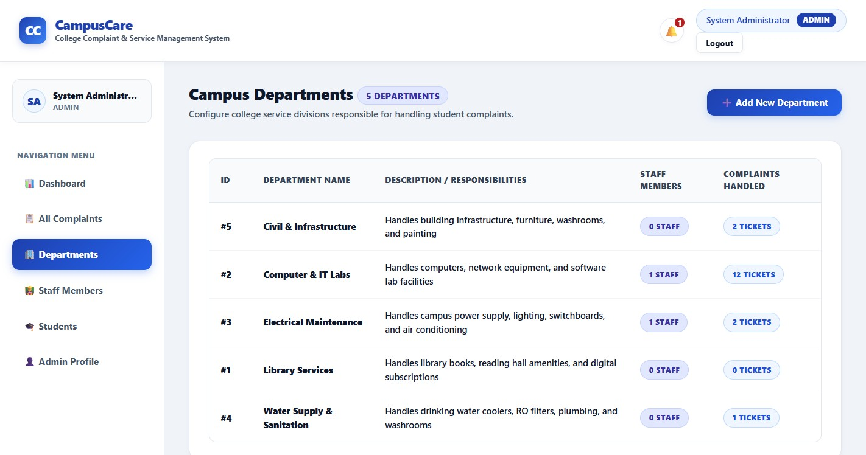
Figure 18: Departments management
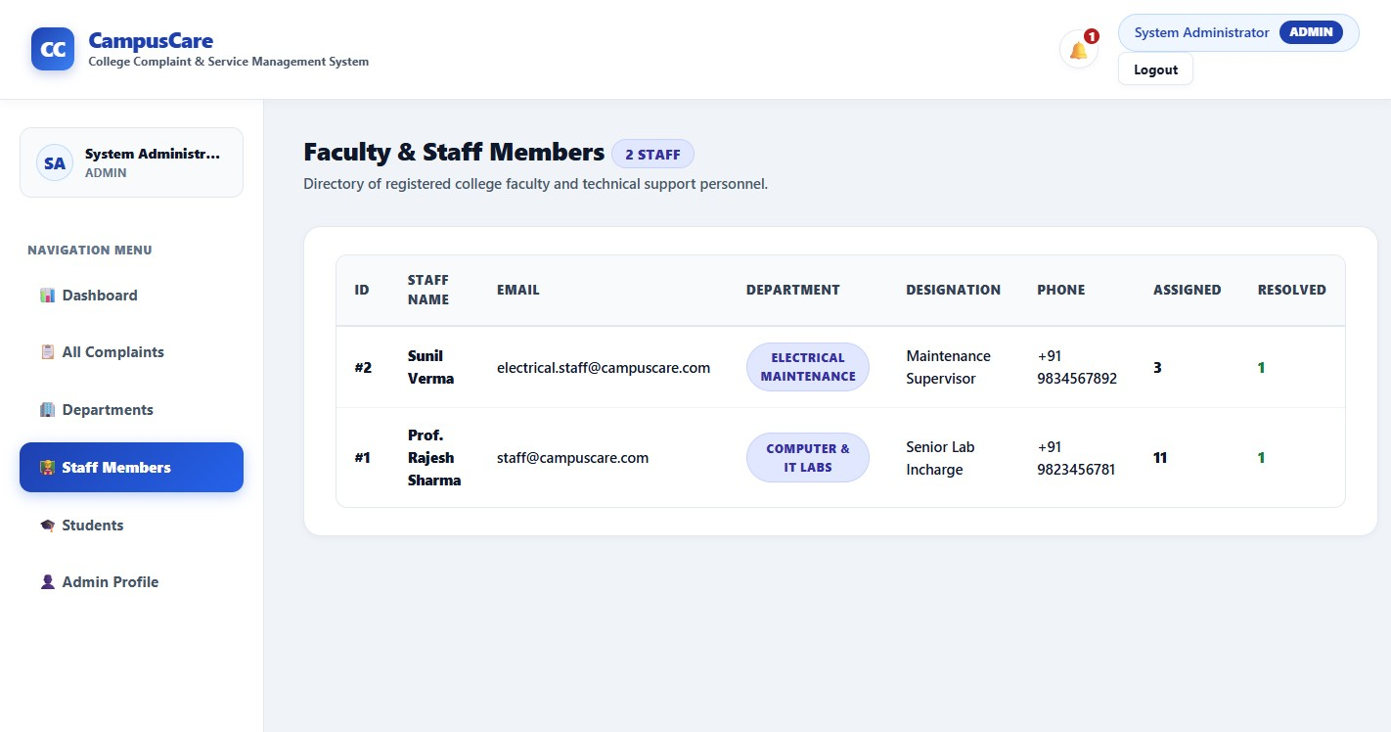
Figure 19: Staff directory
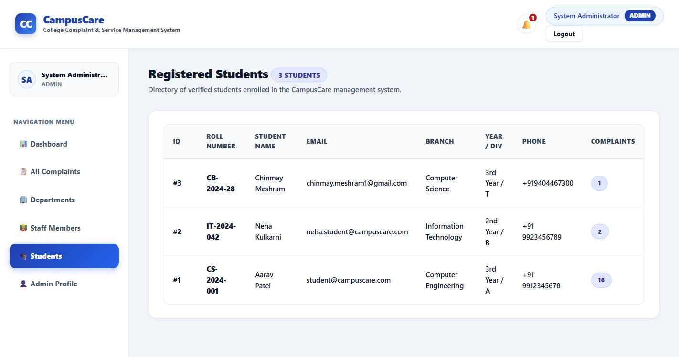
Figure 20: Student directory

Staff portal
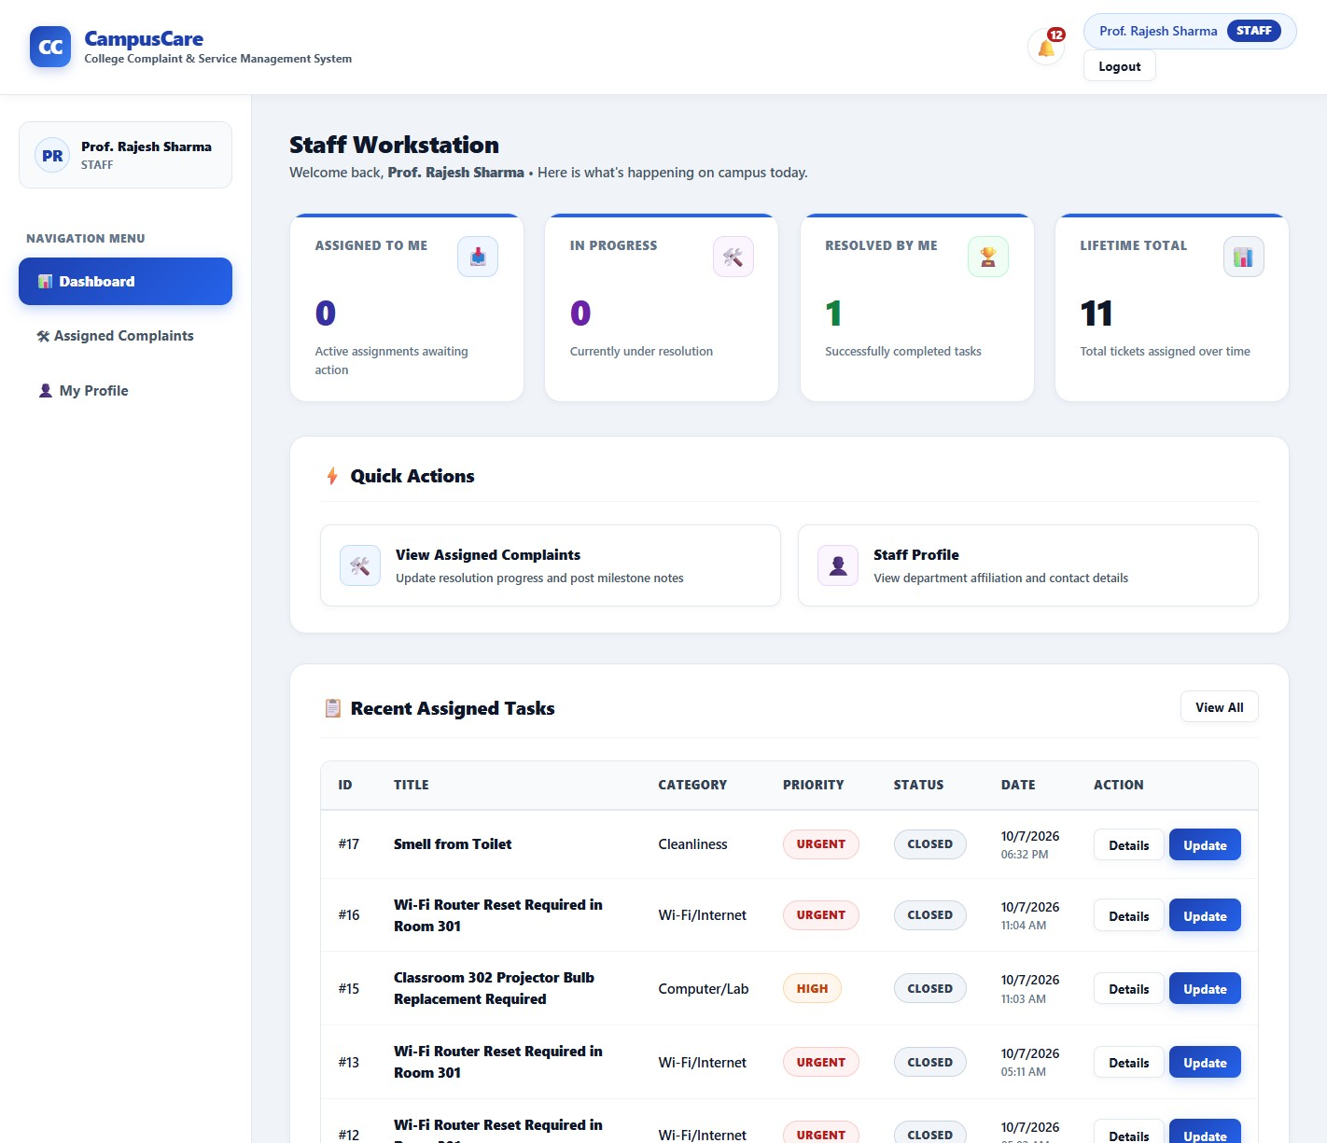
Figure 21: Staff dashboard
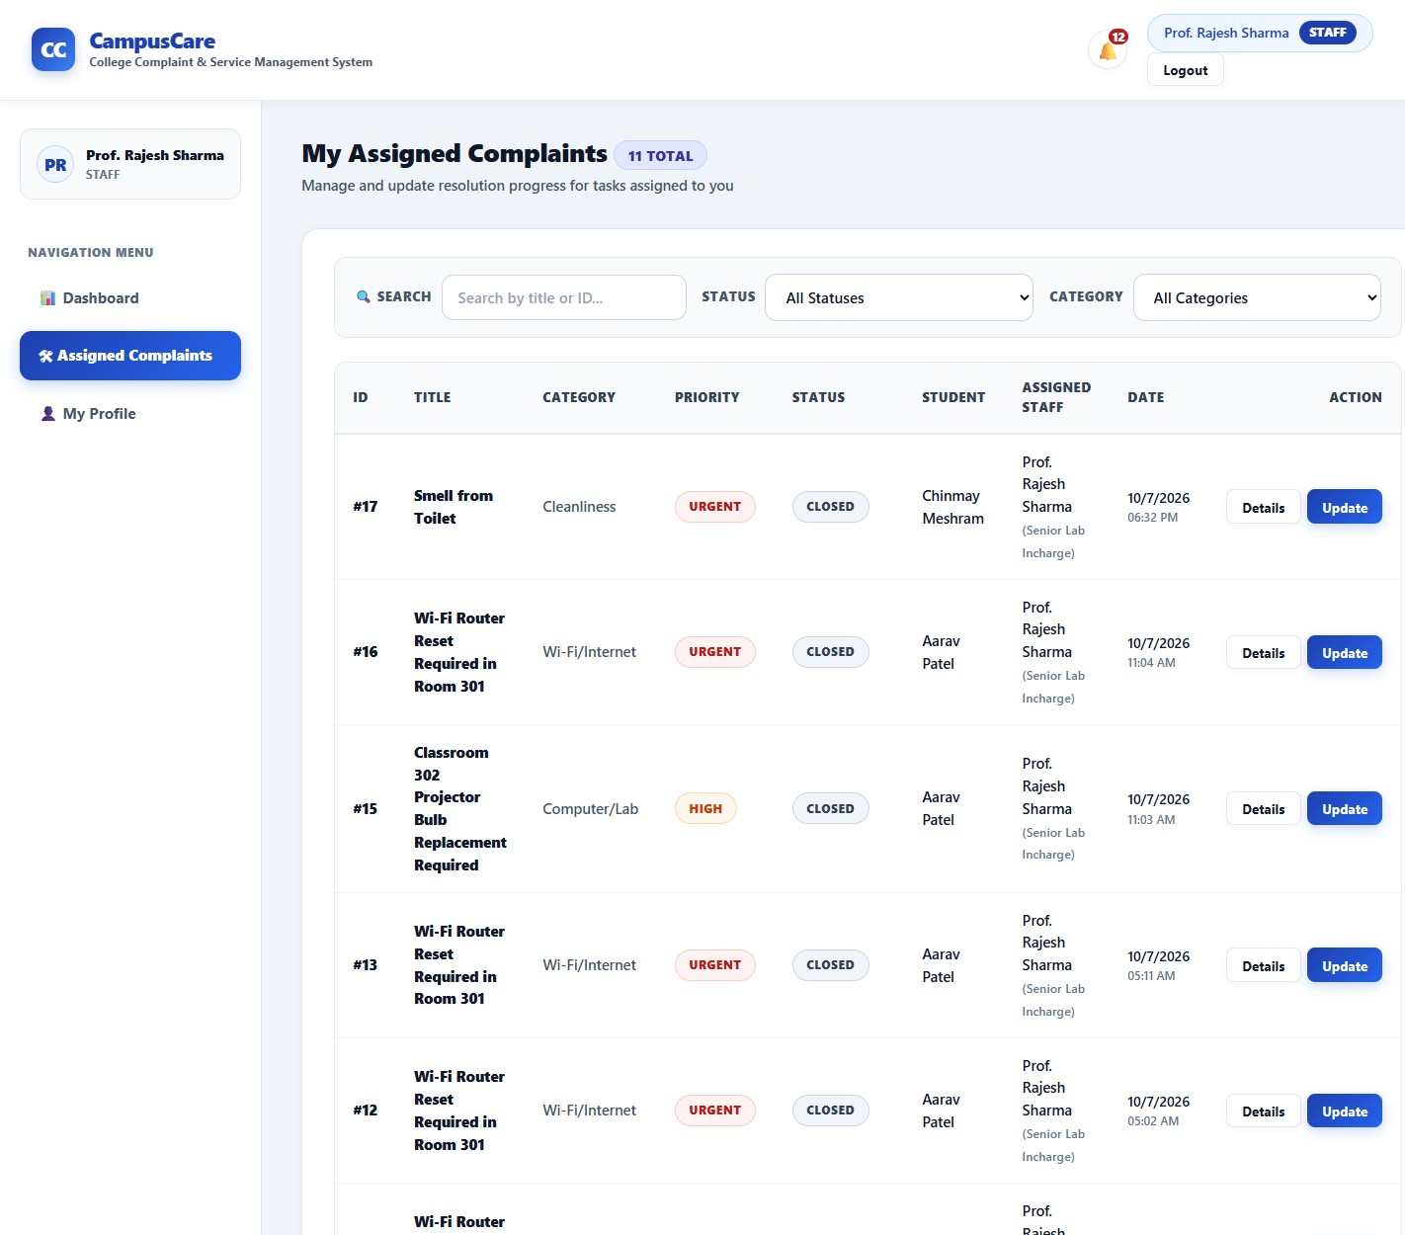
Figure 22: Assigned complaints for staff
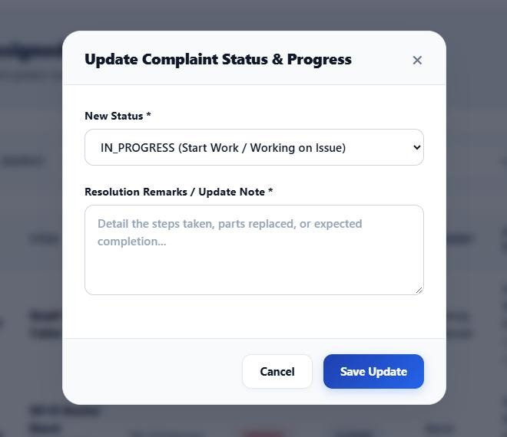
Figure 23: Staff progress update / resolve dialog

Results and Discussion

Outputs Achieved
- A deployable CampusCare.war (about 100 KB) built with Maven and running on GlassFish
7.0.18 with MySQL.
- Three role-specific portals with login, registration and one-click demo access.
- A complete complaint life cycle with enforced transitions and an auditable timeline for every complaint.
- Asynchronous JMS notifications delivered through a queue and a Message-Driven Bean, shown in the notification bell.
- Administrator analytics by status, category, priority and department.
- About 4,200 lines of Java (entities, DTOs, EJBs, REST resources, messaging, security) and about 3,300 lines of HTML/CSS/JavaScript.

Testing and Performance
Functional and security tests were executed against the running server using the REST API and the browser UI. Response times were measured on a local development machine (single GlassFish instance, MySQL on the same host) and are indicative only.
Table 5: Test cases and results
# | Test case | Expected result | Actual result
1 | Login with valid admin credentials | 200 OK + token | Passed – token returned, role ADMIN
2 | Login with wrong password | 401 Unauthorized | Passed – 401 (about 27 ms)
3 | Call /complaints without token | 401 Unauthorized | Passed – 401 (about 3 ms)
4 | Student calls admin-only assign API | 403 Forbidden | Passed – 403
5 | Lodge complaint with short title/description | 400 validation error | Passed – 400 returned by Bean Validation
6 | Student lodges a valid complaint | Created as PENDING with  first timeline entry | Passed – complaint created, JMS notification shown in bell
7 | Staff attempts RESOLVED → CLOSED | 400 invalid transition | Passed – message: Invalid status transition for staff
8 | Register with an existing e-mail | 400 duplicate rejected | Passed – Email already registered
9 | Admin lists all complaints | 200 OK with list | Passed – 200 (about 12 ms)
10 | Passwords stored hashed in MySQL | salt:hash, not plain text | Passed – users.password holds Base64 salt:hash

Observation: simple read and authentication calls completed in roughly 3–35 ms locally. Because notification work is placed on a JMS queue and handled by the MDB, complaint submission is not delayed by notification persistence.

Comparison with Existing Methods
Table 6: Comparison of CampusCare with existing methods
Criteria | Paper / WhatsApp | Generic ticket tool | CampusCare
Live status tracking | No | Yes | Yes (5-stage timeline)
Role-based access | No | Yes | Yes (Student / Staff / Admin)
Department routing | Manual | Configurable | Built-in, with staff assignment
Notifications | Manual calls | E-mail | In-app, JMS-driven
Analytics | None | Yes (paid) | Admin dashboard
Cost / licensing | Free | Subscription | Open-source stack
Customisable for campus | – | Limited | Fully customisable

Discussion
The layered architecture separated concerns cleanly: changing a business rule (for example the status transitions) affected only the EJB, while the UI and REST layers were untouched. Using JMS added resilience – notification creation is decoupled from the user request. During testing, one front-end issue was found and corrected: the server serialises dates as ISO strings with a zoneid suffix (for example 2026-10-15T06:57:39.626Z[UTC]) that browsers cannot parse, which showed "Invalid Date" in the UI; api.js now strips the suffix before parsing.

Conclusion and Future Scope

Summary of Achievements
CampusCare demonstrates how Jakarta EE technologies can be combined into a coherent, secure and maintainable application. The system gives students a transparent way to report problems, gives staff a clear work list, and gives administrators visibility and control. EJBs, JPA with relationships and validation, JAX-RS, CDI, JMS and MDB were all applied in a real workflow, and the course outcomes on front-end development, RESTful services and database connectivity were met.

Limitations and Potential Improvements
- File and photo attachments for complaints are not yet supported.
- Notifications are in-app only and delivered by polling; e-mail, SMS or WebSocket/ServerSent Events push can be added.
- The token signing secret and database credentials are configured in source/README; they should be moved to environment variables or a secrets store for production.
- Tokens are not revocable before expiry and CORS currently allows all origins; a refreshtoken flow and an origin allow-list would harden security.
- Deleting a complaint through the API returned a transaction error in testing and needs a fix in the delete workflow.
- Future work: SLA timers and escalation, feedback ratings after closure, reports export (PDF/Excel), multilingual UI and a mobile client.

References
- Eclipse Foundation, “Jakarta EE 10 Platform Specification,”
https://jakarta.ee/specifications/platform/10/
- Eclipse Foundation, “Jakarta Enterprise Beans 4.0,” “Jakarta Persistence 3.1,” “Jakarta RESTful Web Services 3.1,” “Jakarta Messaging 3.1,” and “Jakarta Bean Validation 3.0” specifications, https://jakarta.ee/specifications/
- Eclipse GlassFish 7 Documentation, https://glassfish.org/docs/
- EclipseLink JPA Documentation, https://eclipse.dev/eclipselink/documentation/
- Oracle Corporation, “MySQL 8.0 Reference Manual,” https://dev.mysql.com/doc/
- Oracle, “The Java EE Tutorial – Enterprise Beans, Persistence, JMS, RESTful Web Services,” https://eclipse-ee4j.github.io/jakartaee-tutorial/
- B. Kaliski, “PKCS #5: Password-Based Cryptography Specification v2.0,” RFC 2898, IETF, 2000.
- H. Krawczyk, M. Bellare, R. Canetti, “HMAC: Keyed-Hashing for Message Authentication,” RFC 2104, IETF, 1997.
- OWASP Foundation, “Password Storage Cheat Sheet,” https://cheatsheetseries.owasp.org/
- Apache Software Foundation, “Apache Maven Project Documentation,”
https://maven.apache.org/guides/
- MDN Web Docs, “Fetch API” and “Web APIs,” https://developer.mozilla.org/
- Apache NetBeans Documentation, https://netbeans.apache.org/

Appendix

Source Code Snippets

JPA entity relationships (Complaint.java)
@Entity @Table(name = "complaints")
public class Complaint implements Serializable {
@Id @GeneratedValue(strategy = GenerationType.IDENTITY) private Long id;
@NotNull @ManyToOne(optional = false, fetch = FetchType.EAGER)
@JoinColumn(name = "student_id", nullable = false) private Student student;
@ManyToOne @JoinColumn(name = "department_id") private Department department;
@ManyToOne @JoinColumn(name = "assigned_staff_id") private Staff assignedStaff;
@NotBlank @Size(min = 3, max = 150) private String title;
@NotBlank @Size(min = 10, max = 2000) private String description;
@OneToMany(mappedBy = "complaint", cascade = CascadeType.ALL, orphanRemoval = true)
@OrderBy("createdAt ASC") private List<ComplaintUpdate> updates;
}

REST resource with role check (ComplaintResource.java)
@POST public Response submitComplaint(@Valid ComplaintRequest request, @Context HttpHeaders headers)
{
TokenUtil.TokenClaims claims = AuthContext.requireRole(headers, "STUDENT");
ComplaintResponse created = complaintService.createComplaint(claims.getUserId(), request); return Response.status(Response.Status.CREATED)
.entity(ApiResponse.ok("Complaint submitted successfully", created)).build();
}

JMS producer and Message-Driven Bean
// ComplaintJmsProducer
connection = connectionFactory.createConnection();
session = connection.createSession(false, Session.AUTO_ACKNOWLEDGE); session.createProducer(queue).send(session.createObjectMessage(event));

// ComplaintNotificationMDB @MessageDriven(activationConfig = {
@ActivationConfigProperty(propertyName = "destinationLookup", propertyValue =
"jms/CampusCareQueue"),
@ActivationConfigProperty(propertyName = "destinationType", propertyValue =
"jakarta.jms.Queue") })
public void onMessage(Message m) { ... notificationService.createNotification(userId, text); }

Persistence unit (persistence.xml)
<persistence-unit name="CampusCarePU" transaction-type="JTA">
<provider>org.eclipse.persistence.jpa.PersistenceProvider</provider>
<jta-data-source>jdbc/CampusCareDS</jta-data-source>
<property name="eclipselink.ddl-generation" value="create-or-extend-tables"/>
<property name="eclipselink.target-database" value="MySQL"/>
</persistence-unit>

Build and Deployment Steps
- Start MySQL; create database campuscare.
- In GlassFish create JDBC pool CampusCarePool + resource jdbc/CampusCareDS,
JMS connection factory jms/CampusCareConnectionFactory and queue jms/CampusCareQueue.
- mvn clean package -> target/CampusCare.war
- asadmin deploy --force=true --contextroot /CampusCare target/CampusCare.war 5. Open http://localhost:8080/CampusCare/

Demo Credentials
Table 7: Seeded demo users
Role | E-mail | Password
Admin | admin@campuscare.com | admin123
Staff | staff@campuscare.com | staff123
Staff | electrical.staff@campuscare.com | staff123
Student | student@campuscare.com | student123
Student | neha.student@campuscare.com | student123

Additional Screenshots
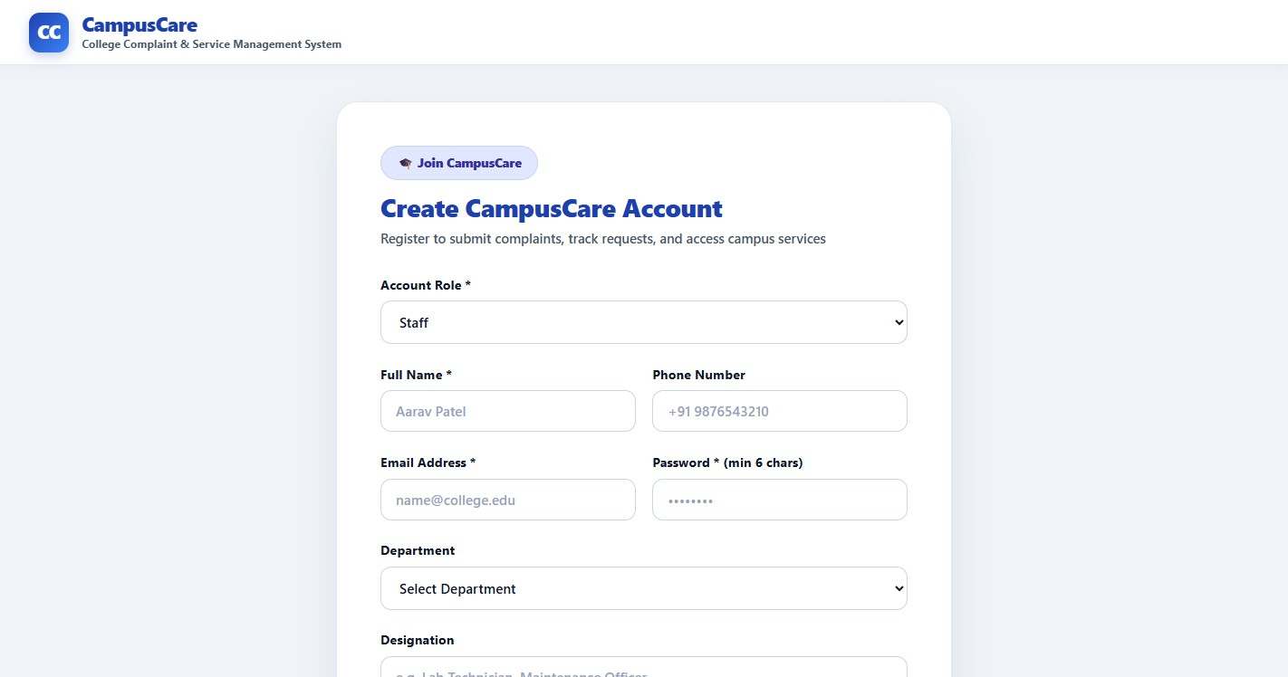
Figure 24: Registration page – staff role (department and designation)
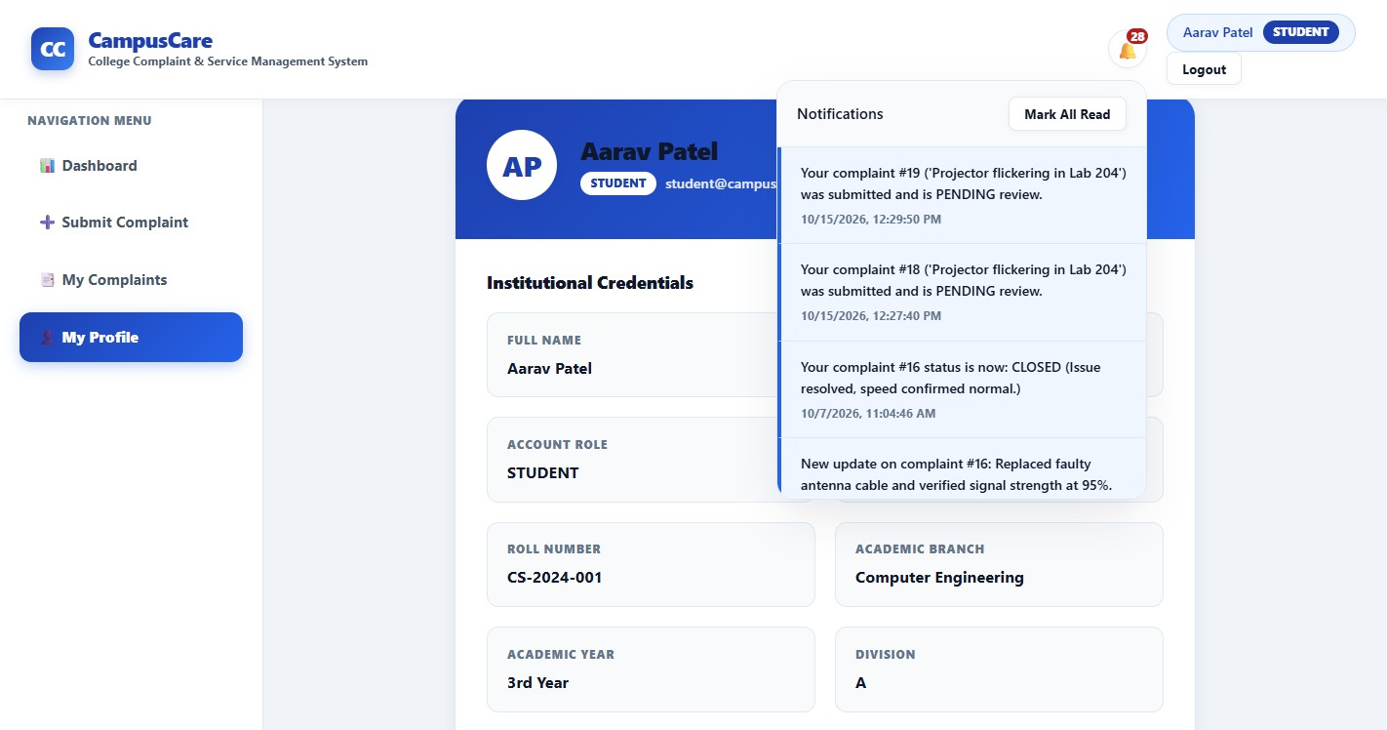
Figure 25: Student profile page
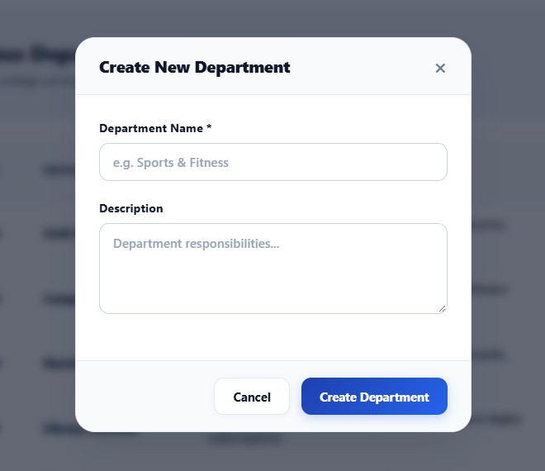
Figure 26: Add new department dialog

