# A PROJECT REPORT ON

**“ASSEMBLEDGE”**

**MES Institute of Management & Career Courses, Pune**



**Submitted By :**

Shubham Sakpal : Roll no.2012118

Chinmay Parulekar: Roll no.2012100

**Project guide**: - Dr. Venugopal Narsingoju

## Acknowledgement

I am very glad to take this opportunity to acknowledge all those who helped me in designing developing and successful execution of my project “**ASSEMBLEDGE**”.

I would like to extend my thanks and gratitude to my project guide **Mr. Venugopal Narsingoju sir** internal guide for their valuable guidance and timely assistance throughout the development of this project.

I would also like to extend my thanks and gratitude to **Dr. Santosh Deshpande** (Director, IMCC), **Dr. Ravindra Vaidya** (HOD, IMCC), **and Mrs. Manasi Shirurkar** (Assistant Professor, IMCC and Class) for their constant help and support.

Last but not least, I would like to thanks all the teaching and Nonteaching faculties for their cooperation.

# Mini Project INDEX

|  |  |  |
| --- | --- | --- |
| Sr. No. | Name of Topic | **Page No** |
| **1** | **1: Introduction** |  |
|  | 1.1 Scope of the Work |  |
|  | 1.2 Operating Environment- Hardware and Software |  |
|  | 1.4 List of Modules and Assigned to member |  |
| **2** | **2: Proposed System** |  |
|  | 2.1 Activity Diagram |  |
|  | 2.2 E-R Diagram |  |
|  | 2.3 Data Flow Diagram |  |
| **3** | **3: Analysis and Design** |  |
|  | 3.1User Interface Design |  |
| **4** | **4:Output Reports** |  |
|  | 4.1 Database Reports |  |
| **5** | **4:Bibliography** |  |

## Chapter 1: Introduction

Taking student’s attendance by teachers during each class on notebook or approving leaves, these paperwork is time consuming as well as one have to store all the data somewhere.

So we are introducing a web application which can store data of attendance, leaves, feedbacks and marks.

As well as admin can store data of teachers and students.

* 1. **Scope of system:**

This project contains a web application in which admin can add students and assign subjects to teachers. Teachers can mark attendance of students.

The web app will provide feedback and leaves facility to student and teachers.

There will be main three characters are Admin, Teacher and Student. Admin can give permission to leave applications.

### Module Assigned to

|  |  |
| --- | --- |
| Module | Assigned to member |
|  | Shubham Sakpal |
|  | Chinmay Parulekar |

* 1. **Operating Environment – Hardware and Software:**
* **Hardware Requirements:-**
* Mobile: Android Phone and IOS phone:
* **Software Requirements:-**
* Operating system: Android OS and Mac OS:

Mobile phones having android operating system (eg. Samsung, Realme) or having ios operating system (eg. iphone) can easily install or operate this application.

* Windows OS

.

## 2. Proposed System

We are providing a website which is User-friendly, Time saving and mainly useful for marking attendance.

Our system will allow Teachers to check subject wise list of students and teacher can mark their attendance. This system will also useful for sharing feedbacks and apply for leave applications.

Student will get attendance reports as well. Admin will decide to approve the leave applications of teacher or student. Admin will assign the subjects to teachers.

##### **ADVANTAGES OF PROPOSED SYSTEM:**

* **Student and Teacher data at one place.**
* **Leave applications**
* **Feedbacks.**
* **Manually handled attendance.**
* **Live Attendance Reports.**

##### **Modules:**

1. ADMIN:-

1.1 Class-Subject Creation

1.2 Assigning Students and Teachers

1.3 Subject Assigning

2. TEACHER:-

2.1 Manual attendance

2.2 Live Attendance Reports

2.3 Apply for Leave

3. STUDENT:-

3.1 Check attendance list

3.2 Give feedbacks

3.3 Apply for Leave

##### **Modules DISCRIPTION:**

1. Admin:-

We are providing add, edit, delete and all access to admin module in which

1) Admin will assign subjects and classes to the teachers.

2) Admin can assign classes and subjects.

3) Admin can check the feedbacks.

4) Admin can approve leave applications.

In short all the functionality will be done by admin only

1. Teacher:-

Teacher can register his or her self and after login we are going to show them the classes and the subject.

1. Teacher can easily select class and subject and it will display student list with the help of which teacher can mark all attendance.
2. One additional feature we are providing which is leave application, teacher can easily apply for leave with this feature.
3. Teacher can add marks of assignments and exams.
4. Student:-

Student can login in the system and check their attendance as well as one can apply for leave.

Students can give feedbacks.

Students can check theirs marks.

## 3: Analysis and Design Flow

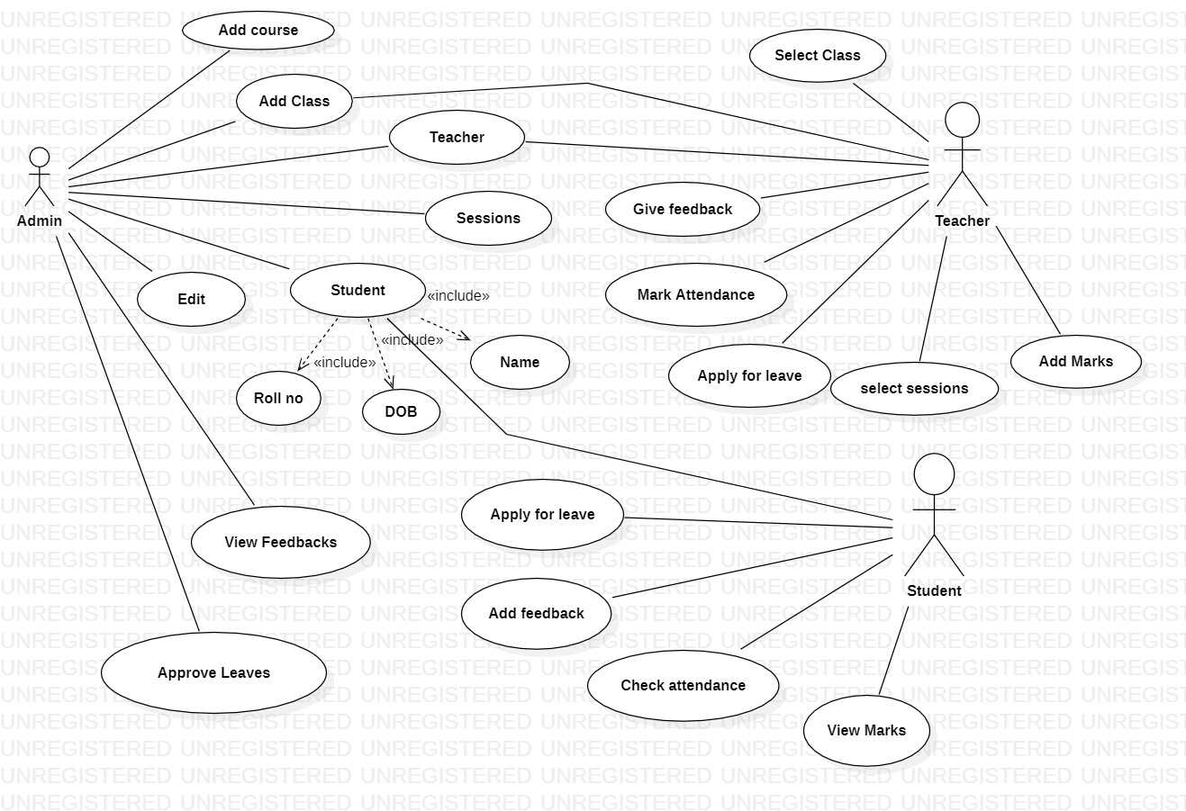**2. Use-case Diagram:-**

**3. Class Diagram:-**

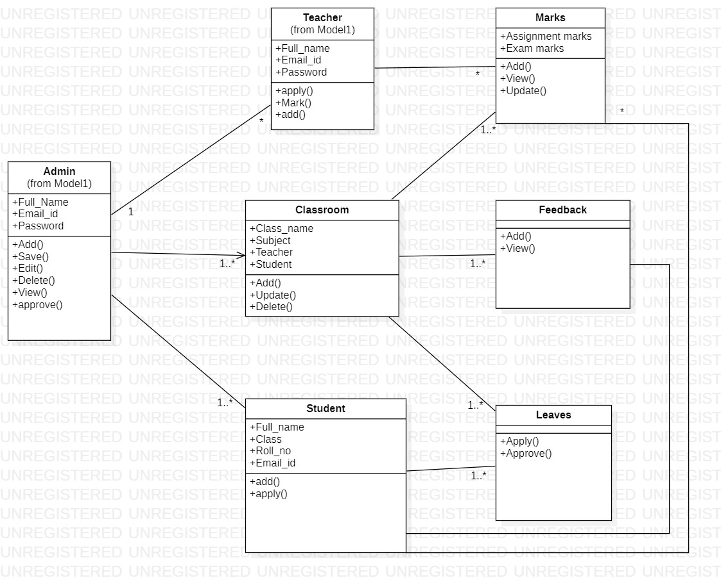

## 4: OUTPUT

## 1: Admin Dashboard

Admin Dashboard contains Add Teacher, Student , Subject , Course ,View Attendance

**2: Admin Dashboard**

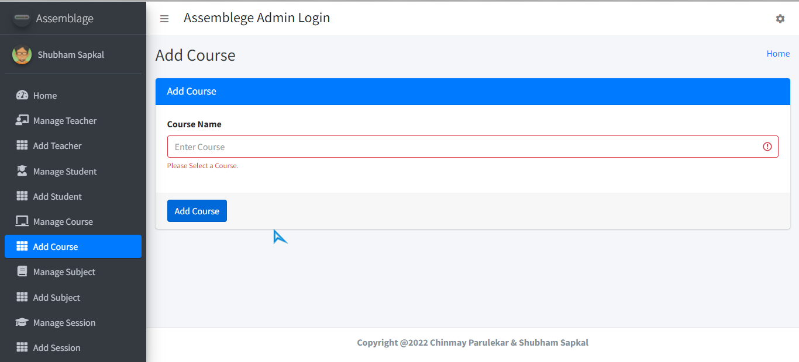

Admin can Add Course here and also edit or delete them

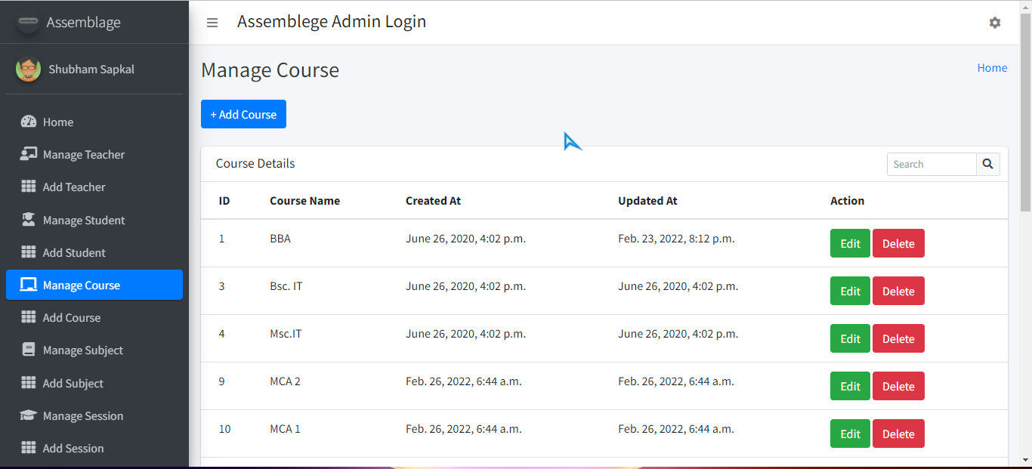

**2: Admin Dashboard**

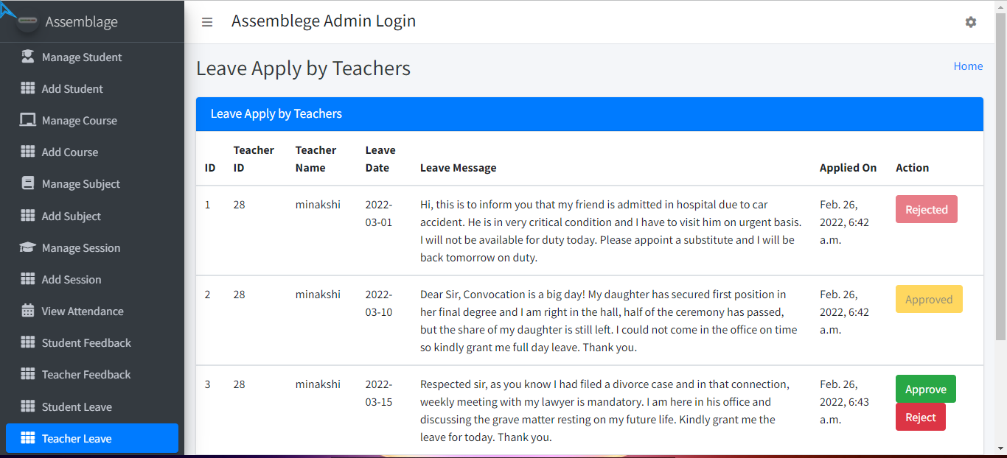

Admin can approve or reject leave applications & gives replies to student feedbacks.

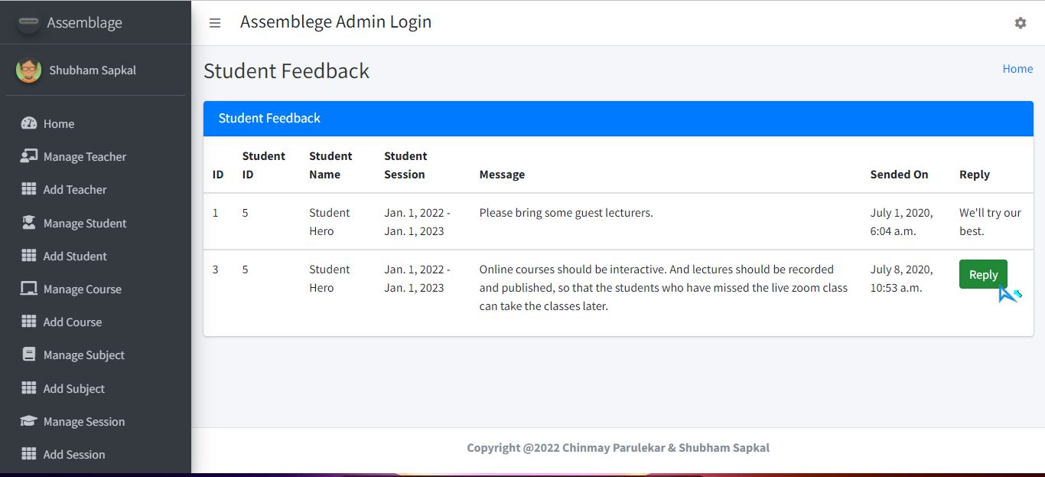

**2: Teacher Dashboard**

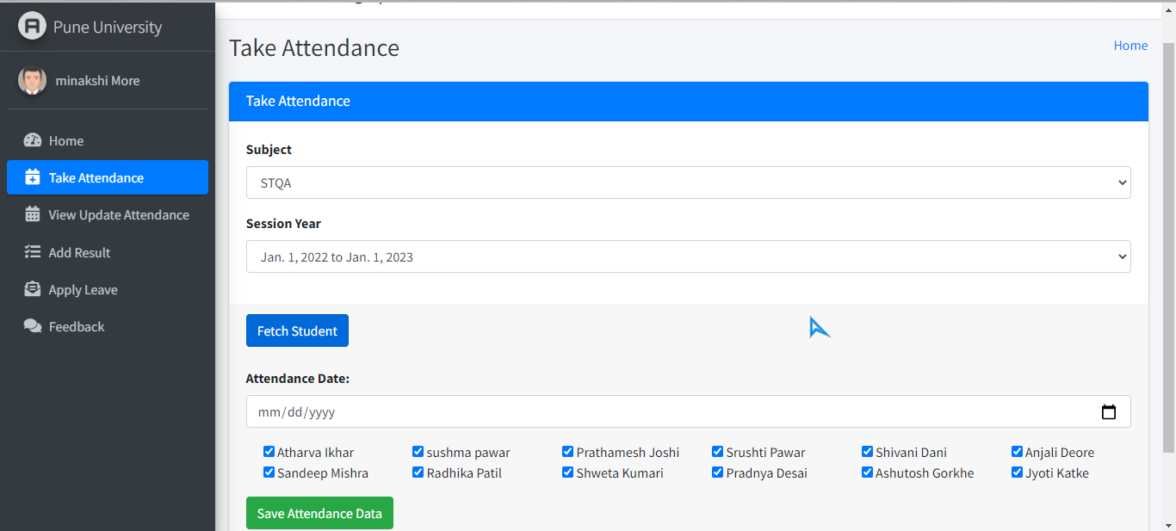

Teacher can take attendance and add marks here

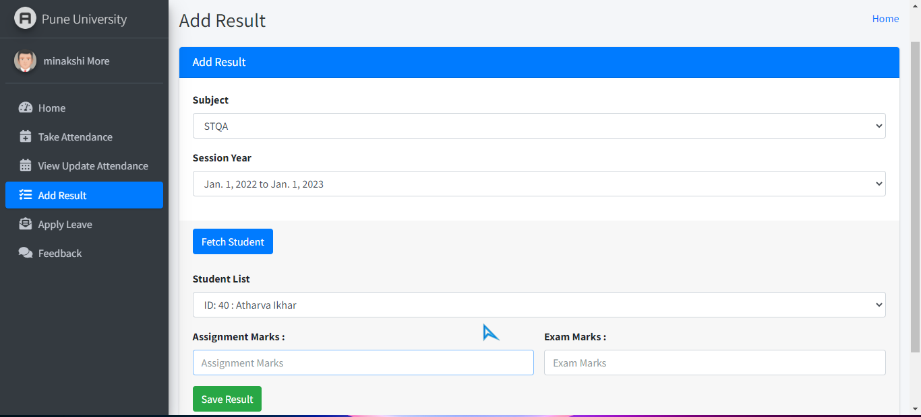

**2: Teacher Dashboard**

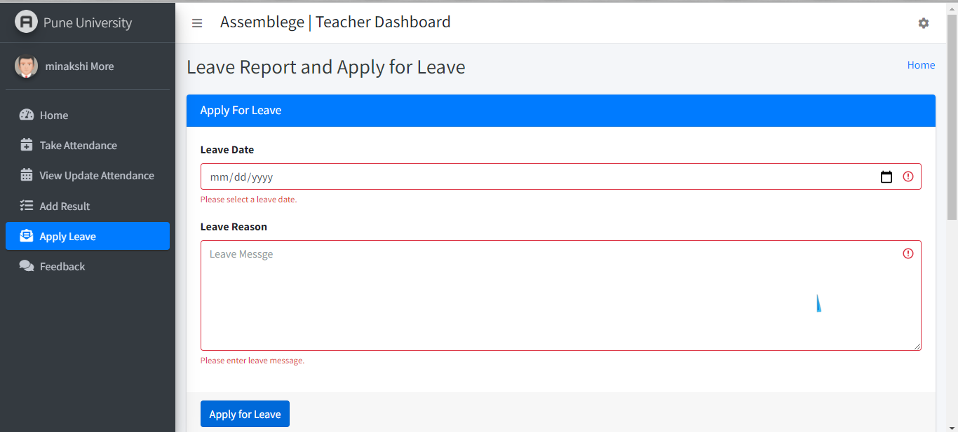

Teacher can apply for leave as well as edit his profile

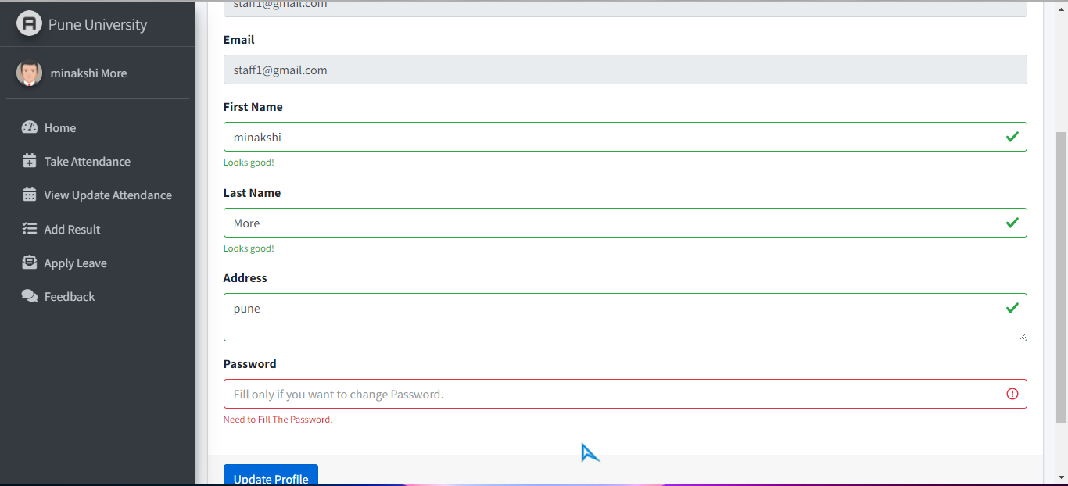

**2: Student Dashboard**

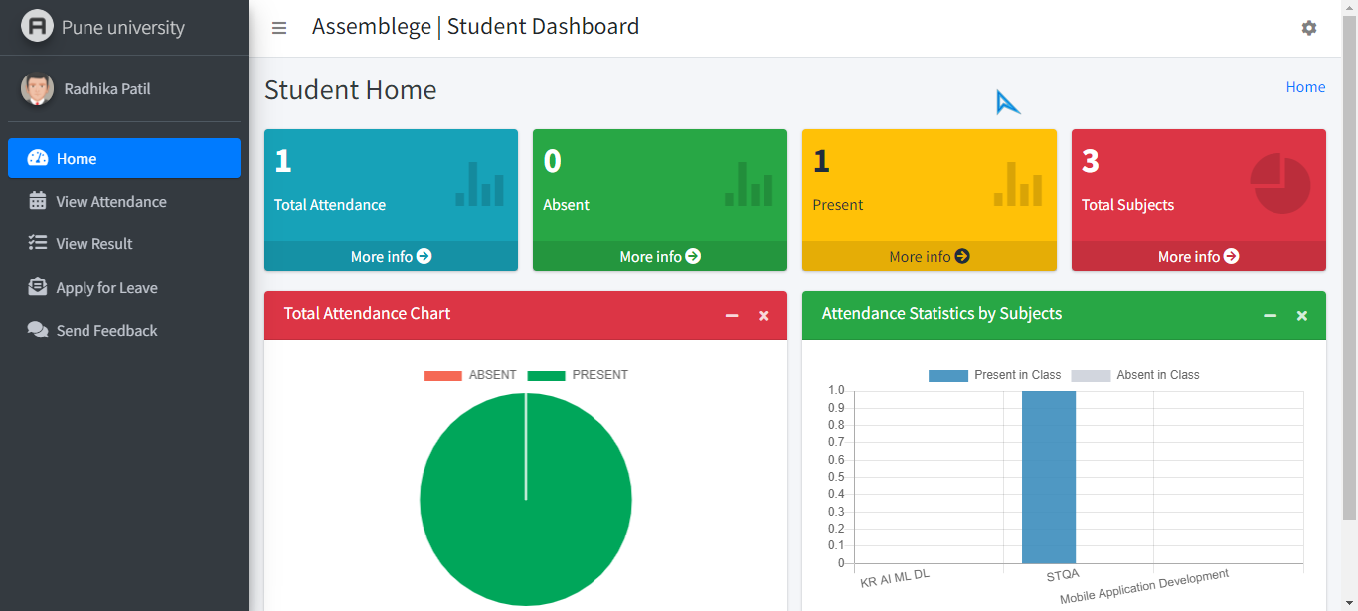

Student can view their attendance and apply for leave and give feedbacks.

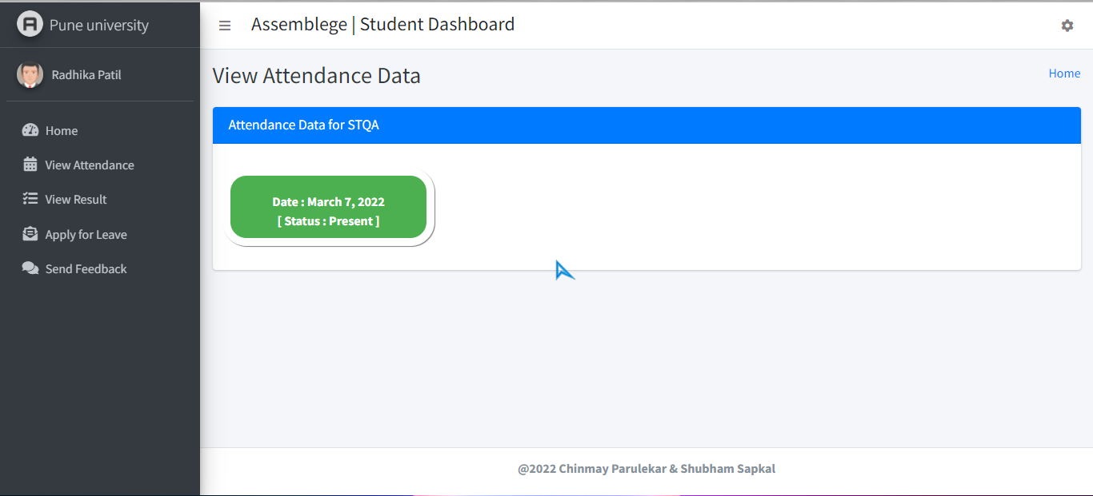

**Future Scope**:-

**1. QR code Scanning:-**

With the help of QR code method teacher can show QR code for particular subject and student can scan it and attendance will get automatically marked.

**2. Automation:-**

**“**Automation” will used to give direct access to user to scan the QR code and attendance will be marked.

**Bibliography:-**

*https://stackoverflow.com

*https://github.com

*https://pub.dev