LSTM AUTOSCALER
Real Kubernetes Actuation, Verified
September 4, 2026 · Step 26 of the project's build log · chinmayraj8/lstm-autoscaler
This document is a factual record of one real event: a forecast produced by this project's decision engine made an actual Kubernetes API call that changed the replica count of a live Deployment on a real cluster. Every log line and terminal capture below is unedited, taken directly from that verification run, including the misconfiguration that was found and fixed along the way. Nothing here is simulated.

What this demonstrates
Through Step 25, this project's live-infrastructure work (Steps 20–25) was deliberately observe-only: a real Prometheus connector, a real forecasting loop, a real in-cluster deployment — but no code anywhere ever called a scaling API. Step 26 adds exactly one real scaling call, gated behind an explicit opt-in that defaults off, and this session verified it end-to-end against the real Docker Desktop Kubernetes cluster used throughout the project:
- A real forecast — an ARIMA model fit against live Prometheus node metrics —
- produced a real decision — a recommended replica count from the project's cost-aware decision engine —
- which made a real Kubernetes API call — patch_namespaced_deployment_scale, via a least-privilege ServiceAccount scoped to exactly one subresource —
- that changed a real Deployment. demo-workload rolled from 2 to 5 replicas live, with nothing manual involved.

Real verification timeline

1. Baseline: actuation off
RBAC and the demo-workload Deployment were applied, the observer image was rebuilt and redeployed as :step26, with actuation still disabled. Both demo-workload pods and the new observer pod came up cleanly. demo-workload's replica count at this point: 2.
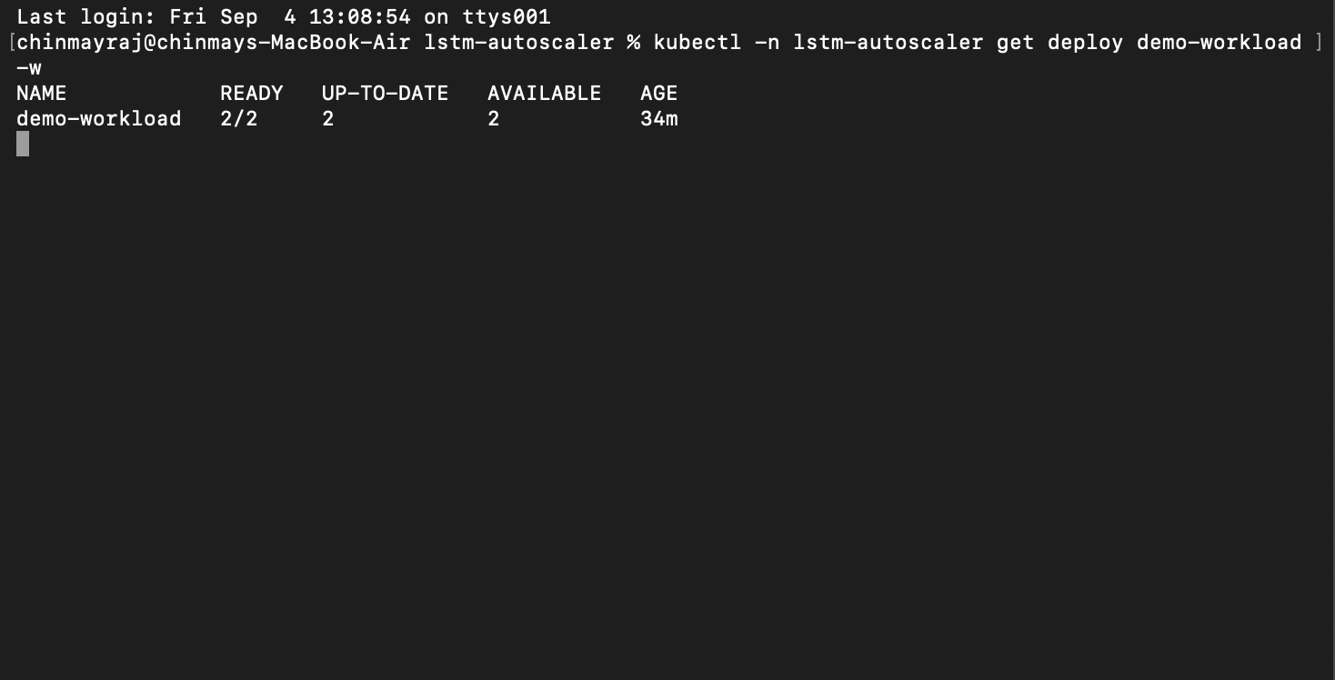
kubectl get deploy demo-workload — 2/2, before any actuation was enabled.

2. First attempt — a real misconfiguration, caught live
Actuation was enabled targeting machine 172.18.0.2 — the node with the most observation history from an earlier step. The startup log confirms actuation is live for it, but the first tick logged observed decisions only for 172.18.0.3 and 172.18.0.5 — nothing at all for 172.18.0.2, not even a caught failure.
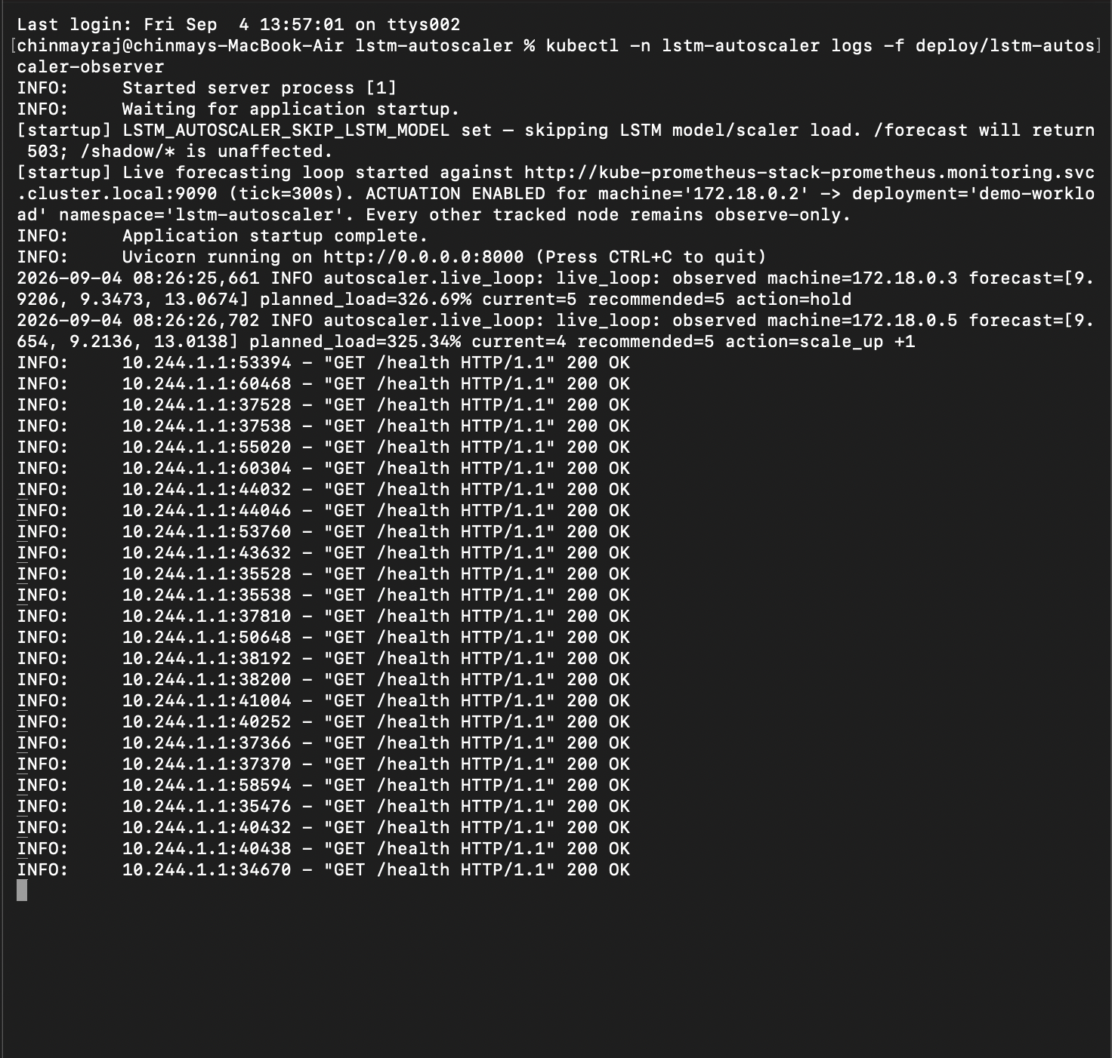
First real tick: ACTUATION ENABLED for 172.18.0.2, but only .3 and .5 actually logged.
A second tick, five minutes later, showed the identical pattern — still nothing for 172.18.0.2:
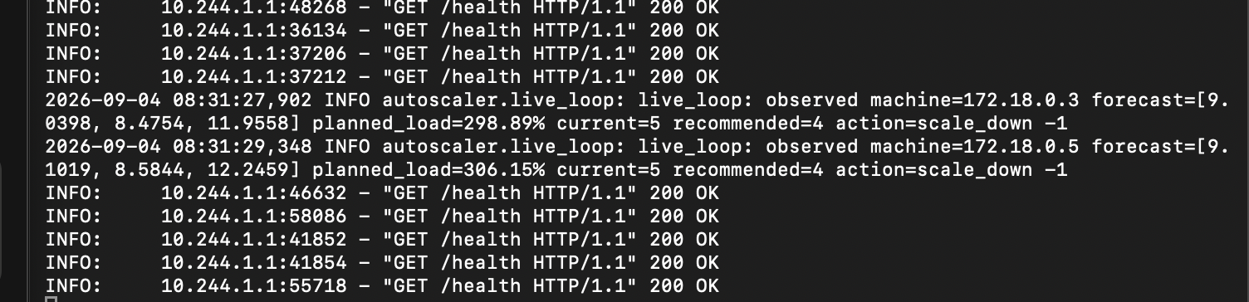
Second tick, same result: 172.18.0.2 never appears.

3. Root cause
The scheduler re-discovers which nodes are live from Prometheus on every single tick (resolve_tracked_machine_ids → PrometheusMetricsSource.list_machine_ids) rather than trusting a fixed list. 172.18.0.2 existed historically in the project's shadow_state.db (from a past tick), but was no longer a Prometheus target actually being scraped — almost certainly a stale node-exporter IP from before a Docker Desktop network/restart event, since Docker Desktop can reassign node IPs. Because it wasn't in that tick's discovered machine list, the observation function was never even called for it, and the actuation branch — which only ever fires for a machine_id present in that tick's loop — never triggered.
This is the live-discovery design working as intended, not a defect in it: a hardcoded tracked-node list would have hidden this instead of surfacing it directly in the logs. The target was switched to 172.18.0.3, confirmed live across both prior ticks.

4. Real actuation fires
The very next tick, a genuine Kubernetes API call succeeded:
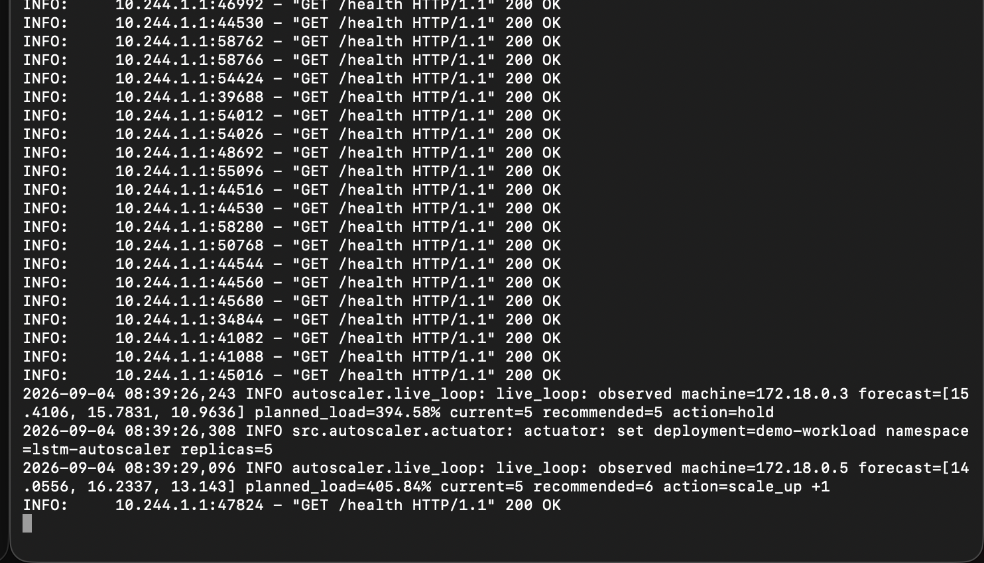
A real forecast → a real decision → a real patch_namespaced_deployment_scale call, confirmed by the actuator's own success log.
observed machine=172.18.0.3 forecast=[15.4106, 15.7831, 10.9636]
planned_load=394.58% current=5 recommended=5 action=hold
actuator: set deployment=demo-workload namespace=lstm-autoscaler replicas=5

5. Real cluster change, confirmed
demo-workload started at 2 replicas. Watching it live during this call showed a genuine Kubernetes rolling scale-up, in real time, entirely driven by the autoscaler:
NAME READY UP-TO-DATE AVAILABLE AGE
demo-workload 2/2 2 2 34m
demo-workload 2/5 2 2 41m
demo-workload 2/5 5 2 41m
demo-workload 3/5 5 3 41m
demo-workload 4/5 5 4 41m
demo-workload 5/5 5 5 41m

A fresh, independent check moments later confirmed the new steady state:
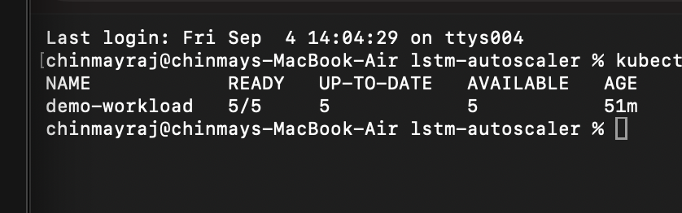
kubectl get deploy demo-workload — 5/5, holding steady after the real scale-up.

Honest limitations — surfaced, not hidden
Consistent with how every step of this project has been documented, what this run exposed is recorded plainly rather than smoothed over:
- No read-before-write reconciliation against live cluster state. actuator.get_current_replicas() exists but is never called in the tick loop — the value the actuator writes comes from the decision engine's own internal “current_servers” ledger (stored in shadow_state.db), not a live read of the Deployment's real replica count. That's exactly why the first real call jumped demo-workload straight from 2 to 5 in one tick instead of the usual ±1 step — the internal ledger and the cluster's real state started out disagreeing, and the write went out blind to that mismatch. The two are now in sync, so the next real scale event should show a correct, single-step change — a genuine next step, not a hidden defect.
- The actuated target is a demo workload, not real traffic. demo-workload is a small nginx:alpine Deployment created specifically so the actuation mechanism has something real to scale. This run proves the mechanism end-to-end; it does not claim the underlying forecast is tuned for any real service's traffic pattern, because this workload has none.
- One designated machine, by design. Actuation only ever applies to a single, explicitly configured machine_id — never an aggregate across nodes — so any real scaling event always traces back to one specific real forecast.

What's next
- A recorded walkthrough combining this real event with the cluster's Grafana/Prometheus dashboards.
- Closing the read-before-write gap above, once the project moves past mechanism-proving toward a more complete control loop.
- README and license rewrite, once every line of this codebase has been personally read through.

Full technical account, including every code change and test result: progress/2026-09-04_step26-real-actuation.md in the project repository.

