rxOptions(reportProgress = 0)

File name: C:\Users\Chinmay\Desktop\KaggleProjects\GroupoBimbo\2007.xdf

Number of observations: 7453215

Number of variables: 29

Number of blocks: 15

Compression type: zlib

Variable information:

Var 1: ArrDelay, Type: integer, Low/High: (-312, 2598)

Var 2: DepDelay, Type: integer, Low/High: (-305, 2601)

Var 3: Distance, Type: integer, Low/High: (11, 4962)

> rxSummary(~DepDelay + Distance,data = flightXdf)

Call:

rxSummary(formula = ~DepDelay + Distance, data = flightXdf)

Summary Statistics Results for: ~DepDelay + Distance

Data: flightXdf (RxXdfData Data Source)

File name: C:\Users\Chinmay\Desktop\KaggleProjects\GroupoBimbo/2007.xdf

Number of valid observations: 7453215

Name Mean StdDev Min Max ValidObs MissingObs

DepDelay 11.39914 36.14189 -305 2601 7292467 160748

Distance 719.80579 562.30512 11 4962 7453215 0

> rxHistogram(~DepDelay,data = flightXdf,xAxisMinMax = c(-50,150),numBreaks = 500,xNumTicks = 10)

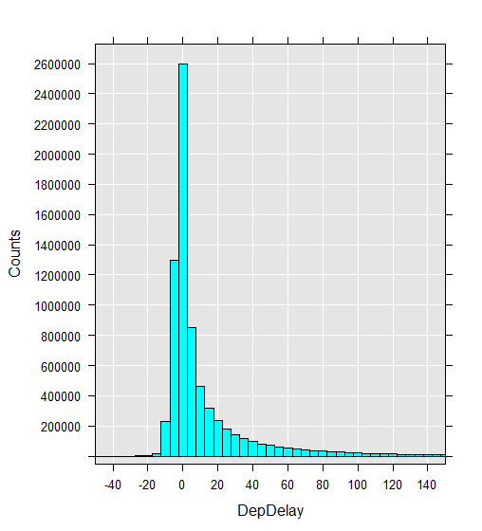

New XDS file to calculate speed and used only AirTime, Distance,DepDelay,ArrDelay,airspeed

> rxGetInfo(data = NewflightXdf,getVarInfo = TRUE)

File name: C:\Users\Chinmay\Desktop\KaggleProjects\GroupoBimbo\2007_airSpeed.xdf

Number of observations: 7453215

Number of variables: 5

Number of blocks: 15

Compression type: zlib

Variable information:

Var 1: AirTime, Type: integer, Low/High: (0, 1257)

Var 2: Distance, Type: integer, Low/High: (11, 4962)

Var 3: DepDelay, Type: integer, Low/High: (-305, 2601)

Var 4: ArrDelay, Type: integer, Low/High: (-312, 2598)

Var 5: airSpeed, Type: numeric, Low/High: (0.2053, 1074.0000)

> rxSummary(~airSpeed,data = NewflightXdf)

Call:

rxSummary(formula = ~airSpeed, data = NewflightXdf)

Summary Statistics Results for: ~airSpeed

Data: NewflightXdf (RxXdfData Data Source)

File name: C:\Users\Chinmay\Desktop\KaggleProjects\GroupoBimbo/2007_airSpeed.xdf

Number of valid observations: 7453215

Name Mean StdDev Min Max ValidObs MissingObs

airSpeed 6.559545 1.986091 0.2052506 1074 7275191 178024

> rxHistogram(~airSpeed,data = NewflightXdf)

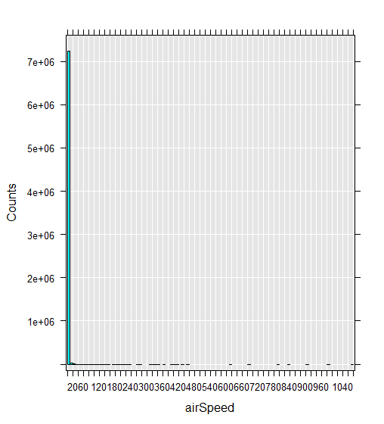

> rxSummary(~airSpeed,data = NewflightXdf)

Call:

rxSummary(formula = ~airSpeed, data = NewflightXdf)

Summary Statistics Results for: ~airSpeed

Data: NewflightXdf (RxXdfData Data Source)

File name: C:\Users\Chinmay\Desktop\KaggleProjects\GroupoBimbo/2007_airSpeed.xdf

Number of valid observations: 7453215

Name Mean StdDev Min Max ValidObs MissingObs

airSpeed 393.5727 119.1655 12.31504 64440 7275191 178024

> rxHistogram(~airSpeed,data = NewflightXdf,rowSelection = (airSpeed>50)&(airSpeed<750),scales = list(x=list(at=seq(100,700,by=100))),xlab=list(label="Air speed(mph)"),ylab=list(label="Frequency"),numBreaks = 5000,xNumTicks = 40)

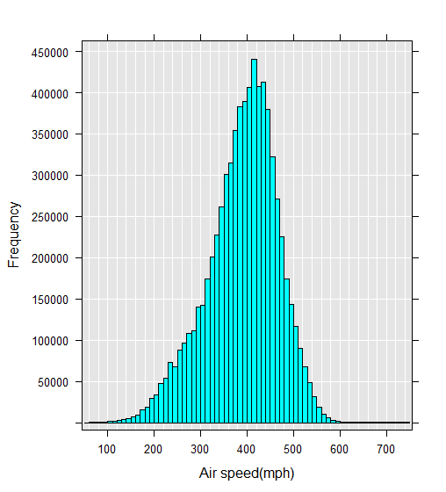

> rxCor(formula = ~DepDelay + ArrDelay + airSpeed,data = NewflightXdf,

+ rowSelection = (airSpeed >50) & (airSpeed <800))

DepDelay ArrDelay airSpeed

DepDelay 1.00000000 0.93192674 0.02083635

ArrDelay 0.93192674 1.00000000 -0.06705657

airSpeed 0.02083635 -0.06705657 1.00000000

Correlation matrix

reg1 <-rxLinMod(formula = airSpeed ~DepDelay,data = NewflightXdf,rowSelection = (airSpeed>50)&(airSpeed <800))

> names(reg1)

[1] "coefficients" "residual.squares" "condition.number" "rank" "aliased"

[6] "coef.std.error" "coef.t.value" "coef.p.value" "total.squares" "y.var"

[11] "sigma" "residual.variance" "r.squared" "f.pvalue" "df"

[16] "y.names" "deviance" "aic" "params" "formula"

[21] "call" "fstatistics" "adj.r.squared" "nValidObs" "nMissingObs"

[26] "coefLabelStyle"

> print(summary(reg1),header =FALSE)

Coefficients:

Estimate Std. Error t value Pr(>|t|)

(Intercept) 3.904e+02 2.956e-02 13209.28 2.22e-16 ***

DepDelay 4.389e-02 7.822e-04 56.12 2.22e-16 ***

---

Signif. codes: 0 ‘***’ 0.001 ‘**’ 0.01 ‘*’ 0.05 ‘.’ 0.1 ‘ ’ 1

Residual standard error: 75.9 on 7250010 degrees of freedom

Multiple R-squared: 0.0004342

Adjusted R-squared: 0.000434

F-statistic: 3149 on 1 and 7250010 DF, p-value: < 2.2e-16

Condition number: 1

#next step is done to check the delay sequence wise for example 0 – 10 mins delay and speed accordingly.

rxDataStep(inData=NewflightXdf,outFile=NewflightXdf,varsToKeep = "DepDelay",transformVars = "DepDelay",transforms =

list(F_DepDelay=cut(DepDelay,breaks = seq(from=-10, to=100,by=10))),append = "cols",

overwrite=TRUE)

print(rxSummary(~F_DepDelay,data = NewflightXdf),header = FALSE)

Category Counts for F_DepDelay

Number of categories: 11

Number of valid observations: 6819077

Number of missing observations: 634138

F_DepDelay Counts

(-10,0] 3894806

(0,10] 1316316

(10,20] 554103

(20,30] 321440

(30,40] 211002

(40,50] 150920

(50,60] 114696

(60,70] 87504

(70,80] 68825

(80,90] 55093

(90,100] 44372

reg2 <-rxLinMod(formula = airSpeed ~F_DepDelay,data = NewflightXdf,rowSelection = (airSpeed>50)&(airSpeed <800),dropFirst = TRUE)

class(reg2)

print(summary(reg2),header =FALSE)

Coefficients: (1 not defined because of singularities)

Estimate Std. Error t value Pr(>|t|)

(Intercept) 387.89666 0.03821 10151.854 2.22e-16 ***

F_DepDelay=(-10,0] Dropped Dropped Dropped Dropped

F_DepDelay=(0,10] 10.97080 0.07603 144.291 2.22e-16 ***

F_DepDelay=(10,20] 9.72038 0.10829 89.758 2.22e-16 ***

F_DepDelay=(20,30] 8.74882 0.13843 63.199 2.22e-16 ***

F_DepDelay=(30,40] 7.56250 0.16862 44.850 2.22e-16 ***

F_DepDelay=(40,50] 6.25256 0.19792 31.591 2.22e-16 ***

F_DepDelay=(50,60] 5.52251 0.22610 24.425 2.22e-16 ***

F_DepDelay=(60,70] 4.47101 0.25797 17.332 2.22e-16 ***

F_DepDelay=(70,80] 3.76816 0.29028 12.981 2.22e-16 ***

F_DepDelay=(80,90] 3.32997 0.32385 10.283 2.22e-16 ***

F_DepDelay=(90,100] 2.50516 0.36051 6.949 3.68e-12 ***

---

Signif. codes: 0 ‘***’ 0.001 ‘**’ 0.01 ‘*’ 0.05 ‘.’ 0.1 ‘ ’ 1

Residual standard error: 75.2 on 6780242 degrees of freedom

Multiple R-squared: 0.004016

Adjusted R-squared: 0.004014

F-statistic: 2734 on 10 and 6780242 DF, p-value: < 2.2e-16

Condition number: 3.3165

From the above final analysis we can say for 0-10 minutes delay the speed increased to 10 and it goes on decreasing as the delay time increases