Visual Analysis of the bank customer data

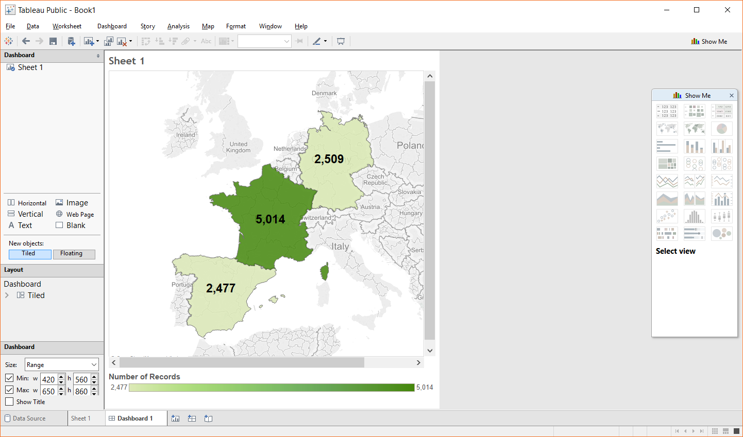

From above visualization we can observe that France (middle dark green part) has half of customers of the bank and rest Spain (lower light green) and Germany (upper light green) have the other half combined.

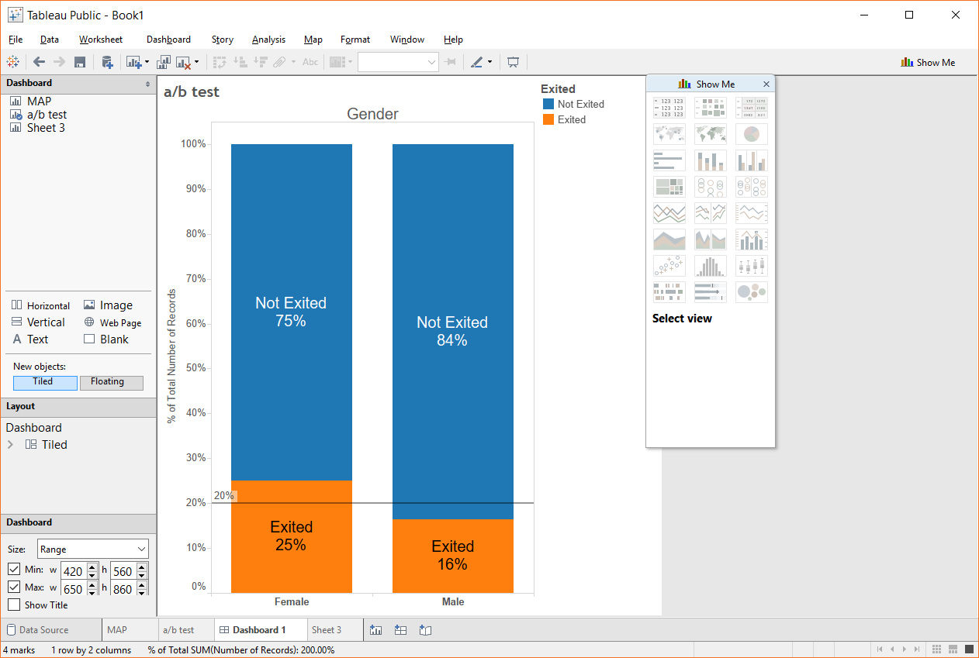

The above figure shows A/B testing of which we can find solutions to who exits, Male or Female. The plot shows that 25 % of females are likely to exit and 16 % of male exits. The line at 20% mark is the 20% mark of the total male female who exits

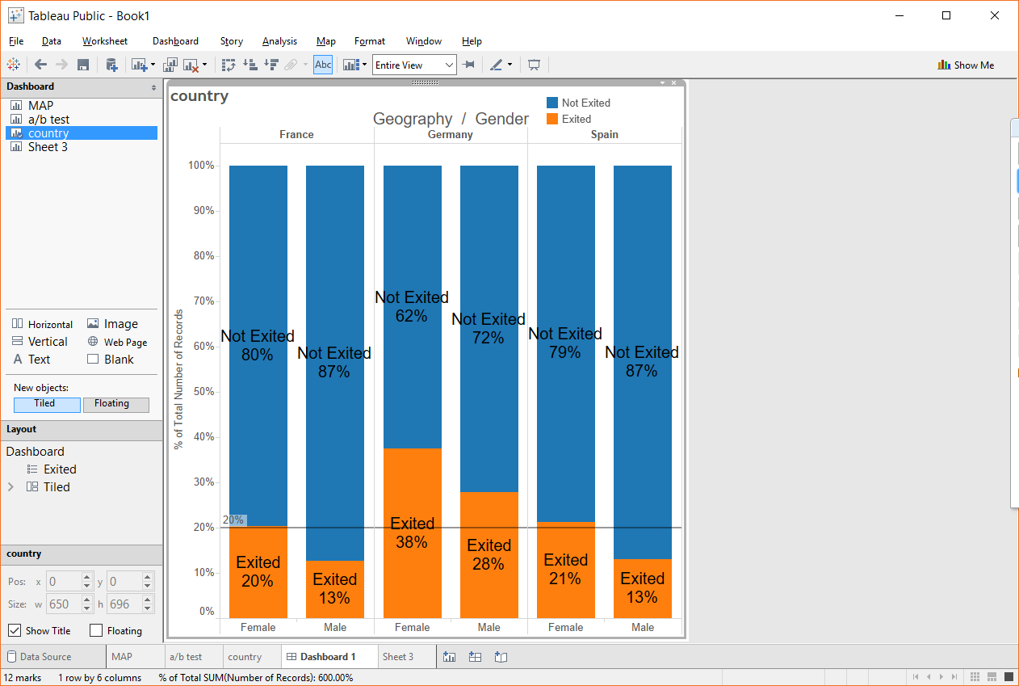

The above figure shows the male/female possibility of exiting the bank for all 3 countries. From the figure we can observe the % of male/female exiting in Germany is much above the average line. Than the other countries.

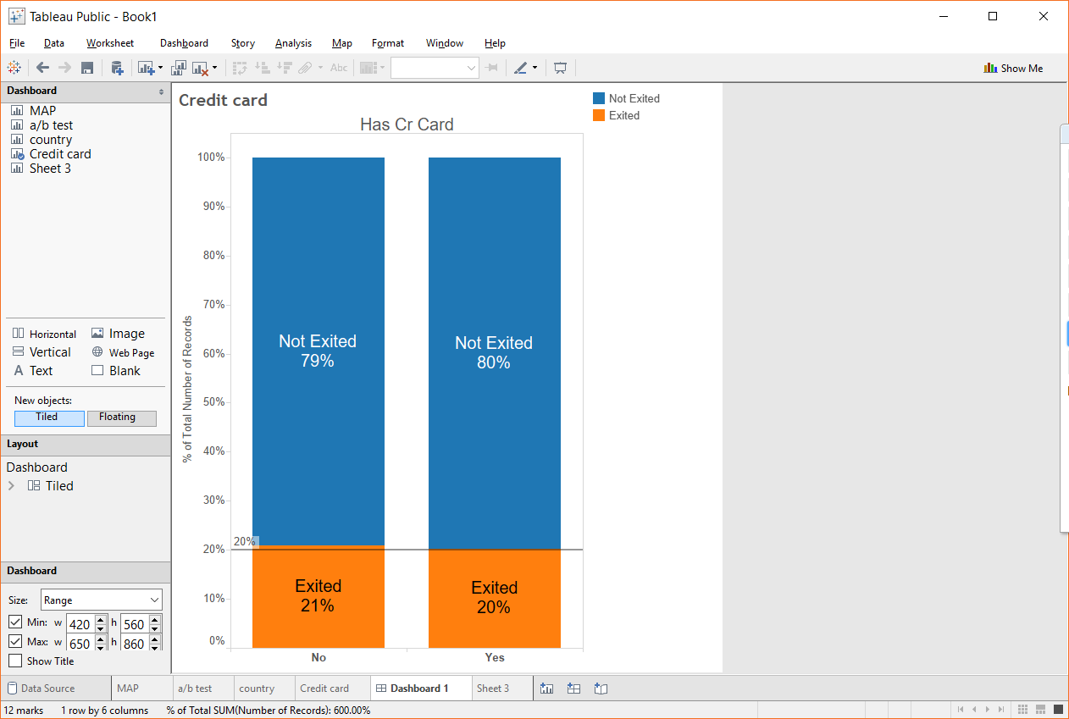

The above figure shows A/B testing of which we can find solutions to who exits depending upon if the customer has credit card or no credit card. The plot shows both 20% mark for customer who has credit card or no who exits.

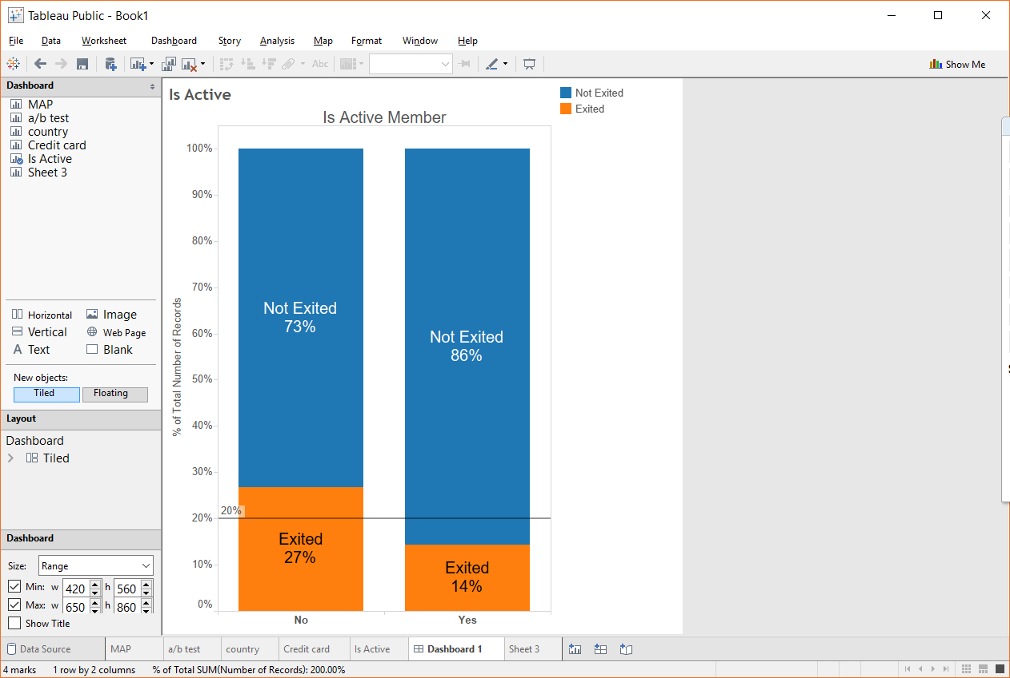

The above plot is similar to the male and female figure where if the customer is an active member not most likely to exit than the ones which are not active.

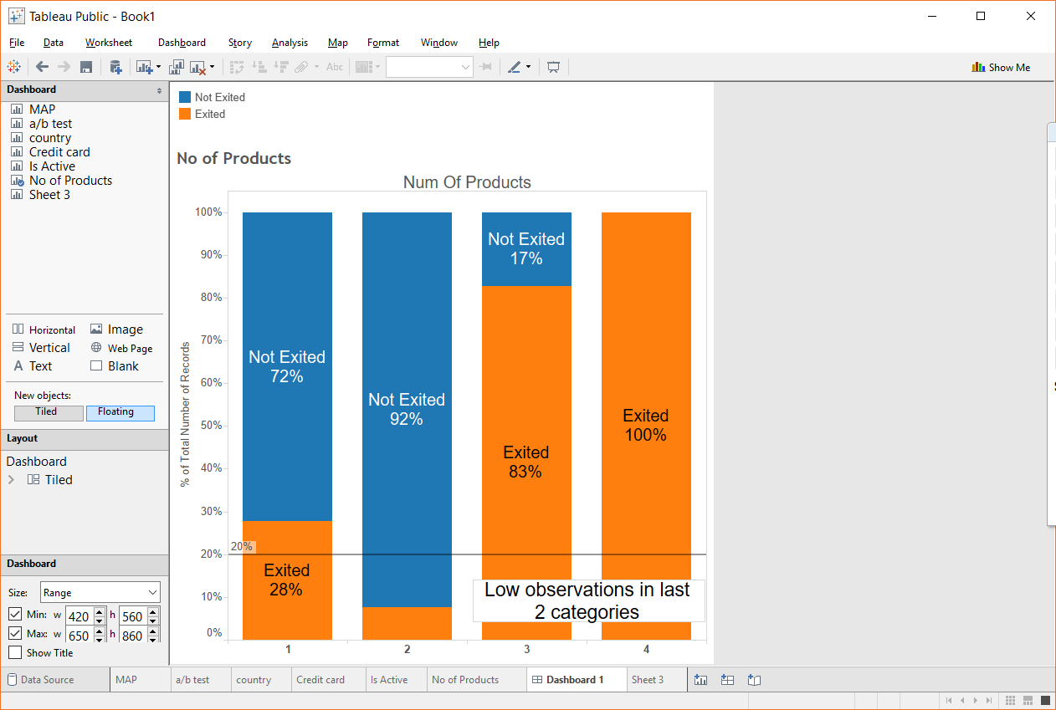

From the above figure we can see that as the number of products increase the possibility of exiting is less but as the number of products increase more than 2 the percentage of exiting increases there can be some problem because 100% can never mean it can either mean that the number of customers can be less, so the next plot shows the number of customers in each of the products.

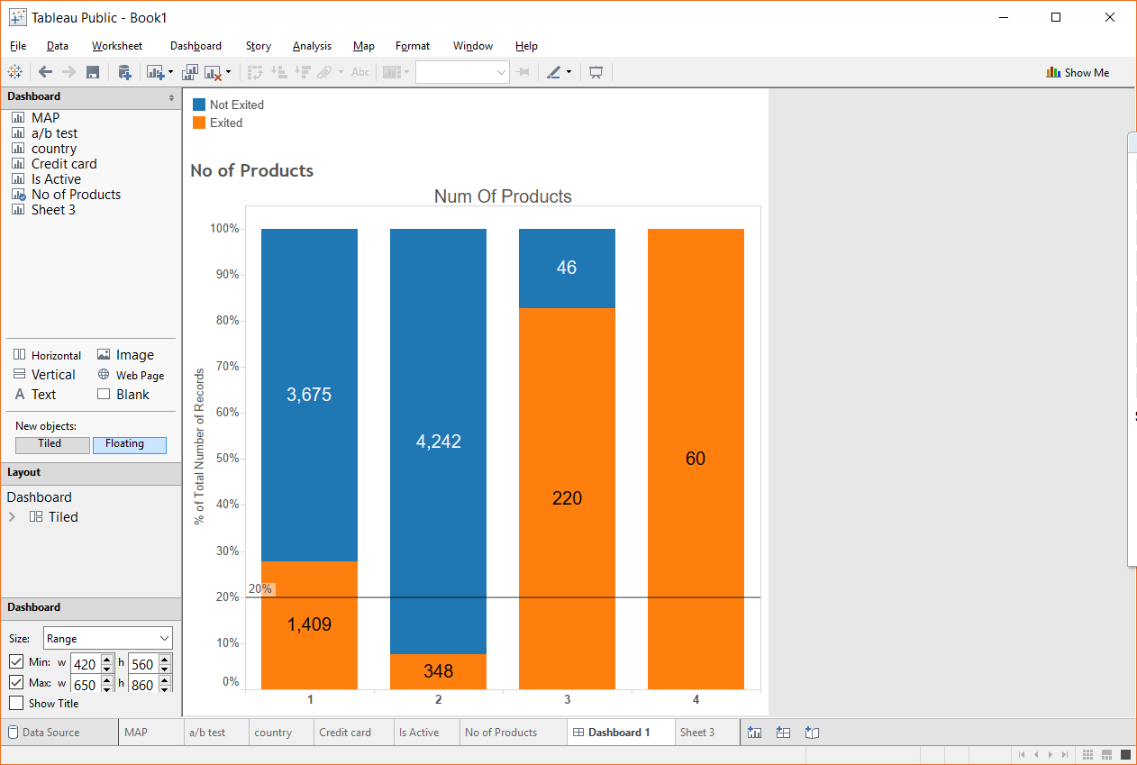

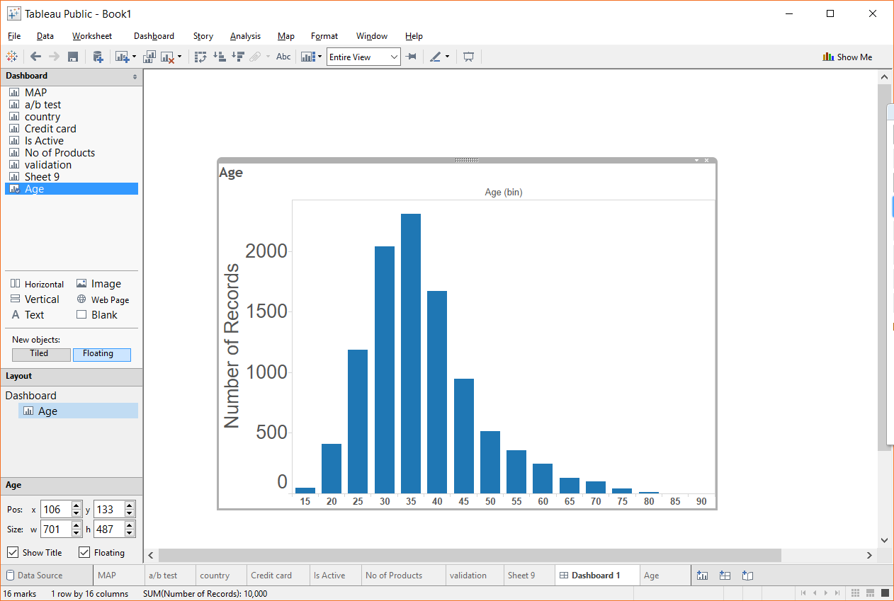

The figure show all the age in a sequence of 5 on ‘x’ axis v/s number of records and we can observe that the age range from 20- 60 has majority of customers. The next figure shows the percentage wise distribution.

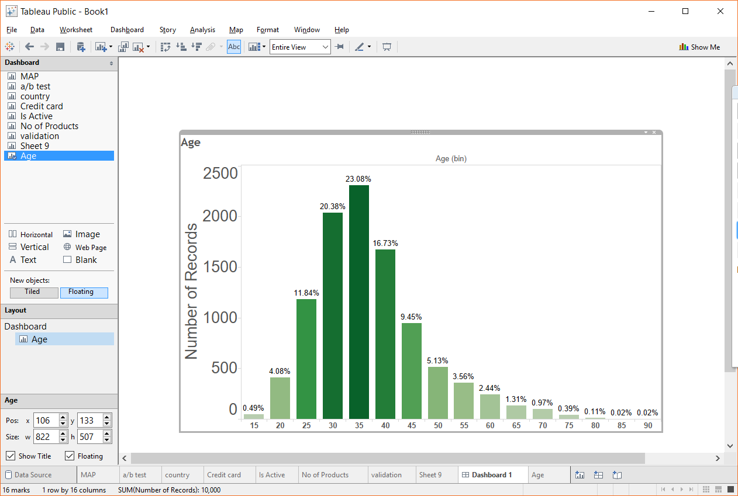

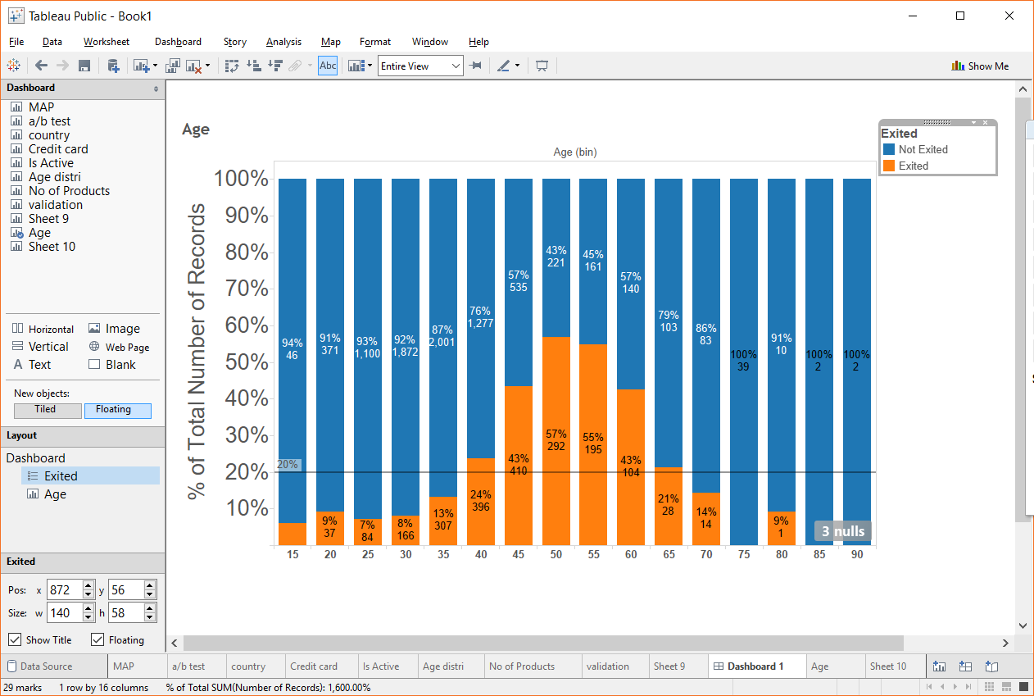

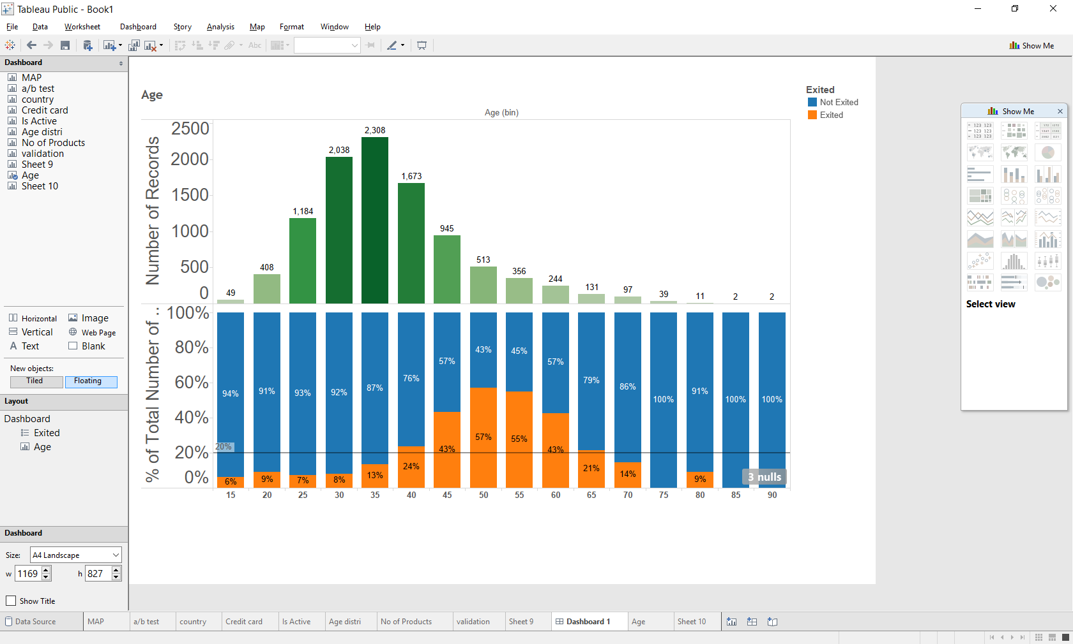

The first is the overall percentage of age v/s the number of records distribution. And the second is for comparison.