ALL ERRORS IN THE PROBLEM,

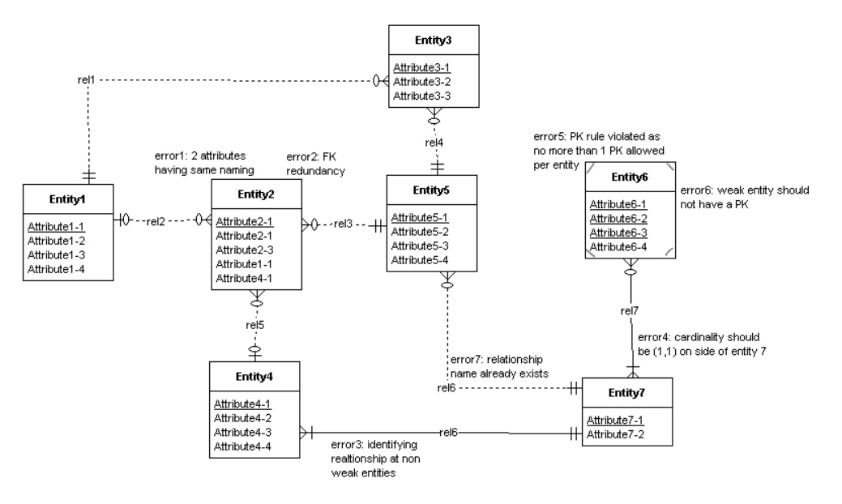

ALL SOLUTIONS APPLIED,

