***Program:***

#include<iostream.h>

#include<conio.h>

void main()

{

clrscr();

int matA[10][10],matB[10][10],matC[10][10],i,j,k,m,n;

cout<<"Enter the number of rows & coloumns:\n";

cin>>m>>n;

cout<<"\nEnter the elements of 1st matrix:\n";

for(i=0;i<m;i++)

{

for(j=0;j<n;j++)

{

cin>>matA[i][j];

}

}

cout<<"\nEnter the elements of 2nd matrix:\n";

for(i=0;i<m;i++)

{

for(j=0;j<n;j++)

{

cin>>matB[i][j];

}

}

for(i=0;i<m;i++)

{

for(j=0;j<n;j++)

{

matC[i][j]=0;

for(k=0;k<n;k++)

{

matC[i][j]=matC[i][j]+matA[i][k]*matB[k][j];

}

}

}

cout<<"\nmatrix C is:\n";

for(i=0;i<m;i++)

{

cout<<"\n";

for(j=0;j<n;j++)

{

cout<<matC[i][j];

cout<<"\t";

}

}

getch();

}

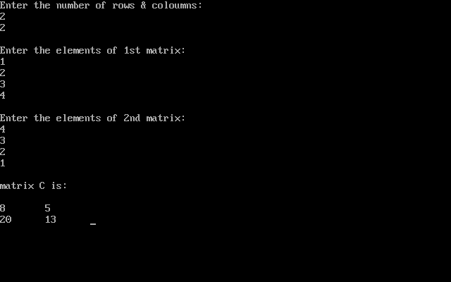**Output:**