Mini Operating System - walkenOS

Roll No . Name Contribution
E030 Adhishree Ranpura Menus, Process Status
E042 Kewal Shah Applications, Memory Status
E044 Chinmay Shah File Manager, Shell Interpreter
E050 Dhruv Shilotri Authentication, File Handling

B. Tech., Computer Engineering Students, MPSTME, Mumbai, India

Abstract— An operating system is a collection of software that manages computer hardware resources by providing abstraction and provides common services for computer programs. The operating system is an essential component of the system software in a computer system and can be regarded as the heart of the system. In our attempt of demonstrating the working of an operating system, we have tried to implement some of the most basic functionalities of an early command-line operating system like DOS with Multiple User Support, Authentication and Security using file handling, File Management using a Shell Interpreter, and some basic applications like a Calculator with parenthesis matching using the Stack Data Structure and a primitive console Audio Player, and an integrated VIM text editor. It also has a System Monitor to understand what processes are active with how much space occupied in the memory and how much of it exists in a swapped state using system calls to the kernel.

Keywords—Operating System, Authentication, File Management System, Process Management, Kernel, Applications

- Type of Operating System
The Operating System that we have implanted in our project is a standalone operating system named walkenOS. With C++ as our medium, we have tried to incorporate concepts of Operating System and Data Structures to build our own primitive command line UNIX based operating system.

- Introduction
Operating systems have played a crucial role in the evolution of the computing field, adapting continuously to the evolution of hardware and to the evolving demands of user communities. They have been the subject of intense research since the early days of computing, and now are able to efficiently support multiple processes, files, users and various uncountable features and functionalities. In our attempt of demonstrating the working of an operating system, we have tried to implement some of the most basic functionalities of

the early command-line operating systems like Multiple User Support, Authentication and Security, File Management and some basic applications like a Calculator and a primitive Audio Player, all coded in the C++ language.

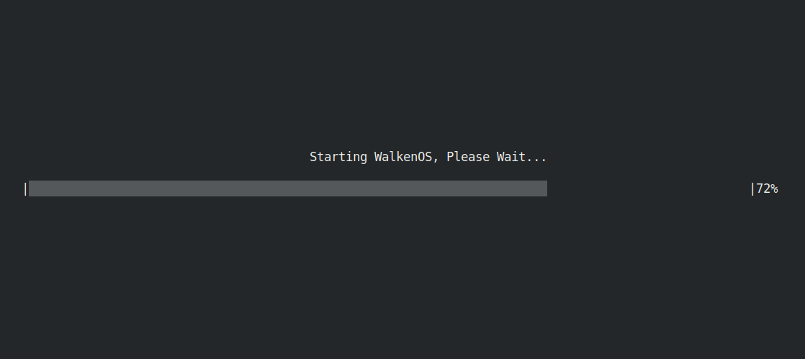
Figure 1

- Authentication And Security
Operating System security is the process of ensuring OS integrity, confidentiality and availability. The walkenOS has a multi-user software to fulfil this necessity. A Multi-user software is a software that allows access of a computer by multiple users. Every user has his own unique User ID. No two users can have same User ID which makes the OS more secure and reliable. Each user has to login with their personal User ID and Password before using various features of the OS. The User ID and the Password are case sensitive which indirectly enables the system to allow more number of Users.

If a new user wants to use the walkenOS, he has to set up a new account with his own unique name which has not been used by other users and a secure password so that it is difficult to predict. The user information is stored in the memory in a secure manner so that no user can access the credentials of other users. The walkenOS is capable of enabling infinite number of users but at the cost of a slower run time.

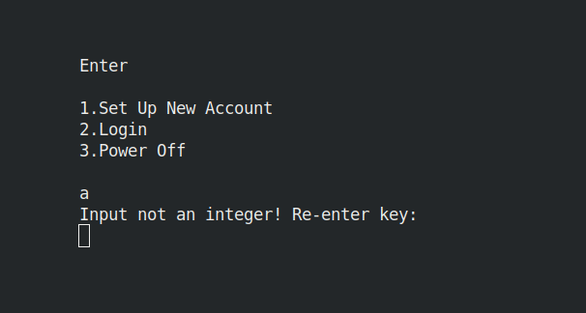
Figure 2

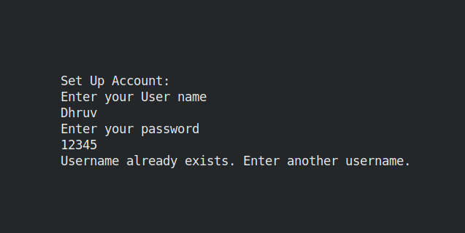
Table 1
Figure 3

- Shell Interpreter and File System
A shell line interpreter provides command line interface. The users directs the operation to the computer by entering commands as text for a command line interpreter to execute. The shell interpreter will allow user to enter commands like copy, rename, delete, display all the files, create a folder, create a new file, as well as various commands supported by linux. All these commands are first ran through a robust error checking for whether that given file exists and then, the relevant command is executed. The shell also supports opening of files in-line through the help of vim, i.e., within the terminal. The file is first ran through the robust first where it is checked whether the given file exists, and then opens the file through calling vim.

The rename function checks whether the given file exists and also checks whether the new file exists. If the new file doesn’t exist then he file is renamed. This is one through utilizing the inbuilt libraries of C++ 11. The create directory creates a new directory utilizing the inbuilt support of linux shell. The creating new file first checks whether the given file already exists, if it exists then the operation is aborted, else, a new file is created through linux tools and then opens a new file in vim. The display command displays all the files an folders in the directory with all permissions as well as size.

The file deletion checks whether the file exists, else exits the program. If the file exists, the file is deleted through the C++11 library function.
The copy file command creates a copy of the file. It checks whether the source a destination file already exists. If the destination file doesn’t exist, then it processes with copying process. It utilizes the concept file pointers, i.e., from the source file, each character by character, the is copies in the destination file.

Function | Command
Open file | open filename
Rename file | rename filename newfilename
Create folder | cfolder fodername
Create File | cfile filename
Display all contents of directory | display
Delete the file | delete filename
Copy file | copy sourcefile destinationfile
Exit interpreter | exitsi

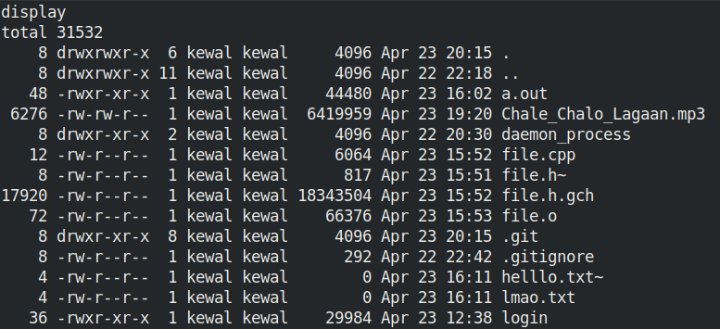
Figure 4

- Process And Memory Management
Operating system must have a optimal process management system.walkenOS is a simple single process operating system. walkenOS processes are very limited resource intensive since it is serve very few functions. This combined with almost unlimited resources makes need for complex process management techniques redundant. It can view multiple process that are running but can run a single one at a time. It has an active process monitor that can view the processes that are currently running on the system.

walkenOS runs a single process at a time and therefore avoids concurrency problems like deadlock and starvation. It however maintains a consistent state of the system by function calls to different processes.[1]

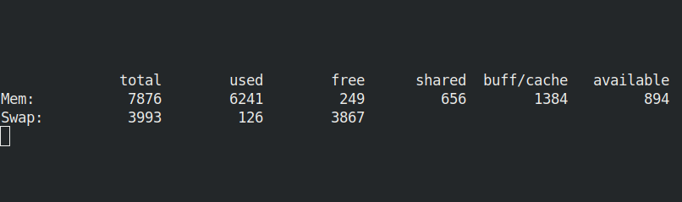
Figure 5

- Applications
walkenOS supports some basic console applications like a Calculator that can compute simple mathematical calculations, an integrated Text Editor to create and modify text files and a primitive audio player to play files in limited audio formats as of now.

1. Calculator
The calculator, inspired from the GNOME Calculator [2] is a tool to execute simple mathematical operations which also validates parenthesis balance using stacks. It however cannot perform advanced scientific calculations but we wish to develop it in the future to be able to do so.

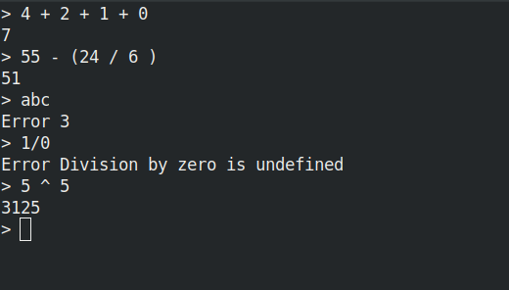
Figure 6

2. Text Editor
A text editor is provided by walkenOS by integrating the already powerful command line and widely known console text-editor VIM.[3] It is not as user-friendly as other GUI based text-editors but one of the most powerful command line text editors.

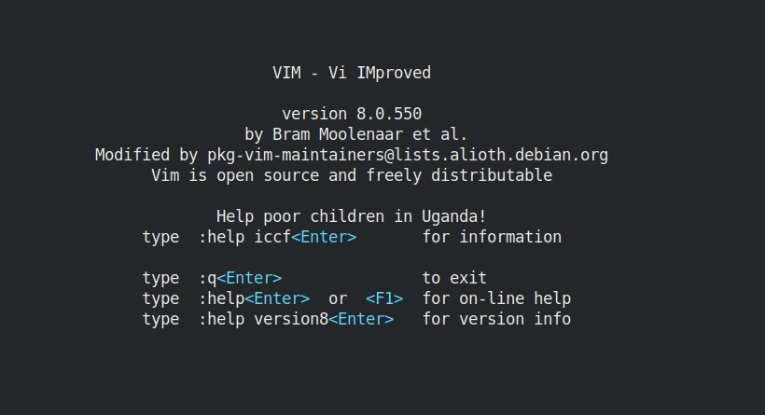
Figure 7

3. Audio player
The audio player used by walkenOS is a useful tool to play mp3 files. Although it is yet to support multiple audio formats it does currently provide a user friendly experience. [4]

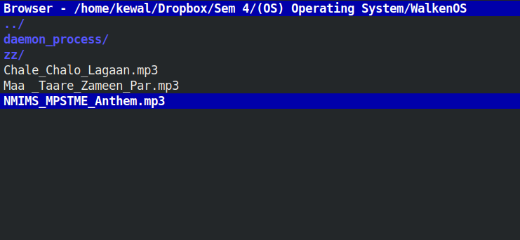
Figure 8

- User Friendliness
A smooth, user experience is very necessary for providing any user a platform for performing their tasks intuitively. walkenOS does just that. It is visually pleasing. It has a menu driven experience that provides users with a palette of processes. It also takes cares of all the input validations. All the process too have a text input command system which is very easy to learn and use. The process commands are listed in the user manual. walkenOS puts user-friendliness as one of its top priorities.

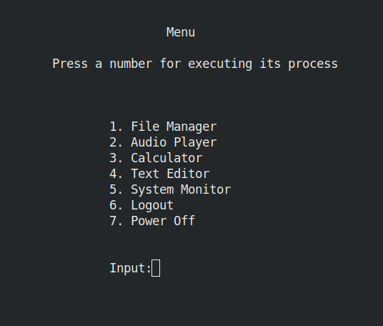
Figure 9

Conclusion
In our attempt to make our own operating system we have tried to incorporate basic functionalities of a command-line operating system, yet we realize that this attempt is far from a well-functioning basic operating system. We intend to make major changes in the future like supporting a multiple processes with inter-process communication and a deadlock prevention algorithm like the Banker’s Algorithm and a Monitor with semaphores to support mutual exclusion. We have also thought of supporting I/O operations using a buffering system like circular buffer.

Though the current file management system in walkenOS works directly through a shell interpreter, we intend to add an indexed file allocation system with a variable length file allocation table. These and many more features are in our scheme of things to make walkenOS a user-friendly, dynamic, multi-user and multi-process operating system in the future.

Acknowledgments
While it is important to know and understand the functionalities of an operating system, it is more important to put all this learning to practical use in life. We would like to thank Dr. Dhirendra Mishra for providing us with this wonderful opportunity of creating and simulating our own Operating System. His valuable advice and motivation in this project were key to its development, and will continue to be as we look forward to develop walkenOS into a more refined and smoothly functioning operating system in the near future.

References
[1] https://codeyarns.com/2016/06/15/free-command-in-linux/
[2] https://help.gnome.org/users/gnome-calculator/stable/
[3] https://www.vim.org/docs.php
[4] https://wiki.archlinux.org/index.php/Cmus

