OFFICIAL RULE BOOK
TECH ROULETTE
Innovate for Tomorrow
Theme: Resource Conservation & Sustainability
A Three-Round Flagship Technical Competition
Eco Buzzer Battle • Build for Impact • Rapid Ideation Pitch
This document is binding on all registered participants.

Table of Contents
1. About the Event
2. Eligibility & Team Registration
3. Event Format & Flow
4. Round 1 — Eco Buzzer Battle
5. Round 2 — Build for Impact (Prototype Development)
6. Round 3 — Rapid Ideation Pitch (Grand Finale)
7. Judging & Evaluation Criteria
8. General Code of Conduct
9. Malpractice & Disqualification Policy
10. Intellectual Property, Originality & Submission Ownership
11. Equipment, Software & Technology Guidelines
12. Awards & Recognition
13. Organizing Committee & Contact
14. Acceptance of Rules

1. About the Event
Tech Roulette: Innovate for Tomorrow is a flagship technical event that challenges students to design practical, technology-driven solutions for real-world sustainability challenges. Built around the theme of Resource Conservation & Sustainability, the competition combines technical knowledge, creativity, teamwork, problem-solving, and communication across a structured three-round format.
Unlike single-skill competitions, Tech Roulette evaluates participants progressively — from knowledge-based assessment, to prototype development, to solution pitching — so that the eventual winners demonstrate well-rounded technical and presentation ability.

Focus Areas
Participants are encouraged to address issues such as:
- Waste management
- Water conservation
- Renewable energy
- Carbon footprint reduction
- Green computing
- Smart resource utilisation

Objectives
- Promote awareness of resource conservation and sustainable development through technology-driven problem solving.
- Encourage critical thinking and innovative solutions for environmental challenges.
- Assess participants across technical knowledge, logical reasoning, rapid prototyping, creativity, teamwork, and communication.
- Provide hands-on experience of real-world problem solving under time and resource constraints.
- Create a competitive yet collaborative platform for showcasing technical ability.
- Enable interdisciplinary participation across engineering branches.
- Embed sustainability as a core part of technological innovation.

2. Eligibility & Team Registration

2.1 Who Can Participate
- Open to all undergraduate students from any engineering discipline.
- Approximately 30–40 teams are expected to participate, subject to venue capacity.

2.2 Team Composition
- Each team must consist of 2 to 3 members.
- Team composition is locked at the time of registration — no additions, removals, or substitutions are permitted afterward.
- Cross-branch and interdisciplinary teams are welcome and encouraged.

2.3 Registration Rules
- Teams must register through the official registration channel before the announced deadline.
- All participants must report to the venue at least 30 minutes before the event begins.
- Valid college ID cards must be presented at registration and may be checked at any stage.
- Teams qualifying from one round are eligible only for the immediate next round — there is no direct entry into later rounds.
⚠ Incomplete registration, missing ID proof, or late arrival beyond the reporting window may result in forfeiture of the team's slot, at the discretion of the Organizing Committee.

3. Event Format & Flow
Tech Roulette is conducted as a full-day, three-round elimination competition lasting approximately 6–7 hours, inclusive of registration, evaluation, breaks, and prize distribution. Each round is independently scored while collectively assessing technical knowledge, innovation, practical implementation, and communication.
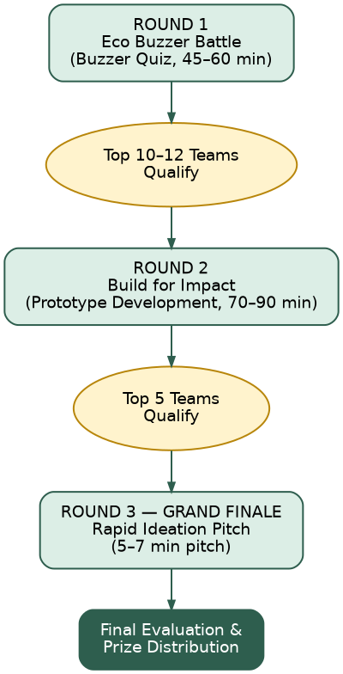

3.1 Quick-Reference Table
Round | Format | Duration | Qualifiers Advancing
Round 1 | Eco Buzzer Battle (Live Quiz) | 45–60 min | Top 10–12 teams
Round 2 | Build for Impact (Prototype Build) | 70–90 min | Top 5 teams
Round 3 | Rapid Ideation Pitch (Grand Finale) | 5–7 min pitch + 5–10 min Q&A | Winners declared

4. Round 1 — Eco Buzzer Battle
A live, buzzer-based screening quiz assessing technical knowledge, sustainability awareness, analytical thinking, and decision-making. Conducted in the seminar hall / laboratory with full audience engagement.

4.1 Question Categories
- Sustainable Technology, Green Computing, Renewable Energy
- Water Conservation, Circular Economy, Carbon Footprint
- Programming Fundamentals, Artificial Intelligence, Cyber Security
- Cloud Computing, Internet of Things (IoT)
- Guess the Resource (image-based identification)
- Sustainability Myth or Fact

4.2 Gameplay Rules
- Questions are projected on screen; the team that buzzes first earns the right to answer.
- Correct answers receive positive marks; incorrect answers carry negative marking.
- If a team answers incorrectly, the question passes to the next eligible team.
- Cross-talk, coaching from the audience, or use of mobile phones/internet during the quiz is strictly prohibited.
- The Quiz Master's ruling on any buzzer or scoring dispute is final.

4.3 Qualification
The top 10–12 teams by cumulative score qualify for Round 2. In the event of a tie at the qualification boundary, a sudden-death tie-breaker question will be used.

5. Round 2 — Build for Impact (Prototype Development)
The core round of the competition, where teams convert a randomly assigned sustainability problem into a working prototype, proof-of-concept, or interactive UI within a fixed time window.

5.1 Process
- Each team draws a unique problem statement from the Luck Card Box — no two teams receive the same problem.
- Teams select their preferred technology stack (e.g., HTML/CSS/JS, React, Flutter, Python, Figma, or any suitable framework).
- Each team spins the Innovation Twist Wheel, which assigns one mandatory additional requirement (e.g., offline-first functionality, accessibility-focused design, QR code integration, data visualisation, gamification, or basic AI/chatbot integration).
- Teams are given 70–90 minutes to design and build their solution.
- Each team presents a 3-minute prototype demonstration followed by a 5-minute Question & Answer session with the judging panel.

5.2 Sample Problem Statements
- Smart Water Conservation System
- Food Waste Management Platform
- Smart Waste Segregation System
- Green Campus Dashboard
- Carbon Footprint Calculator
- Plastic Recycling Tracker
- Rainwater Harvest Monitoring System
- Sustainable Transportation Solution
- E-Waste Collection Platform
- Smart Energy Saving System

5.3 Mandatory Round Rules
- Only resources, tools, and materials available during the event may be used. Pre-built or previously prepared projects will result in immediate disqualification.
- Internet access is permitted during this round only, for research and development purposes.
- Each team's final code/build must be submitted to the Lab Coordinator at the end of the time window; late submissions will not be evaluated unless extra time was explicitly granted by the judging panel.
- Teams must be able to explain and justify every part of their own implementation during Q&A.

5.4 Round 2 Deliverables
- A working prototype / proof-of-concept / interactive UI
- Source files or a shareable project link
- A brief explanation of the assigned problem statement and how the Innovation Twist was incorporated

5.5 Qualification
The top 5 teams by judge score advance to the Grand Finale.

6. Round 3 — Rapid Ideation Pitch (Grand Finale)
The final round tests critical thinking, communication, and the ability to design a feasible implementation strategy under pressure — without building any prototype.

6.1 Process
- Each finalist team draws a Challenge Card describing a real-life sustainability scenario requiring an immediate technological response.
- Each team then draws a Constraint Card, which imposes a real-world limitation on their proposed solution.
- Teams are given 5 minutes to brainstorm using pen and paper only — laptops and internet access are not permitted at this stage.
- Each team delivers a structured 5–7 minute presentation, followed by 5–10 minutes of judge interaction.

6.2 Sample Challenge Scenarios
- Water Shortage During a City Festival
- Plastic-Free College Campus
- Flood Management Using Technology
- Air Pollution in Metropolitan Cities
- Sustainable Public Transportation
- Food Waste Reduction in Hostels
- Electronic Waste Management
- Power Outage in a Smart City

6.3 Sample Constraints
- Budget limited to ₹1 Lakh
- Internet connectivity not available
- Rural area implementation
- Maximum setup time — 30 days
- Open-source technologies only
- Solution designed for senior citizens
- Minimal hardware requirement

6.4 Required Presentation Structure
- Problem Analysis
- Proposed Solution
- Technology Stack
- Implementation Plan
- Sustainability Impact
- Expected Outcomes
- Future Scope
⚠ No laptops, tablets, or internet-enabled devices may be used during the 5-minute brainstorming period or the presentation itself, except where the venue's own display system is used to show a pre-approved static card.

7. Judging & Evaluation Criteria
Standardised, transparent marking parameters apply in every round. A panel of at least three judges evaluates each team independently; final scores are the average across all judges. The decision of the judging panel is final and binding in every round.

7.1 Round 1 Scoring
- Correct answer: positive marks awarded.
- Incorrect answer: negative marking applied, and the question passes to the next team.
- Ranking is based on cumulative score at the end of the quiz.

7.2 Round 2 — Build for Impact (100 Marks)
Evaluation Parameter | Marks
Innovation & Creativity | 20
Technical Implementation | 25
User Experience & Interface | 15
Sustainability Impact | 20
Completion of Innovation Twist | 10
Presentation & Demonstration | 10
Total | 100

7.3 Round 3 — Rapid Ideation Pitch (100 Marks)
Evaluation Parameter | Marks
Creativity of Solution | 20
Feasibility | 20
Technical Understanding | 15
Sustainability Impact | 20
Communication & Presentation | 15
Confidence & Q&A Handling | 10
Total | 100
⚠ Presentation time limits are strictly enforced. Additional time may be granted only at the discretion of the judging panel.

8. General Code of Conduct
- Participants must behave respectfully toward organizers, volunteers, judges, and fellow participants at all times.
- Professional conduct is expected throughout the event, both on and off stage.
- Participants must strictly adhere to the allotted time for every activity and presentation.
- Any team found disrupting another team's presentation, workspace, or evaluation will be subject to penalty.
- Photography/media coverage will be conducted by the official Photography & Media Team; participants should cooperate with reasonable requests for event documentation.
- All queries or disputes must be raised with the Event Coordinator or Faculty Coordinator through proper channels — not directly contested with judges.

9. Malpractice & Disqualification Policy
The following decision tree summarises how common rule violations are handled. Organizers reserve the right to apply proportionate action for any situation not explicitly listed below.
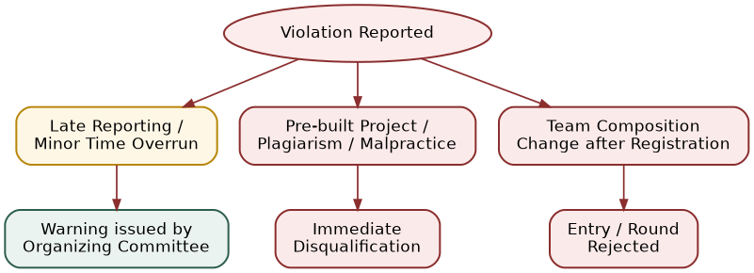

9.1 Grounds for Immediate Disqualification
- Submitting a pre-built, previously prepared, or third-party project as original work in Round 2.
- Plagiarism, impersonation, or misrepresentation of team members.
- Use of internet or unauthorised digital devices during Round 3.
- Any act of malpractice, cheating, or deliberate disruption of the competition.

9.2 Grounds for Warning / Penalty
- Minor delays in reporting to a round (subject to organizer discretion).
- Exceeding allotted presentation time without prior permission.
- Unregistered changes to team composition after registration closes.

10. Intellectual Property, Originality & Submission Ownership
- All prototypes, code, and presentations must be the original work of the participating team, created within the time limits of the respective round.
- Teams retain ownership of the original work they create, subject to these rules.
- Use of open-source libraries, frameworks, or publicly available assets is permitted, provided they are properly acknowledged and do not constitute the core/pre-built solution.
- Any third-party assets, APIs, templates, or datasets used must comply with their respective licenses and terms of use.
- Participants consent to their prototypes, pitches, photographs, and video recordings being used by the institution for event documentation, promotion, and reporting purposes, unless a written objection is submitted to the Organizing Committee in advance.
- The Organizing Committee is not liable for loss of, or unauthorized access to, any team's work during the event; teams are encouraged to keep personal backups.

11. Equipment, Software & Technology Guidelines

11.1 What Teams Should Bring
- At least one laptop per team, fully charged, with a compatible charger.
- Any personal peripherals needed for their chosen tech stack (e.g., mouse, drawing tablet for UI work).
- Valid college ID cards for all members.

11.2 Permitted Software & Tools
- Any suitable development framework or language, including HTML, CSS, JavaScript, React, Flutter, Python, and Figma.
- Google Forms / Kahoot-based quiz interfaces, Microsoft PowerPoint, and standard web browsers where applicable.
- AI-assisted coding or design tools may be used only where explicitly permitted for a given round; teams should confirm permitted-tool lists with the Organizing Committee before the event.

11.3 Venue-Provided Infrastructure
- Seminar hall / classroom for the Opening Ceremony, Round 1, Round 3, and Prize Distribution.
- Computer laboratory with high-speed Wi-Fi and LAN backup for Round 2.
- Projectors, public address system, microphones, backup laptops, and power extension boards.

12. Awards & Recognition

12.1 Competition Awards
- Tech Roulette Champion
- First Runner-Up
- Second Runner-Up

12.2 Special Awards (Optional)
- Best Sustainability Innovation
- Best Prototype Design
- Best Technical Implementation
- Best Presentation
- Most Innovative Idea
All participants receive certificates of participation. Winners and special award recipients receive certificates and trophies during the valedictory ceremony.

13. Organizing Committee & Contact
For registration queries, rule clarifications, or on-the-day assistance, please contact the Organizing Committee listed below.
Role | Name | Contact
Event Coordinator | [To be filled] | [To be filled]
Faculty Coordinator | [To be filled] | [To be filled]
Registration Team | [To be filled] | [To be filled]
Technical Support Team | [To be filled] | [To be filled]
⚠ Please update the contact table above with actual names and phone numbers/emails before circulating this rule book.

14. Acceptance of Rules
By registering for Tech Roulette: Innovate for Tomorrow, all team members confirm that they have read, understood, and agree to abide by every rule set out in this Rule Book, including the judging criteria, code of conduct, and disqualification policy. The Organizing Committee reserves the right to amend these rules where necessary for the fair conduct of the event; any such changes will be communicated to all registered teams before the affected round begins.
— End of Rule Book —

