**PRO LAB INDIA – QUOTATION GENERATOR**

|  |  |  |
| --- | --- | --- |
| **SR NO.** | **INDEX** | **PAGE NO** |
| **01** | **Introduction** | **02** |
| **02** | **TECH STACK** | **03** |
| **03** | **Running Project** | **04** |
| **04** | **USAGE** | **05** |
| **05** |  |  |
| **06** |  |  |
| **07** |  |  |

**INTRODUCTION :-** In today's fast-paced digital era, time efficiency is a valuable asset for businesses and individuals alike. One area where time is often consumed is in the process of generating quotations for products or services. However, with the advent of web applications, this cumbersome task can be significantly streamlined, allowing users to generate quotations quickly and efficiently based on their specific requirements. This introduction explores the concept of a web application designed to generate quotations based on user inputs, ultimately saving valuable time.

The primary goal of the web application is to simplify the quotation generation process, eliminating the need for manual calculations and repetitive data entry. By harnessing the power of automation and intelligent algorithms, users can effortlessly generate accurate quotations tailored to their unique needs. This not only saves time but also reduces the potential for human errors that can arise during manual calculations or data entry.

Through an intuitive user interface, the web application allows users to input relevant details such as product or service specifications, quantities, pricing, and any additional parameters necessary for generating an accurate quotation. The application then processes these inputs and generates a comprehensive quotation, often including itemized costs, taxes, discounts, and any other relevant information.

Moreover, the web application can offer customization options, enabling users to personalize the quotation format, incorporate branding elements, and add specific terms and conditions. This level of flexibility ensures that each quotation reflects the user's unique requirements while maintaining a professional appearance.

Additionally, the web application may feature a centralized database or cloud storage, allowing users to save and retrieve quotations for future reference. This eliminates the need for manual document management, enabling quick access to previously generated quotations, making it easier to track and manage customer interactions.

By leveraging technology to automate the quotation generation process, businesses can significantly increase their productivity and focus on more critical tasks. Whether it's a small business, a sales team, or a freelance professional, the ability to generate quotations efficiently saves time and boosts overall efficiency.

In conclusion, a web application designed for generating quotations based on user inputs offers a convenient and time-saving solution for businesses and individuals. By streamlining the process, eliminating manual calculations, and enabling customization, the application helps users generate accurate quotations quickly and effortlessly. With the ability to save and retrieve quotations, it enhances organization and efficiency, ultimately empowering users to focus on core business activities while delivering professional and tailored quotations.

**TECH STACK :-**

1. Backend

* JAVA

1. Data Base

* PostgreSQL (Local)

1. Front End

* React

1. Deployments

* AWS (Not Decided)
* AZURE (Not Decided)

**Running Project**

1. Download the File from Given Link Below (ProLab_India-0.0.1-SNAPSHOT.jar).

[https://drive.google.com/drive/folders/1APWoL9D7fI1ciGWw2-iGeSiIMAv1QL- f?usp=sharing](https://drive.google.com/drive/folders/1APWoL9D7fI1ciGWw2-iGeSiIMAv1QL-%20%20f?usp=sharing)

1. Copy the File to Any location of your choice once downloaded successfully.
2. Open the folder where you have copied the file and open cmd from same folder.
3. Type cmd and press Enter.

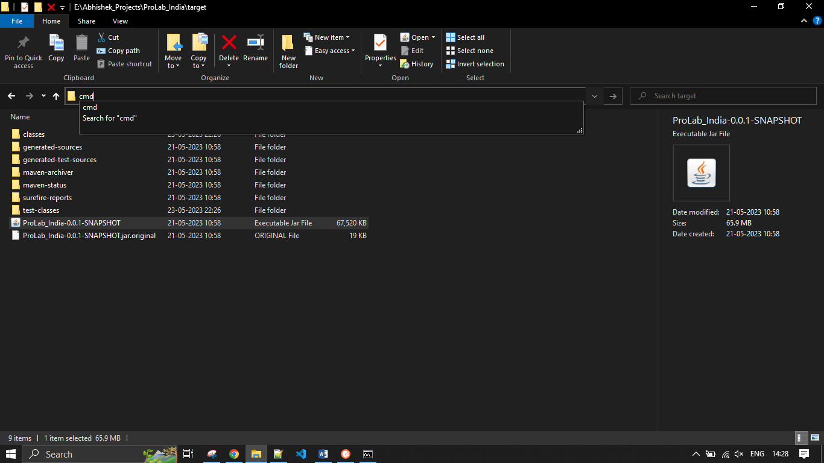

1. Enter the below cmd to make the services up and running.

java -jar ProLab_India-0.0.1-SNAPSHOT.jar



**USAGE:-**

1. Visit Below Link to get REST Endpoints.

url:-<http://localhost:9000/swagger-ui-custom.html>

1. Create Product, Customer with respected REST Endpoints.

Product : localhost:9000/product/create

Customer: localhost:9000/customer/create

1. Generate Quotation PDF for the Customer by using the Product created.

url:- <localhost:9000/pdf-service/generate-pdf>