MULTI-ENVIRONMENT
APPLICATION
Docker Compose Deployment & Verification Report

Submitted by | Chinmay Vyas
Repository | https://github.com/chinmayvyas7/Multi-Environment-Application
Deployment environment | Windows with Docker Desktop
Report date | 18 October 2026
Deployment scope: local containerized application

1. Executive Summary
This report documents the containerization and local deployment of a ticket management application with distinct Development and Production environments. The solution uses a React frontend served by Nginx, two Flask backend services, and two separate MongoDB containers. Docker Compose builds and runs the components on a shared Docker network.
The deployment was verified locally: all five containers were running, the MongoDB containers reported healthy status, the frontend pages loaded, both backend APIs returned environment-specific responses, and the Nginx proxy routes successfully reached the appropriate backend.

2. Technology Stack
Component | Technology / Purpose
Frontend | React single-page application
Backend | Python and Flask; separate Development and Production services
Database | Two independent MongoDB containers
Containerization | Docker images and Dockerfiles
Orchestration | Docker Compose
Web server / reverse proxy | Nginx; serves the frontend and proxies API requests
Host environment | Windows with Docker Desktop; PowerShell used for verification

3. Architecture and Ports
Service | Port / access | Role
frontend | Host port 3000 | React build served by Nginx
backend-dev | Host port 3001 | Development Flask API
backend-prod | Host port 3002 | Production Flask API
mongo-dev | Container port 27017 | Development database; separate named volume
mongo-prod | Container port 27017 | Production database; separate named volume
The Development backend connects to mongodb://mongo-dev:27017/devdb. The Production backend connects to mongodb://mongo-prod:27017/proddb. These service hostnames resolve on the Docker Compose network, and the databases use separate persistent volumes.

4. Repository Changes
The following deployment files and application changes were added or updated:
- backend/dev/Dockerfile — container image for the Development Flask API.
- backend/prod/Dockerfile — container image for the Production Flask API.
- frontend/Dockerfile — multi-stage Node build followed by a lightweight Nginx runtime image.
- frontend/nginx.conf — serves the React single-page application and proxies the two API paths.
- docker-compose.yml — defines the two MongoDB containers and three application containers.
- frontend/src/pages/Tickets.js — uses relative proxy paths for Development and Production requests.
- docs/DEPLOYMENT.md — detailed deployment and troubleshooting guide.
- submission/submission-info.txt — submission metadata and local access URLs.
- README.md — project overview, architecture, setup, endpoints, and link to the deployment guide.

5. Build and Deployment Procedure
The application was built and started from the repository root with Docker Compose.
docker compose up --build -d
docker compose ps

Docker Compose created the network and persistent database volumes, built the frontend and backend images, and started the application services. The MongoDB health checks reached a healthy state before dependent backend services were started.

6. Application URLs
Resource | URL
Frontend home | http://localhost:3000
Development page | http://localhost:3000/dev
Production page | http://localhost:3000/prod
Development API | http://localhost:3001/api/tickets
Production API | http://localhost:3002/api/tickets
Development API via Nginx | http://localhost:3000/api/dev/tickets
Production API via Nginx | http://localhost:3000/api/prod/tickets

7. Verification and Test Evidence
The following checks were performed during local verification. The test results below reflect the terminal/browser checks reported during the deployment session.
Check | Method | Observed result
Container status | docker ps / docker compose ps | Five containers running; MongoDB containers healthy.
Frontend | Open http://localhost:3000 | Home page loaded.
Development UI | Open http://localhost:3000/dev | Development page loaded.
Production UI | Open http://localhost:3000/prod | Production page loaded.
Direct APIs | Invoke-RestMethod on ports 3001 and 3002 | Responses identified Development and Production; task arrays were empty.
Nginx proxy | Invoke-RestMethod on port 3000 proxy paths | Both proxy routes returned the correct environment response.
Service logs | docker compose logs | Flask and Nginx startup logs were observed; API requests returned HTTP 200.

8. Verification Commands
Run these commands from PowerShell to repeat the checks:
docker compose ps
docker ps
docker images
docker compose logs --tail=100
Invoke-RestMethod http://localhost:3001/api/tickets
Invoke-RestMethod http://localhost:3002/api/tickets
Invoke-RestMethod http://localhost:3000/api/dev/tickets
Invoke-RestMethod http://localhost:3000/api/prod/tickets

9. Operational Notes and Limitations
- This report documents a local Docker Compose deployment on Windows; it does not claim deployment to AWS or another cloud host.
- The application returned empty ticket arrays during verification because no ticket records were present. Empty data did not prevent API connectivity checks.
- The Flask application logs indicated the built-in development server/debug mode. A production-grade WSGI server and production security hardening are recommended before a real production deployment.
- The frontend build required disabling the Create React App ESLint plugin in the Docker build because of an eslint-config-react-app/jest environment-key error. Linting should be repaired and re-enabled as a follow-up.
- docker compose down stops and removes the containers/network but preserves named database volumes. docker compose down -v deletes the volumes and their stored data.

10. Evidence Images
The following screenshots document repository setup, Docker deployment, the frontend pages, and direct and proxied API responses.
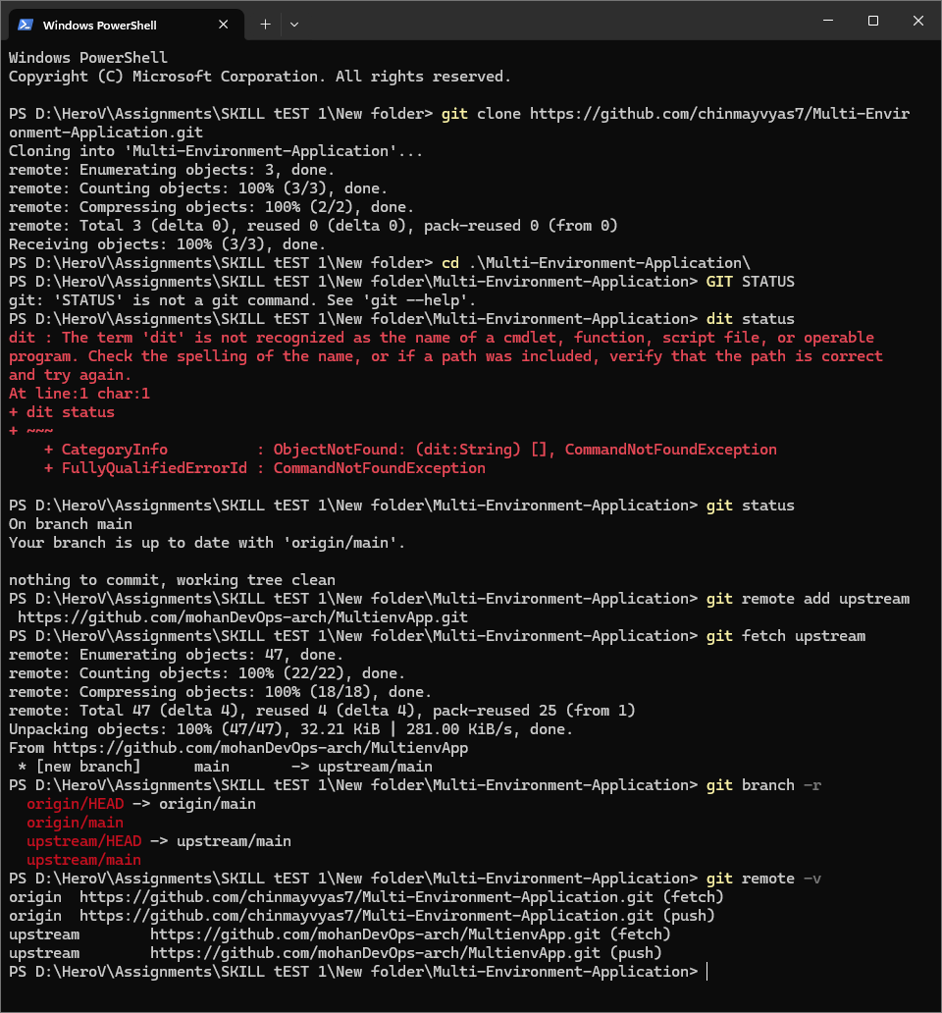
Evidence 1 — Repository cloning and upstream remote configuration
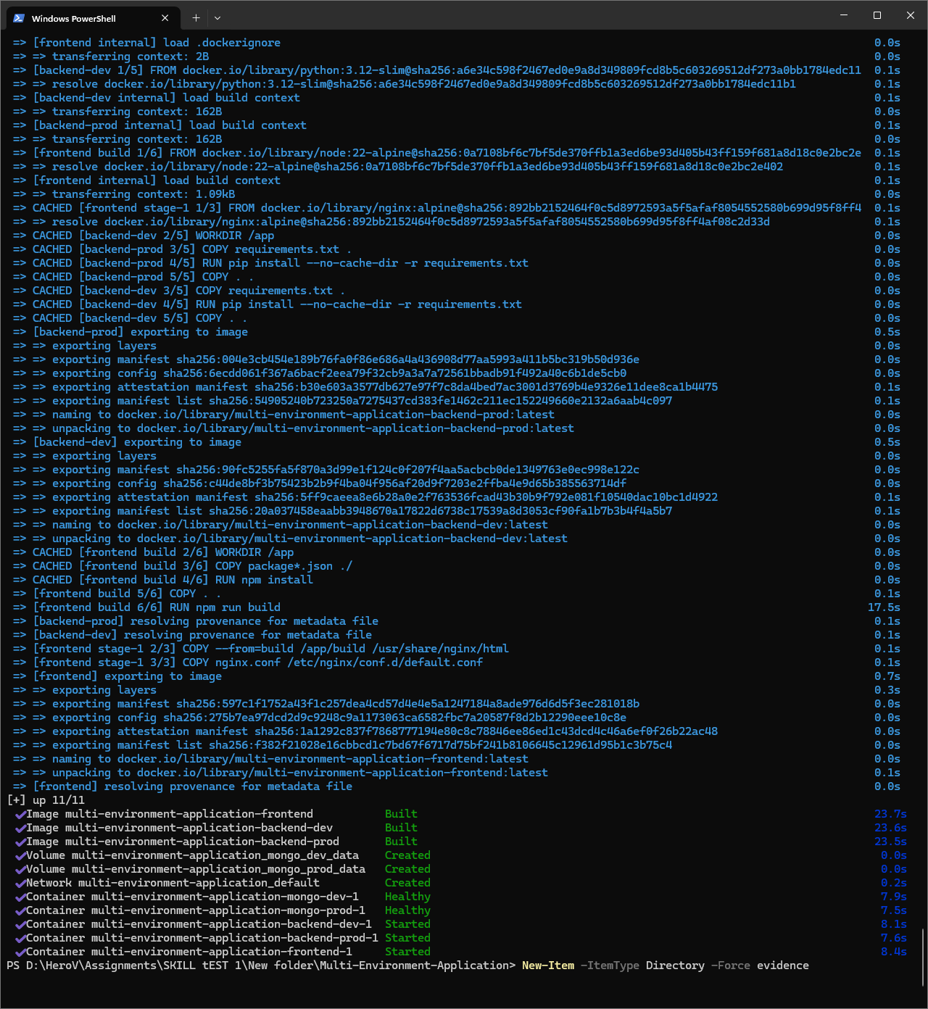
Evidence 2 — Docker Compose image build and service startup
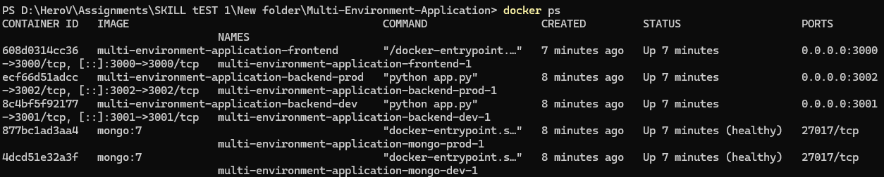
Evidence 3 — Running Docker containers and exposed ports
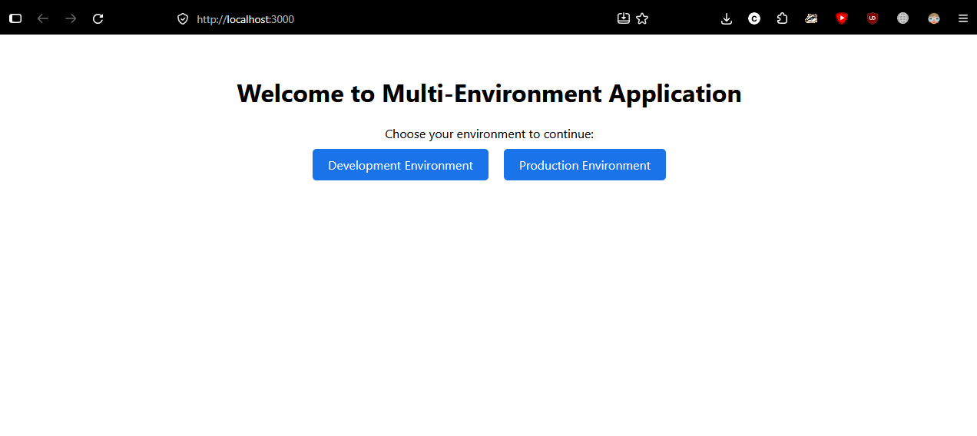
Evidence 4 — Application home page with environment selection
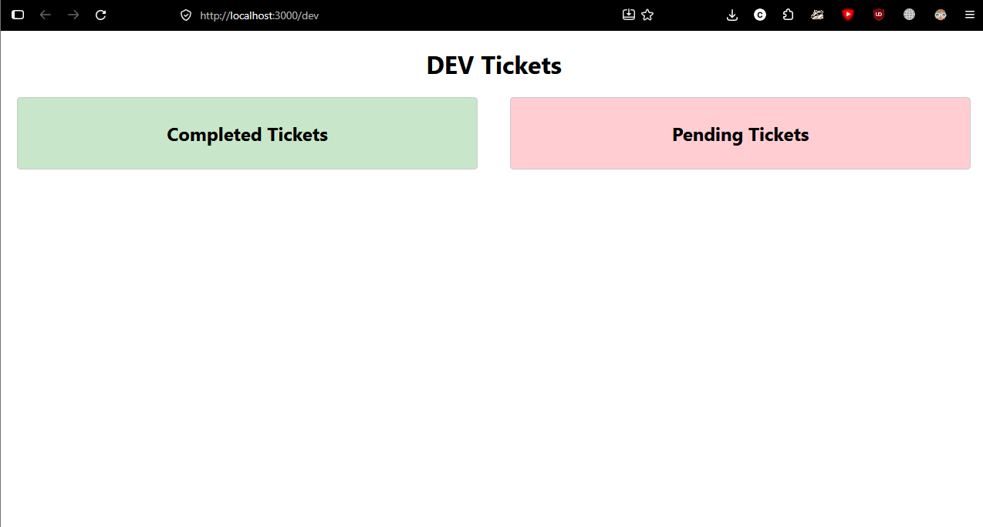
Evidence 5 — Development environment ticket dashboard
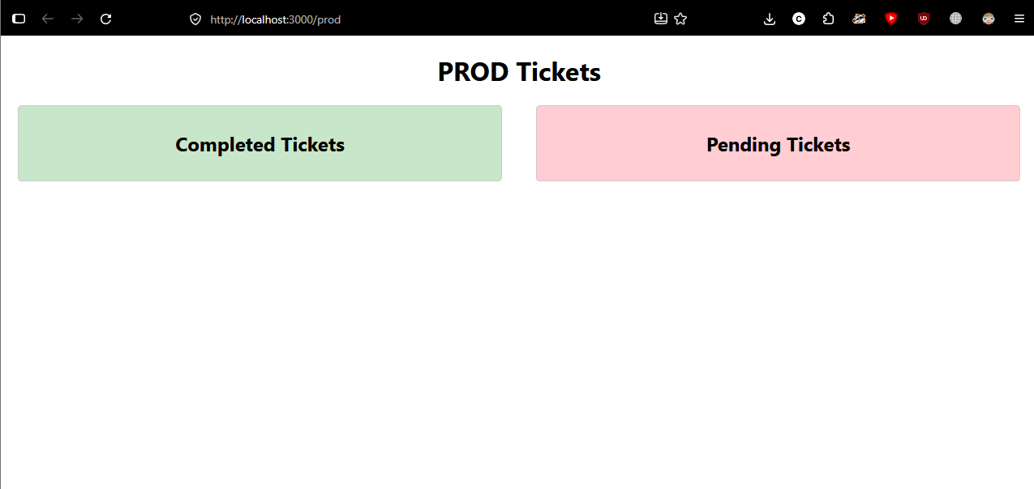
Evidence 6 — Production environment ticket dashboard
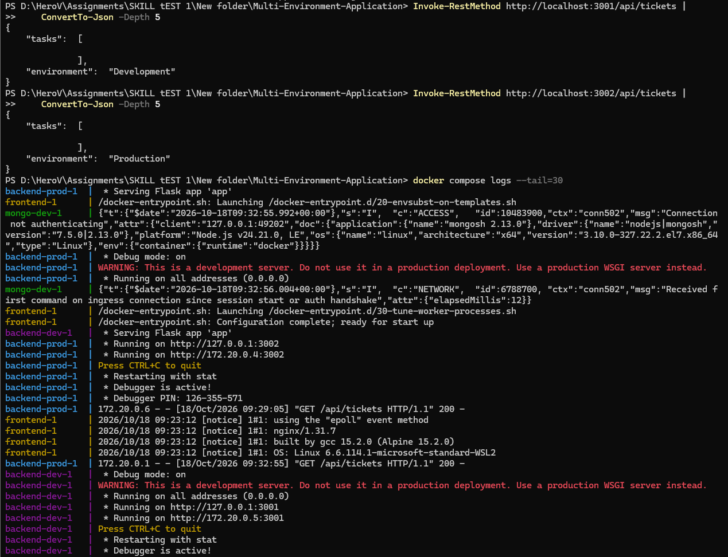
Evidence 7 — Direct backend API responses and service logs
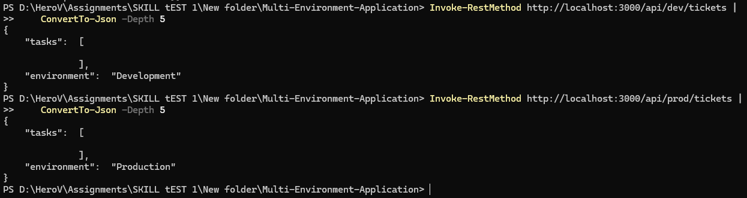
Evidence 8 — Nginx proxy responses for Development and Production

11. Repository and Submission
GitHub repository:
https://github.com/chinmayvyas7/Multi-Environment-Application
The Docker Compose implementation and deployment documentation were committed and pushed to the repository's main branch. The final README was also updated and pushed.

12. Conclusion
The application was successfully containerized and launched locally using Docker Compose. The Development and Production APIs remain separated, each environment has its own MongoDB container, and Nginx provides a single frontend entry point with environment-specific API proxy routes. The core local deployment and connectivity checks passed. The supporting screenshots are included in Section 10.

