STREAMINGAPP
Container Orchestration & Kubernetes Deployment
FINAL ASSIGNMENT SUBMISSION
Submitted By | Chinmay Vyas
Repository | https://github.com/chinmayvyas7/StreamingApp
Deployment Platform | Docker Desktop Kubernetes
Application Access | http://localhost

Submission package: source code • Docker images • Helm chart • Kubernetes deployment • CI validation • verification evidence

1. Project Overview
StreamingApp is a MERN-based streaming platform composed of independent backend services, a React frontend, and MongoDB. For this assignment, the application was containerized, published as versioned Docker images, deployed to Kubernetes using Helm, exposed through an NGINX Ingress, scaled horizontally, and validated through Kubernetes and Jenkins workflows.
- Authentication service — port 3001
- Streaming service — port 3002
- Admin service — port 3003
- Chat service — port 3004
- React/Nginx frontend — exposed through port 80
- MongoDB — port 27017
GIT-05 — Final Git working tree clean
Clean working tree after the Jenkins pipeline fixes were committed and pushed.
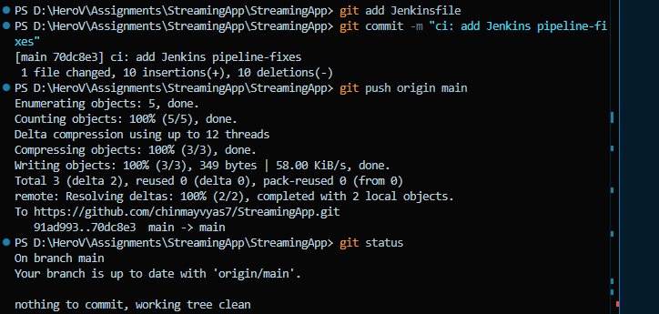

2. Source Repository & Version Control
Final public repository:
https://github.com/chinmayvyas7/StreamingApp
The repository contains the application source, Dockerfiles, Helm chart, Jenkinsfile, frontend NGINX configuration, and deployment documentation.
GIT-03 — Git commit and repository remote
Jenkinsfile commit and push output for the public GitHub repository.
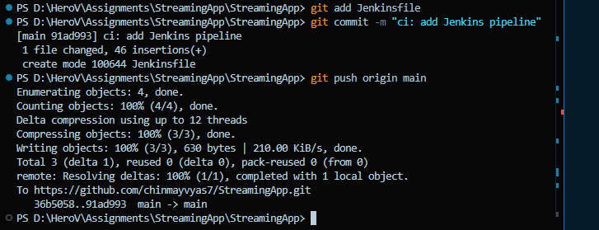
GIT-04 — Final repository clean and Helm chart tracked
Clean repository state with the Helm chart tracked.
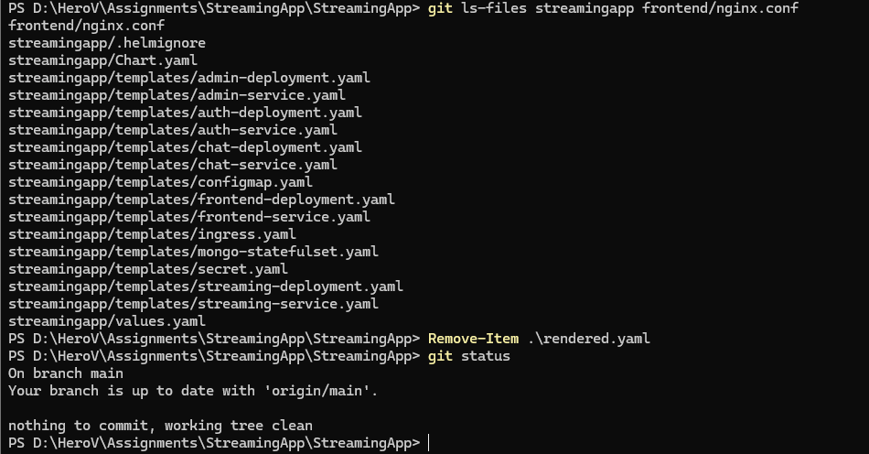

3. Containerization
The existing service Dockerfiles were reused for the five application components. Each image was built with a versioned 1.0.x tag and pushed to Docker Hub.
Component | Docker Hub Repository | Primary Port
Auth | chinmayvyas7/streaming-auth | 3001
Streaming | chinmayvyas7/streaming-stream | 3002
Admin | chinmayvyas7/streaming-admin | 3003
Chat | chinmayvyas7/streaming-chat | 3004
Frontend | chinmayvyas7/streaming-frontend | 80
Example build commands:
docker build -t chinmayvyas7/streaming-auth:1.0.0 backend/authService
docker build -t chinmayvyas7/streaming-stream:1.0.0 -f backend/streamingService/Dockerfile backend
docker build -t chinmayvyas7/streaming-admin:1.0.0 -f backend/adminService/Dockerfile backend
docker build -t chinmayvyas7/streaming-chat:1.0.0 -f backend/chatService/Dockerfile backend
docker build -t chinmayvyas7/streaming-frontend:1.0.x frontend
DOCKER-01 — Five Dockerfiles confirmed
All five service Dockerfiles present.
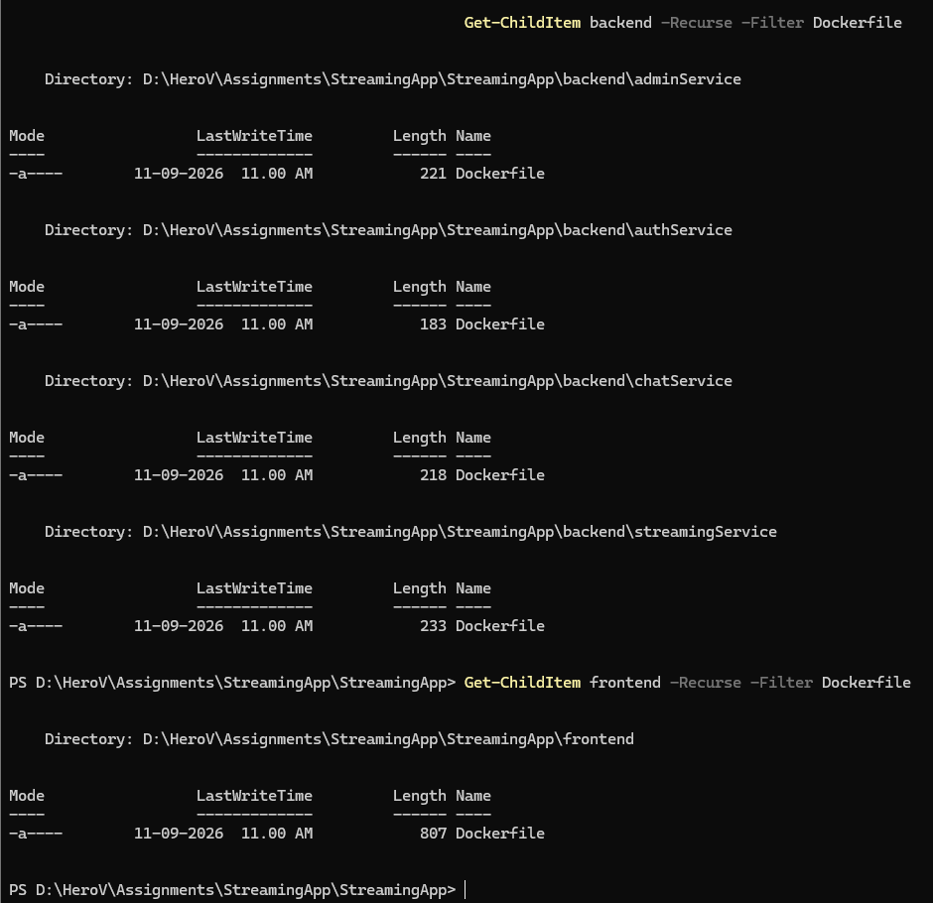
DOCKER-07 — Final Docker images and versioned tags
Final local Docker image list.
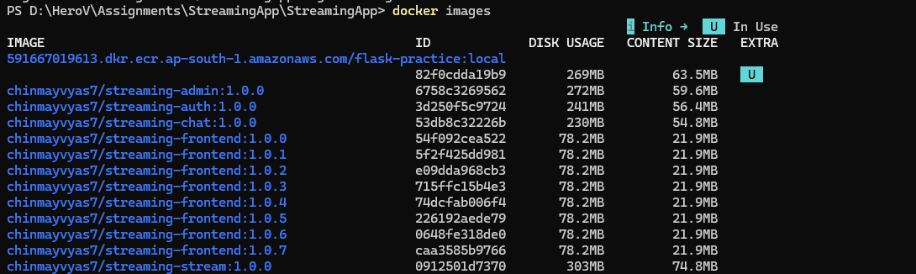
Docker Hub repositories:
- https://hub.docker.com/r/chinmayvyas7/streaming-auth
- https://hub.docker.com/r/chinmayvyas7/streaming-stream
- https://hub.docker.com/r/chinmayvyas7/streaming-admin
- https://hub.docker.com/r/chinmayvyas7/streaming-chat
- https://hub.docker.com/r/chinmayvyas7/streaming-frontend
DH-02 — All five repositories pushed
Docker Hub push evidence for the five application images.
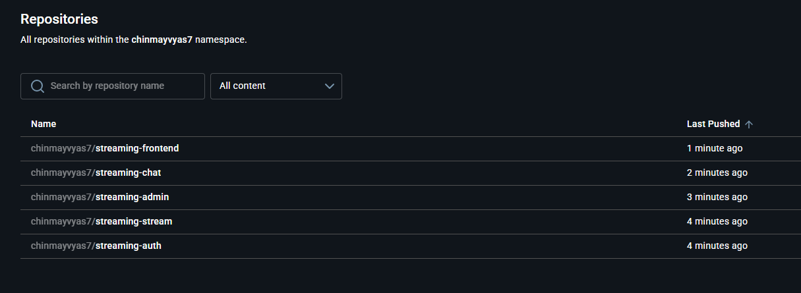

4. Kubernetes Deployment
A Kubernetes deployment was created for each application service. Services provide internal ClusterIP networking, while MongoDB runs as a StatefulSet. ConfigMap and Secret resources provide shared configuration and credentials. Readiness and liveness probes are configured for the workloads.
Helm chart structure:
streamingapp/
Chart.yaml
values.yaml
templates/
auth-deployment.yaml / auth-service.yaml
streaming-deployment.yaml / streaming-service.yaml
admin-deployment.yaml / admin-service.yaml
chat-deployment.yaml / chat-service.yaml
frontend-deployment.yaml / frontend-service.yaml
mongo-statefulset.yaml
configmap.yaml / secret.yaml / ingress.yaml
HELM-03 — Helm lint passed
helm lint completed successfully.
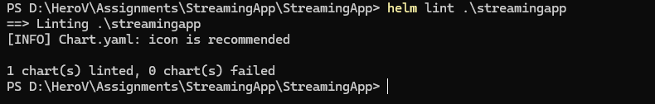
HELM-04 — Rendered Helm manifests
Rendered application image tags and PORT environment-variable entries.
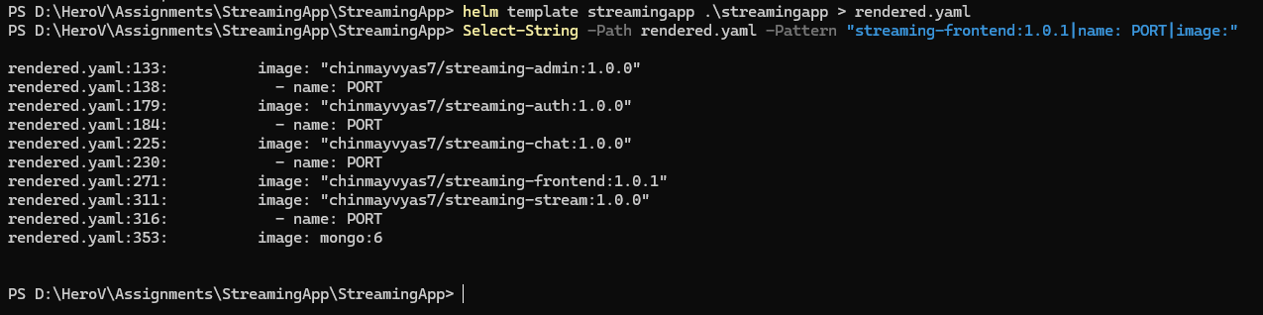
K8S-01 — StreamingApp deployed with all Kubernetes resources
Initial successful Kubernetes deployment.
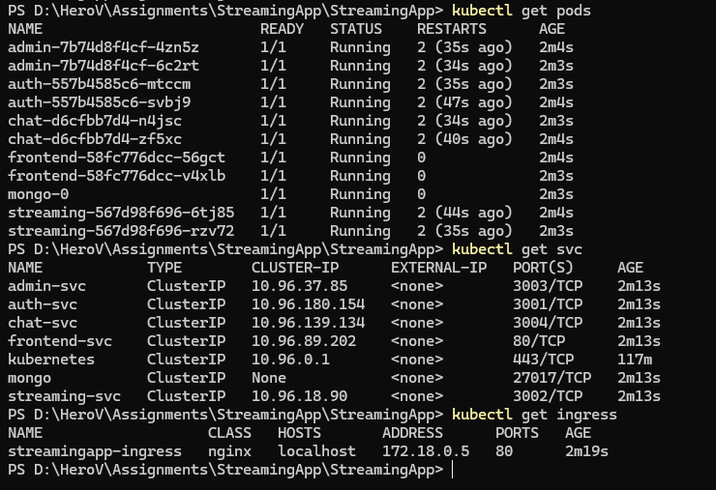
K8S-FINAL — Final Kubernetes pods, services and Ingress
Final cluster state showing all application pods, Services, and the NGINX Ingress.
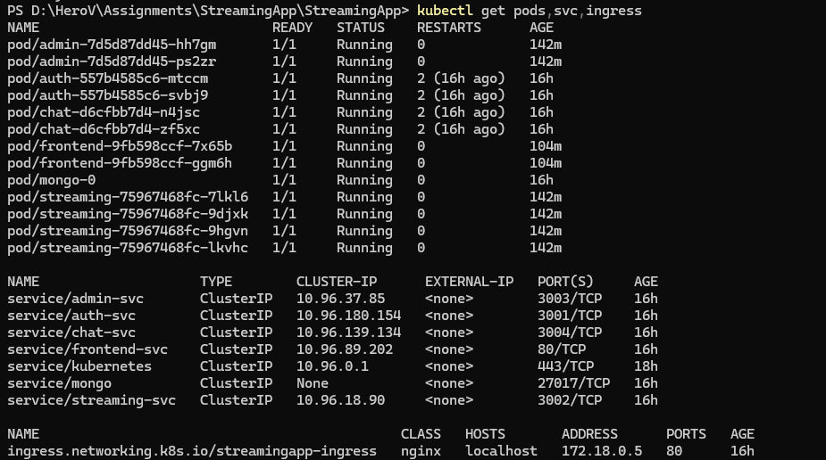

5. Configuration & AWS S3 Integration
Sensitive/local AWS configuration was kept outside the committed Helm values through a local secrets override. The deployed admin and streaming pods were explicitly checked to confirm that the intended S3 bucket was injected into the running containers.
kubectl exec deployment/admin -- printenv AWS_S3_BUCKET
kubectl exec deployment/streaming -- printenv AWS_S3_BUCKET
Verified bucket: chinmayv-s3-demo-bucket
S3-01 — AWS S3 configuration inside running pods
Runtime environment verification for the Admin and Streaming deployments.
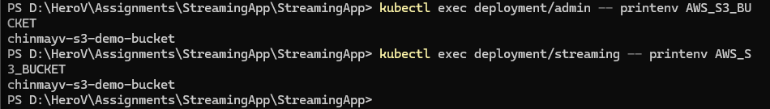

6. Ingress & Application Access
NGINX Ingress provides a single external entry point at http://localhost. The application routes frontend traffic to the frontend Service and API traffic to the appropriate backend Service.
Path | Destination
/ | frontend-svc:80
/api | auth-svc:3001
/api/streaming | streaming-svc:3002
/api/admin | admin-svc:3003
/api/chat | chat-svc:3004
ING-01 — NGINX Ingress controller running
Ingress controller deployment and readiness.
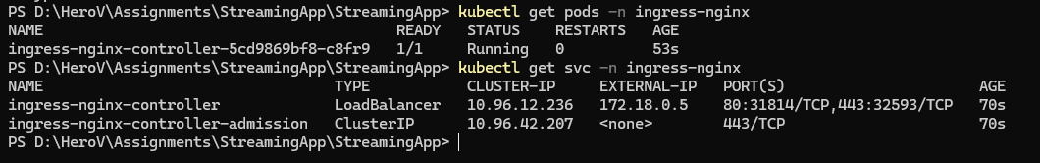
ING-02 — StreamingApp accessible through Kubernetes Ingress
Application frontend loaded through the Kubernetes Ingress.
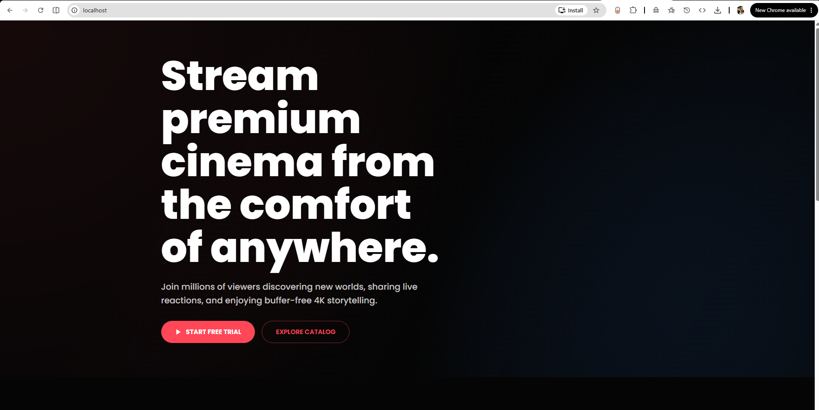

7. Scaling & Rolling Updates
The Streaming service was horizontally scaled from its baseline to four replicas. The deployment uses a RollingUpdate strategy with maxUnavailable: 0 and maxSurge: 1 to support zero-downtime updates.
kubectl scale deployment/streaming --replicas=4
kubectl get deployment streaming
SCALE-01 — Streaming service scaled to 4 replicas
Streaming deployment showing 4 desired, 4 available replicas.
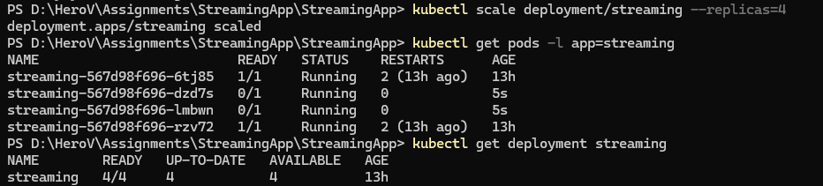
Helm upgrades were also performed successfully, including application image updates. The resulting deployment state was verified through Kubernetes rollout status and pod state.
UPDATE-01 — Helm upgrade successfully deployed revision 2
Successful Helm upgrade and revision evidence.
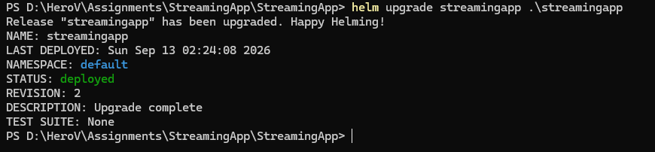
UPDATE-02 — Frontend rolling update completed
Frontend update with the newer version running.
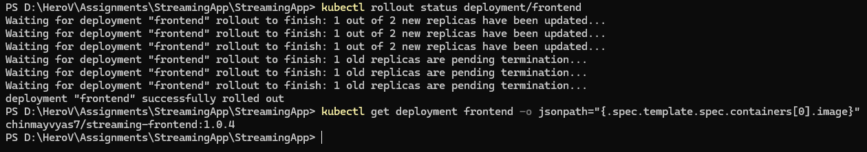
K8S-03 — Final Kubernetes deployment after Jenkins pipeline
Final deployment state after CI validation.
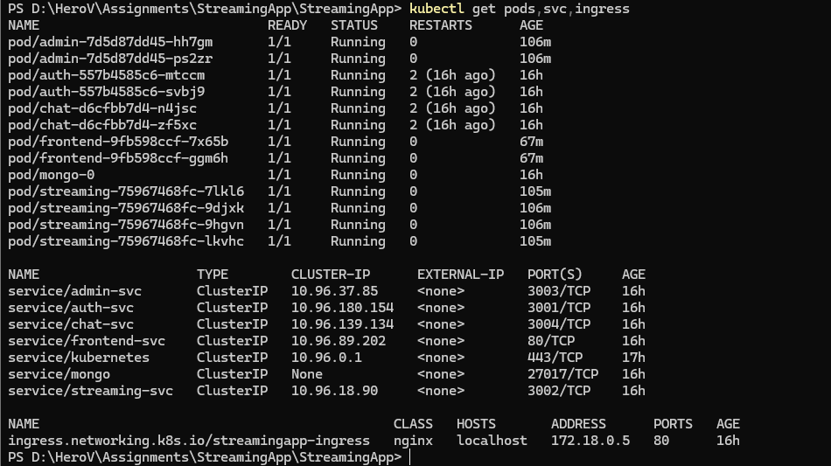

8. CI Pipeline with Jenkins
A personal Jenkins pipeline was configured against the public GitHub repository. The pipeline checks the Docker, kubectl, and Helm client environment, builds the five application images, and validates the Helm chart using helm lint and helm template.
stage('Verify Project') → docker --version / kubectl version --client / helm version
stage('Build Docker Images') → builds five versioned application images
stage('Verify Helm Chart') → helm lint streamingapp / helm template streamingapp streamingapp
The first build exposed a Linux-agent compatibility issue because the pipeline used Windows bat steps. The Jenkinsfile was corrected to use sh steps, after which build #2 completed successfully.
JENKINS-02 — Jenkins pipeline build #2 SUCCESS
Successful personal Jenkins build using the final Linux-compatible pipeline.
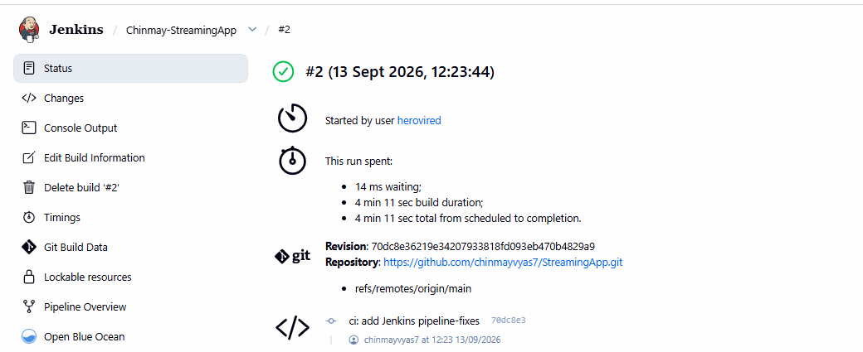
JENKINS-03 — Personal Jenkins pipeline configured
Chinmay-StreamingApp job using the main branch and Jenkinsfile.
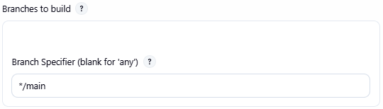
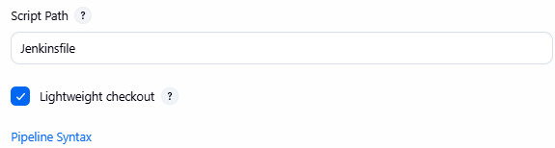

9. Verification & Smoke Testing
The following operational checks were completed:
- All Kubernetes application pods reached Ready/Running state.
- All required ClusterIP Services were present.
- NGINX Ingress was present and reachable through localhost.
- Streaming deployment successfully ran four replicas.
- Deleting a Streaming pod caused Kubernetes to create and start a replacement pod.
- Admin authentication/access was verified.
- A video upload through the Admin Studio was completed successfully.
- Running Admin and Streaming pods contained the correct AWS S3 bucket configuration.
TEST-01 — Admin Studio access
Video-management page at localhost/admin, displaying an uploaded video.
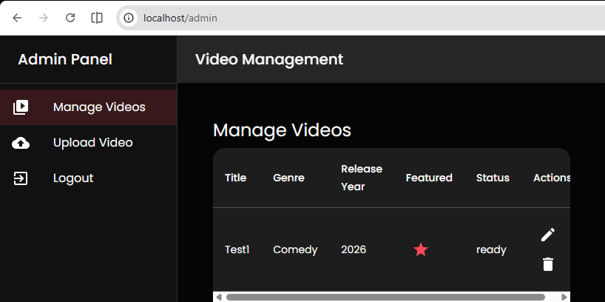
TEST-02 — Successful video upload through Admin Studio
Uploaded videos marked ready, with successful upload requests and an HTTP 201 creation response.
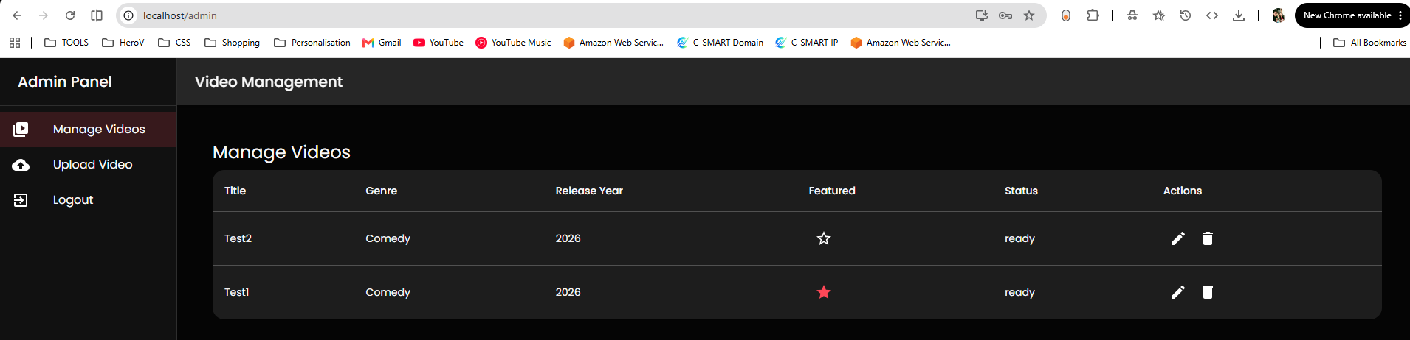
Upload request detail: Name / Status / Type / Initiator
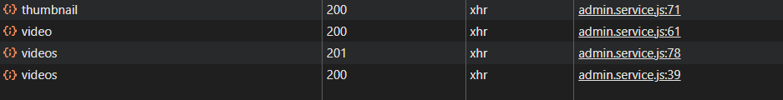
Playback and Chat UI evidence are not included in this submission because they were not conclusively verified during the final test pass. The corresponding services are deployed and running in Kubernetes.

10. Final Kubernetes State
Final observed state:
Workload | Ready | Replicas
admin | 2/2 | 2
auth | 2/2 | 2
chat | 2/2 | 2
frontend | 2/2 | 2
mongo | 1/1 | 1
streaming | 4/4 | 4
Ingress: streamingapp-ingress • Class: nginx • Host: localhost • Address: 172.18.0.5 • Port: 80

11. Production Improvements
- Use dedicated Kubernetes namespaces for application isolation.
- Enable TLS and expose the application over HTTPS.
- Use an HPA for CPU/memory-driven horizontal scaling.
- Move MongoDB to a managed/high-availability database for production.
- Use Kubernetes Secrets backed by an external secret manager rather than local demo credentials.
- Define CPU/memory requests and limits for predictable scheduling.
- Add centralized logs, metrics, alerts, and distributed tracing.
- Use CI/CD to promote immutable image tags through staging and production environments.
- Add multiple application replicas and availability-aware scheduling where required.

12. Deliverables & Links
GitHub repository:
https://github.com/chinmayvyas7/StreamingApp
Docker Hub:
https://hub.docker.com/r/chinmayvyas7/streaming-auth
https://hub.docker.com/r/chinmayvyas7/streaming-stream
https://hub.docker.com/r/chinmayvyas7/streaming-admin
https://hub.docker.com/r/chinmayvyas7/streaming-chat
https://hub.docker.com/r/chinmayvyas7/streaming-frontend

13. Screenshot Index
ID | Evidence | Status
GIT-03 | Git commit and repository remote | Included
GIT-04 | Final repository clean and Helm chart tracked | Included
GIT-05 | Final Git working tree clean | Included
DOCKER-01 | Five Dockerfiles confirmed | Included
DOCKER-07 | Final Docker images and versioned tags | Included
DH-02 | All five Docker Hub repositories pushed | Included
HELM-03 | Helm lint passed | Included
HELM-04 | Rendered Helm manifests | Included
K8S-01 | Initial Kubernetes deployment | Included
K8S-FINAL | Final pods, services and Ingress | Included
S3-01 | AWS S3 configuration in running pods | Included
ING-01 | NGINX Ingress controller | Included
ING-02 | Application through Ingress | Included
SCALE-01 | Streaming scaled to four replicas | Included
UPDATE-01 | Helm upgrade | Included
UPDATE-02 | Frontend rolling update | Included
K8S-03 | Final deployment after Jenkins pipeline | Included
JENKINS-02 | Jenkins build #2 SUCCESS | Included
JENKINS-03 | Personal Jenkins pipeline | Included
TEST-01 | Admin Studio access | Included
TEST-02 | Successful video upload | Included

END OF SUBMISSION

