ASSIGNMENT SUBMISSION
Flask Student Registration System
Dockerized AWS Deployment with GitHub Actions CI/CD

Submitted By | Chinmay Vyas
Assignment | Flask CI/CD Deployment
Repository | https://github.com/chinmayvyas7/flask_Practice
Cloud Platform | Amazon Web Services (AWS)
CI/CD Platform | GitHub Actions
AWS Region | ap-south-1

Final Implementation and Replication Guide
This document contains the implementation steps, configuration details, deployment procedure,
validation evidence and supporting implementation evidence required for final submission.

1. Executive Summary
This project implements a Student Registration System using Flask and MongoDB and extends it with a complete containerized CI/CD deployment pipeline. The Flask application is packaged as a Docker image, stored in Amazon Elastic Container Registry (ECR), and automatically deployed to an Ubuntu Amazon EC2 instance through GitHub Actions.
The pipeline was designed with a test gate. Automated Pytest tests must pass before the Docker image is built and pushed. After deployment, the workflow performs a health check against the Flask /health endpoint. The health endpoint also verifies MongoDB connectivity. Email notifications are generated for both successful and failed pipeline executions.
An intentional test failure was also performed to demonstrate that the pipeline correctly prevents Docker build and EC2 deployment when the test stage fails. The test was subsequently restored and the final pipeline was executed successfully.

2. Objectives Achieved
- Containerize the Flask application using Docker.
- Create a reproducible Python testing process using Pytest.
- Create an Amazon ECR repository for Docker images.
- Configure an Ubuntu EC2 deployment target.
- Use Git commit SHA values as Docker image tags.
- Automate testing, Docker build, ECR push and EC2 deployment.
- Replace the existing EC2 container automatically during deployment.
- Verify deployment through a MongoDB-aware /health endpoint.
- Send success and failure email notifications.
- Demonstrate failure gating by intentionally failing a test.
- Restore the application and finish with a successful pipeline.
- Document the complete setup for future replication.

3. Final Architecture
Developer
|
| git push origin main
v
GitHub Repository
|
v
GitHub Actions
|
+----------------------+
| |
v v
Pytest Docker Build
| |
| PASS | Git SHA Tag
+----------+-----------+
|
v
Amazon ECR
|
v
SSH to EC2
|
v
docker pull
|
v
Stop/remove old container
|
v
Start new container
|
v
/health check
|
+------+------+
| |
PASS FAIL
| |
v v
Success Email Failure Email
Flask Container
|
v
MongoDB

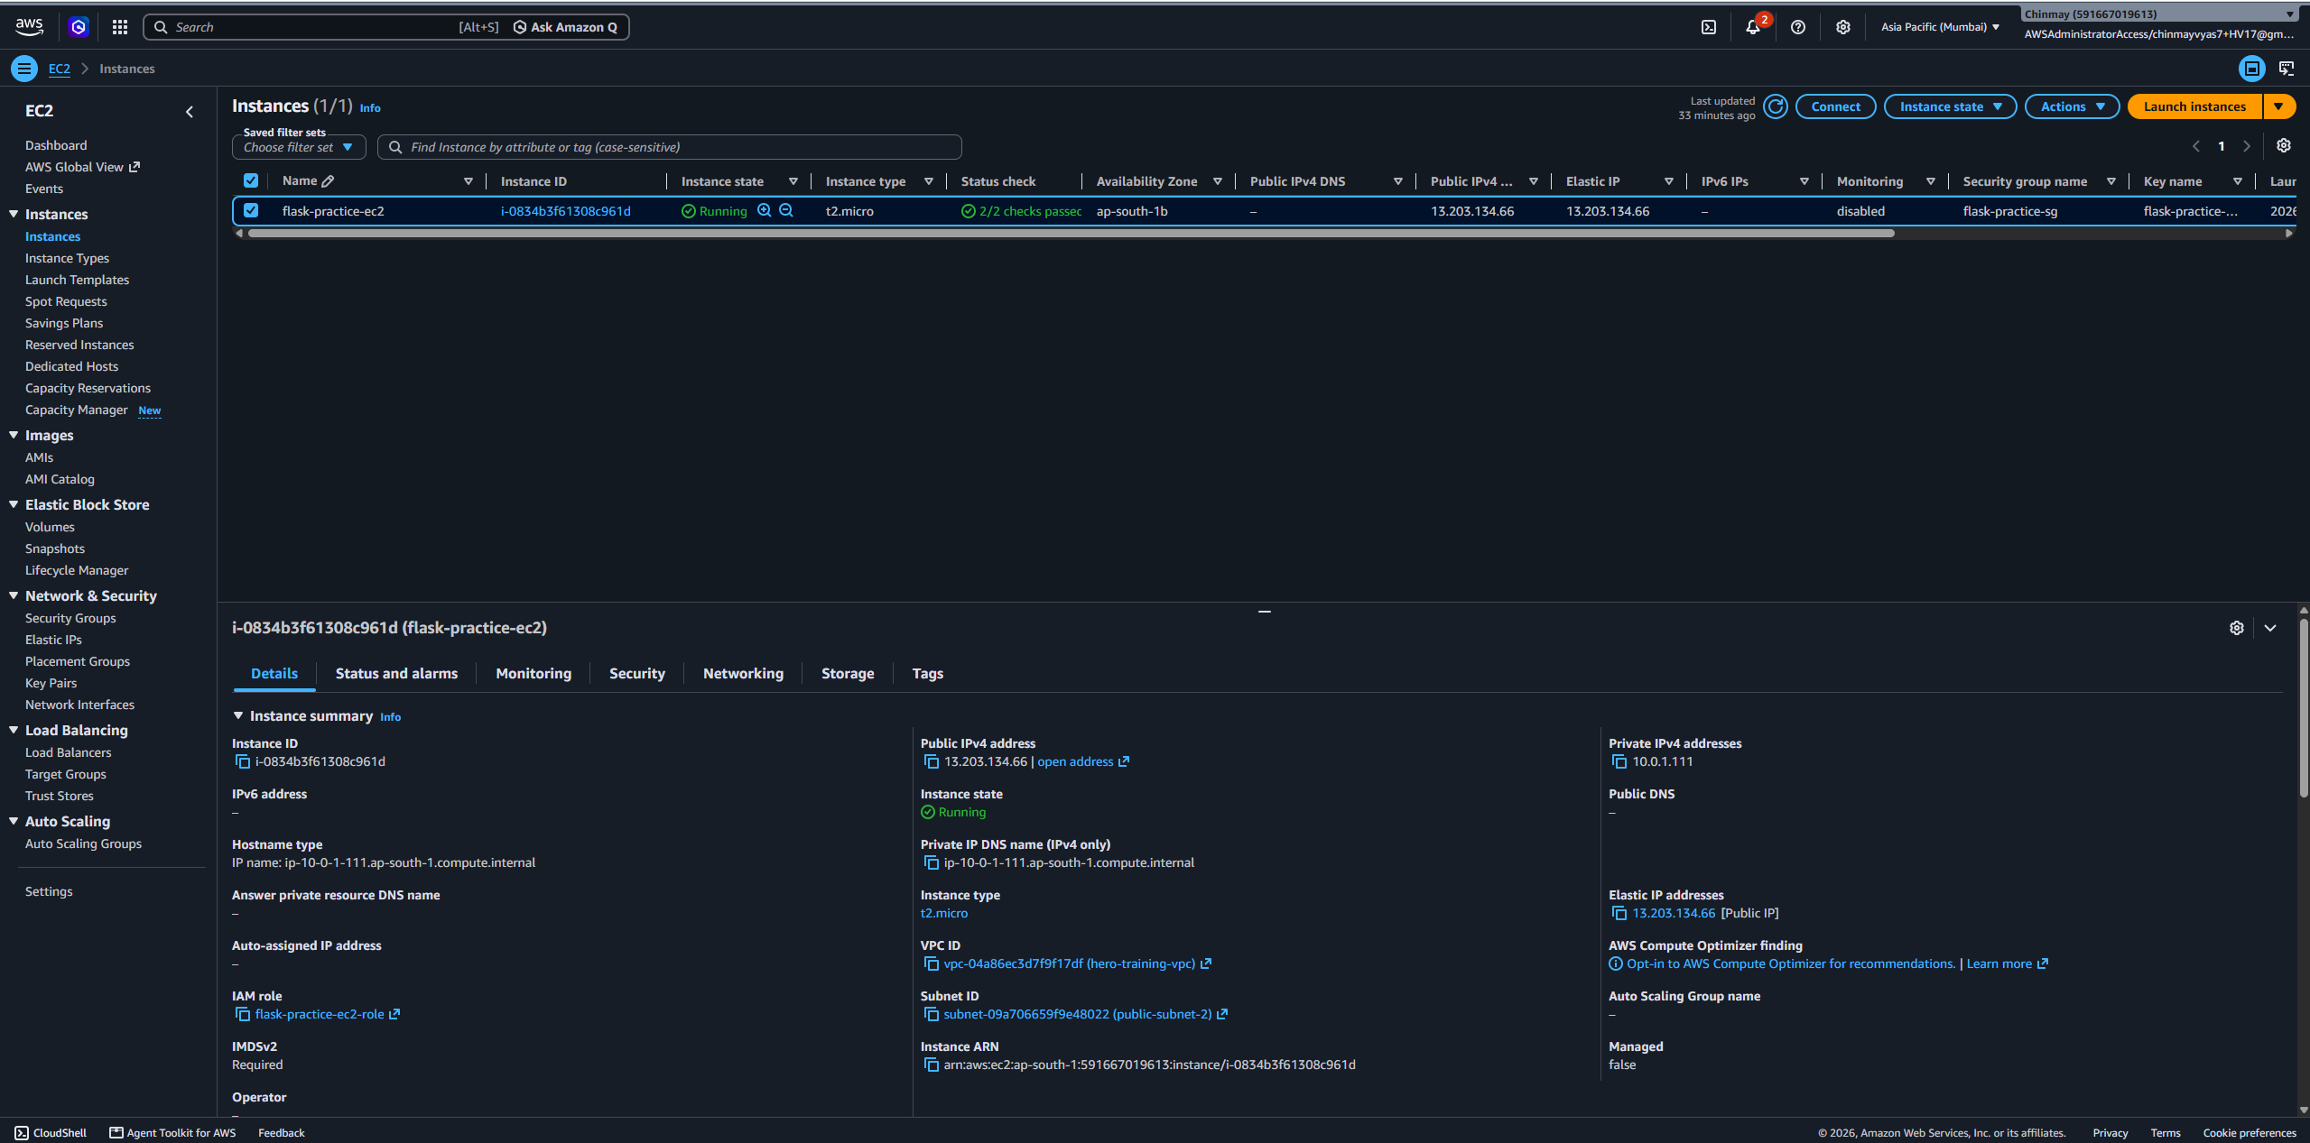
The deployment path is intentionally sequential: source changes first pass automated tests, then a uniquely tagged Docker image is published to Amazon ECR. The EC2 deployment pulls that exact image, replaces the running container and verifies the application through /health. A successful deployment triggers a success notification; a failed test or deployment produces a failure notification.
AWS EC2 console showing the final Ubuntu instance, instance state and public IPv4 address.

4. Prerequisites
- Git and access to the GitHub repository.
- Python 3.12.
- Docker for local testing.
- AWS account with access to EC2, ECR and IAM.
- Ubuntu EC2 instance.
- Public IPv4 address for the EC2 instance.
- EC2 IAM role with appropriate AWS/ECR permissions.
- MongoDB or MongoDB Atlas database and connection string.
- Gmail account with 2-Step Verification and an App Password for SMTP.

5. Repository Setup
The original assignment repository was converted into a repository owned by the submitter so that GitHub Actions could be configured and the final CI/CD workflow could run.
git remote -v
git status
Final repository:
https://github.com/chinmayvyas7/flask_Practice
[
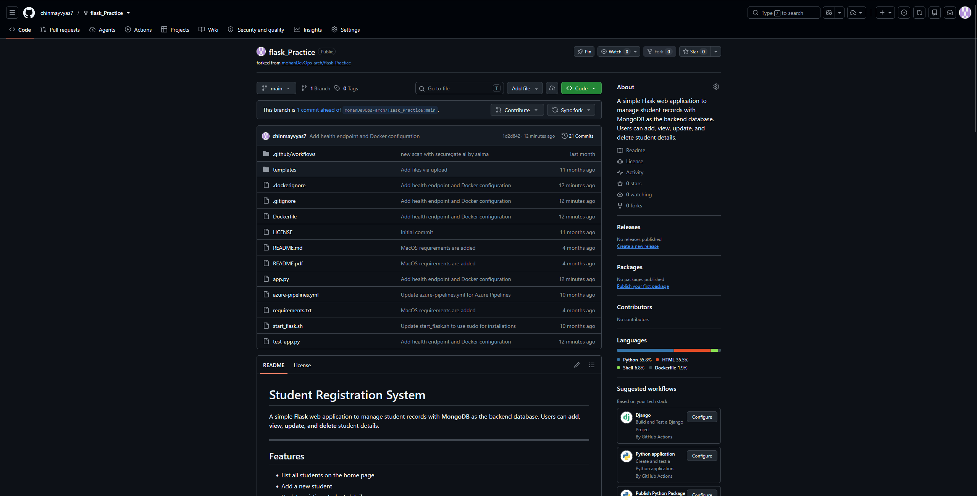
GitHub repository homepage showing the repository name, owner and project files.

6. Flask Application and MongoDB Configuration
The Flask application uses Flask-PyMongo to connect to MongoDB. Environment variables are loaded using python-dotenv.
MONGO_URI=<your-mongodb-connection-string>
SECRET_KEY=<your-secret-key>
The local .env file contains development secrets and is excluded from source control. The production/container environment receives these values from GitHub Secrets during deployment.
git check-ignore -v .env

7. Flask Health Endpoint
A /health endpoint was added/used as the deployment verification endpoint. It returns the application status and MongoDB connection status. This prevents a container that is running but unable to reach MongoDB from being treated as a successful deployment.
curl http://localhost:5000/health
Expected response:
{"status": "healthy", "database": "connected"}

8. Automated Testing
The test_app.py file contains tests for the major application operations and the health endpoint.
- Home page loads successfully.
- A student can be added.
- A student can be updated.
- A student can be deleted.
- The health endpoint returns a healthy status and connected database status.
pytest -v

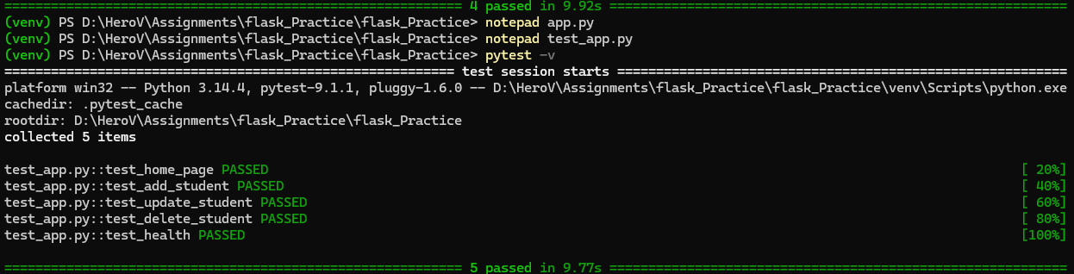
Local pytest execution showing all tests passing and no collection errors.

9. Dockerization
The application was containerized using the following Dockerfile structure:
FROM python:3.12-slim
WORKDIR /app
COPY requirements.txt .
RUN pip install --no-cache-dir -r requirements.txt
COPY . .
EXPOSE 5000
CMD ["python", "app.py"]
The Docker image was also tested locally.
docker build -t flask-practice .
docker run -d --name flask-practice -p 5000:5000 -e MONGO_URI="<your-mongodb-uri>" -e SECRET_KEY="<your-secret-key>" flask-practice
docker ps
curl http://localhost:5000/health
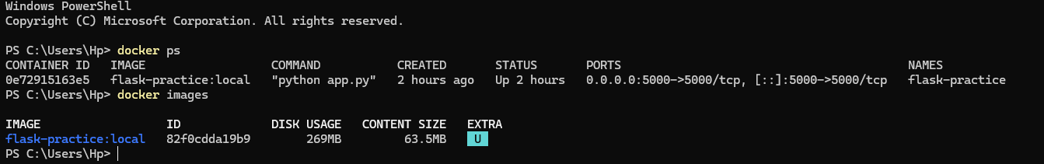
Docker build/run evidence showing the flask-practice container running and mapped to port 5000.

10. .dockerignore and Secret Protection
The .dockerignore file prevents development files, Git metadata, Python cache files and environment files from being copied into the Docker build context.
venv/
__pycache__/
*.pyc
.pytest_cache/
.git/
.gitignore
.env
.env.*
.vscode/
.idea/
This provides an additional layer of protection against accidentally packaging local secrets into the Docker image.

11. AWS IAM and EC2 Verification
The EC2 instance was configured with an IAM role. AWS access was verified directly from the EC2 machine.
aws --version
aws sts get-caller-identity
docker --version
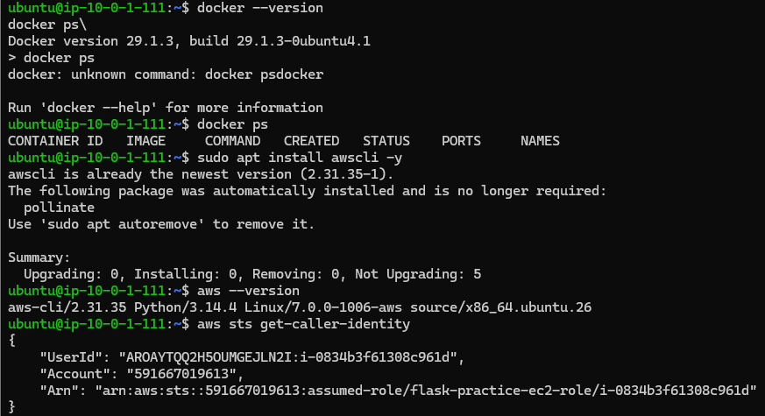
EC2 terminal showing AWS CLI and Docker versions.

12. Amazon ECR Setup
An Amazon ECR repository named flask-practice was used to store Docker images generated by the CI/CD pipeline.
591667019613.dkr.ecr.ap-south-1.amazonaws.com/flask-practice:<commit-sha>
The image tag is the GitHub commit SHA. This means every deployed image can be traced to a specific source-code commit.
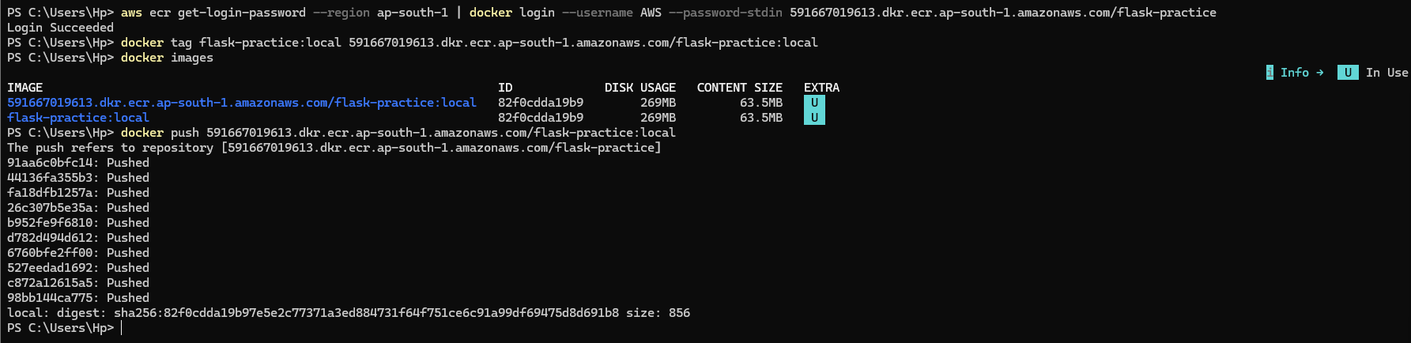
Amazon ECR console showing the flask-practice repository and a SHA-tagged Docker image.
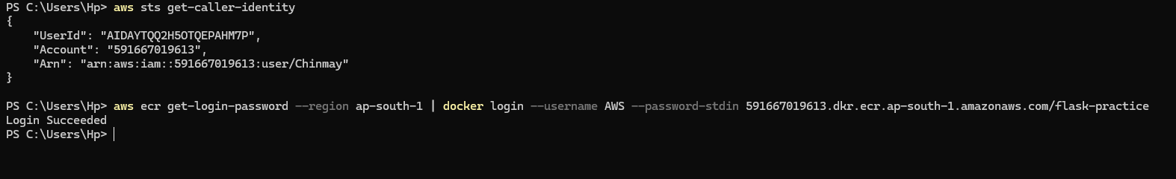
Evidence: successful authentication to Amazon ECR.

13. EC2 Security Group
The EC2 security group was configured to permit SSH administration and application access.
Inbound:
TCP 22 SSH
TCP 5000 Flask application
Port 22 is required for the GitHub Actions SSH deployment. Port 5000 is required for accessing the Flask application.
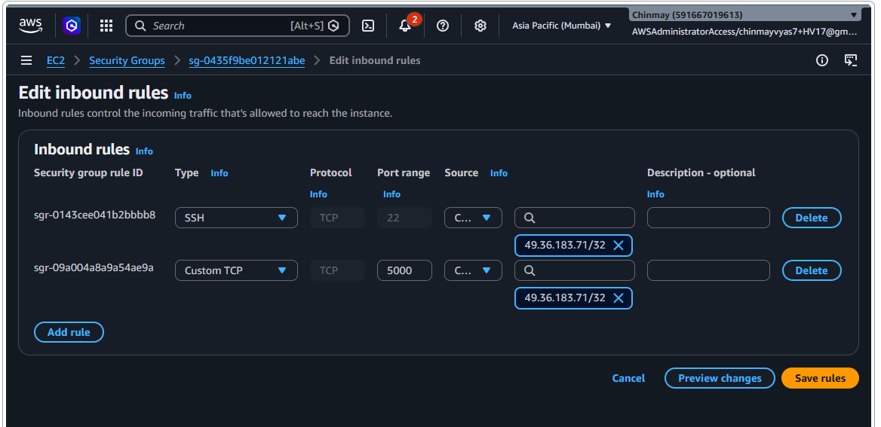
Evidence: EC2 Security Group inbound rules permitting SSH (TCP 22) and the Flask application (TCP 5000).

14. GitHub Repository Secrets
GitHub Repository Secrets were configured under Settings → Secrets and variables → Actions. The actual values were never committed to the repository.
- AWS_ACCESS_KEY_ID — AWS access key used by GitHub Actions.
- AWS_SECRET_ACCESS_KEY — corresponding AWS secret access key.
- AWS_REGION — ap-south-1.
- ECR_REPOSITORY — flask-practice.
- EC2_HOST — EC2 public host/IP.
- EC2_USER — Ubuntu EC2 username.
- EC2_SSH_KEY — private SSH key used by the deployment action.
- MONGO_URI — MongoDB connection string.
- SECRET_KEY — Flask secret key.
- SMTP_HOST — Gmail SMTP server.
- SMTP_PORT — SMTP port.
- SMTP_USERNAME — sender email address.
- SMTP_PASSWORD — Gmail App Password.
- MAIL_TO — notification recipient.
- MAIL_FROM — notification sender.
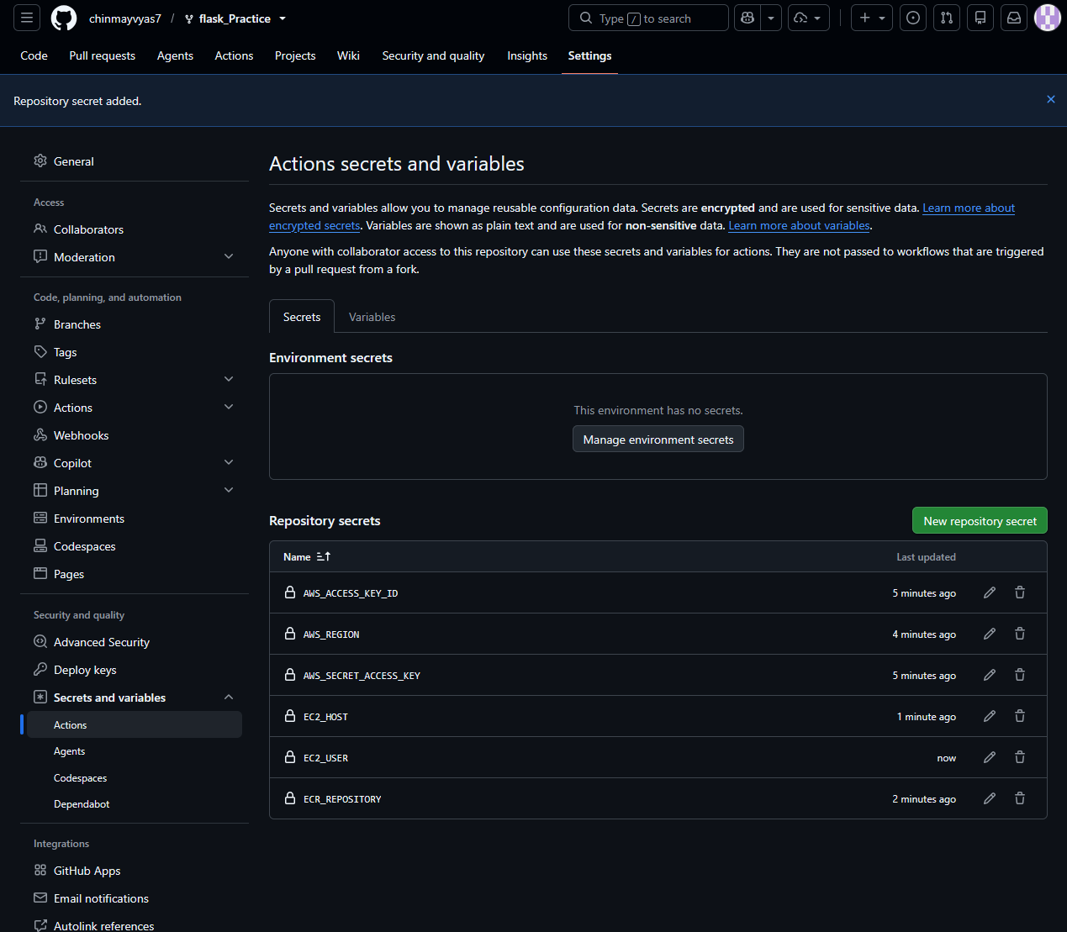
GitHub Secrets page showing secret names only. Values must be completely hidden.

15. Gmail SMTP Configuration
The email notification stage uses Gmail SMTP. A Google App Password was generated and stored as SMTP_PASSWORD. The normal Gmail account password was not used.
SMTP_HOST=smtp.gmail.com
SMTP_PORT=465
SMTP_USERNAME=<gmail-address>
SMTP_PASSWORD=<gmail-app-password>
MAIL_TO=<recipient>
MAIL_FROM=<sender>

16. GitHub Actions Workflow
The primary workflow is .github/workflows/ci-cd.yml. It runs whenever a commit is pushed to the main branch.
on:
push:
branches:
- main
The workflow contains four logical stages:
1. Test
2. Build and Push to ECR
3. Deploy to EC2
4. Email Notification
Two older SecureGate workflow files were present in the assignment repository. They were not part of the Flask deployment pipeline. One of the encountered issues was that the SecureGate workflow expected SECUREGATE_URL. The Flask CI/CD workflow was kept as the deployment workflow.
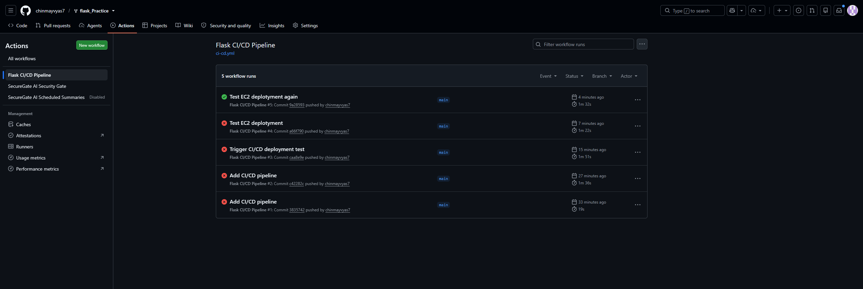
GitHub Actions page showing the Flask CI/CD workflow enabled and available.

17. Stage 1 — Test
The Test job checks out the repository, installs Python 3.12, installs requirements and runs pytest.
python -m pip install --upgrade pip
pip install -r requirements.txt
pip install pytest
pytest -v
The build job depends on the test job. Therefore, a failed test blocks Docker build, ECR push and deployment.

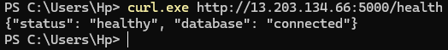
GitHub Actions Test job showing successful pytest execution.

18. Stage 2 — Build and Push to ECR
Once the tests pass, GitHub Actions configures AWS credentials and authenticates with Amazon ECR.
IMAGE_TAG="${GITHUB_SHA}"
IMAGE_URI="${REGISTRY}/${ECR_REPOSITORY}:${IMAGE_TAG}"
docker build -t "${IMAGE_URI}" .
docker push "${IMAGE_URI}"
The use of GITHUB_SHA ensures that the Docker image is uniquely tied to the commit that triggered the workflow.

19. Stage 3 — Deployment to EC2
The deployment stage uses an SSH action to connect to the Ubuntu EC2 instance. The EC2 instance logs into ECR, pulls the new image, stops/removes the previous container and starts the new container.
aws ecr get-login-password --region "$AWS_REGION" | sudo docker login --username AWS --password-stdin "$ECR_REGISTRY"
sudo docker pull "$IMAGE_URI"
sudo docker stop flask-practice || true
sudo docker rm flask-practice || true
sudo docker run -d --name flask-practice -p 5000:5000 --restart unless-stopped -e MONGO_URI="$MONGO_URI" -e SECRET_KEY="$SECRET_KEY" "$IMAGE_URI"

20. Deployment Health Check
After the container starts, the deployment script repeatedly checks the health endpoint. The workflow only exits successfully if the endpoint responds.
curl -fsS http://localhost:5000/health
The expected response is a healthy Flask application with a connected MongoDB database.

21. EC2 Container Verification
The final deployment was independently verified on the EC2 instance.
docker ps
curl http://localhost:5000/health
The deployed container used a SHA-tagged image from the flask-practice ECR repository and exposed port 5000.
Evidence: EC2 /health check showing a healthy application and connected MongoDB database.

22. External Health Check
The application was also verified externally using the EC2 public address.
curl.exe http://<EC2_PUBLIC_IP>:5000/health
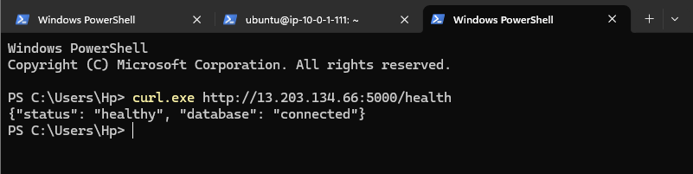
Windows PowerShell or browser showing the externally accessible /health response.

23. Successful Pipeline Result
The completed pipeline successfully executed all four stages.
Test PASS
Build and Push ECR PASS
Deploy to EC2 PASS
Email Notification PASS
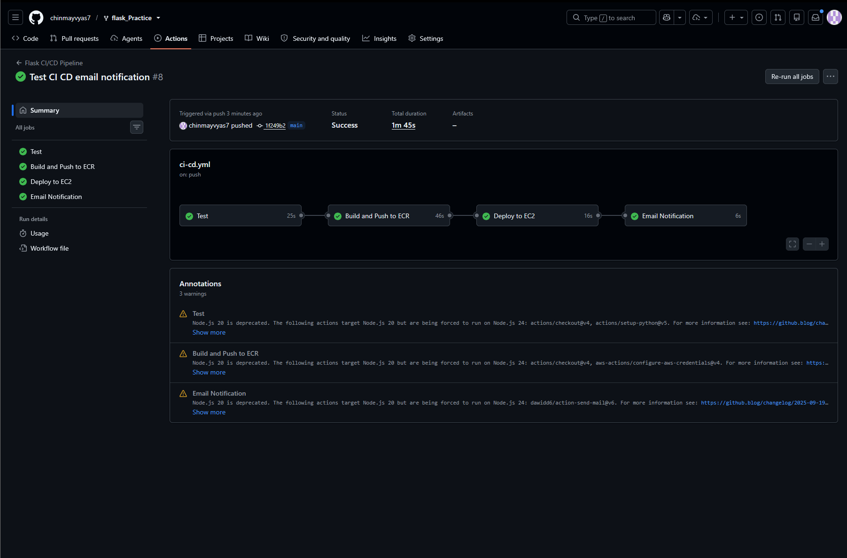
Full GitHub Actions run with all four stages/jobs green.

24. Success Email Notification
The success notification includes the deployment result, commit SHA, branch, Docker image tag, ECR repository, EC2 target, health endpoint and GitHub Actions run.
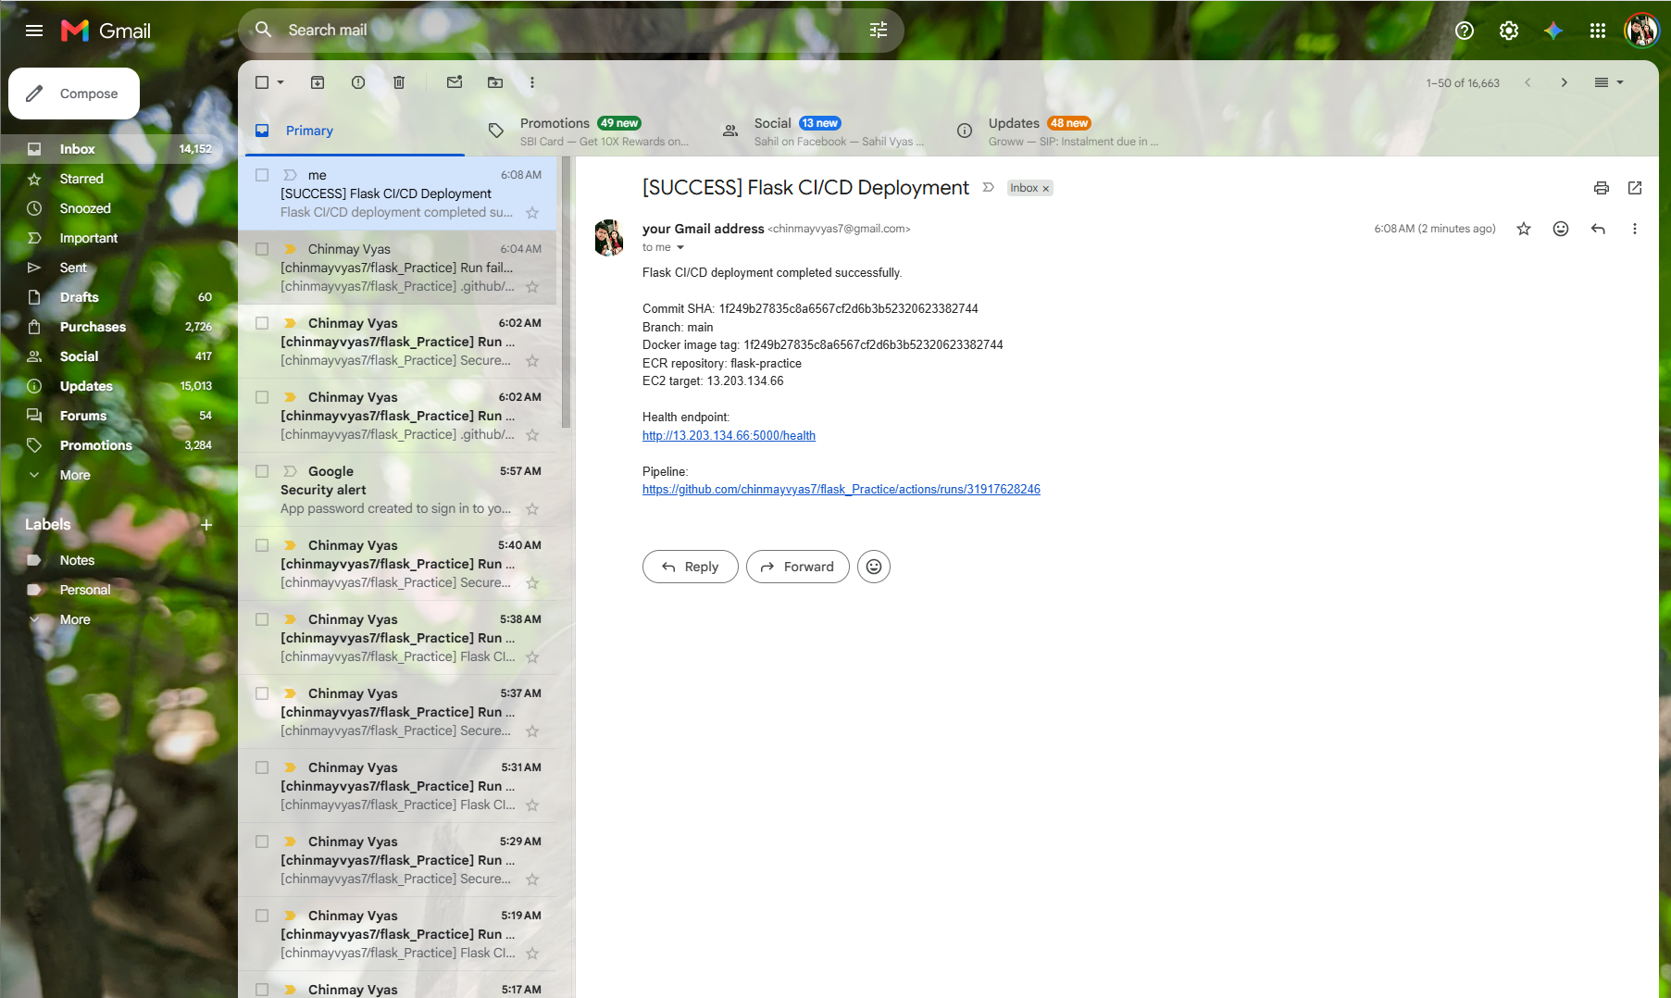
Success email with subject [SUCCESS] Flask CI/CD Deployment. Ensure no passwords, tokens or private keys are visible.

25. Intentional Failure Demonstration
To prove that the pipeline is test-gated, one test was intentionally changed so that it would fail. The change was committed and pushed to main.
git add test_app.py
git commit -m "Demonstrate CI test failure"
git push origin main
Expected result:
Test FAILED
Build and Push ECR SKIPPED
Deploy to EC2 SKIPPED
Email Notification FAILURE
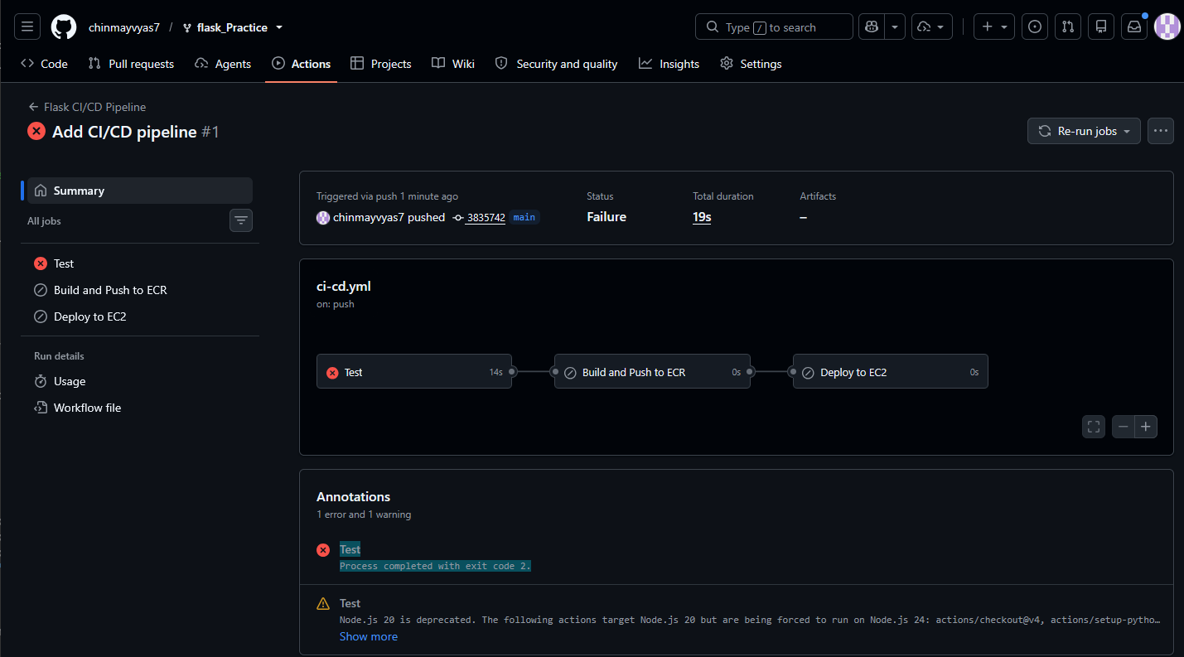
Failed GitHub Actions run clearly showing the Test stage failed and the Build/Push and Deploy stages did not execute.

26. Failure Email
The failure notification identifies the failed stage and provides the pipeline run information.
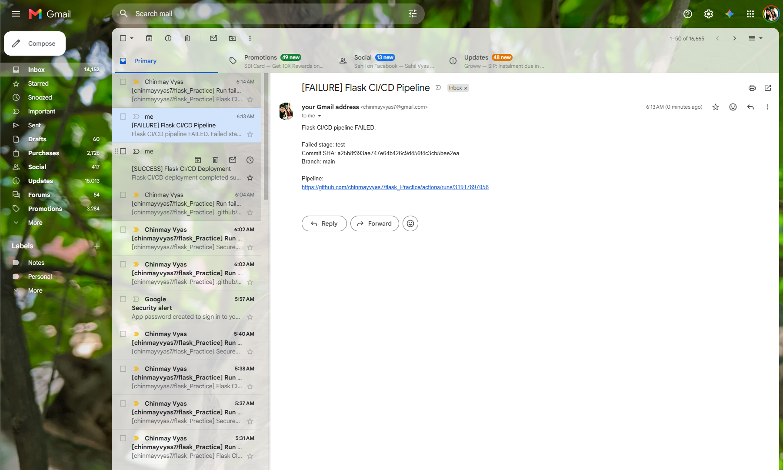
Failure email showing [FAILURE] Flask CI/CD Pipeline and failed stage = test.

27. Restore Passing Tests
After capturing the failure evidence, the intentionally failing assertion was restored. A new commit was pushed and the final pipeline was allowed to complete successfully.
git add test_app.py
git commit -m "Restore passing tests"
git push origin main
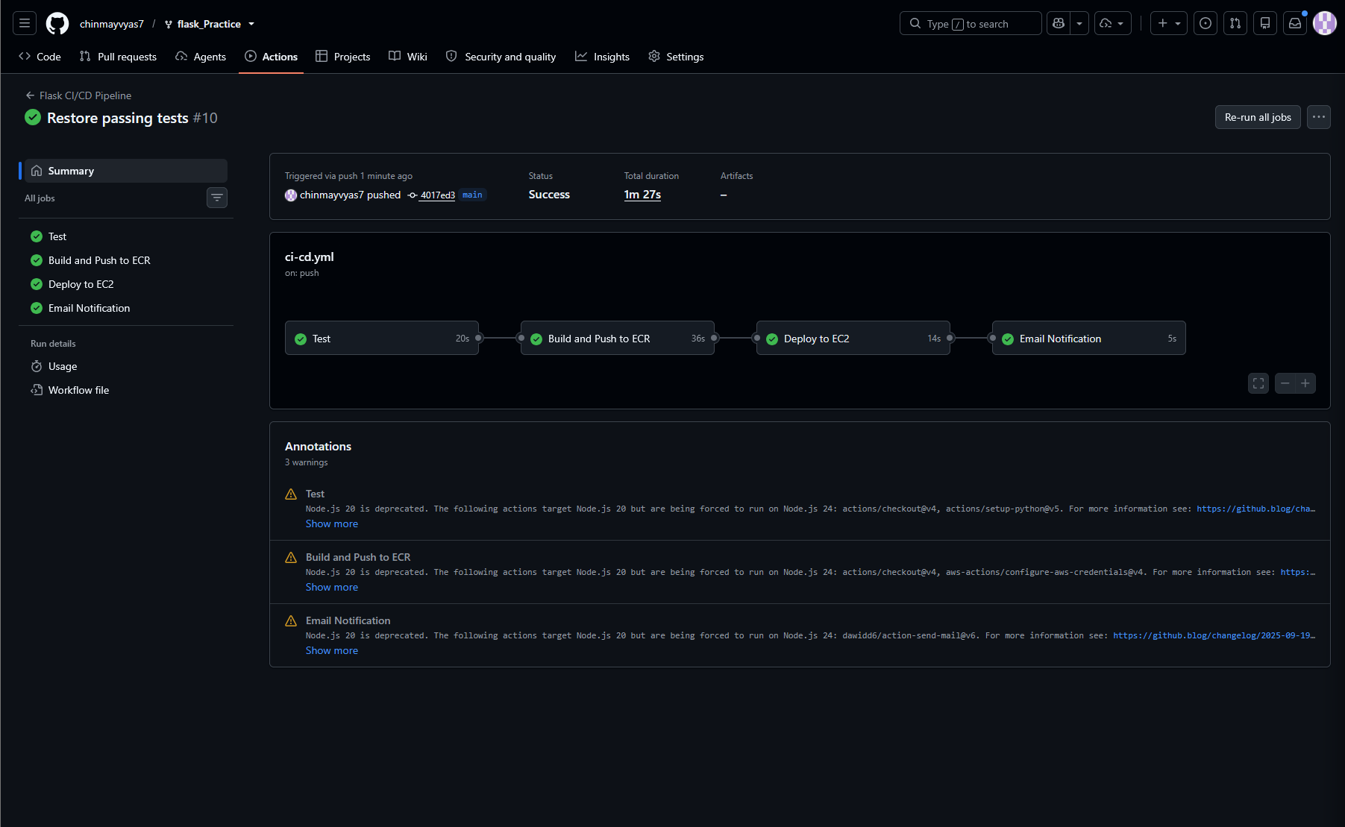
Evidence: final restored pipeline execution with all stages successful.

28. README Documentation
The project README was updated to document the application, setup, AWS infrastructure, Docker configuration, GitHub Actions workflow, secrets, health checks, email notifications, failure behavior, manual deployment and troubleshooting.
git add README.md
git commit -m "Complete project documentation"
git push origin main
GitHub repository showing the final README and the latest documentation commit.


29. Manual Deployment Fallback
If GitHub Actions is unavailable, the same image can be deployed manually from EC2.
aws ecr get-login-password --region ap-south-1 | docker login --username AWS --password-stdin <account-id>.dkr.ecr.ap-south-1.amazonaws.com
docker pull <account-id>.dkr.ecr.ap-south-1.amazonaws.com/flask-practice:<commit-sha>
docker stop flask-practice || true
docker rm flask-practice || true
docker run -d --name flask-practice -p 5000:5000 --restart unless-stopped -e MONGO_URI="<your-mongodb-uri>" -e SECRET_KEY="<your-secret-key>" <account-id>.dkr.ecr.ap-south-1.amazonaws.com/flask-practice:<commit-sha>
curl http://localhost:5000/health

30. Final Verification Checklist
☐ GitHub repository is owned by the submitter and contains the final code.
☐ .env is ignored and no secrets are committed.
☐ Flask application runs successfully.
☐ Pytest suite passes.
☐ Docker image builds successfully.
☐ Docker image uses Git commit SHA tagging.
☐ ECR repository contains the SHA-tagged image.
☐ EC2 instance is running Ubuntu and Docker.
☐ EC2 IAM access is working.
☐ EC2 Security Group permits required ports.
☐ GitHub Actions can connect to EC2 through SSH.
☐ New image is pulled successfully on EC2.
☐ Old container is stopped and removed.
☐ New container starts on port 5000.
☐ MongoDB connection is successful.
☐ /health returns healthy and database connected.
☐ External health endpoint works.
☐ Success email was received.
☐ Intentional failure was demonstrated.
☐ Build/deploy were skipped after the failed test.
☐ Failure email was received.
☐ Test was restored.
☐ Final pipeline is green.
☐ README is committed and pushed. 31. Security and Submission Notes
All supporting evidence included in this document is presented directly alongside the related implementation step. Optional setup screens that were not captured are intentionally omitted.

32. Final Outcome
Final implementation status and submission summary
The Student Registration System was successfully transformed from a locally runnable Flask application into a Dockerized AWS deployment with automated CI/CD. The final pipeline performs automated testing, Docker image creation, SHA-based versioning, ECR storage, SSH-based EC2 deployment, container replacement, MongoDB-aware health verification and email notification. Both successful and intentionally failed pipeline executions were demonstrated. The application was restored to a passing state and the final documentation was committed to the GitHub repository.

Submitted by: Chinmay Vyas
Final Deliverable | Status
Application | Flask Student Registration System with MongoDB
Containerization | Docker image built and executed successfully
Registry | SHA-tagged image published to Amazon ECR
Deployment | Container deployed automatically to Ubuntu EC2
Validation | /health returned healthy with MongoDB connected
CI/CD | Test → Build → Push → Deploy pipeline completed successfully
Failure handling | Intentional test failure demonstrated pipeline gating
Notifications | Success and failure email flows configured
Documentation | README and final assignment documentation completed

