ASSIGNMENT REPORT

Deploying a MERN Application through Terraform and Ansible
  - TravelMemory Application Deployment
AWS Mumbai Region | 26–27 October 2026
Made by: Chinmay Vyas
GitHub Repository: https://github.com/chinmayvyas7/mern-terraform-ansible-deployment.git
I deployed the TravelMemory application on an AWS web server and kept MongoDB on a separate private server. I used Terraform to create the AWS infrastructure and Ansible to configure the servers. I then checked the application using its health endpoint and tested the trip creation form.
The screenshots in this report show the main steps I followed and the results I checked in the terminal, AWS Console and browser.
Recorded result | Evidence outcome
Terraform apply | 17 added, 0 changed, 0 destroyed
EC2 instances | 2 Running; both passed 3/3 status checks
Latest database and web plays | 0 failed and 0 unreachable hosts
Application health | HTTP 200; status ok; database connected
Functional test | Goa trip saved and displayed on the homepage

Application endpoint
http://65.2.190.50
Public address used for the deployment tests.

Contents
Deployment overview 3
AWS access and preparation 4
Terraform initialization and validation 5
Terraform plan 6
Infrastructure provisioning 7
EC2 verification and network access 8
Ansible environment and preflight 9
Ansible connectivity and common configuration 10
MongoDB deployment and verification 11
Web application and Nginx configuration 12
Health endpoint verification 13
Functional application testing 14
Trip creation confirmation 15
Homepage display verification 16
Troubleshooting and secrets handling 17
Repository and documentation 18
Results and acceptance checklist 19
Appendix A Ubuntu and EC2 configuration 20
Appendix A Terraform output definitions 21
Appendix B Evidence index 22
Appendix C Duplicate and excluded screenshots 24

Screenshots and results
The report includes screenshots of the Terraform, Ansible, AWS and application tests. Sensitive values have been hidden where needed.
The results described below reflect what was visible when the screenshots were taken.

Deployment overview
TravelMemory uses React for the frontend, Node.js and Express for the backend, and MongoDB for storage. Nginx serves the application from a public EC2 instance, while MongoDB runs on a separate private EC2 instance. I used Terraform for infrastructure and Ansible for server configuration.
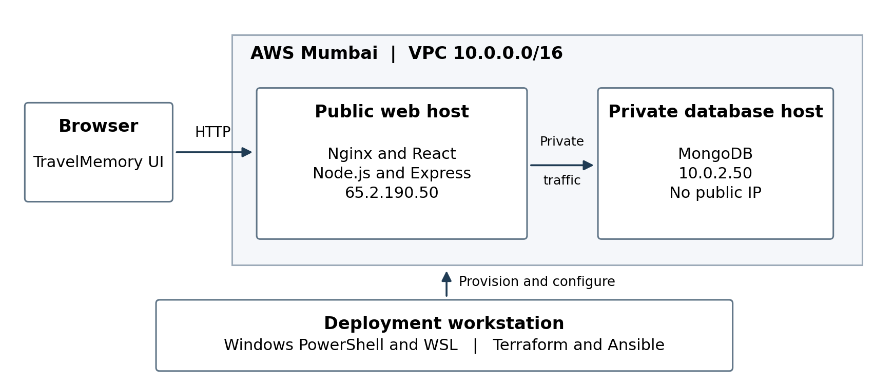
Diagram 1. Overview of the deployed architecture.
Component | Recorded configuration or role
AWS region | ap-south-1, Mumbai
Web host | Public IP 65.2.190.50; private IP 10.0.1.146
Database host | Private IP 10.0.2.50; no public IP
Compute | Two t3.micro instances in ap-south-1a, as captured in Figure 7
Network resources | VPC, public and private subnets, internet gateway, NAT gateway, route tables and security groups appear in the apply log

The web server is publicly reachable, while the database server has no public IPv4 address. This keeps the database separate from direct public access.

AWS access and preparation
I checked the AWS CLI identity and confirmed that the configured region was ap-south-1 (Mumbai). The screenshot also shows the policies attached to the account. Account identifiers have been hidden.
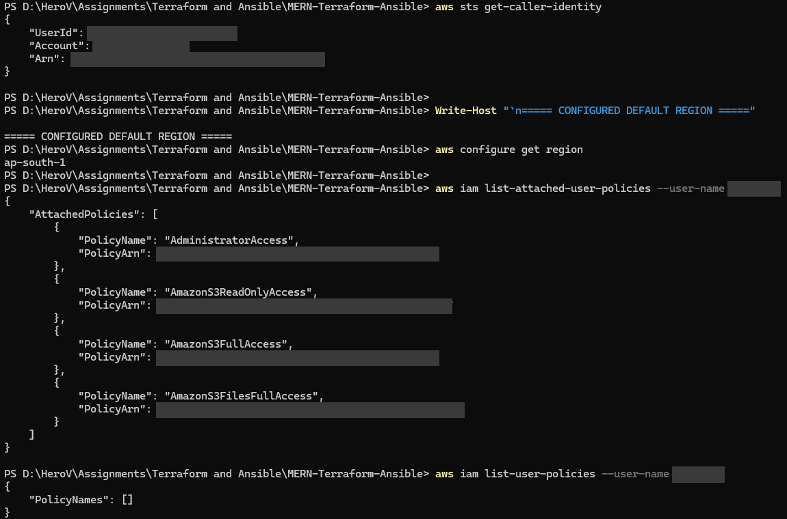
Figure 1. AWS CLI identity, Mumbai region and attached IAM policies. Identity values and policy ARNs are masked.
I created the SSH key file and restricted its Windows file permissions. The private key itself is not shown.
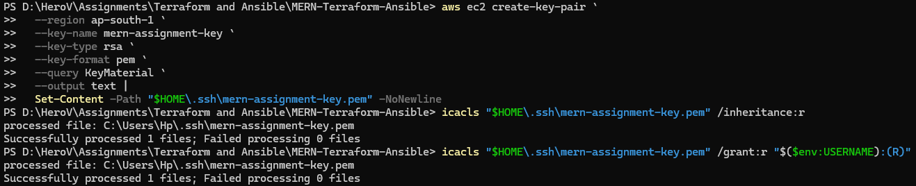
Figure 2. SSH key creation writes private material to a local file; the Windows ACL commands report success.

Terraform initialization and validation
Terraform v1.16.6 was installed on Windows. I initialized the working directory with the AWS provider and ran validation successfully before creating the plan.
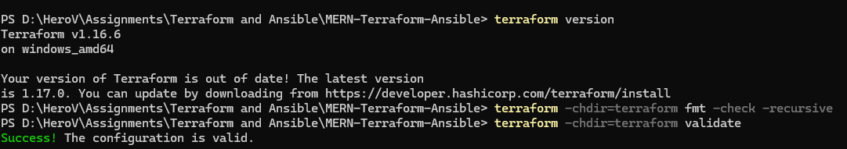
Figure 3. Terraform v1.16.6 and successful configuration validation. The unrelated identity output is cropped.
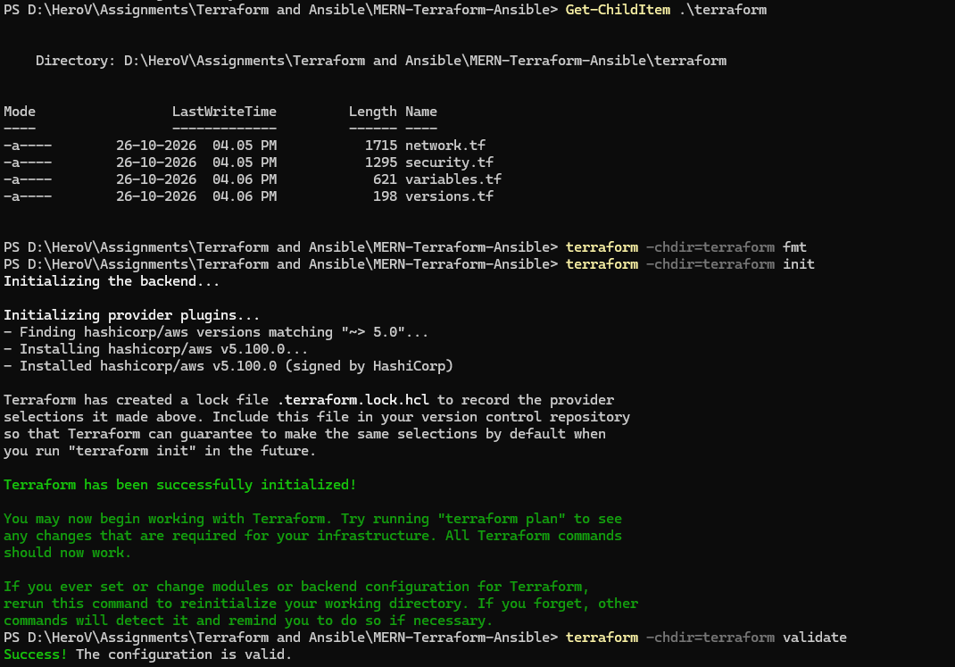
Figure 4. Terraform initializes the AWS provider and reports that the configuration is valid.
The following plan and apply results show the infrastructure changes made by Terraform.

Terraform plan
The Terraform plan showed 17 resources to add, with no changes or deletions. The VPC uses the 10.0.0.0/16 CIDR range and enables DNS support and hostnames.
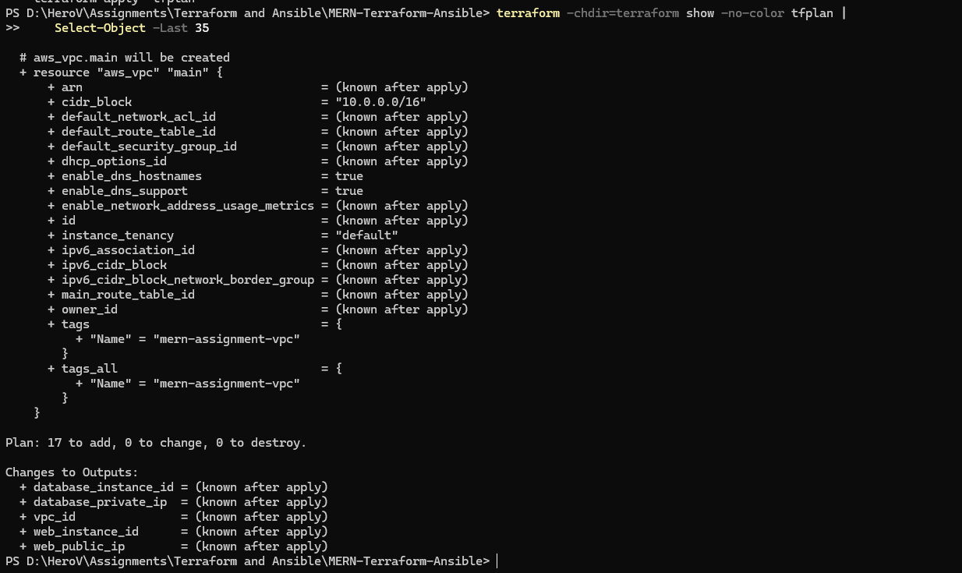
Figure 5. The saved Terraform plan proposes 17 additions, no changes and no destruction.
Plan item | Recorded value
Resource actions | 17 to add; 0 to change; 0 to destroy
VPC CIDR | 10.0.0.0/16
Expected outputs | Web public IP, database private IP, both instance IDs and VPC ID

After reviewing the plan, I applied it to create the AWS resources.

Infrastructure provisioning
Running `terraform apply tfplan` completed successfully: 17 resources were added, with no changes or deletions. Resource identifiers are hidden in the screenshot.
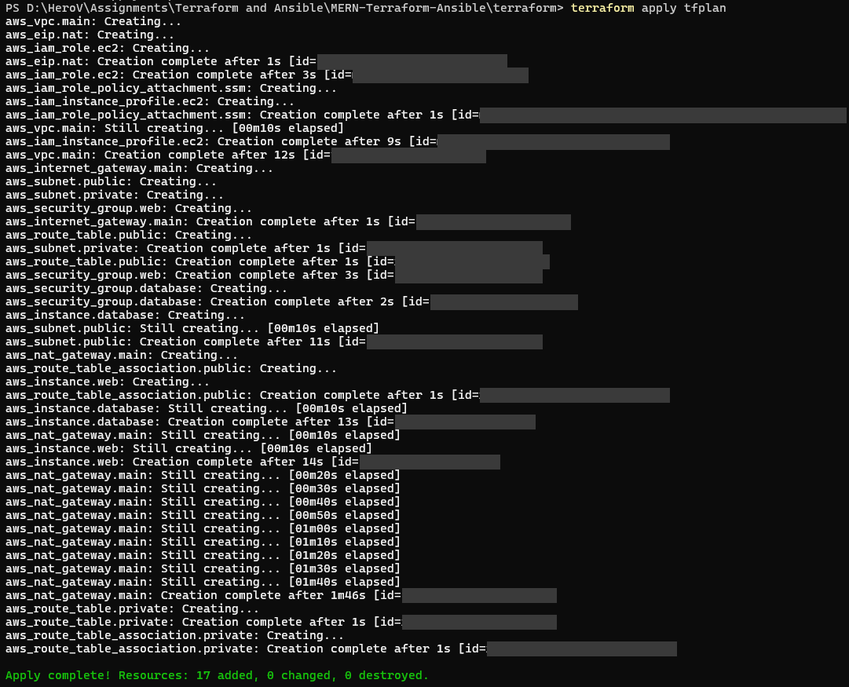
Figure 6. Terraform apply completes with 17 resources added, 0 changed and 0 destroyed. Resource IDs are masked.
The creation log includes both EC2 instances, the public and private subnets, their route tables and associations, the internet and NAT gateways, security groups, and the EC2 IAM resources. The completed apply is the primary infrastructure-provisioning result. Instance health is checked separately in the AWS Console.

EC2 verification and network access
In the AWS Console, both t3.micro instances were Running and had passed all 3 status checks. The web instance had the public IP used for testing; the database instance had no public IP.
Figure 7. Both EC2 instances are Running and have passed 3/3 checks. Only the web instance has a public IPv4 address.
Host | Instance state | Status checks | Public IPv4
mern-web-server | Running | 3/3 passed | 65.2.190.50
mern-database-server | Running | 3/3 passed | None shown

Web security group
The web security group allows inbound HTTP (80) and HTTPS (443). SSH (22) is limited to a single administrator IP address. The exact administrator address is hidden.
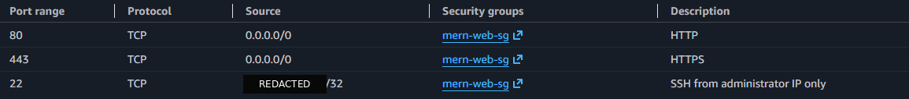
Figure 8. Web security-group inbound rules allow HTTP and HTTPS, with SSH limited to an administrator /32 address.
Port | Protocol | Source | Purpose
80 | TCP | 0.0.0.0/0 | HTTP
443 | TCP | 0.0.0.0/0 | HTTPS allowed by security group
22 | TCP | Administrator address /32 | SSH administration

The screenshot shows outbound traffic allowed for the web security group. The application tests in this report use HTTP; HTTPS was not separately tested.

Ansible environment and preflight
I ran Ansible through WSL on Windows. The environment reported Ansible Core 2.16.3, Python 3.12.3 and Jinja 3.1.2. For the project commands, I set the Ansible configuration path explicitly.
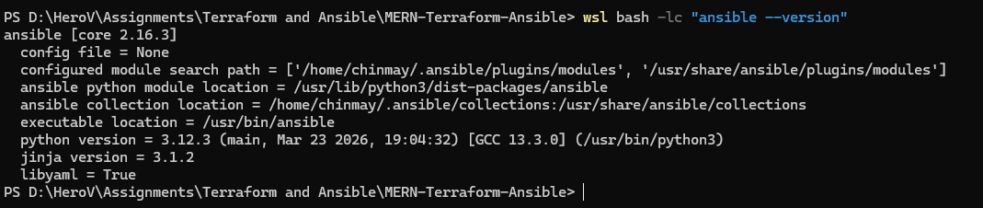
Figure 9. Ansible core 2.16.3 runs through WSL with Python 3.12.3. This version invocation reports config file = None.
I ran syntax checks on site.yml, common.yml, database.yml and web.yml. The output included inventory and unmatched-host warnings, so I checked host connectivity separately before running the playbooks.
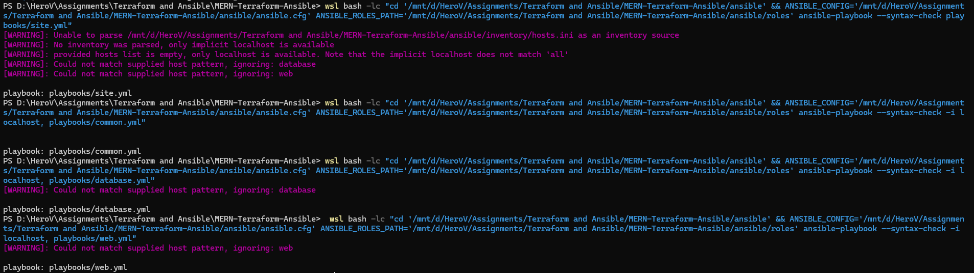
Figure 10. Ansible syntax checks list the site, common, database and web playbooks. Inventory warnings remain visible.
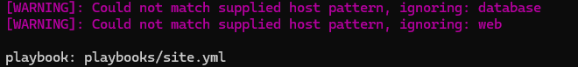
Figure 10 detail. Enlarged output showing the unmatched database and web host patterns.

Preflight notes
The initial inventory check had a problem, and the localhost inventory did not match the web and database groups. I resolved the workflow sufficiently to run the later connectivity and configuration checks successfully.
Check | What the capture establishes
Ansible runtime | The WSL installation and recorded runtime versions
Playbook syntax | Each named playbook is returned without a visible syntax error
Host access | Established later by web1 and db1 ping results, not by this syntax check

Ansible connectivity and common configuration
Using the project inventory, I connected to both web1 and db1. Ansible returned `ping: pong` for each host.
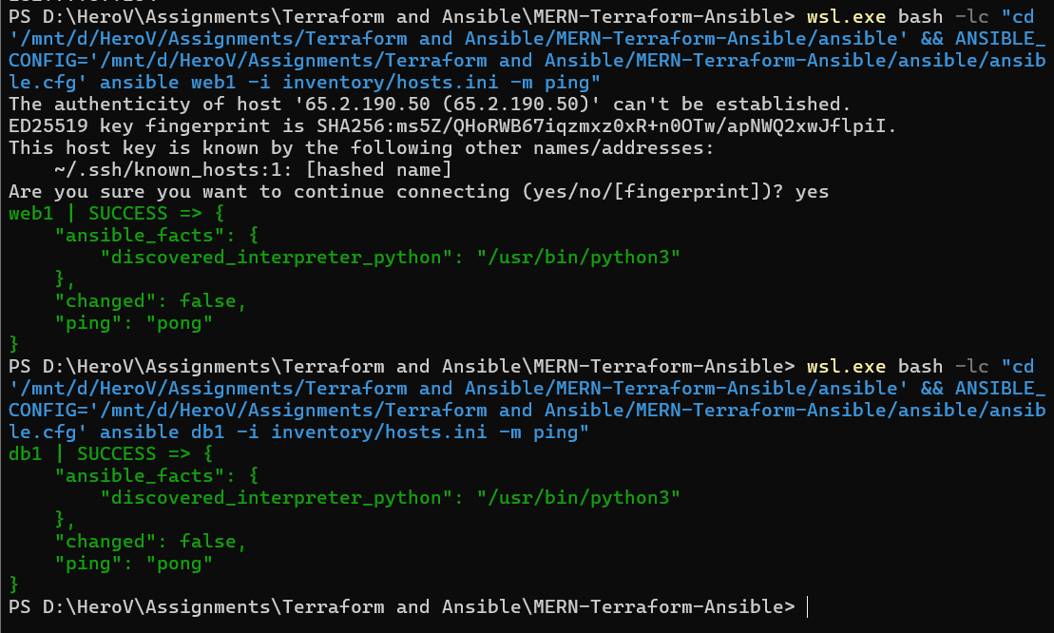
Figure 11. Ansible connects to web1 and db1 and returns ping: pong for both inventory hosts.
The common configuration run completed for both hosts. Each host reported 10 successful tasks, 2 changes, no failures and no unreachable hosts.
Figure 12. The two-host common configuration recap has zero failed and unreachable hosts; each host reports ok=10 and changed=2.
Host | ok | changed | unreachable | failed | skipped
db1 | 10 | 2 | 0 | 0 | 1
web1 | 10 | 2 | 0 | 0 | 1

MongoDB deployment and verification
The database playbook completed without failed or unreachable hosts. It installed MongoDB, configured its network binding and authorization, and created or verified the database users.
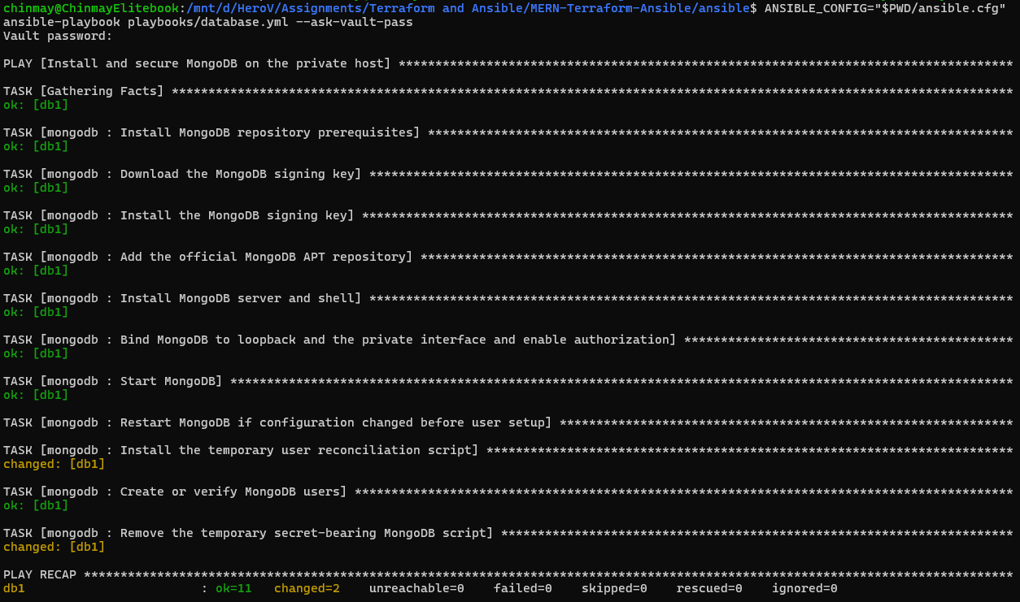
Figure 13. The database playbook completes with ok=11, changed=2, unreachable=0 and failed=0.
I checked that the MongoDB service was active and that an authenticated local database ping returned `ok: 1`. The application-to-database connection was checked separately using the health endpoint.
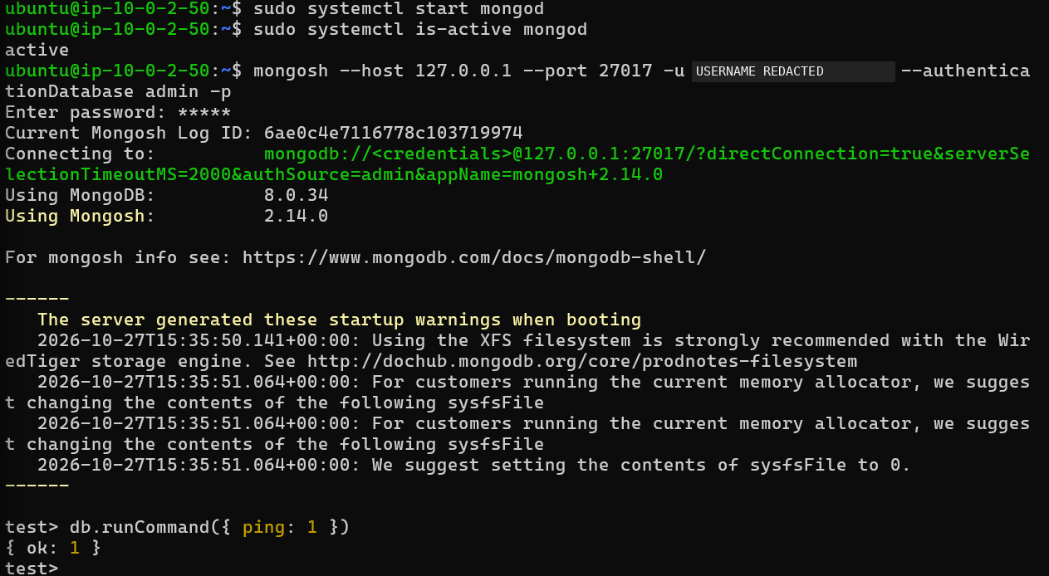
Figure 14. MongoDB is active and an authenticated local ping returns ok: 1. The administrator username is masked.

Web application and Nginx configuration
The web playbook completed successfully. It configured the backend environment and systemd service, enabled the Nginx site, validated the Nginx configuration and ensured the service was enabled. Dependency installation and the React build were skipped during this rerun.
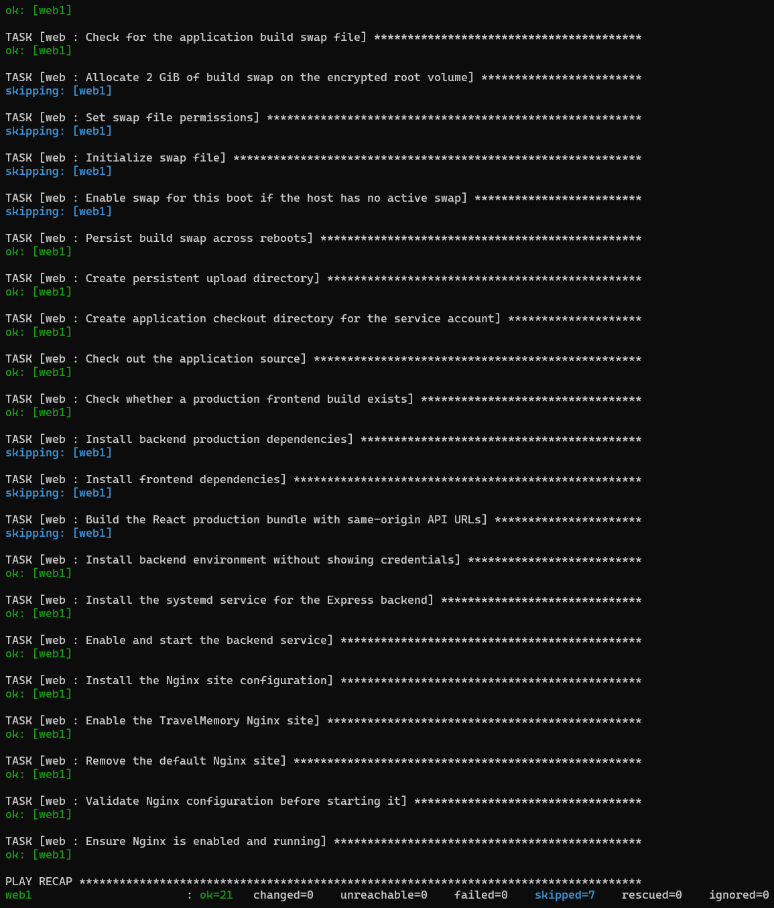
Figure 15. The web playbook rerun reports ok=21, changed=0, unreachable=0, failed=0 and skipped=7.
This was a rerun, so no changes were needed. The figure shows the Ansible task recap.

Health endpoint verification
I tested the public `/health` endpoint. It returned HTTP 200 and reported that the application was running and the database was connected.
curl -i http://65.2.190.50/health
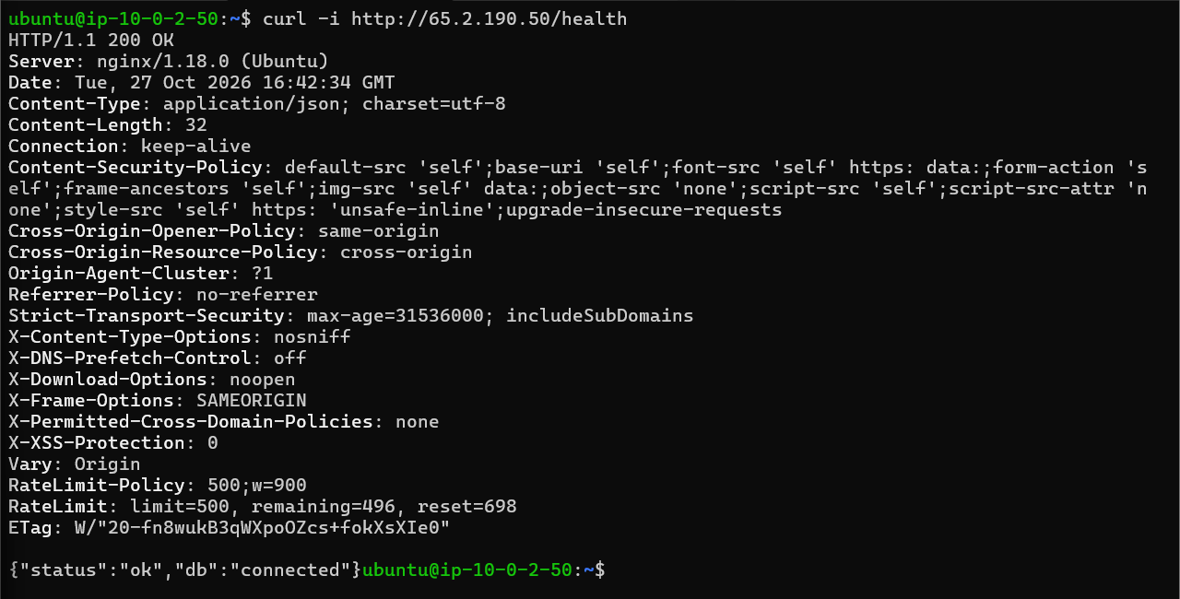
Figure 16. The public HTTP health endpoint returns 200 OK and the JSON result status: ok, db: connected.
{"status":"ok","db":"connected"}
Check | Observed result | Interpretation
HTTP response | 200 OK | The requested endpoint returned successfully
Application status | status = ok | The health response reports the application ready
Database status | db = connected | The application reports an established database connection

I ran the curl request from the database host against the public web address. The browser screenshots also show that I could access the application from my workstation.
The response identifies Nginx on Ubuntu. I tested the HTTP endpoint; I did not verify an HTTPS certificate.

Functional application testing
To test the application, I added a trip named Goa with dates from 19 to 25 October 2026 and selected Backpacking as the trip type. I filled in the other trip details and marked it as featured.
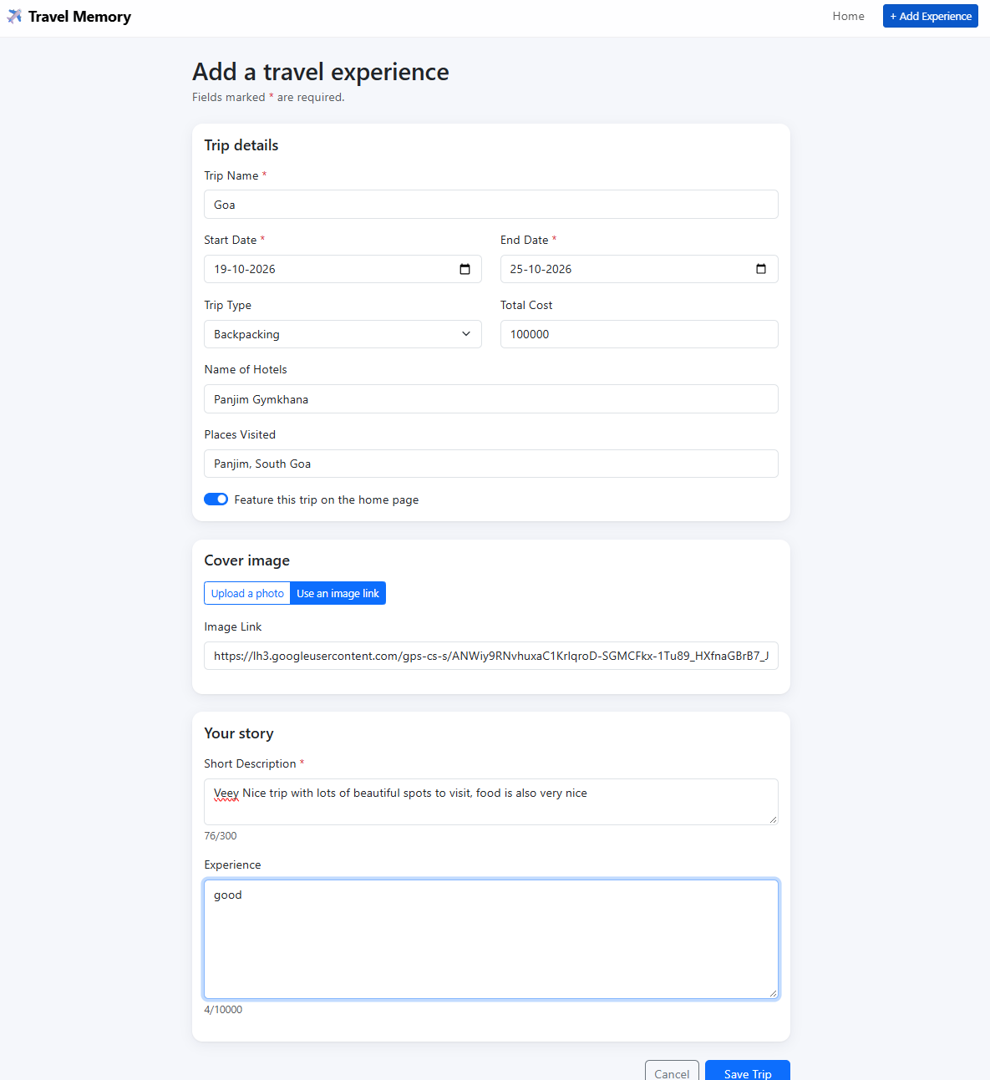
Figure 17. The Goa trip form is populated before submission. The original capture partially cuts off the bottom button edge.

Trip creation confirmation
After saving, the application displayed a success message and showed the details for the Goa trip. The page was served from the public web address.
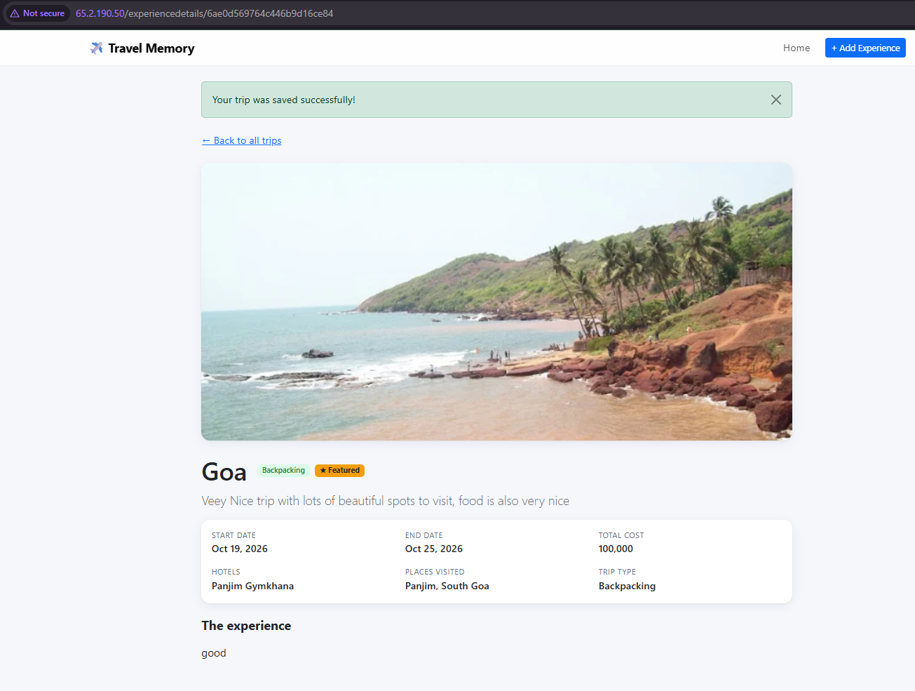
Figure 18. The application confirms that the trip was saved successfully and displays the matching Goa trip details.
Test field | Result shown after saving
Trip name and type | Goa; Backpacking
Travel dates | 19 October 2026 to 25 October 2026
Hotel and places | Panjim Gymkhana; Panjim, South Goa
Save outcome | The application displays an explicit success message

Homepage display verification
The homepage displayed the new Goa trip in the Featured trips section. The title, dates, image and description matched the details I entered.
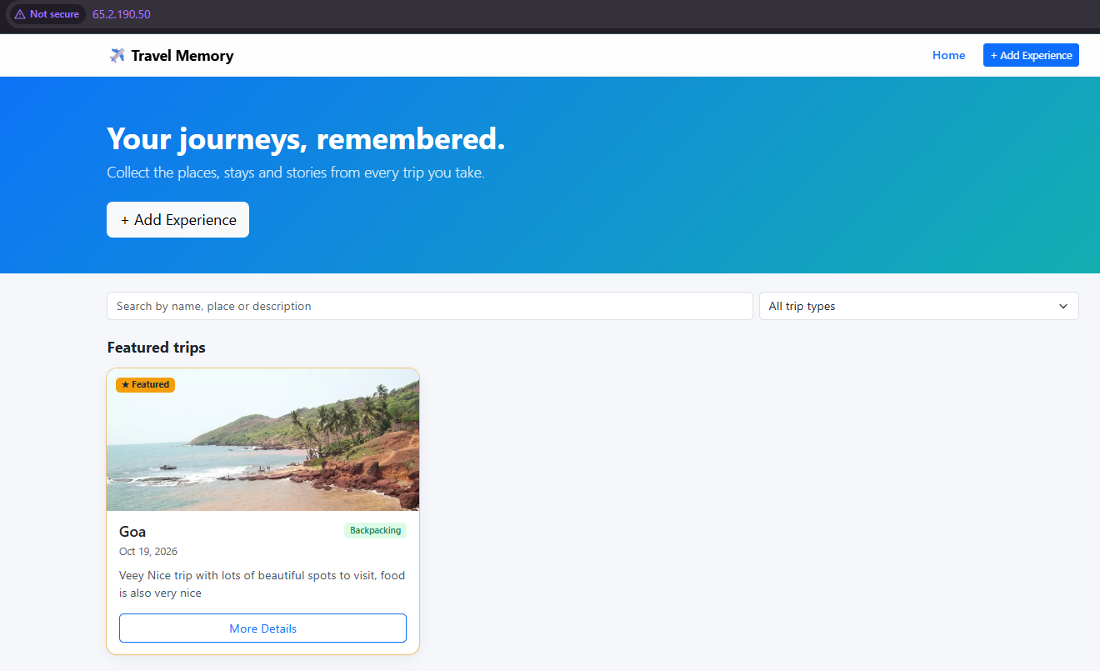
Figure 19. The public homepage displays the saved Goa trip under Featured trips.
Functional step | Evidence | Observed outcome
Enter a trip | Figure 17 | The form contains the intended test fields
Save the trip | Figure 18 | The application confirms successful saving and shows the details
View the homepage | Figure 19 | The same trip appears in the featured listing

This test covers creating a trip and seeing it on the homepage. I did not separately test editing, deleting or persistence after a service restart.

Troubleshooting and secrets handling
During setup, an Ansible connection to the web server timed out on SSH port 22. Later connectivity checks succeeded for both hosts.
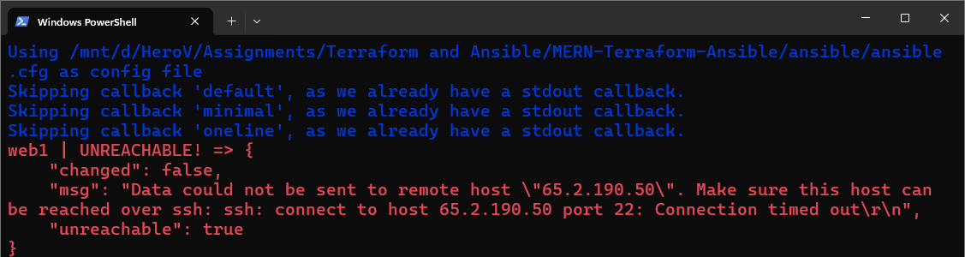
Figure 20. An earlier Ansible attempt fails because the web host SSH connection times out.
I also encountered MongoDB authentication issues during setup. The later authenticated database check and the connected health response show the final configuration working.

Vault encryption and source handling
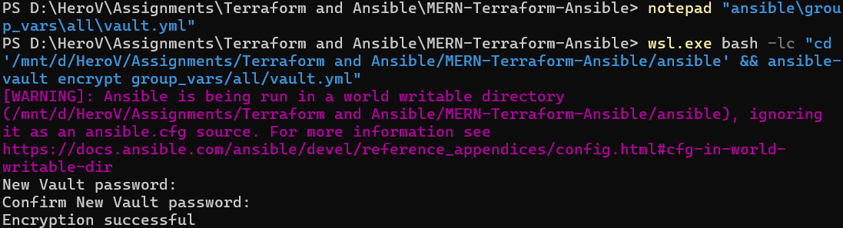
Figure 21. Ansible Vault reports successful encryption while retaining a warning about configuration discovery in a world-writable directory.
Ansible Vault encryption completed successfully. The command also showed a warning about configuration discovery in a world-writable directory, so the project commands specified the configuration file explicitly.
I have not included private keys or plaintext passwords in this report, and sensitive identifiers are hidden in selected screenshots. Vault encryption alone does not prove that every file in the repository is free of secrets.

Repository and documentation
I uploaded the assignment to the `assignment-upload` branch of the GitHub repository below.
GitHub repository: https://github.com/chinmayvyas7/mern-terraform-ansible-deployment/tree/assignment-upload
Reported item | Recorded value
Upload branch | assignment-upload
Local commit | 8d70cf2
Commit message | Add Terraform and Ansible MERN deployment assignment
Push result | 125 objects uploaded; upload branch created without overwriting main

Project folder structure
Location | Purpose
.gitignore and README.md | Repository exclusions and project instructions
terraform/ | Provider, variables, network, security, compute and output definitions
ansible/ | Configuration, playbooks, roles, templates and example vault variables
app/ | TravelMemory frontend and backend source
docs/ | architecture-and-deployment-report.md and ASSIGNMENT-CHECKLIST.md
evidence/ | Setup, identity, environment, Terraform validation and planning captures

The assignment is available on the `assignment-upload` branch. The repository `main` branch was not overwritten as part of this upload.

Repository exclusions to preserve
The `.gitignore` is intended to exclude Terraform state, real variable files, Vault secrets, generated inventory, SSH private keys, environment files, dependencies and generated builds. Example files should still be checked before sharing.

Results and acceptance checklist
The checks in this report show that the infrastructure was created, both hosts were reachable, the database was running and the application could save and display a trip.
Acceptance item | Status | Evidence and result
AWS identity and region | Verified | Figure 1: identity response and ap-south-1
Terraform initialization and validation | Verified | Figures 3 and 4: initialization and validation succeed
Terraform plan | Verified | Figure 5: 17 additions, no changes or destroys
Infrastructure apply | Verified | Figure 6: 17 resources added successfully
Two EC2 instances healthy | Verified | Figure 7: both Running with 3/3 checks passed
Database without a public IP | Verified | Figure 7: database public-address fields are empty
Ansible host connectivity | Verified | Figure 11: web1 and db1 return pong
Common configuration recap | Verified | Figure 12: zero failed or unreachable hosts
Database playbook | Verified | Figure 13: ok=11, changed=2, failed=0, unreachable=0
MongoDB authenticated check | Verified | Figure 14: active service and local ping ok: 1
Web configuration rerun | Verified | Figure 15: ok=21, changed=0, failed=0, unreachable=0
Public health endpoint | Verified | Figure 16: HTTP 200; application ok; database connected
Trip creation and display | Verified | Figures 18 and 19: save confirmation and homepage entry
Vault encryption | Verified | Figure 21: Encryption successful
GitHub branch upload | Reported | GitHub: assignment-upload branch

HTTPS, load testing, restart durability and every database security-group rule were not tested as part of this assignment.

Appendix A Ubuntu and EC2 configuration
This configuration excerpt records the Ubuntu image lookup and the IAM resources used by EC2. The lookup selects a recent Ubuntu Jammy 22.04 amd64 server image, with x86_64 architecture and HVM virtualization filters. The trust policy names the EC2 service. The role has AmazonSSMManagedInstanceCore attached and is included in an EC2 instance profile. [Figure 22]
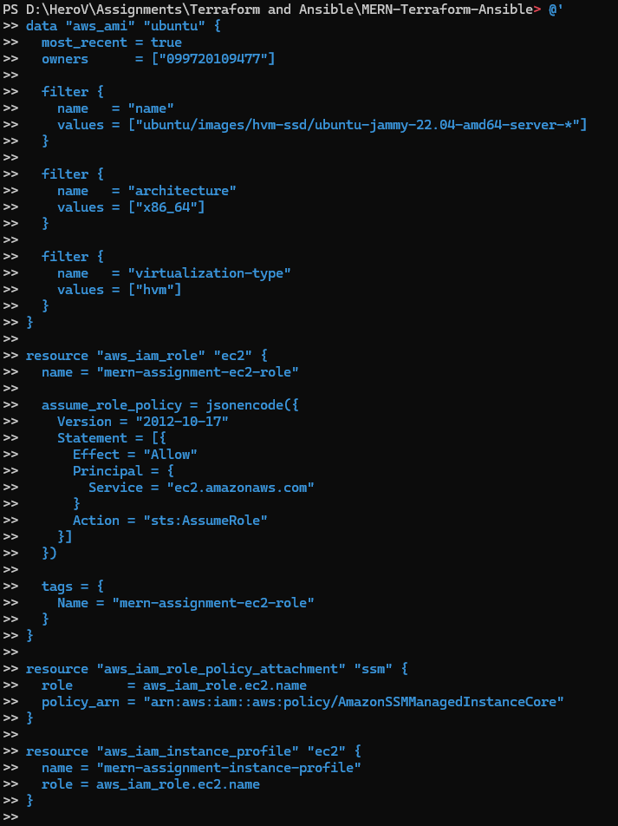
Figure 22. Terraform configuration declares the Ubuntu image lookup, EC2 trust role and Systems Manager instance profile.
This figure shows part of the Terraform configuration used for the Ubuntu image lookup and EC2 IAM setup. Figure 6 shows the corresponding resource creation.

Appendix A Terraform output definitions
The Terraform outputs are defined for the web public IP, database private IP, instance IDs and VPC ID.
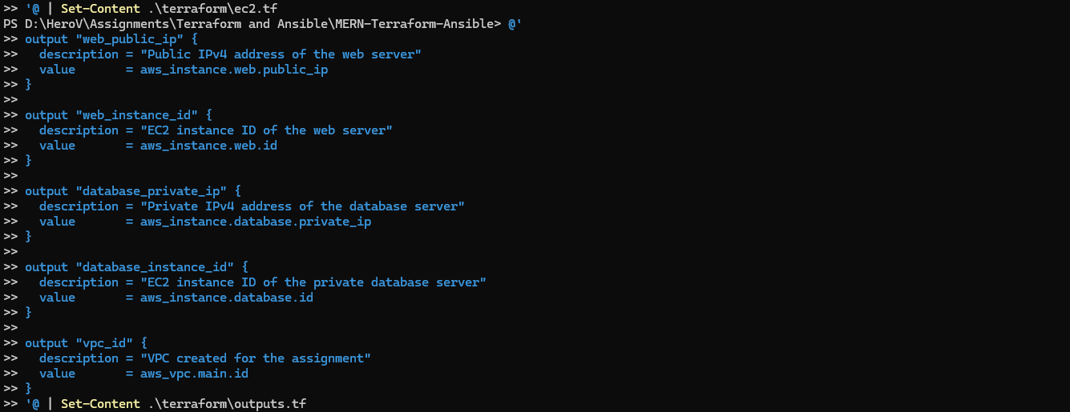
Figure 23. Terraform output definitions name the web public address, database private address and infrastructure identifiers.
Output name | Declared value
web_public_ip | Public IPv4 address of the web instance
web_instance_id | Identifier of the web instance
database_private_ip | Private IPv4 address of the database instance
database_instance_id | Identifier of the database instance
vpc_id | Identifier of the main VPC

These lines define the outputs. The AWS Console and database terminal screenshots show the relevant host addresses.

Project files
The project files are organized into `terraform/`, `ansible/`, `app/`, `docs/` and `evidence/` directories.
The figures in this report are selected screenshots from the deployment process. Sensitive values have been hidden where appropriate.

Appendix B Evidence index
The following index lists the screenshots used in the report and the step each one supports.
Figure | Original screenshot filename | Use and treatment
1 | 1.AWS identity and region verification..png | Identity, region and IAM; cropped and identifiers masked
2 | Screenshot 2026-10-27 105230.png | Key setup and file-permission commands; full image
3 | 03-current-terraform-validation.png | Version and validation excerpt; identity output omitted
4 | terraform-init-validate.png | Initial provider setup and validation; full image
5 | terraform-plan-summary.png | Saved plan summary; full image
6 | 05-terraform-apply-success.png | Successful apply; resource IDs masked
7 | Screenshot 2026-10-27 222646.png | EC2 table excerpt; instance IDs masked
8 | Screenshot 2026-10-27 222646.png | Web inbound rules excerpt; administrator address masked
9 | 03-current-terraform-validation2.png | WSL version excerpt; unrelated identity output omitted
10 | 01-playbook-syntax-checks.png | Full preflight capture plus an enlarged host-warning excerpt
11 | 03-web-ssh-restored.png | Both successful inventory pings; full image
12 | 01-common-playbook-success.png | Complete two-host recap excerpt

Diagram 1 is an architecture overview created for this report.

Appendix B Evidence index continued
Figure | Original screenshot filename | Use and treatment
13 | Screenshot 2026-10-27 222424.png | Database playbook and recap; full image
14 | mongodb-working.png | Service and local authenticated ping; username masked
15 | Screenshot 2026-10-27 222043.png | Web rerun and recap; skipped tasks retained
16 | Screenshot 2026-10-27 221728.png | Terminal excerpt; full HTTP status and JSON retained
17 | Screenshot 2026-10-27 221631.png | Form excerpt; blank side margins removed
18 | Screenshot 2026-10-27 221642.png | Save confirmation and details; whitespace cropped
19 | Screenshot 2026-10-27 221654.png | Homepage and trip card; empty lower area cropped
20 | Screenshot 2026-10-27 202507.png | Initial timeout excerpt; later duplicate recovery omitted
21 | Screenshot 2026-10-27 203909.png | Vault encryption; warning retained
22 | Screenshot 2026-10-27 111111.png | Ubuntu lookup and EC2 IAM declarations; full image
23 | Screenshot 2026-10-27 111127.png | Output-definition excerpt; variable-file content omitted

Evidence coverage
The 23 figures use 22 distinct original screenshots. The final AWS Console image supplies two focused figures: the instance table and web inbound rules. Three other uploaded files are exact copies of included sources. The remaining four unique images are recorded in Appendix C as redundant or sensitive.

Appendix C Duplicate and excluded screenshots
Only the screenshots needed to explain the setup and results are included.
Original screenshot filename | Disposition | Reason or retained source
Screenshot 2026-10-27 110900.png | Exact duplicate | Identical to terraform-init-validate.png, used as Figure 4
Screenshot 2026-10-27 111512.png | Exact duplicate | Identical to terraform-plan-summary.png, used as Figure 5
Screenshot 2026-10-27 210651.png | Exact duplicate | Identical to mongodb-working.png, used as Figure 14
Screenshot 2026-10-27 111227.png | Redundant | Repeated validation and variable output; Figures 3, 4 and 23 retain useful context
Screenshot 2026-10-27 111350.png | Redundant | Earlier plan excerpt; Figures 5 and 6 retain the summary and completed apply
Screenshot 2026-10-27 105312.png | Excluded | Contains visible SSH private key material; safe key setup is shown in Figure 2
Screenshot 2026-10-27 203747.png | Excluded | Contains plaintext password values; successful Vault encryption is shown in Figure 21

