KARNATAK LAW SOCIETY’S

GOGTE INSTITUTE OF TECHNOLOGY

UDYAMBAG, BELAGAVI-590008

(An Autonomous Institution under Visveswaraya Technological University, Belagavi)

###### (APPROVED BY AICTE, NEW DELHI)



*Course Activity Report on*

***“TELEGRAM BOT FOR ISE DEPARTMENT”***

*Submitted in the partial fulfilment for the academic requirement of*

**4TH *Semester B.E In***

***Information Science Engineering***

***Submitted by***

#### Chinmay B W 2GI20IS008

**Shubham P R 2GI20IS040**

#### Samarth Awati 2GI20IS034

**Amar A Kamble 2GI20IS004**

Under the Guidance Of Dr.Kiran K Tangod HOD,Dept Of ISE Academic Year 2021-2022

**CERTIFICATE**



This is to certify that the Seminar entitled “REAL-TIME HUMAN DETECTION AND COUNTING ” is a Bonafede record of the Seminar work done by **Chinmay B W, Shubham P R, Samarth Awati, Amar A Kamble** having **USN 2GI20IS008,2GI20IS040, 2GI20IS032, 2GI20IS004** under my supervision and guidance, in partial fulfilment of the requirements for the Outcome Based Education Paradigm in ISE from Gogte Institute of Technology for the academic year 2021-2022.

Faculty In charge Head of the Department

**Rubrics for evaluation of Course Project**

|  |  |  |  |  |  |  |
| --- | --- | --- | --- | --- | --- | --- |
| Sl. No | Batch No. :02 | | | | | |
| 1. | Project Title: REAL-TIME HUMAN DETECTION AND COUNTING | MARKS RANGE | USN | | | |
| 2GI29I S008 | 2GI20I S040 | 2GI20I S034 | 2GI20I S004 |
| 2. | Problem statement(PO 2) | 0-1 |  |  |  |  |
| 3. | Objectives of Defined Problem(PO1  ,PO2) | 0-2 |  |  |  |  |
| 4. | Design/Algor ithm/ Flowchart/M ethodology  (PO3) | 0-3 |  |  |  |  |
| 5. | Implementati on details/Funct ion/ Procedure/Cl asses and objects(Lang  uage/Tools) | 0-4 |  |  |  |  |
| 6. | Working model of the final solution  (PO3,PO12) | 0-5 |  |  |  |  |
| 7. | Report and Oral presentation skill  (PO9,PO10) | 0-5 |  |  |  |  |
|  | Total | 20 |  |  |  |  |

1. **Engineering Knowledge:** Apply the knowledge of mathematics, science, engineering fundamentals and an engineering specialization to the solution of complex engineering problems.
2. **Problem Analysis:** Identify, formulate, review research literature, and analyse complex engineering problems reaching substantiated conclusions using first principles of mathematics, natural sciences and Engineering sciences.
3. **Design/Development of solutions:** Design solutions for complex engineering problems and design system components or processes that meet the specified needs with appropriate consideration for the public health and safety, and the cultural, societal, and environmental consideration. **Conduct investigation of complex problems:** Use research-based knowledge and research methods including design of experiments, analysis and interpretation of data, and synthesis of the information to provide valid conclusion.
4. **Modern tool usage:** Create, select, and apply appropriate techniques, resources, and modern engineering and IT tools including prediction and modelling to complex engineering activities with an understanding of the limitations.
5. **The engineer and society:** Apply reasoning informed by the contextual knowledge to assess societal, health, safety, legal and cultural issues and the consequent responsibilities relevant to the professional engineering practice.
6. **Environment and sustainability:** Understand the impact of the professional engineering solutions in societal and environmental contexts, and demonstrate the knowledge of, and need for sustainable development.
7. **Ethics:** Apply ethical principles and commit to professional ethics and responsibilities and norms of the engineering practice.
8. **Individual and team work:** Function effectively as an individual and as a member or leader in diverse teams, and in multidisciplinary settings.
9. **Communication:** Communicate effectively on complex engineering activities with the engineering community and with society at large, such as,being able to comprehend and write effective reports and design documentation, make effective presentations, and give and receive clear instructions.
10. **Project management and finance:** Demonstrate knowledge and understanding of the engineering management principles and apply these to one's own work, as a member and leader in a team, to manage projects and in multidisciplinary environments
11. **Life-long learning:** Recognize the need for and have the preparation and ability to engage in independent and lifelong learning in the broadest context of technological change.

**TELEGRAM BOT FOR ISE DEPARTMENT**

A Bot for ISE DEPT OF OUR COLLEGE

***ABSTRACT***

*This paper presents a design of Telegram bot to*

*support Campus information sharing. The communication*

*method used is Webhooks. Webhooks is able to provide*

*zero latency and handle multiple requests concurrently*

*during communication within the Telegram bot. Such bot*

*serves the information via specific commands. The*

*Telegram bot prototype shows that even though Webhooks*

*is able to provide information as requested, Webhooks*

*setting is difficult and trickier.*

**Table of Contents:**

* 1. Introduction 1
     1. Problem Statement 1
     2. Objectives 1
     3. Methodology 2
        1. Creating a new Bot 2
        2. Instalastion of Modules……………………………………3
        3. Python Libraries Used.……………………………………4
  2. Literature Survey… 6
  3. Implementation………………………………………………………..7

3.1 Source Code………………………………………………………7

* 1. Outputs…………………………………………………………………9
  2. Conclusion………………………………..……………………………10
  3. Reference………………………………………………………………10

**List of Figures:**

Figure 1.1 Bot Father 2

Figure 1.2 New bot creation…………………………………………………………2

Figure 1.3 Naming new Bot………………………………………………………….2

Figure 1.4 Generation of API Key……………………………………………………3

Figure 1.5 Output Image ..9

Figure 1.6 Output Image ..9

# INTRODUCTION

#### Problem Statement:

Creating a telegram bot for ise department of our college to answer the

quaries and questions of parents during admission.

#### Objectives:

A Telegram Bot is a programme that behaves like a normal chat partner with additional functions. It performs predefined tasks independently and without the user’s involvement. The term bot is derived from the term for robot.

* + 1. The main objective of the project is to help parents / students to get to know about the courses offered and admission related stuff of the particular college.
    2. To provide them with necessary details at ease , making them easier to get to know rather then visiting the college.. during this COVID pandamic situations.
    3. To implement the concepts of python programming in day today life..

**1.3 Methodology:**

### **Getting started**

Before we start to write the program, we need to generate a token for our bot. The token is needed to access the Telegram API, and install the necessary dependencies.

#### **Create a new bot in BotFather:**

If you want to make a bot in Telegram, you have to “register” your bot first before using it. When we “register” our bot, we will get the token to access the Telegram API.

**Step 1**: After opening an account on Telegram, in the search bar at

the top search for “BotFather”

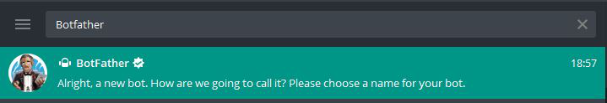

*Fig.1.1 Botfather*

The Botfather (the name is an allusion to the Mafia epic “The Godfather” – based on the novel by Mario Puzo and successfully filmed in three parts with Marlon Brando as “The Godfather” from 1972) is basically a Telegram Bot and responds to commands. It helps with the creation of one’s own bot, organises unique bot names, for example, and assigns access authorisations for programming.

**Step 2**: Click on the ‘BotFather’ (first result) and type /newbot

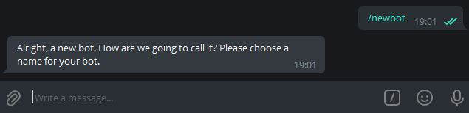

*Fig.1.2 newbot creation*

**Step 3**: Give a unique name to your bot. After naming it, Botfather will

ask for its username. Then also give a unique name BUT remember the username

of your bot must end with the bot, like my_bot, hellobot etc..

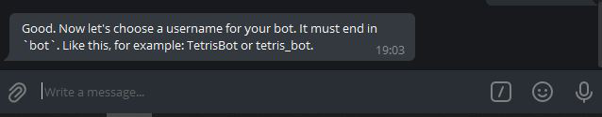

*Fig 1.3 naming new bot*

**Step 4**: After giving a unique name and if it gets accepted you will get a

message something like this –

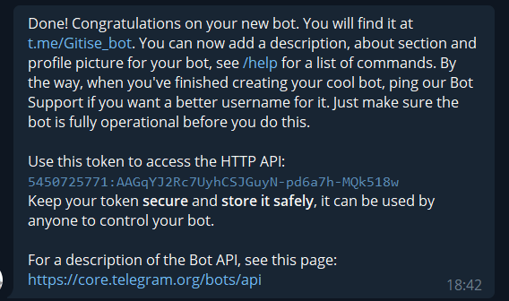

*Fig1.4 API key of the bot*

#### Installation of the module

We can install this module via pip with the below command.

# installing via pip

pip install python-telegram-bot

###### Python Libraries Used:

Here the token value will be different for you, we will use this token in our python code to make changes in our bot and make it just like we want, and add some commands

in it.

Stepwise implement:-

***Step 1: Importing required libraries***

from telegram.ext.updater import Updater

from telegram.update import Update

from telegram.ext.callbackcontext import CallbackContext

from telegram.ext.commandhandler import CommandHandler

from telegram.ext.messagehandler import MessageHandler

from telegram.ext.filters import Filters

Brief usage of the functions we are importing:

Updater: This will contain the API key we got from BotFather to specify in

which bot we are adding functionalities to using our python code.

Update: This will invoke every time a bot receives an update i.e.

  message or command and will send the user a message.

CallbackContext: We will not use its functionality directly in our code

but when we will be adding the dispatcher it is required

(and it will work internally)

CommandHandler: This Handler class is used to handle any command

sent by the user to the bot, a command always starts

with “/” i.e “/start”,”/help” etc.

MessageHandler: This Handler class is used to handle any normal message

sent by the user to the bot,

FIlters: This will filter normal text, commands, images, etc from a sent message.

***Step 2: Define functions for operation***

Start function: It will display the first conversation, you may name it something else but the message inside it will be sent to the user whenever they press ‘start’ at the very beginning.

updater = Updater("your_own_API_Token got from BotFather",

use_context=True)

def start(update: Update, context: CallbackContext):

update.message.reply_text("Enter the text you want to show to the user whenever they start the bot")

Basically, in the start message, you should add something like “Hello Welcome to the Bot” etc.

Help function: It is basically in this function you should add any kind of help the user might need, i.e. All the commands your bot understands, The information related to the bot, etc)

def help(update: Update, context: CallbackContext):

update.message.reply_text("Your Message")

***Step 3: Adding the Handlers to handle our messages and commands***

updater.dispatcher.add_handler(CommandHandler('start', start))

updater.dispatcher.add_handler(CommandHandler('youtube', youtube_url))

updater.dispatcher.add_handler(CommandHandler('help', help))

updater.dispatcher.add_handler(CommandHandler('linkedin', linkedIn_url))

updater.dispatcher.add_handler(CommandHandler('gmail', gmail_url))

updater.dispatcher.add_handler(CommandHandler('geeks', geeks_url))

updater.dispatcher.add_handler(MessageHandler(Filters.text, unknown))

updater.dispatcher.add_handler(MessageHandler(

# Filters out unknown commands

Filters.command, unknown))

# Filters out unknown messages.

updater.dispatcher.add_handler(MessageHandler(Filters.text, unknown_text))

***Step 4: Running the bot***

***Python3***

***updater.start_polling()***

Here whenever we start polling the bot will be active and it will look for any new message sent by any of the users and if it matches the command specified there it will reply accordingly.

# LITERATURE SURVEY:

In the computer world and ELIZA [a natural language processing computer made in 1964] E-commerce Chatbots are not new programs. The first chatbot was released in 1966. But the main use of existing chatbots are for recreational and research purposes. The banking sector has released Most of the e-commerce chatbots. for example virtual assistant created by DBS bank of Singapore called DigiBank.

Customers can check their transaction history, check interest rate and transfer money IS is done by a voice and text enabaled assistant called DigiBank. In the same way, Ally Bank ,Bank of America, Barclays Africa and Capital one have created their own e-commerce chat bots as well. To helps customers buy suitable products, Authors developed a ecommerce telegram chatbot. Their e-commerce chatbot is integrated with their website which is coded in PYTHON and has a MYSQL database and razoropay payment gateway

In the United States and several other countries, Telegram is the number one application for the category of social networking after Facebook and WhatsApp. The success of the Telegram bot stems from its easy-to-use interface compared to the various apps and services available. This bot saves time by easily registering and logging in, along with simple communication with timely replies.

The use of Telegram application as a communication medium is influenced by several factors, one of which is knowledge. Knowledge is the result of "knowing" and this occurs after people have sensed a certain object. Sensing occurs through the five human senses, namely: the senses of sight, hearing, smell, taste and touch. Most of human knowledge is obtained through eyes and ears . According to (Notoatmodjo, 2014), knowledge in the cognitive domain has 6 levels, namely Know, Comprehension, Application, Analysis, Synthesis, Evaluation10. Evaluation relates to the ability to make an assessment of a material or object. Factors that influence knowledge include Education, Information/Mass Media, Social, Culture and Economics, Environment, Experience, Age. Satisfaction is a person's feeling after comparing the perceived performance or outcome with expectations for the product. The level of satisfaction is the difference in perceived usefulness of consumers and existing expectations. Satisfaction is the user's response to the suitability of the level of interest or expectations of users before and after receiving their services

# IMPLEMENTATION

##### Source Code:

**main.py**

import constants as keys

from telegram.ext import *

import Responses as R

print("Bot Started....")

def start_command(update, context):

update.message.reply_text('Type something to get start')

def help_command(update, context):

update.message.reply_text('Search in Google')

def handle_message(update, context):

text = str(update.message.text).lower()

response = R.sample_responses(text)

update.message.reply_text(response)

def error(update , context):

print(f"Update {update} caused error {context.error}")

def main():

updater = Updater(keys.API_KEY, use_context=True)

dp = updater.dispatcher

dp.add_handler(CommandHandler("start",start_command))

dp.add_handler(CommandHandler("help",help_command))

dp.add_handler(MessageHandler(Filters.text, handle_message))

dp.add_error_handler(error)

updater.start_polling()

updater.idle()

main()

**Responses,py**

def sample_responses(input_text):

user_message = str(input_text).lower()

if user_message in ("hello", "hi", "sup",):

return "Hey! Welcome to Gogte Institute of Technology"

if user_message in ("who are you", "who are you?"):

return "Iam a Gitise_bot created by Chinmay and group!!"

if user_message in ("can you help me"):

return "yup how can i help you"

if user_message in ("what are the courses offered?"):

return "There are mainy 9 Undergraduate courses offered, they are 1.Computer Science & Engineering " \" 2.Information Science &

Engineering 3.Mechanical Engineering " \

"4.Electronics & Communication Engineering 5.Electrical & Electronics Engineering " \ "6.Civil Enginnering 7.Aeronautical Enginnering 8.B.Sc(Honors) 9.Architecture"

if user_message in ("what is ise?"):

return "ISE stands for Information Science and Engennering"

if user_message in ("what is cse?"):

return "ISE stands for Computer Science and Engennering"

if user_message in ("what is the minimum qualification required?"):

return "Passed in 2nd PUC / 12th Std / Equivalent Exam with English as one of the " \

"Languages and obtained a Minimum of 45% of Marks in aggregate in Physics and " \"Mathematics along with Chemistry / Bio-Technology / Biology / Electronics /Computer. " \ "(40% for SC, ST, Cat-1, 2A, 2B, 3A and 3B category candidates of Karnataka State)."

if user_message in ("which is the highest salary package in ise?"):

return "Highest Salary Package is 13.6 lpa"

if user_message in ("what is the under graduate intake?"):

return "intake is around 60"

return "I don't understand you."

**Constants,py**

API_KEY ='5450725771:AAGqYJ2Rc7UyhCSJGuyN-pd6a7h-MQk518w'

# OUTPUTS

The screenshots of Outputs are as shown in the figure 1.6,Figure1.7 and Figure 1.8.

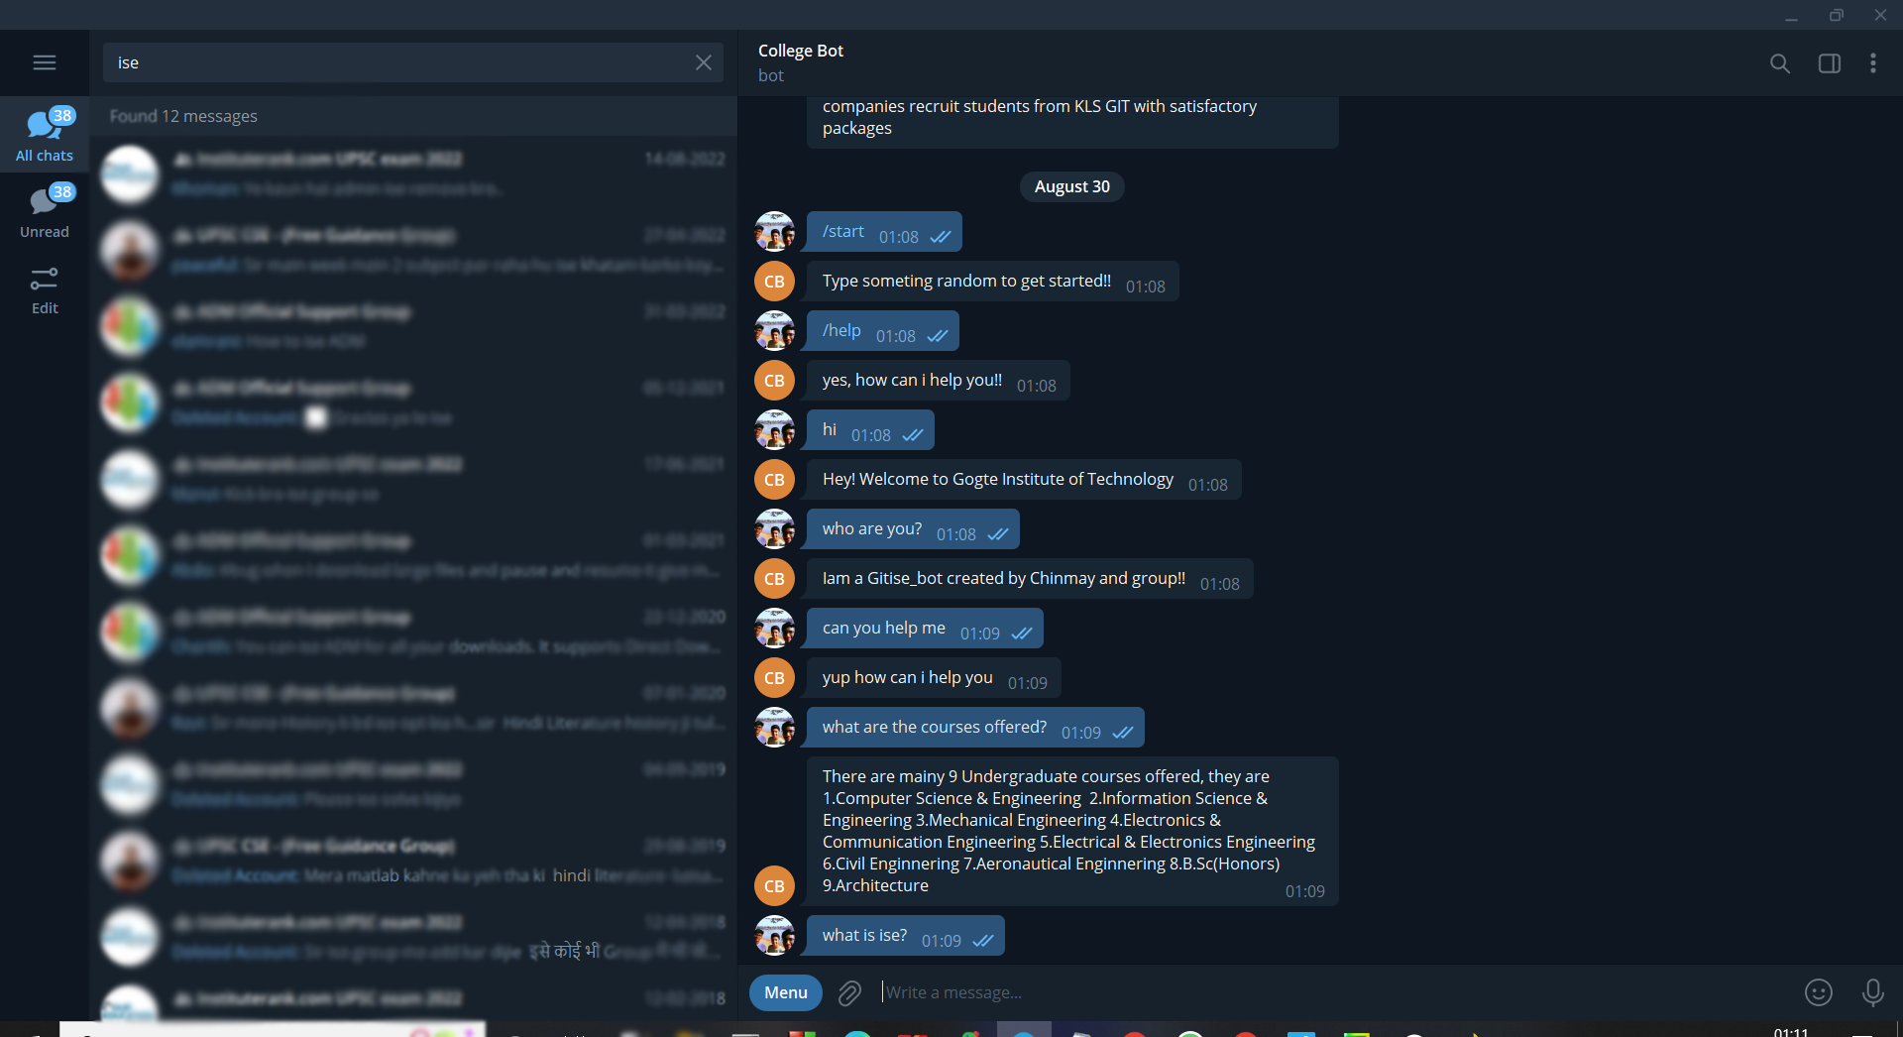

*Fig1.5*

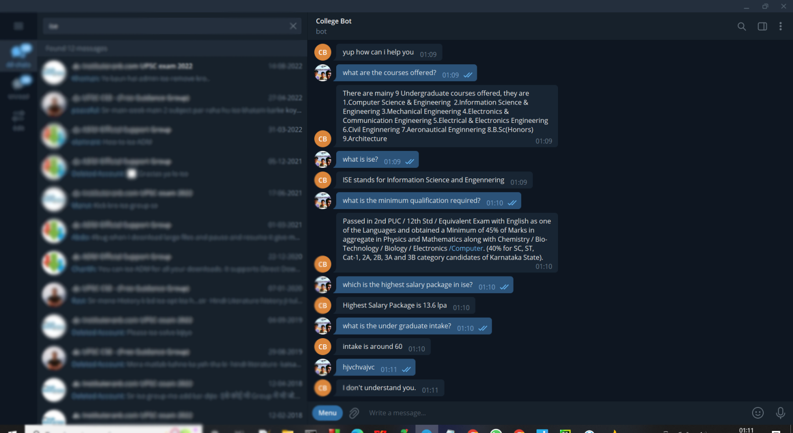

*Fig 1.6*

### CONCLUSION

In the last section of the project, we have created a telegram bot for the college I.e for particular ise department. For this we took quaries from parent or user (student) and we replied to it using python program.

A Telegram bot is a useful addition to smart communication, especially in professional areas. Compared to the most popular messaging services, Telegram offers additional advantages in the exchange of information with the special queries and actions of a bot listed in our article. However, like all programming, Telegram usually requires concrete programming knowledge for extensive use. Particularly for use in industry and machine connection, the OPC Router is a recommendable tool that extremely simplifies precisely this complex programming.

# REFERENCE

## Programming Computer Vision with Python, 1st Edition, Jan Eric Solem, 2012, O’ Reily

1. Learning OpenCv, Adrian Kaehler and Gary Rost Bradski, 2008, O’ Reily

## Python GUI Programming with Tkinter, Alan D. Moore, 2018

## 