Analysis Record
Sulfur 2p speciation and bioactive column performance, sulfate reducing bioreactor.
Method
The sulfur 2p scan on sheet Fig 3 was smoothed with a Savitzky-Golay filter over a 5-point window using a second-order polynomial, with the ends reflected about the first and last points so every recorded binding energy carries a smoothed value; the 0.1 eV grid is unchanged. A straight-line background through the mean of the first 5 and the last 5 points of the smoothed trace was subtracted, and the measured amplitude of each species is the corrected trace at its assigned position. Each reference binding energy was matched to the nearest local maximum of the smoothed trace within 0.5 eV, taking the taller maximum where two were equally close; the modelled heights are the values printed on the individual species sheets. The aqueous record was split at the failure day, taken as the first sampling day on which the treated effluent pH falls below 4.0 and stays below it for the rest of the run, which is day 458. Entries reported below the limit were replaced by half that limit, and sampling days missing either the influent or the treated effluent value were left out of the means.
Table 1. Sulfur 2p peak assignments.
Species | Reference (eV) | Assigned (eV) | Offset (eV) | Measured amplitude (counts/s) | Modelled height (counts/s) | Difference (counts/s) | Source sheet
S4+ 2p1/2 | 167.9 | 168.0 | +0.1 | 15.9 | 12 | +3.9 | S4+_2p12.png
S4+ 2p3/2 | 167.0 | 167.2 | +0.2 | 21.1 | 21 | +0.1 | S4+_2p32.png
S2- 2p1/2 | 162.5 | 162.2 | -0.3 | 21.9 | 6 | +15.9 | S2-_2p12.png
S2- 2p1/2 (B) | 161.1 | 161.2 | +0.1 | 77.7 | 78 | -0.3 | S2-_2p12_2.png
S2- 2p3/2 | 160.5 | 160.4 | -0.1 | 128.8 | 36 | +92.8 | S2-_2p32.png
S2- 2p3/2 (B) | 159.7 | 159.7 | +0.0 | 141.2 | 136 | +5.2 | S2-_2p32_2.png

Table 2. Bioactive column performance either side of the failure day.
Analyte | Table 1 influent | Mean influent, operating | Mean effluent, operating | Removal, operating (%) | Mean influent, after failure | Mean effluent, after failure | Removal, after failure (%)
Sulfate (mg/L) | 1990 | 1960 | 619 | 68.4 | 2540 | 1430 | 43.6
Cd (mg/L) | 0.296 | 0.297 | 0.00138 | 99.5 | 0.283 | 0.00100 | 99.6
Fe (mg/L) | 24.0 | 24.5 | 8.82 | 64.1 | 12.7 | 37.8 | -198.2
Mn (mg/L) | 1.67 | 1.67 | 1.19 | 29.0 | 1.65 | 2.99 | -81.1
Zn (mg/L) | 72.9 | 72.9 | 0.172 | 99.8 | 72.5 | 35.9 | 50.6

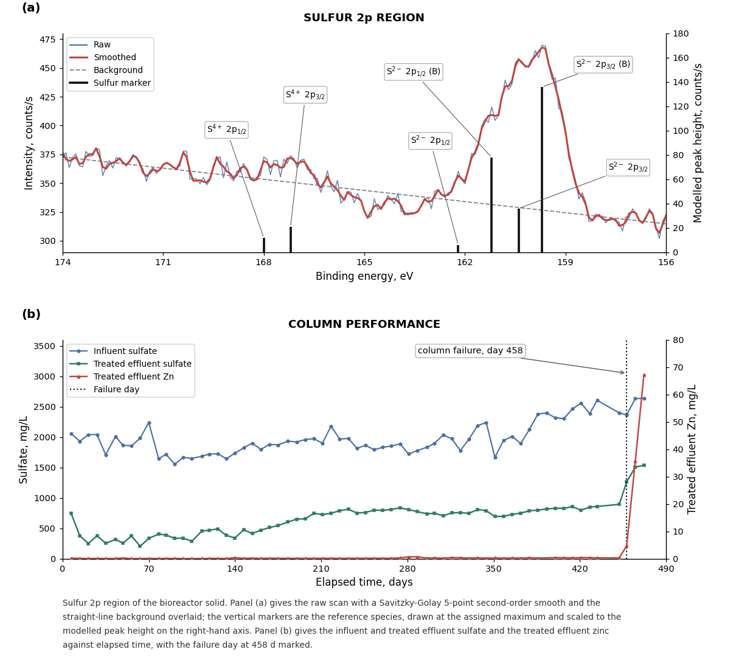
Figure 1. Sulfur 2p region and column performance.
Conclusions
All 6 reference species were resolved on the smoothed trace. The largest offset is 0.3 eV at S2- 2p1/2, which sits below its reference value; two maxima lie equally close to that reference, at 162.8 and 162.2 eV, and the taller of the two was taken. The modelled heights and the measured amplitudes agree closely for the isolated components but diverge where the doublet overlaps, most at S2- 2p3/2, where the measured amplitude exceeds the modelled height by 92.8 counts/s because the strong component at 159.7 eV sits under it. Reduced sulfur dominates the surface: the S2- components carry 7.76 times the modelled height of the S4+ components. On the aqueous side the column held sulfate removal at 68.4 per cent and zinc removal at 99.8 per cent while the treated effluent averaged pH 6.43. From day 458 the effluent pH averages 3.24, sulfate removal falls to 43.6 per cent and zinc removal to 50.6 per cent, while iron and manganese turn negative at -198.2 and -81.1 per cent, so the column releases more of both than it receives once the sulfide inventory is exhausted.

