Autonomy Modes and Validation Depth in Disaster Search-and-Rescue Robotics: A Systematic Review of the 2025–2026 Literature
Sadman Adib Avi¹, Sadia Sultana¹, and Chinmoy Sarker¹*
¹Department of Computer Science and Engineering, Bangladesh Army International University of Science and Technology (BAIUST), Cumilla, Bangladesh
*Corresponding author: [[AUTHOR INPUT NEEDED: corresponding author's name and email]]. ORCID iDs: [[AUTHOR INPUT NEEDED: ORCID for each author; required for the submitting author]].

Abstract
Robots are increasingly proposed for disaster search and rescue (SAR), but their autonomy and their validation are rarely examined together. Following PRISMA 2020, one author cataloged 130 records published in 2025–2026. They were identified through publisher-platform searches (78), Google Scholar (15), and AI-assisted discovery (37). After deduplication, two reviewers screened 125 full texts against three eligibility criteria, and 39 studies were included. Each study was assigned one of four autonomy/human-robot interaction modes under explicit decision rules. Validation depth, self-reported realism limitations, and reproducibility were coded with page-level evidence. Fully Autonomous systems made up 69.2% of the corpus (27/39); the rest were Teleoperation (5), Supervisory Control (4), and Shared-Collaborative Control (3). None of the 27 Fully Autonomous studies evaluated a human role, and 16 were simulation-only. Their field-testing rate was 7.4% (95% CI 2.1–23.4), against 33.3% for human-in-the-loop modes (primary, strict coding; exploratory Fisher p = 0.060). Under lenient coding the rates were 14.8% vs. 41.7% (p = 0.10). No contrast survived multiplicity adjustment, and the difference weakened when abstract simulations were excluded or boundary cases re-coded. Field testing tracked human participation in the evaluation more than designed mode. Two thirds of the studies acknowledged idealized test conditions, and 5 of 39 released code or data. Limitations include non-reproducible AI-assisted discovery, a narrow search, unrecorded screener agreement, and AI-assisted extraction. The review was not registered. Autonomy's prevalence should not be read as deployment readiness; studies should report validation depth, human roles, and per-function autonomy.
Keywords: disaster response, field validation, human-robot interaction, levels of autonomy, search and rescue robotics, sim-to-real gap, systematic review

I. INTRODUCTION
Natural hazards continue to impose a heavy burden on lives and infrastructure. The Centre for Research on the Epidemiology of Disasters (CRED) recorded 358 natural-hazard disasters in 2025, which caused 16,607 deaths, affected 110.2 million people, and caused an estimated US$169.7 billion in economic losses (Delforge et al., 2026). These figures are below the 2005–2024 annual averages (377 disasters, 57,429 deaths, 169.0 million people affected, and US$215.0 billion in losses). CRED attributes the difference largely to the absence of a single catastrophic "mega-disaster" in 2025 (Delforge et al., 2026). Asia accounted for 72.8% of disaster deaths in 2025, largely because of two major earthquakes (Delforge et al., 2026). A magnitude 7.7 earthquake near Mandalay, Myanmar, on March 28, 2025 caused at least 3,820 deaths. A magnitude 6.0 earthquake in eastern Afghanistan on August 31, 2025 killed an estimated 2,200 people (Delforge et al., 2026). In both events, structural collapse concentrated casualties in confined, unstable spaces. Locating survivors there is both urgent and dangerous for responders.
Time to rescue strongly shapes survival after structural collapse. In the 1980 southern Italy earthquake, most trapped people were extricated within two days, and survival fell as extrication was delayed (de Bruycker et al., 1983). In a cohort from the 2023 Türkiye earthquakes, time to extrication was a strong predictor of mortality (Kaya Özdoğan et al., 2025). Live rescues after 48 hours are nonetheless well documented, occasionally after more than a week (Macintyre et al., 2006). Disaster-medicine researchers therefore caution against any single universal survival cutoff (Macintyre et al., 2011). The consistent message is that survival declines as entrapment lengthens, which puts a premium on finding victims quickly while limiting responders' exposure to unstable structures. Robotic search and rescue (SAR) systems address both demands. They can enter spaces that are unsafe for people, search systematically, and reduce the number of responders exposed to hazards.
Research on SAR robotics has grown steadily. A bibliometric analysis of 2,201 disaster-robotics publications from 1992 to 2025 documents this growth and a shift from hardware toward perception- and learning-enabled systems (Hu et al., 2026). Reviews of the field have multiplied with it. Earlier surveys organized SAR robotics by control level, from low-level mobility to semi-autonomous and multi-robot control (Liu & Nejat, 2013), or by multi-robot coordination and perception (Drew, 2021; Queralta et al., 2020). Murphy (2014) synthesized documented disaster deployments. Drew (2021) notes, citing field reports, that of at least 40 documented disaster responses only four used three or more robots at once, and only two of those involved any autonomy.
The systematic review closest to the present one is that of Kareem et al. (2026a), which covered 74 SAR robotics studies published between 2016 and 2024. It proposes a five-layer system architecture (human-robot interaction (HRI), perception, navigation, control, and robot layers). In its HRI section (Section III-F of that review), it discusses three modes: teleoperation, supervisory control, and collaborative control. It does not treat full autonomy as a separate category or report how its studies are distributed across modes.
Other recent reviews organize the field along different axes:
- Sinha et al. (2026) surveyed over 190 studies (2020–2025) of ground-based reconnaissance robots for disaster management, admitting aerial systems only for comparison. They categorized the studies by research type in eight categories, from algorithm development and simulation to field deployment. They found that only 4.2% of the studies reported full field deployment, but they did not relate validation to autonomy or HRI mode.
- Jamwal and Singh (2026) compared aerial and ground reconnaissance software and identified sim-to-real transfer as a principal barrier to field deployment.
- Shuvo et al. (2026) synthesized 130 SAR studies (2005–2025) around human-to-machine, machine-to-machine, and machine-to-human learning paradigms. They noted qualitatively that many approaches depend heavily on controlled experimental settings.
- Single-technology reviews cover path planning (Khalil et al., 2026), simultaneous localization and mapping (SLAM; Chen, Rushworth, et al., 2026), and air–ground mapping and navigation (Zhang et al., 2026).
- Man et al. (2026) reviewed human-machine interaction for teleoperated rescue vehicles, a single interaction mode.
- Bakzadeh et al. (2026), for mine rescue, described 15 documented coal-mine rescue platforms. They placed autonomy algorithms and software architecture outside their scope, but coded 14 of the platforms on a three-band autonomy scale adapted from Sheridan and Verplank; 12 of the 14 are teleoperated.
- Bakzadeh et al. (2025), an earlier paper by an overlapping team, set out interface-design guidelines for mining emergency robots without reporting a built or tested system.
- Tong et al. (2024) reviewed aerial and ground approaches to SAR in harsh environments. It is cited here as an immediate predecessor in framing, not as a structurally comparable peer, because it is itself a review rather than a primary study of the kind analyzed in Kareem et al. (2026a) or here.
Table I summarizes these reviews.
TABLE I. Comparison with related recent reviews.
Review | Scope | Corpus/method | Primary organizing axis | Relation to this review
Kareem et al. (2026a) | UAV/UGV/UUV, general SAR | 74 studies, 2016–2024, PRISMA | Five-layer system architecture | Three HRI modes discussed qualitatively; no Fully Autonomous category; no per-study mode distribution
Sinha et al. (2026) | Ground robots (aerial only for comparison) | Over 190 studies, 2020–2025, multi-database | Research type (8 categories) | Reports field-deployment prevalence (4.2%); no autonomy/HRI classification
Shuvo et al. (2026) | General SAR, learning-enabled collaboration | 130 studies, 2005–2025 | Learning paradigm | Validation discussed qualitatively; no autonomy-mode classification
Jamwal and Singh (2026) | Aerial vs. ground disaster reconnaissance | Survey | Software function by platform | Names the sim-to-real gap as the main barrier; no per-study validation coding reported
Khalil et al. (2026) | SAR path planning | Systematic and bibliometric | Path-planning algorithm family | No HRI/autonomy axis
Man et al. (2026) | Teleoperated rescue vehicles | Bibliometric and systematic | Human, vehicle, and environment factors | Single mode (teleoperation) only
Bakzadeh et al. (2026) | Coal-mine rescue robots | 15 platforms (14 classified), narrative | Design requirements; three-axis platform taxonomy | Three-band autonomy coding of a platform inventory; no validation analysis
Bakzadeh et al. (2025) | Mine-rescue interfaces | Narrative guideline synthesis | Interface-design principles | No empirical corpus
This review | UAV/UGV/legged/USV, general SAR | 39 studies, 2025–2026, PRISMA 2020 | Four autonomy/HRI modes | Cross-tabulates autonomy mode against validation depth

These reviews show that field deployment is rare in SAR robotics (Sinha et al., 2026) and that the sim-to-real gap is a principal obstacle (Jamwal & Singh, 2026; Shuvo et al., 2026). To our knowledge, however, none organizes a research corpus primarily by how much decision authority the human retains during the mission, and none examines whether validation depth differs with that authority. If it does, the prevalence of autonomous systems in recent studies would say less about deployment readiness than it appears to.
This review addresses that question for the 2025–2026 primary literature, the period immediately after the corpus of Kareem et al. (2026a). Its contributions are as follows:
- A classification of 39 studies into four autonomy/HRI modes. The modes are Teleoperation, Supervisory Control, Shared-Collaborative Control, and Fully Autonomous. They are grounded in levels-of-automation theory and applied with explicit decision rules, a released coding manual, and a reliability check.
- To our knowledge, the first cross-tabulation in a SAR robotics review of validation depth against autonomy mode. Fully Autonomous studies (69.2% of the corpus) were rarely field-tested (2 of 27) and never evaluated with a human in the mission. Human-in-the-loop studies were field-tested more often. This difference is consistent in direction but not statistically established. It is concentrated in abstract and sensor-free simulation studies, which suggests that it reflects the algorithm-first character of most Fully Autonomous research more than autonomy as such.
- Evidence on how the field reports realism and reproducibility. Two thirds of the studies acknowledge idealized test conditions, but only 5 of 39 release code or data.
- Reporting recommendations and a public data package. The package contains the extraction table with page references, the screening log, the coding manual, and the analysis scripts.
The remainder of the paper is organized as follows. Section II describes the review methods. Section III reports the results. Section IV synthesizes the studies by autonomy mode. Section V discusses mechanisms, threats to validity, and implications. Section VI concludes.

II. METHODOLOGY
This section describes how records were identified, screened, coded, and synthesized. Reporting follows the PRISMA 2020 statement (Page et al., 2021) and, for the search, the PRISMA-S extension (Rethlefsen et al., 2021). The completed checklists for both are provided as supplementary material. Record identification and full-text screening took place in [[AUTHOR INPUT NEEDED: month(s) and year of searching and of screening; the earlier draft said screening took place on 18–19 July 2026, which the authors have not confirmed]].

A. Research Questions
Four research questions guided the review. Each is organized around a four-mode autonomy/human-robot interaction (HRI) taxonomy, defined in Section II-G:
RQ1: Which autonomy/HRI mode (Teleoperation, Supervisory Control, Shared-Collaborative Control, or Fully Autonomous) characterizes each robotic search and rescue (SAR) system reported in the 2025–2026 literature, and how are the modes distributed across the corpus?
RQ2: Which robot platform types are used for disaster SAR in this period, and how do platform choices relate to autonomy mode?
RQ3: Which sensor configurations, computational architectures, and validation approaches (simulation, laboratory, or field) characterize current SAR robotic systems, and does validation depth differ by autonomy mode?
RQ4: Which disaster scenarios are modeled, and to what extent does the literature target hazard-specific conditions rather than generic disaster environments?

B. Information Sources and Search Strategy
Records were identified by one author through two routes. They are broken down by publisher in Table II and Fig. 1, and the two routes are shown separately in the PRISMA diagram (Fig. 2).
- Publisher-platform searches (n = 78). The author queried the native search interfaces of MDPI, Elsevier ScienceDirect, IEEE Xplore, Nature Portfolio (Scientific Reports), PLOS, Frontiers, and Wiley. The query was the phrase "rescue robot" on every platform except MDPI, where it was "disaster rescue robot". Results were limited to publications dated 2025 or later.
- Identification via other methods (n = 52). These records came from Google Scholar (n = 15) and from AI-assisted discovery (n = 37). Under AI-assisted discovery, the large language models ChatGPT (OpenAI; n = 34) and Gemini (Google; n = 3) were asked to suggest candidate papers. The Google Scholar queries were [[AUTHOR INPUT NEEDED: the record list logs only "rescue robot" (8 records) and "disaster rescue robot" (7 records) for Google Scholar, whereas the authors' search notes list seven queries ("rescue robot", "teleoperation", "search and rescue", "disaster management", "disaster search and rescue", "search and rescue robot", "disaster management robot"); confirm which were actually run, with any year filter]]. The AI prompts were [[AUTHOR INPUT NEEDED: prompt wording, or a description of it, plus model versions and dates]]. Every AI-suggested record was retrieved from its publisher and its bibliographic details were checked against the publisher's page before it was cataloged. No record was accepted on the strength of an AI-generated description alone.
Cataloged records were grouped by publisher, using the DOI prefix (Table II). The search did not cover bibliographic databases such as Scopus and Web of Science, trial or protocol registers, or grey literature, and it included no citation chasing. AI-assisted discovery cannot be reproduced. From each result list, the searcher cataloged only records judged potentially relevant from their title and abstract. Total hit counts were not recorded [[AUTHOR INPUT NEEDED: confirm; give the hit counts per source if any were kept]], so the first box of Fig. 2 counts cataloged records, not search hits. No study authors were contacted, no validated search filters were used, no earlier search strategy was reused, the search was not updated, and the strategy was not peer reviewed. Section V-D discusses these limits. [[AUTHOR INPUT NEEDED: if the supplementary Scopus/Web of Science/IEEE Xplore search in the supplementary search protocol is run, insert its date, strings, and yield here and add it to Fig. 2; otherwise delete this note.]] Every cataloged record appeared in a journal ranked in the first or second quartile (66 Q1, 64 Q2). [[AUTHOR INPUT NEEDED: state whether journal quartile was used when deciding which results to catalog. If it was, add it to the eligibility criteria in Section II-D and to the limitations; if it was not, say so explicitly.]]
TABLE II. Records identified, by publisher and identification route.
Publisher (DOI prefix) | Publisher-platform search | Google Scholar | AI-assisted (ChatGPT/Gemini) | Total
MDPI | 34 | 5 | 2 | 41
Elsevier ScienceDirect | 18 | 3 | 10 | 31
IEEE Xplore | 5 | 2 | 8 | 15
Springer | 0 | 3 | 11 | 14
Scientific Reports (Springer Nature) | 8 | 1 | 3 | 12
PLOS One | 6 | 0 | 0 | 6
Frontiers | 4 | 0 | 2 | 6
Tech Science Press | 2* | 0 | 1 | 3
Wiley | 1 | 0 | 0 | 1
ASCEE Publications | 0 | 1 | 0 | 1
Total | 78 | 15 | 37 | 130

*Retrieved through the ScienceDirect search interface.
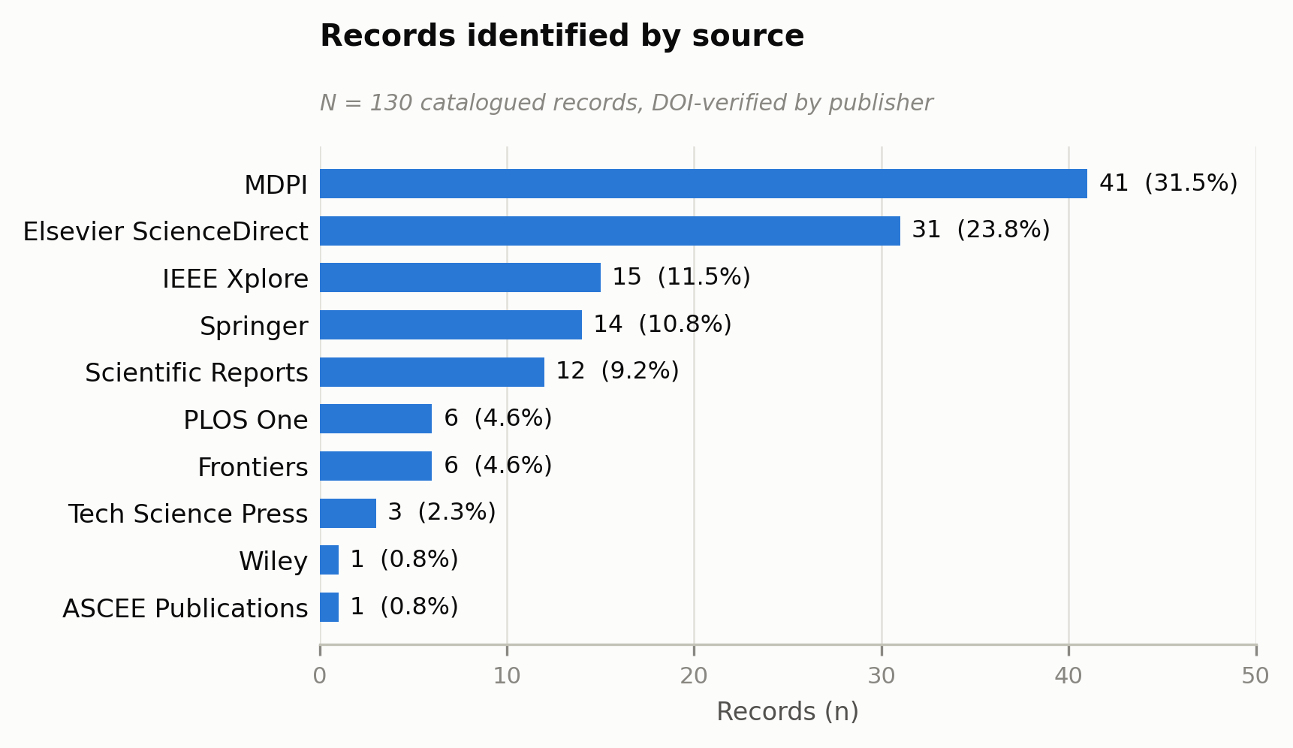
Fig. 1. Records identified by publisher (N = 130 cataloged records, grouped by DOI prefix).

C. Deduplication
Duplicates were identified by matching DOIs across the full catalog. Five duplicate pairs were found. In four pairs the two PDF files were byte-identical (same MD5 checksum). In the fifth pair the text was identical but the files differed. The later-cataloged copy of each pair was removed: one from the publisher-platform route and four from other methods. This left 125 unique records.

D. Eligibility Criteria
A record was included only if it met all three criteria:
C1, disaster SAR application domain. The paper's primary stated application is disaster SAR, for example post-earthquake or collapsed-structure search, urban SAR, flood, wildfire, mine, wilderness, or maritime rescue. In operational terms, SAR has to frame the problem statement and the evaluation, not only the introduction or future work. Papers whose primary application is industrial, agricultural, medical, military, or general Internet of Things (IoT) were excluded even when they mentioned SAR in passing.
C2, robotic system with an active operational role. The paper presents a robot, or a robot-control framework, that performs or directly supports SAR tasks under any mode of control. Papers in which the robot serves only as a sensor carrier, communication relay, or logistics vehicle were excluded.
C3, empirical contribution. The paper evaluates its system by simulation, laboratory or bench experiment, prototype testing, or field deployment. Opinion pieces, conceptual frameworks with no evaluation, reviews, and editorials were excluded. For example, the needs-assessment study of Rajashekhar and Prabhakar (2026) combines a literature review, a public survey, and interviews with first responders on post-earthquake robot use. It was excluded because it neither presents nor tests a robotic system.
The publication-year limit (2025 onward) was applied at the identification stage. For the AI-assisted records it was enforced by checking the publication date of each retrieved record. Peer-reviewed journal articles in English were eligible [[AUTHOR INPUT NEEDED: confirm that conference papers and non-English records were not eligible, or state the actual rule]].

E. Screening Process
All 125 unique records were screened in a single full-text pass rather than a title/abstract stage followed by a full-text stage. Several exclusions only became apparent beyond the abstract. Typical cases were papers that mention SAR as motivation but evaluate generic navigation, industrial teleoperation, or abstract routing problems.
Two authors screened every record against C1–C3 independently and recorded, for each exclusion, every criterion it failed. [[AUTHOR INPUT NEEDED: who the two screeners were (initials); how disagreements were resolved, given that the screening record says the two sets of decisions were "averaged out", a term that has no meaning for include/exclude decisions; whether the per-screener decisions were kept.]] The screeners' separate decisions were not kept, so agreement between the screeners cannot be reported. Section V-D notes this as a limitation. Every record received a final include or exclude decision. The full screening log, with the reason for each decision, is provided as supplementary material.
After screening, as a post hoc check, an AI assistant re-applied C1–C3 to the full texts of a sample of 23 excluded records, chosen to over-represent borderline and multi-criterion cases. It agreed with the logged decision for 17 records, judged 4 as borderline, and flagged 2 (both excluded under C2 as abstract grid-world agents) as possibly eligible. These results are reported in Section V-D as a threat to validity. They were not used to change the screening decisions.

F. Data Extraction
Eighteen fields were extracted for each of the 39 included papers (Table III). Extraction was carried out by an AI assistant (see the AI-use statement) from the full texts supplied by the authors, under the field definitions and classification rules described below. [[AUTHOR INPUT NEEDED: which author(s) checked the extracted values, and how, e.g. every cell or a sample.]] The original extraction workbook was not retained. The extraction table released with this review was therefore rebuilt from the 39 full texts, with a page reference for every coded cell, and checked against the classifications reported here (supplementary material).
TABLE III. Data extraction fields.
# | Field | # | Field
1 | Record ID | 10 | Perception/Detection Algorithm
2 | Citation | 11 | Navigation/Path-Planning Method
3 | Journal/Venue | 12 | Computational Architecture
4 | DOI | 13 | Disaster Scenario Modeled
5 | Robot Platform Type | 14 | Validation Type
6 | Single- or Multi-Robot | 15 | Key Reported Metric/Result
7 | Autonomy/HRI Mode | 16 | Reported Advantage(s)
8 | HRI Interface/Modality | 17 | Reported Limitation(s)
9 | Sensor Suite | 18 | Notes and Classification Rationale

Four fields were reduced to single clean categories for counting, and the sensor field was converted to flags:
- Validation Type: Simulation only; Partial (simulation plus limited physical testing); Real-world field test; Prototype bench test.
- Robot Platform Type: a system that tests two or more platform classes, or that combines two locomotion modes in one body, is coded Hybrid/Multi-Platform.
- Computational Architecture: coded by where computation runs during the mission, not by where any model was trained.
- Disaster Scenario: coded by physical setting, not hazard mechanism. For example, a flash flood in a mountain valley is coded Wilderness/Mountain.
- Sensor Suite: coded as ten independent modality flags plus a "no physical sensor modeled" flag, because most papers use several modalities.
Two further items were coded from each paper's own text:
- Human in the evaluated mission (yes/no): whether a real or simulated human makes or approves decisions, or controls the robot, during the evaluated mission. Humans who appear only as search targets, or as pilots collecting data for later offline evaluation, do not count. This variable describes the evaluation, while autonomy mode describes the designed control paradigm. The two are reported separately.
- Environmental-realism limitation (yes/no): yes when the authors themselves state that the test environment omitted or idealized physical conditions of the target disaster (for example weather, wind, lighting, smoke, dust, vegetation, rubble, water current, or degraded positioning or communications), or that validation was confined to simulation or the laboratory, with real-environment testing left for future work. The item records only what the authors state, not what the reviewers judged to be missing.

G. Autonomy/HRI Mode: Definitions and Decision Rules
Theoretical grounding. The four modes are coarse bands over the levels-of-automation (LOA) continuum. Sheridan and Verplank (1978) introduced that continuum as a ten-level scale running from full human control to full computer autonomy. Parasuraman et al. (2000) separated automation by function into four stages (information acquisition, information analysis, decision selection, and action implementation), each of which can be automated to a different degree. Endsley and Kaber (1999) showed that the allocation of monitoring, option generation, selection, and implementation shapes performance, situation awareness, and workload. Beer et al. (2014) carried this framework into human-robot interaction, defining levels of robot autonomy by which agent senses, plans, and acts. The National Institute of Standards and Technology Autonomy Levels for Unmanned Systems (ALFUS) framework rates autonomy in context, with human independence as one of its axes (Huang, 2008). In rescue robotics specifically, Murphy (2004) identified operator workload, situation awareness, and team structure as the central HRI problems. Yanco and Drury (2004) likewise treat autonomy as a continuum between teleoperation and full autonomy, with shared control in between. Kim et al. (2024) argue that autonomy is not a single dimension and distinguish its operational, intentional, and shared forms. Coarse banding of this kind has precedent in SAR. Bakzadeh et al. (2026) grouped mine-rescue platforms into three autonomy bands derived from the Sheridan–Verplank scale. Table IV shows how the four modes used here map onto these frameworks.
TABLE IV. Correspondence between the review's four modes and established autonomy frameworks (approximate).
This review | Sheridan–Verplank LOA (approx.) | Holder of decision (stage 3) / action (stage 4; Parasuraman et al., 2000) | Beer et al. (2014), approx.
Teleoperation | 1–2 | Human / human; the robot may stabilize or execute | Teleoperation, assisted teleoperation
Shared-Collaborative Control | 3–5, partitioned by function | Split by function or by asset between the human and a machine decision layer | Decision support, shared control
Supervisory Control | 5–7, at mission level | Robot, under human goal setting, consent, veto, or re-tasking / robot | Supervisory control
Fully Autonomous | 8–10 | Robot / robot; no human role in the evaluated mission | Executive control, full autonomy

Shared-Collaborative Control is placed below Supervisory Control because the human keeps real-time authority over a class of task decisions. Under Supervisory Control the human only sets goals and intervenes. The modes are therefore treated as ordered bands, not equally spaced levels, and the boundary between Shared-Collaborative and Supervisory Control at level 5 (management by consent) is the least sharp. Each paper was coded by the control paradigm as executed in its headline closed-loop evaluation, whether that evaluation was in simulation or on physical hardware. How a pre-recorded dataset was collected was not treated as evidence of mode, and nor were designs the authors recommend but did not test. Where the headline evaluation was open-loop, for example a perception module tested offline or a robot driven along a route fixed in advance, the mode was coded from the control paradigm of the platform as designed and described. The study was then coded as having no human in the evaluated mission. Mode (the designed paradigm) and human presence (the evaluation) are therefore separate variables, and the paper reports them separately.
- Teleoperation: a human decides each individual motion or action in real time, through a joystick, radio controller, virtual-reality (VR) interface, or voice or graphical commands that each map to one atomic motion. Onboard stabilization or compliance loops that only carry out the human's command do not change the mode.
- Supervisory Control: a human sets goals, waypoints, regions, or mission parameters and monitors progress. The robot's own planner sequences the actions. The human may re-task the robot or switch its autonomy level but does not drive individual actions.
- Shared-Collaborative Control: authority over task decisions is split during the mission. An autonomous decision layer (not merely a servo loop) holds real authority over some task-relevant actions, while the human keeps real-time authority over others.
- Fully Autonomous: no human makes or approves decisions during the evaluated mission. A human at most launches the system.
Borderline cases were resolved with a single tie-break: who decides each action, and who decides only the goal, in the headline experiment. Every paper received exactly one primary mode. Secondary capabilities, such as an autonomous follow-me function on a teleoperated platform, were recorded in the Notes field. The coding manual, with worked boundary cases and the rationale for each paper's classification, is provided as supplementary material.
Classification reliability. The original labels were assigned during AI-assisted extraction (Section II-F), in a single coding stream. As a post hoc check, a separate AI session that had not seen those labels coded all 39 papers from the full texts, using only the definitions above. It agreed with the original labels for 35 of 39 papers (89.7%; Cohen's κ = 0.79, 95% CI 0.61–0.97 [Cohen, 1960]; Gwet's AC1 = 0.88 [Gwet, 2008]). On the binary contrast between Fully Autonomous and human-in-the-loop modes, it agreed for 37 of 39 papers (κ = 0.88). The four disagreements were as follows:
- two at the Shared-Collaborative boundary (one study coded as Teleoperation, one as Supervisory Control);
- one between Supervisory Control and Fully Autonomous, which turned on whether goals set before the mission count as supervision;
- one study that offers both manual and autonomous modes without stating which was evaluated.
Because both codings were AI-assisted, these figures measure how consistently the written rules can be applied. They are not agreement between independent human raters. In a further post hoc pass, a third AI session coded each study by function, recording whether the machine, the human, or both held information acquisition, analysis, decision, and action in the evaluated configuration (Parasuraman et al., 2000). Every code is supported by page-referenced evidence. The designed control paradigm implied by these function codes matched the mode labels for 36 of 39 studies. The three exceptions are boundary cases discussed in Section IV. [[AUTHOR INPUT NEEDED: a co-author who did not assign the original labels should complete the blind human second-coding sheet provided in the supplementary material; report that κ here in place of, or alongside, the AI check.]]

H. Quality Appraisal
No established risk-of-bias instrument exists for primary studies in robotics engineering, and the appraisal used here is not one. It does not assess bias in the reported results. Instead, each included paper was appraised for evidential strength with a two-dimension validation-depth and reproducibility (VDR) score designed for this review [[AUTHOR INPUT NEEDED: name who assigned the scores and who checked them]]:
- Validation depth (VD):
- 1: simulation in an abstract or idealized environment.
- 2: physics-based or high-fidelity simulation, or a physical laboratory or bench test.
- 3: a physical test in a mission-representative outdoor, field, or real-site environment.
- Reproducibility (RP):
- 1: method described at a high level, with key parameters missing.
- 2: parameters and experimental setup reported in enough detail to re-implement.
- 3: as level 2, plus public code or data.
The VDR score is VD + RP, giving a range of 2–6. The appraisal also recorded whether results came from repeated trials with reported variance, or from comparison against a baseline. VD partly overlaps with Validation Type by design. The sensitivity analysis therefore uses RP, which is independent of validation setting.

I. Synthesis Methods
The synthesis is descriptive. Proportions are reported with Wilson 95% confidence intervals (CIs; Wilson, 1927). The review's primary contrast compares the field-testing rate of Fully Autonomous papers with that of papers in which a human acts during the mission (Teleoperation, Supervisory Control, and Shared-Collaborative Control combined). It was tested with a two-sided Fisher's exact test and summarized by an odds ratio (OR) with an exact 95% CI. Two secondary analyses were run: an exact Freeman–Halton test of mode (four levels) against field testing, and Fully Autonomous versus Teleoperation plus Supervisory Control. Because validation depth (VD) is ordinal, it was compared between the two groups with a Mann–Whitney U test. The platform comparisons are descriptive only, because platform is confounded with mode and the cells are small.
All tests were chosen after the data had been tabulated. They are therefore exploratory. Nominal p-values are reported. Holm-adjusted values are also given for the family formed by the five contrasts in Table XIII. The p-values in the sensitivity analyses are unadjusted. Five sensitivity analyses test the primary contrast:
- (a) restricting to studies with a physical platform, which excludes abstract agents and sensor-free simulations (a planned restriction to studies with a human in the evaluated mission cannot be estimated, because no Fully Autonomous study has one);
- (b) restricting to papers with RP ≥ 2;
- (c) re-coding the boundary cases identified by the reliability check;
- (d) adding the two possibly misexcluded records identified in Section II-E, coded as Fully Autonomous and simulation-only;
- (e) restricting to studies identified through publisher-platform searches.
Three further descriptive comparisons were tested exploratorily:
- realism acknowledgment, generic vs. hazard-specific scenarios (Fisher's exact test);
- reproducibility (RP), Fully Autonomous vs. human-in-the-loop studies (Mann–Whitney U test);
- UAV vs. Hybrid platforms (Fisher's exact test).
Reporting bias across studies, such as non-publication of failed field trials, was not formally assessed and is discussed qualitatively in Section V-D. The certainty of the body of evidence was not graded with a formal framework such as GRADE, which is designed for clinical interventions. Section V-D gives a qualitative judgment of confidence for each main finding. Analysis scripts and the extraction table are provided as supplementary material.

J. Protocol and Registration
The review protocol was not registered, and no protocol was published in advance [[AUTHOR INPUT NEEDED: confirm; optionally deposit a retrospective record on OSF and cite it here]]. The eligibility criteria and coding rules were refined during screening and extraction, and the rules that resulted are reported in full above.

K. PRISMA Flow
Fig. 2 shows the flow of records. Of the 130 cataloged records, 78 were identified through publisher-platform searches and 52 through other methods. Five duplicates were removed, leaving 125 unique records: 77 from publisher platforms and 48 from other methods. All 125 were retrieved in full text and assessed for eligibility. In all, 39 studies were included (18 identified through publisher platforms and 21 through other methods) and 86 records were excluded. Table V breaks the exclusions down by criterion violated. Twelve excluded records violated two criteria: C1 and C2 (6), C2 and C3 (5), and C1 and C3 (1). The per-criterion counts therefore sum to 98.
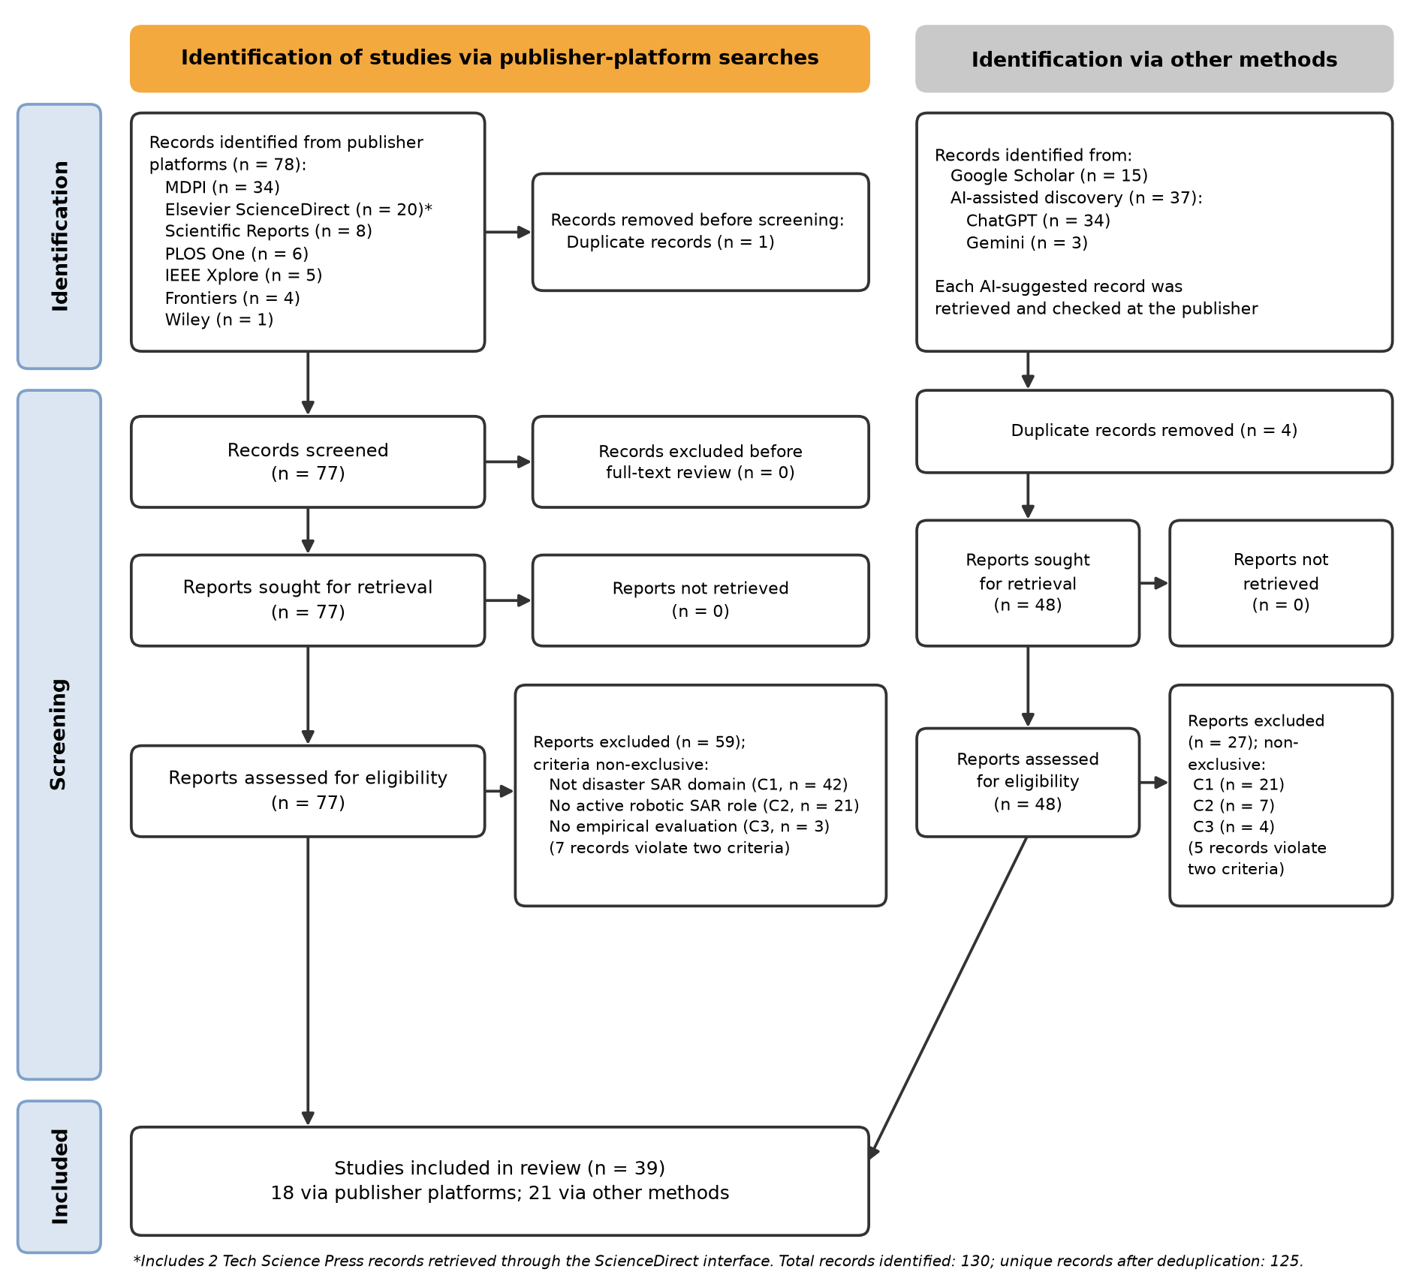
Fig. 2. PRISMA 2020 flow diagram, with records identified through publisher-platform searches and through other methods (Google Scholar and AI-assisted discovery) shown separately.
TABLE V. Exclusions by criterion violated (non-exclusive: a record violating two criteria is counted under each).
Criterion violated | n (non-exclusive) | n (first criterion failed, in order C1–C3)
C1, not disaster SAR domain | 63 | 63
C2, no active robotic SAR role | 28 | 22
C3, no empirical evaluation | 7 | 1
Total | 98 | 86
Records violating two criteria | 12 (C1+C2 6; C2+C3 5; C1+C3 1) | —

III. RESULTS
This section reports the coded characteristics of the 39 included studies, addressing RQ1–RQ4 in turn. Percentages are of N = 39 unless stated otherwise, and 95% Wilson CIs are given for the key proportions. All counts come from the released extraction table, and the analysis script reproduces every table in this section.

A. Autonomy/HRI Mode Distribution (RQ1)
Fully Autonomous systems dominate the corpus: 27 of 39 studies (69.2%; 95% CI 53.6–81.4). Teleoperation accounts for 5 studies (12.8%), Supervisory Control for 4 (10.3%), and Shared-Collaborative Control for 3 (7.7%; Table VI).
The Fully Autonomous label has to be read alongside how these studies were evaluated. In none of the 27 does a human, real or simulated, make or approve decisions during the evaluated mission. One borderline case is Vani et al. (2026): its hexapod offers both manual and autonomous modes, and the two codings disagreed on whether a human acted during its tests. Counting it would give 1 of 27. In the three human-in-the-loop modes, a human takes part in the evaluated mission in 8 of 12 studies (Table XII). For most of the corpus, then, "Fully Autonomous" describes an experimental setup in which no operator was modeled. It does not describe a system that has been shown to operate without one.
TABLE VI. Autonomy/HRI mode distribution (N = 39).
Mode | n | % (95% CI)
Fully Autonomous | 27 | 69.2 (53.6–81.4)
Teleoperation | 5 | 12.8 (5.6–26.7)
Supervisory Control | 4 | 10.3 (4.1–23.6)
Shared-Collaborative Control | 3 | 7.7 (2.7–20.3)

B. Robot Platform Type and Its Relationship to Autonomy Mode (RQ2)
Platform counts are as follows (Table VII, Fig. 3):
- unmanned aerial vehicles (UAVs): 13 studies (33.3%);
- unmanned ground vehicles (UGVs): 13 (33.3%);
- Hybrid/Multi-Platform systems: 7 (17.9%);
- Abstract/Unspecified simulated agents: 3 (7.7%);
- legged robots: 2 (5.1%);
- uncrewed surface or underwater vehicles (USV/UUV): 1 (2.6%).
TABLE VII. Robot platform type distribution (N = 39).
Platform | n | %
UAV | 13 | 33.3
UGV | 13 | 33.3
Hybrid/Multi-Platform | 7 | 17.9
Abstract/Unspecified | 3 | 7.7
Legged | 2 | 5.1
USV/UUV | 1 | 2.6

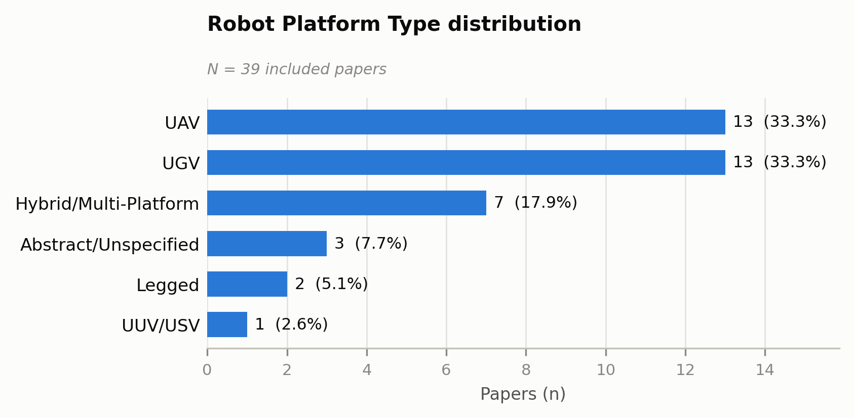
Fig. 3. Robot platform type distribution across the 39 included studies.
Autonomy mode is unevenly distributed across platforms (Table VIII):
- All three Shared-Collaborative studies use UAVs.
- No Teleoperation study uses a UAV on its own. Its five instances are two UGVs and three Hybrid/Multi-Platform systems.
- Fully Autonomous studies span every platform category.
These cells are small, so the pattern is descriptive only.
TABLE VIII. Autonomy mode × platform type.
Mode | UAV | UGV | Legged | USV/UUV | Hybrid/Multi-Platform | Abstract/Unspecified | Total
Teleoperation | 0 | 2 | 0 | 0 | 3 | 0 | 5
Supervisory Control | 1 | 2 | 0 | 0 | 1 | 0 | 4
Shared-Collaborative Control | 3 | 0 | 0 | 0 | 0 | 0 | 3
Fully Autonomous | 9 | 9 | 2 | 1 | 3 | 3 | 27
Total | 13 | 13 | 2 | 1 | 7 | 3 | 39

C. Sensor Suite and Computational Architecture (RQ3, Part 1)
Sensor modalities are coded as non-exclusive flags (Table IX, Fig. 4). Visual sensing is the most common modality (17 studies, 43.6%), followed by light detection and ranging (LiDAR) or other range sensing (14, 35.9%) and inertial or proprioceptive sensing (inertial measurement unit (IMU), 13, 33.3%). One in four studies (10, 25.6%) models no physical sensor at all and evaluates planning or coordination on idealized maps.
TABLE IX. Sensor modality prevalence (non-exclusive; N = 39).
Modality | n | %
Visual | 17 | 43.6
LiDAR/range | 14 | 35.9
IMU/proprioceptive | 13 | 33.3
None (idealized simulation) | 10 | 25.6
GNSS/GPS | 7 | 17.9
Thermal | 5 | 12.8
Depth | 5 | 12.8
Gas/chemical | 3 | 7.7
Acoustic | 3 | 7.7
RF/radar | 2 | 5.1
Physiological (human-worn) | 2 | 5.1

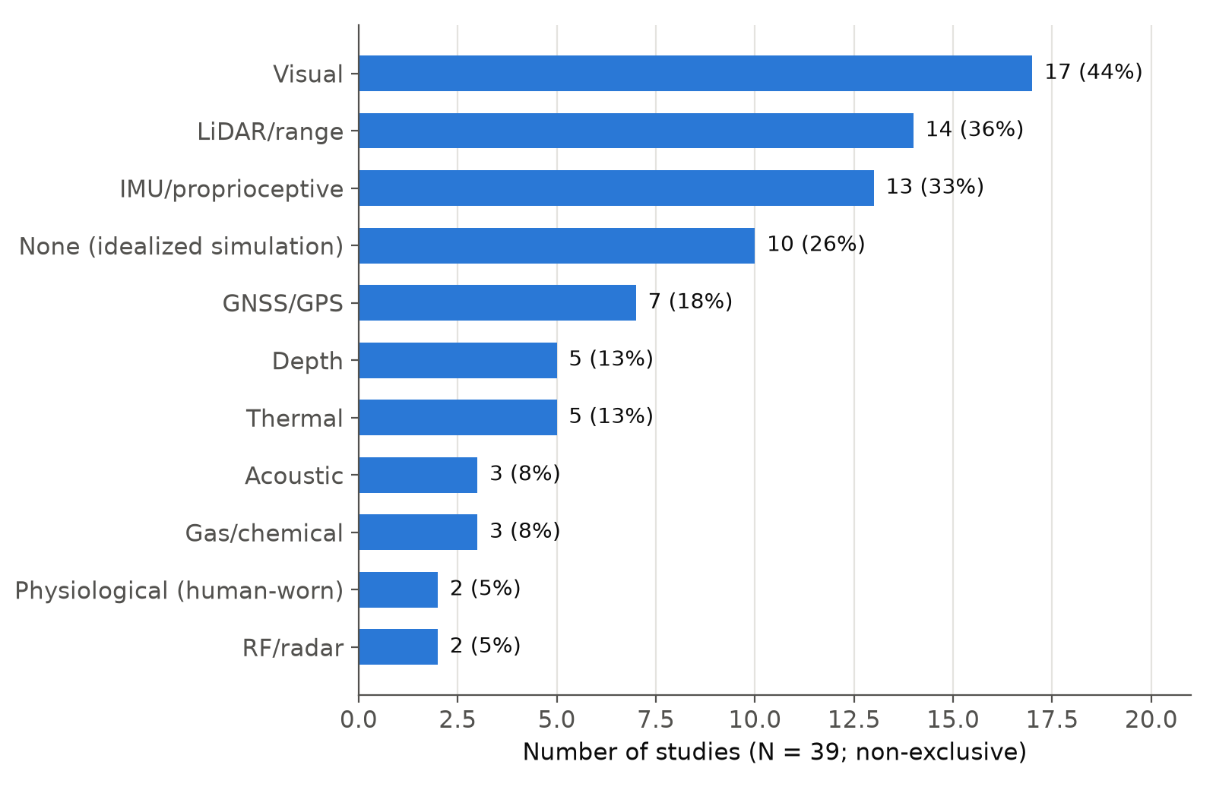
Fig. 4. Sensor modality prevalence across the 39 included studies (non-exclusive; percentages do not sum to 100%).
Computational architecture was coded by where computation runs during the mission (Table X). The categories are:
- PC/Offline: 21 studies (53.8%). This category includes every study evaluated only in simulation.
- Runtime-hybrid: 8 (20.5%). Two or more compute locations are active during the mission.
- Onboard/Edge: 7 (17.9%).
- Cloud: 1 study, whose decisions depend on a remotely hosted large language model (LLM).
- Not reported: 2.
TABLE X. Computational architecture distribution (N = 39).
Architecture | n | %
PC/Offline (incl. simulation-only) | 21 | 53.8
Hybrid (runtime) | 8 | 20.5
Onboard/Edge | 7 | 17.9
Cloud | 1 | 2.6
Not reported | 2 | 5.1

D. Validation Type and Its Relationship to Autonomy Mode (RQ3, Part 2)
Under the primary (strict) coding, validation splits as follows (Table XI, Fig. 5):
- simulation only: 19 studies (48.7%);
- partial physical testing, i.e. simulation plus a limited physical test, or a physical test in a laboratory or mock facility: 12 (30.8%);
- a real-world field test at a non-mock outdoor or real site: 6 (15.4%; 95% CI 7.2–29.7);
- a prototype bench test: 2 (5.1%).
Under the lenient coding, which also counts constructed outdoor courses and competition venues as field tests, 9 studies (23.1%) were field-tested.
TABLE XI. Validation type distribution under the primary (strict) and sensitivity (lenient) codings (N = 39).
Validation | Strict n (%) | Lenient n (%)
Simulation only | 19 (48.7) | 19 (48.7)
Partial (simulation + limited physical, or lab/mock facility) | 12 (30.8) | 10 (25.6)
Real-world field test | 6 (15.4) | 9 (23.1)
Prototype bench test | 2 (5.1) | 1 (2.6)

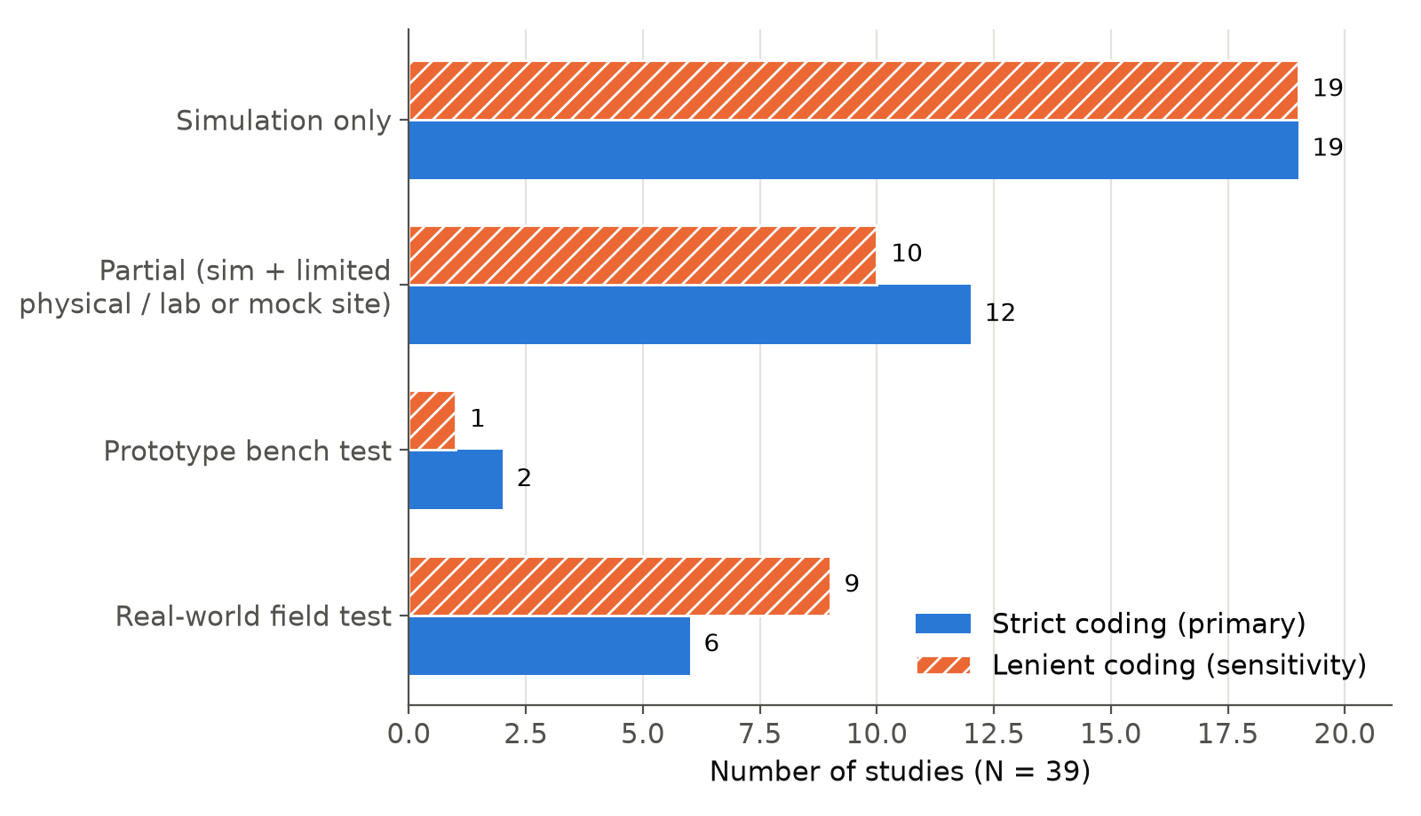
Fig. 5. Validation type distribution across the 39 included studies under the primary (strict) and sensitivity (lenient) codings.
Table XII cross-tabulates validation against autonomy mode, and Fig. 6 shows the field-testing rates with their confidence intervals. The comparison groups are defined by designed mode. "Human-in-the-loop modes" means Teleoperation, Supervisory Control, and Shared-Collaborative Control combined. Whether a human actually took part in the evaluated mission is a separate variable, reported in the last two columns.
Fully Autonomous studies:
- field-tested: 2 of 27 (7.4%; 95% CI 2.1–23.4) under the strict primary coding, and 4 of 27 (14.8%) under the lenient coding;
- simulation only: 16 of 27 (59.3%);
- no human in the evaluated mission: all 27.
Human-in-the-loop studies:
- field-tested: 4 of 12 (33.3%; 95% CI 13.8–60.9) under the strict coding, and 5 of 12 (41.7%) under the lenient coding;
- a human took part in the evaluated mission in 8 of 12.
Any physical testing showed the same direction (11 of 27 [40.7%] against 9 of 12 [75.0%]), as did mean validation depth (VD, 1–3: 1.70 against 2.25).
TABLE XII. Autonomy mode × validation type (strict coding), with per-mode validation indicators.
Mode | Simulation only | Partial | Bench | Field | Field, strict % (95% CI) | Field, lenient % | Any physical test % | Human in evaluated mission | Mean VD
Teleoperation (n = 5) | 1 | 1 | 0 | 3 | 60.0 (23.1–88.2) | 60.0 | 80.0 | 3/5 | 2.40
Supervisory Control (n = 4) | 0 | 3 | 0 | 1 | 25.0 (4.6–69.9) | 50.0 | 100 | 3/4 | 2.75
Shared-Collaborative (n = 3) | 2 | 1 | 0 | 0 | 0.0 (0.0–56.1) | 0.0 | 33.3 | 2/3 | 1.33
Fully Autonomous (n = 27) | 16 | 7 | 2 | 2 | 7.4 (2.1–23.4) | 14.8 | 40.7 | 0/27 | 1.70
All (N = 39) | 19 | 12 | 2 | 6 | 15.4 (7.2–29.7) | 23.1 | 51.3 | 8/39 | 1.87

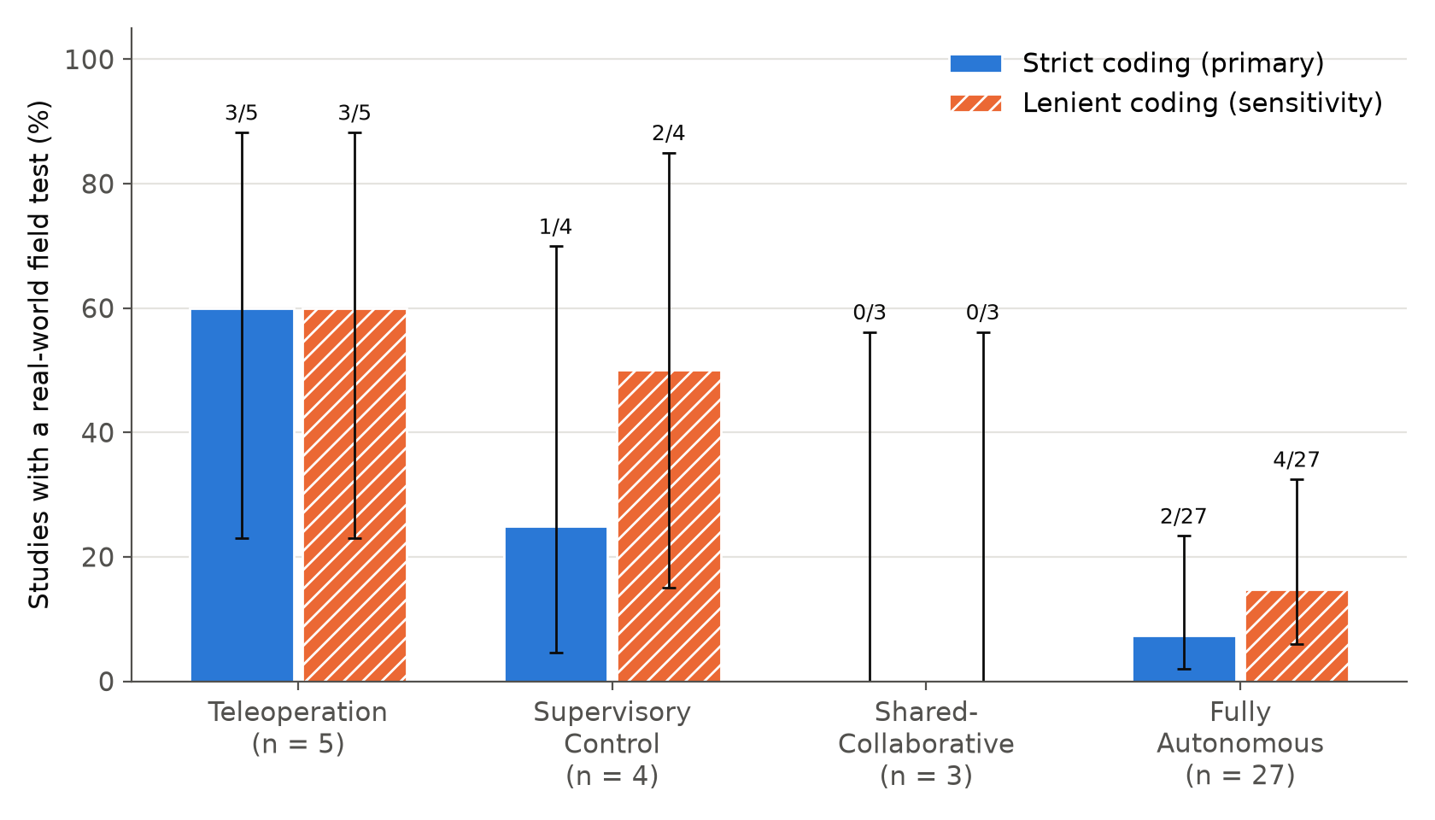
Fig. 6. Real-world field-testing rate by autonomy/HRI mode under the strict (primary) and lenient (sensitivity) codings, with 95% Wilson confidence intervals and group sizes.
Table XIII reports the exploratory tests. On every indicator the odds of validation were lower for Fully Autonomous studies, but the evidence is weak:
- Primary outcome (strict field testing): OR 0.17 (95% CI 0.013–1.43), p = 0.060.
- Lenient field testing: p = 0.10.
- Any physical testing: p = 0.082.
- Validation depth: Mann–Whitney p = 0.060.
- Four modes together: the exact Freeman–Halton test of mode against field testing gave p = 0.029 (strict) and p = 0.049 (lenient).
After Holm adjustment across the five contrasts in Table XIII, no contrast falls below 0.05 (adjusted p = 0.12–0.18). The direction of the difference is consistent, but this corpus is too small to establish it statistically.
The rates are also not ordered along the autonomy scale: Supervisory Control (25%) falls below Teleoperation (60%), and Shared-Collaborative Control (0%) falls below both. The data therefore do not support a monotonic gradient.
Field testing was more strongly associated with whether a human took part in the evaluated mission than with designed mode:
- strict coding: 4 of 8 studies with a human present against 2 of 31 without (p = 0.011);
- lenient coding: 5 of 8 against 4 of 31 (p = 0.009).
This association is partly circular. Physical demonstrations usually require an operator, and operator studies usually require a physical system. It is reported as a description of how evaluations are designed, not as an effect of autonomy.
TABLE XIII. Exploratory contrasts: Fully Autonomous (FA) vs. human-in-the-loop modes (two-sided Fisher's exact test; conditional maximum-likelihood OR with exact 95% CI; Holm adjustment across the five rows).
Outcome | FA | Human-in-the-loop | OR (95% CI) | p | Holm p
Field test, strict (primary) | 2/27 (7.4%) | 4/12 (33.3%) | 0.17 (0.013–1.43) | 0.060 | 0.180
Field test, lenient | 4/27 (14.8%) | 5/12 (41.7%) | 0.25 (0.038–1.54) | 0.102 | 0.180
Any physical test | 11/27 (40.7%) | 9/12 (75.0%) | 0.24 (0.034–1.24) | 0.082 | 0.180
Mission-representative site (VD = 3) | 4/27 (14.8%) | 6/12 (50.0%) | 0.18 (0.028–1.05) | 0.043 | 0.171
Field test, strict: FA vs. Teleoperation + Supervisory (secondary) | 2/27 (7.4%) | 4/9 (44.4%) | 0.11 (0.008–0.99) | 0.025 | 0.122

Field-testing rates also differ by platform (Table XIV), but these differences are not statistically distinguishable:
- UAV studies: 3 of 13 (23.1%).
- Hybrid/Multi-Platform studies: 3 of 7 (42.9%), or 4 of 7 under the lenient coding. UAV and Hybrid do not differ (p = 0.61).
- UGV studies: 0 of 13, or 2 of 13 under the lenient coding.
Platform is also confounded with mode: all three Hybrid field tests are Teleoperation studies. These differences are therefore reported descriptively.
TABLE XIV. Platform type × validation type (strict coding).
Platform | Simulation only | Partial | Bench | Field | Total
UAV | 8 | 2 | 0 | 3 | 13
UGV | 7 | 6 | 0 | 0 | 13
Hybrid/Multi-Platform | 1 | 2 | 1 | 3 | 7
Abstract/Unspecified | 3 | 0 | 0 | 0 | 3
Legged | 0 | 1 | 1 | 0 | 2
USV/UUV | 0 | 1 | 0 | 0 | 1
Total | 19 | 12 | 2 | 6 | 39

E. Disaster Scenario Modeled (RQ4)
Most studies (24 of 39, 61.5%) test a Generic/Unspecified disaster environment, such as rubble, an indoor building, or an urban area, without modeling a specific hazard (Table XV). The remaining scenarios are:
- Underground/Mine/Tunnel/Cave: 5 (12.8%);
- Wilderness/Mountain/Forest: 4 (10.3%);
- Earthquake/Structural Collapse: 3 (7.7%);
- Maritime/Water, Wildfire/Fire, and volcanic eruption: 1 each (2.6%).
Generic scenarios occur in every mode. None of the five Underground studies uses Teleoperation: three are Fully Autonomous and two use Supervisory Control. By contrast, the mine-rescue platform inventory of Bakzadeh et al. (2026) is predominantly teleoperated.
TABLE XV. Disaster scenario distribution (N = 39).
Scenario | n | %
Generic/Unspecified | 24 | 61.5
Underground/Mine/Tunnel/Cave | 5 | 12.8
Wilderness/Mountain/Forest | 4 | 10.3
Earthquake/Structural Collapse | 3 | 7.7
Maritime/Water | 1 | 2.6
Wildfire/Fire | 1 | 2.6
Other (volcanic eruption) | 1 | 2.6

F. Self-Reported Realism Limitations and Reporting Quality
Under the author-stated rule (Section II-F), 26 of 39 studies (66.7%; 95% CI 51.0–79.4) acknowledge that their test environment omitted or idealized physical conditions of the target disaster, or that real-environment testing remains future work (Table XVI). Under a broader reading, 33 of 39 (84.6%) mention some real-world-condition gap; that reading also counts sensor or communication limits and the absence of field testing. Acknowledgment was not more common among Generic-scenario studies: 14 of 24 (58.3%) against 12 of 15 (80.0%) for hazard-specific studies (p = 0.30).
Validation-depth and reproducibility (VDR) scores averaged:
- 4.40 for Teleoperation;
- 5.00 for Supervisory Control;
- 3.33 for Shared-Collaborative Control;
- 3.81 for Fully Autonomous studies.
No difference in reproducibility (RP) was detected between Fully Autonomous studies and human-in-the-loop studies (mean 2.11 against 2.08; p = 0.83). Most studies (35 of 39) report repeated trials or a baseline comparison. Only 5 of 39 (12.8%; 95% CI 5.6–26.7) link to publicly released code or data.
TABLE XVI. Self-reported realism limitations and reporting-quality indicators.
Indicator | All (N = 39) | Generic scenario (n = 24) | Hazard-specific (n = 15)
Realism limitation, author-stated rule | 26 (66.7%) | 14 (58.3%) | 12 (80.0%)
Realism limitation, broad reading | 33 (84.6%) | 19 (79.2%) | 14 (93.3%)
Repeated trials or baseline comparison | 35 (89.7%) | — | —
Public code or data | 5 (12.8%) | — | —

G. Sensitivity Analyses
Table XVII tests how robust the Fully Autonomous contrast is. Its direction never reverses, but the strength of the evidence depends on which studies are included:
- (a) Physical platform only. Excluding abstract agents and sensor-free simulations removes 10 Fully Autonomous studies, all of them simulation-only, so part of the attenuation follows by construction. The contrast weakens: field tests 2 of 17 against 4 of 12 (p = 0.20); any physical test 11 of 17 against 9 of 12 (p = 0.69). Because the restriction removes only simulation-only studies, this analysis cannot by itself show where the gap originates. It shows only that the gap does not persist clearly among studies with a physical platform.
- (b) Restricting to studies with RP ≥ 2. The results change little.
- (c) Boundary cases re-coded with the independent blind codes. The strict field-testing contrast weakens to 3 of 27 against 3 of 12 (p = 0.35).
- (d) Adding the two possibly misexcluded records (Section II-E). The results change little (strict field testing p = 0.050).
- (e) Only studies identified through publisher-platform searches. This leaves 14 Fully Autonomous and 4 human-in-the-loop studies, too few for inference. Strict field testing was 2 of 14 against 1 of 4.
A restriction to studies that model a human role could not be estimated, because none of the Fully Autonomous studies models one.
TABLE XVII. Sensitivity analyses of the FA vs. human-in-the-loop contrast (Fisher's exact p).
Analysis | n (FA / human-in-the-loop) | Field, strict | Field, lenient | Any physical test
Primary (all studies) | 27 / 12 | 2/27 vs 4/12, p = 0.060 | 4/27 vs 5/12, p = 0.102 | 11/27 vs 9/12, p = 0.082
(a) Physical platform only (excludes abstract agents and sensor-free simulations) | 17 / 12 | 2/17 vs 4/12, p = 0.198 | 4/17 vs 5/12, p = 0.422 | 11/17 vs 9/12, p = 0.694
(b) Reproducibility RP ≥ 2 | 26 / 12 | 2/26 vs 4/12, p = 0.066 | 4/26 vs 5/12, p = 0.108 | 10/26 vs 9/12, p = 0.079
(c) Boundary cases re-coded (blind codes) | 27 / 12 | 3/27 vs 3/12, p = 0.348 | 5/27 vs 4/12, p = 0.416 | 11/27 vs 9/12, p = 0.082
(d) Two possibly misexcluded records added as FA, simulation only | 29 / 12 | 2/29 vs 4/12, p = 0.050 | 4/29 vs 5/12, p = 0.093 | 11/29 vs 9/12, p = 0.043
(e) Publisher-platform-identified studies only | 14 / 4 | 2/14 vs 1/4, p = 1.000 | 3/14 vs 2/4, p = 0.533 | 6/14 vs 3/4, p = 0.576

IV. TAXONOMY OF AUTONOMY/HRI APPROACHES
This section synthesizes the 39 studies by autonomy/HRI mode. For each mode it describes the technical approaches, how they were evaluated, and the trade-offs their authors report. Fig. 7 shows the four modes as ordered bands of decision authority (Section II-G), with the number of studies in each.
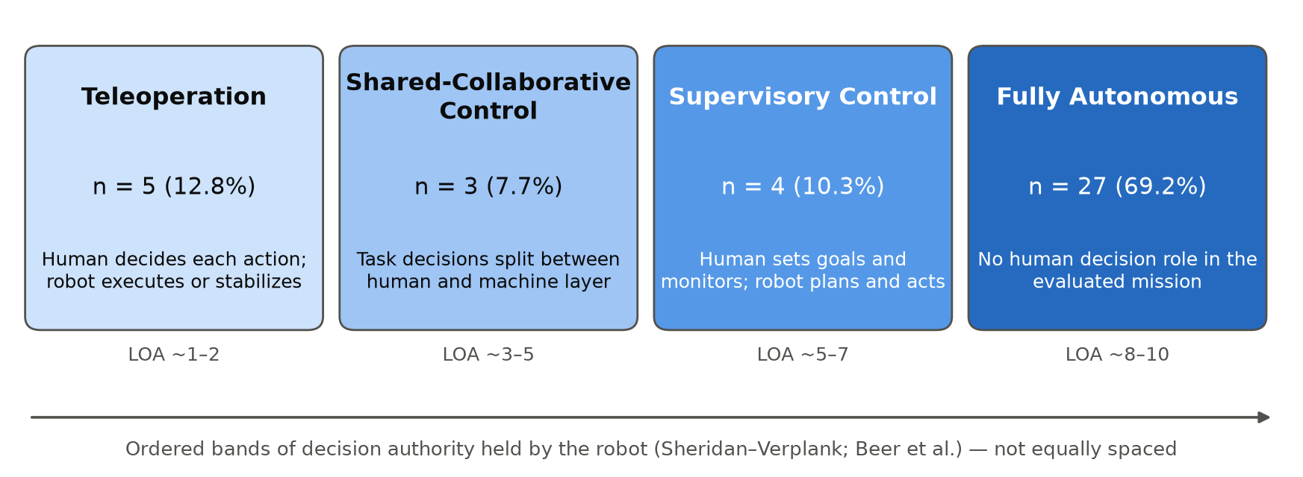
Fig. 7. The four autonomy/HRI modes, ordered by the decision authority held by the robot (Section II-G), with the number and share of the 39 included studies in each mode. The boundaries between modes are bands, not points.

A. Teleoperation (n = 5)
In the Teleoperation studies, the research effort goes into mechanical design and perception rather than control autonomy. All five platforms are designed for human-driven locomotion. In three of them, a human drove the robot during the evaluated mission. The other two (Khattab et al., 2025; Raghavan et al., 2026) evaluated perception offline. Three are Hybrid/Multi-Platform systems:
- A voice-controlled add-on controller tested on a drone and on a quadruped (Cafolla et al., 2026). Its voice commands each trigger one motion. The platform also offers an autonomous person-following mode and scripted patrol routes, which were demonstrated but were not the primary evaluated behavior.
- A terrestrial–aerial vehicle whose separation-cage structure avoids the camera and LiDAR occlusion of single-cage designs (Jia et al., 2025).
- A wheeled-hexapod rescue platform with a 1,200 kg payload, the highest among the three wheeled-hexapod platforms it is compared with Liu et al. (2026). A hierarchical controller keeps its body level on uneven terrain.
The remaining two are ground vehicles built around perception:
- An occluded-victim detector based on YOLOv8 that reaches 93.1% mean average precision (mAP; Raghavan et al., 2026).
- A visual–thermal–audio fusion system validated on synthetic data, not on the physical prototype (Khattab et al., 2025).
Two of the five (Khattab et al., 2025; Raghavan et al., 2026) explicitly leave autonomous navigation to future work.

B. Supervisory Control (n = 4)
In the Supervisory Control studies, the human sets goals and monitors while the robot plans and executes. All four tested physical systems, but only one did so at a non-mock field site:
- Coal-mine rescue robot (S. You et al., 2026). It combines point-cloud navigation with a digital-twin operator interface and was evaluated in a mock coal-mine tunnel inside a university explosion laboratory.
- Sampling-based semantic navigation planner (Ahmad & Humbert, 2025). The exploration planner ran on legged and wheeled robots at the DARPA Subterranean Challenge final. The semantic-navigation extension was tested separately, on one legged robot inside a university building. The planned aerial component was not fielded.
- Semantics-based situational-awareness framework (Ruan et al., 2025). It builds interpretable, expert-tunable indicators rather than relying on an opaque end-to-end model. Its own experiments were run in a laboratory arena along predefined waypoints, without a live operator. The authors cite a companion user study for reduced workload and reaction time and increased trust.
- Terrain-aware UAV search planner (Schomer & Adams, 2026). It visits high-probability regions first, so that a flight cut short still covers the most valuable area. In its field trials every flight ended early, most often through loss of line of sight and also through wind and battery limits. This is precisely the operating constraint the method is designed to absorb.

C. Shared-Collaborative Control (n = 3)
All three Shared-Collaborative studies use UAVs. Each assigns specific task decisions to the human and others to the machine.
- Bhattacharya and Butail (2025): human pilot plus autonomous swarm. A human teleoperates a primary search UAV, while a separate autonomous swarm infers the operator's state from the UAV's movement and adapts its search. The adaptive swarm was evaluated in simulation on replayed participant trajectories; during the live user study the swarm stayed stationary. The authors describe the underlying physiological correlations as weak.
- Gaitan et al. (2025): radio-controlled UAV plus agentic layer. The UAV is radio-controlled, and an LLM-orchestrated multi-agent layer filters and prioritizes what the operator sees. The paper is inconsistent about whether the payload release is triggered by the operator or by the agent. Validation took place in a controlled laboratory, against synthetic scenarios, without human participants. Detection of strongly occluded victims remained weak, with a per-class mAP@0.5 of 0.026–0.264 for the hardest occlusion classes.
- F. You et al. (2026): mixed-reality swarm interface. The interface was evaluated in a simulated mountain-wilderness flash-flood scenario with 35 participants; physiological data were usable for 27. Compared with the same interface without its resilience features, it improved situation awareness and usability. Resilience was measured by questionnaire, and heart-rate variability was used to index workload and recovery.
This is the least reproducible mode. In the independent blind check (Section II-G), Gaitan et al. (2025) was read as Teleoperation and F. You et al. (2026) as Supervisory Control. Section V-D discusses the implications.

D. Fully Autonomous (n = 27)
Fully Autonomous is both the largest mode and the most varied. Its 27 studies are grouped below into four clusters by primary technical contribution. The grouping was made for this synthesis and is not a coding category. Table XVIII shows that the clusters differ sharply in validation.
TABLE XVIII. Fully Autonomous cluster × validation type (strict coding).
Cluster | n | Simulation only | Partial | Bench | Field
Multi-robot coordination and task allocation | 12 | 10 | 2 | 0 | 0
Single-robot navigation and path planning | 7 | 4 | 2 | 0 | 1
Perception-driven detection and search | 5 | 2 | 2 | 0 | 1
Platform/architecture design | 3 | 0 | 1 | 2 | 0

Multi-robot coordination and task allocation (12 studies). These studies address how multiple agents divide a search area, avoid redundant coverage, or allocate rescue tasks. Control ranges from fully decentralized to explicitly centralized schemes. The methods include:
- multi-agent or parameter-shared deep reinforcement learning (DRL; Gao et al., 2026; Mead et al., 2026; Tan & Zhao, 2026);
- reinforcement-learned safe-return decisions combined with heuristic frontier allocation (Xue et al., 2026);
- decentralized reward shaping without explicit communication (ur Rehman et al., 2026);
- a PX4/Gazebo UAV swarm in which each drone chooses its next waypoint with bio-inspired metaheuristics over a shared thermal-confidence map (Kareem et al., 2026c);
- information-driven team collaboration in the RoboCup Rescue simulator (Bedi et al., 2026);
- air–ground map fusion with DRL navigation (Tao et al., 2025);
- centrally coordinated multi-person search (Wang & Benhabib, 2025) and fleet mission planning (Romero et al., 2026);
- radio-frequency-guided exploration (Maresca et al., 2026);
- prediction-based distributed task allocation (Li et al., 2026).
Ten of the twelve were evaluated in simulation only, and none reached a field test. The closest to physical validation is Mead et al. (2026). Its curriculum-trained multi-UGV policy ran on one physical robot alongside three simulated teammates. All ten hybrid trials extinguished their fires, but three involved collisions, attributed to long grass read as obstacles (false positives) and wind-moved obstacles that were missed (false negatives). Its scaling results (95.83% success with 4 agents falling to 69.36% with 24) come from simulation. Team-size effects also appear in (Gao et al., 2026; Tan & Zhao, 2026).
Single-robot navigation and path planning (7 studies). The methods are:
- obstacle-anticipating model predictive control (MPC; Rado et al., 2025);
- energy-aware Q-learning coverage (Xue et al., 2025);
- a low-cost quadcopter that flew one autonomous mission in an underground car park (Allan & Barczyk, 2025);
- improved adaptive Monte Carlo localization (AMCL) with a dynamic A* variant for Ackermann vehicles (Chen, Sun, et al., 2026);
- thermal–visual–inertial odometry for satellite-denied environments, piloted in corridors and on mock rubble (Almalkawi et al., 2026);
- GPS–inertial heading estimation, tested on a constructed volcanic-terrain course (Yeoh et al., 2026);
- symmetric path planning for coal mines (Kozhubaev et al., 2025).
Four of the seven are simulation-only, two include partial physical testing, and one (Allan & Barczyk, 2025) is a field test.
Perception-driven detection and search (5 studies). These studies improve detection or search strategy rather than mobility:
- dual-altitude thermal-then-visual UAV victim confirmation, in simulation (Kareem et al., 2026b);
- next-best-view planning that located five of seven targets partly hidden by vegetation (Strand et al., 2026). Its real-world evaluation was offline, on images recorded during a single flight.
- a shore-based vision station that steers a radio-controlled rescue boat toward floating targets, tested in nine runs in a calm indoor pool (Srijiranon et al., 2026);
- trajectory optimization that raises detection confidence without changing the detector, flown outdoors over several terrain types with human subjects (He et al., 2026);
- survivor-location prediction with path planning that its authors say works best in sparsely populated areas (Gowry Sailaja et al., 2026).
Platform and architecture design (3 studies).
- Cruz Ulloa et al. (2026): a bio-inspired quadruped that uses material-aware risk mapping to reduce slippage, tested in an indoor arena with mixed-friction surfaces.
- Vani et al. (2026): a modular hexapod with LoRa and Wi-Fi links. It offers both manual and autonomous modes, and its reported tests do not state which mode was used.
- Cho et al. (2026): IMPACT-Agent, the clearest example of how the Fully Autonomous label should be read. Its multimodal-LLM-driven UGV reached a 40% path-planning success rate with chain-of-thought prompting, a rate the authors call modest for safety-critical use. Its perception task reached up to 86% mAP. The authors recommend a human-supervised architecture in which the model reasons at a high level under meaningful human control. That architecture was not implemented in the reported experiments, which tested end-to-end autonomous control on a tabletop mock-up.
Across the clusters, physical evaluation is rare among Fully Autonomous coordination and planning algorithms. Where it does occur, it is usually confined to one platform, a laboratory, or a constructed site.

E. Synthesis: The Taxonomy as an Organizing Axis
Three observations follow from coding every study on one autonomy/HRI axis.
- The modes may differ in validation, not only in design. Human-in-the-loop studies reached physical and field testing more often than Fully Autonomous studies. The difference is consistent in direction but not statistically established in this corpus (Section III-D).
- The modes are not equally reproducible. The Teleoperation/Fully Autonomous distinction was coded reliably. The Shared-Collaborative/Supervisory boundary was not, which suggests that future reviews should code who holds each decision function (Parasuraman et al., 2000) rather than assign a single mode.
- The Fully Autonomous label describes the experiment as much as the system. In none of the 27 Fully Autonomous studies did a human take part in the evaluated mission, so no human role was present to be removed (Section III-A).
These observations depend on classifying a corpus primarily along this axis, which the reviews compared in Section I do not do.

V. DISCUSSION
This section interprets the results, compares them with external evidence, sets out the threats to validity, and draws implications for research and reporting.

A. Why Fully Autonomous Studies Are Validated Less Often
Fully Autonomous studies make up 69.2% of the corpus. Only 2 of 27 were field-tested under the strict coding, and 16 of 27 were evaluated in simulation only. Human-in-the-loop studies were field-tested and physically tested more often (Section III-D). The direction of this difference held under every coding and sensitivity analysis, but its statistical support is weak:
- the primary outcome, strict field testing, gave p = 0.060;
- no contrast survives Holm adjustment;
- the difference weakens further when abstract agents and sensor-free simulations are excluded, or when boundary cases are re-coded (Table XVII).
We therefore treat it as a hypothesis that this corpus supports in direction but cannot establish statistically.
If the difference is real, one possible explanation, which we could not test, is a difference in research genre rather than an intrinsic property of autonomy. Contribution type was not coded systematically. Most Fully Autonomous studies contribute an algorithm for coordination, coverage, or planning. They evaluate it on idealized maps or abstract agents, and none of the 12 multi-robot coordination studies reached a field test (Table XVIII). Human-in-the-loop studies, by contrast, usually contribute a system: a platform, an interface, or an operator workflow. A system can hardly be evaluated without being built, and once built it is easier to take into the field. Three observations are consistent with this hypothesis, although none tests it:
- Field testing tracks whether a human took part in the evaluation more closely than it tracks designed mode (Section III-D).
- The gap does not persist clearly among studies with a physical platform. Because that restriction removes only simulation-only Fully Autonomous studies, part of the attenuation follows by construction.
- No difference in reproducibility scores was detected between the two groups (p = 0.83). This does not show that the groups are equivalent, but it gives no indication that Fully Autonomous studies are reported less carefully.
This reading is consistent with the broader robotics literature:
- Simulators approximate contact dynamics, sensing, and environmental disturbance only imperfectly, so controllers learned in simulation often degrade on hardware (Salvato et al., 2021). Domain randomization and adaptation reduce, but do not remove, this reality gap (Zhao et al., 2020).
- Robotics practitioners report heavy reliance on simulation for testing, with the reality gap among the main obstacles (Afzal et al., 2021).
- In SAR specifically, earlier readiness assessments found a persistent gap between laboratory capability and responders' requirements for robustness and ease of use (Delmerico et al., 2019).
- Recent reviews identify sim-to-real transfer as a principal barrier to deployment and note a heavy dependence on controlled experimental settings (Jamwal & Singh, 2026; Shuvo et al., 2026). They also report that full field deployment is rare: 4.2% of the more than 190 ground-robot studies surveyed in Sinha et al. (2026).
Our corpus-wide field-testing rate is 15.4% under the strict coding and 23.1% under the lenient coding. That is comparable to the 14.7% of ground-robot studies that Sinha et al. (2026) classify as experimental field studies, and well above their 4.2% full field deployments. The categories are not identical, but the order of magnitude agrees. What this review adds is the observation that the shortfall is concentrated in the mode that dominates current research. In that mode, no evaluated mission includes a human.
Table XIX lists the nine studies that tested a physical system at a real site or a competition venue. Their own limitations follow a common pattern:
- Short or single trials. One study's evidence is a single autonomous flight without ground truth (Allan & Barczyk, 2025).
- Simplified sites. Field sites were easier than the conditions targeted (Ahmad & Humbert, 2025; Liu et al., 2026; Schomer & Adams, 2026).
- Perception failures in real vegetation and wind. One physical robot collided because of grass and wind (Mead et al., 2026).
- Missing hazard conditions. For example, the volcanic-terrain trials had no ash, thermal gradients, or magnetic anomalies (Yeoh et al., 2026).
- Operational interruptions. Missions were cut short by line-of-sight loss, wind, and battery limits (Schomer & Adams, 2026).
Even where field testing occurs, then, it is closer to a demonstration than to the stress testing implied by standardized response-robot test methods (ASTM International, 2020).
TABLE XIX. Studies with testing at a real site or competition venue (lenient coding), with the limitations their authors report.
Study | Mode | Platform | Site and scope (strict code) | Reported limitation
Cafolla et al. (2026) | Teleoperation | Hybrid (UAV + quadruped) | Indoor and outdoor trials in wind and noise (field) | Person-following not tested on the quadruped; slow scene reconstruction
Jia et al. (2025) | Teleoperation | Hybrid (air–ground) | Outdoor flight and ground tests in strong wind; drop tests (field) | Abbreviated impact and recognition testing
Liu et al. (2026) | Teleoperation | Hybrid (wheel–leg) | Gravel slope and sand/soil terrain (field) | Not tested on extreme terrain
Ahmad and Humbert (2025) | Supervisory | Hybrid (legged + wheeled) | DARPA SubT final course; semantic extension in a campus building (partial) | Simplified mapping; map-origin error correction
Schomer and Adams (2026) | Supervisory | UAV | Field flights with a mountain rescue unit (field) | Every flight ended early; field terrain simpler than other sites
Mead et al. (2026) | Fully Autonomous | UGV | One physical robot with three simulated teammates on an outdoor fire-scenario course (partial) | Collisions from grass false positives and wind-induced false negatives
Allan and Barczyk (2025) | Fully Autonomous | UAV | One autonomous flight in an underground car park (field) | Single flight; no ground truth; odometry drift
Yeoh et al. (2026) | Fully Autonomous | UGV | About 30 trials on constructed volcanic terrain (partial) | No ash, thermal, or magnetic-anomaly conditions
He et al. (2026) | Fully Autonomous | UAV | Outdoor flights over several terrains with human targets (field) | False-target rejection; no thermal fusion

The practical consequence is interpretive. The prevalence of Fully Autonomous systems (69.2%) should not be read as evidence that disaster robotics has moved toward field-ready autonomy. Only 2 of 27 Fully Autonomous studies (strict coding) tested a physical system at a non-mock site. One study states this caution explicitly. Cho et al. (2026) recommends human supervision of its LLM-based controller after measuring a 40% path-planning success rate, yet it tested only the unsupervised configuration.

B. What the Fully Autonomous Label Measures
In none of the 27 Fully Autonomous studies did a human, real or simulated, take part in the evaluated mission, so there was no operator to remove. In these studies, "no human in the loop" is partly a property of the test setup. That has two consequences.
- The comparison between Fully Autonomous and human-in-the-loop studies is not a comparison of systems that differ only in autonomy. Mode, contribution type, and evaluation setting are confounded, and a review cannot separate them.
- Single-label coding hides the functional allocation that matters in the field. Parasuraman et al. (2000) distinguished four functions (information acquisition, analysis, decision, and action) and noted that each can be automated to a different degree. To test what a single label hides, every study was also coded post hoc by function (Section II-G). Table XX summarizes the result, and three points stand out:
- Analysis is automated almost everywhere. It is machine-held in 34 of 39 studies, including 3 of the 5 Teleoperation studies, which automate victim detection.
- The modes separate on decision and action, not on perception. In Teleoperation the human held the decision function in all five studies. In Supervisory Control the machine held action in all four. Most Fully Autonomous studies automate all four functions (24 of 27).
- Shared-Collaborative studies split authority in a different way each time. The three studies have three different profiles, which helps explain why this mode was the least reliably coded.
A per-function profile therefore describes these systems more faithfully than a single mode. We recommend it for future reviews and for primary studies.
TABLE XX. Holder of each function by autonomy mode (post hoc AI-assisted coding; counts of studies with the function held by the machine / shared / human, M/S/H).
Mode | Acquisition | Analysis | Decision | Action
Teleoperation (n = 5) | 0/0/5 | 3/1/1 | 0/0/5 | 0/1/4
Supervisory Control (n = 4) | 2/1/1 | 3/0/1 | 0/3/1 | 4/0/0
Shared-Collaborative (n = 3) | 0/1/2 | 1/1/1 | 0/2/1 | 1/0/2
Fully Autonomous (n = 27) | 24/2/1 | 27/0/0 | 25/1/1 | 25/2/0
All (N = 39) | 26/4/9 | 34/2/3 | 25/6/8 | 30/3/6

Function codes describe the evaluated configuration, and they count decisions fixed before the mission (such as a preset target or route) as human-held. They can therefore differ from the mode label, which considers only decisions made during the mission. Examples are Yeoh et al. (2026), where the target was set in advance, and Bhattacharya and Butail (2025), whose adaptive swarm was evaluated only on replayed trajectories.

C. Realism and Reproducibility
Two thirds of the studies (66.7%) state that their test environment omitted or idealized the conditions of the target disaster. Under a broader reading, 84.6% mention some real-world-condition gap. No difference was detected between hazard-specific and generic studies (80.0% against 58.3%, p = 0.30). Naming a hazard therefore did not make acknowledgment of idealized conditions less likely. Reproducibility was limited by data and code availability, not by reporting detail. Most studies report repeated trials or baselines, but only 5 of 39 release code or data. Without released code or data, independent groups cannot test the simulation-trained Fully Autonomous methods that dominate the corpus on new terrain or hardware.

D. Threats to Validity
We group the threats to validity into four types.
Construct validity.
- The four modes are bands over a continuous LOA scale, and a single label per study compresses function-specific autonomy (Section V-B).
- The Shared-Collaborative/Supervisory boundary proved the least reliable. A blind AI recoding disagreed on two of the three Shared-Collaborative studies (Section II-G).
- "Field test" depends on how laboratories, mock facilities, and competition courses are treated. We therefore report a strict and a lenient coding.
- The realism item records what authors chose to report, not the realism actually achieved.
Internal validity (selection and coding).
- One author identified the records. Of the 130 cataloged records, 52 came from Google Scholar or AI-assisted discovery (ChatGPT, Gemini), and 21 of the 39 included studies came through these routes. AI-assisted discovery is not reproducible. Its coverage may be biased toward highly visible papers, and it may have missed eligible studies entirely.
- The search used two short phrases on publisher platforms and did not cover Scopus or Web of Science. A reproducible bibliographic search with a full Boolean strategy would probably find additional eligible studies.
- The searcher cataloged a selection from each result list, and total hit counts were not recorded. Selection before cataloging is therefore not documented.
- Every cataloged record came from a Q1 or Q2 journal. If journal ranking influenced cataloging, studies from lower-ranked venues are systematically missing.
- Inclusion was more likely for records found through Google Scholar or AI-assisted discovery (21 of 48) than through publisher platforms (18 of 77). The two routes may therefore have reached different parts of the literature.
- Two screeners assessed every record, but their individual decisions were not kept, so screening agreement cannot be quantified.
- A post hoc check found two excluded records (#70 and #83 in the supplementary screening log), both abstract grid-world agents, that are hard to reconcile under C2 with one included study of the same kind (Xue et al., 2025). Adding the two records does not change the conclusions (Table XVII, row d), but it shows that the C2 boundary for abstract agents was not applied uniformly.
- Data were extracted by an AI assistant from full texts. The original extraction workbook was not retained, so the released table is a page-referenced re-extraction. Re-extraction reproduced every mode and platform label but changed several validation, sensor, architecture, and scenario codes relative to an earlier draft of this review.
- Reliability was assessed only by a post hoc AI recoding (κ = 0.79), not by an independent human coder.
External validity.
- The corpus covers only 2025–2026 and comprises English-language journal articles. It contains 39 studies, and some cells have three to five studies.
- Industrial and military SAR systems, conference papers, and unpublished field deployments are not represented.
- The findings describe what is published, which may differ from what is deployed.
Reporting bias. Unsuccessful field trials and negative results are less likely to be published. The published literature may therefore overstate the performance of the systems that were field-tested, while understating how often field testing was attempted.
Confidence in the main findings (qualitative judgment):
- Moderate: that Fully Autonomous systems predominate in the 2025–2026 literature. This depends on search coverage.
- Moderate: that most Fully Autonomous studies are evaluated in simulation, without any human in the evaluated mission.
- Moderate: that few studies release code or data.
- Low: that Fully Autonomous studies are field-tested less often than human-in-the-loop studies. The direction is consistent, but the difference is not statistically established and is sensitive to coding.
- Low to moderate: for the realism-acknowledgment rate, which depends on how authors chose to report.
Conclusion validity.
- All tests were chosen after tabulation. Nominal p-values are reported alongside Holm-adjusted values, and none of the adjusted values falls below 0.05.
- The headline contrast is significant under some codings and outcomes but not others.
- Platform comparisons are confounded with mode.
- We therefore present the inferential results as exploratory. The robust conclusion is the direction of the difference and its attenuation, not any single p-value.

E. Implications for Research and Reporting
The results point to five reporting practices that would make SAR robotics studies easier to synthesize and to trust:
- Report validation depth explicitly: simulation fidelity, laboratory or mock facility, or a real site, with the environmental conditions actually present.
- State the human role in the evaluated mission, including the role a deployed system would require. A study should not leave the reader to infer that role from the absence of an operator in simulation.
- Describe autonomy per function (perception, decision, action) rather than with one label.
- Decompose performance where perception and control differ. In Cho et al. (2026), perception reached up to 86% mAP while control succeeded in 40% of trials.
- Release code, simulation environments, and data so that methods trained in simulation can be tested elsewhere.

F. Future Research Directions
- Field-representative benchmarks for autonomous SAR, extending simulation suites with standardized physical test methods for response robots, such as those developed under ASTM subcommittee E54.09 (ASTM International, 2020). Most Fully Autonomous coordination and planning methods have never left simulation (Table XVIII).
- Human-in-the-loop evaluation of autonomous systems, testing them with the supervisory role that their own authors recommend. Cho et al. (2026) is an example.
- Multi-robot coordination at realistic team sizes and on physical platforms. Team-size effects in this corpus come almost entirely from simulation (Gao et al., 2026; Mead et al., 2026; Tan & Zhao, 2026).
- Transfer testing across tasks and environments, not only peak-performance reporting. For example, Mead et al. (2026) reached 77.92% when its navigation-stage policy was applied directly to the firefighting stage, against 99.67% after retraining.
- Reviews that update this one with a reproducible database search and human double-coding, testing whether the patterns reported here persist.

VI. CONCLUSION
This review classified 39 disaster SAR robotics studies published in 2025–2026 into four autonomy/HRI modes and cross-tabulated those modes against how the studies were validated. Fully Autonomous systems dominate the current literature (69.2%). Yet only 2 of the 27 were field-tested, most were evaluated only in simulation, and none included a human in the evaluated mission. Human-in-the-loop systems were field-tested more often. That difference held in direction under every coding, but it is not statistically established in a corpus of this size: the primary outcome gave p = 0.060, and no contrast survived multiplicity adjustment. It also weakened when abstract simulations were excluded. If real, we read it, cautiously, as a feature of how autonomous SAR research is done (algorithm-first, simulation-based, and usually without any modeled operator), not as a property of autonomy itself.
Two further findings bear on how the field reports its work. Two thirds of the studies acknowledge that their test conditions were idealized. Only 5 of 39 release code or data.
These conclusions rest on a small, two-year corpus. Part of it was identified through non-reproducible AI-assisted discovery, screening agreement was not recorded, and coding relied on AI assistance with a post hoc reliability check. An update with a reproducible database search and human double-coding is the most direct way to test them.
Within these limits, the prevalence of autonomy in recent SAR robotics should be read as evidence of research activity, not of field readiness. Primary studies would become more comparable and more useful to responders if they reported:
- validation depth and test conditions;
- the human role in the evaluated mission;
- autonomy per function;
- released code and data.

References
Afzal, A., Katz, D. S., Le Goues, C., & Timperley, C. S. (2021). Simulation for robotics test automation: Developer perspectives. In 2021 14th IEEE Conference on Software Testing, Verification and Validation (ICST) (pp. 263–274). IEEE. https://doi.org/10.1109/ICST49551.2021.00036
Ahmad, S., & Humbert, J. S. (2025). Sampling-based path planning and semantic navigation for complex large-scale environments. Robotics, 14(11), 149. https://doi.org/10.3390/robotics14110149
Allan, S., & Barczyk, M. (2025). A low-cost experimental quadcopter drone design for autonomous search-and-rescue missions in GNSS-denied environments. Drones, 9(8), 523. https://doi.org/10.3390/drones9080523
Almalkawi, I. T., Shtaiwi, S., Alhowaide, A., & Guerrero Zapata, M. (2026). AI-enhanced thermal–visual–inertial odometry and autonomous planning for GPS-denied search-and-rescue robotics. Sensors, 26(8), 2462. https://doi.org/10.3390/s26082462
ASTM International. (2020). Standard test method for evaluating response robot mobility using symmetric stepfields terrains (ASTM E2828/E2828M-20). https://doi.org/10.1520/E2828_E2828M-20
Bakzadeh, R., Androulakis, V., Khaniani, H., Shao, S., Hassanalian, M., & Roghanchi, P. (2026). Robots in mine search and rescue operations: A review of platforms and design requirements. Frontiers in Robotics and AI, 13, 1857704. https://doi.org/10.3389/frobt.2026.1857704
Bakzadeh, R., Joao, K. M., Androulakis, V., Khaniani, H., Shao, S., Hassanalian, M., & Roghanchi, P. (2025). Enhancing emergency response: The critical role of interface design in mining emergency robots. Robotics, 14(11), 148. https://doi.org/10.3390/robotics14110148
Bedi, A., Zhang, S., & Chabot, E. (2026). Information-driven team collaboration in RoboCup Rescue. Information, 17(1), 8. https://doi.org/10.3390/info17010008
Beer, J. M., Fisk, A. D., & Rogers, W. A. (2014). Toward a framework for levels of robot autonomy in human-robot interaction. Journal of Human-Robot Interaction, 3(2), 74–99. https://doi.org/10.5898/JHRI.3.2.Beer
Bhattacharya, A., & Butail, S. (2025). Robot movement based inference of teleoperator state for multi-robot search. Complex & Intelligent Systems, 11(10), 443. https://doi.org/10.1007/s40747-025-02055-9
Cafolla, D., Chaparro-Rico, B. D. M., & Xie, X. (2026). Design and testing of a universal platform for search and rescue operation: Exploring indoor and outdoor potentials. Robotics and Autonomous Systems, 196, 105237. https://doi.org/10.1016/j.robot.2025.105237
Chen, H., Sun, S., Wang, Z., Shen, W., Yu, J., Nianga, J.-M., Peyrodie, L., & Wang, H. (2026). Autonomous navigation for mobile robots in emergency rescue. IEEE Sensors Journal, 26(9), 13775–13784. https://doi.org/10.1109/JSEN.2026.3670485
Chen, T., Rushworth, A., & Jia, F. (2026). A review on search and rescue robots in complex scenarios: Key technologies of simultaneous localisation and mapping. Journal of Field Robotics, 43(7), 4783–4820. https://doi.org/10.1002/rob.70256
Cho, T., You, H., & Choi, A. J. (2026). IMPACT-Agent: Intelligent multimodal prompt-driven agent for collaborative teaming. IEEE Access, 14, 50575–50583. https://doi.org/10.1109/ACCESS.2026.3674148
Cohen, J. (1960). A coefficient of agreement for nominal scales. Educational and Psychological Measurement, 20(1), 37–46. https://doi.org/10.1177/001316446002000104
Cruz Ulloa, C., Prieto Mateos, A., del Cerro, J., & Barrientos, A. (2026). Bio-inspired risk-aware adaptive navigation for quadruped robots in search and rescue scenarios. Biomimetic Intelligence and Robotics, 6, 100330. https://doi.org/10.1016/j.birob.2026.100330
de Bruycker, M., Greco, D., Annino, I., Stazi, M. A., de Ruggiero, N., Triassi, M., de Kettenis, Y. P., & Lechat, M. F. (1983). The 1980 earthquake in southern Italy: Rescue of trapped victims and mortality. Bulletin of the World Health Organization, 61(6), 1021–1025. https://pmc.ncbi.nlm.nih.gov/articles/PMC2536241/
Delforge, D., Below, R., Wathelet, V., Tonnelier, M., Alonso, A., & Speybroeck, N. (2026). 2025 disasters in numbers. Centre for Research on the Epidemiology of Disasters (CRED). https://files.emdat.be/reports/2025_EMDAT_report.pdf
Delmerico, J., Mintchev, S., Giusti, A., Gromov, B., Melo, K., Horvat, T., Cadena, C., Hutter, M., Ijspeert, A., Floreano, D., Gambardella, L. M., Siegwart, R., & Scaramuzza, D. (2019). The current state and future outlook of rescue robotics. Journal of Field Robotics, 36(7), 1171–1191. https://doi.org/10.1002/rob.21887
Drew, D. S. (2021). Multi-agent systems for search and rescue applications. Current Robotics Reports, 2(2), 189–200. https://doi.org/10.1007/s43154-021-00048-3
Endsley, M. R., & Kaber, D. B. (1999). Level of automation effects on performance, situation awareness and workload in a dynamic control task. Ergonomics, 42(3), 462–492. https://doi.org/10.1080/001401399185595
Gaitan, N. C., Batinas, B. I., & Ursu, C. (2025). AI-enhanced rescue drone with multi-modal vision and cognitive agentic architecture. AI, 6(10), 272. https://doi.org/10.3390/ai6100272
Gao, L., Xiang, X., Zhao, H., Chen, H., & Xie, Y. (2026). UAV swarm safe coverage path planning with deep reinforcement learning. Discover Computing, 29, 156. https://doi.org/10.1007/s10791-026-10052-w
Gowry Sailaja, V., Pramanik, S., Sidhanta, S., & Ghosh, N. (2026). PB-PAPP: An efficient mechanism for real-time survivor detection in disaster regions. IEEE Transactions on Mobile Computing, 25(6), 8655–8666. https://doi.org/10.1109/TMC.2025.3649563 [[UNVERIFIED: author name form; Crossref/IEEE metadata gives family name "V" and given name "Gowry Sailaja" (APA form would be V, G. S.); authors to confirm]]
Gwet, K. L. (2008). Computing inter-rater reliability and its variance in the presence of high agreement. British Journal of Mathematical and Statistical Psychology, 61(1), 29–48. https://doi.org/10.1348/000711006X126600
He, S., Wang, K., Shi, Z., Qin, H., & Huang, G. (2026). Improved target detection in unmanned aerial vehicles search and rescue via V-circular trajectory optimization. Journal of Field Robotics, 43(5), 3264–3275. https://doi.org/10.1002/rob.70191
Hu, Q., Komagata, T., Kanbara, S., Yu, T., & Jiang, Y. (2026). The shifting paradigms of disaster robotics: Three decades of research. Journal of Field Robotics, 43(6), 3783–3793. https://doi.org/10.1002/rob.70223
Huang, H.-M. (Ed.). (2008). Autonomy levels for unmanned systems (ALFUS) framework, Volume I: Terminology (NIST Special Publication 1011-I-2.0). National Institute of Standards and Technology. https://doi.org/10.6028/NIST.SP.1011-I-2.0
Jamwal, H. D. S., & Singh, S. (2026). Comprehensive survey on autonomous disaster reconnaissance: A comparative analysis of UAVs and UGVs. Telecom, 7(2), 31. https://doi.org/10.3390/telecom7020031
Jia, C., Xing, Y., Li, Z., & Ge, X. (2025). A novel amphibious terrestrial–aerial UAV based on separation cage structure for search and rescue missions. Applied Sciences, 15(16), 8792. https://doi.org/10.3390/app15168792
Kareem, A. A., Abid, A. J., Hammood, D. A., Al-Naji, A. A., & Chahl, J. (2026a). Safe search and rescue operations based on autonomous robots: A systematic review of the general system architecture. IEEE Access, 14, 19157–19182. https://doi.org/10.1109/ACCESS.2026.3660002
Kareem, A. A., Abid, A. J., Hammood, D. A., Alroobaea, R., & Yousef, A. (2026b). Enhancing search and rescue missions for victim detection using a coordinated bio-inspired dual-altitude UAV swarm framework. Engineering Science and Technology, an International Journal, 77, 102353. https://doi.org/10.1016/j.jestch.2026.102353
Kareem, A. A., Abid, A. J., Hammood, D. A., Alubady, R., Yaqoob, S. J., Almomani, O., & Rubanenko, O. (2026c). A bio-inspired swarm UAV framework integrating thermal sensing and optimization-based coordination for efficient search and rescue operations. Scientific Reports, 16, 3361. https://doi.org/10.1038/s41598-025-33223-z
Kaya Özdoğan, H., Arslan, B., Cantimur Işık, E., Kara, Ü., Çiloğlu, O., Eryılmaz, M., & Özdoğan, M. (2025). Factors affecting mortality in patients undergoing surgical procedures after the 2023 Türkiye earthquake. Turkish Journal of Trauma and Emergency Surgery, 31(4), 381–388. https://doi.org/10.14744/tjtes.2025.68317
Khalil, Y., Jafari Navimipour, N., Arsan, T., & Hosseinzadeh, M. (2026). Path planning for search and rescue robots: A systematic and bibliometric review. Applied Soft Computing, 204, 116380. https://doi.org/10.1016/j.asoc.2026.116380
Khattab, O., Saravana Balaji, B., Al-Kadri, M. O., Alsaeed, A., Alofaisan, A., Aboutamar, J., Alharbi, H., & Shikfa, A. (2025). Design and implementation of a smart earthquake rescue robot to enhance rescue operations. Scientific Reports, 15, 42287. https://doi.org/10.1038/s41598-025-16003-7
Kim, S., Anthis, J. R., & Sebo, S. (2024). A taxonomy of robot autonomy for human-robot interaction. In Proceedings of the 2024 ACM/IEEE International Conference on Human-Robot Interaction (pp. 381–393). ACM. https://doi.org/10.1145/3610977.3634993
Kozhubaev, Y., Novak, D., Ershov, R., Xu, W., & Cheng, H. (2025). Research on navigation and dynamic symmetrical path planning methods for automated rescue robots in coal mines. Symmetry, 17(6), 875. https://doi.org/10.3390/sym17060875
Li, Y., Zhang, C., Fang, Q., Zhao, X., & Zhang, J. (2026). Prediction-based dual-stage distributed task allocation for maximizing assignments in search and rescue scenarios. IEEE Transactions on Network Science and Engineering, 13, 2981–2997. https://doi.org/10.1109/TNSE.2025.3624250
Liu, S., Wang, J., Liu, D., & Zheng, H. (2026). Mechanical structure design and locomotion control framework for a wheeled hexapod rescue device. Mechanism and Machine Theory, 225, 106472. https://doi.org/10.1016/j.mechmachtheory.2026.106472
Liu, Y., & Nejat, G. (2013). Robotic urban search and rescue: A survey from the control perspective. Journal of Intelligent & Robotic Systems, 72(2), 147–165. https://doi.org/10.1007/s10846-013-9822-x
Macintyre, A. G., Barbera, J. A., & Petinaux, B. P. (2011). Survival interval in earthquake entrapments: Research findings reinforced during the 2010 Haiti earthquake response. Disaster Medicine and Public Health Preparedness, 5(1), 13–22. https://doi.org/10.1001/dmp.2011.5
Macintyre, A. G., Barbera, J. A., & Smith, E. R. (2006). Surviving collapsed structure entrapment after earthquakes: A "time-to-rescue" analysis. Prehospital and Disaster Medicine, 21(1), 4–17. https://doi.org/10.1017/S1049023X00003253
Man, S. S., Jiang, X., Zhou, S., Tong, M., & Chan, A. H. S. (2026). Human-machine interaction in teleoperated rescue vehicles: A bibliometric analysis and systematic review. International Journal of Human–Computer Interaction, 42(18), 14819–14846. https://doi.org/10.1080/10447318.2026.2618584
Maresca, F., Devoti, F., Encinas-Lago, G., Sciancalepore, V., Paradells, J., & Costa-Pérez, X. (2026). Localization-driven multi-robot exploration for indoor search and rescue. IEEE Open Journal of the Communications Society, 7, 421–441. https://doi.org/10.1109/OJCOMS.2026.3650890
Mead, T., Wang, Z., Foo, E., Dong, J. S., Dong, N., Ko, R., Koay, A. M. Y., Nguyen, K., Xu, Y., Kim, J., Bornstein, S., & Hou, Z. (2026). Multi-agent reinforcement curriculum learning for real unmanned ground vehicles. Engineering Applications of Artificial Intelligence, 167, 113780. https://doi.org/10.1016/j.engappai.2026.113780
Murphy, R. R. (2004). Human–robot interaction in rescue robotics. IEEE Transactions on Systems, Man, and Cybernetics, Part C (Applications and Reviews), 34(2), 138–153. https://doi.org/10.1109/TSMCC.2004.826267
Murphy, R. R. (2014). Disaster robotics. MIT Press. https://doi.org/10.7551/mitpress/9407.001.0001
Page, M. J., McKenzie, J. E., Bossuyt, P. M., Boutron, I., Hoffmann, T. C., Mulrow, C. D., Shamseer, L., Tetzlaff, J. M., Akl, E. A., Brennan, S. E., Chou, R., Glanville, J., Grimshaw, J. M., Hróbjartsson, A., Lalu, M. M., Li, T., Loder, E. W., Mayo-Wilson, E., McDonald, S., … Moher, D. (2021). The PRISMA 2020 statement: An updated guideline for reporting systematic reviews. BMJ, 372, n71. https://doi.org/10.1136/bmj.n71
Parasuraman, R., Sheridan, T. B., & Wickens, C. D. (2000). A model for types and levels of human interaction with automation. IEEE Transactions on Systems, Man, and Cybernetics—Part A: Systems and Humans, 30(3), 286–297. https://doi.org/10.1109/3468.844354
Queralta, J. P., Taipalmaa, J., Can Pullinen, B., Sarker, V. K., Nguyen Gia, T., Tenhunen, H., Gabbouj, M., Raitoharju, J., & Westerlund, T. (2020). Collaborative multi-robot search and rescue: Planning, coordination, perception, and active vision. IEEE Access, 8, 191617–191643. https://doi.org/10.1109/ACCESS.2020.3030190
Rado, K., Baglioni, M., & Jamshidnejad, A. (2025). Enabling robots to autonomously search dynamic cluttered post-disaster environments. Scientific Reports, 15, 34778. https://doi.org/10.1038/s41598-025-18573-y
Raghavan, A., Ramesh, Y., Shyam, H., V, B. H., & Halgamuge, M. N. (2026). Enhancing earthquake response with AI: Real-time human detection using deep learning and robotic systems. Results in Engineering, 30, 110608. https://doi.org/10.1016/j.rineng.2026.110608
Rajashekhar, V. S., & Prabhakar, G. (2026). From preparedness to action: Synthesising insights on robot usage in post-earthquake search operations. Resilient Cities and Structures, 5(1), 60–70. https://doi.org/10.1016/j.rcns.2026.01.001 [[UNVERIFIED: author name form; Crossref lists family name "V S" and given name "Rajashekhar"; authors to confirm]]
Rethlefsen, M. L., Kirtley, S., Waffenschmidt, S., Ayala, A. P., Moher, D., Page, M. J., Koffel, J. B., & PRISMA-S Group. (2021). PRISMA-S: An extension to the PRISMA statement for reporting literature searches in systematic reviews. Systematic Reviews, 10, 39. https://doi.org/10.1186/s13643-020-01542-z
Romero, A., Delgado, C., Baguer, J., Suárez, R., & Costa-Pérez, X. (2026). Enhancing cellular-enabled collaborative robots planning through GNSS data for SAR scenarios. Computer Communications, 247, 108376. https://doi.org/10.1016/j.comcom.2025.108376
Ruan, T., Ramesh, A., Wang, H., Johnstone-Morfoisse, A., Altindal, G., Norman, P., Nikolaou, G., Stolkin, R., & Chiou, M. (2025). A framework for semantics-based situational awareness during mobile robot deployments. Frontiers in Robotics and AI, 12, 1694123. https://doi.org/10.3389/frobt.2025.1694123
Salvato, E., Fenu, G., Medvet, E., & Pellegrino, F. A. (2021). Crossing the reality gap: A survey on sim-to-real transferability of robot controllers in reinforcement learning. IEEE Access, 9, 153171–153187. https://doi.org/10.1109/ACCESS.2021.3126658
Schomer, N. L., & Adams, J. A. (2026). Terrain-aware probabilistic search planning for uncrewed aerial vehicles. IEEE Transactions on Field Robotics, 3, 40–58. https://doi.org/10.1109/TFR.2025.3641875
Sheridan, T. B., & Verplank, W. L. (1978). Human and computer control of undersea teleoperators (Technical report, NTIS ADA057655). Man-Machine Systems Laboratory, Massachusetts Institute of Technology.
Shuvo, M. I. R., Fime, A. A., Ashraf, R., Alam, N., & Kim, J.-H. (2026). Learning-enabled collaborative intelligence in search and rescue robotics: A survey of paradigms, models, and challenges. Frontiers in Robotics and AI, 13, 1832982. https://doi.org/10.3389/frobt.2026.1832982
Sinha, S., Lee, S., & Singh, S. (2026). Survey on reconnaissance autonomous robotic systems for disaster management. Sensors, 26(5), 1659. https://doi.org/10.3390/s26051659
Srijiranon, K., Varisthanist, N., Tardtong, T., Pumthurean, C., & Tanantong, T. (2026). Towards intelligent water safety: Robobuoy, a deep learning-based drowning detection and autonomous surface vehicle rescue system. Applied System Innovation, 9(1), 12. https://doi.org/10.3390/asi9010012
Strand, S. H., Wiedemann, T., Burczek, B., & Shutin, D. (2026). Enhancing UAV search under occlusion using next best view planning. IEEE Journal of Selected Topics in Applied Earth Observations and Remote Sensing, 19, 1085–1096. https://doi.org/10.1109/JSTARS.2025.3638881
Tan, L., & Zhao, H. (2026). A multi-UAV rapid post-disaster search and rescue method based on deep reinforcement learning. Complex & Intelligent Systems, 12(1), 41. https://doi.org/10.1007/s40747-025-02166-3
Tao, H., Zhao, W., Zhao, L., & Wang, J. (2025). Research on disaster environment map fusion construction and reinforcement learning navigation technology based on air–ground collaborative multi-heterogeneous robot systems. Sensors, 25(16), 4988. https://doi.org/10.3390/s25164988
Tong, K., Hu, Y., Dikic, B., Solmaz, S., Fraundorfer, F., & Watzenig, D. (2024). Robots saving lives: A literature review about search and rescue (SAR) in harsh environments. In 2024 IEEE Intelligent Vehicles Symposium (IV) (pp. 953–960). IEEE. https://doi.org/10.1109/IV55156.2024.10588685
ur Rehman, H. M. R., Gul, M. J., Younas, R., Jhandir, M. Z., Alvarez, R. M., Miro, Y., & Ashraf, I. (2026). End-to-end emergency response protocol for tunnel accidents augmentation with reinforcement learning. Scientific Reports, 16, 6226. https://doi.org/10.1038/s41598-026-37191-w
Vani, R., Lalitha, K., Prasanna Venkatesh, Priesnitz Filho, W., Camargo, M. E., & Sathiyanarayanan, M. (2026). Hexapod robot for enhancing emergency response in disaster scenarios. Discover Applied Sciences, 8(4), 454. https://doi.org/10.1007/s42452-026-08418-2 [[UNVERIFIED: author name forms; Crossref lists family names "R" (Vani), "K" (Lalitha) and "Venkatesh" (given name Prasanna); authors to confirm]]
Wang, Z., & Benhabib, B. (2025). Concurrent multi-robot search of multiple missing persons in urban environments. Robotics, 14(11), 157. https://doi.org/10.3390/robotics14110157
Wilson, E. B. (1927). Probable inference, the law of succession, and statistical inference. Journal of the American Statistical Association, 22(158), 209–212. https://doi.org/10.1080/01621459.1927.10502953
Xue, Y., Tan, C. K., & Wong, W. P. (2025). An energy aware Q-learning framework for comprehensive coverage path planning in unknown complex environments. Scientific Reports, 15, 44724. https://doi.org/10.1038/s41598-025-28477-6
Xue, Y., Tan, C. K., & Wong, W. P. (2026). Energy-aware multi-robot exploration and coverage in fragmented unknown environments using collaborative reinforcement learning. Results in Engineering, 29, 109171. https://doi.org/10.1016/j.rineng.2026.109171
Yanco, H. A., & Drury, J. (2004). Classifying human-robot interaction: An updated taxonomy. In 2004 IEEE International Conference on Systems, Man and Cybernetics (Vol. 3, pp. 2841–2846). IEEE. https://doi.org/10.1109/ICSMC.2004.1400763
Yeoh, K., Sumaryo, S., & Susanto, E. (2026). Navigation in a search pointer robot for victim detection in volcanic eruption using hybrid GPS-inertial navigation system. International Journal of Robotics and Control Systems, 6(1), 79–91. https://doi.org/10.31763/ijrcs.v6i1.2156
You, F., Jiang, Y., Pan, S., Wang, Y., & Fu, Q. (2026). Resilient MR-based human-swarm interaction for UAV search and rescue in risk-conflict scenarios. International Journal of Human-Computer Studies, 212, 103809. https://doi.org/10.1016/j.ijhcs.2026.103809
You, S., Li, M., Wu, B., Wang, J., & Tang, C. (2026). Digital twin of coal mine rescue robot—Research on intelligence and visualization. Sensors, 26(9), 2840. https://doi.org/10.3390/s26092840
Zhang, Y., Yan, H., Zhu, D., Wang, J., Zhang, C.-H., Ding, W., Luo, X., Hua, C., & Meng, M. Q.-H. (2026). Air–ground collaborative robots for fire and rescue missions: A survey from the mapping and navigation perspective. IEEE Transactions on Systems, Man, and Cybernetics: Systems. Advance online publication. https://doi.org/10.1109/TSMC.2026.3736745
Zhao, W., Peña Queralta, J., & Westerlund, T. (2020). Sim-to-real transfer in deep reinforcement learning for robotics: A survey. In 2020 IEEE Symposium Series on Computational Intelligence (SSCI) (pp. 737–744). IEEE. https://doi.org/10.1109/SSCI47803.2020.9308468

Statements
Acknowledgments. [[AUTHOR INPUT NEEDED: acknowledgments of non-author contributors, if any.]]
AI-use statement. Generative AI tools were used at three stages of this review:
- Identification. ChatGPT (OpenAI; [[AUTHOR INPUT NEEDED: version]]) and Gemini (Google; [[AUTHOR INPUT NEEDED: version]]) were prompted to suggest candidate papers. Each suggested record was retrieved and checked at its publisher before it was cataloged (Section II-B).
- Extraction and analysis. An AI assistant, Claude (Anthropic; [[AUTHOR INPUT NEEDED: confirm the model and version used in earlier sessions; Claude Opus 5.5 was used in the November 2026 revision]]), extracted data from the full texts. It re-extracted the released table with page references, carried out the post hoc reliability and exclusion checks, and wrote the analysis scripts.
- Drafting. The same assistant drafted and revised the manuscript text.
The AI tools influenced the identification of candidate records and the wording of the manuscript. The classification rules, analytic choices, and conclusions were set by the authors. [[AUTHOR INPUT NEEDED: state how the authors personally verified AI-generated content, e.g. "All extracted values, citations, and quotations were checked by [initials] against the source PDFs"; Wiley requires this.]] The authors take full responsibility for the content.
Funding. [[AUTHOR INPUT NEEDED: funding sources, or "This research received no specific grant from any funding agency in the public, commercial, or not-for-profit sectors."]]
Conflict of interest. [[AUTHOR INPUT NEEDED: confirm "The authors declare no conflicts of interest."]]
Author contributions (CRediT). [[AUTHOR INPUT NEEDED: e.g. Conceptualization; Methodology; Investigation (search, screening); Data curation; Formal analysis; Writing, original draft; Writing, review and editing; Supervision, for each of S.A.A., S.S. and C.S.]]
Data availability statement. The following are provided as supporting information:
- the screening log for all 125 screened records, with the reason for each decision;
- the extraction table for the 39 included studies, with page references for every coded cell;
- the coding manual and the per-study classification rationale;
- the search record;
- the blank second-coder sheet;
- the analysis and figure scripts.
They will also be deposited in a public repository ([[AUTHOR INPUT NEEDED: OSF or Zenodo DOI]]).
Ethics statement. Not applicable. This review analyzed published literature only.

