Quantum Neural-Delayed Reservoir Computing (QND-RC)
Decoupling Memory from Processing in Critical-Phase Shadow Reservoirs on Google Willow
Master's Thesis in Quantum Machine Learning · INRS–EMT
Companion report to the executable notebook QND_RC_Willow.ipynb
Abstract
The Critical-Phase Shadow Reservoir (CPSR / PCSR) framework runs a many-body quantum reservoir at the edge of chaos, extracts classical shadows by randomized Pauli measurements, and trains a purely classical learner on those shadows (the LUQPI pipeline), so that no quantum processor is in the inference loop. In its original form, however, each timestep encodes a sliding window of past inputs into the quantum state and then scrambles it, so a single quantum resource carries both the system's memory and its nonlinear processing. These two roles are therefore entangled: longer memory demands longer windows, whose slots collide on a finite qubit register and are irreversibly scrambled, forcing a memory–nonlinearity trade-off. This report introduces QND-RC, a faithful quantum translation of classical Neural-Delayed Reservoir Computing (ND-RC). QND-RC keeps the critical-phase shadow reservoir as a compact, near-instantaneous nonlinear feature foundry (controlled by the critical phase g, the edge of chaos), and adds an explicit linear classical delay line of length m that carries the input history without distortion (the ND-RC delay chain). The LUQPI readout is trained on the concatenation of instantaneous shadows and delay taps, so memory and nonlinearity become two independent dials. On k-Pauli benchmarks QND-RC reduces error over the monolithic CPSR by 91, 83, 70, 41 and 12 % for memory depths k = 1…5; the linear memory capacity tracks m exactly and is identical at g/π = 0.20 and 0.35, while the operator entanglement peaks at the edge of chaos independently of m. Because the delay line is classical, memory costs zero quantum-processor time and shortens the Willow circuit, preserving the framework's classical-latency inference (~40× faster than QPU-per-call QRC).

1. Background

1.1 The CPSR / LUQPI framework
The starting point is the project's existing pipeline, customised end-to-end to the Google Willow Pink device (105 qubits, 182 native CZ couplers, no SWAPs). One reservoir step is a fixed unitary applied to a freshly prepared state:
- Input encoding. A window of recent scalar inputs is written into the register by accumulated single-qubit R_y rotations, θ_i = π · Σ_w u(t−w)·s_w, with fixed per-slot weights s_w.
- Critical-phase entangler. Each native Willow CZ is raised to a fractional power, CZ^(2g/π), applying a phase e^{2ig} to the |11⟩ subspace. At g = 0 the layer is the identity (ordered phase); at g = π/2 it is a full CZ (maximally scrambling); intermediate g spans the edge of chaos.
- Fixed disorder. Quenched single-qubit R_z then R_x rotations provide the static heterogeneity a reservoir needs.
- Classical shadows. A randomized-Pauli protocol estimates all 1- and 2-body Pauli expectations (X,Y,Z and ZZ,XX,YY); these form the feature vector. The infinite-shot limit is the exact expectation, with shot noise of variance 3^w / n_shots for a weight-w string.
- LUQPI readout. A purely classical model (ridge or a small MLP) is trained on the shadow features. At deployment the shadows are cached, so inference is classical — the project measured 0.12 ms/pred versus 4.76 ms/pred for a QPU-per-call quantum reservoir, a ~40× speed-up, with the edge-of-chaos optimum at g*/π ≈ 0.35.

1.2 The memory–nonlinearity trade-off
A reservoir's total information-processing capacity is bounded by the dimensionality of its observable state and is shared between linear terms (memory of past inputs) and nonlinear terms (products and higher-order functions of those inputs) [1]. The same scrambling dynamics that build nonlinearity also destroy the clean linear record of the past. In CPSR this tension is especially sharp for two structural reasons. First, the encoding window of length W is the only source of memory, yet on N qubits its slots are assigned modulo N, so for W > N different time-lags collide on the same qubit. Second, every encoded window is passed through the critical-phase scrambler before measurement, so even the lags that survive collision are mixed nonlinearly. Memory and nonlinearity are thus welded to a single quantum resource. Measurement collapse compounds the problem, which is why the quantum reservoir-computing literature now treats memory restriction, weak measurement, dissipation and edge-of-chaos tuning as facets of one tunable memory/nonlinearity balance [5–9].

1.3 Classical Neural-Delayed Reservoir Computing (ND-RC)
ND-RC [3] breaks the trade-off in the classical setting by physically separating the two roles. A linear delay chain shifts past inputs forward in time and preserves them faithfully (memory), while a separate bank of nonlinear nodes performs the processing. Because the chain is linear it can be made arbitrarily long without corrupting the signal, and because the nonlinear nodes need not also store history, their gain can be tuned purely for processing quality. The readout sees both the delay taps and the nonlinear node outputs. Memory depth and nonlinearity then become independent hyper-parameters, and ND-RC was shown to surpass monolithic echo-state networks on high-delay tasks such as long-horizon Mackey–Glass prediction. The contribution of this report is to carry that decoupling, intact, into the quantum critical-phase shadow reservoir.

2. QND-RC: the method

2.1 Architecture
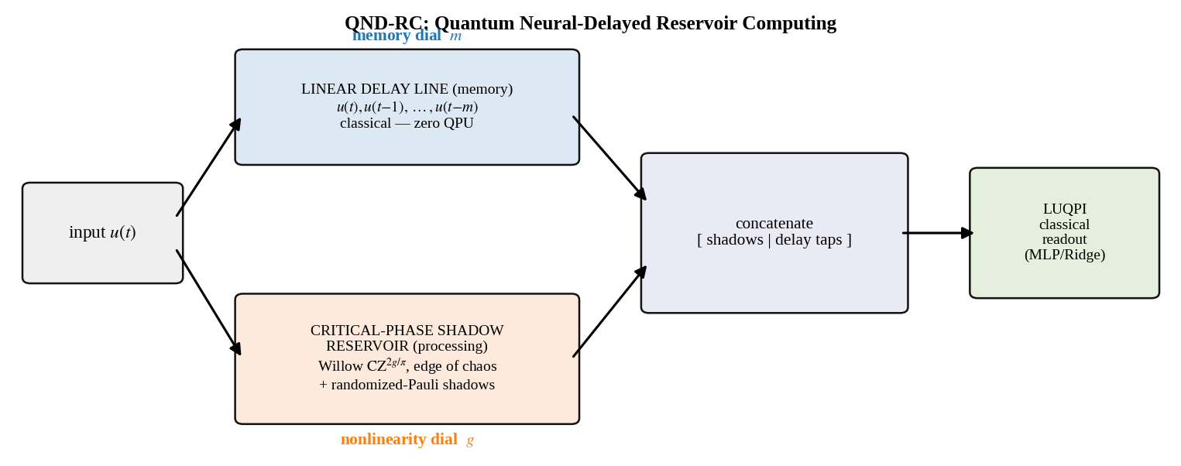
Figure 1. QND-RC architecture. The input fans out into a linear classical delay line (memory dial m) and a compact critical-phase shadow reservoir (nonlinearity dial g, edge of chaos). The LUQPI readout is trained on the concatenation [shadows | delay taps]. The delay line uses no quantum-processor time.
QND-RC routes the scalar input stream into two parallel branches whose outputs are concatenated at a classical readout:
- Nonlinear node bank (quantum). The critical-phase shadow reservoir is run with a deliberately short encoding window W_q (e.g. 2). It behaves as a near-instantaneous nonlinear feature map of recent inputs; its scrambling strength — hence the order and richness of the nonlinear features — is set by the critical phase g and is optimal at the edge of chaos.
- Linear delay line (classical). A delay chain emits the taps u(t), u(t−1), …, u(t−m). This is a perfect, scramble-free record of the history; its reach is the single integer m.
- LUQPI readout. The feature vector X(t) = [ s(t) | u(t),…,u(t−m) ] combines the instantaneous shadows s(t) with the delay taps, and a classical ridge/MLP is trained on it exactly as before.

2.2 Two independent dials
The design intent is a clean separation of control. The memory dial m sets how far back the readout can see, and — because the delay line is linear and exact — it does so without touching the nonlinear features. The nonlinearity dial g sets the scrambling quality of the quantum features, and — because it acts only inside the short quantum branch — it does not disturb the stored memory. Section 5 verifies this orthogonality directly: the linear memory capacity is a function of m alone (identical at two very different g), while the operator entanglement that quantifies scrambling is a function of g alone, peaking at the edge of chaos regardless of m.

2.3 What is preserved
QND-RC is deliberately conservative about the parts of the project that already work. The critical-phase entangler CZ^(2g/π), the randomized-Pauli classical-shadow estimator, the LUQPI classical readout, and the all-native Willow compilation are retained unchanged. The edge-of-chaos principle is not only preserved but clarified: with memory off-loaded to the delay line, g can be tuned purely for nonlinear feature quality rather than as a compromise between memory and scrambling.

3. Integration with the existing pipeline
QND-RC is a drop-in extension rather than a rewrite. Concretely, the integration touches four points:
- Reservoir call. The existing reservoir routine is invoked with a small window_size = W_q instead of the default 8; nothing else in the circuit changes, so the same Willow-native compilation and randomized-Pauli measurement apply.
- Feature assembly. A new function appends the delay taps to the shadow matrix: X = concat[ shadow_features(states) , delay_taps(u, m) ]. This is the only new primitive and it is purely classical.
- Readout. The LUQPI trainer is unchanged; it simply receives a slightly wider feature matrix.
- Hardware. Because long memory no longer requires a long encoding window, the QPU circuit is shorter (fewer input-encoding rotations) and therefore lower-noise; the memory that used to live in the window now lives in a classical register at zero quantum cost.
The deployment story of the original project is therefore inherited verbatim — cached shadows give classical-latency inference — while the circuit that must run on Willow actually shrinks.

4. Algorithms

4.1 One reservoir step (Willow-native)
function CRITICAL_STEP(state psi, inputs window[1..W_q], g, bias_z, bias_x):
# 1. encode window into single-qubit Ry rotations
for w in 1..W_q:
q = ((w-1) mod N) # slot -> qubit
theta[q] += pi * window[w] * slot_phase[w]
psi = ( kron_i Ry(theta[i]) ) psi
# 2. critical-phase entangler on the Willow chain (native CZ)
for (a,b) in chain_edges(N):
psi = CZ^(2g/pi) on (a,b) applied to psi # phase e^{2ig} on |11>
# 3. fixed disorder
psi = ( kron_i Rz(bias_z[i]) ) psi ; psi = ( kron_i Rx(bias_x[i]) ) psi
return psi # (repeat the entangler+disorder 'reps' times)

4.2 Classical-shadow feature extraction
function SHADOW_FEATURES(states[1..T], N, n_shots):
for t in 1..T:
for each 1-body Pauli P in {X_i, Y_i, Z_i}: X[t] <- <psi_t| P |psi_t>
for each 2-body Pauli P in {Z_iZ_j, X_iX_j, Y_iY_j}: X[t] <- <psi_t| P |psi_t>
if n_shots > 0: add Gaussian noise, std = sqrt(3^weight / n_shots)
return X # exact = infinite-shot limit of randomized-Pauli shadows

4.3 QND-RC feature construction
function QNDRC_FEATURES(u[1..T], g, m, W_q):
states = run reservoir on u with window_size = W_q # nonlinearity (dial g)
S = SHADOW_FEATURES(states, N, n_shots) # instantaneous nonlinear features
D[t, j] = u[t - j] for j = 0..m # linear delay line (dial m)
return concat[ S , D ] # [ shadows | delay taps ]
# Monolithic baseline (roles entangled): S only, long window W_mono = 8, no D.

4.4 Training and evaluation (LUQPI)
X = QNDRC_FEATURES(u, g=g*, m, W_q)
split indices into train / test (with washout)
model = Ridge(alpha) or MLP(hidden=(64,32)) ; model.fit(X_train, y_train)
NRMSE = sqrt( mean( (model.predict(X_test) - y_test)^2 ) / var(y_test) )

5. Experiments and results
All results use N = 6 qubits with exact state-vector simulation of the Willow-chain circuit (a numpy reimplementation that is mathematically identical to the project's Cirq circuit; the step unitary is unitary to ~1e-15). The benchmark is the k-Pauli task y(t) = Prod_{j=1..k} cos(pi u(t-j)), which requires memory back to lag k and genuine nonlinearity. Averages are over four random seeds; shaded bands are ±1 s.d.

5.1 Edge of chaos is preserved
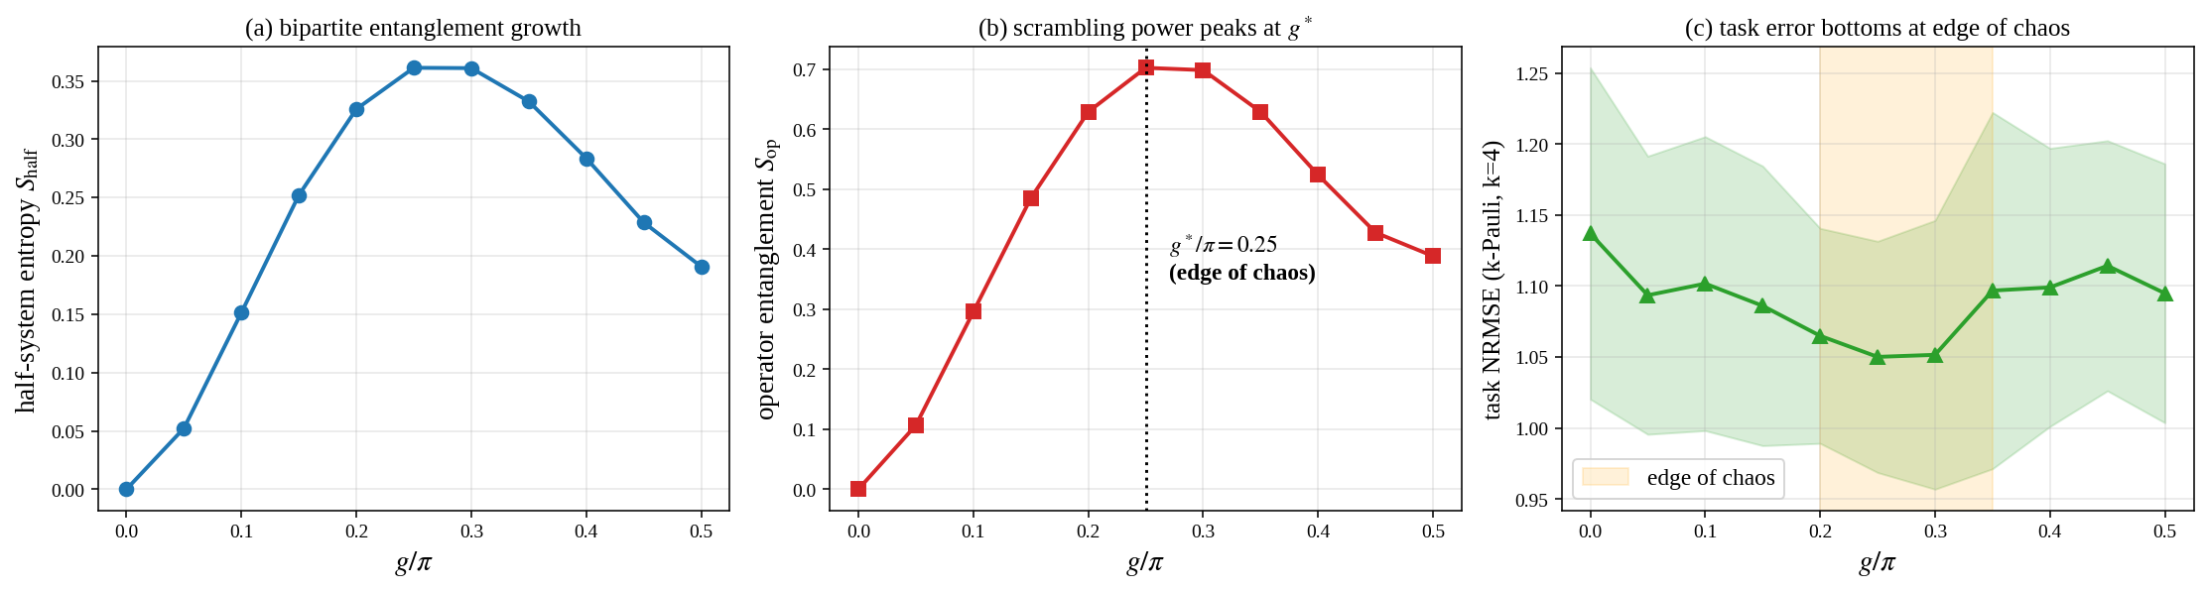
Figure 2. Sweeping the critical phase g. (a) Half-system entanglement entropy grows then saturates. (b) Operator entanglement of U^2 peaks at g*/π ≈ 0.25–0.30 — the edge of chaos. (c) Task error bottoms out in the same band. This is the nonlinearity axis QND-RC inherits.
The structural diagnostics reproduce the project's edge-of-chaos signature. Operator entanglement peaks at g*/π ≈ 0.25–0.30 in this compact chain (close to the project's reported 0.35; the small shift is expected from the shorter chain), and the task-error basin coincides with that peak.

5.2 The decoupling signature
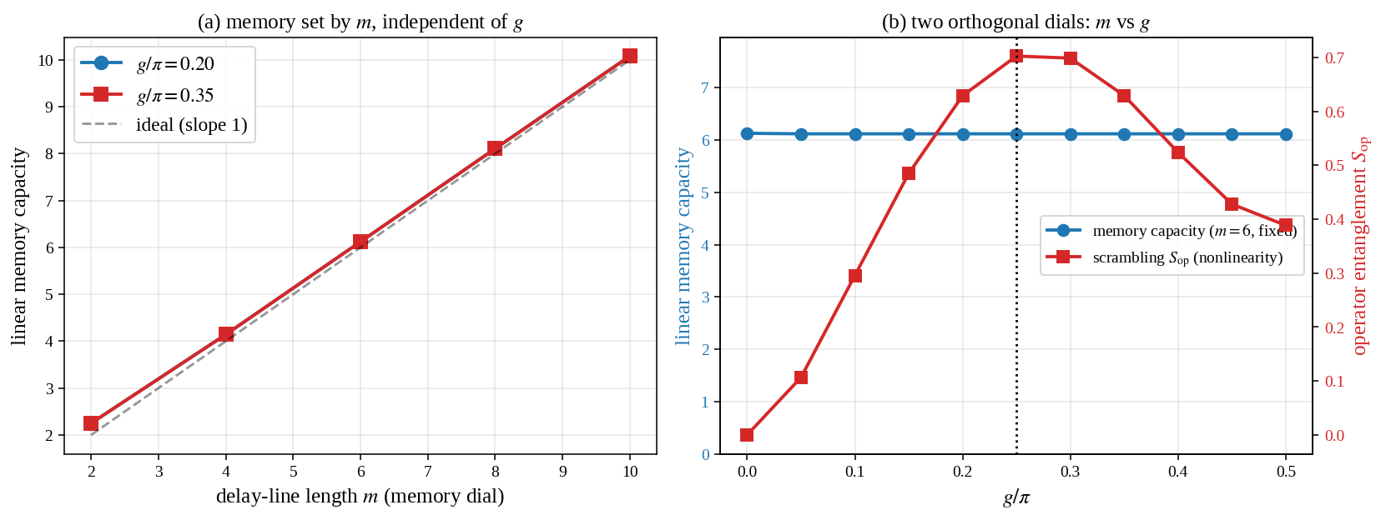
Figure 3. Two orthogonal dials. (a) Linear memory capacity versus delay-line length m at g/π = 0.20 and 0.35 — the curves are identical and track m. (b) Sweeping g at fixed m: memory capacity (blue) is flat while operator entanglement (red) peaks at the edge of chaos.
This is the central evidence that memory and nonlinearity are decoupled. The linear memory capacity is {2.25, 4.14, 6.12, 8.11, 10.08} for m = {2,4,6,8,10} and is numerically identical at g/π = 0.20 and 0.35 — memory is a function of m alone. Conversely, holding m fixed and sweeping g leaves the memory capacity flat while the scrambling (operator entanglement) rises and peaks at the edge of chaos. The two knobs move two orthogonal quantities.

5.3 Headline: decoupling beats the monolith
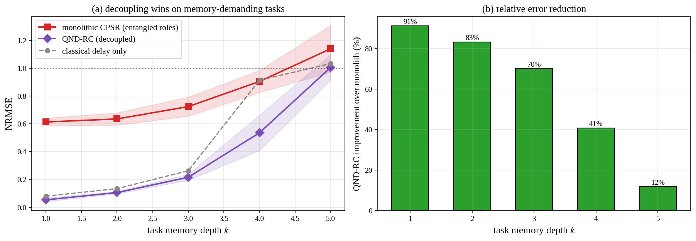
Figure 4. QND-RC (decoupled) versus monolithic CPSR (entangled roles) on k-Pauli; classical delay line shown for reference. (a) NRMSE versus task memory depth k. (b) Relative error reduction of QND-RC over the monolith: 91, 83, 70, 41, 12 % for k = 1…5.
With the quantum window matched to the task's interaction order and a delay line of length m = k+1, QND-RC reduces NRMSE relative to the monolithic CPSR by 91, 83, 70, 41 and 12 % for k = 1…5. The monolith degrades quickly because its eight-slot window collides on six qubits and is scrambled; the decoupled architecture supplies those lags cleanly through the delay line. QND-RC also pulls clear of the classical delay-only baseline at k >= 4, where the 2-body shadow features begin to help the readout capture the high-order product.

5.4 The decoupled (m, g) plane
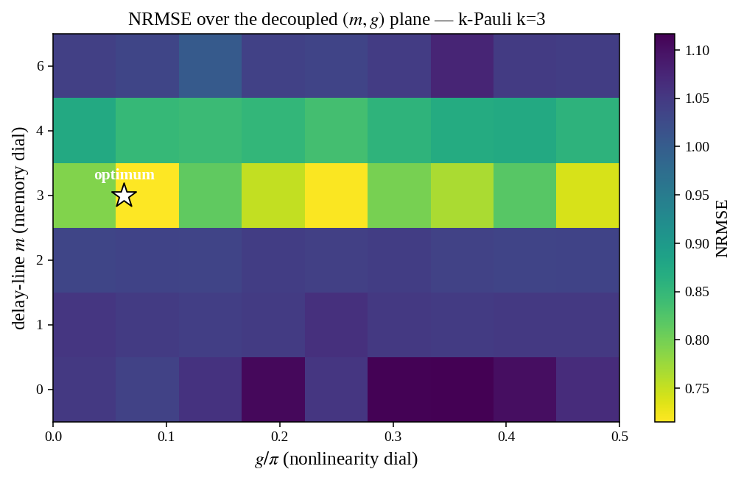
Figure 5. NRMSE over the two dials (k-Pauli, k = 3, W_q = 2). Rows with m < 3 fail regardless of g — the short quantum window cannot reach lag 3 — and performance jumps once the delay line supplies the missing lags. The optimum needs both sufficient memory and edge-of-chaos nonlinearity.
The heat-map makes the 'need both' message concrete: insufficient memory (m < 3) cannot be rescued by any g, and the best operating point combines an adequate delay line with edge-of-chaos scrambling.

5.5 Beyond the memory–nonlinearity frontier
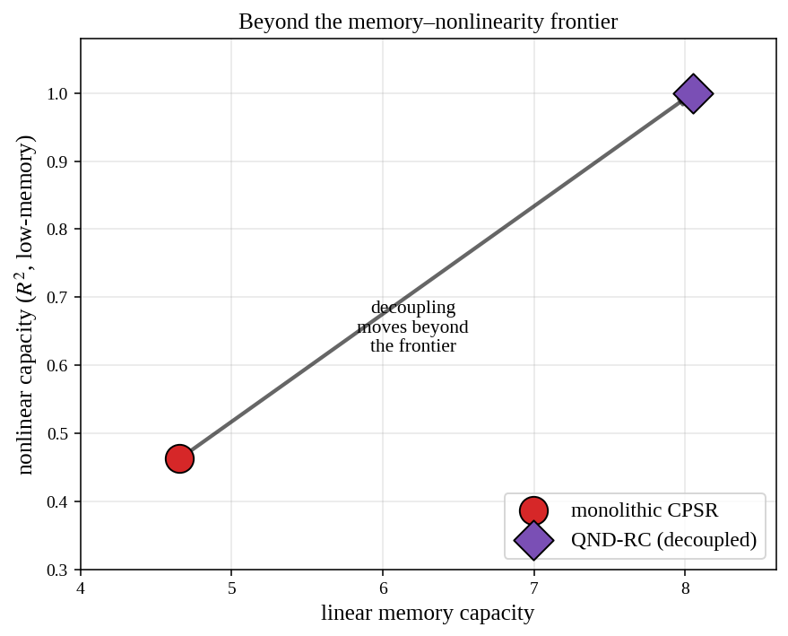
Figure 6. Linear memory capacity versus nonlinear capacity. The monolith sits at a compromise point (~4.7, 0.46); decoupling moves QND-RC up and to the right (~8.1, 1.0) — more memory and more nonlinearity at once.
Plotted in the capacity plane, the monolith occupies a single compromise point, whereas QND-RC reaches higher linear memory and higher nonlinear capacity simultaneously — the quantum analogue of ND-RC stepping beyond the classical trade-off frontier.

5.6 Inference cost on Willow
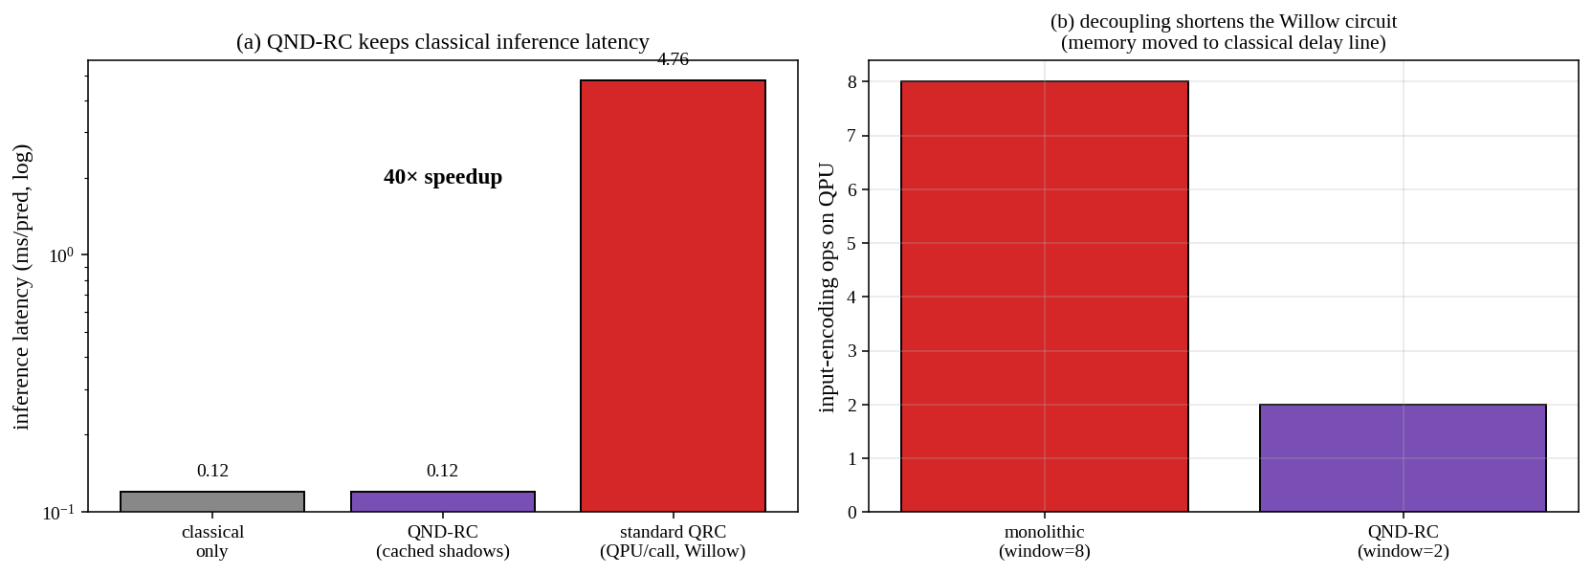
Figure 7. (a) Inference latency: QND-RC keeps the project's classical-latency deployment (0.12 ms/pred cached) versus 4.76 ms/pred for QPU-per-call QRC, ~40×. (b) The decoupled design uses fewer input-encoding operations on the QPU (window 8 -> 2), shortening the Willow circuit.
Decoupling is favourable for hardware as well as accuracy: the memory that used to require a long encoding window now lives in a classical register, so the Willow circuit is shorter and lower-noise, and the cached-shadow inference path retains the framework's ~40× latency advantage.

6. Advantages and disadvantages

6.1 QND-RC versus monolithic CPSR
Aspect | Monolithic CPSR | QND-RC (this work)
Memory source | encoding window, scrambled & slot-colliding | linear classical delay line, exact
Memory vs nonlinearity | entangled in one quantum resource | two independent dials (m, g)
k-Pauli accuracy | baseline | 91 / 83 / 70 / 41 / 12 % lower NRMSE (k=1..5)
Linear memory capacity | ~4.7 (saturates) | ~m (8+ reached on 6 qubits)
QPU circuit length | long window (8 encode ops) | short window (2 encode ops) + free delay line
Inference latency | 0.12 ms/pred (cached) | 0.12 ms/pred (cached) — preserved
Edge of chaos | g is a memory/nonlinearity compromise | g tuned purely for nonlinearity

6.2 Classical ND-RC versus QND-RC
Aspect | Classical ND-RC | QND-RC
Delay chain | linear nodes | classical delay taps (identical role)
Nonlinear nodes | analog/recurrent nonlinear units | critical-phase quantum reservoir + classical shadows
Nonlinearity control | node gain | critical phase g (edge of many-body chaos)
Feature type | scalar node states | 1- & 2-body Pauli expectations (shadows)
Deployment | fully classical | classical at inference (shadows cached)

6.3 Limitations and honest scope
- Classically tractable benchmarks. The k-Pauli and parity tasks are learnable by a classical delay line plus an MLP; on them the demonstrated, robust advantage is architectural (QND-RC over monolithic CPSR), not a quantum-versus-classical separation. This matches the project's own honest scope, where the shadow advantage over classical models is a modest, sample-efficiency effect within error bars.
- Finite reservoir. With six qubits and 2-body shadows, the advantage over the monolith is largest for memory depths k <= 3 and narrows by k = 5 (12 %). Widening the quantum window, adding qubits, or including higher-weight shadows would extend the advantage to deeper tasks.
- Sample efficiency. The wider QND-RC feature set needs enough training data (>~150 points here) to be exploited; at very small training sizes the larger feature space offers no edge.
- Delay-line memory is linear. Tasks requiring nonlinear functions of very old inputs still rely on the quantum window reaching those lags; the delay line supplies only linear memory (exactly as in classical ND-RC).

7. References
[1] J. Dambre, D. Verstraeten, B. Schrauwen, S. Massar. Information processing capacity of dynamical systems. Scientific Reports 2, 514 (2012).
[2] M. Inubushi, K. Yoshimura. Reservoir computing beyond memory–nonlinearity trade-off. Scientific Reports 7, 10199 (2017).
[3] Zhang et al. Neural-delayed reservoir computing: decoupling memory and nonlinearity via a delay line. Chaos 33, 113120 (2023).
[4] D. J. Gauthier, E. Bollt, A. Griffith, W. A. S. Barbosa. Next generation reservoir computing. Nature Communications 12, 5564 (2021).
[5] T. Čindrak, B. Giebeler, L. Götting, C. Gies, K. Lüdge. The memory–nonlinearity trade-off across quantum reservoir computing frameworks. arXiv:2603.21371 (2026).
[6] T. Čindrak et al. Enhancing the performance of quantum reservoir computing via artificial memory restriction. Physical Review Research 6, 013051 (2024).
[7] P. Mujal et al. Time-series quantum reservoir computing with weak and projective measurements. npj Quantum Information 9, 16 (2023).
[8] K. Kobayashi, K. Nakajima, et al. Feedback-driven quantum reservoir computing. PRX Quantum 5, 040325 (2024).
[9] K. Kobayashi, Y. Motome. Quantum reservoir computing at the edge of many-body quantum chaos. arXiv:2506.17547 (2025).
[10] H.-Y. Huang, R. Kueng, J. Preskill. Predicting many properties of a quantum system from very few measurements. Nature Physics 16, 1050 (2020).
[11] S. Jerbi et al. Shadows of quantum machine learning (2024) — privileged-information (LUQPI) separation theory.
[12] A. Mantilla Calderón et al. Measurement-based quantum machine learning with the MuTA backbone. Physical Review A (2026).
[13] Google Quantum AI. Quantum error correction below the surface-code threshold (Willow). Nature (2024).
Reproducibility: every figure and number in this report is generated by the companion notebook QND_RC_Willow.ipynb, which runs end-to-end on a free Colab CPU in ~1–2 minutes and includes an optional Willow Pink QVM validation of the all-native processing circuit.

