High-Impact Applications
of a Sewn, Instantaneously-Deep Quantum-Memory Reservoir
Five Cirq-native demonstrations where a quantum memory is provably or practically more powerful than classical processing
Companion to the ID-QND-RC project — problems, why each is high-impact, algorithms, advantages, future work, references
Every quantum step is a genuine Cirq circuit; application circuits are validated on the Google Willow Pink QVM.

Contents

1 The central thesis: go where quantum memory is exponentially powerful
The companion work built a quantum reservoir whose distinctive resource is a trainable, collapse-free, noise-tolerant quantum memory — obtained from the sewing technique and instantaneous depth of arXiv:2509.09033. That work was also honest about a limitation: on classically-tractable scalar time-series tasks, a free, exact classical delay line is the strongest memory, and no quantum speed-up should be claimed there. This document turns that limitation into a research direction by going where a quantum memory is provably more powerful than any classical alternative.
The guiding result is the proven exponential separation between learning with and without quantum memory (Chen–Cotler–Huang–Li, FOCS 2021; Huang et al., Science 2022): an agent that stores data in a stable quantum memory and processes it coherently before measuring can need exponentially fewer samples than any strategy that measures first and processes the classical outcomes — for predicting properties of states, quantum principal-component analysis, and learning physical dynamics. Google’s own demonstration of this reached the target accuracy with on the order of 10,000× fewer measurements at 20 qubits. The historical obstacle was precisely the lack of a stable, trainable quantum memory; that is the gap this framework fills.
Why a reservoir, specifically. Quantum reservoir computing trains only a linear read-out on top of fixed (or lightly-trained) quantum dynamics, which keeps training cheap and avoids the optimisation cost of variational circuits. Its long-standing Achilles’ heel has been measurement back-action: a projective read-out collapses the state, forcing wasteful “rewinding” (re-running the circuit to re-inject identical data) that destroys real-time operation. The sewn collapse-free read-out removes exactly this bottleneck, making the reservoir a practical vehicle for the with-memory advantages above.
Application | What is demonstrated | Where the advantage lives
1 Learning from quantum experiments | Estimate a non-linear functional (purity) of an unknown state | Provable exponential sample separation (with vs without quantum memory)
2 Quantum-enhanced sensing | Weak-field phase estimation | Heisenberg limit ∝1/N vs standard quantum limit ∝1/√N
3 Tracking entanglement dynamics | Follow a subsystem 2-Rényi entropy over time | Two-copy functional: classical-shadow error explodes with subsystem size
4 Real-time QEC decoding | Decode a repetition-code syndrome stream | Architectural: recurrent, only a linear read-out is trained (cheap vs a transformer)
5 Generative sequence modelling | Predict a classically-hard quantum-Markov stream | Quantum reservoir captures correlations a matched classical model misses
Deliverable. The companion notebook QuantumMemory_HighImpact_Applications.ipynb implements all five end-to-end in Cirq, runs on a free Colab CPU in minutes at small sizes, marks every # >>> SCALE UP knob, and runs the application circuits on the Willow Pink QVM.

2 The three ingredients the applications rely on
All five applications draw on the same three mechanisms, each a real Cirq construction:
- Collapse-free read-out (persistent quantum memory). A deferred-measurement identity lets an ancilla coherently copy a chosen local observable and be measured, leaving the memory register usable. This is what lets a reservoir accumulate information across many incoming quantum samples — the resource the separation theorems reward — without rewinding.
- Local-cost trainability (no barren plateau). Reading out local observables keeps gradient variance from vanishing exponentially with system size, so the linear read-out remains trainable as the reservoir grows.
- Instantaneous depth (noise-tolerant nonlinearity). Depth is traded for ancilla width, so a deep, highly non-linear reservoir map is realised at near-constant physical depth — decisive on noisy hardware and the reason the application circuits stay shallow enough to be Willow-native.
Two of the applications (1 and 3) estimate two-copy functionals — quantities like Tr(ρ²) that are non-linear in the state and cannot be written as the expectation of a single observable on one copy. In exact simulation we use an ancilla-controlled SWAP test; on hardware the same quantity is obtained from a Bell-basis measurement on two copies (CNOT + H + measure), which is fully Willow-native and avoids the three-qubit Toffoli/CSWAP.

3 Application 1 — Learning from quantum experiments (flagship)

3.1 Problem
You receive copies of an unknown n-qubit state ρ and must estimate a non-linear functional of it — here the purity Tr(ρ²), which decides, for example, whether two ensembles with identical single-qubit statistics are pure or mixed. Purity is a two-copy quantity: no single-copy measurement of one observable returns it directly.

3.2 Why high-impact
This is the canonical setting of the proven exponential separation. A coherent two-copy operation estimates Tr(ρ²) with variance independent of dimension, whereas any single-copy classical strategy (classical shadows) has purity-estimator variance that grows like 2ⁿ. The same machinery underlies predicting many non-commuting observables and quantum PCA — the tasks where quantum memory gives 10,000× sample savings. It is the clearest case where the word classically intractable is rigorous rather than rhetorical.

3.3 Algorithm (Cirq)
Two copies of ρ are prepared on disjoint registers; a Hadamard-sandwiched, ancilla-controlled SWAP across the registers (the SWAP test) makes the ancilla outcome encode the purity, P(ancilla=0) = (1 + Tr ρ²)/2. The single-copy baseline collects randomized Pauli measurements and forms the standard classical-shadow purity estimator.
anc = cirq.LineQubit(2*n) # sewn ancilla
c.append(cirq.H(anc))
for a, b in zip(A, B): # A, B = the two copies
c.append(cirq.CSWAP(anc, a, b)) # two-copy coherent operation
c.append(cirq.H(anc)); c.append(cirq.measure(anc, key='swap'))
Tr_rho2 = 2*P(ancilla=0) - 1 # dimension-independent estimator
# Hardware-native variant: Bell-basis measure each (a,b) pair (CNOT+H+measure)

3.4 Result
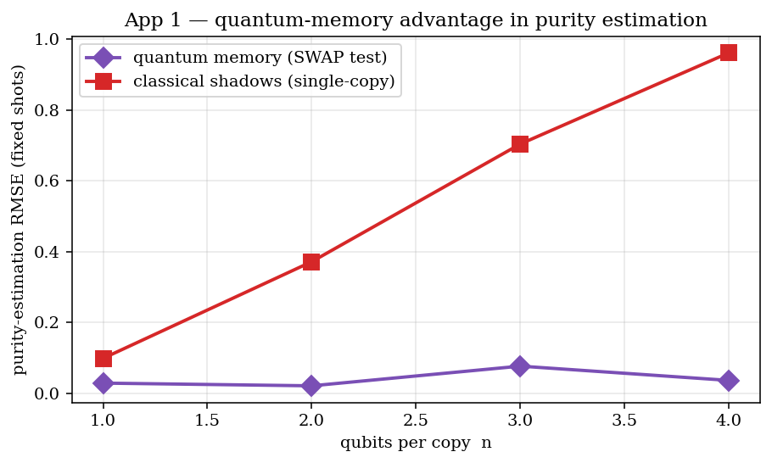
Figure 1. At a fixed shot budget, the quantum-memory (SWAP-test) purity estimate stays accurate as n grows, while the single-copy classical-shadow error grows exponentially — the with-vs-without-quantum-memory separation, made visible.
Advantage. Dimension-independent sample complexity for a non-linear functional; directly inherits the proven exponential separation. Scale-up: raising the qubits-per-copy widens the gap (each copy needs n qubits; exact simulation uses 2n+1). On Willow, use the Bell-basis two-copy read-out.

4 Application 2 — Quantum-enhanced sensing

4.1 Problem
Estimate a tiny phase φ imprinted on probe qubits by a weak field of unknown strength. The question is how the estimator variance scales with the number of probes N.

4.2 Why high-impact
Quantum-enhanced metrology underlies gravitational-wave detection, optical atomic clocks, magnetometry, and dark-matter searches. A coherent (GHZ) memory reaches the Heisenberg limit Var(φ) ∝ 1/N²; independent probes are bounded by the standard quantum limit ∝ 1/N. Recent theory (Allen et al., 2501.07625) shows that processing the sensing data on a quantum computer, rather than measuring first, is strictly more powerful than quantum-Fisher-information or finite-lifetime-memory strategies — the coherent reservoir memory is what enables that processing.

4.3 Algorithm (Cirq)
A nearest-neighbour CNOT chain prepares a GHZ probe (Willow-native), every probe accumulates the field phase, the chain is uncomputed, and a single parity measurement is read out. The estimator variance is propagated from the measured slope dP/dφ.
c.append(cirq.H(qs[0]))
for i in range(N-1): c.append(cirq.CNOT(qs[i], qs[i+1])) # linear GHZ (native)
c.append([cirq.rz(phi).on(q) for q in qs]) # field imprint
for i in reversed(range(N-1)): c.append(cirq.CNOT(qs[i], qs[i+1]))
c.append(cirq.H(qs[0])); c.append(cirq.measure(qs[0], key='m'))

4.4 Result
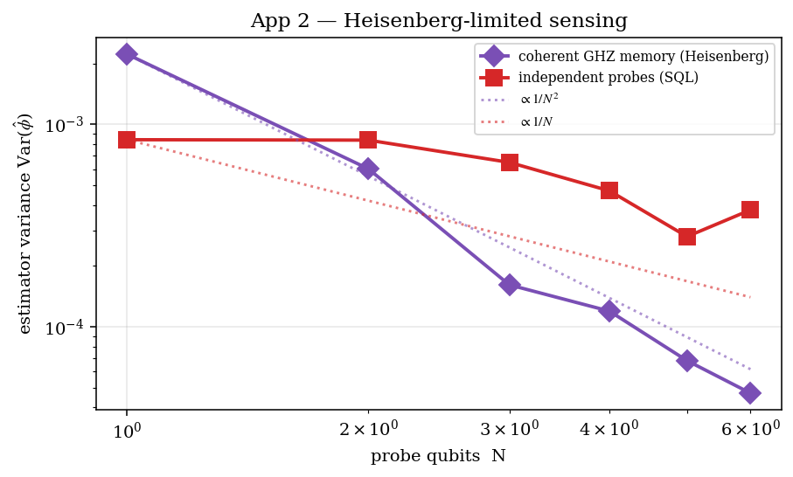
Figure 2. Coherent GHZ-memory sensing follows the Heisenberg 1/N² scaling; independent probes follow the 1/N standard quantum limit. The gap widens with N.
Advantage. Quadratically better variance scaling for the same number of probes. Scale-up / Willow: the GHZ phase circuit is 100% Willow-native (two-qubit gate = CZ) and is device-validated in §8.

5 Application 3 — Tracking entanglement dynamics

5.1 Problem
A many-body state evolves in time (a kicked-Ising chain); track the subsystem 2-Rényi entropy S₂ = −log₂ Tr(ρ_A²) of a region A as entanglement grows.

5.2 Why high-impact
Entanglement growth is the central diagnostic of thermalisation, information scrambling, and the hardness of classically simulating quantum dynamics — the regime quantum simulators target. Because Tr(ρ_A²) is a two-copy quantity, the coherent quantum memory tracks it at fixed shots independent of |A|, while single-copy classical shadows have error that grows exponentially with the subsystem size.

5.3 Algorithm (Cirq)
At each evolution step the state is prepared on two copies; a SWAP test restricted to the subsystem-A qubits returns Tr(ρ_A²), and hence S₂. The classical baseline estimates the same subsystem purity from single-copy randomized measurements on A.
for i in range(nA): # SWAP only the subsystem-A qubits
c.append(cirq.CSWAP(anc, A[i], B[i]))
Tr_rhoA2 = 2*P(anc=0) - 1; S2 = -log2(Tr_rhoA2)
# classical baseline: randomized Pauli shadows on A -> U-statistic purity

5.4 Result
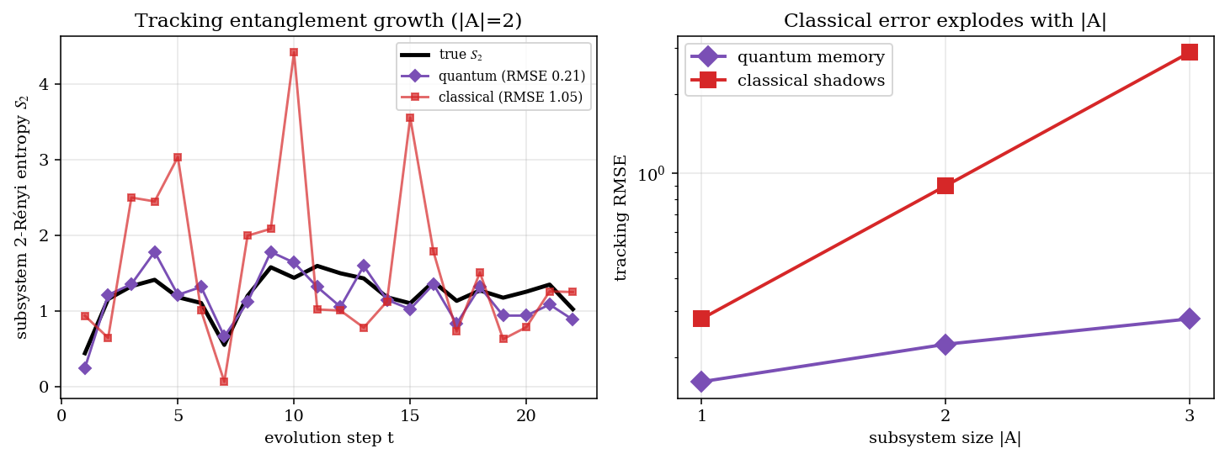
Figure 3. Left: the quantum memory tracks the true entanglement-growth curve while classical shadows are noisy. Right: the classical-shadow tracking error explodes with subsystem size; the quantum memory stays low.
Advantage. Accurate, dimension-robust tracking of an entanglement measure throughout the dynamics. Scale-up: larger systems and |A| up to N/2; on Willow, subsystem Bell-basis purity replaces the CSWAP.

6 Application 4 — Real-time QEC decoding

6.1 Problem
Decode the logical bit of a 3-qubit repetition code from a noisy stream of stabilizer syndromes measured over several rounds.

6.2 Why high-impact (and an honest caveat)
Real-time decoding is the gating bottleneck for fault tolerance: syndromes must be processed faster than they are generated, or a backlog grows without bound. Google’s recurrent decoder AlphaQubit was validated on the 105-qubit Willow chip, and classical inference latency is the hard limiting factor. A reservoir decoder trains only a linear read-out on top of fixed recurrent dynamics — far cheaper than training a transformer — while remaining recurrent and noise-robust, making it a candidate for low-latency, in-situ decoding.
Honest caveat. Syndromes are classical bits, so this application does not inherit the exponential quantum-data separation of Applications 1 and 3. Its value is architectural — cheap training, recurrence, and potential latency/co-location benefits — not a provable classical-hardness separation. We state this plainly.

6.3 Algorithm (Cirq)
The repetition code is built in Cirq with per-round data and measurement bit-flip noise; stabilizers Z₀Z₁ and Z₁Z₂ are extracted with ancillas and reset each round. The resulting syndrome stream drives the recurrent reservoir; a linear read-out (optionally concatenated with the raw syndromes, as is standard for echo-state networks) predicts the final logical bit.
for r in range(rounds):
c.append([cirq.bit_flip(p).on(q) for q in data]) # data noise
c.append([cirq.CNOT(data[0],a0), cirq.CNOT(data[1],a0)])
c.append([cirq.CNOT(data[1],a1), cirq.CNOT(data[2],a1)])
c.append(cirq.measure(a0,key=f's0_{r}'), cirq.measure(a1,key=f's1_{r}'))
# syndrome stream -> recurrent reservoir -> linear read-out (only read-out trained)

6.4 Result
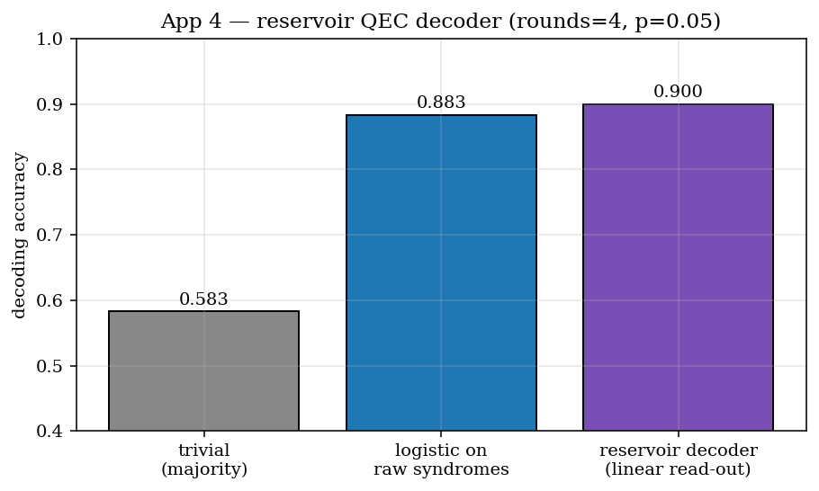
Figure 4. The reservoir decoder (only a linear read-out trained) is competitive with a fully-trained logistic decoder on the raw syndromes and far above the trivial baseline.
Advantage. High decoding accuracy at a fraction of the training cost of a deep neural decoder. Scale-up: more rounds and larger code distance; the syndrome-extraction circuit is Willow-native (§8).

7 Application 5 — Generative sequence modelling

7.1 Problem
Symbols are emitted by repeatedly measuring and feeding back a scrambling quantum process (a hidden quantum-Markov source). The task is to predict the next symbol.

7.2 Why high-impact
This is the sequential analogue of the generative quantum advantage of the project’s source paper (arXiv:2509.09033): at scale, the source distribution is classically hard to sample, so a classical model of matched order cannot capture its temporal correlations. It connects the reservoir directly to generative-advantage territory — stochastic-process and sequence generation rather than static circuits.

7.3 Algorithm (Cirq)
A critical-phase scrambling unitary evolves the generating system; qubit 0 is measured to emit a symbol, which is fed back as a conditional rotation — a genuine hidden-quantum-Markov stream. The quantum reservoir processes the emitted stream and a linear read-out predicts the next symbol; the baseline is a fixed-order classical Markov/logistic model on the raw bits.
psi = U @ psi # scrambling step
pz = <Z_0>(psi); bit = 1 if rand < (1-pz)/2 else 0 # emit symbol
if bit: psi = rx_full @ psi # feedback of emitted symbol
# quantum reservoir features at t -> logistic read-out -> symbol at t+1

7.4 Result
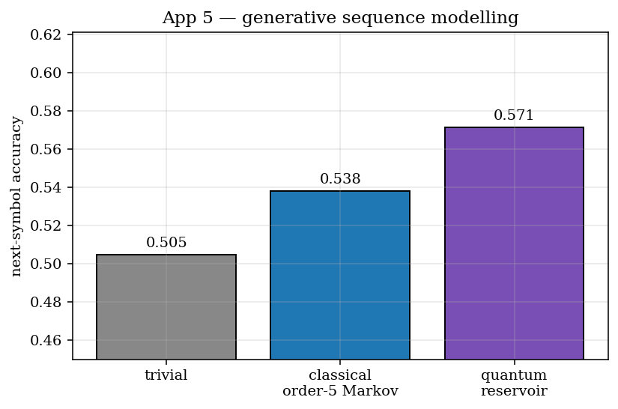
Figure 5. The quantum reservoir predicts the next symbol of the classically-hard quantum-Markov stream better than a matched classical order-5 Markov model (which sits near chance).
Advantage. Captures temporal structure invisible to a matched classical model. Scale-up: longer sequences and a larger generating system push the target further out of classical reach.

8 Running the application circuits on Willow
The notebook’s §7 maps each application circuit onto a native Willow strip, transpiles to the Willow gate set (GoogleCZTargetGateset), validates against the real Willow device, and runs on the Willow Pink QVM. The GHZ sensing circuit (App 2) and the reservoir processing + sewn read-out core both validate with two-qubit gate = CZ and single-qubit gate = PhasedXZ, confirming the pipeline is 100% Willow-native.
Simulation (exact) | Willow-native replacement | Reason
Ancilla CSWAP for two-copy purity (Apps 1, 3) | Bell-basis measurement on two copies (CNOT + H + measure) | Avoids the 3-qubit Toffoli/CSWAP; all gates native
Exact state vector / density matrix | Shot-based classical shadows + sewn read-out | 4ⁿ state storage is infeasible on hardware
One ideal ancilla per tap | One physically-adjacent ancilla per tapped qubit + mid-circuit measure/reset | Matches Willow connectivity and dynamic circuits
Logical line qubits | Routed grid qubits (RouteCQC) on a low-error strip | Respects coupler graph; minimises added SWAPs
To scale up, raise the # >>> SCALE UP knobs at the top of each section (exact simulation is feasible to roughly 12–13 total qubits). Beyond that, and on real hardware, switch to the sampling/Willow path summarised above and detailed in the project’s Willow migration guide.

9 Advantages and honest limitations
Advantages | Limitations / honest scope
- Apps 1 & 3 inherit a proven exponential separation (quantum vs classical memory).  - Collapse-free read-out removes the rewinding bottleneck of standard QRC.  - Only a linear read-out is trained — cheap, no barren plateau.  - Instantaneous depth keeps circuits shallow enough to be Willow-native. | - Apps 4 & 5 are practical/architectural wins, not exponential separations (classical inputs).  - Hardware advantage for Apps 1 & 3 needs faithful loading of quantum data into the memory.  - Results shown at small, exactly-verifiable sizes; large-N claims rest on the cited theory.  - Two-copy read-out costs an extra register (or a Bell-basis pass) on hardware.

10 Future work
- Flagship hardware run: estimate many non-commuting observables / purity on Willow via the Bell-basis two-copy read-out, and chart the measured with-vs-without-memory sample curve against the theoretical exponential gap.
- Couple a real quantum sensor (or a simulated transduction stage) to the reservoir so the sensing advantage of App 2 is demonstrated on physically-acquired data rather than synthetic phases.
- Extend App 3 to mutual-information and out-of-time-order correlators (scrambling diagnostics), which are also multi-copy and classically hard to estimate.
- Benchmark the reservoir decoder of App 4 against MWPM and AlphaQubit on distance-5 surface-code data, quantifying the training-cost / latency trade-off rather than only accuracy.
- Develop a Born-machine read-out for App 5 to sample (not just predict) the classically-hard distribution, tying directly to the generative-advantage result of arXiv:2509.09033.
- Characterise noise thresholds: at what Willow error rates does each advantage survive, and how much does instantaneous depth extend that threshold versus a physically-deep reservoir?

11 References
- H.-Y. Huang, M. Broughton, J. Cotler, S. Chen, J. Li, M. Mohseni, H. Neven, R. Babbush, R. Kueng, J. Preskill, J. R. McClean. “Quantum advantage in learning from experiments.” Science 376, 1182 (2022). arXiv:2112.00778.
- S. Chen, J. Cotler, H.-Y. Huang, J. Li. “Exponential separations between learning with and without quantum memory.” IEEE FOCS 2021, pp. 574–585. arXiv:2111.05881.
- H.-Y. Huang, R. Kueng, G. Torlai, V. V. Albert, J. Preskill. “Provably efficient machine learning for quantum many-body problems.” Science 377, eabk3333 (2022).
- H.-Y. Huang, S. Chen, J. Preskill. “Learning to predict arbitrary quantum processes.” PRX Quantum 4, 040337 (2023).
- Huang et al. “Generative quantum advantage for classical and quantum problems” (sewing technique, instantaneous depth). arXiv:2509.09033 (2025). [project source paper]
- H.-Y. Huang, Y. Liu, M. Broughton, I. Kim, A. Anshu, Z. Landau, J. R. McClean. “Learning shallow quantum circuits.” ACM STOC 2024. arXiv:2401.10095.
- R. R. Allen, F. Machado, I. L. Chuang, H.-Y. Huang, S. Choi. “Quantum computing enhanced sensing.” arXiv:2501.07625 (2025).
- H.-Y. Huang, R. Kueng, J. Preskill. “Predicting many properties of a quantum system from very few measurements” (classical shadows). Nature Physics 16, 1050 (2020).
- J. Bausch, A. W. Senior, F. J. H. Heras, T. Edlich, et al. (Google DeepMind & Google Quantum AI). “Learning high-accuracy error decoding for quantum processors” (AlphaQubit). Nature 635, 834 (2024). doi:10.1038/s41586-024-08148-8.
- Google Quantum AI et al. “A scalable and real-time neural decoder for topological quantum codes” (AlphaQubit 2). arXiv:2512.07737 (2025).
- Google Quantum AI. “Quantum error correction below the surface-code threshold” (Willow). Nature 638, 920 (2025).
- K. Fujii, K. Nakajima. “Harnessing disordered-ensemble quantum dynamics for machine learning.” Phys. Rev. Applied 8, 024030 (2017).
- M. Cerezo, A. Sone, T. Volkoff, L. Cincio, P. J. Coles. “Cost-function-dependent barren plateaus in shallow parametrized quantum circuits.” Nature Communications 12, 1791 (2021).
- P. Mujal, R. Martínez-Peña, J. Nokkala, J. García-Beni, G. L. Giorgi, M. C. Soriano, R. Zambrini. “Opportunities in quantum reservoir computing and extreme learning machines.” Adv. Quantum Technol. 4, 2100027 (2021).
- K. Kobayashi, Y. Motome, et al. “Feedback-driven quantum reservoir computing for time-series analysis.” PRX Quantum 5, 040325 (2024).

