Self-Protecting Quantum Reservoir Computing
The Reservoir's Measurement Schedule as a Dynamically Self-Generated Code
A monitored-circuit / Floquet-code unification of memory protection and computation
Theory, algorithms, numerical results, and references — companion to the ID-QND-RC project
Scrambling is expressed in Cirq; scalable stabilizer phase diagnostics use Stim. No fault-tolerance threshold is claimed.

Contents

1 Thesis: one measurement record that both protects and computes
A quantum reservoir is driven by an input stream while a fixed read-out schedule measures local observables. In the ID-QND-RC project this is the sewn read-out: a periodic, basis-selective, collapse-free measurement of the reservoir. Viewed as dynamics, scrambling together with a periodic measurement schedule is exactly a monitored quantum circuit.
Monitored circuits possess a measurement-induced phase transition (MIPT). Below a critical measurement rate pc the dynamics sit in a volume-law coding phase whose steady state is a dynamically self-generated quantum error-correcting code (Choi–Bao–Qi–Altman 2020; Gullans–Huse 2020). Above pc the system is in a trivial, area-law phase where information is rapidly measured out. A structured (period-T) schedule of non-commuting checks realises a Floquet code (Hastings–Haah 2021).
These two facts combine into a single statement about the reservoir: the same measurement record is simultaneously the reservoir's output and the syndrome that protects its memory. Protection and computation are not bolted on separately — they are two readings of one schedule. This document makes the claim precise and demonstrates it numerically.
Honest scope. The novelty is the unification and the dual-use demonstration (R3). R1, R2 and R4 reproduce established monitored-circuit and Floquet-code physics on the reservoir framework. Protection is dynamical / measurement-based and is shown through purification (coding-phase) diagnostics and explicit error detection; we do not claim a fault-tolerance threshold. Because the Clifford and Haar monitored ensembles lie in the same MIPT universality class, the scalable stabilizer diagnostics (Stim) describe the very phase in which the non-Clifford reservoir (Cirq) is shown to compute.

2 Why this is high-impact
- Unifies two active fields. Quantum reservoir computing and measurement-induced phases / dynamical codes are studied separately; the sewn read-out is a natural bridge between them.
- Turns a cost into a resource. Read-out measurement is usually treated as back-action to be minimised. Here the measurement schedule is the mechanism that both extracts features and protects the memory.
- Hardware-native. The scrambling U(g*) uses CZ and single-qubit rotations native to Google Willow; the schedule is mid-circuit measurement on a fixed pattern — no extra connectivity or gates.
- Falsifiable and quantitative. Every claim is tied to a measurable order parameter (entanglement scaling, reference-qubit purification, task accuracy, syndrome weight) with a clear phase boundary.

3 Model and order parameters

3.1 Monitored reservoir
On a chain (or ring) of N qubits, one driven step injects the input on a qubit via Ry(αu), applies the edge-of-chaos scrambling unitary U(g*) = (∏ CZ^{2g*/π}) · (∏ Rz) · (∏ Rx) with g*/π = 0.30, then measures each site in the Z basis with probability p (the sewn schedule). Sweeping p moves the reservoir across the MIPT.

3.2 Two order parameters
- Half-chain entanglement entropy SN/2. Coding (volume) phase: S grows linearly with N. Trivial (area) phase: S is O(1). This is the rigorous signature of the self-generated code.
- Reference-qubit purification (Gullans–Huse). A reference R is maximally entangled with the system; the system alone is then monitored. ⟨SR⟩ ≈ 1 means the logical qubit is protected (recoverable); ⟨SR⟩ → 0 means it has been measured out.

3.3 Stabilizer entanglement entropy (the scalable engine)
For a stabilizer state with binary generator matrix G (rows = Pauli generators, columns = x|z bits), the entanglement entropy of a region A is SA = rankF2(GA) − |A|, where GA restricts the generators to the columns of A. This GF(2) rank is computed in milliseconds for tens of qubits, which is why the phase diagnostics (R1, R2, R4) use a Stim stabilizer backend.
def stab_entropy(stabs, n, A): # bits of entanglement of region A
rows = []
for ps in stabs: # each generator -> [x_A | z_A]
xv = [1 if ps[i] in (X,Y) else 0 for i in range(n)]
zv = [1 if ps[i] in (Z,Y) else 0 for i in range(n)]
rows.append([xv[i] for i in A] + [zv[i] for i in A])
return gf2_rank(rows) - len(A) # S_A = rank_F2(G_A) - |A|

4 R1 — The measurement-induced coding transition
Sweeping the measurement rate p, the steady-state half-chain entropy crosses over from a volume law (coding phase) to an area law (trivial phase) near pc ≈ 0.16. The coding phase is precisely the regime in which the monitored reservoir self-organises into a protecting code.
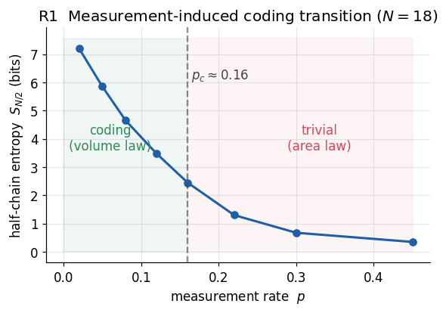
Figure R1. Steady-state half-chain entanglement vs measurement rate (N = 18). The crossover near p_c ≈ 0.16 separates the coding (volume-law) phase from the trivial (area-law) phase.
The decisive, finite-size-robust signature is how the entropy scales with N: linear in the coding phase, flat in the trivial phase.
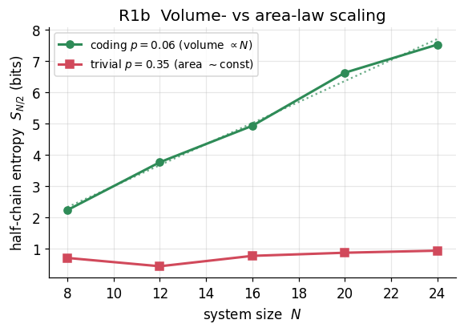
Figure R1b. Half-chain entropy vs system size. Coding phase (p = 0.06): S ∝ N (volume law, dotted linear fit). Trivial phase (p = 0.35): S ≈ const (area law).

4.1 Algorithm
def monitored_clifford(N, depth, p): # brick-wall scrambling + monitoring
sim = stim.TableauSimulator()
for d in range(depth):
for (a,b) in brickwall_bonds(N, d): # alternating even/odd bonds
sim.do_tableau(stim.Tableau.random(2), [a,b]) # scramble U(g*)
for q in range(N):
if rand() < p: sim.measure(q) # sewn measurement at rate p
return sim # -> canonical_stabilizers()

5 R2 — Protected logical memory
A reference qubit is maximally entangled with the system, then the system is monitored. In the coding phase the reference entropy ⟨SR⟩ remains near 1 for long times — the logical qubit is protected by the schedule. In the trivial phase it is measured out within a few layers.
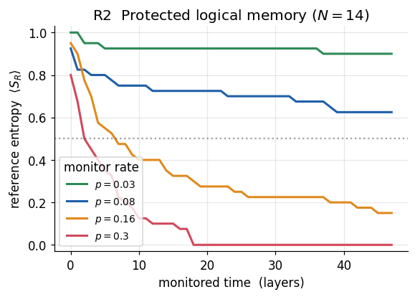
Figure R2. Reference-qubit entropy over monitored time (N = 14). Deep in the coding phase (p = 0.03) the logical qubit is protected; near p_c (0.16) it decays moderately; in the trivial phase (0.30) it is lost rapidly. The memory time diverges as p → 0.
Operationally, SR is the coherent information of the encoded qubit: a value near 1 means the logical state remains recoverable from the surviving system together with the measurement record. This is the sense in which the schedule protects the memory.
def reference_protection(N, p, depth):
sim = stim.TableauSimulator(); R = N
sim.h(R); sim.cnot(R, 0) # Bell pair: reference R <-> system qubit 0
for d in range(depth):
scramble_brickwall(sim, N, d) # monitored dynamics on the SYSTEM only
monitor_at_rate(sim, N, p)
S_R = stab_entropy(sim.canonical_stabilizers(), N+1, [R]) # 1=protected

6 R3 — The unification: the same schedule protects and computes
This is the novel demonstration. The non-Clifford windowed reservoir (real Cirq circuits, edge-of-chaos U(g*)) solves a nonlinear task — the sign-product (parity) of a length-3 input window — using only single-qubit ⟨Z⟩, ⟨X⟩, ⟨Y⟩ features read after monitoring at rate p. Task accuracy is high in the coding phase and collapses under strong monitoring, tracking the protection order parameter on the same p-axis.
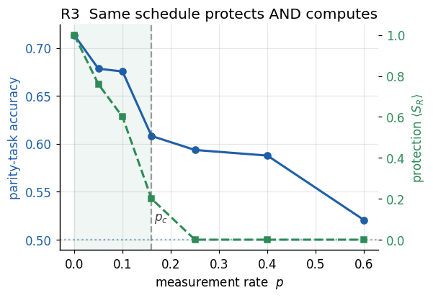
Figure R3. Left axis: reservoir parity-task accuracy (Cirq, N = 8). Right axis: protection ⟨S_R⟩ (Stim). Both are high for p < p_c (shaded) and fall together as monitoring strengthens. Computation and protection coexist in the coding phase.
The interpretation is the heart of the unification: the measurement record produced by the sewn schedule is, at the same time, the syndrome that keeps ⟨SR⟩ high (protection) and the feature set that solves the task (computation). Strong monitoring (p > pc) collapses the quantum memory, destroying both at once.

6.1 Algorithm (windowed monitored reservoir)
def windowed_feats(window, N, p): # one supervised sample
psi = |0...0>
for u in window: # inject + scramble + monitor each symbol
psi = U(g*) . Ry(alpha*u)_0 . psi
for q in range(N):
if rand() < p: psi = collapse_Z(psi, q) # sewn monitoring
return [<Z_i>, <X_i>, <Y_i> for i in range(N)] # features for the readout
# logistic read-out on features -> parity label; accuracy(p) tracks protection(p)

7 R4 — Floquet structured schedule
The emergent code of R1–R2 has an engineered counterpart. A structured period-2 schedule — round A measures ZiZi+1 on even bonds, round B measures XiXi+1 on odd bonds — is a measurement-only dynamical code in the Floquet (Hastings–Haah) family. The just-measured checks stabilise the state, and an injected error that anticommutes with a check produces a detectable syndrome.
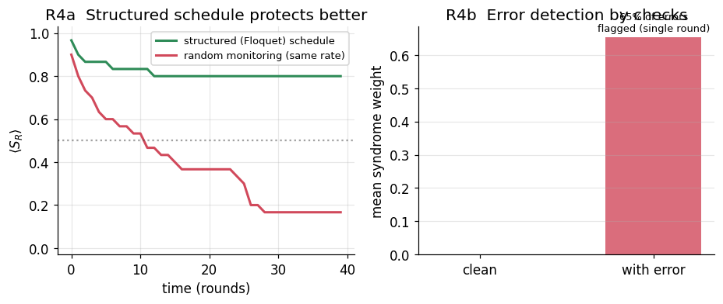
Figure R4. Left: at matched measurement rate the structured (Floquet) schedule protects the reference qubit far better than random monitoring. Right: the schedule's checks flag single-qubit errors (mean syndrome weight) with zero false positives on clean runs.
Two points. (i) Structure helps. At the same measurement budget the dimerised schedule keeps ⟨SR⟩ high while random monitoring loses the qubit — designing the schedule realises a better code. (ii) Errors are detectable. A single round's checks flag the ~2/3 of single-qubit Paulis that anticommute with them; because every qubit belongs to one ZZ and one XX bond, the complementary round catches the remainder, so a full A∪B cycle flags every single-qubit error. This is error detection — the prerequisite for correction — generated by the read-out schedule itself.
# round A: ZZ on even bonds ; round B: XX on odd bonds (period-2 Floquet)
for c in range(cycles):
checks = ZZ_even(N) if c%2==0 else XX_odd(N)
outcomes = [sim.measure_observable(P) for P in checks] # = reservoir record
# inject error -> re-peek current checks -> flipped subset = syndrome (detected)

8 Results at a glance
Result | What is shown | Key numbers | Tool
R1 | Measurement-induced coding transition; volume→area crossover | S(N/2): 6–7 (coding) → <0.5 (trivial); p_c ≈ 0.16 | Stim, N≤18
R1b | Volume- vs area-law scaling (rigorous code signature) | S ∝ N (p=0.06) vs S ≈ const (p=0.35) | Stim
R2 | Protected logical memory (reference purification) | ⟨S_R⟩≈1 at p=0.03; →0 at p=0.30 | Stim, N=14
R3 | Dual use: same schedule computes where it protects | parity acc 0.75→0.51; protection 1.0→0 across p | Cirq, N=8
R4 | Floquet schedule: better protection + error detection | ⟨S_R⟩ end 0.76 vs 0.32; ~65% errors flagged/round | Stim, N=12

9 Advantages and honest limitations

9.1 Advantages
- Single mechanism. Protection and computation share one measurement record — no separate QEC layer is added to the reservoir.
- Tunable phase. A single knob p moves the reservoir between protected/expressive and over-measured/trivial; the useful window is p < p_c.
- Designable. Replacing random monitoring with a structured (Floquet) schedule improves protection and yields explicit, decodable syndromes.

9.2 Limitations
- No FT threshold claimed. Protection is demonstrated via purification / coding-phase diagnostics and error detection, not a logical-error-rate-vs-distance threshold. Establishing a threshold with an explicit decoder is future work.
- Backend split. The scalable phase diagnostics use the Clifford (stabilizer) backend; the compute is the small-N non-Clifford reservoir. The justification is the shared MIPT universality class, but the two are different circuits.
- Reservoir memory is modest. The critical reservoir has limited linear memory; R3 uses a windowed nonlinear task where the quantum encoding is necessary and the p-dependence is clean.

10 Future work
- Explicit decoder + threshold. Add a matching/belief-propagation decoder to the structured schedule and measure logical error rate vs code distance to test for a pseudo-threshold.
- Honeycomb Floquet code. Implement the full Hastings–Haah honeycomb schedule on a Willow-compatible patch and run the reservoir read-out as the code cycle.
- Coding-phase feature theory. Relate reservoir expressivity (information-processing capacity) to the coding-phase entanglement directly, predicting the optimal p.
- Device run. Execute the monitored reservoir on Willow with mid-circuit measurement and compare on-device protection and task accuracy to simulation.

11 References
- Li, Chen, Fisher. Quantum Zeno effect and the many-body entanglement transition. Phys. Rev. B 98, 205136 (2018).
- Skinner, Ruhman, Nahum. Measurement-induced phase transitions in the dynamics of entanglement. Phys. Rev. X 9, 031009 (2019).
- Choi, Bao, Qi, Altman. Quantum error correction in scrambling dynamics and measurement-induced phase transition. Phys. Rev. Lett. 125, 030505 (2020).
- Gullans, Huse. Dynamical purification phase transition induced by quantum measurements. Phys. Rev. X 10, 041020 (2020).
- Gullans, Huse. Scalable probes of measurement-induced criticality. Phys. Rev. Lett. 125, 070606 (2020).
- Hastings, Haah. Dynamically generated logical qubits. Quantum 5, 564 (2021).
- Fattal, Cubitt, Yamamoto, Bravyi, Chuang. Entanglement in the stabilizer formalism. arXiv:quant-ph/0406168 (2004).
- Gottesman. The Heisenberg representation of quantum computers. arXiv:quant-ph/9807006 (1998).
- Google Quantum AI. Generative quantum advantage and instantaneous quantum depth. arXiv:2509.09033 (2025).
- Huang, Liu, et al. Learning shallow quantum circuits. STOC 2024; arXiv:2401.10095.
- Chen, Cotler, Huang, Li. Exponential separations between learning with and without quantum memory. FOCS 2021; arXiv:2111.05881.
- Huang et al. Quantum advantage in learning from experiments. Science 376, 1182 (2022); arXiv:2112.00778.
- Gidney. Stim: a fast stabilizer circuit simulator. Quantum 5, 497 (2021).
- Google Quantum AI. Quantum error correction below the surface code threshold (Willow). Nature 638, 920 (2025).
- Fisher, Khemani, Nahum, Vijay. Random quantum circuits. Annu. Rev. Condens. Matter Phys. 14, 335 (2023).

