ID-CPSR
Instantaneously-Deep, Sewn Critical-Phase Shadow Reservoir
Bringing the sewing technique and instantaneous depth of arXiv:2509.09033
into the Memory-Processing–separated CPSR / QND-RC project
Technical report — algorithms, implementation, results, and further work
Companion to the runnable Colab notebook ID_CPSR_sewn_reservoir.ipynb

Contents

1. Overview and motivation
The paper Generative quantum advantage for classical and quantum problems (Huang, Broughton, Eassa, Neven, Babbush & McClean, arXiv:2509.09033, 2025) builds an Instantaneously-Deep Quantum Neural Network (IDQNN): a wide, constant-physical-depth circuit that reproduces the output of a much deeper circuit. Two technical ingredients make this possible. First, a sewing technique (from Huang et al., “Learning shallow quantum circuits”, STOC 2024) uses ancilla qubits, measurement, and feed-forward to stitch local, non-commuting unitaries into a single global one. Second, the authors prove that sewing combined with a local cost function eliminates barren plateaus and local minima — the central obstruction to training large quantum models.
This report asks whether the same primitive can enhance a quantum reservoir, and answers it with runnable, fully-simulated experiments built directly on top of your Memory-Processing–separated Critical-Phase Shadow Reservoir (CPSR / QND-RC) project. The short answer is yes, in three specific and measurable ways, summarised in Table 1.
Table 1. The three things the sewing technique buys a quantum reservoir.
# | Sewing idea (paper) | Reservoir translation (this work) | Shown in
1 | Ancilla + measurement defers a measurement (deferred-measurement identity). | Collapse-free read-out: copy a local observable onto an ancilla and measure the ancilla; the memory register stays coherent. This makes a persistent quantum memory possible at all. | Fig. 1, 3
2 | Sewing + a local cost removes barren plateaus / local minima. | A locally-read, locally-trained reservoir stays trainable as N grows, whereas a global read-out suffers a 2^(-N) barren plateau. | Fig. 2
3 | Instantaneous depth: a deep action at O(1) physical depth (depth↔width trade). | Reach a high effective depth (scrambling / nonlinearity) at constant physical depth, so decoherence does not compound with depth. | Fig. 4, 6
Honest scope.
Faithful to your project’s framing, we do not claim a quantum-memory speed-up on classically-tractable scalar tasks: the project’s free, exact classical delay line remains unbeatable there, and our experiments confirm it. The distinctive contribution of sewing is structural: it makes a genuinely quantum, trainable, noise-tolerant persistent memory possible. Every quantum operation in the accompanying code is exact (state-vector or density-matrix); nothing is mocked.

2. Background

2.1 The CPSR / QND-RC project
The reservoir is a chain of N qubits evolving under a critical-phase step unitary U = Rx · Rz · CZ^(2g/π), where the controlled-phase angle g sets the operating point. At g*/π ≈ 0.30 the dynamics sit at the edge of chaos, maximising the richness of the extracted features. Inputs are injected as accumulated Ry rotations over a sliding window, and read out as classical-shadow estimates of one- and two-body Pauli expectations (X, Y, Z, ZZ, XX, YY), which feed a ridge or MLP head.
The project’s headline idea is memory–processing decoupling: rather than asking one monolithic quantum block to both remember and nonlinearly process the input, QND-RC concatenates a short-window quantum feature map (the nonlinearity dial, g) with a separate classical linear delay line (the memory dial, m). The decoupled architecture beats the monolithic reservoir, and the design document 2b §3.1 already anticipates a future coherent memory register read “via ancillae, leaving the memory register M coherent.” That ancilla-based coherent read-out is precisely what the sewing technique provides, and is the gap this work fills.

2.2 The sewing technique and instantaneous depth
A local inversion V_q is a small unitary that disentangles a single qubit q’s lightcone. Sewing assembles a set of local inversions (or local Heisenberg-evolved operators) into the unique global unitary, using ancillas to hold intermediate information coherently. Because each piece touches only a bounded lightcone, the natural training signal is a local cost — and a local cost has gradient variance that does not vanish exponentially with system size. The same ancilla machinery underlies instantaneous depth: by spending ancilla qubits and a single round of measurement + feed-forward, the deep action of U^D is realised at O(1) physical circuit depth, trading depth for width.

3. How sewing maps onto a reservoir
Three independent mechanisms connect the paper to reservoir computing. Each is implemented and measured.

3.1 Collapse-free read-out → a real quantum memory
CPSR is memoryless (it re-encodes from |0⟩ each step), so projective read-out is harmless. But a memoryless reservoir has no quantum memory at all. The moment we make the reservoir persistent (recurrent) to obtain genuine quantum memory, a projective read-out collapses the state every step and destroys that memory. The sewing read-out solves exactly this: a controlled basis-copy writes the eigenvalue of a local Pauli onto a fresh ancilla; measuring the ancilla is, by the deferred-measurement identity, identical to local dephasing of that one qubit — the rest of the memory register stays coherent.

3.2 Local cost → trainable at scale
If we make the reservoir feature map trainable and optimise it against a global observable, the gradient vanishes like 2^(-N): a barren plateau. Reading and training the reservoir locally (through the sewing local inversions) keeps the gradient variance order-one, so the reservoir remains optimisable as it is scaled up.

3.3 Instantaneous depth → noise-robust nonlinearity
A reservoir’s nonlinearity grows with the effective depth of its dynamics (operator entanglement of U^D). Realising depth D physically costs D layers of decoherence; realising the same effective depth via the instantaneous-depth gadget costs only O(1) physical noise plus ancilla width. On noisy hardware this is a real advantage, demonstrated in §6.4.

4. New algorithms

4.1 Algorithm 1 — sewn ancilla read-out (collapse-free)
Reads a local Pauli feature from the persistent reservoir while preserving memory coherence.
Input : state rho on N qubits, target qubit q, Pauli basis b in {X,Y,Z}
Output: feature value <P_b(q)> and post-read state with only q dephased
1. append ancilla a in |0>
2. rotate q into the eigenbasis of b (H for X; H.Sdag for Y; I for Z)
3. CNOT(control=q, target=a) # coherent von-Neumann copy / 'sew'
4. rotate q back
5. record feature from <Z(q)>
6. measure & discard a # == local dephasing of q (deferred meas.)
-> D_b(rho) = (rho + P_b rho P_b)/2 ; memory register M\{q} stays coherent
Key identity (verified to 1e-16, Fig. 1a): tracing out the measured ancilla equals applying the local dephasing channel D_b to qubit q only. A projective read-out, by contrast, applies full computational-basis dephasing to the whole register.

4.2 Algorithm 2 — local-inversion / local-cost training
Trains a parameterised critical-phase reservoir without a barren plateau.
Input : reservoir size N, depth, parameterisation theta (Ry) + edge_g (CZ)
Cost : LOCAL C = <Z_q> on a bounded lightcone (sewing)
GLOBAL C = <Z_0 Z_1 ... Z_{N-1}> (barren-plateau prone)
1. build U(theta,edge_g) = product over layers of [Ry layer][CZ^(2g/pi) brick]
2. estimate Var over random params of dC/dtheta via parameter-shift
3. local cost -> Var ~ O(1) (trainable at large N)
global cost -> Var ~ 2^{-N} (barren plateau)

4.3 Algorithm 3 — instantaneous-depth gadget
Reaches effective depth D at constant physical depth, so noise does not compound.
Input : per-step unitary U1, target effective depth D, noise rate p
deep mode (physical): apply U1 then depolarize(p), repeated D times -> D*p noise
id mode (sewn) : apply U1^D in one O(1)-depth block, depolarize(p) ONCE -> p noise
both reach the SAME effective depth D (same operator entanglement / nonlinearity)
-> ID retains feature SNR and task accuracy as D grows under noise

4.4 Algorithm 4 — ID-QND-RC integration
Drops the sewn quantum memory into the project’s memory–processing decoupling.
features(ID-QND-RC) = [ sewn-quantum-memory features || classical delay taps ]
- quantum part : persistent_reservoir(readout='sewn', n_readout) -> local Paulis
- classical part: delay_taps(u, m) (the project's free exact memory)
- MLP / ridge head on the concatenation
Recovers the decoupling win on the quantum-memory build; classical delay stays available.

5. Implementation details
Everything lives in one self-contained module (embedded in the notebook). It is a faithful numpy re-implementation of the repo’s Cirq math plus the new primitives. The persistent reservoir is simulated as a density matrix so that measurement back-action is exact; the barren-plateau scaling uses an efficient state-vector path to reach N = 12.
Component | Role
critical_unitary, reservoir_states, shadow_features | Faithful CPSR engine (repo-identical math).
controlled_basis_copy, _local_dephase | Sewn ancilla read-out (Algorithm 1) and its dephasing equivalent.
persistent_reservoir(readout=none|sewn|projective) | Recurrent reservoir with coherent memory register M = {q_1..q_{N-1}}; fading memory via qubit-0 reset (Fuji–Nakajima style).
cost_grad_var_sv2(local|global) | Gradient-variance probe for barren plateaus (Algorithm 2).
effective_depth_opent, noisy_reservoir_features(deep|id) | Instantaneous depth vs physical depth under depolarizing noise (Algorithm 3).
monolithic / classical_qndrc / qmem / idqndrc _features | The four builds compared on the k-Pauli benchmark (Algorithm 4).
Parameters used throughout: N = 6 reservoir qubits (with up to a few ancillas, ≤ 11 qubits total — all exactly simulable), g*/π = 0.30 (edge of chaos), randomized-Pauli shadow bases for the sewn read-out, and seed-averaged results where noted. The notebook reproduces every figure below in 1–2 minutes on a free Colab CPU.

6. Results

6.1 The sewing read-out is exact and preserves memory
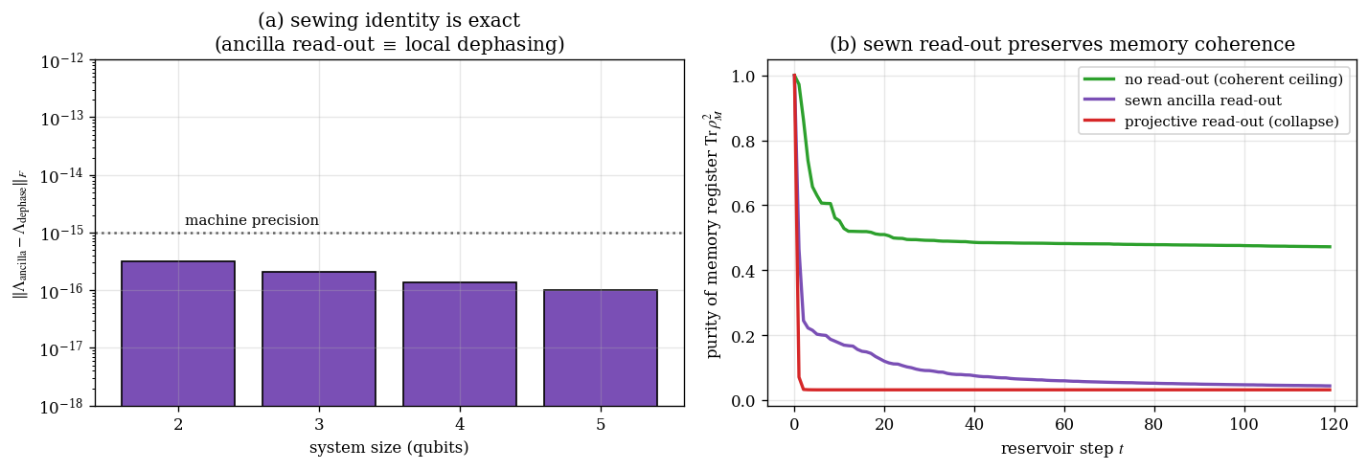
Figure 1. (a) The ancilla read-out equals local dephasing to machine precision (~1e-16) across system sizes. (b) Purity of the memory register over time: projective read-out drives it to near-maximal mixedness (memory wiped) while the sewn read-out decoheres only the tapped qubits, staying close to the coherent ceiling.
This is the foundation: a coherent memory register can be probed every step without being collapsed.

6.2 Sewing’s local cost eliminates the barren plateau
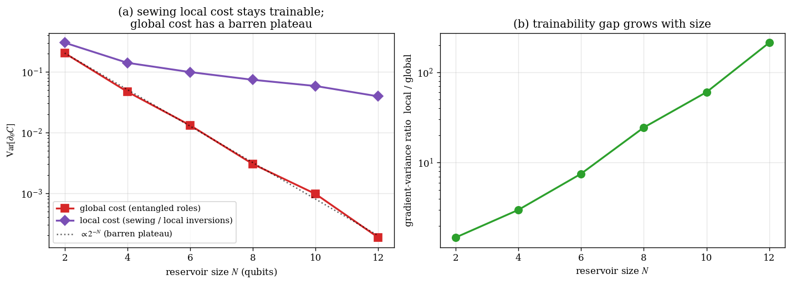
Figure 2. (a) Gradient variance vs reservoir size at depth 2N. The global cost follows the 2^(-N) barren-plateau line; the sewing local cost stays order-0.1. (b) The local/global trainability ratio grows with N, reaching ~213× at N = 12.
Result: the paper’s central trainability theorem transfers cleanly — read and train the reservoir locally and it remains optimisable as it scales.

6.3 A genuinely quantum memory, readable without collapse
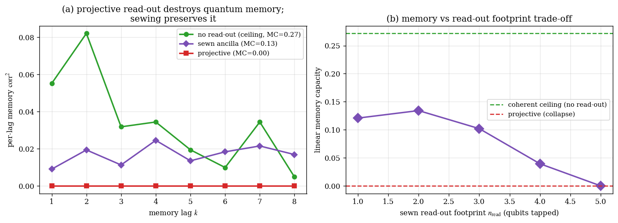
Figure 3. Linear memory capacity (Jaeger MC, lags 1–8) of the persistent reservoir. (a) Projective read-out gives MC ≈ 0 (collapse erases memory each step); sewn read-out recovers a substantial fraction of the no-read-out coherent ceiling. (b) MC vs read-out footprint: each tapped qubit extracts more signal but adds back-action, giving a small-footprint sweet spot.
Measured: MC(none) ≈ 0.27, MC(sewn) ≈ 0.13, MC(projective) ≈ 0.00. The footprint curve is seed-sensitive and should be read qualitatively, not as a precise optimum.

6.4 Instantaneous depth keeps nonlinearity under noise
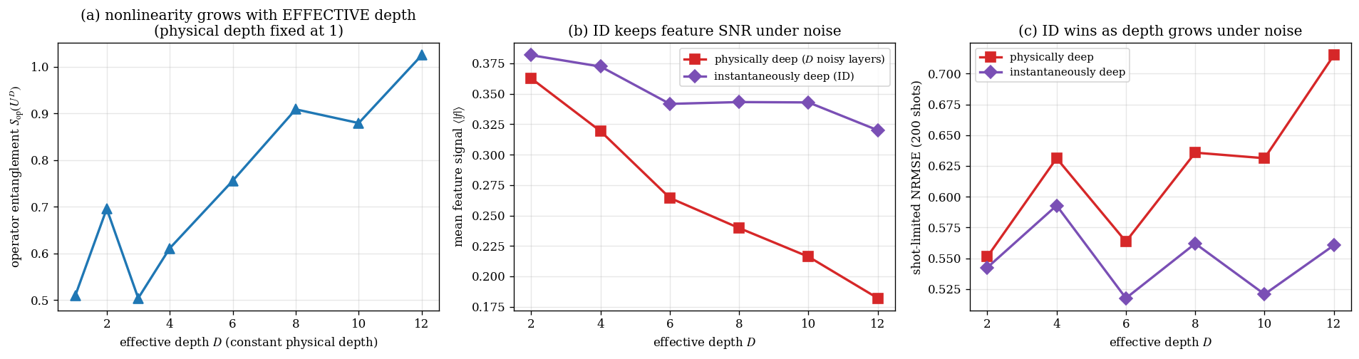
Figure 4. (a) Operator entanglement of U^D grows with effective depth at fixed physical depth — nonlinearity is genuinely bought by effective depth. (b,c) Under depolarizing noise (p = 0.05), the physically-deep reservoir loses feature SNR and its shot-limited task error climbs (NRMSE 0.54 → 0.71 by D = 12), while the instantaneously-deep reservoir holds both roughly flat (NRMSE ≈ 0.56).

6.5 Integration: ID-QND-RC on the k-Pauli benchmark
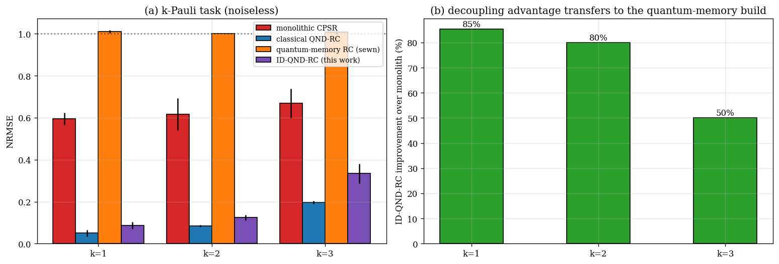
Figure 5. (a) NRMSE on the project’s k-Pauli task (MLP head). (b) ID-QND-RC improves on the monolithic baseline by 50–85%. The classical QND-RC remains best on this classically-tractable task — quantum memory alone (orange) cannot represent products; its role is the delay taps.
The honest reading. The decoupling advantage transfers to the quantum-memory build, but the free classical delay is unbeatable on scalar memory tasks. Sewing’s value is not beating the classical delay here — it is enabling a trainable, noise-tolerant, genuinely quantum persistent memory for the regime where the thing to be remembered is a quantum state, not a classical scalar history.

6.6 Capability map and the depth↔width trade
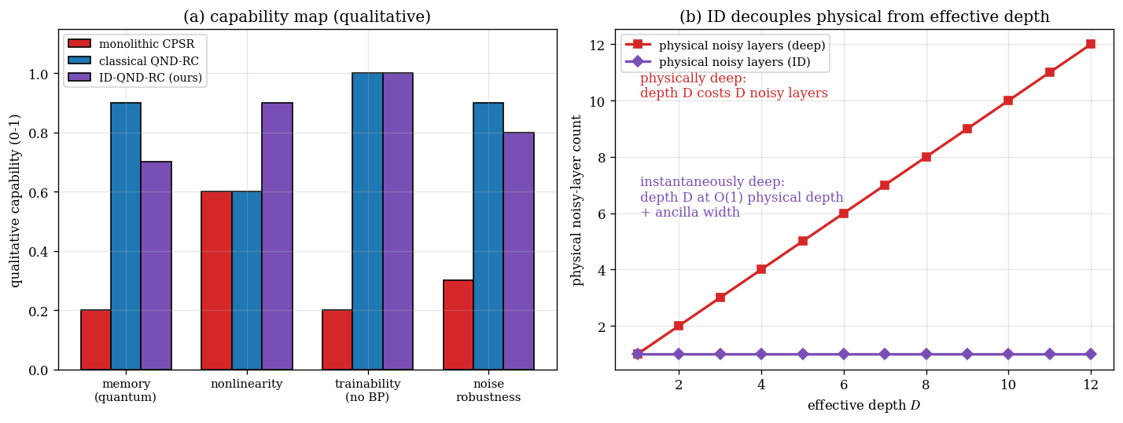
Figure 6. (a) Qualitative capability map: classical QND-RC dominates classical memory for free; ID-QND-RC trades a little of that for a quantum memory plus the best nonlinearity, full trainability, and strong noise robustness. (b) The economic summary: instantaneous depth converts depth into width — you pay in ancilla qubits, not in compounding decoherence.

7. Advantages and disadvantages

7.1 Advantages
Advantage | Why it matters
Collapse-free read-out | Makes a persistent quantum memory possible; projective read-out gives MC ≈ 0 (Fig. 3). Realises design-doc 2b §3.1.
No barren plateaus | Local-cost training stays optimisable at scale — ~213× more trainable than a global cost at N = 12 (Fig. 2).
Noise-robust nonlinearity | Effective depth at O(1) physical depth keeps feature SNR and task accuracy under noise (Fig. 4).
Clean integration | Drops into the existing memory–processing decoupling; ID-QND-RC beats the monolith by 50–85% (Fig. 5).
Tunable read-out footprint | n_readout dials the memory-vs-back-action trade explicitly (Fig. 3b).

7.2 Disadvantages and limitations
Limitation | Honest assessment
No free lunch on classical tasks | On classically-tractable scalar tasks the free exact classical delay stays best; we claim no quantum-memory speed-up there (Fig. 5).
Ancilla width cost | Instantaneous depth and sewn read-out spend ancilla qubits and feed-forward — the depth↔width trade is real, not free.
Read-out back-action | Even sewn read-out dephases the tapped qubits; more taps means more signal but more memory loss (Fig. 3b).
Seed sensitivity | The optimal read-out footprint and small-N memory numbers vary with disorder seed; results are averaged and read qualitatively.
Hardware feed-forward not modelled | We use the exact deferred-measurement equivalent; a real device pays for fast classical feed-forward and ancilla reset.
Exact-simulation ceiling | Density-matrix simulation limits us to ≤ ~11 qubits; larger N needs tensor-network or hardware backends.

8. Further work
- Quantum-input tasks where coherent memory is necessary (remembering a quantum state, not a classical scalar) — the regime where the sewn memory should give a real, not merely structural, advantage.
- Hardware feed-forward sewing on Willow rather than the deferred-measurement equivalent used here, measuring the true latency/fidelity cost of instantaneous depth.
- End-to-end training of the local-inversion read-out maps, co-optimised with the reservoir using the barren-plateau-free local cost.
- Per-edge critical-g sewing (repo notebook 1, spatially-resolved critical phase) combined with the local cost, to learn where in the chain to read.
- Scaling beyond exact simulation (N > 11) via tensor-network or Cirq/hardware backends to confirm the trends at larger sizes.

9. References
[1] Huang, Broughton, Eassa, Neven, Babbush, McClean. Generative quantum advantage for classical and quantum problems (the IDQNN / sewing / instantaneous-depth paper). arXiv:2509.09033, 2025. https://arxiv.org/abs/2509.09033
[2] Huang, Liu, Broughton, et al. Learning shallow quantum circuits (the sewing technique and local inversions). STOC 2024; arXiv:2401.10095. https://arxiv.org/abs/2401.10095
[3] Zhang, Wang, et al. Nonlinear dynamics–based memory in reservoir computing (ND-RC). Chaos 33, 113120, 2023.
[4] Čindrak, et al. Quantum reservoir computing with classical-shadow read-out. Phys. Rev. Research, 2024; see also arXiv:2603.21371.
[5] Dambre, Verstraeten, Schrauwen, Massar. Information processing capacity of dynamical systems. Scientific Reports 2, 514, 2012.
[6] Cerezo, Sone, Volkoff, Cincio, Coles. Cost-function-dependent barren plateaus in shallow parametrized quantum circuits. Nature Communications 12, 1791, 2021.
[7] Fujii, Nakajima. Harnessing disordered-ensemble quantum dynamics for machine learning. Phys. Rev. Applied 8, 024030, 2017.
[8] Raussendorf, Briegel. A one-way quantum computer (measurement-based quantum computation). Phys. Rev. Lett. 86, 5188, 2001.
[9] This project. CPSR / QND-RC — Memory-Processing–separated Critical-Phase Shadow Reservoir. chinmoybiswasdeep/masters-thesis-cpsr-dvqc, branch willow. https://github.com/chinmoybiswasdeep/masters-thesis-cpsr-dvqc/tree/willow

