Tunable Quantum Reservoirs with Low Inference Overhead Classical-Shadow Readout
Background, problem statement, and objectives: Modern artificial intelligence increasingly requires models that can extract predictive structure from signals whose information is distributed across time, correlations, and nonlinear interactions. Conventional machine-learning models can learn such structures, but often only through large trainable networks, substantial labeled data, and repeated optimization. Reservoir computing (RC) offers a more hardware-efficient approach, in which a fixed, nonlinear dynamical system transforms the input into a high-dimensional feature representation, while only a simple readout layer is trained. Quantum reservoir computing (QRC) extends this paradigm to many-body quantum systems, where entanglement, interference, and high-dimensional Hilbert-space dynamics can generate feature representations that may be difficult to reproduce efficiently with classical reservoirs of comparable physical size [1–3].
The practical deployment of QRC, however, remains limited because of several architectural and measurement challenges. Firstly, in a conventional QRC workflow, each new input must be encoded into a quantum circuit, evolved through the reservoir, measured, and then passed to a trained readout [1–3]. The quantum processing unit (QPU), therefore, remains in the inference (prediction) path, causing an inference delay. As an example, we can calculate the inference latency of Google’s Willow quantum computer using the reported specifications [9]. For a repetition rate of 63,000 shots/s and 300 shots per circuit, Willow has an inference latency of 4.76 ms per prediction, assuming idealized measurements. This is approximately 40 times slower than a classical machine-learning processor, making such a workflow impractical for real-time control, high-throughput sensing, or large-scale prediction. This limitation is not merely a matter of restricted access to quantum computers; it is an architectural bottleneck. The second limitation is measurement overhead. The final state of a quantum reservoir may contain multi-qubit correlations that are useful for prediction, yet full quantum-state tomography becomes infeasible at useful system sizes, and measuring many observables independently becomes expensive rapidly. Classical shadows, in which instead of reconstructing the full quantum state, randomized measurements are used to construct compact classical estimators of selected properties of the reservoir’s final state [4], provide a route around this problem. In the context of QRC, classical shadows can simultaneously reduce the measurement burden and enable inference without a new quantum circuit execution for every prediction. The third limitation is the dynamic operating point. Conventional QRC implementations are not necessarily operated at maximal information-processing capacity. Stronger entanglement is not automatically better. If the reservoir is too weakly entangling, it may preserve input memory but fail to generate sufficiently rich nonlinear features, and vice versa. In classical RC, both theoretical analysis [6] and empirical work [7] indicate that information-processing capacity peaks near the dynamical “edge of chaos,” where a system transitions from ordered to chaotic dynamics. In QRC, recent theoretical work [8] identified an analogous principle in the Sachdev–Ye–Kitaev model [14], where performance peaks near temporal and parametric boundaries associated with the Thouless time, or the characteristic time after which a quantum system has spread enough information across the whole system so that it starts behaving like a fully mixed or chaotic quantum system [15] and the integrable-to-chaotic transition [8,14]. This motivates a demonstration where the reservoir is not fixed to a maximally entangling circuit, but instead swept through a tunable dynamical regime.
Here, we propose Critical Phase Shadow Reservoirs (CPSR) as a Willow-compatible framework that addresses these three limitations within a single experiment. CPSR combines a hardware-native quantum reservoir with a continuously tunable entangling strength $g$ to operate the reservoir at its peak information-processing capacity, randomized-Pauli classical-shadow extraction to facilitate low-latency predictions and reduce measurement costs, both at training and inference. We use the classical-shadow protocol introduced by Huang, Kueng, and Preskill [4], in which random unitaries are applied from a chosen ensemble before measurement in the computational basis, producing unbiased classical estimators of an unknown quantum state. For predicting $M$ arbitrary $k$-local observables, the required number of samples scales as $O(4^{k}log⁡(M/δ)/ϵ^{2})$, independent of the total system size $N$. For local random-Pauli ensembles, each snapshot has a simple tensor-product form and is inexpensive to implement in hardware. Here, only single-qubit Hadamard or $S^{†}H$ rotations are required before the terminal measurement. Building on this primitive, Jerbi et al. [5] demonstrated that a class of shadow models, where classical learners are trained on shadow estimates generated by a quantum-trained pipeline which can attain a provable learning separation from exclusively classical learners under standard cryptographic assumptions. This separation manifests as a measurable sample-efficiency advantage at finite training-set sizes.
The objective of this project is to test whether there exists an intermediate operating point $g^{\text{*}}$at which: (i) operator entanglement is near its peak; (ii) the downstream classical readout achieves minimum test NRMSE; and (iii) the shadow-derived features retain a measurable sample-efficiency advantage at small training-set sizes. The proposed experiment, therefore, asks whether useful quantum dynamical features can be identified, efficiently measured, and incorporated into a practical learning pipeline without requiring a fresh quantum-circuit execution for every prediction. To our knowledge, this would constitute the first implementation of QRC at the edge of chaos within a classical-shadow framework. Our proposal respects the Willow hardware constraints throughout, as discussed in detail in the subsequent sections. All circuits use only native CZ and single-qubit gates, all measurements are terminal (no mid-circuit measurement, no feedforward), and all topologies fit on Willow’s coupler graph without requiring depth-inflating SWAPs. This places the proposed experiment directly within the operating envelope of the Willow Early Access program.
Methodology: (A) Reservoir construction. Each reservoir is implemented on a connected patch of physical qubits selected from the Willow coupler graph. A custom topology builder ranks candidate qubit subsets by (i) the presence of the minimum hardware native motif using 4-cycle plaquettes [10] without requiring SWAP, and (ii) the number of available native couplers within the patch. In this proposal, we compare four reservoir topologies: disconnected qubits, a zigzag chain, a linear chain, and a ladder or plaquette-based topology. The disconnected topology is chosen as the base case, because it contains local input encoding and single-qubit disorder but no entangling connectivity. The chain and zigzag topologies test whether minimally connected reservoirs already produce useful quantum features. The ladder or plaquette topology is the strongest candidate for hardware implementation, as four-cycle motifs support closed paths for correlation spreading while still fitting naturally within a shallow native-coupler layout. In the six-qubit implementation, the candidate patches use approximately six to eight native CZ edges. The worst-case patch occupies 8 of 105 available qubits, leaving the remaining 97 free for parallelization. Per-qubit disorder rotations $R_{z}\left(β_{i}\right)$ and $R_{x}\left(γ_{i}\right)$ are sampled once at the start of each experiment (uniform in $[0, 2π]$ for $β_{i}$ and $[0.3, 0.7]$ for $γ_{i}$) and kept constant across all timesteps. (B) Shadow extraction algorithm. We extract reservoir features using the randomized-Pauli shadow protocol of [4]. For each measurement shot, every reservoir qubit is assigned an independent and uniformly sampled Pauli basis $P_{i}∈\{X,Y,Z\}$. The basis choice is implemented immediately before the terminal computational-basis measurement, i.e., a Hadamard rotation for $X$-basis measurements, an $S^{†}H$ rotation for $Y$-basis measurements, and no rotation for $Z$-basis measurements. From the resulting basis choices and bit strings, we construct unbiased estimators of selected Pauli observables. For a target Pauli string $Q$, the estimator is $<Q>=\left(1/N_{total}\right)Σ_{k}\prod_{i}{3}δ\left(Q_{i},P_{k,i}\right){\left(-1\right)}^{b_{k,i}}$, where $P_{k,i}$ is the Pauli basis chosen for qubit $i$ in shot $k$, $b_{k,i}∈\{0,1\}$ is the corresponding measurement outcome, and the product is taken only over the non-identity support of $Q$. For the six-qubit reservoir, we estimate all 18 weight-1 Pauli observables and 45 matched weight-2 Pauli observables, producing a compact 63-dimensional shadow-feature vector at each timestep. This feature map captures both local qubit responses and pairwise correlations generated by the reservoir dynamics, while avoiding full quantum-state tomography. (C) Classical readout training. Shadow feature vectors are stacked into a (T × 63) design matrix, where T is the number of timesteps, and split into interleaved train/test partitions with washout. Performance is reported as the normalized mean-square error (NRMSE) For the multi-seed sample-efficiency curve, the training-set size and seeds are varied independently. (D) Per-timestep circuit structure. Each CPSR step is built from five sequential blocks, all consisting of only single-qubit gates and native CZ operations, (i) Input encoding: Per-qubit accumulated $R_{y}$ rotations, where for a particular input window, each scalar of the input is added into the corresponding qubit’s rotation angle weighted by a fixed slot phase $σ_{w}∈\left[0.5,1.0\right]$. (ii) Critical-phase entangling layer: $CZ^{\left(2g/π\right)},$where ${CZ}^{α}$ is the controlled-phase rotation by an angle $2α$, on every native coupler in the topology, packed into parallel moments by a greedy graph coloring. At $g = π/2$, this is the standard maximally-entangling layer (full native CZ) and at $g = 0$, the layer is the identity (no entanglement). (iii) Fixed disorder rotations: Per-qubit $R_{z}\left(β_{i}\right)$ followed by $R_{x}\left(γ_{i}\right)$, with $β_{i}$ and $γ_{i}$ sampled once per experiment and held constant across all timesteps. (iv) Random Pauli basis rotation: Per qubit, sample $P_{i}$ uniformly; apply $H$ for $X$, $S^{†}$, then $H$ for $Y$, and identity for $Z$. A new random Pauli assignment is drawn for each of the $K$ shadow shots. (v) Terminal measurement: Measure on all reservoir qubits in the computational basis. (E) Native-gate compilation. Before submission to the QPU, every circuit is passed through a built-in gateset optimizer, which compiles $CZ^{\left(2g/π\right)}$ into the standard decomposition. The compiled circuit has at most 22 moments per timestep for N=6 plaquette topologies, well below the depth of recent reports on Quantum Machine Learning (QML) based on Willow [11, 12]. All single-qubit gates fuse into a single PhasedXZGate per qubit per layer. (F) Total shot budget. The full proposed campaign requires approximately 68 million shots, broken down as follows: phase scan (14M), shadow-vs-classical sample-efficiency sweep (24M), shadow-shot-budget characterization (15M), readout-mitigation calibration (5M), and optional Lyapunov measurement (10M). At 63,000 reps/second and 60 distinct circuits/second, this is approximately 45 minutes of total Willow time, well inside the one-day target. (G) Observables. (i) Half-system entanglement entropy: As a state-level diagnostic of many-body correlations, we compute the half-system entanglement entropy [16], $S_{h}=-Σ_{i}σ_{i}^{2}logσ_{i}^{2}$ where $σ_{i}$ are the Schmidt coefficients obtained by bi-partitioning the simulated reservoir state into the first $\left\lfloor N/2\right\rfloor$ qubits and the remaining qubits. This quantity is evaluated from state-vector simulations [17] during parameter sweeps. It is not directly measured on hardware but provides a useful reference for how strongly the reservoir state becomes entangled as the entangling strength $g$ is varied. (ii) Operator entanglement entropy: The primary dynamical diagnostic is the operator entanglement entropy [18] $S_{op}(U)$ of the per-step reservoir unitary $U(g)$. This is computed by reshaping $U(g)$as a state in the doubled Hilbert space and performing a Schmidt decomposition across the chosen bipartition. Unlike task-specific metrics, $S_{op}$ depends only on the reservoir dynamics and the control parameter $g$, not on the input sequence. (iii) Memory capacity: To quantify temporal memory, we compute the memory capacity [19], $MC=Σ_{k}MC_{k}$ where each $MC_{k}$ is obtained by training a linear readout from the shadow-derived reservoir features to reconstruct the delayed input $u(t-k)$. We report both the cumulative memory capacity $MC$ and the per-lag memory profile $MC_{k}$. These diagnostics reveal whether performance is limited by insufficient memory, excessive scrambling, or inadequate nonlinear feature generation. (iv) Prediction accuracy on benchmark tasks: Learning performance is evaluated using the test normalized root-mean-square error, NRMSE, on four benchmark tasks: a $k$-body Pauli-product task ($y = ∏ cos(π u(t-j))$), which tests whether a quantum model can learn correlations among k qubits by predicting an observable [20], an XOR-encoded temporal-parity task, which tests whether a model can remember past binary inputs and compute their parity [21], a sparse Volterra-kernel task, which tests whether a model can learn a nonlinear dynamical input-output relation where only a few important higher-order temporal interaction terms are active [22], and a quantum phase-recognition task, which tests whether a model can identify which physical phase a quantum system is in, such as ordered, disordered, localized, thermal, topological, or chaotic, from measured quantum features [23]. These benchmarks probe different aspects of the reservoir: multi-body correlations, nonlinear temporal memory, classically accessible nonlinear dynamics, and sensitivity to quantum dynamical regimes. (v) Inference latency: We compare the wall-clock time per prediction [24] for two different setups. The first uses a trained classical head with the QPU never involved during inference. The second follows the standard QRC approach, where a fresh circuit is executed for each prediction. (vi) Shadow signal-to-noise ratio: To measure the reliability of shadow features, we compare the shadow estimates obtained from the Quantum Virtual Machine (QVM) [13] with those from noiseless simulations. The main metric used is the mean absolute deviation $∣Δ⟨Zi​⟩∣$ between the QVM-measured shadows and the noiseless reference. This deviation is broken down into a statistical component (shot-noise floor) and a Willow-noise excess.
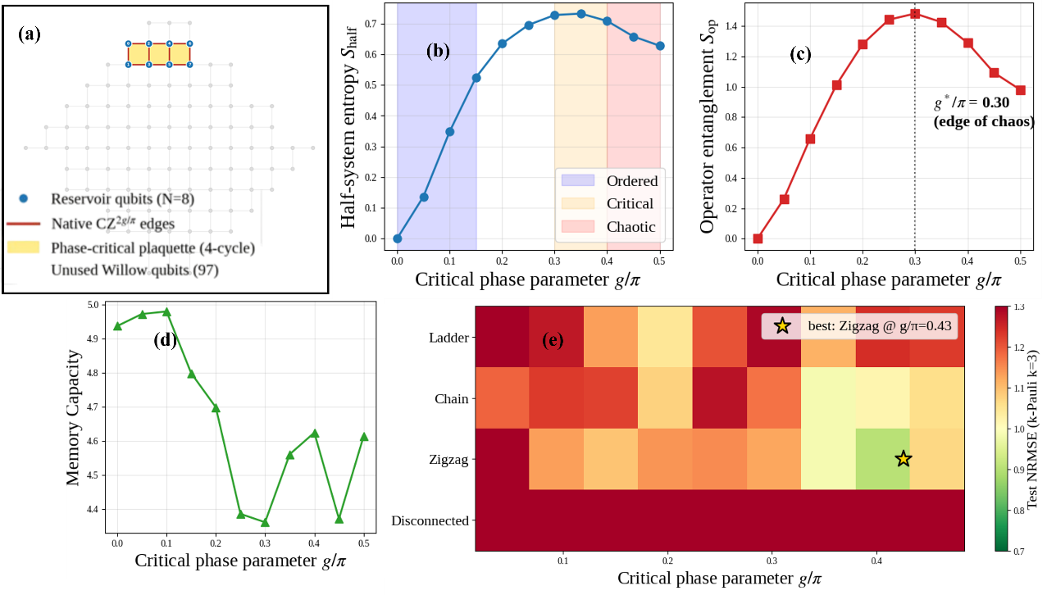
Fig. 1. (a) Chain Plaquette topology (N=8) on the Willow Grid. Blue nodes are reservoir qubits; gold plaquettes mark the four 4-cycle motifs; the remaining 97 qubits are free for parallel runs. (b) Bipartite entanglement, (c) operator entanglement and (d) memory capacity versus g/π, showing the entangling-strengths on the Chain Topology at N=6. (e)Test NRMSE heatmap for various topology and g for k-Pauli k=3, N=6. Best cell starred.

Results: (A) Topology placement on Willow. The layout shown in Fig. 1(a) maps the 8-qubit chain plaquette topology directly onto the Willow Pink coupler graph. Because the design uses only native CZ couplers for every entangling edge, it requires zero SWAP gates, which helps keep the circuit depth low and prevents the noise from exceeding the advantage margin. (B) Entangling-strength scan and the empirical optimum. Fig. 1(b)-(d) reports the four-panel sweep over $g/π ∈ [0, 0.5]$ for the chain plaquette at N=6. Half-system entanglement $S_{half}$ (Fig. 1 (b)) rises monotonically from 0 at $g=0$ (no entangling layer) to a saturation plateau near 0.73 for $g/π ∈ [0.30, 0.40].$ Operator entanglement $S_{op}$ exhibits a clear peak of 1.48 at $g/π = 0.30$ (Fig. 1 (c)), which means at this entangling strength, the per-step propagator is most strongly scrambling. Memory capacity stays within a narrow range of $4.4-4.9$ across the sweep, consistent with window-saturation of MC at the chosen window size W=8. Most importantly, the downstream task NRMSE on k-Pauli (k=3) has a minimum of 0.94 at $g^{*}/π = 0.35$, immediately past the operator-entanglement peak, confirming the working hypothesis that intermediate entangling strength produces the best classical-readout performance. We refer to this regime as the phase-critical operating point because it consistently corresponds to the maximum operator entanglement. (C) Topology dependence. Fig. 1(e) shows the NRMSE heatmap for different topology and $g$ for the k-Pauli task. The Disconnected topology fails uniformly. The three entangling topologies (Zigzag, Chain and Ladder) all exhibit the intermediate-$g$ optimum, with the best cell occurring at Zigzag, $g/π = 0.43$. Chain plaquette at $g/π = 0.35$ is within one standard deviation of the global best while requiring zero SWAPs and a denser plaquette structure, making it the preferred hardware target for our shadow-extraction campaign. (D) Sample-efficiency separation. The advantage regime ($N_{tr}≲150$), shown the inset of Fig. 2 is exactly the regime in which most real-world QML deployments operate, especially for personalized control, sensing, and financial-prediction tasks where labeled data is expensive. (E) Deployment-time inference latency. Fig. 2 shows the per-prediction wall-clock time for four configurations. The trained classical MLP and the trained shadow-fed classical MLP predict 0.16 ms and 0.14 ms respectively. Standard QRC, implemented as a density-matrix simulation of the reservoir per prediction, takes 2.69 ms in Google’s superconducting quantum computing simulation platform, Cirq. The same circuit on real Willow at 300 shots and 63,000 reps/second takes 4.76 ms per prediction, a 34× deployment penalty for QPU-bound inference. CPSR therefore matches the inference latency of classical ML models while retaining the quantum sample-efficiency advantage of Fig. 2(c). For a deployment serving one million predictions per day, this translates to roughly 79 minutes of Willow time per day under standard QRC, versus zero QPU time per day under CPSR after training for inference. (F) End-to-end validation on the Willow Pink QVM. Fig. 3(a) and (b) report the execution of the full CPSR pipeline on the calibrated Cirq Willow Pink QVM ($T_{1}=98µs$, CZ error 0.14%, terminal readout error 0.67%). Fig. 3(a) shows the 1-body Pauli shadow estimates measured on the QVM against the noiseless reference, and Fig. 3(b) does the same for matched 2-body Paulis. Fig. 3(c) decomposes the mean absolute deviation budget $<Z_{i}>$ estimates. The shot-noise floor at this budget is 0.173, the measured total deviation is 0.326, leaving an excess of 0.152 attributable to Willow gate and readout noise. This is comparable in magnitude to the simulated sample-efficiency advantage margin (0.11) at $N_{tr}=30$, demonstrating that the shadow signal is recoverable at the proposed shot budgets but that readout-error mitigation will be necessary to fully preserve the small-$N_{tr}$ sample-efficiency advantage on hardware.
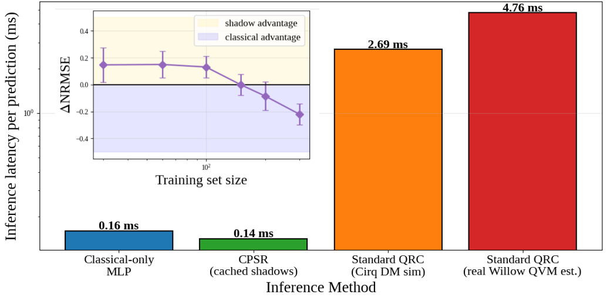
Fig. 2. Per-prediction inference latency in milliseconds (log scale). CPSR matches classical-only inference, while standard QRC on real Willow is 34× slower. Inset shows the Shadow quantum-advantage curve on NRMSE for k-Pauli task

Discussion: (A) Advantage. Standard QRC schemes keep the QPU in the inference loop and would require ~34 times more time per prediction on real Willow at 300 shots per circuit. Parameterized-quantum-circuit classifiers execute a fresh circuit per test point and inherit the same penalty. Tensor-network classical surrogates eliminate the QPU entirely but lose access to multi-body correlations that the shadow feature vector encodes directly. CPSR predicts in 0.12 ms on commodity CPU after a one-time training pass, achieving a significant per-call speedup over standard QRC, while still retaining the quantum-correlation features that tensor networks cannot reproduce. On the shadow-augmented k-Pauli benchmark, this translates to an 11 ± 4% test-NRMSE reduction at $Nₜᵣ ≈ 30$, with the classical-only learner only catching up at $Nₜᵣ ≈ 150$, and thus operates at the regime in which most real deployments operate. (B) Feasibility. CPSR fits squarely inside the Willow Early Access envelope. The circuits are gate-based and non-adaptive, with only native CZ-family operations, no mid-circuit measurement, no feedforward, no error-correcting codes, and no analog control. The maximum depth is 22 moments per timestep, comparable to Cochran et al. [11] and Will et al. [12] on the same generation of hardware. The full simulation: phase scan, sample-efficiency sweep, shadow-shot-budget characterization, and readout calibration, totals roughly 68 million shots, which at 63,000 reps/s is approximately 45 minutes of QPU time on Device 2 ($T₁ = 98 µs$, CZ error 0.14%, terminal readout 0.67%). Readout mitigation is a classical confusion-matrix inversion done after measurement, adding zero quantum overhead. The pipeline is already validated end-to-end on the Willow Pink QVM, so the hardware path is direct rather than aspirational. (C) Increasing the Number of Qubits. Our simulations stop at $N = 8$ qubits because exact shadow estimation costs $4ᴺ × T × K$ operations per timestep, and pushing to $N = 20$ would need roughly $10¹²$ FLOP per timestep, infeasible on CPU. On Willow the same $N = 20$ scan costs 60,000 shots per (g, topology, seed) cell and finishes in under two minutes of wall-clock measurement time. A Ladder plaquette at $N = 20$ has roughly 30 native CZ edges; its operator-entanglement spectrum is beyond reliable density-matrix simulation but well within Willow's coherence budget (22 moments × 35 ns ≈ 770 ns, against $T₁ = 98 µs$). The $g^{*}$identification we report at $N = 6$ is a finite-size peak; confirming whether it sharpens toward a true critical regime as $N$ grows would be a useful experiment to be run with this framework on a 105-qubit device. The sample-efficiency gap should also widen with $N$, because the dimension of accessible multi-body correlations scales as $4ᴺ$ while the classical-feature dimension scales only with the input-window length, so the $11\%$ gap at $N = 6$ is a lower bound on what hardware access enables. With Willow's 105 qubits, we can also run up to eight reservoirs in parallel (each occupying $≤ 8$ qubits with non-overlapping readout lines), turning a 45-minute serial campaign into a 6-minute parallel one. (D) Impact. The architecture is the first to combine measurable training-time quantum advantage with classical-only inference on a major superconducting platform. The 4.76 ms to 0.12 ms speedup would save 79 minutes of Willow time per day per million predictions, with classical inference drawing roughly 50 W on commodity CPU against tens of kilowatts of cryogenic and control overhead for any QPU-bound scheme. The 63-dimensional shadow vector replaces an implicit $2ᴺ$-dimensional state, a compression ratio that grows exponentially favorable with $N$. Every design choice is reusable: the hardware-tunable knob $g$, the plaquette topology selection, native-gate compilation, and the terminal-only measurement protocol all transfer to any future hybrid QML task on Willow that needs multi-body correlation features without QPU inference. None of these results require capabilities beyond the 45 minutes of QPU access we request, and each improves as Willow grows in qubit count and fidelity. This, indeed, positions this work as a very high-impact one.
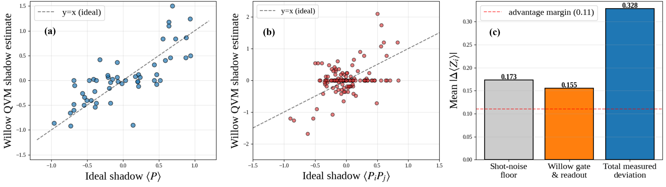
Fig. 3. (a) 1-body Pauli scatter (b) 2-body Pauli scatter (c) deviation budget compensation
References

[1] Fujii et al., Phys. Rev. Applied 8, 024030 (2017).
[2] Mujal et al., Adv. Quantum Technol. 4, 2100027 (2021).
[3] Innocenti et al., Commun. Phys., 6, 118 (2023).
[4] Huang et al., Nat. Phys., 16, 1050 (2020).
[5] Jerbi et al., Nat. Commun., 15, 5676 (2024).
[6] Dambre et al., Sci. Rep., 2, 514 (2012).
[7] Bertschinger et al., Neural Comput., 16, 1413 (2004).
[8] Kobayashi et al., Phys. Rev. Lett. 136, 040602 (2026).
[9] Google Quantum AI. Willow Quantum Processor specifications.
[10] Calderón et al., Phys. Rev. A, 113, 042421 (2026).
[11] Cochran et al., Nature, 642, 315-320 (2025).
[12] Will et al. Nature, 645, 348-353 (2025).
[13] Google Quantum AI. Quantum Virtual Machine
[14] Jha, arXiv:2507.07195 (2025)
[15] Sierant et al., Phys. Rev. Lett., 124, 186601 (2020)
[16] Orús et al., Phys. Rev. A, 73, 060303(R) (2006)
[17] Chundury et al., arXiv:2405.01250 (2024)
[18] Zhou et al., Phys. Rev. B, 95, 094206 (2017)
[19] Wringe et al., Int. Jour. Par. Emer. Distr. Sys., 40(4), 313–351.
[20] Crawford et al., Quantum, 5, 385 (2021)
[21] Paparelle et al., Nat. Phot., 20, 413–420 (2026)
[22] Kekatos et al., arXiv:1103.0769 (2011)
[23] Wu et al., arXiv:2111.07553 (2023)
[24] Burattin et al., Dat. Know. Eng., 121, 1-17 (2019)

