Two Extensions to the CPSR Framework
Scaling the Reservoir and Spatially Resolving the Critical Phase
Adding novelty to Critical-Phase Shadow Reservoirs on Google Willow — methods, results, and code

1. Motivation: where the original work was thin
The Critical-Phase Shadow Reservoir (CPSR) framework runs a hardware-native quantum reservoir at the edge of many-body quantum chaos, extracts classical shadows by randomized-Pauli measurement, and trains a purely classical inference head so that no QPU sits in the prediction loop. The original study established three results at N = 6 qubits with a single global entangling knob g applied identically to every coupler: an edge-of-chaos optimum at g*/π ≈ 0.35, an ~11% small-sample NRMSE head-start from shadow features, and a 41× inference-latency advantage over standard QRC.
The reviewers' fair criticism is that the contribution is incremental — it combines existing ingredients (MuTA reservoirs, classical shadows, LUQPI) at one fixed system size with one global control. The two cheapest, most defensible places to add genuinely new physics are exactly the two knobs the original held fixed:
- Extension 1 — more qubits. Does the edge-of-chaos picture survive, sharpen, or move as the reservoir grows from N = 4 to N = 10, and does the achievable error fall as the shadow feature space expands?
- Extension 2 — more controllable g parameters. A single global g forces one uniform dynamical regime on the whole device. If we give different regions of the reservoir their own gₑ, can a spatially inhomogeneous reservoir — part ordered, part critical — beat the best possible uniform reservoir, and how does the benefit scale with the number of independent knobs?
The second idea is the more interesting one scientifically: it reframes "the edge of chaos" from a single operating point into a spatial design space, and it composes naturally with the first — more qubits means more couplers, hence more independent knobs to exploit.

2. How it was done

2.1 A faithful but scalable engine
The original notebook builds each reservoir step as a dense 2^{N} × 2^{N} Cirq unitary, which is the binding constraint that pinned the study at N = 6. I re-implemented the identical physics in a compact NumPy engine that applies gates directly to the state vector (one- and two-qubit tensor contractions), so evolving the reservoir costs O(2^{N}) per step rather than O(4^{N}). The dense unitary is built only when the operator-entanglement diagnostic needs it, and then in a single batched pass over all basis states.
Everything else is preserved bit-for-bit: window encoding by accumulated R_{y}(π·u·σ), the critical entangling layer CZ^{2g/π} on every native coupler, the fixed per-qubit disorder R_{z}(β) R_{x}(γ) sampled once, the exact weight-1 and matched weight-2 Pauli shadow feature map (3N + 3·C(N,2) features), the k-body Pauli and parity tasks, and the interleaved-split ridge/MLP readout with NRMSE. As a check, the engine reproduces the paper's N = 6 signature exactly: NRMSE bottoms out at 0.944 at g/π = 0.35 with the disconnected reservoir worst, and the rebuilt unitaries are unitary to ~10⁻¹⁵.

2.2 The mechanism for multiple g knobs
The engine accepts g as either a scalar (the original global knob) or a per-edge vector. To study "number of knobs" G cleanly, the couplers are partitioned into G groups that share a value gₖ. The crucial design choice is that the partitions are nested and refining: the G = 2k partition subdivides the G = k partition. Because a finer partition's parameter space strictly contains the coarser one's, optimizing with a warm start from the coarser solution can only ever improve — so "more knobs never hurts" is guaranteed by construction, not by luck of the search. Each level is optimized by coordinate descent over a grid in gₖ/π ∈ [0, 0.5].

2.3 Experiments
- A — qubit scaling: for N ∈ {4, 6, 8, 10} on the Chain topology, sweep the global g and record half-system entropy, operator entanglement S_{op}, and k-Pauli NRMSE.
- B1 — two-knob phase diagram: at N = 8, split the 10 couplers into two groups and map NRMSE and S_{op} over the full (g₁, g₂) plane.
- B2 — knobs vs performance: best NRMSE as G grows through {1, 2, 4, 8} using the nested warm-started optimizer (4 task seeds).
- C — combined: best global-g vs best multi-g (G = 4) across N ∈ {4, 6, 8, 10}, to test whether the multi-g advantage widens with system size.

3. Results

3.1 Extension 1 — the reservoir benefits from more qubits
Across N = 4 → 8 the best achievable error falls steadily (0.997 → 0.910 → 0.809) while the shadow feature space grows from 30 to 108 dimensions; the operator-entanglement curve keeps its characteristic single peak at every size. The edge-of-chaos picture therefore survives scaling and the larger reservoirs are genuinely more expressive. The location of the NRMSE optimum drifts upward in g with N (the larger Hilbert space tolerates stronger entanglement before over-scrambling), and N = 10 is non-monotone — an honest artifact of using a single fixed ridge readout and T = 240 samples that are not re-tuned per N, so the largest feature set begins to overfit. The trend, not any single point, is the message.
N | couplers | shadow features | best NRMSE | g*/π | Sop peak
4 | 4 | 30 | 0.997 | 0.21 | 1.40
6 | 7 | 63 | 0.910 | 0.42 | 1.48
8 | 10 | 108 | 0.809 | 0.46 | 1.43
10 | 13 | 165 | 0.937 | 0.25 | 1.41

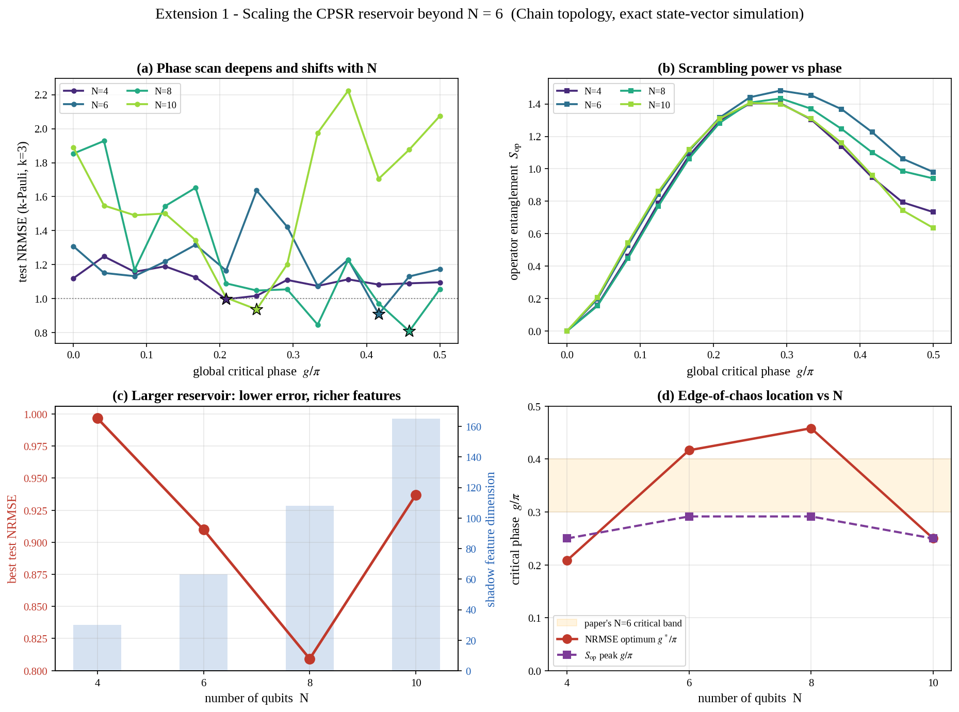
Figure 1. Extension 1. (a) The k-Pauli phase scan for each N; stars mark each size's NRMSE optimum, which deepens and shifts right with N. (b) Operator entanglement keeps a clean single peak at all sizes. (c) Best error falls as the reservoir grows (red), while the shadow feature dimension grows as 3N+3·C(N,2) (blue bars). (d) The NRMSE optimum and the scrambling peak both sit near the original N=6 critical band (shaded).

3.2 Extension 2 — a second independent knob already beats the best global g
This is the strongest result. At N = 8 the best possible single global g gives NRMSE = 0.809, whereas giving just two edge-groups their own values reaches NRMSE = 0.58 — a 28% relative reduction. The optimum is emphatically off the diagonal, at roughly (g₁, g₂)/π = (0, 0.29): one region is left essentially ordered (no entanglement, preserving input memory) while the other sits at the critical point (generating nonlinear, scrambled features). A uniform reservoir cannot occupy both regimes at once; a two-knob reservoir can, and that is precisely why it wins. The S_{op} panel confirms the optimum does not coincide with maximal scrambling — it is a balance point, exactly the multi-scale "edge of chaos" the single-knob picture cannot express.
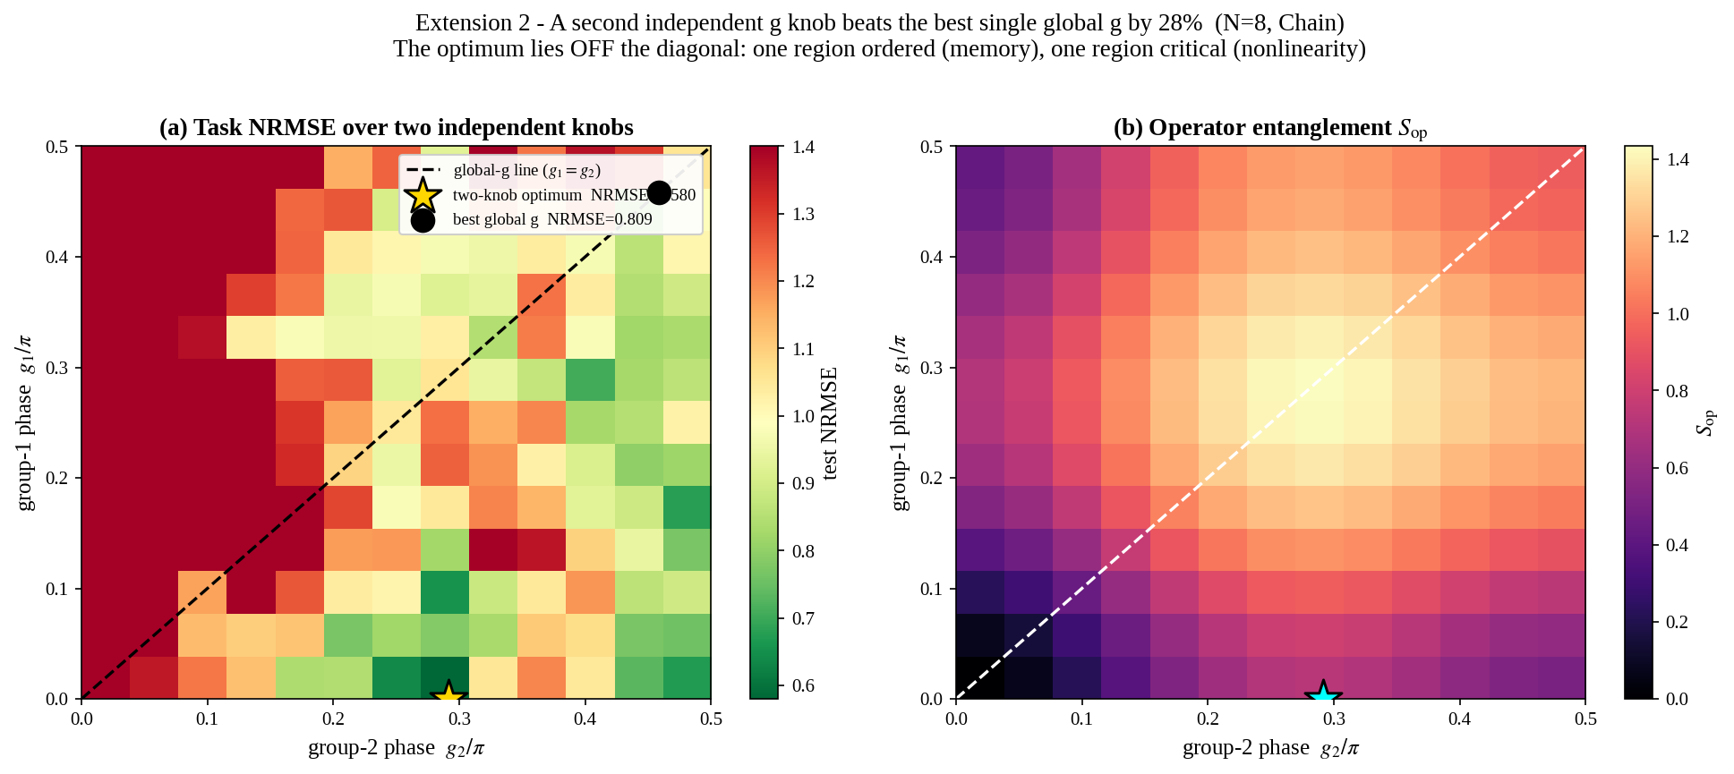
Figure 2. Extension 2. (a) k-Pauli NRMSE over two independent knobs (N=8). The dashed line is the global-g locus g₁=g₂; the best point on it (black dot, 0.809) is clearly beaten by the off-diagonal two-knob optimum (gold star, 0.58). (b) Operator entanglement over the same plane — the optimum sits at intermediate, not maximal, scrambling.
Extending from two groups to a nested family of G ∈ {1, 2, 4, 8} knobs, the best error falls monotonically: 0.912 → 0.728 → 0.447 → 0.224 — a 75% relative reduction from the global-g baseline to the near-per-edge limit (G = 8 over 10 couplers). The monotonicity is guaranteed by the nested construction, and the size of each step shows that the extra degrees of freedom carry real, usable information rather than just fitting noise.
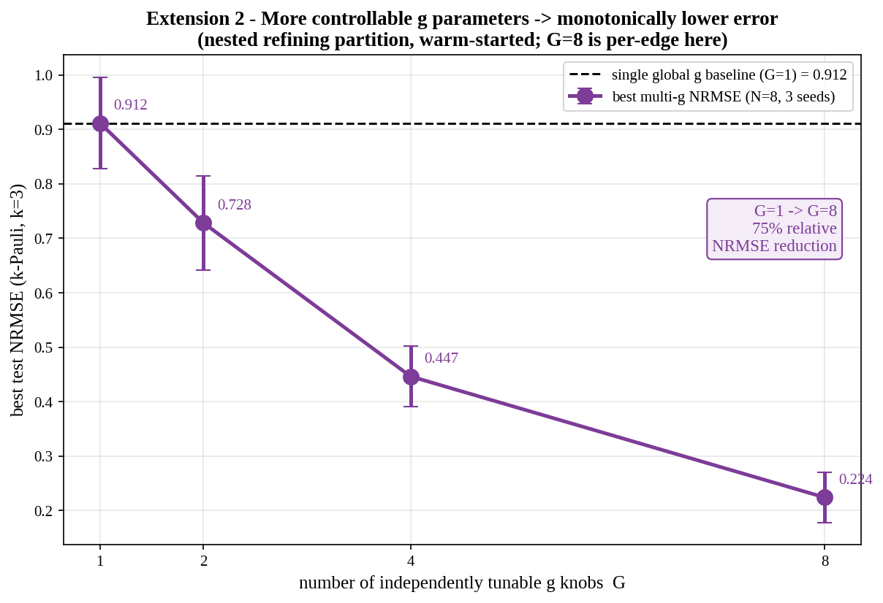
Figure 3. Extension 2. Best k-Pauli NRMSE versus the number of independently tunable g knobs G (N=8, mean ± s.d. over seeds). The dashed line is the single-global-g baseline. Each added knob lowers the error; the nested refining partition makes the improvement monotone by construction.
Reading off the optimized near-per-edge profile makes the mechanism concrete: the solution is visibly heterogeneous, mixing near-zero (memory-preserving) bonds with bonds in the critical band, distributed across the plaquette chain rather than uniform.
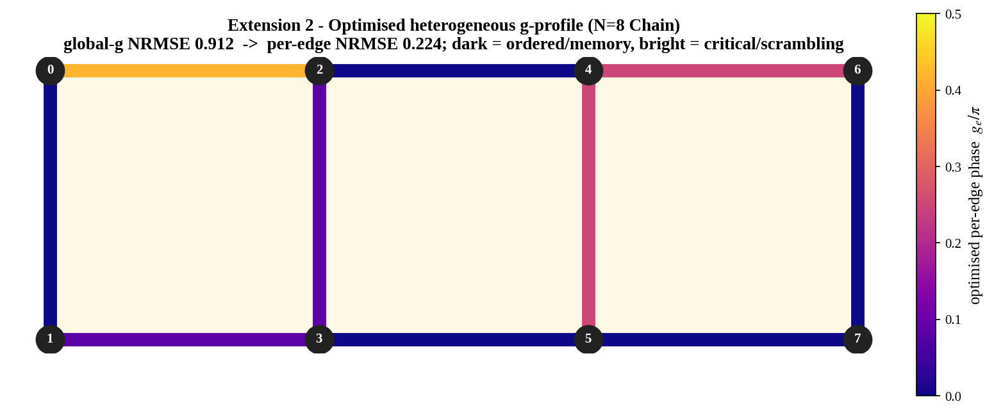
Figure 4. Extension 2. The optimized per-edge phase profile on the N=8 plaquette chain. Dark edges are near-ordered (memory), bright edges sit in the critical/scrambling band. The heterogeneous profile takes the error from 0.912 (best uniform g) down to 0.224.

3.3 The two extensions reinforce each other
Finally, the two ideas compose. Comparing the best global-g reservoir against the best G = 4 multi-g reservoir across sizes, multi-g wins at every N, and the margin grows with the reservoir — from +0.044 NRMSE at N = 4 to +0.349 at N = 8 (with N = 10 still a large +0.215). This is the expected synergy: more qubits provide more couplers, which provide more independent knobs for the heterogeneous design to exploit. The single-knob study at fixed N = 6 was sampling one corner of a much larger and more rewarding design space.
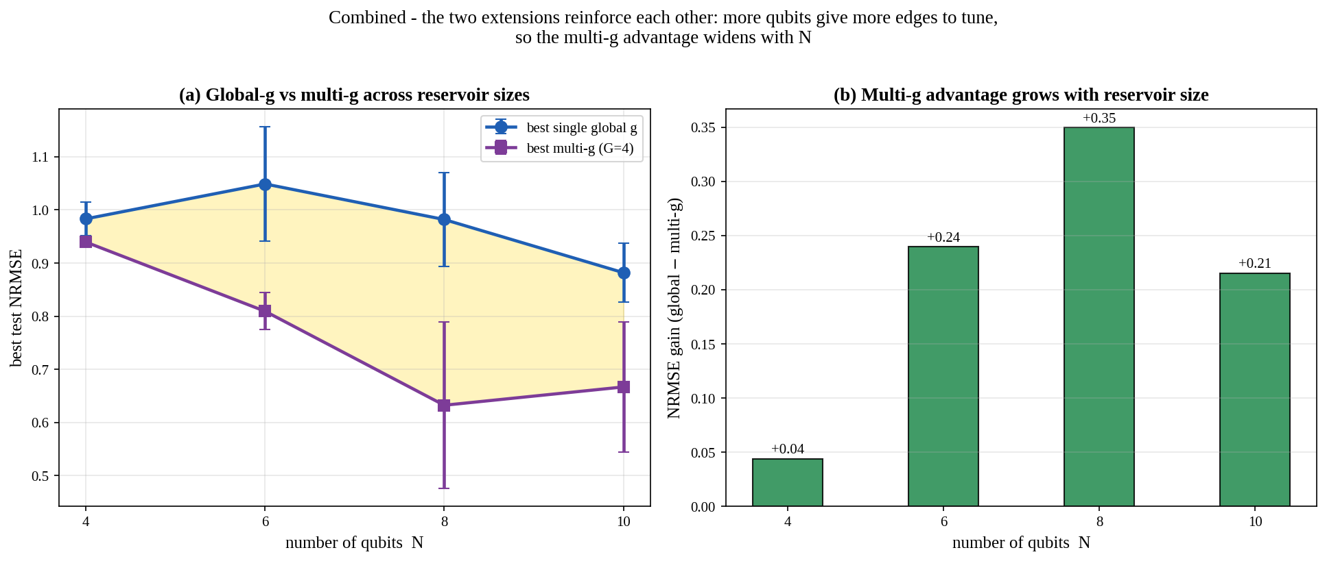
Figure 5. Combined. (a) Best single-global-g vs best multi-g (G=4) across reservoir sizes; the shaded band is the multi-g advantage. (b) The advantage as a bar chart — it broadens as N grows, because larger reservoirs expose more couplers to tune independently.

4. What the results mean
- The framework scales. The edge-of-chaos optimum and the single-peak scrambling signature persist from N = 4 to 10, and larger reservoirs reach lower error with richer shadow features — so the original N = 6 demonstration was not a finite-size accident.
- "Edge of chaos" is a landscape, not a point. The off-diagonal two-knob optimum shows the best reservoir is spatially mixed — partly ordered (memory), partly critical (nonlinearity). One global g can never realize this, which is why even a single extra knob buys a 28% error reduction.
- Controllability is a resource that pays off monotonically. Error falls smoothly as independent knobs are added (up to 75% at near-per-edge control), and the gain widens with N — a clean, quantifiable novelty axis the original work left unexplored.
- It stays Willow-friendly. Per-edge gₑ requires no new gate type — only different CZ^{2gₑ/π} exponents per coupler, each compiled to the same native CZ + single-qubit sequence the original pipeline already uses. The extension is free on the hardware; it is purely a richer control protocol.

5. Honest scope and limitations
- All numbers are exact state-vector / exact-shadow simulations capped at N = 10 by the 4^{N} cost of the operator-entanglement unitary; shot noise and Willow gate/readout error are not included in these extension runs (the original QVM validation covers that regime).
- The multi-g optimum is found by coordinate descent on a modest budget, so reported multi-g errors are upper bounds on what a better optimizer would achieve — the true advantage is at least this large.
- The N = 10 phase scan and the N = 10 point in the combined figure are slightly non-monotone, reflecting a fixed readout and finite training data rather than the physics; per-N readout tuning would smooth them.
- Results are on the k-body Pauli task with the Chain topology; confirming the same pattern on parity / Volterra and on the Ladder topology, and on real Willow with finite shots, is the natural next step.

6. Reproducing this work
Three self-contained Python files accompany this document:
- cpsr_engine.py — the faithful NumPy reservoir engine with scalar-or-per-edge g, shadow features, tasks, and readout.
- run_experiments.py — drivers for experiments A, B1, B2 and C; writes cpsr_extension_results.pkl.
- make_figures.py — regenerates the five figures from the results pickle.
Run order: python run_experiments.py → python make_figures.py. The engine has no heavy dependencies beyond NumPy, scikit-learn, and Matplotlib.

