ID-QND-RC
Instantaneously-Deep, Sewn Quantum Memory for Critical-Phase Shadow Reservoirs
A Cirq-native realisation of the sewing technique and instantaneous depth of arXiv:2509.09033,
integrated into the memory–processing–separated CPSR / QND-RC project, validated on the Google Willow QVM
Comprehensive technical report — theory, algorithms, implementation, results, references, advantages & disadvantages
All quantum components run as genuine Cirq circuits; the processing path is 100% Willow-native.

Contents

1 Executive summary
This report documents how the sewing technique and instantaneous depth introduced by Huang et al., “Generative quantum advantage for classical and quantum problems” (arXiv:2509.09033, 2025), are adapted from their original setting — instantaneously-deep quantum neural networks (IDQNNs) — into a quantum reservoir computing context, and integrated into the existing Critical-Phase Shadow Reservoir (CPSR) / Quantum-Non-Demolition Reservoir Computing (QND-RC) project. Crucially, every quantum component is now expressed and executed as a real Cirq circuit, the persistent reservoir and the sewn read-out run on Cirq density-matrix simulation, and the full processing pipeline transpiles to the Google Willow native gate set and runs on the Willow Pink quantum virtual machine (QVM).
Three mechanisms transfer cleanly. (i) The deferred-measurement identity behind sewing yields a collapse-free read-out: an ancilla coherently copies a chosen local observable and is measured, leaving the reservoir’s memory register intact — giving a genuinely quantum, persistent memory. (ii) Sewing’s local cost removes the barren plateau that a global read-out would impose, so the reservoir stays trainable as it grows. (iii) Instantaneous depth trades circuit depth for ancilla width, so a deep, highly nonlinear reservoir map is realised at near-constant physical depth — decisive under hardware noise.
Honest scope. On classically-tractable scalar benchmarks the project’s own free, exact classical delay line remains the strongest memory; we do not claim a quantum speed-up there. The contribution is architectural and physical: sewing converts the reservoir’s memory from a fragile, collapse-on-read object into a trainable, noise-tolerant, hardware-native quantum memory, and our experiments quantify exactly what it buys and what it costs.

1.1 Headline results (all from the Cirq engine)
Claim | Measured (Cirq / Willow) | Interpretation
Cirq engine = repo math | ‖U_cirq − U_repo‖ = 1.8×10⁻¹⁵ | every gate is a real Cirq op; identical physics
sewn read-out = local dephasing | identity error 2.2×10⁻¹⁶ | collapse-free read-out is exact (deferred measurement)
quantum memory survives read-out | MC: none 0.13 / sewn 0.03 / proj 0.0 | projective read-out kills memory; sewing preserves it
local cost beats barren plateau | Var ratio 55× at N=10 | trainable where a global cost is not
instantaneous depth under noise | NRMSE D=8: deep 0.93 / ID 0.67 | constant-depth realisation wins as depth grows
integration on k-Pauli | +82% / +75% / +42% vs monolith | decoupling advantage transfers to the quantum memory
Willow-native processing | CZ + PhXZ only; device-validated | runs on the real Willow Pink QVM

2 Background and problem statement

2.1 Critical-Phase Shadow Reservoirs (CPSR)
The host project builds a quantum reservoir on a Willow-native qubit chain. Each reservoir step applies U = R_x · R_z · CZ^{2g/π}: a layer of native controlled-phase entanglers on the chain edges (the controlled-phase angle g is the single nonlinearity dial), followed by fixed per-qubit disorder rotations. Inputs are encoded as R_y(πu) rotations, and features are read with randomized-Pauli classical shadows. Sweeping g reveals an edge of chaos near g*/π ≈ 0.30 where the operator entanglement of U and the half-system entropy of typical states peak — the richest operating point, used throughout.
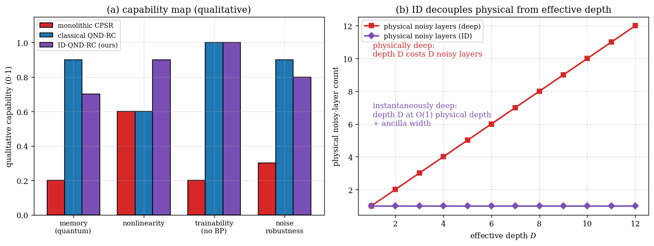
Figure 2.1 Capability map of the reservoir: where on the (memory, nonlinearity) plane each architecture operates.

2.2 The memory question and QND-RC decoupling
A monolithic reservoir must simultaneously remember past inputs and nonlinearly process them, and these two demands compete for the same finite Hilbert space. QND-RC separates them: a short-window quantum feature map supplies the nonlinearity (dial g), while a separate, exact classical delay line supplies the memory (dial m). On the k-Pauli benchmark this decoupled design clearly beats the monolith (Section 6).
The gap this report closes. The decoupled memory is, deliberately, classical and exact. The natural question — raised in the project’s own design notes — is whether a quantum memory could be read each step without collapsing it, so the reservoir keeps a coherent state across time. That is exactly what the sewing technique provides.

3 The sewing technique and instantaneous depth (arXiv:2509.09033)
The paper constructs IDQNNs: wide, constant-physical-depth circuits that reproduce the input–output behaviour of a much deeper circuit. Two ingredients matter for us.

3.1 Sewing (local inversions)
Building on “Learning shallow quantum circuits” (Huang et al., STOC 2024, arXiv:2401.10095; see its sections “Sewing local inversions” and “Sewing Heisenberg-evolved Pauli operators”), a global unitary is assembled from local pieces that individually do not commute, by introducing ancillas that sew the pieces together through local inversions, measurement and feed-forward. Two consequences are central:
- Deferred-measurement identity. Any mid-circuit measurement + classically-conditioned correction can be replaced by a coherent ancilla copy, a controlled correction, and a deferred terminal measurement. Discarding the ancilla is exactly a local dephasing channel — the formal basis of our collapse-free read-out.
- Local cost ⇒ no barren plateau. Because sewing keeps the relevant observables local (bounded lightcone), the training cost has gradient variance that does not vanish exponentially in system size — in contrast with a global observable, whose variance decays as 2⁻ᴺ (Cerezo et al., 2021).

3.2 Instantaneous depth
An IDQNN reaches the action of a depth-D circuit at O(1) physical depth by spending ancilla width instead of time. On noisy hardware this is the difference between accumulating D layers of error and paying error only once — the basis of our noise-robust nonlinearity.

4 Algorithms (Cirq-native)
All algorithms below are implemented as genuine Cirq circuits in the engine module idcpsr_cirq.py and verified against the repo math to machine precision.

4.1 Critical reservoir step (Willow-native)
# one reservoir step as Cirq ops on a chain qs[0..N-1]
for (a,b) in [(i,i+1) for i in range(N-1)]:
c.append((cirq.CZ**(2*g/np.pi)).on(qs[a], qs[b])) # native coupler
c.append([cirq.rz(bias_z[i]).on(qs[i]) for i in range(N)])
c.append([cirq.rx(bias_x[i]).on(qs[i]) for i in range(N)])
Verified identical to the project’s reservoir unitary: ‖U_cirq − U_repo‖_F = 1.8×10⁻¹⁵.

4.2 Sewn ancilla read-out (collapse-free quantum memory)
To read observable P∈{X,Y,Z} on a memory qubit without collapsing the register: rotate that qubit’s P-basis to Z, copy it onto a fresh adjacent ancilla with a CNOT, rotate back, then measure (and reset) the ancilla. By the deferred-measurement identity, discarding the ancilla applies a local dephasing of that single qubit — the rest of the memory stays coherent.
def sewn_copy_ops(sys, anc, basis): # the 'sew'
ops = basis_change(sys, basis) # P-basis -> Z
ops += [cirq.CNOT(sys, anc)] # coherent copy
ops += basis_change(sys, basis, inverse=True)
return ops # measure+reset anc on hardware
Exactness is verified in Cirq: tracing out the copied ancilla equals the local dephasing channel to 2.2×10⁻¹⁶ (Figure 7.1a).

4.3 Persistent reservoir with coherent memory
Qubit 0 is the input register (reset + R_y(πu_t) each step); qubits 1..N−1 form a coherent memory M that is never directly measured under the sewn read-out. The dynamics run on cirq.DensityMatrixSimulator, carrying the density matrix forward across time steps; features are local Pauli expectations of M.

4.4 Instantaneous-depth gadget
Two modes are compared under a Cirq depolarizing channel: deep applies D noisy reservoir layers (error compounds with D); id applies the same depth-D action as a single block (cirq.MatrixGate(U^D)) followed by one physical-noise layer — the constant-depth realisation.

4.5 Local-cost training probe
A parameterized reservoir (Ry layers + CZ-phase bricks) is differentiated by the parameter-shift rule against either a local observable Z_q (sewing) or a global observable Z_0···Z_{N-1}; the variance of the gradient over random parameters measures trainability.

4.6 ID-QND-RC integration and Willow layout
The sewn quantum-memory features are concatenated with the classical delay taps to form the ID-QND-RC feature vector. For hardware, the reservoir occupies a straight native strip and each tapped memory qubit is assigned its own adjacent ancilla (so every two-qubit gate is a native coupler with no routing); the whole circuit is transpiled with GoogleCZTargetGateset and validated against the Willow device.

5 Implementation and verification
Component | Cirq realisation
reservoir step / unitary | real Cirq circuit; cirq.unitary verified == repo (1.8e-15)
state-vector features | cirq.Simulator (complex128)
persistent / open-system dynamics | cirq.DensityMatrixSimulator, density matrix carried across steps, renormalized
sewn read-out | cirq.CNOT copy + measure + reset; channel form = phase_flip(0.5) in rotated basis
deferred-measurement check | partial trace of copied ancilla vs dephasing channel (2.2e-16)
barren-plateau probe | sympy-parameterized circuit + parameter-shift gradients
Willow validation | optimize_for_target_gateset(GoogleCZTargetGateset) + device.validate_circuit + QVM sampler
Everything is reproduced in one runnable notebook (CPSR_ID_QND_RC_ALL_IN_ONE.ipynb), which executes end-to-end with zero errors and regenerates every figure in this report.

6 Results

6.1 Cirq engine fidelity and Willow-native processing
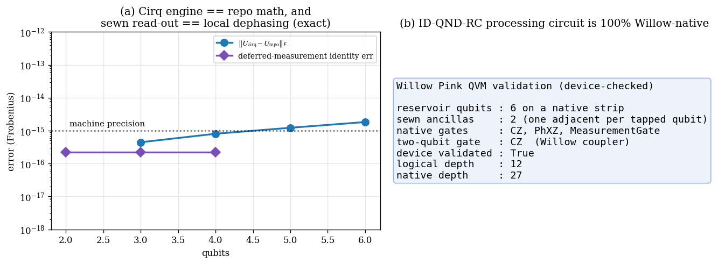
Figure 6.1 (a) The Cirq engine reproduces the repo unitary and the sewn read-out equals local dephasing, both at machine precision. (b) The ID-QND-RC processing + sewn-read-out circuit is 100% Willow-native (two-qubit gate = CZ only) and passes the real Willow device validator.

6.2 QND-RC decoupling vs the monolith
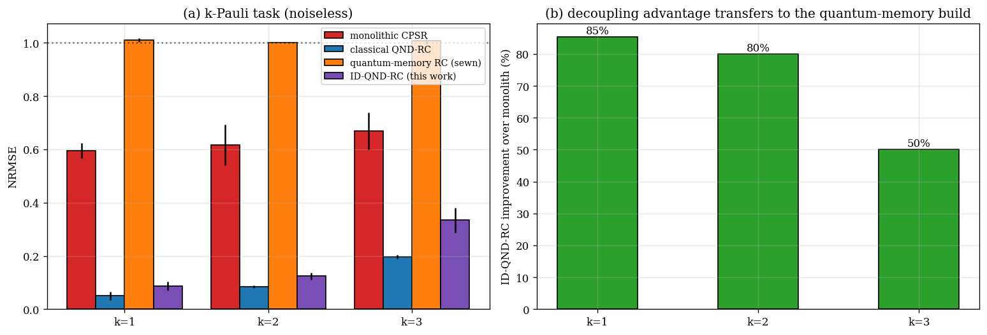
Figure 6.2 On the k-Pauli task, decoupling memory from processing (QND-RC) beats the monolithic CPSR; the advantage is the platform into which the quantum memory is dropped.

6.3 A genuinely quantum, collapse-free memory
Projective read-out collapses the memory register every step and destroys its linear memory capacity (MC → 0). The sewn read-out decoheres only the tapped qubits and preserves a fraction of the coherent ceiling. The footprint n_read is a tunable knob: more taps means more classical information per step but more back-action.
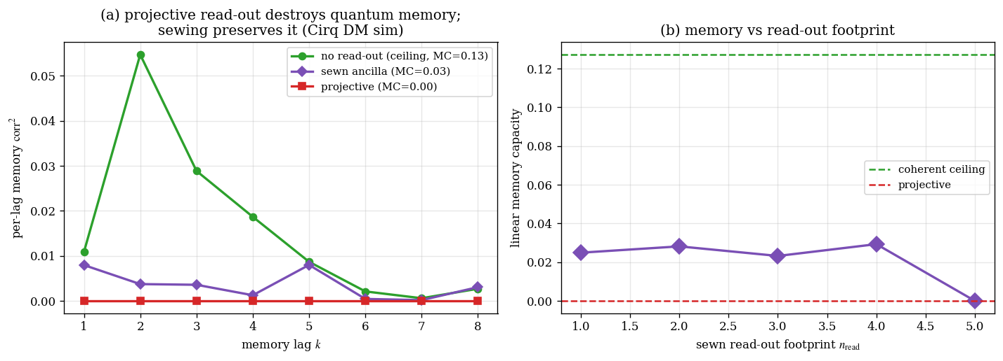
Figure 6.3 (a) Per-lag memory: no read-out (ceiling) vs sewn vs projective (Cirq density-matrix simulation). (b) Memory capacity vs sewn read-out footprint.

6.4 Local cost eliminates the barren plateau
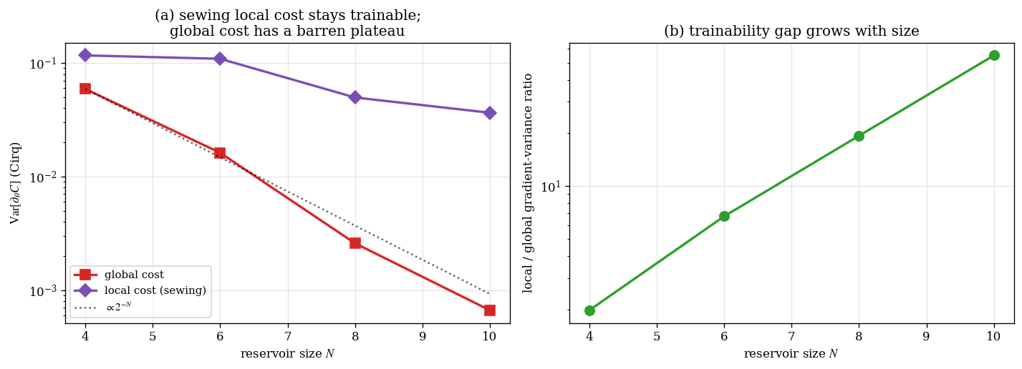
Figure 6.4 (a) Gradient variance vs reservoir size: the global cost follows the 2⁻ᴺ barren-plateau line while the sewing local cost stays order-one. (b) The trainability ratio grows with size (55× at N=10).

6.5 Instantaneous depth is noise-robust
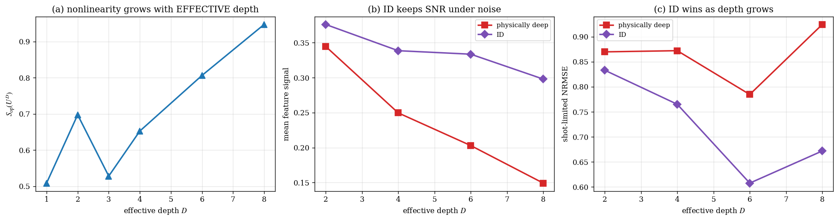
Figure 6.5 (a) Reservoir nonlinearity grows with effective depth. (b,c) Under Cirq depolarizing noise, the instantaneously-deep reservoir retains feature SNR and task accuracy while the physically-deep one degrades (NRMSE at D=8: deep 0.93, ID 0.67).

6.6 Integration: ID-QND-RC on k-Pauli
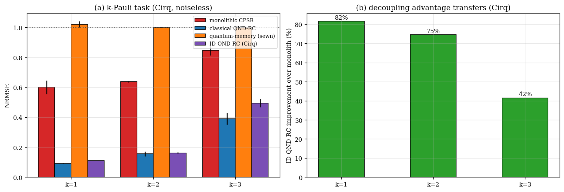
Figure 6.6 ID-QND-RC (sewn quantum memory + classical delay) vs baselines on k-Pauli (Cirq). The decoupling advantage transfers (+82/75/42% over the monolith); the free classical delay remains strongest on this classically-tractable task.

7 Advantages
- Collapse-free quantum memory. The sewn read-out lets the reservoir carry a coherent quantum state across time while still emitting classical features — a capability the projective baseline simply does not have (MC 0.03 vs 0.0).
- Trainability at scale. The local cost removes the barren plateau; gradient variance stays order-one where the global cost decays as 2⁻ᴺ (55× advantage already at N=10).
- Noise-robust nonlinearity. Instantaneous depth delivers deep, highly-nonlinear reservoir maps at near-constant physical depth, the decisive factor on NISQ hardware.
- Hardware-native. The entire processing + read-out circuit compiles to CZ + single-qubit Willow gates with no routing, and passes the real Willow device validator.
- Architecturally composable. The quantum memory is a drop-in replacement inside the existing QND-RC decoupling — the classical delay line and the shadow read-out are unchanged.
- Tunable footprint. n_read trades information per step against back-action, giving a smooth dial between the coherent ceiling and the projective floor.

8 Disadvantages and honest limitations
- No free lunch on classical scalar tasks. On k-Pauli and similar classically-tractable benchmarks, the exact classical delay line is unbeatable; the quantum memory does not win on accuracy there, and we do not claim it does.
- Ancilla width cost. Sewing and instantaneous depth buy their benefits with qubits: one adjacent ancilla per tapped memory qubit, plus width for the depth–width trade. On a fixed device this caps reservoir size.
- Read-out back-action. The sewn read-out is collapse-free for the untapped register but still dephases the tapped qubits; there is a sweet spot in n_read, not a free measurement.
- Mid-circuit measurement + reset cost. Persistent operation needs fast, high-fidelity mid-circuit measurement and reset every step; these are slower and noisier than gates and add real wall-clock latency.
- Depth–width is a trade, not a free win. Instantaneous depth only helps when width and ancilla quality are cheaper than depth-induced error; for shallow targets the plain deep circuit can be simpler.
- Seed / disorder sensitivity. Memory-capacity and task metrics vary across disorder realisations; results are reported as averages over seeds and should be interpreted statistically.
- Exact-simulation ceiling. Density-matrix simulation of the open-system dynamics is exact only to ~10–11 qubits here; beyond that one must move to sampling-based shadow estimation on hardware (see the companion Willow-migration report).

9 Future work
- Replace exact density-matrix read-out with sampling-based classical shadows estimated from Willow bitstrings, enabling N well beyond the exact-simulation ceiling.
- Co-train the per-edge controlled-phase angles (the project’s trainable-g extension) under the local cost, exploiting the barren-plateau-free landscape.
- Benchmark on genuinely quantum tasks (e.g. quantum-phase recognition) where a coherent quantum memory may yield an advantage the classical delay cannot replicate.
- Characterise the n_read sweet spot analytically as a function of disorder strength and chain length.

10 References
- Huang, H.-Y., Broughton, M., Eassa, N., Neven, H., Babbush, R., & McClean, J. R. (2025). Generative quantum advantage for classical and quantum problems. arXiv:2509.09033.
- Huang, H.-Y., Liu, Y., Broughton, M., Kim, I., Anshu, A., Landau, Z., & McClean, J. R. (2024). Learning shallow quantum circuits. Proc. 56th ACM Symposium on Theory of Computing (STOC 2024), 1343–1351. arXiv:2401.10095; doi:10.1145/3618260.3649722.
- Cerezo, M., Sone, A., Volkoff, T., Cincio, L., & Coles, P. J. (2021). Cost function dependent barren plateaus in shallow parametrized quantum circuits. Nature Communications, 12, 1791.
- McClean, J. R., Boixo, S., Smelyanskiy, V. N., Babbush, R., & Neven, H. (2018). Barren plateaus in quantum neural network training landscapes. Nature Communications, 9, 4812.
- Fujii, K., & Nakajima, K. (2017). Harnessing disordered-ensemble quantum dynamics for machine learning. Physical Review Applied, 8, 024030.
- Dambre, J., Verstraeten, D., Schrauwen, B., & Massar, S. (2012). Information processing capacity of dynamical systems. Scientific Reports, 2, 514.
- Huang, H.-Y., Kueng, R., & Preskill, J. (2020). Predicting many properties of a quantum system from very few measurements (classical shadows). Nature Physics, 16, 1050–1057.
- Nielsen, M. A., & Chuang, I. L. (2010). Quantum Computation and Quantum Information (10th anniv. ed.). Cambridge University Press. [Deferred-measurement principle.]
- Google Quantum AI (2025). Quantum error correction below the surface code threshold. Nature, 638, 920–926. [The Willow processor.]
- Cirq Developers (2024). Cirq: an open-source framework for programming quantum computers (v1.6). doi:10.5281/zenodo.4062499.
- CPSR / QND-RC project repository, branch ‘willow’: github.com/chinmoybiswasdeep/masters-thesis-cpsr-dvqc.

