ONE

Create HTML File in the Servlet Maven.

1.First we have to create html file with in the web app

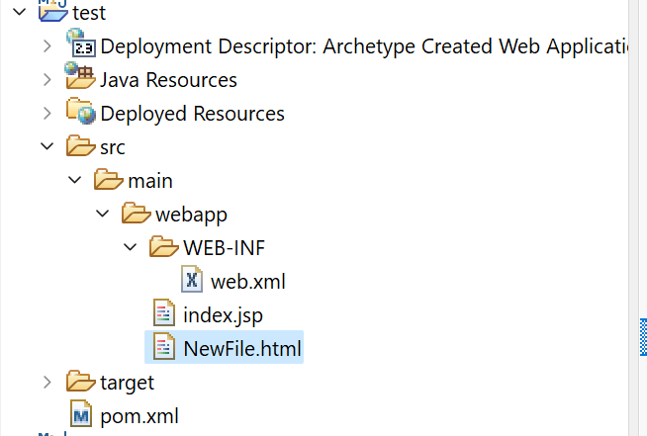

2.Open web.

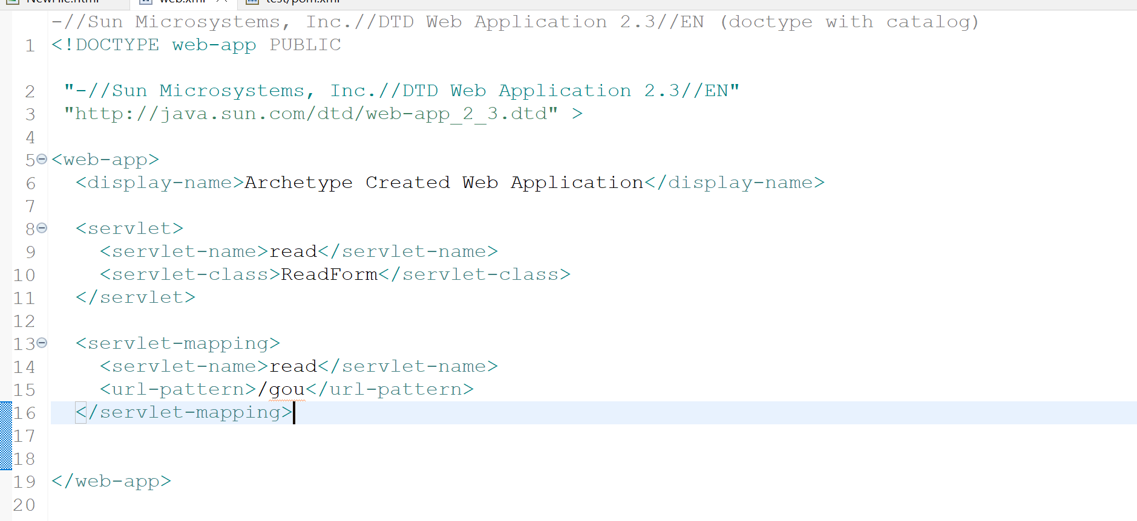

3.Open pom.xml

With in the pom.xml file

Copy this

<!-- https://mvnrepository.com/artifact/javax.servlet/javax.servlet-api -->

<dependency>

<groupId>javax.servlet</groupId>

<artifactId>javax.servlet-api</artifactId>

<version>4.0.1</version>

<scope>provided</scope>

</dependency>

<!-- https://mvnrepository.com/artifact/javax.servlet.jsp/javax.servlet.jsp-api -->

<dependency>

<groupId>javax.servlet.jsp</groupId>

<artifactId>javax.servlet.jsp-api</artifactId>

<version>2.3.3</version>

<scope>provided</scope>

</dependency>

Then save it.

4.Create ReadForm.java

In the source file ever you are working in the project .

We have connect to the GenericServlet interface and implement service with 2 argument

ServiceRequest and ServiceResponce.

5.Create