**How AI can supercharge content understanding for businesses**

[[Facebook](https://www.facebook.com/share.php?u=https%3A%2F%2Fazure.microsoft.com%2Fblog%2Fhow-ai-can-supercharge-content-understanding-for-businesses%2F)](https://www.facebook.com/share.php?u=https%3A%2F%2Fazure.microsoft.com%2Fblog%2Fhow-ai-can-supercharge-content-understanding-for-businesses%2F)[[Twitter](https://twitter.com/share?url=https%3A%2F%2Fazure.microsoft.com%2Fblog%2Fhow-ai-can-supercharge-content-understanding-for-businesses%2F&text=How+AI+can+supercharge+content+understanding+for+businesses)](https://twitter.com/share?url=https%3A%2F%2Fazure.microsoft.com%2Fblog%2Fhow-ai-can-supercharge-content-understanding-for-businesses%2F&text=How+AI+can+supercharge+content+understanding+for+businesses)[LinkedIn](https://www.linkedin.com/shareArticle?mini=true&url=https%3A%2F%2Fazure.microsoft.com%2Fblog%2Fhow-ai-can-supercharge-content-understanding-for-businesses%2F)

Posted on November 20, 2019

[John 'JG' Chirapurath](https://azure.microsoft.com/en-us/blog/author/jgc/) General Manager, Azure Data & AI

Organizations face challenges when it comes to extracting insights, finding meaning, and uncovering new opportunities in the vast troves of content at their disposal. In fact, 82 percent of organizations surveyed in the latest [Harvard Business Review (HBR) Analytic Services report](https://aka.ms/HBR-AS-KnowledgeMining) say that exploring and understanding their content in a timely manner is a significant challenge. This is exacerbated because content is not only spread over multiple systems but also in multiple formats such as PDF, JPEG, spreadsheets, and audio files.

The first wave of artificial intelligence (AI) was designed for narrow applications, training a single model to address a specific task such as handwriting recognition. What’s been challenging, however, is that these models individually can’t capture all the different attributes hidden in various types of content. This means developers must painfully stitch together disparate components to fully understand their content.

Instead, organizations need a solution that spans vision, speech, and language to fully unlock insights from all content types. We are heavily investing in this new category of AI, called knowledge mining, to enable organizations to maximize the value of their content.

**Knowledge mining with Azure Cognitive Search**

Organizations can take advantage of knowledge mining today with Azure Cognitive Search. Organizations can now easily glean insights from all their content through web applications, bots, and Power BI visualizations. With Azure Cognitive Search, organizations can not only benefit from the industry’s most comprehensive domain-specific models but also integrate their own custom models. What used to take months to accomplish can be realized in mere hours without needing data science expertise.

[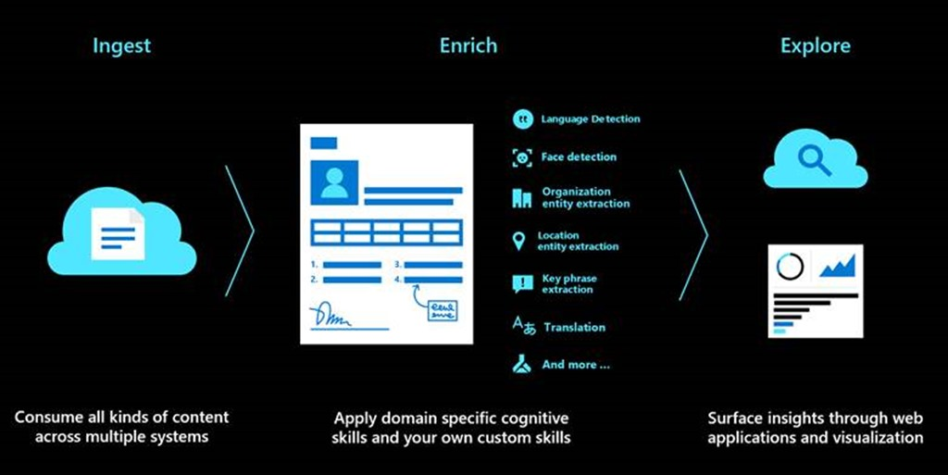](https://azurecomcdn.azureedge.net/mediahandler/acomblog/media/Default/blog/0ee2ccfc-af7b-4612-ab30-bf8f78950c0d.jpg)

**Delivering real business impact**

The same Harvard Business Review report describes how our customers across industries are benefiting from knowledge mining in ways that were previously unimaginable.

* **Financial Services**: “The return on investment (ROI) for knowledge mining at a small fund with one or two analysts is 30 percent to 58 percent. For much larger funds, with 50 or more analysts, it is over 500 percent.”—Subra Bose, CEO of Financial Fabric.
* **Healthcare**: “A reliable knowledge mining platform can drive roughly a third of the costs out of the medical claims process.” —Ram Swaminathan, CEO at BUDDI Health.
* **Manufacturing:** “Unlocking this potential will significantly change the way we do business with our customers and how we service their equipment.” —Chris van Ravenswaay, global business solutions manager for Howden.
* **Legal:** “AI tells you what is inside the contract. It also tells you what the relationship of the contract is with the outside world.” —Monish Darda, CTO of Icertis.

And we’re just getting started. You can expect even deeper integration and more great knowledge mining experiences built with Azure Cognitive Search as we continue this journey. I encourage you to take a look at Harvard Business Review’s survey and findings and hear their perspective on the landscape of knowledge mining.

**Getting started**

* Read the Harvard Business Review Analytics Services report, [Knowledge Mining: The Next Wave of Artificial Intelligence-Led Transformation](https://azure.microsoft.com/en-us/resources/preview/knowledge-mining-the-next-wave-of-artificial-ingelligence-led-transformation/).
* Learn more about [Azure Cognitive Search](https://azure.microsoft.com/en-us/services/search/).