High Availability (HA) Distributed File Storage

Document: Software Requirements Specification

Version 1.1

Publication date: 25-April-2016

Group name: Gryffindor

Group Members:

- ARJITH CHALASANI

- JITENDRA NEELAM

- URMILA JYOTHULA

- CHINNA BALAJI YALLA

- NITISH NAGABHAIRAVA

- PRANEEL REDDY PADALA

- SURYA TEJA BOLLIMPALLI

- SRI GANESH SAI GUNNAM

- SRI KASYAP KAPPAGANTULA

- SIRISHA MANASWINI BHAMIDI

- RAGHUVINAYAK RAO MEDISETTI

- MAHAMMAD SUHAIL ATCHUKATLA
Contents:

1. Preface

Release v1.1 on 2014-04-25 Release v1.0 on 2014-04-18

- Glossary and abbreviations

- System Architecture

  - Frontend

  - Database
  - Backend

- Requirements

Requirement: Identification string

Creation date: Date when this requirement was created

Change date: Date when this requirement was changed

Module: Architecture module it belongs to

Type: Functional/Non-Functional

Dependencies: What other requirements does this depend on

Test: Test case identification string

Assignee: Team member responsible for the requirement being fulfilled

Description: Detailed information, including graphs, tables or UML diagrams

Comment: Reason why this requirement was changed.

  - User requirements

  - System requirements

- References

1. Preface

The main concept of this project is to develope a secure file storage to the company SecuriFile in the form of a distributed file storage system with high availability to the customers.

In this we are creating replicas for the servers and when a user uploads a file, the file is stored in a randomly chosen server. we use file transfer protocol for the transfer of data.
Service Developer: Gryffindor

Customer: Dragos llie

In this document we defined the technical terms and a short note on them, system architecture, user and system requirements and references.

Release v1.1 on 2014-04-25

Preface changed

Release v1.0 on 2014-04-18

Initial Release

2. Glossary and abbreviations

HTTP: Hyper Text Transfer Protocol

It is a transfer of version data formats between server and client

EX: plain txt, hyper txt, video and sound

FTPS: File Transfer Protocol Security

It is an extension for commonly used file transfer protocol(FTP) that adds support for the transfer layer security(TLS) and secure sockets layer (SSL).

Message digest: SHA-1

IT is a crypto graphic hash function which is consider practically impossible to invert that is to recreate the input data from its hash value alone.

SHA-1: secure Hash algorithm.SHA-1 produces a 160bit (20 byte) hash value known as a message digest. SHA-1 advancements are SHA-2 and SHA-3.

GUI: Graphical User Interface

It is a type of interface which helps in interaction with electronic devices through graphical icon and visual indicators.

SQL Server: Structured Query Language Server

SQL is used to store, query and manipulate data. It is used for manage data in a relational data base.

Restful API: Representation State Transfer

An architectural pattern to improve probability and scalability of a system.
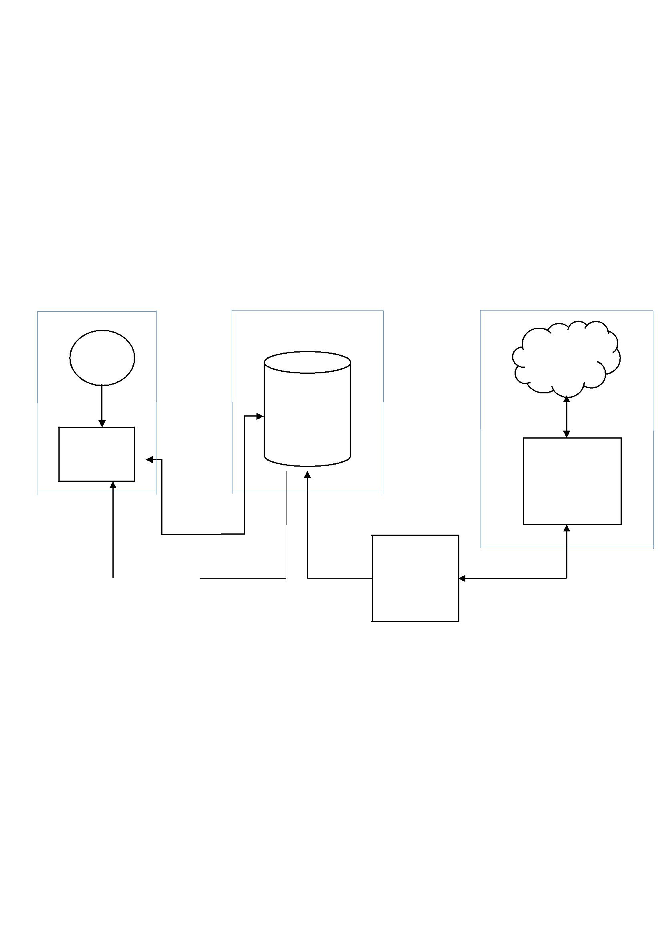

3. System architecture

In this section of the proposal we provide the system architecture, which determines the working of the system. Initially the system can be determined in three sections they are the front end, database and the back end of the system

Module 1: Front End | Module 2: Data Base |  | Module 3: Back End
USER |  |  | Replicas
 | MySQL |  | ssh
 |  |  | connection
Web GUI |  |  | Origin
 |  |  | Server
Graphs on uptime
of each service.
Lib MySQL | Lib MySQL | Backend Tool | ssh Connection
 |  | Continuously
 |  | monitors

Fig 1: System Architecture

3.1 Frontend

At first the user is asked to login, he gets his access from database and this is done through a series of process through HTML and CSS. We create a login page to login into the server but first he needs to register into the admin server, the admin server provides a verification mail to the user and later conformation of the mail is done and the connections for the web pages are done through PHP. Now a separate account is allocated to the customer through which user can store files. Through the login page the customer logins into the user’s account and user can upload the file and make modifications to the existing file. The storage capacity is limited to the customer and users can’t exceed the given storage capacity, later he can logout from the page.
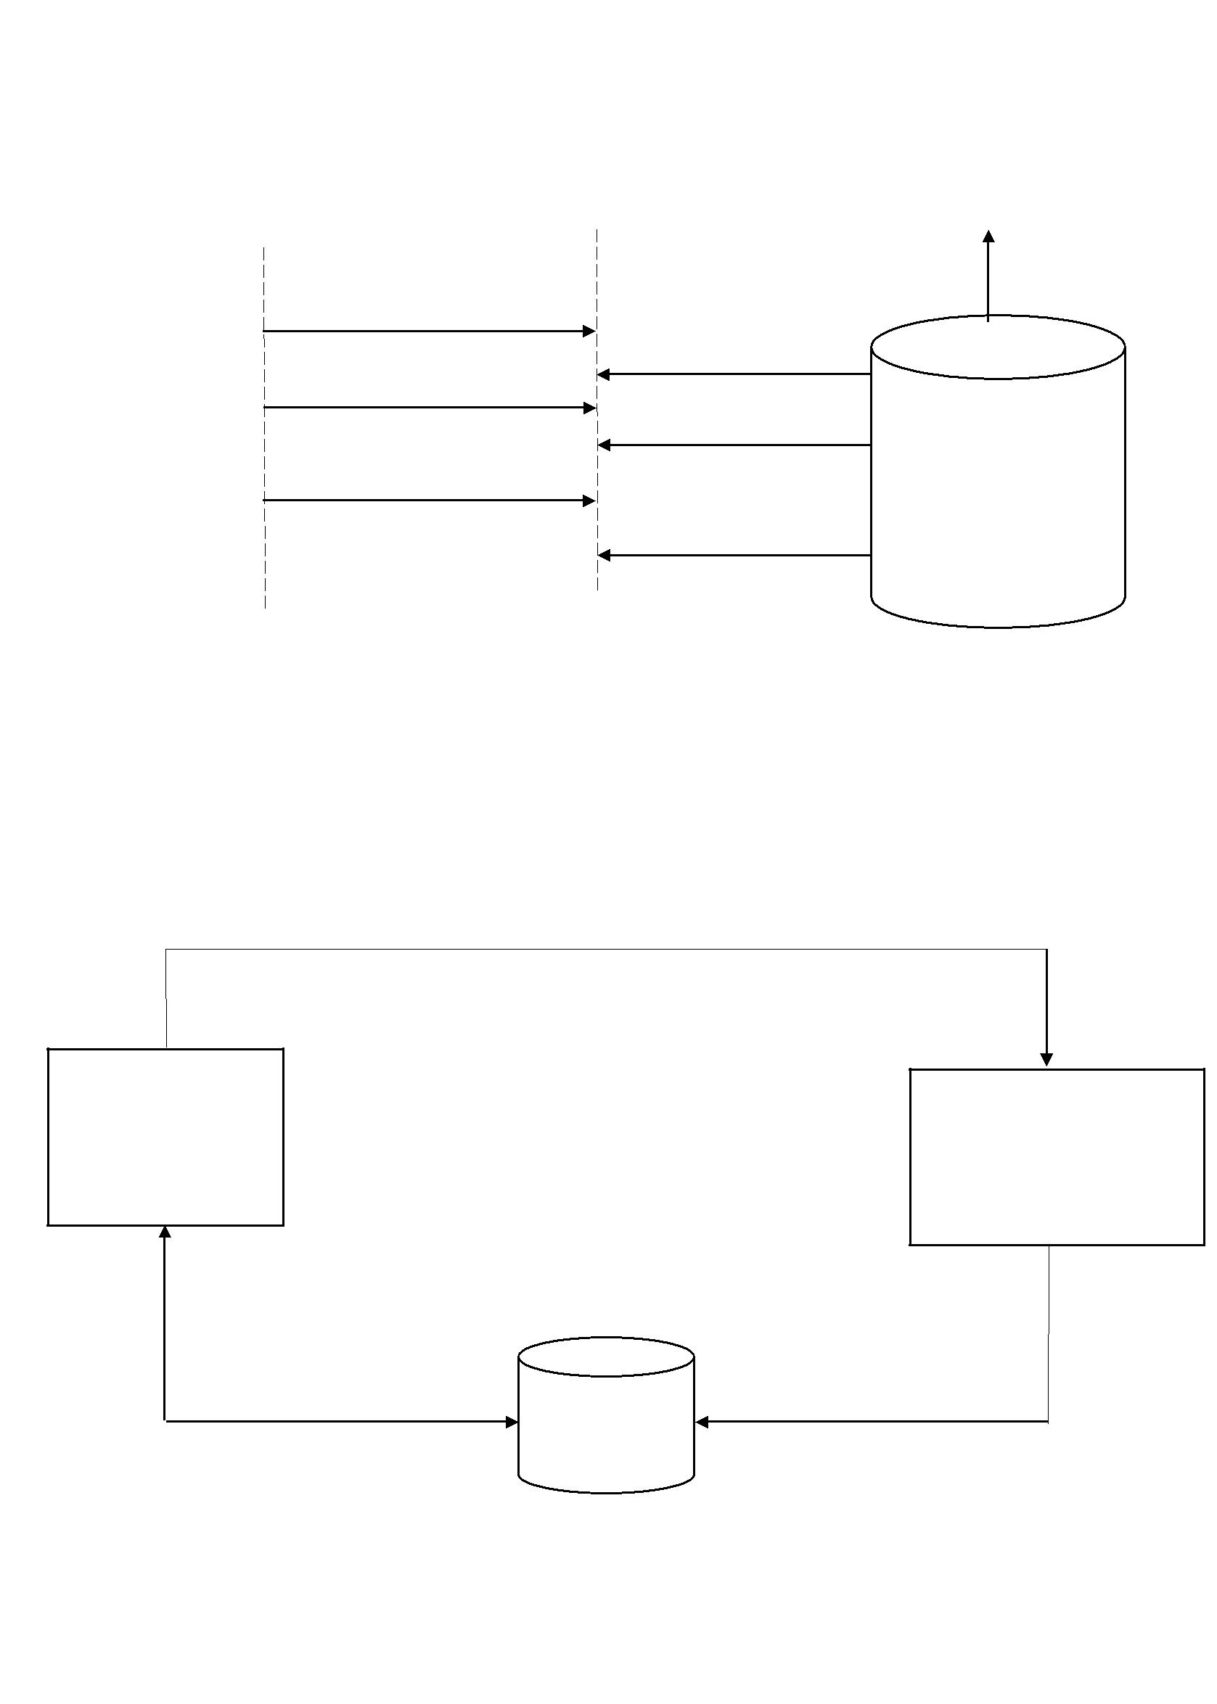

 |  |  |  |  | Admin Server
User |  |  | Dash Board |  | Admin Server
 | 1.Registration
 |  |  | 2.Storage of user files
3.Authentication through login page
 |  |  | 4.Provides the service
 | 5.Request for the file |  |  |  | MySQL
 |  |  | 6.Permits user to open |  | Data Base
 |  |  | the files and access it

Fig 2: Front End

3.2 Database

The MySQL database contains user’s information, data status and uptime information inserted into their respective service tables

In the MySQL database we create a data slot for each customer. Through front end the user can access into user’s login account and through backend the user can access user’s files.

Request for restart service

Web GUI

Stores user files and retrieves files status and obtain information from the tables

MySQL

Data Base

Back End

Insert Status and uptime in the tables

Fig 3: Data Bases

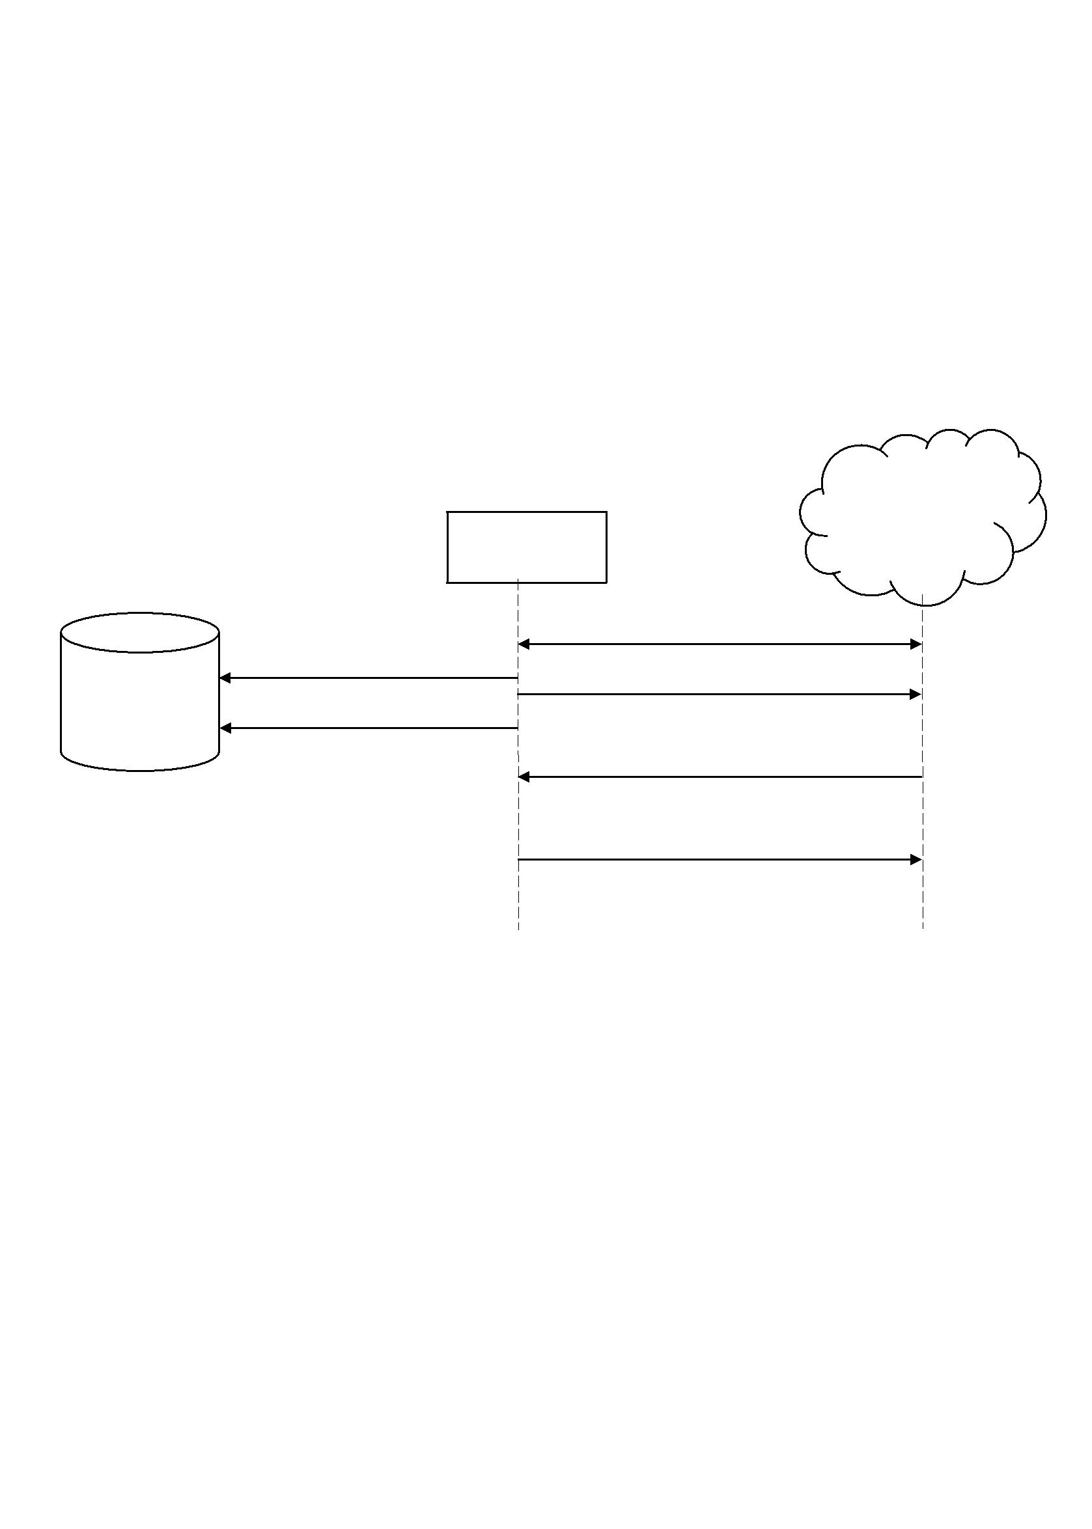

3.3 Backend

The third section of the architecture is used to connect the entire architecture. For backend programming we use Python, which is used to connect the servers. Backend is also use to ping the servers constantly, if the ping is lost or server is down it sends a message to database and in the database it is stored if the connection is lost.

It retrieves the status and stores it in the database in MySQL. Separate tables are allocated for each server.

Replicas

 |  | Back End
 | Inserts status and uptime | Establishes ssh connection
 | into respective tables | Monitors Replicas
MySQL |  | Monitors Replicas
MySQL | Stores number of restarts

Retrieves status and uptime data

Restarts service upon demand

Fig 4: Back End

4. Requirements

The project requirements defines the basic lists of requirements for Distributed File Storage system. Requirements are classified in to user and system Requirements

4.1 User Requirements:

The User requirements describes what the services provided for the customer, hear we describe the function and non-functional requirements.
Requirement | Identification | Module | Type | Dependencies | Test | Description
Simple GUI | REQ-USR_1 | Frontend | Functional | REQ-SYS_1 |  | To | provide
 |  |  |  | REQ-NFSYS_1 |  | interface
 |  |  |  |  |  | between |  | the
 |  |  |  |  |  | computer |  | and
 |  |  |  |  |  | its users
Login | REQ-USR_2 | Frontend | Functional | REQ-SYS_1 |  | To | reject | the
Authentication |  |  |  | REQ-SYS_2 |  | unauthorised
 |  |  |  | REQ-SYS_3 |  | users
File | REQ-USR_3 | Database | Functional | REQ-SYS_2 |  | To provide file
Availability |  |  |  | REQ-SYS_3 |  | availability |  | for
 |  |  |  |  |  | particular user
Documentation | REQ- |  | Non- |  |  | Documentation
 | NFUSR_1 |  | Functional |  |  | provides |  | user
 |  |  |  |  |  | guide
File Sharing | REQ-USR_4 | Backend | Functional | REQ-SYS_3 |  | To | Provide
 |  |  |  |  |  | sharing of files
Security | REQ-USR_4 | Backend | Functional |  |  | It provides the
 |  |  |  |  |  | security
 |  | Table 1: User requirements

4.2 System requirements

System requirements describes the technical details of Distributed File Storage system. These

are classified into function and non-functional requirements.

Requirement | Identifica | Creation | Module | Type | Dependencies | Test | Description
 | tion | date
Web Server | REQ- | 2016-04-21 | Frontend | Functional |  |  | It provides | the
 | SYS_1 |  |  |  |  |  | requested | web
 |  |  |  |  |  |  | pages to Clients.
 |  |  |  |  |  |  | We use Apache2
 |  |  |  |  |  |  | Server
Database | REQ- | 2016-04-21 | Database | Functional |  |  | MYSQL-To store
 | SYS_2 |  |  |  |  |  | The Data
Connecting | REQ- | 2016-04-21 | Backend | Functional |  |  | Duplication | of
Replicas | SYS_3 |  |  |  |  |  | files
Operating System | REQ- | 2016-04-21 |  | Non |  |  | Ubuntu | 16.04
 | NFSYS_1 |  |  | Functional |  |  | LTS
Languages: | REQ- | 2016-04-21 |  | Non |  |  | Programming
HTML | NFSYS_2 |  |  | Functional |  |  | languages to build
CSS |  |  |  |  |  |  | distributed | file
Python |  |  |  |  |  |  | storage
JavaScript
Compatibility | REQ- | 2016-04-21 |  | Non |  |  | Compatible | with
 | NFSYS_3 |  |  | Functional |  |  | older versions
Testability | REQ- | 2016-04-21 |  | Non |  |  | Flaw detection
 | NFSYS_4 |  |  | Functional

Table 2: System Requirements

5. References:

- Sommerville, Ian. Software Engineering, 9th ed. Addison-Wesley, 2011

