Project Specification

High Availability (HA) Distributed File Storage

Document: Project Specification

Version 1.2

Publication date: 2017-06-15

Group name: Gryffindor

Group Members:

- JITENDRA NEELAM
- CHINNA BALAJI YALLA
- NITISH NAGABHAIRAVA
- SIRISHA MANASWINI BHAMIDI
- RAGHUVINAYAK RAO MEDISETTI
- MAHAMMAD SUHAIL ATCHUKATLA
Project Specification

Contents:

1. Preface

Release v1.2 on 2017-06-10

Release v1.1 on 2016-04-25

Release v1.0 on 2016-04-18

- Glossary and abbreviations

- Background

- Proposed Solution

- Limitations

- Time Plan

- Project Organization

- Configuration Management

- Progress Tracking

- Quality Control

- Risk Management

- System Release Plan Testing Plan Packaging Plan Documentation Plan
- References
Project Specification

1. Preface

The main concept of this project is to develop a secure file storage to the company SecureFile in the form of a distributed file storage system with high availability to the customers.

In this we are creating replicas for the servers and when a user uploads a file, the file is stored in a randomly chosen server. we use file transfer protocol for the transfer of data.

Service Developer: Gryffindor

Customer: Dragos llie

In this document we discuss about project proposal like defining technical terms, over view of customer’s problems and needs, proposal solutions, limitations, time plan about how we allocated time for each stage in the project, project organisation, process tracing, quality control, risk management, system release plan and references.

- Release v1.2 on 2017-06-10
  - preface updated

  - background modified

  - limitations modified

  - sections 8 to 13 modified

- Release v1.1 on 2016-05-1

  - preface updated

  - background modified

  - made changes in proposal solutions

  - limitations modified

  - sections 8 to 13 added

- Release v1.0 on 2016-04-18

Initial Release

2. Glossary and abbreviations

HTTP: Hyper Text Transfer Protocol

It is a transfer of version data formats between server and client EX: plain txt, hyper txt, video and sound

• FTPS: File Transfer Protocol Security

It is an extension for commonly used file transferprotocol(FTP) that adds support for the transfer layer security(TLS) and secure sockets layer (SSL)

• Message digest: SHA-1

IT is a crypto graphic hash function which is consider practically impossible to invert that

is to recreate the input data from its hash value alone.

SHA-1: secure Hash algorithm.SHA-1 produces a 160bit (20 byte) hash value known as a message digest. SHA-1 advancements are SHA-2 and SHA-3

• GUI: Graphical User Interface

It is a type of interface which helps in interaction with electronic devices through graphical icon and visual indicators.

• SQL Server: Structured Query Language Server

SQL is used to store, query and manipulate data. It is used for manage data in a relational data base.

• nginx

NGINX is open source software for web serving, reverse proxying, caching, load balancing, media streaming, and more. ... In addition to its HTTP server capabilities, NGINX can also function as a proxy server for email (IMAP, POP3, and SMTP) and a reverse proxy and load balancer for HTTP servers

Project Specification

3. Background

XtremeSecurity acts a contractor for a large number of governmental and military . organizations. The company has grown tremendously in the last five years expanding its points of presence throughout the world. Hence Xtreme Security offers security services they hold confidential data which make them very paranoid about security breaches where third party might access confidential data that is being exchange among users. Company want an Enterprise chat System that supports text messages of length (up to 4 kb) and file sharing possibility

So we are designing a new service in the form of a distributed file storage with high-availability to the SecureFile company to overcome this situation.
Project Specification

4. Proposed Solution

The proposed solution is to provide a file storage in the form of a High-Availability (HA) distributed file storage system to the customers. High availability basically means that redundancy throughout network infrastructure

Customers are provided with a Chat Framework so that there is a safe and secure communication between the organization representatives. Chat system is provided with a GUI to edit and read messages to configure the user account, add / remove / browse users in
local address book. Certificates must be used for each user as well as for the central server hosting database. The application is enabled with encryption features both an authentication and chat messages will use this feature. We Provide encrypting to the files for security and also use open SSl for certifications

5. Limitations

- Multimedia files like Video & Audio may not be supported in this framework.

Maintaining consistency among copies when a replicated file is updated is a major design issue of a distributed file system that supports file replication.

 The total storage space of each user is limited to 7 GB because of the limited storage space in the server database.

6. Time Plan
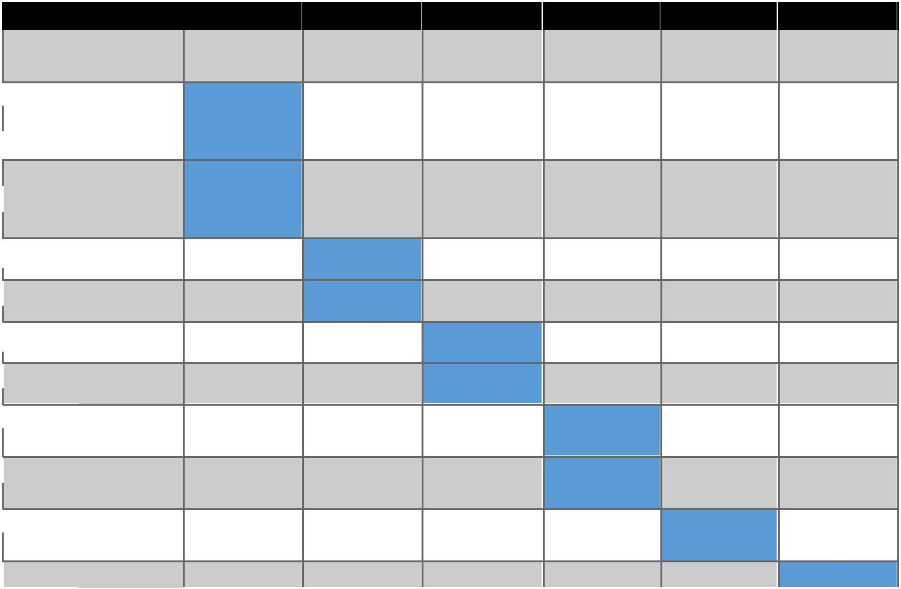

Week |  | 1 | 2 | 3 | 4 | 5 | 6
Starting |  | April | April | April-May | May | May | May
 |  | (10-17) | (18-24) | (25-1) | (2-8) | (9-15) | (16-22)
Project
Specifications
Docs
Project
Specifications
Binaries
SRS Docs

SRS Binaries

Design Docs

Design Binaries

Accept Plan
Docs
Accept Plan
Binaries
Release

Candidate
Product Release

Fig 1: Time Plan

Toll Gates:

- 2016-04-17: Project proposal

- 2016-04-24: Software Requirements Specifications

- 2016-05-08: Acceptance test plan

- 2016-05-22: Product Release
Project Specification

Milestone:

- 2016-04-17: Project Specification

- 2016-05-01: Design document

- 2016-05-15: Project Documentation

7. Project Organization:


 |  | Project
Planning | Documentation | Front End | Data Base | Back End
 |  | CSS | SQL
 |  | PHP | SQL | Python
 |  | PHP | SQL Manager | Python
 |  | HTML | SQL Manager
 |  | HTML | Encryption
 |  | Java Script | Encryption
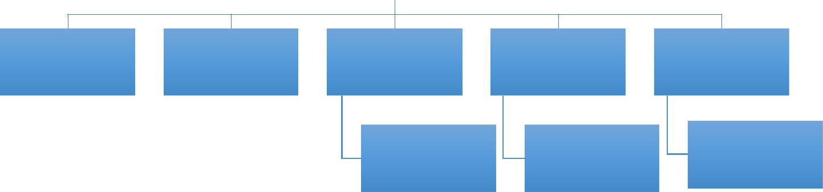

Fig1: project organization

Task Splitting:

1) |  | Documentation |  | Y.chinnabalaji, N.jitendra, M.raghuvinayak, Nitish
2) |  | PHP |  | A Mahammad Suhail
3) |  | HTML |  | M Raghu., N Jitendra., Y.balaji
4) |  | Java Script |  | A Mahammad Suhail ,B Manaswini.
5) |  | SQL |  | A Mahammad Suhail ,Nitish
6) |  | SQL Manager |  | A Mahammad Suhail,Nitish
7) |  | Python |  | A Mahammad Suhail
8) |  | nginx |  | Y.chinnabalaji, N.jitendra, M.raghuvinayak

Project Specification

8. Configuration Management

VERSION MANAGEMENT:

It is the process of keeping track of different versions of software components and the systems in which these components are used.

Gitlab server is used as a part of development to store the versions. With the help of

Gitlab server users can merge their codes to create a new version of component. Git

will monitor the code history and which has composed with portion of code.

It also involves ensuring that changes made by different developers to these versions

do not interfere with each other. Version management systems are used to identify,

store and change history according to the development process. The initial version is

taken as version 1.0 (For Trunk or branch) followed by 1.1,1.2,1.3……..etc. If it is a

branch, then Integration part will be done at last subversion of that branch and this

code is pushes into trunk

SYSTEM DEVELOPING:

It is the process of creating a complete executable system by compiling and linking the system components external libraries etc.

Creating a executable system involves many processes under it, such as development
system which includes development tools such as compliers, source code editors. Developers checkout the code from the version management system into a private workspace before making changes to the system. Developers check-in code to the version management system before it is built. The system build may rely on external libraries that are not included in the version management system

Version management system integration: -

the build system should check out the required versions of components from the version management system
Project Specification

Documentation generation: -

The build systems may be able to generate release notes about the build systems and system help pages

The build system includes code lines and base lines according to the changes done in the code lines and base lines the concluding build is checked out to build server to build definitive editions of the software and final software is compiled.

RELEASE MANAGEMENT:

A system release is a version of a software system that is distributed to customers. There are two types of release namely major releases and minor releases based upon the release they are categorized into major release significant functionality and minor releases consists of bugs which are fixed and are replaced to the customer, to document a release. we record the specific versions of the source code components that were used to create the executable code. we keep the copies of the source code files for future modifications. It consists of minor release which repairs bugs and fix customer problems that have been reported and major releases which delivers a significant new functionality. System release is nothing but the codes which is used to execute the project, data files, documentation of design specifications and software requirements such that the project can be recreated in the future System release depend on the factors like technical quality, changes in the platform, etc.

9. Progress Tracking

To deliver the item in a fixed time, we have a tool named project libre to make sure that our item is done on time which set up with a set of events that have to be planned.In a group project with a time plan, every one in the group have to follow the time plan and discuss with the collegues to divide the tasks and make the project done .
The project head will check the work every week which is given to the assigned team members and he has to organize the meeting weekly according to the time plan and discuss about the work on the project and problems if they face any. After the meeting the team have to assign the issuses to decode and complete the work for the next milestone.if the team members has any problems regarding there task they will clarify the doubts by discussing with the other team members. So, by monitoring all these, the status of the work is updated by the team,so we can accomplish everything without late.
Every member will upload the work completed by them on to the Gitlab server. Program can be tracked by anyone who want to know the status of the project from the following html link https://herkules.comproj.bth.se:6016/users/sign_in

10. Quality Control

Quality management is essential that the developed product is reliable and not slow and easy to use.

Quality Control needs a project head and project team to check the work that has been done, the checking has to be done to decide if the results are in correct order with the given and implemented quality control. By the testing phase, checking whether the expectations of the customer are maintained to all the standards .we have to check the code in a step by step process and after integrating, the testing is done to the final code..we will also release the versions of the product which helps to find out the cons in our product. Finally, the aim is to deliver the bug free product to the customer with encrytion. And checking the software in various OS versions to deliver the error free software.

Project Specification

11. Risk Management

In a group while performing a project we need to access the risks that may affect a project monitor their risks and take action when problems arise

- In the following table, we have divided Risks into 4 major categories and we have approximated their probability of occurrence, their level of Effect and strategy to tackle those challenges.

S.NO | Type of Risk | Probability | Level of Effect | Strategy
1. | Underestimating | High | Serious | Serious Planning regarding
 | Development Time. |  |  | Communication between
 |  |  |  | development team members and
 |  |  |  | predicting Do’s and Don’ts before
 |  |  |  | starting coding part
2. | Team member’s | Moderate | Serious | By using divide and conquer
 | unavailability |  |  | approach, each work is divided
 |  |  |  | into two or more members. Such if
 |  |  |  | one person is unavailable another
 |  |  |  | person can tackle the problem.
3. | Crashing of Software or | Moderate | Serious | Keep track of plugin’s we have
 | Hardware components |  |  | used and perfect using of cloud
 |  |  |  | infrastructure for sharing the code.
4. | Dependencies | Moderate | Serious | There may be multiple preceding
 |  |  |  | tasks and succeeding tasks.The
 |  |  |  | main relationship of the
 |  |  |  | dependencies approach will be a
 |  |  |  | Finish to start approach If 1 and 2
 |  |  |  | are two tasks, task 2 cannot be
 |  |  |  | started before the completion of
 |  |  |  | task 1.

5. | May run out of time for | Low | Low
 | deliverable documents

Work breakdown is used to deliver the documents on time.

6. | Testing | High | Serious

12.1 Testing plan:

  - Mainly testing is used to know the presence of errors in the code. There are different tools in the market to Accomplish this task.

  - Test planning is nothing but scheduling and resourcing all the activities in our testing process.

  - Mainly testing is done in 3 stages in a project; they are

    - Testing in Development phase:

Elementary testing is done by the development team. In this phase, they concern about the most predominant things in testing like component interface testing and Integration of components.This testing is done from 2017.

    - Release testing:

A separate testing team tests the complete source code of the system before it is released to users. In this phase, this individual makes sure that the system meets its requirements and is good enough for external use. This testing is done from.

    - User testing

This is the exact place where they can judge their system. Here users test the system in their own environment.

12.2 Packaging plan:

A compressed file of tar.gz is given to the customer containing the code, Management files, library files, executable files,readme.txt.How to set up and install the product will be explained in the readme.txt file.Changes in software version and any changes in the software will be explained in the version.txt file.We are planning to start the packaging process from

12.3 documentation plan:

12.3.1 installation documentation:

The installation document is in the pdf format it consists all the information bout installation process for the different software’s used in the product and also the configuration settings for different components

Time schedule

It is also divided into two phases they are Documentation testing phase Documentation release phase
Project Specification

12.3.2 user documentation: -

This document is provided in PDF file format. It contains Do’s and Don’ts of the
customer, Troubleshooting, and how to use the system in a more efficient way.

User documentation will be done from

12.3.3Developer documentation: -

It contains all technical aspects regarding system (From designing to Implementation). What type of algorithms we have used, Database entries, apps and encryptions used in the project.

Developer documentation will be done from

The documentation takes us a total of 7 days, as the last part of the documentation has dependencies over the first 2 parts.

13. References

Sommerville, Ian. Software Engineering, 9th ed. Addison-Wesley, 2011

