**High Availability (HA) Distributed File Storage**

**Document: Software Requirements Specification**

**Version 1.1**

**Publication date: 25-April-2016 Group name: Gryffindor**

**Group Members:**

* ARJITH CHALASANI
* JITENDRA NEELAM
* URMILA JYOTHULA
* CHINNA BALAJI YALLA
* NITISH NAGABHAIRAVA
* PRANEEL REDDY PADALA
* SURYA TEJA BOLLIMPALLI
* SRI GANESH SAI GUNNAM
* SRI KASYAP KAPPAGANTULA
* SIRISHA MANASWINI BHAMIDI
* RAGHUVINAYAK RAO MEDISETTI
* MAHAMMAD SUHAIL ATCHUKATLA

Contents:

1. Preface

Release v1.1 on 2014-04-25 Release v1.0 on 2014-04-18

1. Glossary and abbreviations
2. System Architecture
   1. Frontend
   2. Database
   3. Backend
3. Requirements

Requirement: Identification string

Creation date: Date when this requirement was created Change date: Date when this requirement was changed Module: Architecture module it belongs to

Type: Functional/Non-Functional

Dependencies: What other requirements does this depend on Test: Test case identification string

Assignee: Team member responsible for the requirement being fulfilled Description: Detailed information, including graphs, tables or UML diagrams Comment: Reason why this requirement was changed.

* 1. User requirements
  2. System requirements

1. References

**1. Preface**

The main concept of this project is to develop a secure file storage to the company SecuriFile in the form of a distributed file storage system with high availability to the customers.

When a user uploads a file, the file is stored in a randomly chosen server. In this we are creating replicas for the file uploaded by the user and we use File Transfer Protocol for the transfer of data.

**Service Developer:** Gryffindor

**Customer:** Dragos llie

In this document we defined the technical terms and a short note on them, system architecture, user and system requirements and references.

* **Release v1.1 on 2014-04-25**

Preface changed

System Architecture diagram modified

Added replicas connection

Modifications done in User and System requirements

* **Release v1.0 on 2014-04-18**

Initial Release

1. **Glossary and abbreviations** 
   * **HTTP: Hyper Text Transfer Protocol**

It is a transfer of version data formats between server and client

EX: plain txt, hyper txt, video and sound

 **FTPS: File Transfer Protocol Security**

It is an extension for commonly used file transfer protocol(FTP) that adds support for the transfer layer security(TLS) and secure sockets layer (SSL).

 **Message digest: SHA-1**

IT is a crypto graphic hash function which is consider practically impossible to invert that is to recreate the input data from its hash value alone.

SHA-1: secure Hash algorithm.SHA-1 produces a 160bit (20 byte) hash value known as a message digest. SHA-1 advancements are SHA-2 and SHA-3.

 **GUI: Graphical User Interface**

It is a type of interface which helps in interaction with electronic devices through graphical icon and visual indicators.

 **SQL Server: Structured Query Language Server**

SQL is used to store, query and manipulate data. It is used for manage data in a relational data base.

 **Restful API: Representation State Transfer**

An architectural pattern to improve probability and scalability of a system.

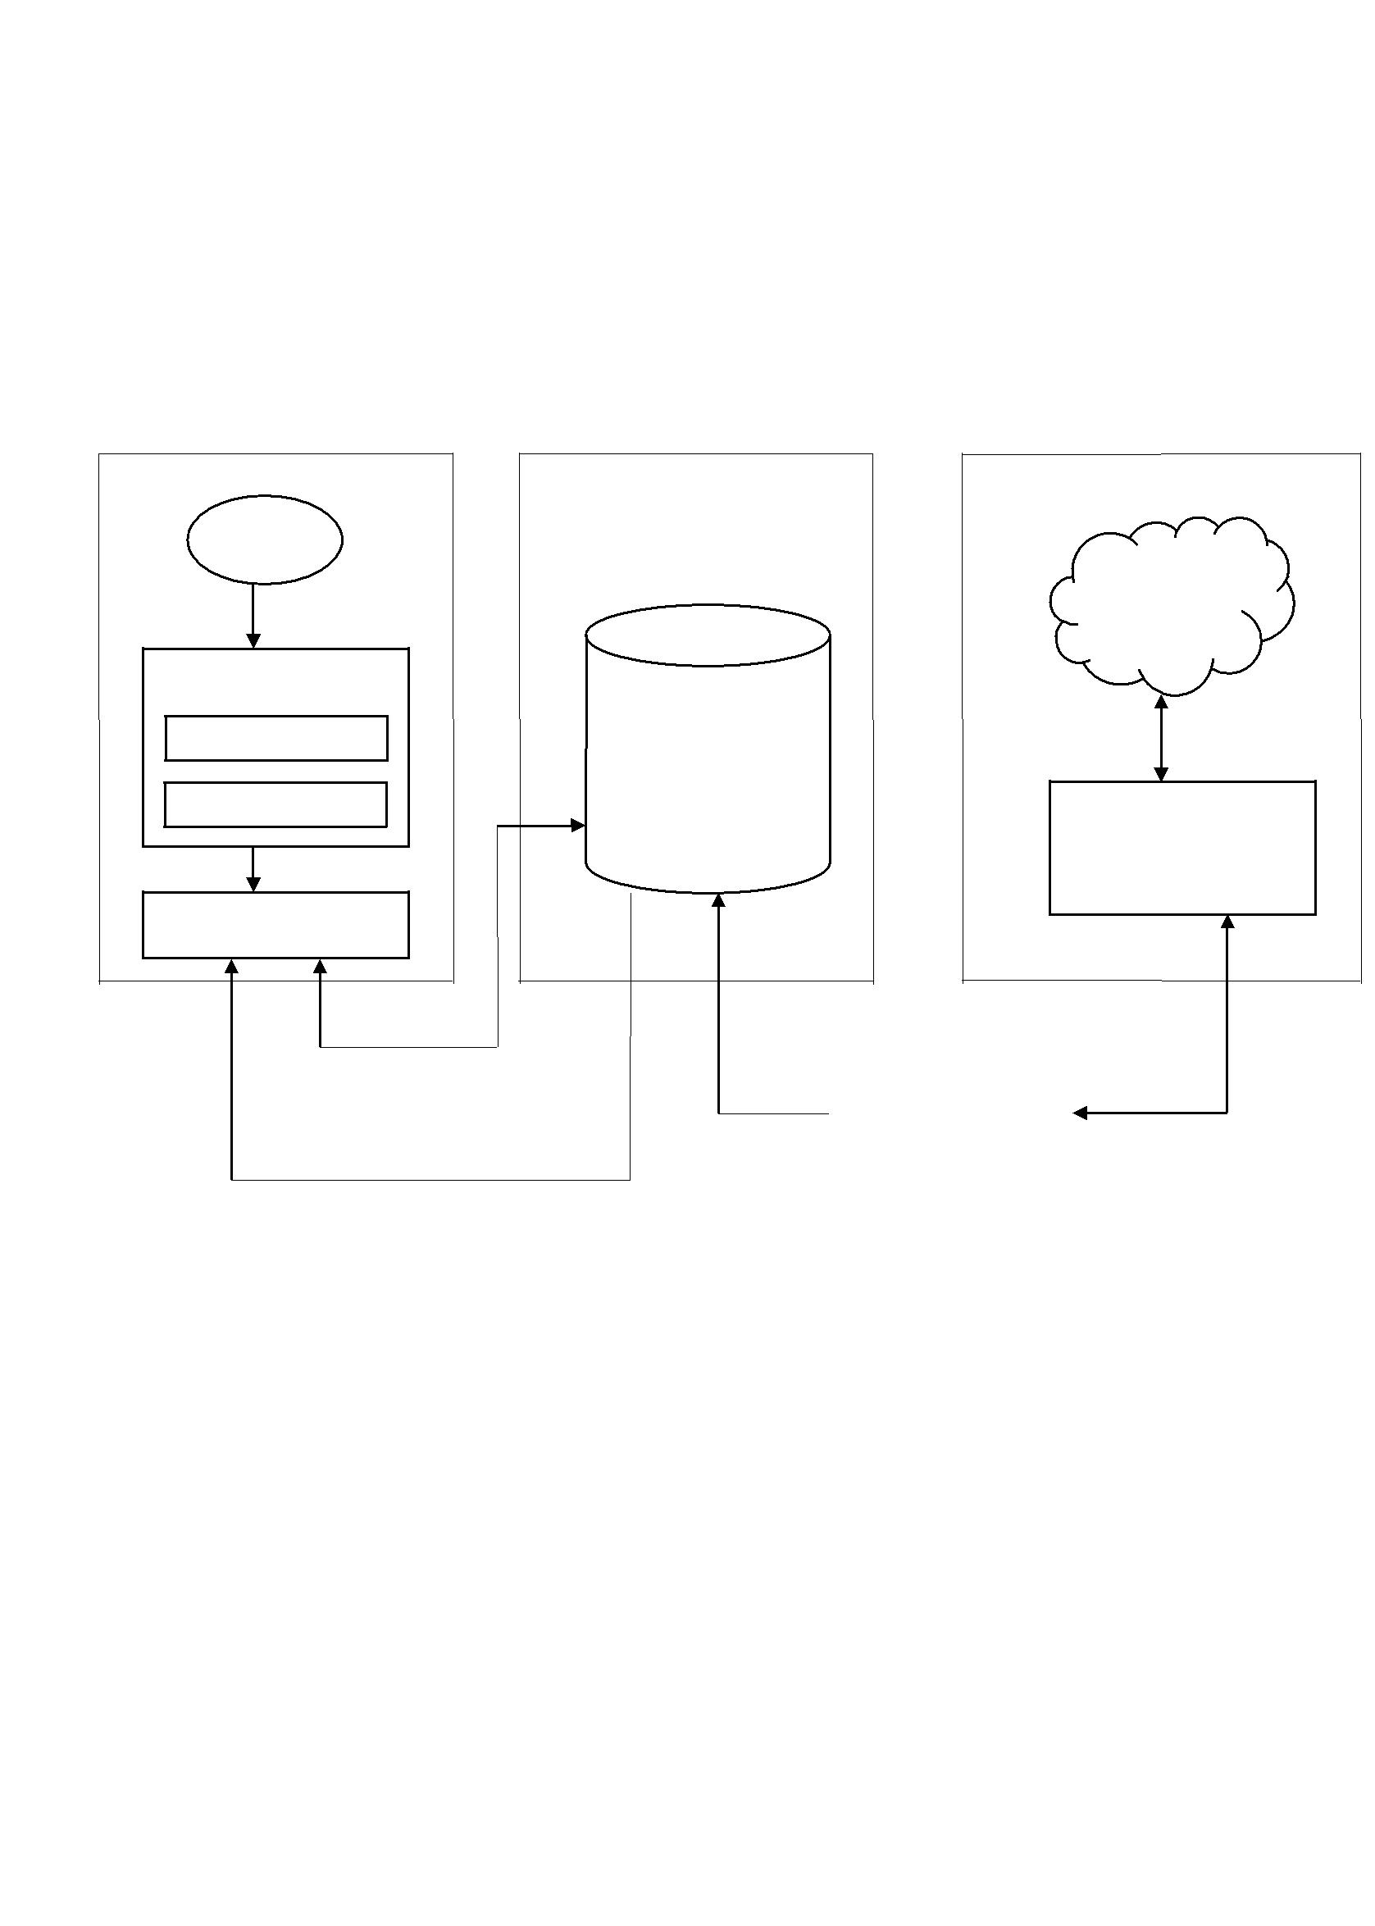

**3. System architecture**

In this section of the proposal we provide the system architecture, which determines the working of the system. Initially the system can be determined in three sections they are the front end, database and the back end of the system.

Module 1: Front End Module 2: Data Base Module 3: Back End

User

Replicas

Encryption

|  |  |  |  |
| --- | --- | --- | --- |
| User Name | MySQL | SSH |  |
|  | Connection |  |

Password

Origin Server

Web GUI

|  |  |  |  |
| --- | --- | --- | --- |
| Graphs on uptime of |  |  |  |
| each service |  |  |  |
| Lib |  | Backend tool |  |
| MySQL |  |  |
|  |  | continuously |  |
| Lib MySQL |  | monitors |  |
|  |  |  |
|  |  |  |  |
| Fig 1: System Architecture | |  |  |

SSH connection

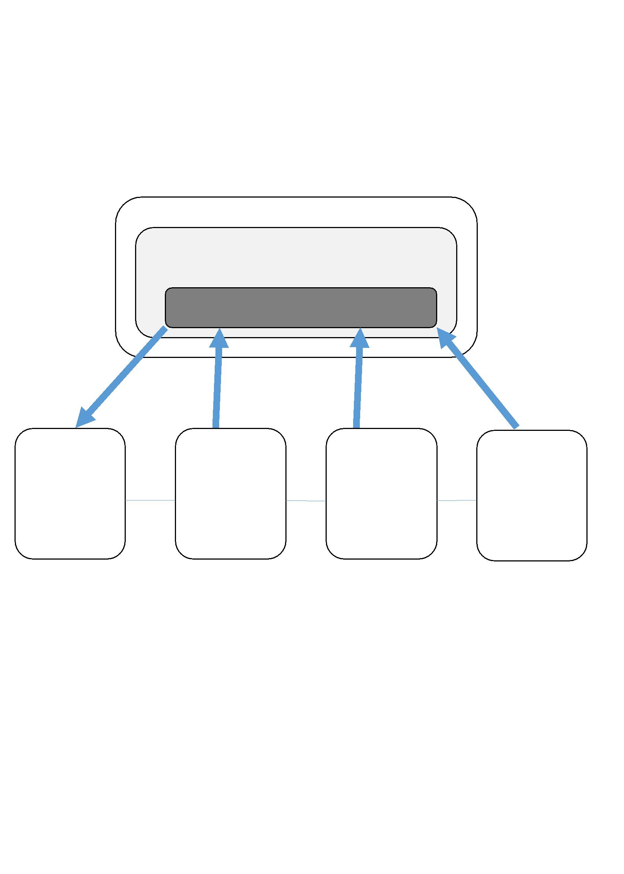

**Replication Connection:**

Web Server

Web Cluster

SQL-Balancer

|  |  |  |  |  |  |  |  |
| --- | --- | --- | --- | --- | --- | --- | --- |
| MySQL | SSH | MySQL | SSH | MySQL | SSH | MySQL |  |
| database | database | database | database |  |
| Master |  | Slave 1 |  | Slave 2 |  | Slave n |  |

**Cluster:**

1. Cluster and users are connected and registered with SSL connection.
2. Cluster connects the master users to the master database and for the slave users slave database is randomly selected.
3. The cluster is connected to master and slave using SSH connection.

**Master and Slave:**

1. Master database can be accessed only by the master users.
2. Master database also consists the files present in the slave database.
3. Slaves and masters are connected with SSH connection.

**3.1 Frontend**

At first the user is asked to login, he gets his access from database and this is done through a series of process through HTML and CSS. We create a login page to login into the server but first he needs to register into the admin server, the admin server provides a verification mail to the user and later conformation of the mail is done and the connections for the web pages are done through PHP. Now a separate account is allocated to the customer through which user can store files. Through the login page the customer logins into the user’s account and user can upload the file and make modifications to the existing file. The storage capacity is limited to the customer and users can’t exceed the given storage capacity, later he can logout from the page.

**3.2 Database**

The MySQL database contains user’s information, data status and uptime information inserted into their respective service tables

In the MySQL database we create a data slot for each customer. Through front end the user can access into user’s login account and through backend the user can access user’s files.

**3.3 Backend**

The third section of the architecture is used to connect the entire architecture. For backend programming we use Python, which is used to connect the servers. Backend is also use to ping the servers constantly, if the ping is lost or server is down it sends a message to database and in the database it is stored if the connection is lost.

It retrieves the status and stores it in the database in MySQL. Separate tables are allocated for each server.

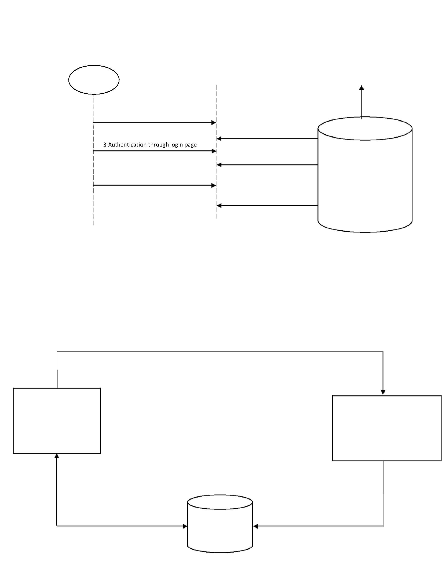

|  |  |  |  |  |  |
| --- | --- | --- | --- | --- | --- |
| User |  | Dash Board |  | Admin Server |  |
|  |  |  |  |  |
|  | 1.Registration | | |  |  |
|  |  | 2.Storage of user files | |  |  |
|  |  | 4.Provides the service | | MySQL |  |
|  |  |  |  |  |
|  | 5.Request for the file | | | Database |  |

6.Permits user to open the files and access it

Fig 2: Front End

Request for restart service

Web GUI Back End

Stores user files and retrieves files status and obtain information from the tablets

MySQL

Data Base

Insert status and uptime in the tablets

Fig 3: Data Base

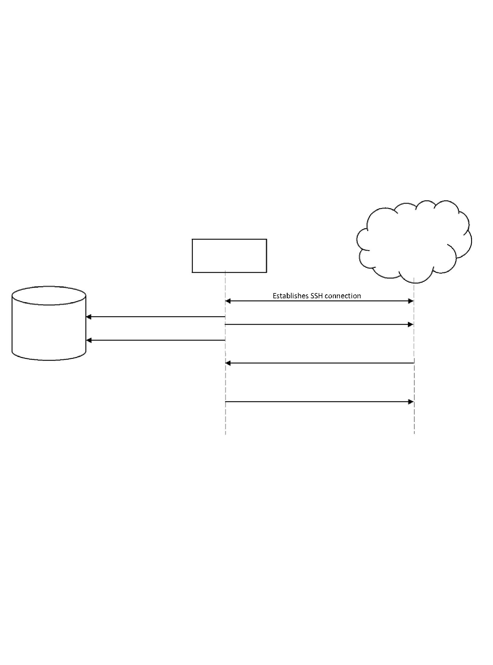

Replicas

Back End

|  |  |  |
| --- | --- | --- |
| Inserts status and |  |  |
| uptime into respective tables | Monitors Replicas |  |
|  |  |

MySQL

Stores number of restarts

Retrieves status and uptime data

Restarts service upon demand

Fig 4: Back End

**4. Requirements**

The project requirements define the basic lists of requirements for Distributed File Storage system. Requirements are classified in to user and system Requirements

**4.1 User Requirements:**

The User requirements describes what the services provided for the customer, hear we describe the function and non-functional requirements.

|  |  |  |  |  |  |  |
| --- | --- | --- | --- | --- | --- | --- |
| **Requirement** | **Identification** | **Module** |  | **Type** | **Dependencies** | **Description** |
|  |  |  |  |  |  |  |
| Simple GUI | REQ-USR_1 | Frontend |  | Functional | REQ-SYS_1 | A web-based GUI shall be provided to |
|  |  |  |  |  | REQ- | enable users to control the database |
|  |  |  |  |  | NFSYS_1 | and manage files |
|  |  |  |  |  |  |  |
| Login | REQ-USR_2 | Frontend |  | Functional | REQ-SYS_1 | To prevent unauthorised users to |
| Authentication |  |  |  |  | REQ-SYS_2 | access the files and to provide login |
|  |  |  |  |  | REQ-SYS_3 | only to the customers with proper user |
|  |  |  |  |  |  | name and password |
|  |  |  |  |  |  |  |
| File | REQ-USR_3 | Database |  | Functional | REQ-SYS_2 | To provide access to the files who |
| Availability |  |  |  |  | REQ-SYS_3 | login to the data base |
|  |  |  |  |  |  |  |
| File Sharing | REQ-USR_4 | Backend |  | Functional | REQ-SYS_3 | To provide sharing and transfer of files |
|  |  |  |  |  |  | between user to user |
|  |  |  |  |  |  |  |
| Security | REQ-USR_5 | Backend |  | Functional |  | To provide ssh encryption between |
|  |  |  |  |  |  | node to node and ssl encryption |
|  |  |  |  |  |  | between server and user |
|  |  |  |  |  |  |  |
|  |  |  | Table 1: User Requirements | | |  |



**4.2 System requirements**

System requirements describes the technical details of Distributed File Storage system. These are

classified into function and non-functional requirements.

|  |  |  |  |  |  |
| --- | --- | --- | --- | --- | --- |
| **Requirement** | **Identification** | **Created Date** | **Module** | **Type** | **Description** |
|  |  |  |  |  |  |
| Web Server | REQ-SYS_1 | 2016-4-21 | Frontend | Functional | It is used to provide |
|  |  |  |  |  | web pages requested |
|  |  |  |  |  | by client’s computers. |
|  |  |  |  |  | The web server that is |
|  |  |  |  |  | requested is Apache2 |
|  |  |  |  |  | Local server |
| Data Base | REQ-SYS_2 | 2016-4-21 | Database | Functional | We use MySQL to |
|  |  |  |  |  | store the user data, |
|  |  |  |  |  | status, login details. |
|  |  |  |  |  | Through MySQL we |
|  |  |  |  |  | create tables where |
|  |  |  |  |  | information is stored |
| Replicas | REQ-SYS_3 | 2016-4-21 | Backend | Functional | duplication of files is |
|  |  |  |  |  | performed. these files |
|  |  |  |  |  | are stored in rest of |
|  |  |  |  |  | the servers |
|  |  |  |  |  |  |
| Operating System | REQ-NFSYS_1 | 2016-4-21 |  | Non Functional | The system |
|  |  |  |  |  | requirement is |
|  |  |  |  |  | Ubuntu 14.04 LTS |
|  |  |  |  |  |  |
| Languages: | REQ-NFSYS_2 | 2016-4-21 |  | Non Functional | HTML, CSS, Java |
| HTML |  |  |  |  | Script are used to |
| CSS |  |  |  |  | building web pages, |
| PYTHON |  |  |  |  | Python is used in |
| JAVA SCRIPT |  |  |  |  | replication and |
|  |  |  |  |  | MySQL is used for |
|  |  |  |  |  | storage |
| Compatibility | REQ-NFSYS_3 | 2016-4-21 |  | Non Functional | The developed |
|  |  |  |  |  | product must be |
|  |  |  |  |  | compatible with |
|  |  |  |  |  | previous and going |
|  |  |  |  |  | versions |
|  |  |  |  |  |  |
| Testability | REQ-SYS_4 | 2016-4-21 |  | Non Functional | The product must |
|  |  |  |  |  | support software |
|  |  |  |  |  | testing to high extent |
|  |  |  |  |  | in order to detect |
|  |  |  |  |  | bugs |
|  |  |  |  |  |  |



Table 2: System Requirements

1. **References:** 
   * Sommerville, Ian. Software Engineering, 9th ed. Addison-Wesley, 2011