**High – availability ( HA) Distributed file storage**

**Group Name**: Gryffindor

**Group Members**:

* Kappagantula Sri Kasyap
* Atchukatla Mahammad Suhail
* Bollimpalli Surya Teja
* Chalasani Arjith
* Gunnam Sri Ganesh Sai
* Padala Praneel Reddy
* Yalla Chinna Balaji
* Medisetti Raghu Vinayak Rao
* Neelam Jitendra
* Jyothula Urmila
* Bhamidi Sirisha Manaswini
* Naga Bhairava Nitish

**Document Type : Project Proposal**

**Publication date: 17- april-2016**

**Version** **: 1.0**



Project



|  |  |  |  |  |  |  |  |  |
| --- | --- | --- | --- | --- | --- | --- | --- | --- |
| Planning | Documentation |  | Front End |  | Data Base |  | Back End |  |
|  |  |  | CSS |  | SQL |  |  |  |
|  |  |  |  |  |  |  |
|  |  |  | PHP |  |  | Python |  |
|  |  |  |  | SQL Manager |  |  |
|  |  |  | HTML |  |  |  |
|  |  |  |  |  |  |  |
|  |  |  |  | Encryption |  |  |  |
|  |  |  | Java Script |  |  |  |  |
|  |  |  |  |  |  |  |  |



**Task Splitting:**

|  |  |  |
| --- | --- | --- |
| 1) | Documentation : P Praneel Reddy., G Ganesh., N Nitish., B Manaswini | |
| 2) | CSS | : Ch Arjith., J Urmila |
| 3) | PHP | : K Sri Kasyap., B Surya Teja., A Mahammad Suhail., Ch Arjith., |
|  |  | N Nitish |
| 4) | HTML | : J Urmila., M Raghu., N Jitendra., G Ganesh |
| 5) | Java Script | : B Manaswini., M Raghu., N Jitendra |
| 6) | SQL | : P Praneel Reddy., K Sri Kasyap., Y Balaji |
| 7) | SQL Manager | : K Sri Kasyap., Y Balaji |
| 8) | Python | : A Mahammad Suhail., B Surya Teja |

**Contents of the Proposal:**

* + Introduction to the Project
  + Glossary and Abbreviations
  + Back ground of the project
  + Proposed solution to the Project
  + Advantages
  + Limitations Faced in the Project
  + Time Plan

1. **INTRODUCTION TO THE PROJECT:**

File Transfer Protocol (FTP) is used to transfer data between computers or from a computer to a web server. The transfer speed of FTP is faster than other protocols like HTTP, POP. Hence it is most preferred. Computer port 21 is used for the transfer of data through FTP.

**Objectives of FTP are:**

1. File sharing is promoted.
2. To promote implicit use of remote computers.
3. To protect users from variations in file storage systems among hosts.
4. Data is transferred efficiently and reliably.

This document is partitioned into various sections:

* + Customer requirements
  + Proposed solution to the given problem
  + Limitations
  + Project plan
  + Project organisation

1. **Glossary and abbreviations:** 
   * HTTP: Hyper Text Transfer Protocol

It is a transfer of version data formats between server and client EX: plain txt, hyper txt, video and sound

* + FTPS: File Transfer Protocol Security

It is an extension for commonly used file transfer protocol(FTP) that adds support for the transfer layer security(TLS) and secure sockets layer (SSL)

* + Message digest: SHA-1

SHA-1: secure Hash algorithm.SHA-1 produces a 160bit (20 byte) hash value known as a message digest.

Message digest: IT is a crypto graphic hash function which is consider practically impossible to invert that is to recreate the input data from its hash value alone.

* GUI: Graphical User Interface

It is a type of interface which helps in interaction with electronic devices through graphical icon and visual indicators.

* SQL Server: Structured Query Language Server SQL is used to store, query and manipulate data. It is used for manage data in relational data base.
* Restful API: Representation State Transfer

An architectural pattern to improve probability and scalability of a system.

**3)Background:**

In here, customers needs a secure file storage and the problems that we need to over come are the performance problems, maintains problems, availability problems these are the basic troubles faced by the customers. In different locations multiple users are responding using single centralized server and this standalone environment is used in most of the applications earlier.

**Centralized Approach and Problems**

* Performance problems
* Availability problems
* Maintenance problems

To overcome all the above problems, we can use replication as a solution.

Replications is used to maintain multiple copies of same database at different locations. Complete database redundancy is maintained by Log shipping and Mirroring whereas replication allows to maintain some part of the database at user location.

**4)Proposed solution:**

High availability basically means that redundancy throughout network infrastructure and particular technology is available

In hear we do the replication and duplication of the files across the servers.

1. In hear we send information to one server and it is randomly chosen and it creates the replicas for the files.

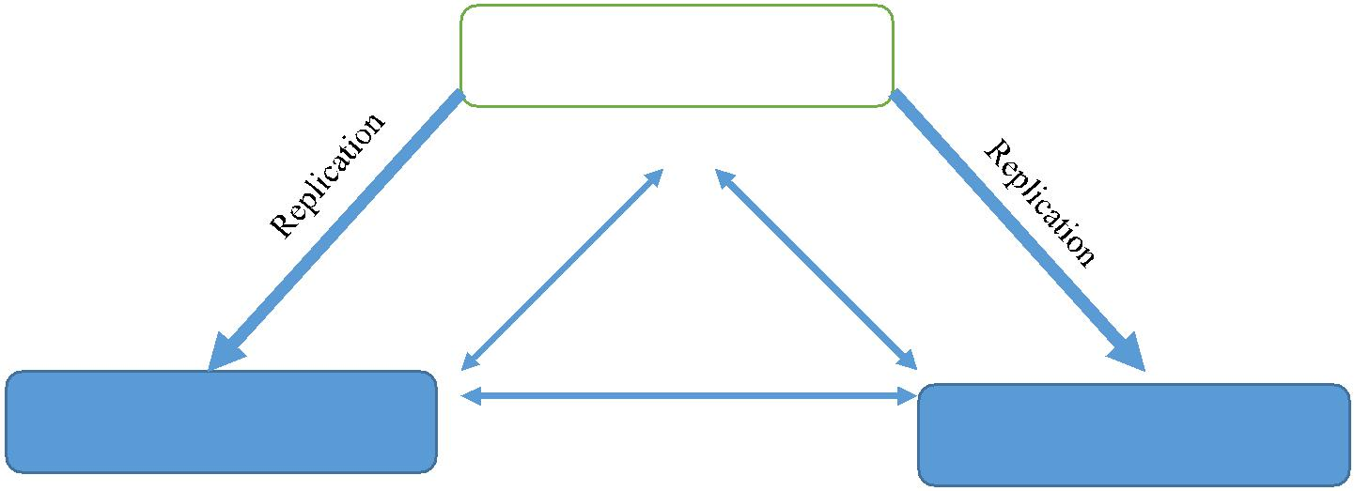

Primary



|  |  |  |
| --- | --- | --- |
|  | Heart Beat |  |
| Secondary | Secondary |  |
|  |  |

1. In hear admin provides with a login id and password for security access and storage limit
2. In hear the server is constantly checked by a pinging process if failure occurs that it is manually repaired by the admin
3. In hear if the server is brought back a constant verification is done if it fails in verification again it is taken as a server down case
4. In hear we Provide encrypting to the files and also use open SSl for certifications

**5)Advantages:**

* Improved performance.
* To reduce locking conflicts when multiple users are working.
* Improved availability.
* Easy maintenance.
* To allow sites work independently. So that each location can set up its own rules and procedures for working with its copy of the data.
* To move data closer to the user.

**6)Limitations:**

* In this if administrator fails total network fails.
* We use MEDIUM BLOB for file storage which has a maximum capacity upto 16MB.
* All servers must be connected using a single LAN.
* The total storage space of database is limited.



**7)Time Plan:**

|  |  |  |  |  |  |  |
| --- | --- | --- | --- | --- | --- | --- |
| **Week** | **1** | **2** | **3** | **4** | **5** | **6** |
| **Starting** | April | April | April-May | May | May | May |
|  | (10-17) | (18-24) | (25-1) | (2-8) | (9-15) | (16-22) |
| **Project** |  |  |  |  |  |  |
| **Specifications** |  |  |  |  |  |  |
| **Docs** |  |  |  |  |  |  |
| **Project** |  |  |  |  |  |  |
| **Specifications** |  |  |  |  |  |  |
| **Binaries** |  |  |  |  |  |  |
| **SRS Docs** |  |  |  |  |  |  |
|  |  |  |  |  |  |  |
| **SRS Binaries** |  |  |  |  |  |  |
|  |  |  |  |  |  |  |
| **Design Docs** |  |  |  |  |  |  |
|  |  |  |  |  |  |  |
| **Design Binaries** |  |  |  |  |  |  |
|  |  |  |  |  |  |  |
| **Accept Plan** |  |  |  |  |  |  |
| **Docs** |  |  |  |  |  |  |
| **Accept Plan** |  |  |  |  |  |  |
| **Binaries** |  |  |  |  |  |  |
| **Release** |  |  |  |  |  |  |
| **Candidate** |  |  |  |  |  |  |
| **Product Release** |  |  |  |  |  |  |
|  |  |  |  |  |  |  |
| **Milestones:** |  |  |  |  |  |  |



* Project plan
* SRS and design plan
* Design documentation
* Final review

**Toll gates:**

* Project proposal
* Software Requirement Specification
* Acceptance Test Plan
* Project documentation