**High Availability (HA) Distributed File Storage**

**Document: Design document**

**Version 1.0**

**Publication date: 14-JUNE-2017**

**Group name: Gryffindor**

**Group Members:**

**JITENDRA NEELAM**

**CHINNA BALAJI YALLA**

**NITISH NAGABHAIRAVA**

**RAGHUVINAYAK RAO MEDISETTI**

**MAHAMMAD SUHAIL ATCHUKATLA**

**Contents:**

1. Preface

Release v1.1 on 2016-04-25 Release v1.0 on 2016-04-18

1. Glossary and abbreviations
2. Model 1 Name
   1. *Detailed Design*
   2. *Unit Test Plane* 
      * **Test:** identification alphanumeric string
      * **Purpose:** what will be tested
      * **Requirements:** requirement IDs that are connected to this test
      * **Environment:** settings that must be performed before the test can be run
      * **Operation:** step-by-step instructions how to execute the test
      * **Expected result:** what should happen after the operation is carried out
      * **Result:** success/failure (testers can ring in the result)
      * **Comment:** useful information filled in by testers
3. Model 2 Name
4. Model 3 Name
5. References

**1. Preface**

The main concept of this project is to develop a secure file storage to the company Secure File in the form of a distributed file storage system with high availability to the customers.

In this we are creating replicas for the servers and when a user uploads a file, the file is stored in a randomly chosen server. we use file transfer protocol for the transfer of data.

**Service Developer:** Gryffindor

**Customer:** Dragos llie

In this document, we defined the technical terms and a short note on them, Design models, Unit test plan and references.

* **Release v1.1 on 2016-04-25**
* **Release v1.0 on 2016-04-18**

**Initial Release**

**2. Glossary and abbreviations**

* + GUI - Graphical User Interface: It is way of communication in which instead of typing instructions we use graphical symbols for what you want a computer application.
  + CSS- Cascading Style Sheets: It is a style sheet language used for describing the presentation of a document written in a mark-up language.
  + HTML- Hypertext Mark-up Language: the standard mark-up language for creating web pages and web applications. With Cascading Style Sheets (CSS) and JavaScript it forms a triad of cornerstone technologies for the World Wide Web.
  + DOM- Document Object Model: The Document Object Model (DOM) is a programming API for HTML and XML documents. It defines the logical structure of documents and the way a document is accessed and manipulated.
  + JSON (JavaScript Object Notation)-JSON is a lightweight data- interchange format. Easy to Read and Write. It is used to exchange data between server and web application.

**3. Model 1 Name**

**Module 1: -FRONT END**

In this module, we described the web interface of the tool. First, the user needs to register into the server, then customer receives the conformation mail from the admin server. now customer can login into the server the information of the user is stored in the MySQL database.

Change password

Share files

Delete files

View files

Download files

Upload files

Login

Send Data

My SQL Database

Receives data

From data base

Fig 1: Front End

**3.1, Detailed design**

The user logins into database through random server. The user can upload all the information into the database through the login page. the admin creates a database to the user and can remove or provide a login to the user.

The random selection of the server is done by the PHP code. When the user enters the dashboard, he can see few options those are upload, download, sharing of files, deletion of files these are the things that are visible in the server. based upon the requirement of the customer the task is performed.

**F-T1**: -**Module**: html -css-php

**Purpose:** display web GUI **Requirement**: req_sys_1, req_nfsys 1 **Environment**: browser for rendering webpages

**Operation**: -the display GUI is used for the user to login into the webpages by entering the login credentials i.e., mail id and password and then click on sign in button to get access to thedatabase. The admin uses it for sending conformation mails for logged user and adding and removing customers from database.

**Expected result: -**after user entering the login credentials and click sign in the user is directed to the database where the user can perform his tasks in the database and this also helps the admin to send the conformation mails when required.

Comment: we use these languages for the creation of thewebserver to the customers where they can login into the database.

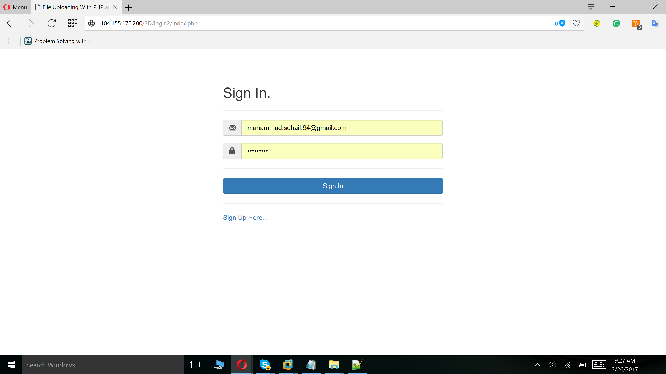

**Module 2: database management**

This module contains the database management portion of the product it also includes how the database interacts with the customers

In here we use MySQL for creation of the database.it is used as an intermediate to interact with the front end the back end of the project.

**4.1, detailed design:**

This module provides the vivid explanation of the database management in the project. we create a database to the customer where customer can store the information and files. The customer is assigned with random server and file is uploaded. we just use database to allocate data to the customer the customer is provided with a limited data of 2 Gb.

**PHP- MySQL I**

Is a relational database driver that provides an interface between the MySQL and php .it includes functions like establishing connection in the database and functions like manipulating the database (create, delete, modify etc) the admin server can create a database to the customer or also remove him from the database.

**Python – MySQL:** -it is a MySQL driver for the python interface. Providing an interfacebetween the python programming language and the MySQL relational database management system

**D-T1: Module: MySQL**

**PURPOSE:** for creation of database to the customer

**REQUIREMENT:** REQ-SYS-2

**ENVIORNMENT:** this Module is used in the PHP script

**Operation:** render the webpage by typing the following in the URL bar of the browser:

http://104.198.152.110

**Expected result:** the functions used in the module are used for creation of space inthe database for users so that they can upload and download a file.

**Comment:** it updates the database periodically whenever a new customer is addedinto the database.

**D-T2: Module:** PHP: MySQL

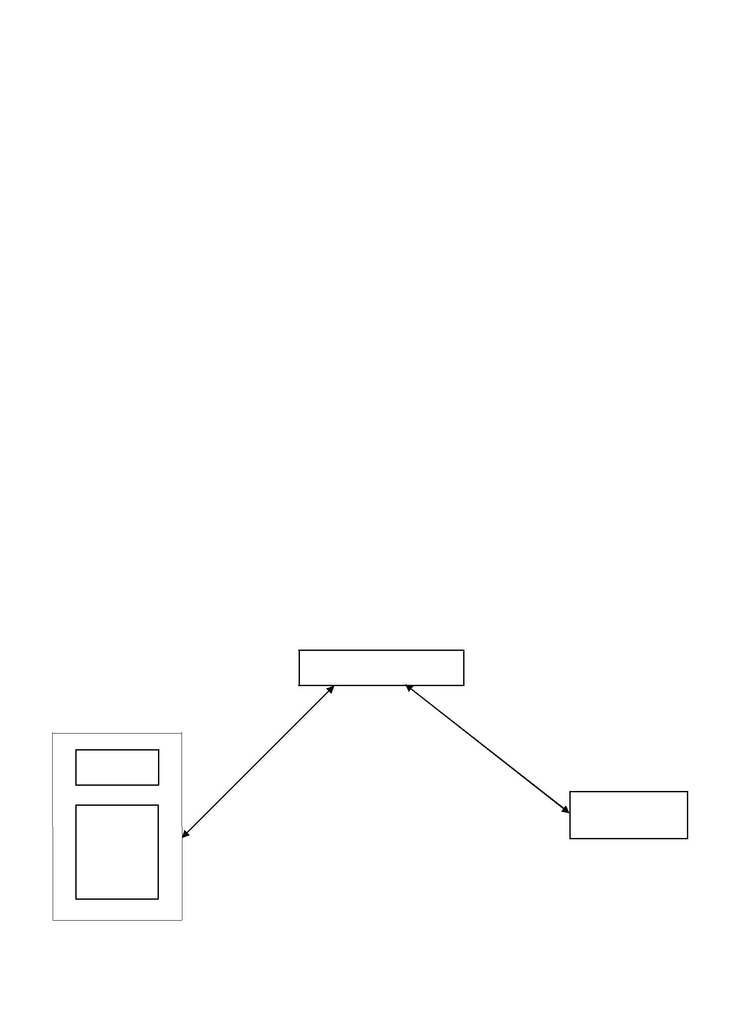

**Purpose:** for interaction between PHP and MySQL

**Requirement:** REQ-SYS-2

**Environment:** module must include in the PHP script

**Operation:** the script needs to be executed from its directory

**Expected result:** the functions used from this module in the test script must interactwith the MySQL database without errors.

**Result:**

**Comment:** interface between MySQL and PHP script

**D-T3 MODULE:** python: MySQL

**Purpose**: for interaction between python and MySQL

**Requirement:** REQ-SYS-2, REQ-SYS-3

**Environment**: module needs to be included in the python script

**Operation:** creation of the replicas and storage of the replicas in MySQL

**Expected result:** the functions used from this module in the test script must interactwith the MySQL database without errors.

**Result**:

**Comment**: interface between MySQL and python

Data Base

MySQL

Front End (GUI)

PHP Back End

HTML Python

Replication

CSS

Java

Script

Fig 2: Data Base

**Module 3: -back end**

The back end of the project is performed over the python language. We use the back end for the creation of replicas of the files

**5.1, detailed design**

The My SQL is used for the creation of replicas to the files at first the file is randomly uploaded into the server and we create replicas to those files and these are stored in the other servers. The connection to the servers are checked by constant pinging performed by the back end. If the connection is lost with the server, it is informed to the admin server he removes the server and manually repairs it later the verification of the server takes place and see that all the files are present and conformation is done.

**5.2, unit test plan**

**B-T1**: **module:** FTP

**Purpose:** it provides a transfer of files from one server to another server

**Requirement:** REQ-NFSYS_3

**Environment:** module must be included in python script

**Operation:** it is executed from the directory

**Expected result:** to receive files

**Result**

**Comment**: it is used to transfer files from a server to another server .it is used todownload files from the server.

Reconnection

Data base

My SQL

Pinging

Fig 3: Back End

**6.References:**

Sommerville, Ian. Software Engineering, 9th ed. Addison-Wesley, 2011