**High availability(HA) Distributed File Storage**

**Document: User Documentation**

**Publication date: 13-june-2017**

**Group name: Gryffindor**

**Group Members:**

* JITENDRA NEELAM
* CHINNA BALAJI YALLA
* NITISH NAGABHAIRAVA
* SIRISHA MANASWINI BHAMIDI
* RAGHUVINAYAK RAO MEDISETTI
* MAHAMMAD SUHAIL ATCHUKATLA

1. **Preface**

The main concept of this project is to develop a secure file storage to the company Secure File in the form of a distributed file storage system with high availability to the customers.

When a user uploads a file, the file is stored in a randomly chosen server. In this we are creating replicas for the file uploaded by the user and we use file transfer protocol for the transfer of data.

**Service Developer:** Gryffindor

**Customer:** Dragos illie

In this document, we defined the technical terms and a short note on them, Organisation of source code, Monitoring process Set up a control node and references.

* **Release v1.0 on 2016-04-18**

**Initial Release**

**This is a user’s documentation and in here we explain how and what languages we used to create software and we are going to explain in detail about the software in the following sections 2 glossary and abbreviations 3, introduction 4, features of the tool 5, replication 6,usage guide of the product**

* **Release v.11 on 2017-06-13**

Final release

In this we are changing the few aspects in the previous release we planned to do the replication through backend but now we perform it in the data base side we used google cloud for this project. Now in this document we use backend for pinging purpose

1. **Glossary and abbreviations**

* **HTTP: Hyper Text Transfer Protocol**

It is a transfer of version data formats between server and client

EX: plain txt, hyper txt, video and sound

* **FTPS: File Transfer Protocol Security**

It is an extension for commonly used file transfer protocol(FTP) that adds support for the transfer layer security(TLS) and secure sockets layer (SSL)

* **Message digest: SHA-1**

IT is a crypto graphic hash function which is consider practically impossible to invert that is to recreate the input data from its hash value alone.

SHA-1: secure Hash algorithm.SHA-1 produces a 160bit (20 byte) hash value known as a message digest. SHA-1 advancements are SHA-2 and SHA-3

* **GUI: Graphical User Interface**

It is a type of interface which helps in interaction with electronic devices through graphical icon and visual indicators.

* **SQL Server: Structured Query Language Server**

SQL is used to store, query and manipulate data. It is used for manage data in a relational data base.

**3,Introduction:**

this document is used by the user to let him know about the product and how to use the product and the limitations of the product. In this documentation we will let him know how to login into his database and what kind of modifications he can make in his database.

4, PREREQUISITES:

* Knowledge about Linux and running commands in terminal for installing prerequisite
* packages for running the tools
* Knowledge about using a web browser
* Knowledge about SSL and SSH
* Basic knowledge about MYSQL-SERVER

5, FEAUTRES OF THE TOOL:

The tool consists of front end, database and back end. The front end consists of web pages written in HTML, CSS and PHP these are used to design graphical user interface. HTML and CSS are used to design the web page and PHP is used to connect the web pages

The database is the main part of our project it is used to connect the front end and backend of the project. The tool used to design the database is the MySQL it is used to create a space to user to store the information into the database. By default, the database name is Gryffindor and can be changed manually. the database consists of tables required for the storing of the user credentials as well as the uptime data retrieved by the back end. The Mysql is also used to replicate the files in the database in case if the server goes down customer can retrieve the files from other servers.

The back end consists of a series of python files that are needed to be running in the system. The backend is used to ensure that the server is constantly pinged to ensure that the system is online

6,USER REGISTRATION:

At first to store the data into the data base the user must first register into the server.so first he needs to enter his credentials into the registration page and he receives a confirmation mail from the admin server and later he must use his login details to log into the database. At first to login page we

see too types of options

1. login details

2. register new user

The user can log into the database by writing the login details in the login page from there they are permitted to login into the dashboard. After logging into the database, he can see at the top where three options are displayed and at the home page we can see all the files and choose a file The file which the customer is uploading shall not exceed 2 gb. For new users they have to create an account through the register page and later they are permitted to log in into the dashboard

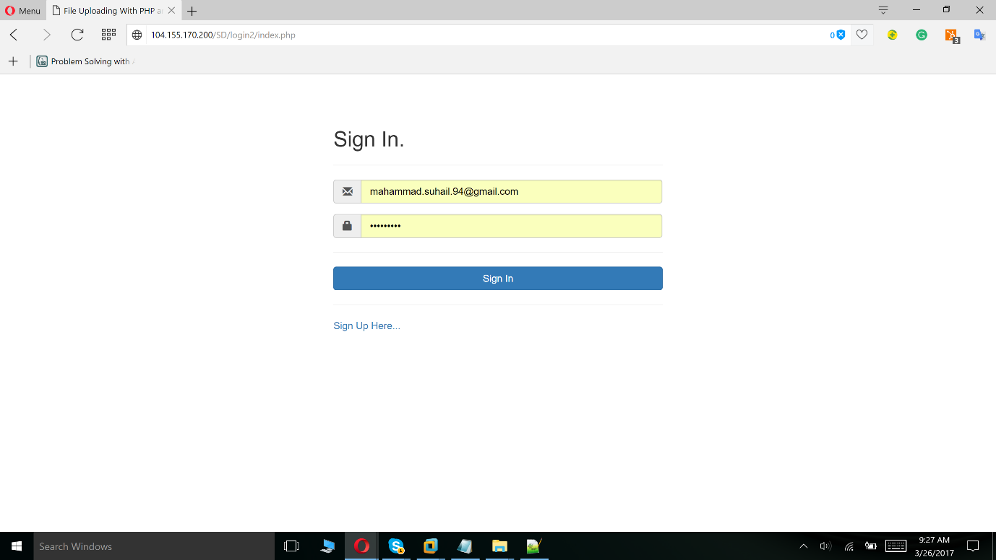

STATUS AND UPTIME OF EACH SERVICE:

After logging in, the user is brought to the home page of the tool dashboard. When the user uploads the file it randomly uploads into any server later it is replicated. The backend programming constantly pings the server if the service of the server is down than the system is taken as error server than the admin server checks over the problem and then it is brought online during the loss of its service due to pinging we can know how long was the service down. All the information about the service is noted down in the tables of the database

Replication of files:

The My-sql programming is used to replicate the files. The user who wants to upload the files and uploads it in a randomly chosen server and from this server the file is replicated into rest of the servers and from these servers the user can download the file if the server he chooses to upload is offline The replication of these files is done by the database cluster in which there are two databases one is master database and slave database. The master has the access to use the both his database and slave database but the slave can access only his database

7,USAGE GUIDE:

* The tool requires a ssh connection to the server to be run in the background continuously
* The connection facilitates the retrieval of status and uptime data from server with the help of
* backend python scripts
* The user will also be given a file containing database parameters which needs to be executed
* before starting
* The file contains ssh host name and passphrase needed for establishment of the ssh
* connection
* The user must enter login page of the tool. Username and password must be entered to gain
* access to the dashboard
* Username:
* Password:
* These are the default user credentials initially login into login page
* When the user enters the dashboard, he can see the following options

1. Upload
2. Download
3. View files
4. Delete files
5. Share files
6. Change password

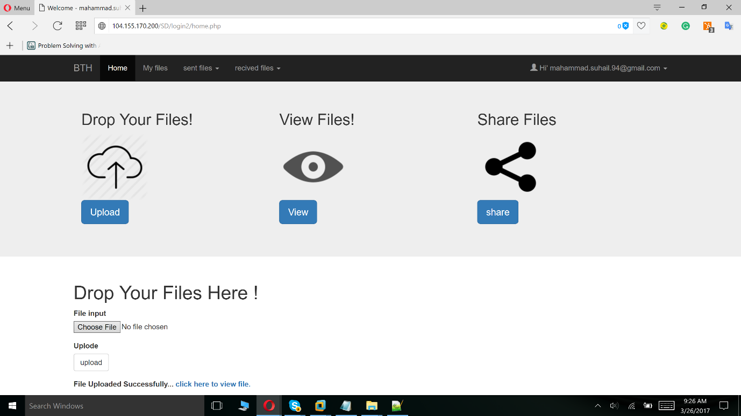

* Upon entering the dashboard, the user is provided with above options he can use these options
* as per his wish
* On dashboard, he can see the files and can do all the modifications required to the files the
* upload of the files is limited
* If he wants to download the file, he can download it from the dash board
* If the user wants to upload the file it randomly selects a server and from the server, he enters
* into the dashboard and uploads the file in that server
* The server in which the file is uploaded is replicated and sent to the rest of the servers
* If the server is down the admin server fixes it and when the user wants to download it during
* that process, he can perform it from the other servers
* When the server is down and after it is repaired it set for the available condition

8,FINAL OUTPUTS

The user will be able to upload and download the files whenever he wants

The service is made sure that it is always uptime and even in the case when the server

References

* Sommerville, Ian. Software Engineering, 9th ed. Addison-Wesley, 2011