ANDHRA PRADESH SKILL DEVELOPMENT CORPORATION
SUMMER INTERNSHIP PROJECT REPORT
ON
EVENT-DRIVEN CLOUD THREAT DETECTION AND ANOMALY ALERTING SYSTEM USING AWS
Submitted in Partial Fulfillment of the APSSDC Summer Internship Program
AT

Under the Guidance of
Mrs. Sumana Bethala, APSSDC & Mr. Juttuka Lovababu, APSSDC
Submitted by:
CHINNAM MALLIKARJUNA RAO, 23B81A1235, SIR C R RCOE, Eluru. (B-2),
DINDI SAI DHANUSH, 23B81A1247, SIR C R RCOE, Eluru. (B-2),
EGALAPATI VAMSI VIJAYA SAI SURAJ CHOWDARY, 23B81A1252, SIR C R RCOE, Eluru. (B-2),
NARMALA BHAGYA SRI, 24NU1A4425, NSRIT. (B-2)

ACKNOWLEDGEMENT
I would like to express my sincere gratitude to the Andhra Pradesh Skill Development Corporation (APSSDC) for providing me with the opportunity to participate in the Summer Internship Program on Amazon Web Services (AWS). This internship has been an invaluable learning experience that enabled me to strengthen my knowledge of cloud computing, cloud security, and event-driven architectures while gaining practical exposure to AWS services through hands-on project development.
I extend my heartfelt thanks to Mrs. Sumana Bethala and Juttuka Lovababu, my mentors at APSSDC, for their continuous guidance, encouragement, and technical support throughout the internship. Their valuable suggestions, constructive feedback, and mentorship played a significant role in the successful completion of my project, "Event-Driven Cloud Threat Detection and Automated Anomaly Alerting System Using AWS."
I also express my sincere appreciation to the APSSDC team for organizing this internship program and providing an excellent platform to learn modern cloud technologies through practical implementation. The knowledge and experience gained during this internship have significantly enhanced my understanding of AWS services, cloud security practices, automation, and real-world solution design.
I would also like to thank the faculty members and management of my college for their continuous encouragement and support throughout the internship period. Their motivation inspired me to successfully complete this project and improve my technical skills.
Finally, I express my heartfelt gratitude to my family and everyone who directly or indirectly supported and encouraged me throughout this journey. Their constant motivation and belief in me have been instrumental in the successful completion of this project.
I sincerely thank everyone who contributed to making this internship a meaningful and rewarding learning experience.
Sincerely,
Chinnam Mallikarjuna Rao, 23B81A1235, chinnammallikarjunarao.99@gmail.com.
Dindi Sai Dhanush, 23B81A1247, dindisaidhanush@gmail.com.
Elagapati Vamsi Vijaya Sai Suraj Chowdary, 23B81A1252, vamsi16027@gmail.com
Narmala Bhagya Sri, 24NU1A4425, bhagyanaramala@gmail.com

ABSTRACT
Cloud environments are increasingly becoming the backbone of modern organizations, making continuous monitoring and rapid threat detection essential for maintaining security and operational reliability. This project, "Event-Driven Cloud Threat Detection and Automated Anomaly Alerting System Using Amazon Web Services (AWS)," presents a serverless, event-driven security monitoring solution that automatically detects suspicious activities within an AWS environment and generates real-time alerts for security incidents.
The proposed system leverages native AWS services to build a scalable and automated cloud security workflow. AWS CloudTrail continuously records API activities performed across AWS resources, while Amazon EventBridge monitors these events and filters security-relevant actions based on predefined event patterns. Whenever a monitored event occurs, an AWS Lambda function is automatically triggered to analyze the event, classify its severity, and generate a detailed security notification. The processed alert is then delivered to administrators through Amazon Simple Notification Service (SNS), enabling rapid awareness and response to potential security threats. Amazon CloudWatch is integrated for centralized logging, monitoring, and troubleshooting, while AWS Identity and Access Management (IAM) ensures secure communication and least-privilege access between AWS services.
The serverless architecture eliminates the need for infrastructure management while providing automatic scalability, high availability, and cost efficiency. By automating threat detection and incident notification, the system significantly reduces manual monitoring efforts, shortens incident response time, and improves overall cloud security posture. The event-driven approach ensures that security events are processed immediately after they occur, allowing administrators to respond proactively to unauthorized or suspicious activities.
This project demonstrates how AWS serverless technologies can be effectively combined to build an efficient, reliable, and extensible cloud security monitoring solution. The proposed architecture also provides a strong foundation for future enhancements such as integration with Amazon GuardDuty, AWS Security Hub, centralized security dashboards, multi-account monitoring, SIEM platforms, and AI-based anomaly detection for advanced threat analysis.

1. INTRODUCTION
In today's cloud-first world, organizations increasingly rely on cloud platforms to host critical applications, manage sensitive data, and deliver scalable services. As cloud adoption continues to grow, ensuring the security of cloud environments has become a fundamental requirement. Organizations generate thousands of management events every day, including user logins, resource modifications, permission changes, and infrastructure updates. Manually monitoring these activities is time-consuming, error-prone, and often results in delayed detection of security incidents. Consequently, there is a growing need for automated, event-driven security monitoring systems capable of identifying suspicious activities and notifying administrators in real time.
This project, titled "Event-Driven Cloud Threat Detection and Automated Anomaly Alerting System Using Amazon Web Services (AWS)," presents a serverless cloud security solution designed to continuously monitor AWS management events and automatically detect predefined security-sensitive activities. By leveraging AWS's event-driven architecture, the system eliminates the need for continuous manual monitoring while enabling rapid incident detection and response. The solution demonstrates how modern cloud-native services can be integrated to build a scalable, reliable, and cost-effective cloud security monitoring platform.
The system utilizes AWS CloudTrail to capture management events generated across AWS resources. These events are continuously monitored by Amazon EventBridge, which filters security-relevant API activities based on predefined event patterns. Whenever a matching event is detected, an AWS Lambda function is automatically invoked to analyze the event details, classify its severity, and generate an informative security alert. The alert is then delivered to administrators through Amazon Simple Notification Service (SNS), ensuring immediate awareness of potential security threats. Additionally, Amazon CloudWatch provides centralized logging and monitoring capabilities, while AWS Identity and Access Management (IAM) ensures secure communication between all AWS services using the principle of least privilege.
The serverless architecture adopted in this project provides several advantages, including automatic scalability, high availability, reduced operational overhead, and cost efficiency. Since AWS services are invoked only in response to specific events, the system efficiently utilizes cloud resources without requiring dedicated servers or manual infrastructure management. This event-driven approach enables organizations to respond more quickly to unauthorized activities such as IAM user creation, security group modifications, instance termination, unauthorized API calls, or other security-critical events.
This report presents a comprehensive overview of the proposed solution, including its architecture, implementation, security design, event processing workflow, testing methodology, and performance evaluation. It also discusses the integration of various AWS services and highlights the benefits of adopting serverless technologies for cloud security automation. Furthermore, the modular architecture allows the solution to be extended with advanced security services such as Amazon GuardDuty, AWS Security Hub, centralized dashboards, SIEM integrations, and AI-driven anomaly detection to enhance cloud security capabilities.
By implementing an automated, event-driven cloud threat detection and anomaly alerting system, this project demonstrates how AWS serverless technologies can significantly improve security monitoring, minimize response time, and strengthen an organization's overall cloud security posture. The solution serves as a practical example of applying cloud-native technologies to address modern cybersecurity challenges while providing a scalable foundation for future enhancements.

2. METHODOLOGY
The development of the Event-Driven Cloud Threat Detection and Automated Anomaly Alerting System Using Amazon Web Services (AWS) followed a structured and systematic methodology to ensure the successful implementation of a secure, scalable, and event-driven cloud security monitoring solution. The development process was divided into several phases, including requirements gathering, system design, implementation, security configuration, testing, deployment, monitoring, and continuous improvement. Each phase was carefully planned to align with AWS cloud security best practices and serverless application design principles.

2.1 Requirements Gathering
The initial phase focused on identifying the functional and technical requirements of a cloud security monitoring system. Existing cloud environments often rely on manual log inspection, making it difficult to detect suspicious activities in real time. Discussions with mentors and an analysis of common cloud security challenges helped define the primary objectives of the project, which include automated event monitoring, real-time threat detection, immediate administrator notification, and a fully serverless implementation. The system was designed to continuously monitor AWS management events and automatically generate alerts whenever predefined security-sensitive activities occur.

2.2 System Design
Based on the identified requirements, a cloud-native event-driven architecture was designed using AWS services. AWS CloudTrail was selected to capture management events generated across AWS resources. Amazon EventBridge was configured to monitor these events and route only security-relevant events to AWS Lambda. The Lambda function was designed to analyze event details, classify incidents, and prepare alert messages. Amazon SNS was integrated to deliver notifications to administrators, while AWS CloudWatch was incorporated for centralized logging and monitoring. IAM roles and policies were carefully planned to ensure secure communication between all AWS services while following the principle of least privilege.

2.3 Implementation
The implementation phase focused on integrating all AWS services into a fully automated event-driven workflow. AWS CloudTrail was configured to continuously record API activities across the AWS account. Amazon EventBridge rules were created to filter selected management events such as IAM modifications, EC2 operations, security group changes, and other predefined security-related activities. Whenever a matching event occurred, AWS Lambda was automatically invoked to process the event, extract relevant information, determine the event severity, and generate a structured security notification. Amazon SNS then delivered the alert to subscribed administrators through email. The application logic was developed using Python within the AWS Lambda runtime environment.

2.4 Security Configuration
Security was implemented throughout the solution using AWS Identity and Access Management (IAM). Separate IAM roles and policies were created to provide Lambda with only the permissions required to read CloudTrail event data, write execution logs to CloudWatch, and publish notifications to Amazon SNS. The implementation followed the Principle of Least Privilege (PoLP) to minimize unnecessary access permissions and improve the overall security posture of the solution.

2.5 Testing
Extensive testing was performed to validate the functionality, reliability, and responsiveness of the system. Various AWS management events were generated intentionally, including IAM user creation, EC2 instance operations, security group modifications, and other monitored activities. Each event was verified to ensure that CloudTrail successfully recorded the activity, EventBridge correctly matched the event pattern, Lambda executed without errors, and SNS delivered the corresponding notification to the administrator. CloudWatch logs were also reviewed to verify successful event processing and troubleshoot any execution issues.

2.6 Deployment
The complete solution was deployed within the AWS Management Console using native AWS services and AWS CLI wherever applicable. CloudTrail trails, EventBridge rules, Lambda functions, SNS topics, CloudWatch log groups, and IAM roles were configured and integrated into a unified event-driven architecture. The deployment process emphasized automation, reliability, and ease of maintenance while eliminating the need for dedicated server infrastructure.

2.7 Monitoring and Continuous Improvement
Amazon CloudWatch was utilized to continuously monitor Lambda execution, collect logs, and analyze system performance. Event processing times, Lambda invocation metrics, execution failures, and error logs were periodically reviewed to ensure reliable system operation. Throughout the development process, the event filtering logic, alert formatting, and Lambda processing workflow were refined based on testing outcomes and mentor feedback. The modular architecture was also evaluated for future enhancements, including integration with Amazon GuardDuty, AWS Security Hub, SIEM platforms, centralized dashboards, and AI-based anomaly detection systems.
The methodology adopted for this project successfully demonstrates the practical implementation of an event-driven cloud security monitoring solution using AWS serverless technologies. By combining automation, real-time event processing, secure service integration, and continuous monitoring, the proposed system provides a scalable, reliable, and efficient approach for improving cloud security and accelerating incident response.

3. TECHNOLOGY STACK
The Event-Driven Cloud Threat Detection and Automated Anomaly Alerting System Using Amazon Web Services (AWS) was developed using a cloud-native, serverless technology stack that enables real-time event processing, automated threat detection, secure communication, and centralized monitoring. The architecture leverages fully managed AWS services to eliminate infrastructure management while providing scalability, reliability, and cost efficiency.
The following technologies and services were utilized throughout the implementation of the project.

3.1 Cloud Platform

Amazon Web Services (AWS)
Amazon Web Services (AWS) serves as the cloud platform for developing and deploying the entire solution. AWS provides highly available, scalable, and fully managed services that enable the implementation of an event-driven security monitoring system without the need to provision or manage servers.

3.2 AWS Services

AWS CloudTrail
AWS CloudTrail records all management API activities performed within the AWS account. It acts as the primary event source by capturing actions such as IAM user creation, EC2 instance operations, security group modifications, and other administrative events required for threat detection.

Amazon EventBridge
Amazon EventBridge continuously monitors CloudTrail events and filters security-relevant activities based on predefined event patterns. When a matching event is detected, it automatically invokes the AWS Lambda function for further analysis.

AWS Lambda
AWS Lambda executes the core business logic of the application. It processes incoming CloudTrail events, extracts important information, classifies the event severity, formats the security notification, and triggers alert delivery without requiring dedicated servers.

Amazon Simple Notification Service (SNS)
Amazon SNS is responsible for sending real-time email notifications to subscribed administrators whenever suspicious or predefined cloud security events are detected.

Amazon CloudWatch
Amazon CloudWatch provides centralized logging, monitoring, and operational insights. It stores Lambda execution logs, monitors invocation metrics, tracks execution duration, and assists in troubleshooting and performance optimization.

AWS Identity and Access Management (IAM)
AWS IAM provides secure authentication and authorization between AWS services. IAM roles and policies are configured using the Principle of Least Privilege (PoLP) to ensure that each service receives only the permissions necessary to perform its intended function.

3.3 Programming & Development

Python 3.12
Python was used to develop the AWS Lambda function responsible for event processing, threat analysis, and notification generation.

Boto3 SDK
Boto3, the AWS SDK for Python, was used within the Lambda function to interact programmatically with AWS services such as Amazon SNS and Amazon CloudWatch whenever required.

3.4 Event Format

AWS CloudTrail Management Events (JSON)
CloudTrail generates management events in JSON format containing detailed information such as event name, event source, user identity, request parameters, response elements, event time, AWS region, and account information. These JSON events serve as the primary input for the threat detection workflow.

3.5 Security & Access Control

IAM Roles and Policies
Dedicated IAM roles and policies were configured to securely allow communication between CloudTrail, EventBridge, Lambda, SNS, and CloudWatch. The implementation strictly follows the Principle of Least Privilege to minimize unnecessary permissions and improve overall system security.

3.6 Monitoring & Logging

Amazon CloudWatch Logs
CloudWatch Logs automatically records Lambda execution details, including incoming events, execution status, errors, and debugging information.

Amazon CloudWatch Metrics
CloudWatch Metrics provides operational insights such as Lambda invocation count, execution duration, error rate, throttling events, and overall system health.

3.7 Development Tools
- AWS Management Console – Used for configuring and managing AWS resources.
- AWS Command Line Interface (AWS CLI) – Used for resource management, testing, and deployment tasks.
- Visual Studio Code – Used for writing and editing Python code.
- Git & GitHub – Used for version control and project source code management.

4. SYSTEM DESIGN & ARCHITECTURE
The Event-Driven Cloud Threat Detection and Automated Anomaly Alerting System Using Amazon Web Services (AWS) is designed as a cloud-native, serverless, event-driven security monitoring solution that automatically detects predefined cloud security events and generates real-time alerts for administrators. The architecture eliminates the need for continuous manual monitoring by leveraging AWS managed services to process cloud events immediately after they occur.
The proposed system follows an event-driven architecture in which every significant management activity performed within the AWS environment is continuously monitored. AWS CloudTrail records management API calls across AWS resources and acts as the primary event source. Amazon EventBridge continuously evaluates these events against predefined security rules and automatically triggers an AWS Lambda function whenever a monitored event is detected.
The Lambda function serves as the core processing component of the system. It analyzes the incoming event, extracts relevant security information, determines the severity of the detected activity, and generates a structured alert message containing important details such as the event name, AWS service, user identity, source IP address, AWS Region, event time, and account information. The generated notification is then delivered through Amazon Simple Notification Service (SNS), allowing administrators to receive immediate email alerts regarding potential security incidents.
To ensure operational visibility and simplify troubleshooting, Amazon CloudWatch is integrated into the architecture to collect execution logs, monitor Lambda performance, and record system metrics. AWS Identity and Access Management (IAM) provides secure authentication and authorization between all AWS services by implementing least-privilege access policies, ensuring that each component can access only the resources required for its operation.
The serverless architecture offers several advantages, including automatic scalability, high availability, reduced operational overhead, and cost efficiency. Since each AWS service is invoked only in response to specific events, the solution minimizes infrastructure management while providing near real-time threat detection and notification capabilities. The modular architecture also enables future integration with advanced AWS security services such as Amazon GuardDuty, AWS Security Hub, AWS Config, SIEM platforms, and AI-based anomaly detection systems.
This chapter presents the overall architecture of the proposed solution, explains the interaction between AWS services, and describes the complete event-processing workflow from the generation of a cloud event to the delivery of a security notification.

4.1 Overall System Architecture

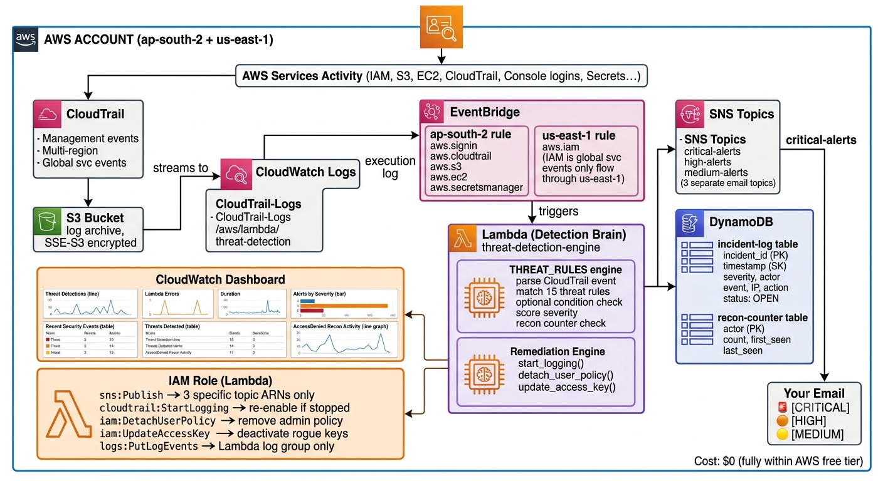
Fig: System Architecture

4.2 Event Collection Layer – AWS CloudTrail

CloudTrail serves as the primary event collection service within the proposed architecture. It continuously records management events generated across AWS resources, including IAM operations, EC2 lifecycle events, security group modifications, and other administrative activities. These events form the input for the event-driven threat detection workflow.

Key Features
- Records AWS Management API Calls
- Captures User Identity
- Records Event Time
- Stores Request Details
- Enables Security Auditing
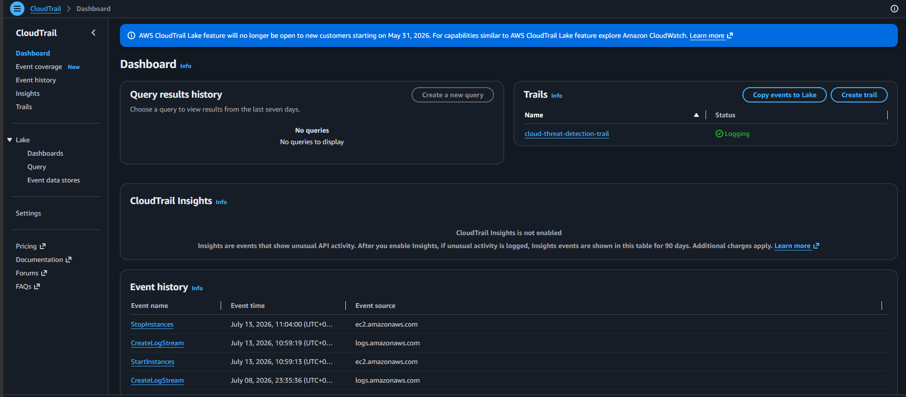
Fig: CloudTrail Dashboard
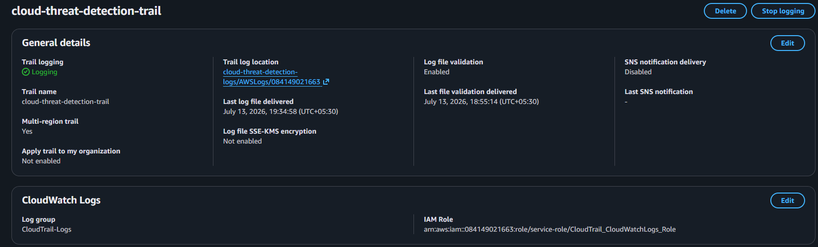
Fig: Trail Configuration
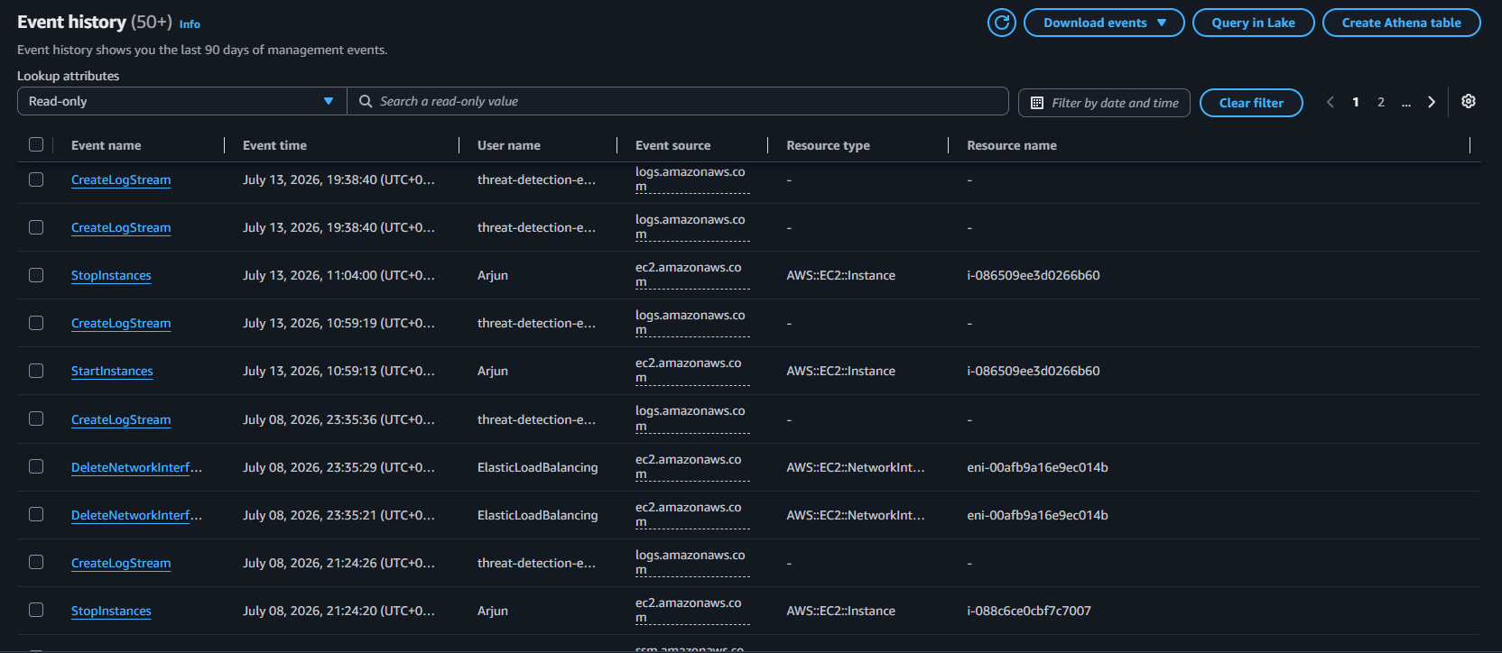
Fig: Events History

4.3 Event Routing Layer – Amazon EventBridge
Amazon EventBridge continuously monitors CloudTrail events and evaluates them against predefined event patterns. Only events that satisfy the configured security rules are forwarded to AWS Lambda for further processing.

Key Features
- Event Filtering
- Rule-Based Routing
- Automatic Invocation
- Near Real-Time Processing
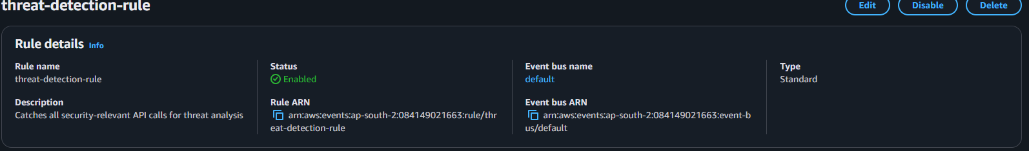
Fig: EventBridge Rule
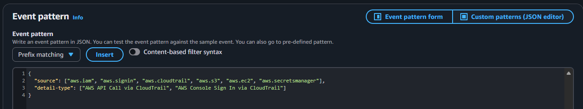
Fig: Event Pattern
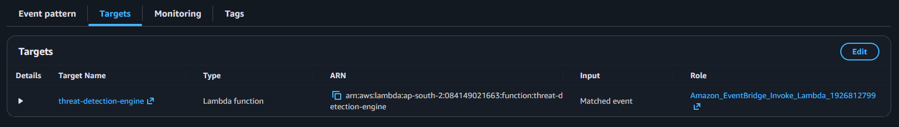
Fig: Target Configuration ( Lambda )

4.4 Threat Processing Layer – AWS Lambda
AWS Lambda performs the core processing logic of the system.
After receiving an event from EventBridge, the function:
- Parses the CloudTrail event
- Extracts event details
- Identifies event type
- Determines severity
- Generates alert message
- Publishes notification to SNS
- Writes execution logs to CloudWatch
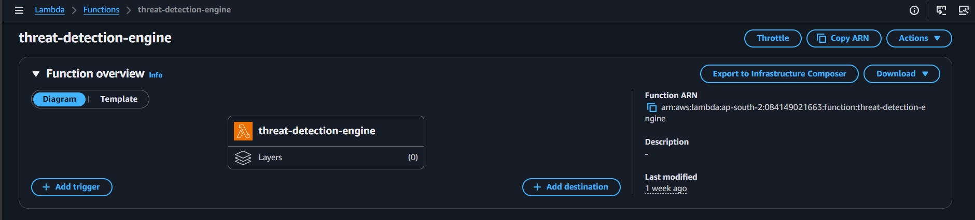
Fig: Lambda Function
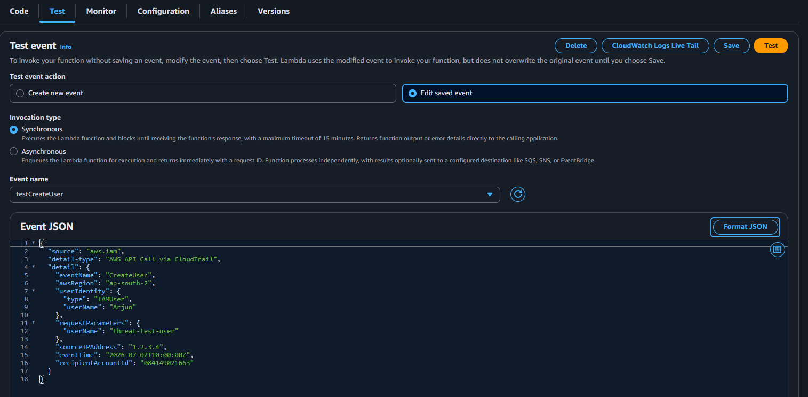
Fig: Test Case ( IAM User Creation )
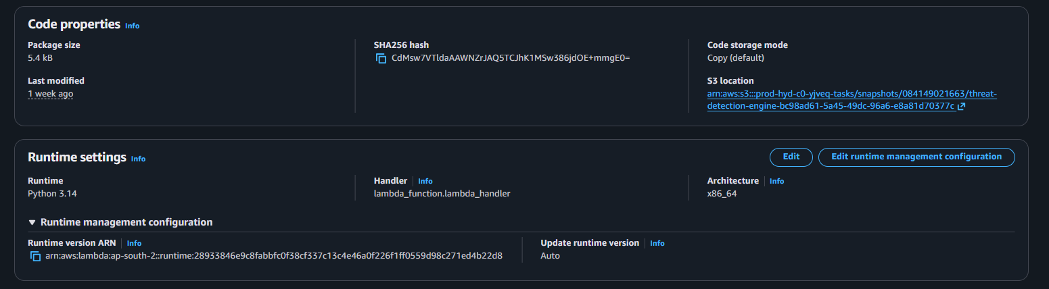
Fig: Lambda Configuration

4.5 Notification Layer – Amazon SNS
Amazon SNS provides the notification layer of the architecture.
Whenever Lambda detects a monitored security event, it publishes a notification to an SNS topic. The topic immediately sends an email alert to subscribed administrators.

Features
- Email Notifications
- Real-Time Alerts
- Reliable Delivery
- Multiple Subscribers
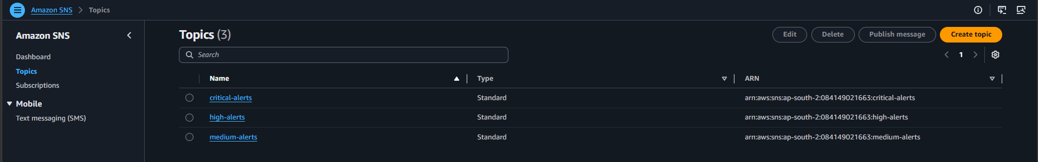
Fig: SNS Topics
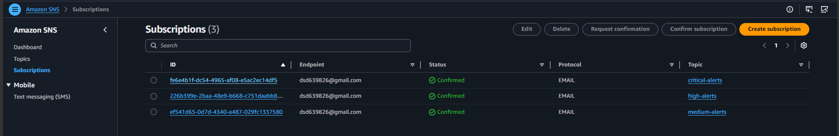
Fig: SNS Subscribtions ( Gmail )
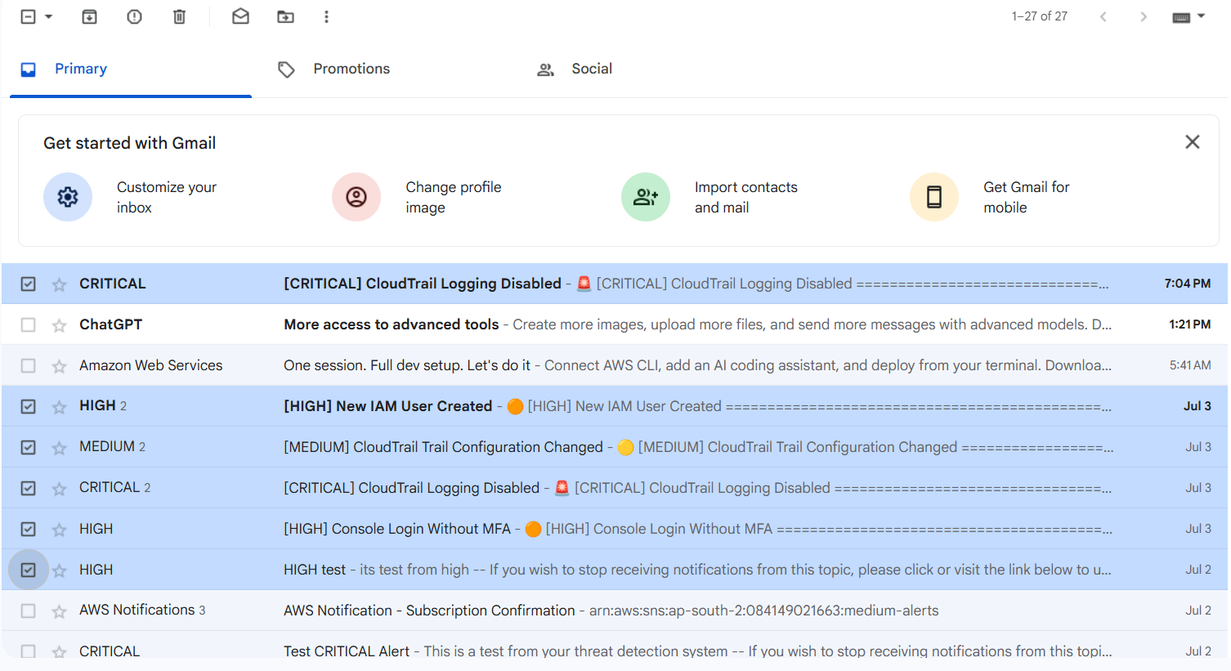
Fig: SNS Email Alerting

4.6 Monitoring & Logging – Amazon CloudWatch
Amazon CloudWatch continuously monitors the execution of the Lambda function and stores detailed execution logs for debugging, auditing, and operational analysis.

Features
- Execution Logs
- Invocation Metrics
- Error Monitoring
- Performance Analysis

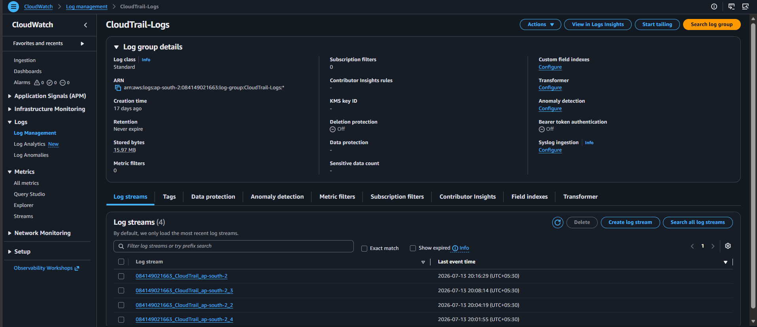
Fig: CloudWatch Log Stream- Trail Logs
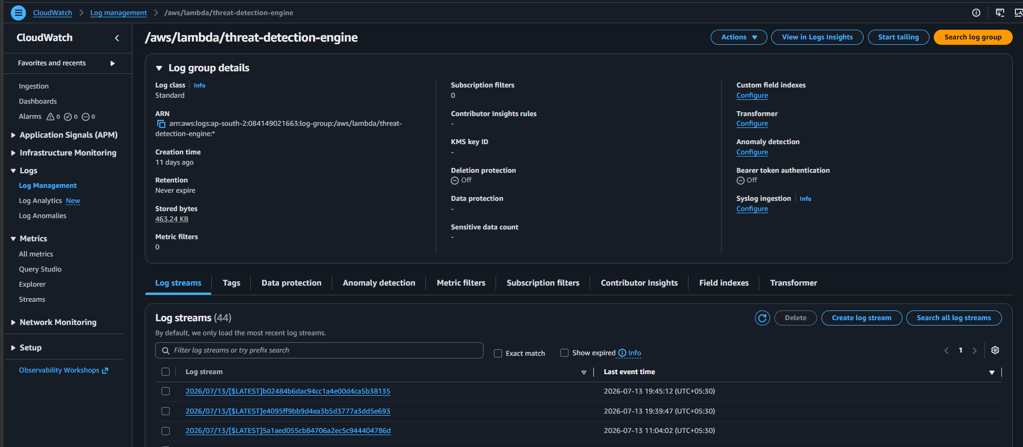
Fig: CloudWatch Log Stream- Lambda Logs

4.7 Security & Access Control – AWS IAM
AWS Identity and Access Management (IAM) ensures secure communication between all AWS services. Dedicated IAM roles and policies were created to implement the Principle of Least Privilege (PoLP).

IAM Permissions
- CloudTrail → EventBridge
- EventBridge → Lambda
- Lambda → SNS
- Lambda → CloudWatch
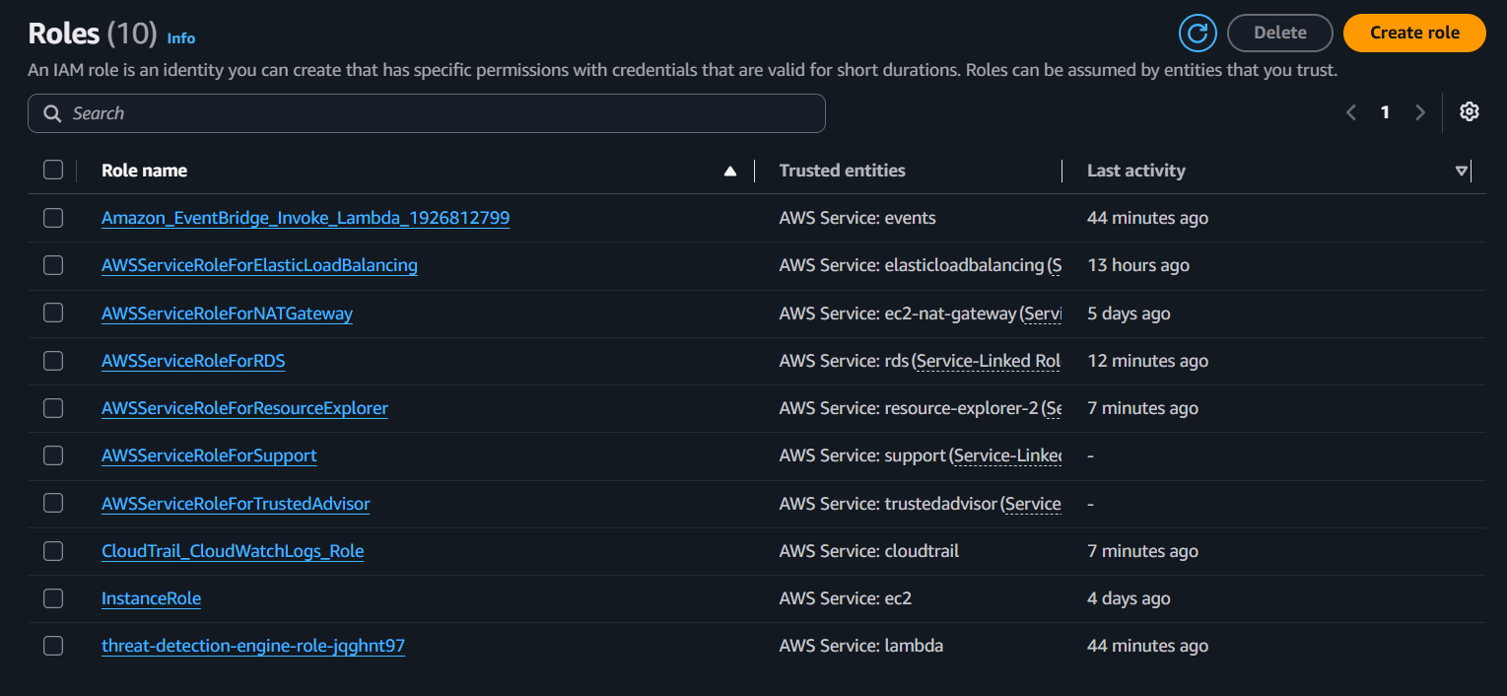
Fig: IAM Roles
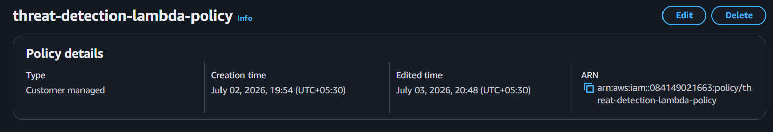
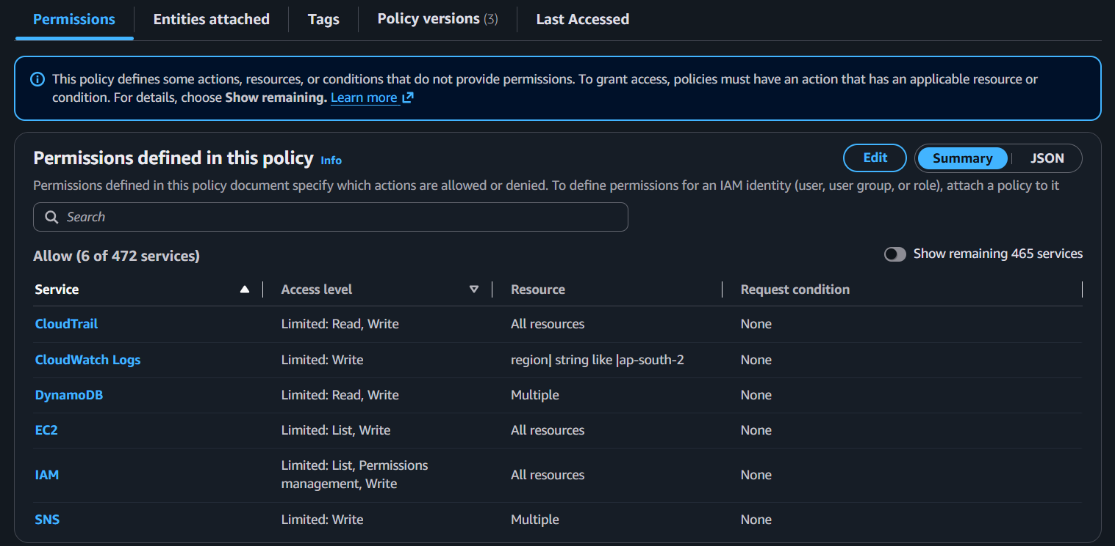
Fig: lambda Execution Policy

5. IMPLEMENTATION
The implementation of the Event-Driven Cloud Threat Detection and Automated Anomaly Alerting System Using Amazon Web Services (AWS) translates the proposed architecture into a fully functional cloud-native security monitoring solution. The implementation integrates multiple AWS managed services to automatically monitor cloud activities, detect predefined security events, and notify administrators in real time. By adopting an event-driven serverless architecture, the system eliminates manual monitoring while ensuring scalability, reliability, and minimal operational overhead.

5.1 AWS CloudTrail Configuration
The implementation begins with configuring AWS CloudTrail, which serves as the primary event source for the system. CloudTrail continuously records management API calls performed across AWS resources, including IAM operations, EC2 instance activities, security group modifications, and other administrative events.
A trail was created to capture management events across the AWS account. These recorded events are used as the input for the threat detection workflow.
Key Configuration:
- Enabled Management Events
- Recorded Read and Write API Events
- Multi-service event collection
- Continuous event logging

5.2 Amazon EventBridge Rule Configuration
Amazon EventBridge was configured to continuously monitor CloudTrail events and filter security-sensitive API activities using predefined event patterns.
Whenever a matching event is detected, EventBridge automatically invokes the AWS Lambda function for further analysis.
Key Configuration:
- Event Source: AWS CloudTrail
- Event Pattern: Selected Management Events
- Target: AWS Lambda Function
- Automatic Event Routing

5.3 AWS Lambda Implementation
AWS Lambda serves as the core processing engine of the proposed system.
Whenever EventBridge forwards a matching event, the Lambda function performs the following operations:
- Receives the CloudTrail event.
- Parses the JSON event payload.
- Extracts important event information.
- Identifies the AWS service involved.
- Determines the type of security event.
- Classifies the event severity.
- Generates a structured alert message.
- Publishes the alert to Amazon SNS.
- Records execution logs in Amazon CloudWatch.
Key Lambda Details:
- Runtime: Python 3.12
- Trigger: Amazon EventBridge
- Language: Python
- Logging: Amazon CloudWatch
- Permissions: IAM Execution Role

5.4 Real-Time Notification Using Amazon SNS
Amazon Simple Notification Service (SNS) was integrated to provide immediate notification whenever a monitored security event is detected.
The Lambda function publishes a structured security notification to an SNS topic, which delivers the alert to subscribed email recipients.
The notification includes important information such as:
- Event Name
- AWS Service
- User Identity
- AWS Region
- Event Time
- Source IP Address
- Account ID
- Severity Level
This enables administrators to quickly identify and respond to suspicious cloud activities.

5.5 IAM Roles and Security Configuration
AWS Identity and Access Management (IAM) was configured to securely manage communication between AWS services.
Dedicated IAM roles and policies were created to ensure that each AWS service receives only the permissions required to perform its specific task.
The implementation follows the Principle of Least Privilege (PoLP) to reduce security risks and prevent unnecessary access permissions.
IAM Permissions Include:
- EventBridge permission to invoke Lambda.
- Lambda permission to publish notifications to Amazon SNS.
- Lambda permission to create CloudWatch Logs.
- CloudTrail permission to generate management events.

5.6 Monitoring and Logging with Amazon CloudWatch
Amazon CloudWatch was integrated to monitor the operational health of the system and simplify troubleshooting.
CloudWatch automatically stores Lambda execution logs and provides performance metrics for monitoring system behavior.
The monitored metrics include:
- Lambda Invocation Count
- Execution Duration
- Error Count
- Success Rate
- CloudWatch Log Streams
- Function Performance Metrics
CloudWatch logs assist in debugging execution failures and verifying that security events are processed successfully.

5.7 End-to-End Event Processing Workflow
The implemented solution follows an automated event-driven workflow:
- A user performs an activity within the AWS environment.
- AWS CloudTrail records the management event.
- Amazon EventBridge evaluates the event against predefined security rules.
- If the event matches a configured rule, EventBridge invokes the AWS Lambda function.
- AWS Lambda analyzes the event and prepares a detailed security notification.
- Amazon SNS immediately sends an email alert to subscribed administrators.
- Amazon CloudWatch records execution logs and monitoring metrics for auditing and troubleshooting.
The implementation successfully demonstrates how AWS serverless services can be integrated to build a scalable, automated, and efficient cloud security monitoring system. The event-driven architecture enables near real-time threat detection, reduces manual monitoring efforts, improves incident response time, and provides a strong foundation for future enhancements such as Amazon GuardDuty integration, AWS Security Hub, centralized security dashboards, and AI-based anomaly detection.

6. RESULTS
The implementation of the Event-Driven Cloud Threat Detection and Automated Anomaly Alerting System Using Amazon Web Services (AWS) successfully achieved the objectives of automated cloud event monitoring, real-time threat detection, and immediate administrator notification. The system was tested using multiple AWS management events to evaluate its functionality, reliability, responsiveness, and overall performance. The results demonstrate that the proposed serverless architecture effectively detects predefined cloud security events and automatically generates notifications without requiring manual intervention.

6.1 Successful Event Detection
The system successfully monitored AWS management activities through AWS CloudTrail. Whenever predefined security-related events such as IAM operations, EC2 instance actions, or other monitored API activities occurred, CloudTrail recorded the event and forwarded it to Amazon EventBridge for evaluation.
Testing confirmed that all configured events were successfully captured and processed by the system.

6.2 Real-Time Threat Notifications
Amazon EventBridge successfully matched configured event patterns and automatically invoked the AWS Lambda function. The Lambda function analyzed the incoming event, extracted relevant information, generated a structured security alert, and published the notification to Amazon SNS.
Email alerts were delivered to subscribed administrators within a few seconds of the event occurrence, demonstrating the effectiveness of the real-time notification mechanism.
The alert messages included essential security information such as:
- Event Name
- AWS Service
- User Identity
- Source IP Address
- AWS Region
- Event Time
- Account ID
- Severity Level

6.3 Automated Event Processing
The complete threat detection workflow operated automatically without requiring any manual intervention.
The implemented workflow consisted of:
- CloudTrail capturing management events.
- EventBridge filtering predefined security events.
- Lambda processing the event.
- SNS delivering notifications.
- CloudWatch recording execution logs.
The event-driven architecture ensured immediate processing while minimizing operational overhead.

6.4 Secure and Controlled Service Communication
AWS Identity and Access Management (IAM) roles and policies successfully secured communication between AWS services.
The implementation followed the Principle of Least Privilege (PoLP), ensuring that:
- EventBridge could invoke only the designated Lambda function.
- Lambda had permission to publish notifications only to the configured SNS topic.
- Lambda could write execution logs only to Amazon CloudWatch.
- AWS services interacted securely without excessive permissions.
This validated that the system follows AWS security best practices.

6.5 System Monitoring and Logging
Amazon CloudWatch successfully monitored Lambda execution and maintained detailed execution logs throughout testing.
The monitoring process confirmed:
- Successful Lambda invocations.
- Event processing completion.
- Execution duration.
- Error handling.
- Log generation for every processed event.
CloudWatch logs proved valuable for debugging, validation, and operational monitoring.

6.6 System Performance
Multiple security events were generated to evaluate system responsiveness under different scenarios.
The system demonstrated:
- Reliable event detection.
- Near real-time notification delivery.
- Automatic scalability through AWS serverless services.
- Stable performance without manual infrastructure management.
The event-driven architecture successfully handled repeated event generation while maintaining consistent processing performance.

6.7 Overall Outcome
The proposed solution successfully demonstrates the practical implementation of an event-driven cloud security monitoring system using AWS serverless technologies. By integrating AWS CloudTrail, Amazon EventBridge, AWS Lambda, Amazon SNS, Amazon CloudWatch, and AWS IAM, the system provides automated event monitoring, rapid threat detection, centralized logging, and real-time administrator notifications.
The implementation significantly reduces manual monitoring effort, improves incident response time, and strengthens the overall cloud security posture. The modular design also provides a scalable foundation for future enhancements, including integration with Amazon GuardDuty, AWS Security Hub, SIEM platforms, centralized security dashboards, and AI-based anomaly detection.

7. CONCLUSION
The successful design and implementation of the Event-Driven Cloud Threat Detection and Automated Anomaly Alerting System Using Amazon Web Services (AWS) demonstrate the effectiveness of serverless, event-driven architectures in improving cloud security monitoring and incident response. By integrating AWS managed services such as AWS CloudTrail, Amazon EventBridge, AWS Lambda, Amazon Simple Notification Service (SNS), Amazon CloudWatch, and AWS Identity and Access Management (IAM), the proposed solution provides an automated, scalable, and reliable mechanism for detecting cloud security events and notifying administrators in real time.
The project successfully achieves its primary objectives by continuously monitoring AWS management activities, identifying predefined security-sensitive events, processing them through an automated serverless workflow, and delivering timely alerts without requiring manual intervention. This significantly reduces the effort involved in monitoring cloud environments, improves incident response time, and enhances the overall security posture of cloud infrastructure.
The implementation also demonstrates the advantages of adopting AWS serverless technologies, including automatic scalability, high availability, reduced operational overhead, cost efficiency, and simplified infrastructure management. The event-driven architecture ensures that computing resources are utilized only when security events occur, making the solution efficient and economical while maintaining reliable performance.
Throughout the project, emphasis was placed on secure service integration by implementing AWS Identity and Access Management (IAM) roles and policies following the Principle of Least Privilege (PoLP). Amazon CloudWatch was utilized for centralized logging and monitoring, enabling effective debugging, performance analysis, and operational visibility. Testing validated that the system successfully detected monitored events, processed them accurately, and delivered real-time notifications to administrators under various test scenarios.
The modular architecture provides an excellent foundation for future enhancements and can be extended with additional AWS security services and enterprise security solutions. Potential future improvements include:
- Integration with Amazon GuardDuty for intelligent threat detection.
- Integration with AWS Security Hub for centralized security findings.
- Support for multi-account AWS environment monitoring.
- Development of a real-time security dashboard for event visualization.
- Integration with SIEM platforms such as Splunk, Microsoft Sentinel, or IBM QRadar.
- AI and Machine Learning-based anomaly detection for advanced threat analysis.
- Multi-channel alerting through Slack, Microsoft Teams, SMS, or mobile push notifications.
- Automated incident response using AWS Systems Manager Automation or AWS Step Functions.
In conclusion, this project demonstrates how AWS event-driven and serverless technologies can be effectively combined to build a modern cloud security monitoring solution that is scalable, secure, and efficient. The proposed system provides organizations with an automated approach to monitoring cloud activities, detecting potential security threats, and accelerating incident response, making it a practical solution for modern cloud environments and a strong foundation for future cloud security automation initiatives.

