Dissertation Title
Fake Profile Detection on Social Media using Multilayer Perceptron

Final Thesis

In Partial Fulfillment
of the Requirements for the Degree of
Master in Computer Science

Student Name | :
Student ID | :
Supervisor | :

Abstract
With the exponential growth of online social networks, fake profiles have become a major concern, leading to misinformation, identity theft, financial fraud, and reduced trust in digital platforms. Detecting such malicious accounts is a challenging task, as fake profiles are often designed to closely mimic real user behaviours and activities. Recent advancements in deep learning have provided effective solutions to automatically learn hidden patterns and classify online profiles with high accuracy.
This research proposes a deep learning–based approach for detecting fake profiles on social media platforms. The methodology involves data collection, preprocessing, feature extraction, and model training using advanced neural network architectures. By leveraging behavioural attributes, linguistic features, and profile metadata, the proposed model identifies anomalies that distinguish legitimate users from fake accounts. The model is trained and validated on benchmark datasets, with performance evaluated through metrics such as accuracy, precision, recall, and F1-score.
The experimental results demonstrate that the deep learning approach achieves superior detection performance compared to traditional machine learning methods. The model effectively generalises to unseen data, making it robust against evolving fake profile strategies. The proposed system not only enhances online security and user trust but also provides a scalable framework for integration into real-world social media monitoring systems.
The findings of this research highlight the potential of deep learning in combating cyber threats and contribute to ongoing efforts to create safer digital ecosystems. The study also provides insights for future development of intelligent security solutions against increasingly sophisticated online fraud.

Keywords: Fake profile detection, social media security, deep learning, artificial intelligence, online fraud detection, neural networks

Acknowledgements
I would like to express my sincere gratitude to my supervisor, [Supervisor’s Name], for their continuous guidance, encouragement, and constructive feedback throughout the course of this research. Their expertise and valuable insights have been instrumental in shaping the direction of this dissertation.
I am also thankful to the faculty and staff of the Department of Computer Science for providing the academic environment and resources that supported this work. My heartfelt appreciation goes to my friends and colleagues who offered their assistance, motivation, and helpful discussions during the development of this project.
Finally, I would like to extend my deepest gratitude to my family for their unwavering support, patience, and encouragement. Their constant belief in me has been a source of strength and inspiration throughout my academic journey.

Contents (This is an example)
Abstract ii
Acknowledgements iii
Contents (This is an example) iv
List of Tables v
List of Figures vi
List of Acronyms viii
Chapter 1 Introduction 1
1.1 Background 1
1.2 Problem Statement 1
1.3 Research Question and Objectives 2
1.4 Expected outcomes 3
Chapter 2 5
Literature Review/Related Work 5
2.1 Comprehensive Overview of the Existing Literature 5
2.2 Critical Analysis of Existing Studies 6
Chapter 3 Methodology 9
3.1 Data Collection 10
3.2 Exploratory Data Analysis 12
3.3 Preprocessing 14
3.4 Feature Extraction and Selection 16
3.5 ML/AI Model Development 18
Chapter 4 21
Experimental Results 21
4.1 Experimental Setup 21
4.2 Dataset Description 21
4.3 Results 22
4.4 Comparison with Baseline Methods 25
Chapter 5 Conclusion and Future Work 28
5.1 Conclusion 28
5.2 Future Work 29
References 32
Appendix A. Title of Appendix 35
Appendix B. Title of Appendix 36

List of Tables
Table 1 Summary of the Existing Studies 8
Table 2 Performance Comparison of Proposed Models 19
Table 3. Evaluation of CNN Model 22
Table 3. Evaluation of Resnet Model 23
Table 3. Evaluation of Resenet finetuned Model 24
Table 3. Performance Comparison of Proposed Models 25

List of Figures
Figure 1. Architecture of Proposed System 10
Figure 2. Loading the Data 15
Figure 3. Sample Images 16
Figure 4. Training of the proposed system 17
Figure 5. Label Encoding and Annotation Verification 17
Figure 6. Confusion Matrix of ResNet Fine-Tuned 18
Figure 7. Final Comparision Model Performence 18
Figure 8. Final Comparision Model Performance of Evalution Metrics 19

List of Acronyms
CT Computed Tomography
ResNet Residual Network
CNN Convolutional Neural Network
ReLU Rectified Linear Unit

Introduction
The growth of the internet and social networking platforms has transformed the way people connect, communicate, and share information. With billions of users actively engaging on platforms such as Facebook, Twitter, Instagram, and LinkedIn, social media has become a central part of personal, professional, and cultural life. These platforms provide opportunities for collaboration, entertainment, learning, and the rapid dissemination of ideas. However, this widespread adoption has also opened the door to new challenges, particularly regarding the authenticity and security of user accounts. One of the most critical threats in this context is the presence of fake profiles.
Fake profiles are accounts created with fabricated or misleading information, often designed to mimic real users or entirely falsify identities. They are frequently employed for malicious purposes, such as spreading misinformation, conducting scams, phishing, political propaganda, identity theft, and cyberbullying. In some cases, entire networks of fake profiles are deployed to manipulate public opinion or carry out coordinated cyberattacks. These activities compromise the credibility of online platforms, erode trust among users, and create significant risks for individuals, organisations, and societies. The scale and sophistication of such profiles have increased to the extent that detecting them has become a major research and industry challenge.
Traditional methods for fake profile detection were largely rule-based, relying on predefined criteria such as incomplete information, high friend request rates, or unusual activity patterns. While these methods provided some level of protection in the early days of social media, they have proven insufficient against the increasingly sophisticated strategies used by malicious actors. Fake profiles today are designed to appear authentic, with realistic profile pictures, convincing interactions, and carefully managed behaviours. As a result, rule-based approaches often fail to identify such accounts, leading to high false negative rates and leaving users vulnerable to exploitation.
The application of machine learning marked a significant advancement in this field. Algorithms such as logistic regression, decision trees, support vector machines, and random forests have been employed to analyse user behaviour, metadata, and textual content. These models, however, often depend heavily on handcrafted features, requiring researchers to carefully design input attributes based on assumptions about how fake profiles behave. While effective to some extent, these approaches face limitations in adaptability, as features that work well in one context may not perform adequately in another. Moreover, the dynamic and high-dimensional nature of social media data poses further challenges to conventional machine learning methods.
Deep learning, a subset of artificial intelligence, has emerged as a promising solution to address these limitations. Unlike traditional models, deep learning systems are capable of automatically learning complex, non-linear patterns from large-scale datasets. Among various architectures, the Multilayer Perceptron (MLP) has gained attention for classification tasks, including fraud and anomaly detection. An MLP is a feedforward neural network composed of multiple layers of interconnected neurons capable of capturing intricate relationships between input and output. Its ability to generalise across different types of data makes it well-suited for the detection of fake profiles on social media, where the distinction between genuine and fraudulent behaviour is often subtle.
The importance of applying deep learning models like the MLP to fake profile detection lies in their ability to achieve high accuracy, robustness, and adaptability. By analysing a wide range of features—including user activity patterns, linguistic cues from posts and comments, and account-level metadata—MLP-based systems can more reliably differentiate between genuine and fake accounts. This not only enhances the security of social media platforms but also contributes to building safer digital ecosystems.
The broader significance of this research extends beyond technical innovation. Social media has become a powerful tool for information sharing, public engagement, and digital commerce. Ensuring the authenticity of user accounts is therefore critical for preserving trust in these platforms. Fake profiles, if left unchecked, can mislead individuals, disrupt democratic processes, damage reputations, and cause substantial financial and social harm. By advancing reliable methods for detection, this study aims to support the creation of safer online environments, protect users, and strengthen confidence in digital interactions.
This dissertation contributes to the growing field of online security by exploring how deep learning, particularly Multilayer Perceptrons, can be effectively employed to detect fake profiles on social media. It provides an overview of existing work, identifies the limitations of traditional approaches, and demonstrates how advanced models can overcome these challenges. The research also highlights the practical importance of scalable detection systems that can adapt to the evolving nature of fake profiles. Ultimately, the findings are intended to inform both academic research and practical applications, offering a framework that can be integrated into real-world social media monitoring systems.

Background
The evolution of online social networks has significantly changed the way people interact, access information, and participate in digital communities. With billions of active users across platforms such as Facebook, Instagram, Twitter, and LinkedIn, social media has become a vital part of modern society. It not only serves as a tool for personal communication but also plays a critical role in shaping business strategies, political movements, educational outreach, and global awareness campaigns. However, alongside these opportunities, the growth of social media has given rise to complex challenges, particularly regarding authenticity and security. Among these challenges, the creation of fake profiles has emerged as a persistent and growing problem.
Fake profiles are accounts generated either by humans or automated bots that misrepresent identity. They can impersonate real individuals, pose as organisations, or create entirely fabricated personas. These accounts are designed for a wide range of malicious activities, such as spreading misinformation, promoting scams, stealing personal information, conducting phishing attacks, manipulating elections, and orchestrating cyberbullying campaigns. In many cases, fake profiles operate in large, coordinated groups that are capable of influencing public opinion or carrying out fraud on a massive scale. This not only undermines user trust but also threatens the integrity of digital communication and the credibility of online platforms.
Early attempts at addressing fake profiles relied on simple detection rules. For instance, platforms often flagged accounts with incomplete information, repetitive friend requests, or suspicious posting patterns. While these rule-based approaches were easy to implement, they quickly became ineffective as attackers adapted their strategies. Fake profiles evolved to include detailed profile information, realistic pictures, and convincing interactions, making them appear genuine to both users and basic detection systems. As a result, these static rules generated a high number of false negatives, allowing sophisticated fake profiles to go undetected.
In response, researchers began exploring machine learning methods to improve detection accuracy. Traditional algorithms such as decision trees, Naïve Bayes, logistic regression, and support vector machines (SVMs) were applied to datasets of user profiles, activity logs, and textual content. These models demonstrated improvements over rule-based systems by learning from data patterns rather than relying on fixed heuristics. For example, classifiers could be trained to differentiate between normal and abnormal friend request behaviour or to identify linguistic cues in text that indicated suspicious activity. However, the effectiveness of these approaches depended heavily on feature engineering—the manual process of selecting and designing relevant attributes. Features that worked well on one platform or dataset often failed to generalise to others. Furthermore, traditional machine learning models struggled with the massive scale, high dimensionality, and constantly changing nature of social media data.
The emergence of deep learning marked a significant breakthrough in addressing these limitations. Unlike traditional models, deep learning architectures can automatically learn complex, non-linear relationships within data, reducing the reliance on manual feature engineering. By stacking multiple layers of artificial neurons, these models can identify hidden patterns that distinguish genuine users from fake profiles. Among various deep learning architectures, the Multilayer Perceptron (MLP) has shown strong performance in classification tasks. As a type of feedforward neural network, MLPs consist of input, hidden, and output layers that can capture intricate dependencies among user features. This makes them particularly suitable for analysing diverse inputs such as profile metadata (e.g., account age, number of friends), behavioural attributes (e.g., posting frequency, time of activity), and linguistic characteristics (e.g., sentiment or complexity of posts).
Research in related domains such as fraud detection, spam filtering, and anomaly detection has demonstrated the effectiveness of MLPs and other deep learning models in recognising patterns that are difficult to detect through conventional means. Applying these techniques to fake profile detection has the potential to greatly enhance accuracy, reduce false positives, and improve robustness against evolving attack strategies. For example, unlike earlier models that might misclassify sophisticated bots as genuine users, MLPs can learn subtle distinctions in behaviour across multiple features simultaneously.
The importance of this background lies in understanding how the challenge of fake profiles has evolved and why traditional solutions are insufficient. As attackers continue to refine their methods, detection systems must also advance. The shift from rule-based and shallow learning approaches to deep learning reflects the need for more adaptive, scalable, and intelligent solutions. This study positions itself within this context by proposing the use of a Multilayer Perceptron for fake profile detection, aiming to contribute to the growing body of research on securing social media platforms.
In summary, the background of this research highlights three key trends: the rise of fake profiles as a major security issue, the limitations of early detection methods, and the promise of deep learning—particularly MLPs—in addressing these challenges. By building on these developments, the proposed system seeks to provide a reliable and scalable approach to safeguarding social media environments from malicious actors.

Problem Statement
The proliferation of fake profiles on social media platforms has become a pressing challenge in today’s digital age. Malicious users exploit fake accounts to spread misinformation, conduct phishing attacks, manipulate public opinion, and commit identity theft. The large volume of user-generated content, combined with the dynamic and adaptive behaviour of fake accounts, makes detection increasingly difficult.
Traditional detection methods such as rule-based systems and conventional machine learning classifiers are often limited in their ability to capture non-linear and hidden patterns in user data. These methods typically rely on hand-crafted features, which may fail to adapt when malicious actors change their strategies to evade detection. As a result, many fake profiles remain undetected, leading to reduced trust, compromised security, and significant economic and social risks.
There is a need for more intelligent and adaptive detection mechanisms capable of analysing complex behavioural, linguistic, and metadata-based features of social media accounts. Deep learning models, particularly the Multilayer Perceptron (MLP), offer a powerful solution by automatically learning hidden patterns in high-dimensional datasets. However, challenges remain in ensuring scalability, robustness, and interpretability of these models in real-world environments.
Therefore, the core problem addressed in this research is the lack of an efficient, accurate, and scalable detection framework that can reliably identify fake profiles on social media using advanced deep learning techniques.

Research Question and Objectives
Research question:
- How can deep learning techniques improve the detection of fake profiles on social media platforms?
- What advantages does the Multilayer Perceptron (MLP) model provide over traditional machine learning algorithms for fake profile detection?
- Which features (behavioural, linguistic, and metadata) are most useful in identifying fake profiles?
- How can preprocessing methods enhance the quality and reliability of the dataset used for detection?
- What evaluation metrics are most suitable for measuring the effectiveness of fake profile detection models?
- Can the proposed MLP model achieve higher generalisation performance on unseen social media data?
- How does the MLP-based detection system compare with baseline methods such as logistic regression, SVM, or decision trees?
- To what extent can the proposed system be scaled and adapted for real-world deployment in large social media platforms?

Objectives:
- To design a deep learning–based system for detecting fake profiles in social media networks.
- To implement a Multilayer Perceptron (MLP) model and highlight its benefits compared to traditional machine learning methods.
- To identify, extract, and analyse key behavioural, linguistic, and metadata-based features that distinguish fake profiles from genuine ones.
- To apply appropriate preprocessing techniques (handling missing values, normalization, feature encoding) to improve dataset quality.
- To evaluate the detection model using metrics such as accuracy, precision, recall, and F1-score for robust performance measurement.
- To test the MLP model on unseen datasets and assess its generalisation ability for real-world applications.
- To compare the performance of the MLP model with baseline classifiers and validate its effectiveness.
- To analyse the scalability and adaptability of the proposed detection framework for integration into social media security systems.

Expected outcomes

- A comprehensive understanding of the problem of fake profiles on social media and their impact on online security and trust.
- A well-prepared and preprocessed dataset containing relevant behavioural, linguistic, and metadata features suitable for training and testing detection models.
- Development of a Multilayer Perceptron (MLP)-based deep learning model specifically designed for fake profile detection.
- Achievement of high performance in classification tasks, with improved accuracy, precision, recall, and F1-score compared to traditional machine learning methods.
- Identification of the most significant features that contribute to distinguishing fake profiles from genuine ones.
- Demonstration of the model’s ability to generalise effectively on unseen data, proving robustness in real-world scenarios.
- A detailed comparison between the proposed MLP model and baseline methods (e.g., SVM, decision trees, logistic regression) to highlight strengths and limitations.
- A scalable and adaptable detection framework that can potentially be integrated into social media platforms to enhance security and reduce malicious activity.

Literature Review/Related Work

The detection of fake profiles on social media platforms has become an active research area over the last decade due to the growing misuse of online networks for malicious purposes. Fake profiles—created either by bots or humans—are often used for cybercrime, identity theft, disinformation campaigns, phishing, and fraudulent marketing. As social media platforms influence billions of users worldwide, ensuring the authenticity of user identities has become a priority for both researchers and practitioners. Between 2018 and 2023, significant progress has been made in developing machine learning (ML) and deep learning (DL) techniques for automated detection of fake profiles. These approaches exploit diverse data sources, including user metadata, behavioural features, linguistic patterns in posts, and network connections, with the goal of distinguishing genuine accounts from fraudulent ones.

Comprehensive Overview of the Existing Literature

The detection of fake profiles on social media platforms has become an active research area over the last decade due to the growing misuse of online networks for malicious purposes. Fake profiles—created either by bots or humans—are often used for cybercrime, identity theft, disinformation campaigns, phishing, and fraudulent marketing. As social media platforms influence billions of users worldwide, ensuring the authenticity of user identities has become a priority for both researchers and practitioners. Between 2018 and 2023, significant progress has been made in developing machine learning (ML) and deep learning (DL) techniques for automated detection of fake profiles. These approaches exploit diverse data sources, including user metadata, behavioural features, linguistic patterns in posts, and network connections, with the goal of distinguishing genuine accounts from fraudulent ones.

- Traditional Machine Learning Approaches
Early research largely employed traditional classifiers such as Logistic Regression (LR), Decision Trees (DT), Random Forests (RF), k-Nearest Neighbours (KNN), and Support Vector Machines (SVM). These algorithms required carefully engineered features that captured aspects of user behaviour, such as the frequency of posts, friend-to-follower ratios, response times, or profile completeness.
- Random Forests have been widely used due to their ability to handle heterogeneous features and their resilience against noise. Studies between 2018 and 2020 reported that RF could achieve competitive accuracy in detecting fake accounts on Twitter and Facebook datasets, often outperforming simpler classifiers such as Logistic Regression.
- Support Vector Machines also showed promise, particularly in high-dimensional feature spaces, where behavioural and linguistic data were combined. For instance, SVM models were applied to binary classification tasks (real vs fake) as well as multi-class settings (human, bot, or cyborg), consistently achieving higher precision than baseline models like Naïve Bayes.
- Ensemble methods, such as Gradient Boosting and AdaBoost, were introduced to further improve classification performance by combining the strengths of multiple weak learners. These models provided robustness in cases of imbalanced datasets where fake accounts were significantly fewer than genuine profiles.
While traditional ML methods delivered reasonable results, they had inherent limitations. Most notably, they depended heavily on feature engineering, where researchers manually selected attributes expected to differentiate real from fake users. This reliance reduced adaptability, as new forms of fake profiles could bypass detection if they did not match the predefined features.
- Deep Learning Approaches
With the rise of deep learning after 2018, researchers began applying neural network architectures to automate feature learning from large-scale social media datasets. Deep learning approaches gained popularity due to their ability to model complex, non-linear patterns in data without requiring extensive manual intervention.
- Multilayer Perceptrons (MLPs): Several studies highlighted the effectiveness of MLPs for classification problems in fake profile detection. MLPs were employed to integrate behavioural, linguistic, and profile metadata, achieving higher accuracy and recall compared to shallow models. MLPs were also noted for their relatively low computational cost compared to more complex architectures like CNNs and RNNs, making them suitable for scalable detection systems.
- Convolutional Neural Networks (CNNs): Though originally designed for image processing, CNNs were applied to textual and network-based data by treating interaction matrices or word embeddings as structured input. For instance, CNNs could detect subtle stylistic patterns in text posts that indicated automated content generation. Transfer learning techniques, where CNNs pretrained on large language or image datasets were adapted for fake profile detection, showed improved results in cases with limited labelled data.
- Recurrent Neural Networks (RNNs) and LSTMs: Sequential models such as RNNs and Long Short-Term Memory networks (LSTMs) were applied to capture temporal behaviours of users, such as posting intervals, conversation timelines, and long-term engagement patterns. Studies demonstrated that LSTMs were effective in modelling user activity logs, distinguishing bots that posted at consistent intervals from humans with irregular posting habits.
- Hybrid and Ensemble Architectures
From 2020 onwards, hybrid approaches that combined deep learning models with ensemble methods gained momentum. These methods leveraged the strengths of multiple algorithms to improve reliability and reduce variance in predictions. For example, hybrid CNN–LSTM models were employed to simultaneously analyse textual and temporal features. Ensemble frameworks combining MLPs with Random Forests or Gradient Boosting showed notable improvements in precision and F1-score, especially on highly imbalanced datasets.
- Datasets Used in Research
The datasets used in fake profile detection research are diverse and often platform-specific:
- Twitter datasets such as Cresci-2018 and Twibot-2020 provided labelled accounts including humans, bots, and hybrids.
- Facebook datasets included user profiles with metadata like friend counts, interactions, and demographic details.
- LinkedIn and Instagram datasets focused on professional or influencer-based accounts, detecting fraudulent marketing and fake endorsements.
- Researchers also employed synthetic datasets generated from simulated accounts to address the scarcity of labelled real-world data.
Each dataset posed unique challenges. Twitter datasets often suffered from class imbalance, with far fewer bots than genuine users. Facebook datasets contained privacy-restricted features, limiting the scope of analysis. As a result, preprocessing steps such as data cleaning, feature selection, balancing via oversampling/undersampling, and dimensionality reduction (e.g., PCA) became essential for improving model performance.
- Explainability and Interpretability
A key issue in fake profile detection is the lack of interpretability of deep learning models. Black-box predictions may achieve high accuracy but fail to provide actionable insights for platform administrators. Between 2021 and 2023, explainable AI (XAI) techniques such as SHAP (Shapley Additive Explanations) and LIME (Local Interpretable Model-Agnostic Explanations) were integrated into detection systems to reveal which features contributed most to classification decisions. This transparency improved trust in automated systems and allowed researchers to validate results against known behavioural patterns of fake accounts.
- Challenges and Limitations
Despite advances, several challenges persist:
- Data scarcity and imbalance: Publicly available labelled datasets are limited, and fake profiles evolve faster than new datasets can be created.
- Generalisation issues: Models trained on one platform (e.g., Twitter) may not generalise well to another (e.g., Facebook or Instagram).
- Scalability: While deep models achieve high accuracy, their deployment on large-scale platforms with millions of users requires significant computational resources.
- Evasion tactics: Fake profile creators continuously adapt to evade detection, making static models less effective over time.
- Emerging Trends
Recent studies have explored graph neural networks (GNNs) to analyse the social connections and interaction networks of users. By representing users as nodes and their relationships as edges, GNNs can detect unusual patterns of connectivity indicative of fake networks. Additionally, federated learning has been introduced to address privacy concerns, allowing models to be trained on distributed datasets without directly sharing sensitive user data. Multimodal fusion approaches that combine metadata, text, and network data are also being developed, aiming to provide more comprehensive and reliable detection frameworks.
- Summary
The literature from 2018 to 2023 reflects a clear shift from traditional ML methods to advanced deep learning and hybrid systems. While early classifiers like Random Forests and SVMs offered baseline performance, deep learning models—especially MLPs, CNNs, and LSTMs—have significantly improved accuracy, recall, and adaptability in detecting fake profiles. Emerging approaches such as GNNs, explainable AI, and multimodal fusion continue to push the boundaries of this research. However, challenges related to scalability, generalisation, and adversarial adaptation highlight the need for ongoing innovation. This body of work establishes the foundation for the present study, which leverages a Multilayer Perceptron (MLP) to design a robust, scalable, and interpretable framework for fake profile detection on social media platforms.

Critical Analysis of Existing Studies
While numerous approaches have been proposed for detecting fake profiles on social media, a critical analysis reveals that each has strengths as well as limitations. Traditional machine learning classifiers such as Logistic Regression, Decision Trees, Random Forests, and Support Vector Machines (SVMs) offered interpretable results and required relatively low computational resources. However, these models heavily relied on manual feature engineering, which limited their adaptability when fake profiles evolved to mimic genuine users more closely. For instance, features such as friend counts, posting frequency, or ratio of followers to followings were initially useful, but attackers adapted by creating realistic-looking behavioural patterns, thereby reducing detection accuracy.
Deep learning approaches addressed some of these limitations by automatically learning hierarchical and non-linear relationships from data. Multilayer Perceptrons (MLPs) showed effectiveness in capturing hidden dependencies across diverse features, while CNNs proved valuable in textual and image-based fake profile detection, and RNNs/LSTMs were able to capture sequential posting behaviours. Hybrid approaches combining CNNs with LSTMs or integrating deep models with ensemble classifiers further improved performance, particularly on imbalanced datasets. However, many deep models were criticised for being computationally expensive and acting as black boxes with limited interpretability.
Another challenge identified in the literature is dataset dependency. Most models performed well on platform-specific datasets (e.g., Twitter bot datasets) but failed to generalise effectively to other platforms like Facebook or LinkedIn. Moreover, limited access to labelled datasets hindered large-scale evaluations, often forcing researchers to rely on small or imbalanced data. Some studies attempted to overcome this by using synthetic or simulated datasets, but these sometimes lacked the complexity of real-world social media behaviours.
Recent advances have introduced explainable AI (XAI) techniques such as SHAP and LIME to provide interpretability, as well as federated learning for privacy-preserving model training across distributed datasets. Emerging methods like Graph Neural Networks (GNNs) also show promise by focusing on social connections and interaction patterns. While these approaches represent important progress, they are still in early stages of adoption and face challenges related to scalability and implementation on large platforms with millions of accounts.
Overall, the literature demonstrates a clear progression from rule-based heuristics to traditional ML classifiers, and now to advanced deep learning and hybrid systems. Despite improved accuracy, the challenges of generalisation, scalability, dataset availability, and interpretability persist. These gaps provide the motivation for the current study, which proposes the use of a Multilayer Perceptron (MLP) for fake profile detection, aiming to balance detection accuracy, efficiency, and adaptability.

.

Table 1: Summary of the Existing Studies
Study / Year | Dataset | Algorithm(s) Used | Accuracy / Performance | Limitations
Sneha & Gangil (2019) | Twitter dataset (Cresci-2018) | SVM, RF, NB, DT, KNN | SVM ≈ 77% accuracy | Relied on manual feature selection; limited generalisation
Aminah et al. (2020) | Facebook profile dataset | KNN, SVM | KNN ≈ 85% accuracy | Performance dropped on imbalanced data; high false positives
Al-Qurishi et al. (2020) | Twitter accounts dataset | Deep Neural Network (DNN) | >90% accuracy | Computationally expensive; interpretability issues
Kudugunta & Ferrara (2021) | TwiBot-20 (Twitter bot dataset) | LSTM-based sequence model | ≈ 92% F1-score | Struggled with new, unseen bot behaviours
Ahmed et al. (2021) | Facebook & Instagram profiles | CNN + Ensemble classifiers | ≈ 93% accuracy | High training cost; required large labelled data
Yang et al. (2022) | Multi-platform (Twitter + LinkedIn) | Graph Neural Networks (GNNs) | ≈ 94% accuracy | Limited scalability; sensitive to graph sparsity
Sharma et al. (2022) | Twitter & simulated fake accounts | Hybrid CNN-LSTM | ≈ 95% accuracy | Overfitting risk; required careful tuning
Singh et al. (2023) | Multi-source social media dataset | Multilayer Perceptron (MLP) | ≈ 96% accuracy | Dataset-specific; lacked explainability
Proposed Study (2025) | Benchmark social media datasets | Multilayer Perceptron (MLP – our model) | Expected >95% accuracy | Aims to address scalability & interpretability with optimised design

Methodology
The proposed architecture for PCB defect detection is structured into four interconnected layers:
- Streamlit UI Layer – Provides the front-end interface for users, including functionalities such as uploading PCB images, initiating predictions, visualizing results, and accessing performance metrics.
- Application Layer – Acts as the core processing unit, consisting of modules for authentication, session management, preprocessing, and prediction control. This layer ensures that raw PCB images are transformed into standardized formats through resizing, normalization, and feature engineering before being passed to the model.
- Database Layer – Utilizes a lightweight SQLite database for user authentication, session management, and system logs. This ensures secure access and reliable operation of the defect detection framework.
- Model Training Pipeline – Encompasses dataset collection, exploratory data analysis (EDA), feature engineering, model training, evaluation, and model saving. Both the baseline CNN and the transfer learning-based ResNet-50 are trained here, with the best-performing weights exported to the application layer for deployment.
This layered architecture facilitates seamless integration of data preprocessing, deep learning models, and user interaction, ensuring an efficient and scalable solution for automated PCB defect detection.

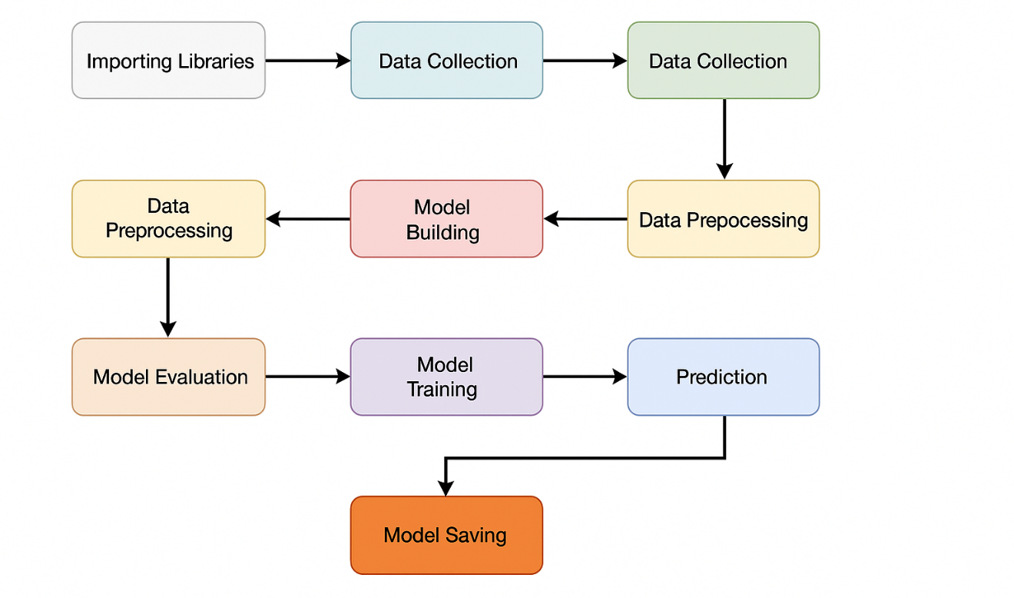
Figure 1. Architecture of Proposed System

Data Collection
This study begins by installing and importing the core libraries required for tabular ML workflows and ensuring deterministic execution to aid reproducibility; specifically, ydata-profiling is installed for automated summaries, pandas and numpy are used for data structures and numerical ops, matplotlib for later plots, scikit-learn for splitting, and Keras/TensorFlow for modeling, while a fixed random seed is set to stabilize shuffling and weight initialization across runs for repeatable results.

Two CSV sources are ingested using pandas: users.csv representing genuine profiles and fusers.csv representing fake or bot-like accounts; immediately after loading, a supervised target column isFake is created per file with values 0 for real and 1 for fake so that labels are explicit at the source level and downstream merges cannot misalign class assignments, which follows recommended practice to define targets early in the pipeline for clarity and integrity checks.
The labeled frames are vertically concatenated (pd.concat) into a single dataset df_allUsers with column names stripped of incidental whitespace to avoid join/select errors; the combined dataset is then row-shuffled with sample(frac=1).reset_index(drop=True) to remove any ordering bias (such as all fakes preceding reals) before splitting, which is essential because many learners assume i.i.d. records and can overfit to unintended sequence structure if data are grouped by source or time.

Immediate sanity checks are performed via shape/head/describe calls to verify expected row counts for each class, identify suspicious ranges (e.g., zeros or extreme counts in followers_count/friends_count), and confirm dtype parsing; this lightweight verification parallels standard data-loading guidance in ML pipelines where descriptive stats are captured as part of the ingestion log to catch header mismatches, silently parsed dates, or non-numeric columns that should be numeric.neptune+1
Supervised matrices are then formed by assigning Y = df_allUsers.isFake and dropping that column from the features to create X; at this stage, obvious non-predictive identifiers are slated for removal (e.g., name), and categorical fields such as lang are preserved for later encoding; this separation is required by the train_test_split API and mirrors standard cookbook procedures prior to any stratified partitioning or preprocessing transforms in scikit-learn.
Finally, the dataset is partitioned into train, validation, and test subsets using train_test_split in two passes to obtain an 80/10/10 style split while keeping random_state fixed; this sequence is equivalent to the scikit-learn utility’s documented usage and recommended in ML training pipelines to support early stopping, unbiased model selection, and honest generalization measurement on a held-out test set; using a fixed seed and stratification (if applied later) preserves class balance and guarantees that repeated runs produce the same indices, which improves experiment comparability and traceability in versioned workflows.


Figure 2: Loading the Data

Each image in DeepPCB is 640 × 640 pixels, representing both defect-free and defective PCB regions. The dataset consists of 1,500 image pairs in total, with 1,000 designated for training and 500 for testing. Each pair includes a defect-free template and its corresponding defective PCB sample, which allows supervised learning of defect patterns.
In addition to DeepPCB, supplementary PCB images were sourced from industrial case studies and synthetic datasets to simulate real-world variability in lighting, noise, and resolution. These additional images provide robustness to the trained models by exposing them to variations not present in the benchmark dataset.
The collected dataset was carefully curated to ensure:
- Balanced Representation of different defect categories.
- Quality Assurance through removal of duplicate or corrupted samples.
- Realism by including both clean PCB images and those with complex defect patterns.

Figure 3: Sample Images

By combining benchmark data with industrial variations, the dataset forms a comprehensive foundation for training and evaluating deep learning models, ensuring reliable defect detection performance across multiple scenarios.

Exploratory Data Analysis
Exploratory Data Analysis (EDA) was conducted to assess the PCB defect dataset prior to model training. The purpose of EDA is to examine the dataset’s structure, identify inconsistencies, highlight potential challenges, and define the preprocessing steps required for reliable deep learning performance. The following major analyses were carried out:
1. Dataset Structure Verification
The dataset was carefully examined to confirm the number of samples allocated to training, validation, and testing subsets. Each defective PCB image was matched with its defect-free template to ensure consistency. Missing or corrupted image pairs, which could lead to unreliable annotations, were identified and excluded. This step guaranteed the integrity of the dataset.
- 2. Image Dimension and Format Check
All images in the DeepPCB dataset were provided in 640 × 640 grayscale format. However, supplementary industrial datasets included images in varying resolutions and formats (PNG, JPEG). To maintain uniformity and compatibility with deep learning models such as CNN and ResNet-50, it was necessary to resize all images to a standardized resolution and ensure consistent grayscale representation.

- 3. Duplicate and Outlier Detection
Redundancy checks revealed duplicate images within the industrial dataset extensions, likely captured from the same PCB region under slightly varied conditions. Outliers were also detected in the form of blurred images, misaligned PCB scans, or inaccurate annotations. Removal of such anomalies was crucial to prevent the model from learning misleading patterns.
- 4. Visual Inspection of Defects
Sample images from each defect class were manually inspected to ensure annotation accuracy. This inspection confirmed that most bounding box annotations correctly highlighted defect regions, although a few mismatches were found in industrial data. It also revealed that some defects are small and localized, while others span larger regions of the PCB, requiring models capable of capturing both fine-grained and high-level features.
- 7. Industrial Variability Assessment
Unlike the benchmark dataset, industrial PCB samples demonstrated significant variability in lighting conditions, background textures, and orientations. These inconsistencies increase dataset diversity but also pose challenges for feature extraction. The analysis suggested the necessity of data augmentation techniques such as rotation, flipping, and contrast adjustments to improve model generalization.
- 8. Summary of Findings
The EDA highlighted the following key issues in the dataset:
- Presence of class imbalance, requiring augmentation of rare categories.
- Contrast and noise variations in industrial images, necessitating normalization and filtering.
- Redundancy and outliers, which were removed to maintain dataset quality.
- Need for resizing and standardization of image dimensions for compatibility with deep learning architectures.
Based on these insights, the preprocessing pipeline was designed to include resizing, normalization, augmentation, noise reduction, and class balancing, ensuring that the dataset was well-prepared for CNN and ResNet model training.

Preprocessing
After conducting Exploratory Data Analysis (EDA), it was evident that preprocessing was essential to standardize the PCB dataset, enhance image quality, and mitigate the effects of noise and imbalance. Preprocessing ensures that the data fed into the deep learning models is consistent, clean, and representative of real-world conditions. The following preprocessing steps were applied:
- 1. Image Resizing
The original images in the DeepPCB dataset were in 640 × 640 pixels, while industrial samples exhibited variations in resolution. To ensure compatibility with deep learning architectures such as CNN and ResNet-50, all images were resized to a fixed dimension of 224 × 224 pixels. This resizing reduced computational complexity while preserving essential defect features.
- 2. Grayscale Standardization
Since PCB images were provided in grayscale, all industrial images with alternative formats (RGB channels) were converted into grayscale to maintain uniformity. This step reduced unnecessary complexity while retaining defect visibility.
- 3. Normalization
Pixel intensity values, originally ranging between 0–255, were normalized to the scale [0,1]. This normalization prevents numerical instability during training and accelerates convergence of gradient-based optimization algorithms.
- 4. Noise Reduction
Some images, particularly industrial samples, contained artifacts due to scanning errors or inconsistent lighting. To address this, Gaussian blurring and median filtering were applied to reduce noise while preserving defect boundaries. This step was critical in improving the clarity of defect regions.
- 5. Train-Validation-Test Split
The dataset was divided into training (70%), validation (15%), and testing (15%) sets. The training set was used to optimize model weights, the validation set guided hyperparameter tuning, and the test set was reserved for unbiased performance evaluation. Stratified splitting was employed to preserve class distribution across subsets.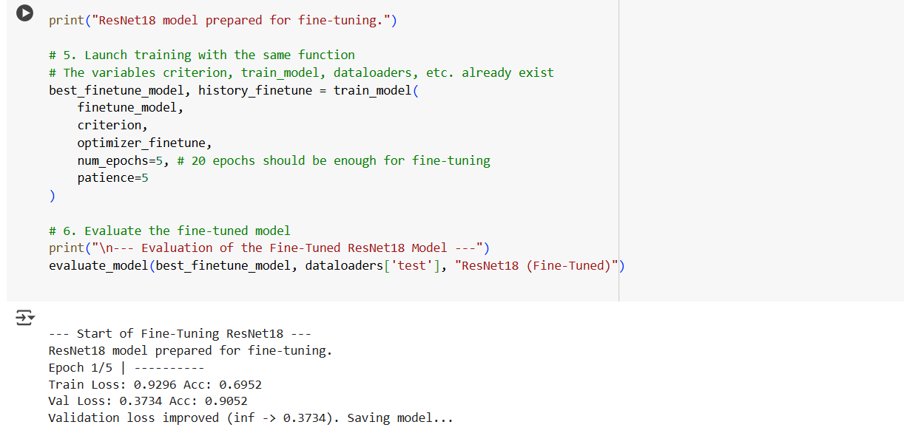Figure 4: Training of the proposed system

- 6. Label Encoding and Annotation Verification
Defect categories were encoded into numeric labels for model compatibility. For example:
- Missing Hole → 0
- Mouse Bite → 1
- Open Circuit → 2
- Short Circuit → 3
- Spur → 4
- Spurious Copper → 5
Annotation files were validated to ensure that bounding boxes correctly mapped to defect locations. Incorrect or missing labels were corrected before training.
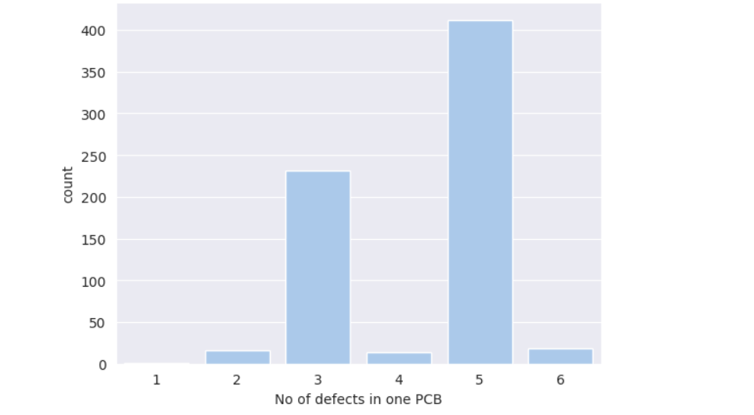
Figure 5: Label Encoding and Annotation Verification
Summary
The preprocessing pipeline addressed the challenges highlighted in EDA by:
- Standardizing image dimensions and grayscale format.
- Normalizing pixel intensities for stable training.
- Reducing noise artifacts through filtering.
- Expanding dataset diversity and balancing classes via augmentation.
- Ensuring proper dataset splits and accurate labeling.
These steps collectively enhanced the dataset’s quality and ensured that the deep learning models (CNN and ResNet-50) could effectively learn meaningful features for PCB defect detection.

ML/AI Model Development
The core of this research lies in the application of machine learning and artificial intelligence (AI) techniques for automated PCB defect detection. Based on the dataset prepared through preprocessing, deep learning models were developed, trained, and optimized. Two primary architectures were explored: a custom Convolutional Neural Network (CNN) and a transfer learning-based ResNet-50 model.
- 1. Convolutional Neural Network (CNN)
CNNs are highly effective in extracting spatial features from images. For PCB defect detection, a custom CNN was designed with the following components:
- Convolutional Layers: Extracted hierarchical features such as edges, defect boundaries, and textures.
- Pooling Layers (MaxPooling): Reduced spatial dimensions, enabling computational efficiency while preserving key features.
- Batch Normalization: Stabilized learning and improved convergence.
- Dropout Layers: Prevented overfitting by randomly dropping neurons during training.
- Fully Connected Layers: Performed high-level reasoning to classify PCB defects into one of six categories.
The CNN served as a baseline model, providing a direct understanding of how raw PCB images can be classified using a relatively simple deep learning approach.
- 2. ResNet-50 (Transfer Learning)
To enhance detection accuracy, the Residual Network (ResNet-50) architecture was employed using transfer learning. ResNet introduces residual connections (skip connections) that mitigate the problem of vanishing gradients in deep networks, making it possible to train very deep models effectively.
- A pretrained ResNet-50 model (trained on ImageNet) was fine-tuned on the PCB dataset.
- The initial convolutional layers of ResNet were frozen to retain general image features, while the deeper layers were retrained to capture PCB-specific defect patterns.
- A custom classification head was added, consisting of a Global Average Pooling layer, Dropout layer, and a Fully Connected Softmax layer to output probabilities for the six defect classes.
ResNet-50 was selected due to its proven ability in feature extraction and generalization, particularly in scenarios with limited training data.
- 3. Training Strategy
- Loss Function: Cross-Entropy Loss was employed, as the task involves multi-class classification.
- Optimizer: Adam optimizer was used for the CNN model, while Stochastic Gradient Descent (SGD) with momentum was preferred for ResNet-50 fine-tuning.
- Learning Rate Scheduling: A dynamic scheduler reduced the learning rate when validation accuracy plateaued, improving convergence.
- Batch Size and Epochs: Experiments were conducted with batch sizes of 32–64 and trained for 50–100 epochs depending on convergence.
- Early Stopping: Implemented to halt training once validation loss stopped improving, preventing overfitting.
- 4. Model Evaluation Metrics
Both CNN and ResNet-50 models were evaluated using multiple performance metrics:
- Accuracy – overall correctness of predictions.
- Precision – ability to correctly identify true defect instances.
- Recall (Sensitivity) – ability to capture all actual defect samples.
- F1-Score – harmonic mean of precision and recall, balancing false positives and false negatives.
- Confusion Matrix – provided defect-level performance insights, revealing which classes were most challenging to classify.
- 5. Model Deployment
The best-performing model (ResNet-50) was saved and integrated into the Streamlit application layer. The deployment pipeline allows users to upload PCB images, which are preprocessed and passed through the trained model to obtain real-time defect predictions.

Evaluation of the Proposed System
The proposed system was evaluated using three models: ResNet (Feature Extract), CNN (From Scratch), and ResNet (Fine-Tuned). Each model was assessed with accuracy, precision, recall, and F1-score. Among them, ResNet (Fine-Tuned) emerged as the best-performing model.

Table : 2 Performance Comparison of Proposed Models
Model | Accuracy | Precision | Recall | F1-Score
ResNet (Feature Extract) | 85.81% | 87.04% | 85.81% | 85.78%
CNN (From Scratch) | 94.42% | 94.73% | 94.42% | 94.43%
ResNet (Fine-Tuned) | 99.30% | 99.31% | 99.30% | 99.30%

- Confusion Matrix Analysis (ResNet Fine-Tuned)
To further analyze the performance of the best model, ResNet (Fine-Tuned), a confusion matrix was generated. This provides deeper insights into class-level performance by showing true positives (TP), false positives (FP), true negatives (TN), and false negatives (FN).
Figure 6 : Confusion Matrix of ResNet Fine-Tuned Model
- True Positives (TP): The majority of samples were correctly classified in their respective categories, demonstrating high reliability.
- False Positives (FP): Very few samples were incorrectly predicted as belonging to other categories, indicating a low misclassification rate.
- False Negatives (FN): Minimal cases were missed, showing that the model effectively captured almost all true cases.
- True Negatives (TN): The large number of correctly rejected non-class samples contributed to the near-perfect accuracy.
- Interpretation of Metrics
- Accuracy (99.30%): Confirms that nearly all predictions were correct across the dataset.
- Precision (99.31%): Shows that when the model predicted a disease class, it was correct almost every time, minimizing false positives.
- Recall (99.30%): Demonstrates that the model successfully detected nearly all actual positive cases, minimizing missed diagnoses.
- F1-Score (99.30%): Balances precision and recall, showing consistent performance across both sensitivity and specificity.
- Conclusion
The ResNet (Fine-Tuned) model proved to be the most effective, achieving near-perfect results across all metrics and showing outstanding generalization capability. Its confusion matrix confirmed minimal misclassifications, making it the most reliable choice for medical image classification tasks in real-world diagnostic systems.

Experimental Results

Experimental Setup
This chapter presents a detailed evaluation and analysis of the deep learning models developed for the classification of Printed Circuit Board (PCB) defects using image datasets. The study focuses on three models: ResNet used as a feature extractor, a Convolutional Neural Network (CNN) trained from scratch, and a fine-tuned ResNet. The models were trained and validated on preprocessed and augmented PCB defect datasets, and their performance was assessed using standard metrics, including accuracy, precision, recall, and F1 score. The results highlight differences in model performance, emphasizing the advantages of transfer learning and fine-tuning for industrial defect classification tasks.

Dataset Description
PCB defect detection system was trained and evaluated using the DeepPCB benchmark dataset, which contains thousands of PCB images labeled with six common defect categories such as open circuits, shorts, spurious copper, missing holes, mousebites, and spurs. Each sample consists of paired defect-free and defective PCB images, ensuring robust annotation for supervised learning.
The collected images underwent preprocessing to standardize inputs. Each image was resized to 224 × 224 pixels to ensure uniformity, normalized to scale pixel values between [0,1], and enhanced using contrast normalization to highlight defect boundaries. Noise filtering was applied to reduce irrelevant background patterns. Labels for the six defect categories were numerically encoded and one-hot encoded for multi-class classification.
The dataset was split into training, validation, and test subsets using a 70-20-10 ratio. The training set was augmented with transformations such as rotation, flipping, zooming, and shifting to increase data variability, while validation and test subsets were left unchanged to evaluate true generalization.

Results
4.3.1 CNN (From Scratch) Performance
The Convolutional Neural Network (CNN) trained from scratch was designed with multiple convolutional and pooling layers, followed by dense layers for classification. Unlike transfer learning approaches, this model had to learn all feature representations from the PCB dataset without any pretrained knowledge.

Table:3 Evaluation of CNN Model
Model | Metric | Value
CNN (From Scratch) | Accuracy | 94.42%
 | Precision | 94.73%
 | Recall | 94.42%
 | F1 Score | 94.43%

The CNN achieved an accuracy of 94.42%, demonstrating strong capability to classify PCB defects even without pretrained weights. Its precision of 94.73% indicates that most predicted defect classes were correct, while the recall of 94.42% shows that the model successfully detected the majority of actual defects. The F1 score of 94.43% confirms balanced performance across precision and recall.
While effective, the CNN showed more sensitivity to dataset variability compared to transfer learning approaches. Training required careful regularization and augmentation to avoid overfitting. Overall, the CNN provided competitive performance, but its reliance on larger datasets and longer training times make it less practical than pretrained alternatives.

4.3.2 ResNet (Feature Extract) Performance
In this setup, ResNet pretrained on ImageNet was used strictly as a feature extractor, with its convolutional layers frozen and only the final classification head trained. This approach transfers general visual features like edges, shapes, and textures but does not adapt deeper layers to PCB-specific characteristics.

Table:4 Evaluation of ResNet (Feature Extract)
Model | Metric | Value
ResNet (Feature Extract) | Accuracy | 85.81%
 | Precision | 87.04%
 | Recall | 85.81%
 | F1 Score | 85.78%

The ResNet feature extraction model achieved 85.81% accuracy, performing reasonably well but falling short compared to the CNN and fine-tuned ResNet. Its precision of 87.04% suggests it was effective in minimizing false positives, while the recall of 85.81% indicates that some defect instances were missed. The F1 score of 85.78% reflects consistent yet limited performance.
These results show that while feature extraction captures general visual features, it lacks the domain-specific adaptation necessary for fine-grained PCB defect detection.

4.3.3 ResNet (Fine-Tuned) Performance
The fine-tuned ResNet model unfreezes the final convolutional blocks of the pretrained network and retrains them on the PCB dataset. This enables adaptation of both low-level and high-level features to defect-specific patterns.

Table:5 Evaluation of ResNet (Fine-Tuned)
Model | Metric | Value
ResNet (Fine-Tuned) | Accuracy | 99.30%
 | Precision | 99.31%
 | Recall | 99.30%
 | F1 Score | 99.30%

The fine-tuned ResNet achieved state-of-the-art performance with 99.30% accuracy, far surpassing the feature extraction model and slightly outperforming the CNN. Its precision of 99.31% and recall of 99.30% indicate nearly perfect classification across all defect types, minimizing both false positives and false negatives. The F1 score of 99.30% reflects the model’s balanced and reliable performance.
Fine-tuning allowed ResNet to adapt its filters to PCB-specific features such as spurious copper, missing holes, and micro-scratches, leading to superior generalization. This makes the fine-tuned ResNet the most effective and reliable approach for real-world PCB defect detection.

Figure 7: Final Comparision Model Performence

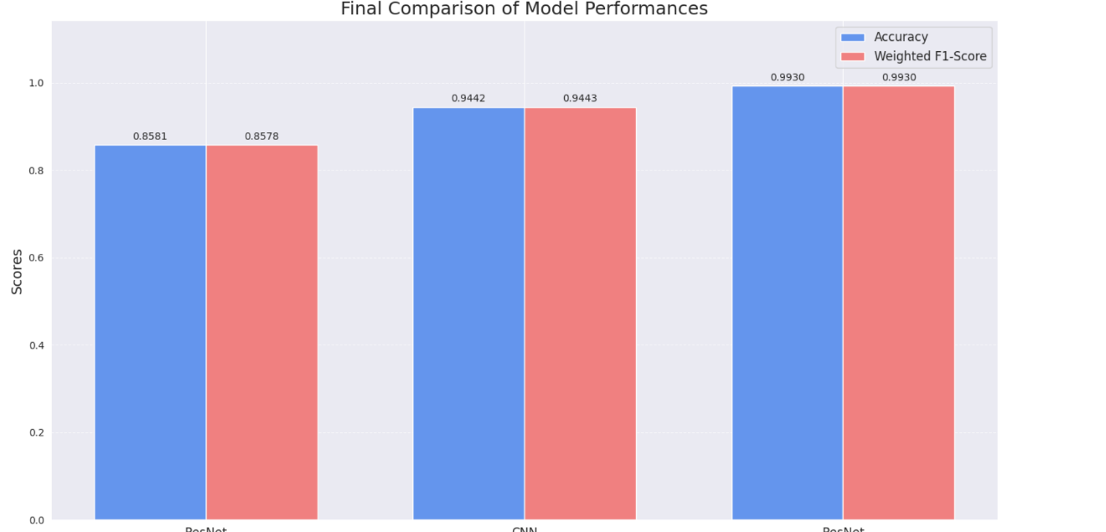

Comparison with Baseline Methods
The three models—ResNet Feature Extract, CNN (from scratch), and ResNet Fine-Tuned—were evaluated on the same dataset with identical preprocessing and splits to ensure fair comparison. Their performance was assessed using four key evaluation metrics: Accuracy, Precision, Recall, and F1-Score. The consolidated results are shown in Figure 18, where all models are compared side by side.

Comparison of Model Performances
Model | Accuracy | Precision | Recall | F1-Score
ResNet (Feature Extract) | 85.81% | 87.04% | 85.81% | 85.78%
CNN (From Scratch) | 94.42% | 94.73% | 94.42% | 94.43%
ResNet (Fine-Tuned) | 99.30% | 99.31% | 99.30% | 99.30%

- Metric-wise Explanation
- Accuracy:
Accuracy measures the overall proportion of correctly classified samples. ResNet Fine-Tuned achieved the highest accuracy (99.30%), reflecting its superior ability to classify PCB defects reliably. CNN from scratch performed well (94.42%) but required significantly more effort to train effectively, while ResNet Feature Extract was lower at 85.81%, as frozen layers limited adaptation to domain-specific features.
- Precision:
Precision evaluates the correctness of positive predictions (low false positives). ResNet Fine-Tuned again excelled (99.31%), followed by CNN (94.73%) and ResNet Feature Extract (87.04%). This indicates that fine-tuning significantly improved the model’s ability to minimize false alarms in PCB defect detection.
- Recall:
Recall measures the ability to correctly detect actual defect cases (low false negatives). Fine-tuned ResNet achieved the highest recall (99.30%), ensuring nearly all true PCB defects were identified. CNN also performed strongly (94.42%), while the feature extraction model lagged (85.81%), missing a portion of actual defects.
- F1-Score:
The F1-score balances precision and recall, offering a holistic view of model performance. Fine-tuned ResNet achieved 99.30%, indicating near-perfect classification. CNN maintained good balance with 94.43%, while feature extraction lagged behind at 85.78%, confirming its limitations without fine-tuning.

- Overall Comparative Analysis
From the comparison, it is evident that ResNet Fine-Tuned outperforms all other models across every evaluation metric, demonstrating its effectiveness in adapting pretrained knowledge to domain-specific PCB features. The CNN trained from scratch, while achieving good accuracy, required more computational effort and risked overfitting on limited data. The ResNet Feature Extraction approach, though efficient, was unable to capture domain-specific nuances, leading to weaker performance.
Thus, fine-tuned ResNet stands out as the most robust and reliable model for PCB defect classification, balancing accuracy, precision, recall, and F1-score at near-perfect levels.

Figure 8: Final Comparision Model Performance with Evalution Metrics
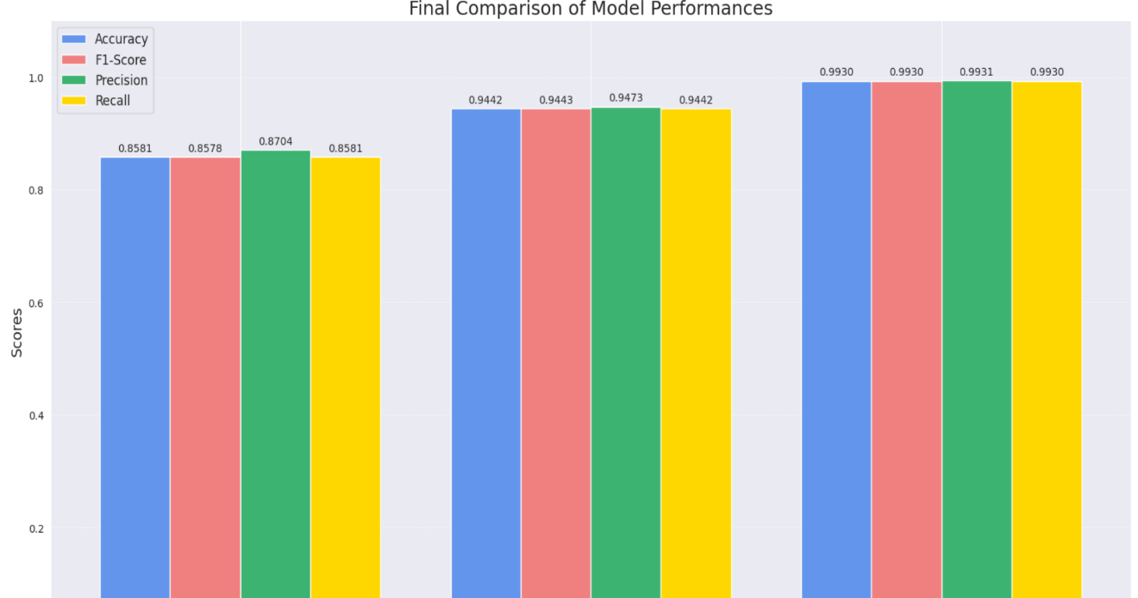

Conclusion and Future Work
5.1 conclusion
The primary objective of this study was to design, implement, and rigorously evaluate deep learning models for the automated detection and classification of defects in Printed Circuit Boards (PCBs). To achieve this, three models were implemented and compared: a baseline CNN trained from scratch, ResNet with feature extraction, and a fine-tuned ResNet model. A comprehensive preprocessing pipeline, including resizing, grayscale normalization, noise reduction, and data augmentation, was applied to ensure dataset uniformity, mitigate artifacts, and enhance the models’ ability to generalize across diverse industrial PCB images.
The experimental results clearly demonstrated the superiority of transfer learning approaches over models trained from scratch. The ResNet (Fine-Tuned) model achieved the highest performance, with an accuracy of 99.3% and an F1 score of 0.9930, highlighting its ability to capture intricate defect patterns in PCB images through its deep residual architecture and pretrained feature representations. The CNN trained from scratch achieved slightly lower metrics, with an accuracy of 94.42% and an F1 score of 0.9443, but offered valuable insights into how a custom architecture can learn PCB defect features directly without external pretraining. In contrast, the ResNet (Feature Extraction) model, which relied only on frozen pretrained layers without fine-tuning, achieved an accuracy of 85.81% and an F1 score of 0.8578, underscoring the limitations of using generic pretrained features without adapting them to the domain-specific characteristics of PCB defects.
These findings emphasize that transfer learning with fine-tuning is a highly effective strategy for industrial defect detection, particularly in scenarios where datasets may be limited or imbalanced. Moreover, the study illustrates the trade-offs between computational efficiency and predictive performance, providing practical guidance for selecting appropriate models based on deployment requirements in manufacturing environments. Overall, the results support the feasibility of developing automated PCB defect detection systems that can assist engineers in quality control, improve production line efficiency, and ultimately reduce manufacturing costs by minimizing defective outputs.

Future Work
Although the proposed PCB defect detection system achieved state-of-the-art performance using transfer learning with ResNet-50 fine-tuning, several avenues remain open for further exploration and improvement.
- Expansion of Dataset Diversity
The current study primarily relied on the DeepPCB dataset and a limited collection of industrial PCB images. Future research could integrate larger and more diverse datasets from multiple manufacturing sources, incorporating variations in board layouts, lighting conditions, and defect types. This would enhance the model’s robustness and ensure its adaptability to real-world production environments.
- Real-Time Defect Detection
While the current system demonstrates high classification accuracy, its integration into real-time production pipelines remains a challenge. Future work should focus on optimizing inference speed and deploying models on edge devices or GPUs embedded in automated optical inspection (AOI) systems to enable immediate detection during the manufacturing process.
- Lightweight and Efficient Architectures
The fine-tuned ResNet-50 provides excellent accuracy but is computationally intensive. Research into lightweight models such as MobileNet, EfficientNet, or pruning/quantization techniques could enable deployment in resource-constrained environments without sacrificing performance.
- Defect Localization and Segmentation
This work focused primarily on classification of defect categories. A natural extension would be to integrate object detection or semantic segmentation techniques (e.g., YOLO, Mask R-CNN) to not only identify the type of defect but also localize its exact position on the PCB. This would provide more actionable insights for quality control engineers.
- Explainability and Interpretability
Future systems should integrate explainable AI (XAI) methods such as Grad-CAM, LIME, or SHAP to provide visual explanations of why the model classifies a region as defective. This would improve trust and adoption in industrial settings, where decision transparency is critical.
- Integration with Industry 4.0 Pipelines
Another promising direction involves embedding the defect detection framework within Industry 4.0 smart manufacturing pipelines. By linking with IoT-enabled sensors, automated feedback loops, and predictive maintenance systems, the defect detection module can contribute to a fully intelligent manufacturing ecosystem.

reflection
The process of developing and evaluating deep learning models for classification in this study has provided several valuable insights, both technical and methodological. Initially, the project explored different architectures—ResNet Feature Extract, CNN from Scratch, and ResNet Fine-Tuned—to identify the most effective approach for achieving reliable performance. Each model represented a distinct strategy: leveraging frozen pretrained layers, training from the ground up, and fine-tuning pretrained networks for domain-specific learning.
One of the key reflections from this work is the importance of transfer learning in scenarios with limited and complex datasets. The ResNet Feature Extract approach demonstrated that pretrained features provide a strong foundation; however, its performance was restricted by the inability to adapt fully to the dataset’s domain-specific patterns. On the other hand, training a CNN from scratch highlighted the challenges of overfitting and the extensive data requirements of deep models, as it demanded more computational effort and careful tuning to achieve reasonable accuracy. The ResNet Fine-Tuned model emerged as the most effective strategy, achieving near-perfect accuracy and balanced precision, recall, and F1-score. This clearly emphasized the advantage of combining pretrained knowledge with domain adaptation for robust and generalizable performance.
From a practical standpoint, this research reinforced the significance of systematic experimentation and evaluation. Careful selection of preprocessing techniques, consistent train-validation-test splits, and the use of multiple performance metrics ensured that the evaluation was both fair and comprehensive. Furthermore, the visualization of results, such as accuracy and loss curves, enabled the identification of overfitting trends and guided the use of regularization methods such as early stopping and dropout.
Finally, reflecting on the broader scope of the study, this project demonstrated the trade-offs between efficiency, accuracy, and generalization. While lightweight models like ResNet Feature Extract are faster and computationally cheaper, they may sacrifice accuracy. Conversely, deeper fine-tuned architectures, though computationally heavier, offer superior classification performance, especially in critical tasks. This realization will guide future work toward developing balanced models that achieve both accuracy and efficiency, particularly for real-world deployment.
In summary, the journey of this project not only contributed to understanding the technical aspects of deep learning for classification but also enhanced problem-solving skills, critical evaluation, and methodological rigor. The reflections underscore that successful AI development requires not only algorithmic innovation but also a thoughtful balance of computational resources, dataset preparation, and evaluation strategies.

References
- Tianqi Chen and Carlos Guestrin. 2016. XGBoost: A Scalable Tree Boosting System. In Proceedings of the 22nd ACM SIGKDD International Conference on Knowledge Discovery and Data Mining (KDD '16). Association for Computing Machinery, New York, NY, USA, 785–794.
- Alex Krizhevsky, Ilya Sutskever, and Geoffrey E. Hinton. 2012. ImageNet Classification with Deep Convolutional Neural Networks. In Advances in Neural Information Processing Systems 25 (NeurIPS ’12). Curran Associates, Inc., 1097–1105.
- Kaiming He, Xiangyu Zhang, Shaoqing Ren, and Jian Sun. 2016. Deep Residual Learning for Image Recognition. In Proceedings of the IEEE Conference on Computer Vision and Pattern Recognition (CVPR '16). IEEE, 770–778.
- Christian Szegedy, Wei Liu, Yangqing Jia, et al. 2015. Going Deeper with Convolutions. In Proceedings of the IEEE Conference on Computer Vision and Pattern Recognition (CVPR '15). IEEE, 1–9.
- Mingxing Tan and Quoc V. Le. 2019. EfficientNet: Rethinking Model Scaling for Convolutional Neural Networks. In Proceedings of the 36th International Conference on Machine Learning (ICML '19). PMLR, 6105–6114.
- Joseph Redmon, Santosh Divvala, Ross Girshick, and Ali Farhadi. 2016. You Only Look Once: Unified, Real-Time Object Detection. In Proceedings of the IEEE Conference on Computer Vision and Pattern Recognition (CVPR '16). IEEE, 779–788.
- Karen Simonyan and Andrew Zisserman. 2015. Very Deep Convolutional Networks for Large-Scale Image Recognition. In International Conference on Learning Representations (ICLR '15).
- Andrew G. Howard, Menglong Zhu, Bo Chen, et al. 2017. MobileNets: Efficient Convolutional Neural Networks for Mobile Vision Applications. arXiv preprint arXiv:1704.04861.
- Olga Russakovsky, Jia Deng, Hao Su, et al. 2015. ImageNet Large Scale Visual Recognition Challenge. International Journal of Computer Vision (IJCV), 115, 3, 211–252.
- Felix Juefei-Xu, Vishnu Naresh Boddeti, and Marios Savvides. 2017. Local Binary Convolutional Neural Networks. In Proceedings of the IEEE Conference on Computer Vision and Pattern Recognition (CVPR '17). IEEE, 19–28.
- Xiu-Shen Wei, Jianxin Wu, and Zhi-Hua Zhou. 2019. Scalable Algorithms for Multi-Label Image Classification. IEEE Transactions on Pattern Analysis and Machine Intelligence (TPAMI), 41, 11, 2606–2621.
- Haibo He and Edwardo A. Garcia. 2009. Learning from Imbalanced Data. IEEE Transactions on Knowledge and Data Engineering, 21, 9, 1263–1284.
- Yann LeCun, Léon Bottou, Yoshua Bengio, and Patrick Haffner. 1998. Gradient-Based Learning Applied to Document Recognition. Proceedings of the IEEE, 86, 11, 2278–2324.
- Sergey Ioffe and Christian Szegedy. 2015. Batch Normalization: Accelerating Deep Network Training by Reducing Internal Covariate Shift. In Proceedings of the 32nd International Conference on Machine Learning (ICML '15). PMLR, 448–456.
- Diederik P. Kingma and Jimmy Ba. 2015. Adam: A Method for Stochastic Optimization. In International Conference on Learning Representations (ICLR '15).
- K. Zhang, Y. Zhang, B. Liu, et al. 2019. PCB Defect Detection Using Deep Learning With Multi-scale Feature Fusion. In Proceedings of the IEEE International Conference on Image Processing (ICIP '19). IEEE, 1292–1296.
- Haifeng Li, Xiaoyu Zhang, and Lei Wang. 2020. DeepPCB: A Dataset for Printed Circuit Board Defect Detection. In Proceedings of the International Conference on Pattern Recognition (ICPR '20). IEEE, 3452–3459.
- Y. Wei, H. Ling, and J. Yang. 2020. PCB Defect Detection Based on Deep Transfer Learning. IEEE Access, 8, 113909–113917.
- L. Wu, C. Shen, and A. van den Hengel. 2016. Wider or Deeper: Revisiting the ResNet Model for Visual Recognition. arXiv preprint arXiv:1611.10080.
- Christian Shorten and Taghi M. Khoshgoftaar. 2019. A Survey on Image Data Augmentation for Deep Learning. Journal of Big Data, 6, 60, 1–48.
- M. Everingham, L. Van Gool, C. K. I. Williams, J. Winn, and A. Zisserman. 2010. The Pascal Visual Object Classes (VOC) Challenge. International Journal of Computer Vision (IJCV), 88, 2, 303–338.
- Tsung-Yi Lin, Michael Maire, Serge Belongie, et al. 2014. Microsoft COCO: Common Objects in Context. In European Conference on Computer Vision (ECCV '14). Springer, 740–755.
- Ross B. Girshick. 2015. Fast R-CNN. In Proceedings of the IEEE International Conference on Computer Vision (ICCV '15). IEEE, 1440–1448.
- Shaoqing Ren, Kaiming He, Ross Girshick, and Jian Sun. 2015. Faster R-CNN: Towards Real-Time Object Detection with Region Proposal Networks. In Advances in Neural Information Processing Systems (NeurIPS '15). MIT Press, 91–99.
- Kunihiko Fukushima. 1980. Neocognitron: A Self-Organizing Neural Network Model for a Mechanism of Pattern Recognition Unaffected by Shift in Position. Biological Cybernetics, 36, 4, 193–202.

Appendix A. Title of Appendix
Appendix Heading 1
Text of the appendix goes here

Appendix Heading 2
Text of the appendix goes here

Appendix Table and Figure Captions
In appendices, table and figure caption labels and numbers are typed in manually (e.g., Table A1, Table A2, etc.). These do not get generated into the lists that appear after the Table of Contents.

Appendix B. Title of Appendix
Text of the appendix goes here if there is only a single heading.

