**ARM processor and its Features**

**1. Introduction to ARM**

**• What is ARM?**

**◦ ARM, which stands for Advanced RISC Machines, is a family of computer processors based on a RISC (Reduced Instruction Set Computing) architecture. Originally developed by Acorn Computers in the 1980s, the instruction set is now developed by Arm Holdings.**

**• Business Model:**

**◦ Arm Holdings does not manufacture its own physical chips. Instead, it develops the instruction set architecture and licenses this intellectual property (IP) to other companies like Apple, Qualcomm, and Samsung.**

**◦ This licensing model allows companies to customize processor cores for a wide variety of devices. There are different licensing models, including an "Architectural Licence" that allows companies to design their own custom cores compliant with the ARM instruction set.**

**• Widespread Adoption:**

**◦ With over 230 billion chips produced, ARM is the most widely used instruction set architecture in the world.**

**◦ It is dominant in light, portable, battery-powered devices like smartphones, laptops, and tablets due to its low power consumption, low cost, and low heat generation.**

**◦ It is also scalable enough for high-performance computing, powering servers and even the Fugaku supercomputer.**

**2. Core Architectural Features & Functionality**

**The functionality of ARM processors is based on several key RISC design principles.**

**• RISC Load-Store Architecture:**

**◦ Operations are typically performed on data held in the processor's registers.**

**◦ Memory is only accessed through specific "load" and "store" instructions, which is a core feature of RISC design.**

**• Efficient Instruction Execution:**

**◦ ARM processors are optimized for one-cycle execution time for most instructions. Each instruction has a fixed length, which allows the processor to fetch future instructions while executing the current one.**

**◦ Pipelining is used to process instructions in parallel stages, which increases the rate of processing (throughput).**

**• Key Hardware Features:**

**◦ Large Register File: ARM processors have a large set of general-purpose registers to function as fast, local storage for the CPU. This minimizes the need for memory access, which reduces bottlenecks and speeds up execution.**

**◦ Conditional Execution: A standout feature of ARM is that almost every instruction can be executed conditionally based on processor flags. This reduces the need for branching (jumps) for small if statements, which improves efficiency by preserving the instruction pipeline.**

**◦ Barrel Shifter: This hardware component allows most arithmetic instructions to perform shifts and rotates in a single cycle without a performance penalty. This makes ARM programs denser and more efficient.**

**3. Evolution and Instruction Sets**

**There have been several generations and instruction sets in the ARM family.**

**• 32-bit Architecture (AArch32):**

**◦ Early designs like ARM1 and ARM2 evolved into architectures up to ARMv7, which were 32-bit.**

**◦ The standard 32-bit, fixed-width instruction set is called A32 and offers maximum performance and flexibility.**

**• Thumb Instruction Set (T16):**

**◦ To improve code density, ARM introduced Thumb, a compressed 16-bit encoding of a subset of the full ARM instruction set. This is especially useful in systems with limited memory.**

**• Thumb-2 Technology:**

**◦ Introduced in 2003, Thumb-2 extends the Thumb set with 32-bit instructions, creating a variable-length instruction set. It was designed to achieve the code density of Thumb with performance close to the 32-bit A32 set.**

**• 64-bit Architecture (AArch64):**

**◦ Released in 2011 with the ARMv8-A architecture, this added support for a 64-bit address space and a new 64-bit instruction set called A64.**

**◦ It maintains backward compatibility by supporting a 32-bit state (AArch32), allowing 32-bit applications to run on a 64-bit operating system.**

**4. Other Key Processor Features**

**• Multiprocessing: ARM processors are designed for systems where more than one processor is used to process information concurrently. Modern ARM processors are commonly found in multi-core (e.g., octa-core) System on Chips (SoCs).**

**• Tightly Coupled Memory (TCM): This is a type of memory with a very fast response time and low latency. It provides deterministic access times, making it ideal for real-time and safety-critical applications where cache performance can be unpredictable.**

**• Memory Management: Processors include advanced memory management components like the Memory Management Unit (MMU) for implementing virtual memory and the Memory Protection Unit (MPU) for protecting critical sections of memory.**

**5. Common ARM Processor Families**

**ARM licenses different processor families for specific use cases:**

**• Cortex-A Series: For application processors (e.g., smartphones, tablets).**

**• Cortex-R Series: For real-time systems (e.g., automotive, robotics).**

**• Cortex-M Series: For microcontrollers (low power, real-time control).**

**• Neoverse: For infrastructure and cloud computing.**

**• Apple Silicon (e.g., M1, M2): Custom ARM-based processors designed by Apple for Macs.**

**6. ARM vs. x86 Architecture**

**Here is a summary of the key differences between ARM and x86 architectures:**

|  |  |  |
| --- | --- | --- |
| **Feature** | **ARM** | **x86** |
| **Architecture** | **RISC (Reduced Instruction Set Computing)** | **CISC (Complex Instruction Set Computing)** |
| **Instruction Execution** | **Executes a single instruction per cycle** | **Executes complex instructions that may require more than one cycle** |
| **Optimization** | **Performance is optimized through a software-based approach** | **Performance is optimized through a hardware-based approach** |
| **Typical Use Case** | **Mobiles and other devices where power consumption, speed, and size are critical** | **Servers and Laptops where performance and stability are the primary concerns** |

**7. Advantages and Disadvantages of ARM**

**Advantages**

**• Low Power Consumption: Ideal for battery-powered and mobile devices.**

**• High Performance per Watt: Delivers efficient processing with minimal energy use.**

**• Compact and Cost-Effective Design: Simplified RISC design leads to smaller chip sizes and lower production costs.**

**• Scalability: Used in everything from small microcontrollers to high-performance supercomputers.**

**• Wide Ecosystem Support: Benefits from extensive software and development tools.**

**Disadvantages**

**• Incompatible with x86 Systems: Cannot natively run software compiled for x86, which can limit compatibility with some Windows systems.**

**• Limited High-End Performance: ARM processors have historically offered lower performance compared to high-end x86 CPUs, though this is changing.**

**• Requires Skilled Programming: Programming for ARM can be complex.**

**• Less Efficient Instruction Scheduling: May be less efficient at handling instruction scheduling in some complex tasks.**

**[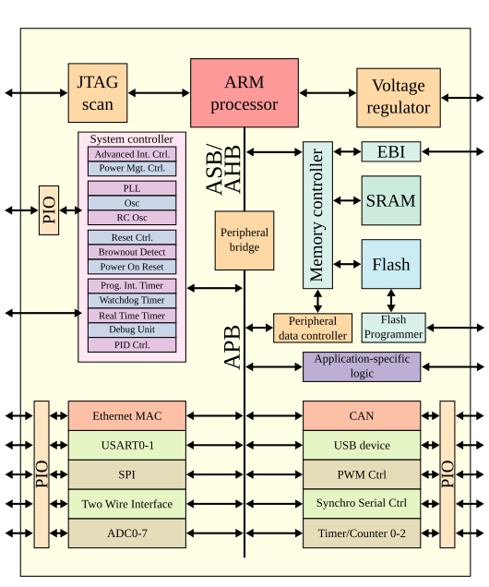](https://en.wikipedia.org/wiki/File:ARMSoCBlockDiagram.svg)Microprocessor-based system on a chip[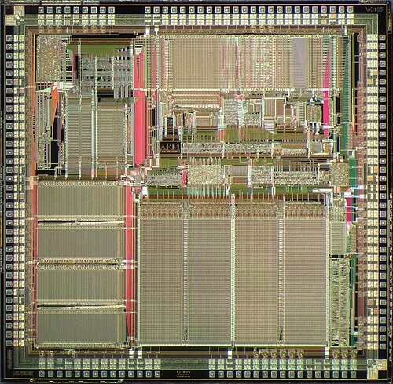](https://en.wikipedia.org/wiki/File:GPS_ARM610_die.JPG)**[**Die shot**](https://en.wikipedia.org/wiki/Die_shot)**of an ARM610 microprocessor**

**ARM (Advanced RISC Machine) processors** are a family of CPUs based on the **RISC** (Reduced Instruction Set Computing) architecture. Originally developed by **Acorn Computers** in the 1980s, ARM processors are now designed by Arm Holdings and widely licensed by other companies (like Apple, Qualcomm, Samsung, etc.) for use in their chips.

It is a widely-used computer chip known for its efficiency and versatility. Designed by ARM Limited using a streamlined RISC architecture these processors are licensed to various companies rather than manufactured directly.

ARM unique business model allows tech companies to customize and build processors for diverse devices, from smartphones and tablets to computers and smart devices. Their exceptional balance of processing power and energy efficiency has made them the preferred choice for mobile computing, enabling longer battery life without compromising performance.

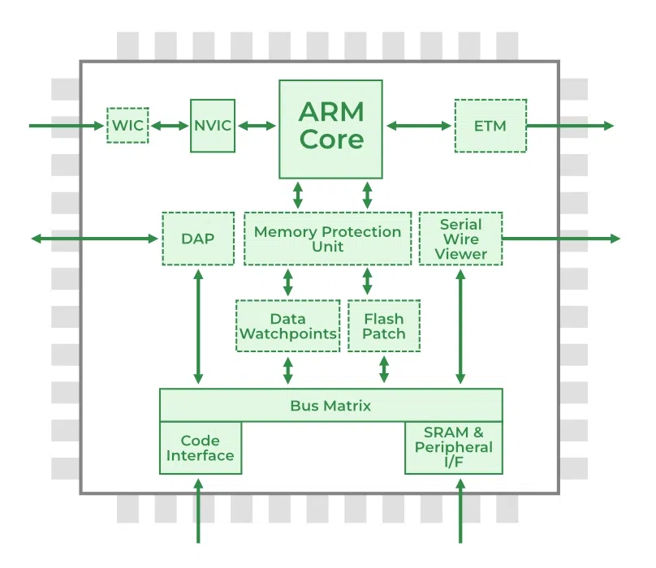

Advanced RISC Machine (ARM)

**Common ARM Processor Families**

* **Cortex-M Series** : For microcontrollers (low power, real-time control)
* **Cortex-R Series** : For real-time systems (e.g., automotive, robotics)
* **Cortex-A Series** : For application processors (e.g., smartphones, tablets)
* **Neoverse** : For infrastructure and cloud computing
* **Apple Silicon (e.g., M1, M2)** : Custom ARM-based processors for Macs

**Features of ARM Processor**

**Multiprocessing Systems**

ARM processors are designed for use in multiprocessing systems, where more than one processor is utilized to process information concurrently. The first Asymmetric Multiprocessing (AMP) processor, introduced under the name ARMv6K, supported up to four CPUs with integrated hardware support.

Modern ARM processors are available in single-core to octa-core (or more) configurations and are commonly used in multi-core SoCs (System on Chips) to enable efficient multitasking and enhanced performance.

**Tightly Coupled Memory**

The memory of ARM processors is tightly coupled. This has a very fast response time. It has low latency (quick response) that can also be used in cases of cache memory being unpredictable. TCM provides deterministic access times, making it ideal for real-time and safety-critical applications.

**Memory Management**

ARM processors include advanced memory management components such as the [Memory Management Unit (MMU)](https://www.geeksforgeeks.org/computer-organization-architecture/what-is-memory-management-unit/) and the Memory Protection Unit (MPU). These systems are essential for:

* Efficient memory utilization
* Virtual memory implementation (MMU)
* Protecting critical sections of memory (MPU)
* Enabling operating system support (e.g., Linux)

**Thumb-2 Technology**

Thumb-2 Technology, introduced in 2003, enables variable-length instruction sets. It extends the original 16-bit Thumb instruction set to include 32-bit instructions, improving code density and execution performance. This dual-width capability offers:

* Reduced memory usage.
* Better performance than standard 16-bit Thumb.
* Improved compatibility with existing ARM instructions.

**One-Cycle Execution Time**

ARM processor is optimized for each instruction on the [CPU](https://www.geeksforgeeks.org/computer-organization-architecture/what-are-the-functions-of-a-cpu/). Each instruction is of a fixed length that allows time for fetching future instructions before executing the present instructions. ARM has CPI (Clock Per Instruction) of one cycle.

**Pipelining**

Processing of instructions is done in parallel using pipelines. Instructions are broken down and decoded in one [pipeline stage](https://www.geeksforgeeks.org/computer-organization-architecture/computer-organization-and-architecture-pipelining-set-1-execution-stages-and-throughput/). The channel advances one step at a time to increase throughput (rate of processing).

**A large number of Registers**

ARM processors provide a large set of general-purpose registers to minimize memory access operations. These registers store data, addresses, and control information, functioning as fast, local storage for the CPU. This architecture:

* Reduces memory bottlenecks.
* Speeds up execution.
* Improves overall system efficiency.

**Reasons ARM Architecture is Valuable**

Given below are the reasons which makes the ARM processor valuable to the us :

* **Widespread Adoption Across Devices**: ARM (Advanced RISC Machine) architecture is one of the most commonly used electronic architectures in the world. It is widely adopted in smartphones, feature phones, laptops, and embedded systems.
* **Better Alternative to x86 in Many Areas**: While x86 processors dominate the server market with high performance, ARM offers cost-effective, energy-efficient, and smaller-sized processors. It is increasingly seen as a better fit for portable and scalable applications due to these advantages.
* **Low Power Consumption and Better Battery Life**: ARM processors require less power to operate, making them ideal for battery-powered devices. This leads to longer battery life, which is critical for mobile and portable technologies.
* **Compact and Cost-Effective Design**: ARM processors are smaller in size, helping reduce device form factors. Their simplified RISC-based design leads to lower production costs, making them more affordable for large-scale use.
* **Used in High-Performance Computing**: ARM is not limited to mobile devices it powers Fugaku, the world's fastest supercomputer (as of 2021). This shows ARM’s ability to scale for high-performance computing (HPC).
* **Flexibility for Hardware Designers**: ARM provides more design feasibility to hardware engineers. Designers have the ability to customize processor cores and maintain better control over the supply chain, unlike fixed-architecture solutions like x86.

**Difference between ARM and x86**

| **ARM** | **x86** |
| --- | --- |
| ARM uses Reduced Instruction Set Computing Architecture (RISC). | x86 uses Complex Instruction Set Architecture (CISC). |
| ARM works by executing single instruction per cycle. | It works by executing complex instructions at once and it requires more than one cycle. |
| Performance can be optimized by a Software-based approach. | Performance can be optimized by Hardware based approach. |
| It require fewer registers, but they require more memory. | It processors require less memory, but more registers. |
| Execution is faster in ARM Processes. | Execution is slower in an x86 Processor. |
| [ARM Processor](https://www.geeksforgeeks.org/computer-organization-architecture/advanced-risc-machine-arm-processor/) work by generating multiple instructions from a complex instruction and they are executed separately. | [x86 Processors](https://www.geeksforgeeks.org/computer-organization-architecture/microprocessor-intel-x86-evolution-and-main-features/) work by executing complex statements at a single time. |
| They use the memory which is already available to them. | They require some extra memory for calculations. |
| They are deployed in mobiles which deal with the consumption of power, speed, and size. | They are deployed in Servers, Laptops where performance and stability matter. |