Railway Passengers and Revenue Analyst 🚆📊
A data analytics project focused on Indian Railways passenger traffic, passenger classes, railway-zone performance, and revenue analysis for 2019–2024.
The project combines MySQL + SQL + Microsoft Power BI to build a structured railway database, validate relationships and data quality, and present the results through interactive dashboards.
---

📌 Project Title
Railway Passengers and Revenue Analyst

🏭 Industry
Railway Transportation & Data Analytics
---

📖 Project Overview
The Railway Passengers and Revenue Analyst project analyzes railway passenger and financial performance using historical data from 2019 to 2024.
The project covers:
- Passenger traffic and originating passengers
- Passenger kilometres
- Passenger earnings
- Passenger classes
- Railway-zone performance
- Passenger revenue
- Freight revenue
- Total revenue
- Revenue trends
- Train and route information
- Train schedules
- Station information
The data is stored and validated in MySQL, analyzed using SQL, and visualized in Power BI.
---

🎯 Project Objectives
- Analyze railway passenger trends from 2019–2024.
- Measure total passenger traffic and passenger kilometres.
- Analyze passenger performance by passenger class.
- Compare railway-zone passenger performance.
- Analyze passenger, freight, and total revenue.
- Identify yearly revenue trends.
- Compare revenue performance across railway zones.
- Validate primary-key and foreign-key relationships.
- Check duplicate and invalid records using SQL.
- Build interactive Power BI dashboards.
- Present railway performance through business-focused KPIs and visualizations.
---

🛠️ Tools & Technologies
Tool / Technology | Purpose
**MySQL** | Database creation, storage and validation
**SQL** | Data analysis and data-quality checks
**Microsoft Power BI** | Dashboard development and visualization
**Power Query** | Data preparation/transformation
**DAX** | KPI and analytical calculations
**CSV** | Source data format
**GitHub** | Repository and project sharing

---

📂 Dataset Description
The repository contains 10 CSV files divided into dimension and fact data.

Dimension Tables
File | Description | Rows*
`dim_zone.csv` | Railway-zone master data | 5
`dim_station.csv` | Station information | 112
`dim_train.csv` | Train master information | 2,500
`dim_passenger_class.csv` | Passenger class master data | 5

Fact Tables
File | Description | Rows*
`fact_revenue.csv` | Railway revenue information | 6
`fact_passenger_class.csv` | Passenger performance by class and year | 30
`fact_passenger_traffic.csv` | Passenger traffic by year, zone and category | 96
`fact_zone_performance.csv` | Zone-level passenger and revenue performance | 96
`fact_route.csv` | Train route information | 2,500
`fact_train_schedule.csv` | Train schedule and station sequence information | 12,000

\*Row counts are based on the uploaded CSV files excluding header rows.
---

🗄️ Database Structure
The MySQL database is named:
railway

Main tables
dim_zone
dim_station
dim_train
dim_passenger_class
fact_revenue
fact_passenger_class
fact_passenger_traffic
fact_zone_performance
fact_route
fact_train_schedule
The SQL script creates primary keys, foreign-key relationships, unique constraints, and indexes for the railway data model.
---

🔍 SQL Analysis
SQL was used for both database creation and data validation.

Database Operations
- Created the `railway` database.
- Created dimension and fact tables.
- Defined primary keys.
- Defined foreign-key relationships.
- Created indexes.
- Loaded CSV data.
- Checked table structures.
- Checked row counts.

Data Validation
The SQL analysis includes checks for:
- Invalid Train IDs
- Invalid Station Codes
- Invalid Railway Zones
- Invalid Passenger Classes
- Duplicate Train IDs
- Duplicate Train Numbers
- Duplicate Zone Codes
- Duplicate route relationships
- Missing values
- Foreign-key relationships
Example:
SELECT COUNT(*) AS Invalid_Train_IDs
FROM fact_route r
LEFT JOIN dim_train t
ON r.Train_ID = t.Train_ID
WHERE t.Train_ID IS NULL;
---

📊 Power BI Dashboards
The Power BI report contains 3 dashboard pages.

1. Railway Performance Overview
This dashboard provides an overall view of railway passenger performance.

Main KPIs
- Total Passengers — **285M**
- Total Passenger KM — **127.08bn**
- Total Earnings — **33.81bn**
- Average Fare — **118.59**

Main Visuals
- Passenger Trend by Year
- Revenue by Railway Zone
- Passenger Traffic by Railway Zone
- Passengers by Class
- Railway Zone filter
- Year filter
- Passenger Class filter
---

2. Passenger Analysis Dashboard
This dashboard focuses on passenger trends, passenger classes, and traffic patterns.

Main KPIs
- Total Passengers — **285M**
- Total Passenger KM — **127.08bn**
- Total Revenue — **33.81bn**
- Average Fare — **3.56K**

Main Visuals
- Passenger Trend by Year
- Passenger Share by Class
- Passenger Trend by Passenger Class
- City map
- Year filter
- Passenger Class filter
- Zone-related filtering
---

3. Revenue Analysis Dashboard
This dashboard focuses on railway financial performance from 2019–2024.

Main KPIs
- Total Revenue — **1.94T**
- Passenger Revenue — **227.19bn**
- Freight Revenue — **1.72T**
- Average Passenger Revenue — **2.37bn**
- Revenue Growth % — **-13.1%**

Main Visuals
- Total Revenue Trend | 2019–2024
- Passenger vs Freight Revenue
- Passenger & Freight Revenue vs Total Revenue
- Total Revenue by Railway Zone
- Total Revenue gauge
- Year slicer
- Railway Zone slicer
---

📌 Key KPIs
KPI | Value
Total Passengers | **285M**
Total Passenger KM | **127.08bn**
Total Earnings | **33.81bn**
Average Fare | **118.59**
Total Revenue | **1.94T**
Passenger Revenue | **227.19bn**
Freight Revenue | **1.72T**
Average Passenger Revenue | **2.37bn**
Revenue Growth | **-13.1%**

---

💡 Key Insights
Based on the Power BI dashboards included in this project:
- The project analyzes railway performance across **2019–2024**.
- Total passenger volume shown in the overview dashboard is approximately **285M**.
- Total passenger kilometres are approximately **127.08bn**.
- Total earnings shown in the overview are approximately **33.81bn**.
- Freight revenue is substantially higher than passenger revenue in the Revenue Analysis dashboard.
- Total revenue shown in the Revenue Analysis dashboard is approximately **1.94T**.
- Freight revenue contributes approximately **1.72T**, compared with approximately **227.19bn** from passenger revenue.
- Revenue varies considerably across railway zones.
- Passenger traffic and passenger-class distributions can be compared using the interactive Power BI visuals.
- The revenue dashboard shows a **-13.1% Revenue Growth %** KPI for the measure used in the report.
---

🔄 Project Workflow
CSV Dataset
↓
Data Understanding
↓
MySQL Database Creation
↓
Table Creation
↓
CSV Data Loading
↓
SQL Data Validation
↓
SQL Analysis
↓
Power BI Data Connection
↓
Data Modeling
↓
DAX Measures / KPIs
↓
Dashboard Development
↓
Data Visualization
↓
Business Insights

📁 Repository Structure
Railway-Passengers-and-Revenue-Analyst/
│
├── Dataset/
│ ├── dim_passenger_class.csv
│ ├── dim_station.csv
│ ├── dim_train.csv
│ ├── dim_zone.csv
│ ├── fact_passenger_class.csv
│ ├── fact_passenger_traffic.csv
│ ├── fact_revenue.csv
│ ├── fact_route.csv
│ ├── fact_train_schedule.csv
│ └── fact_zone_performance.csv
│
├── Documentation/
│
├── Power BI/
│ └── Railway Passenger.pbix
│
├── Screenshot/
│ ├── Railway Performence Overview.png
│ ├── Passenger Analyst Dashboard.png
│ └── Revenue Analysis Dashboard.png
│
├── SQL/
│ └── Railway_Passenger.sql
│
└── README.md
---

🖼️ Dashboard Screenshots

Railway Performance Overview
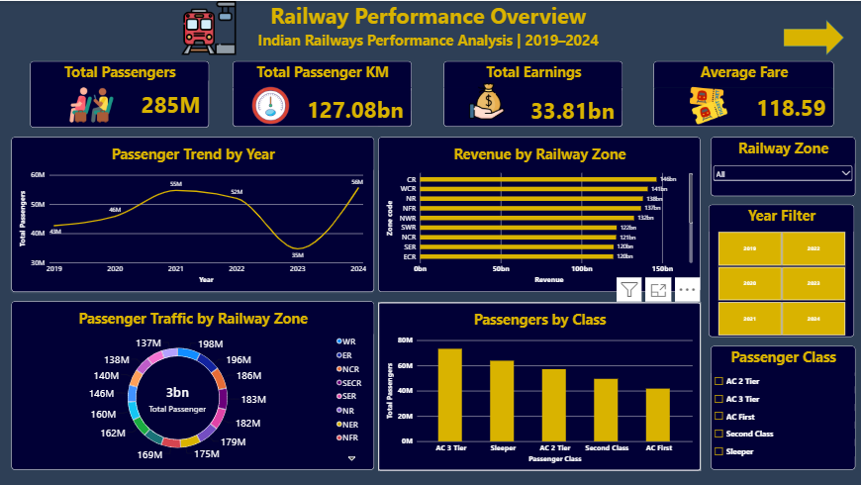

Passenger Analysis Dashboard
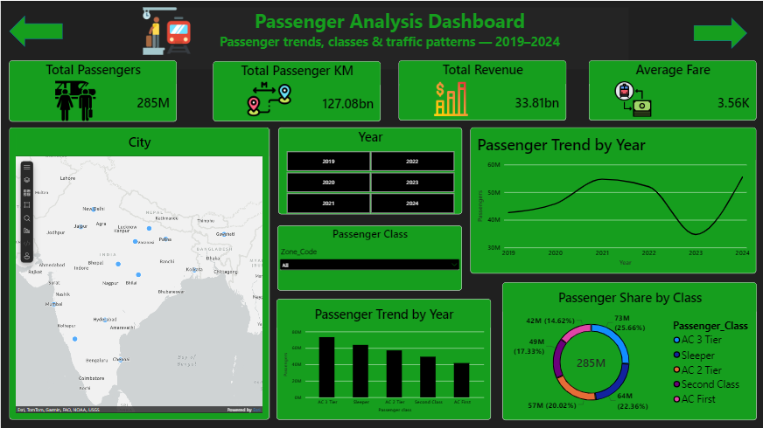

Revenue Analysis Dashboard
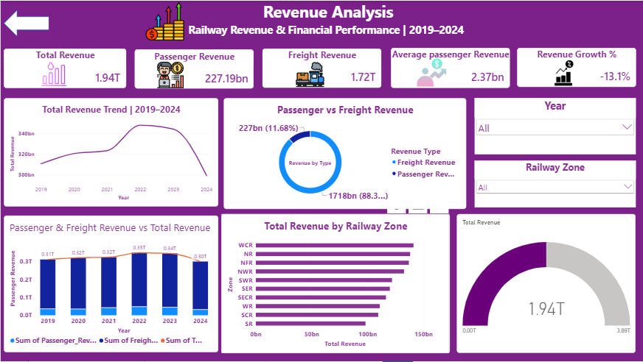---

▶️ How to Run the Project

Step 1 — Clone the Repository
git clone <your-github-repository-url>
cd Railway-Passengers-and-Revenue-Analyst

Step 2 — Prepare MySQL
Install MySQL Server and MySQL Workbench.
Open MySQL Workbench and create/use the railway database:
CREATE DATABASE railway;
USE railway;

Step 3 — Run the SQL Script
Open:
SQL/Railway_Passenger.sql
Run the database/table creation statements.
**Important:** The SQL script contains local CSV file paths. Update the `LOAD DATA LOCAL INFILE` paths to match the location of the `Dataset` folder on your computer before running those data-loading statements.
For example:
LOAD DATA LOCAL INFILE 'YOUR_LOCAL_PATH/fact_train_schedule.csv'
INTO TABLE fact_train_schedule;

Step 4 — Load the CSV Data
The CSV files are available inside:
Dataset/
Load the required files into their corresponding MySQL tables.

Step 5 — Open Power BI
Open:
Power BI/Railway Passenger.pbix

Step 6 — Update the Data Source
If Power BI asks for database credentials or the MySQL server connection:
- Select the MySQL connection.
- Enter your MySQL server details.
- Select the `railway` database.
- Confirm the tables.
- Refresh the dataset.

Step 7 — Explore the Dashboards
Navigate through the three Power BI pages:
- Railway Performance Overview
- Passenger Analysis Dashboard
- Revenue Analysis
Use the available year, railway-zone, and passenger-class filters to interact with the report.
---

📈 Project Deliverables
This repository contains:
- ✅ Railway CSV datasets
- ✅ MySQL SQL script
- ✅ Power BI dashboard file
- ✅ Dashboard screenshots
- ✅ Project documentation
- ✅ GitHub README
---

👨‍💻Author
Yakesh C
Project: Railway Passengers and Revenue Analyst
Focus: Data Analytics | SQL | Power BI | Data Visualization
Industry: Railway Transportation & Data Analytics
Course: Data and Business Analyst with AI

---

⭐ Skills Demonstrated
- SQL
- MySQL
- Data Cleaning & Validation
- Relational Database Design
- Data Modeling
- Power BI
- DAX
- Power Query
- KPI Development
- Data Visualization
- Business Intelligence
- Dashboard Development
- Data Analysis
---

📜 License
This project is intended for educational, portfolio, and demonstration purposes.

