Ask 1

Approach 1

Responsiveness of D3 charts 1

Code Snippets 1

Alternate suggestions 2

Axis Manipulation 2

Decimal value Manipulations 2

Syntax 2

Code Snippets 3

Customization of tick format 4

Code snippets 5

Exporting chart as PNG 6

Code Snippet 6

Conclusion 6

Resources 6

# Ask

* Responsiveness of the d3 charts.
* Axis manipulations.
* Export chart as PNG.

# Approach

## Responsiveness of D3 charts

* You can make the chart resize using a combination of viewBox and preserveAspectRatio attributes on the SVG element.
* You won't even need a resize handler with this method.

### Code Snippets

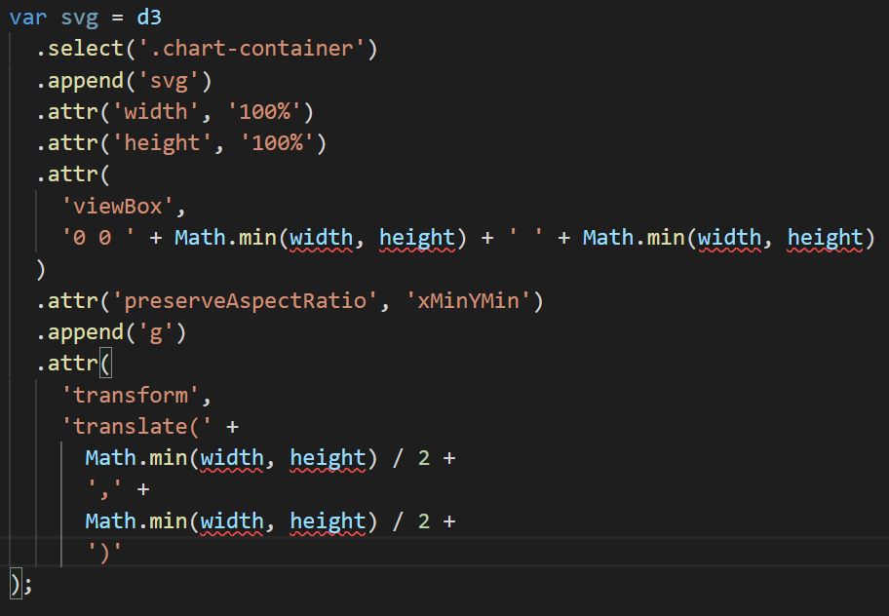

### Alternate suggestions

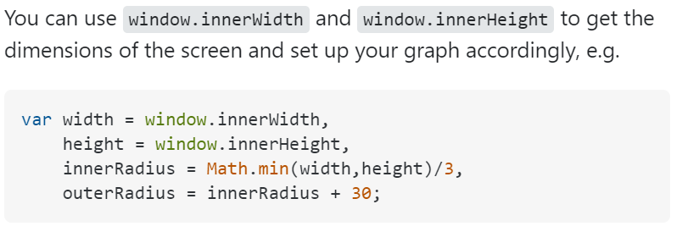

## Axis Manipulation

### Decimal value Manipulations

* Use *axis*.ticks to control which ticks are displayed by the axis. *axis*.ticks passes the arguments you specify to *scale*.ticks whenever the axis is rendered. The meaning of the arguments thus depends on the class of scale.

##### Syntax

axis.ticks(arguments…)  
axis.ticks([count[, specifier]])  
axis.ticks([interval[, specifier]])

**Parameters:** This function accepts the following parameters.

* **count/interval:** This parameter is used to display the number of ticks.
* **specifier:** This parameter is an optional format specifier to customize how the tick values are formatted.

**Return Value:** This function returns the axis generator.

##### Code Snippets

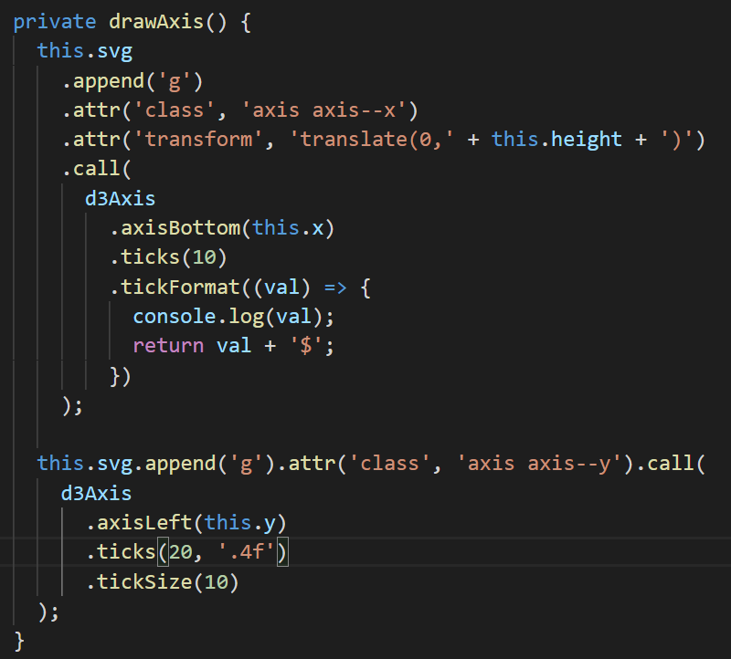

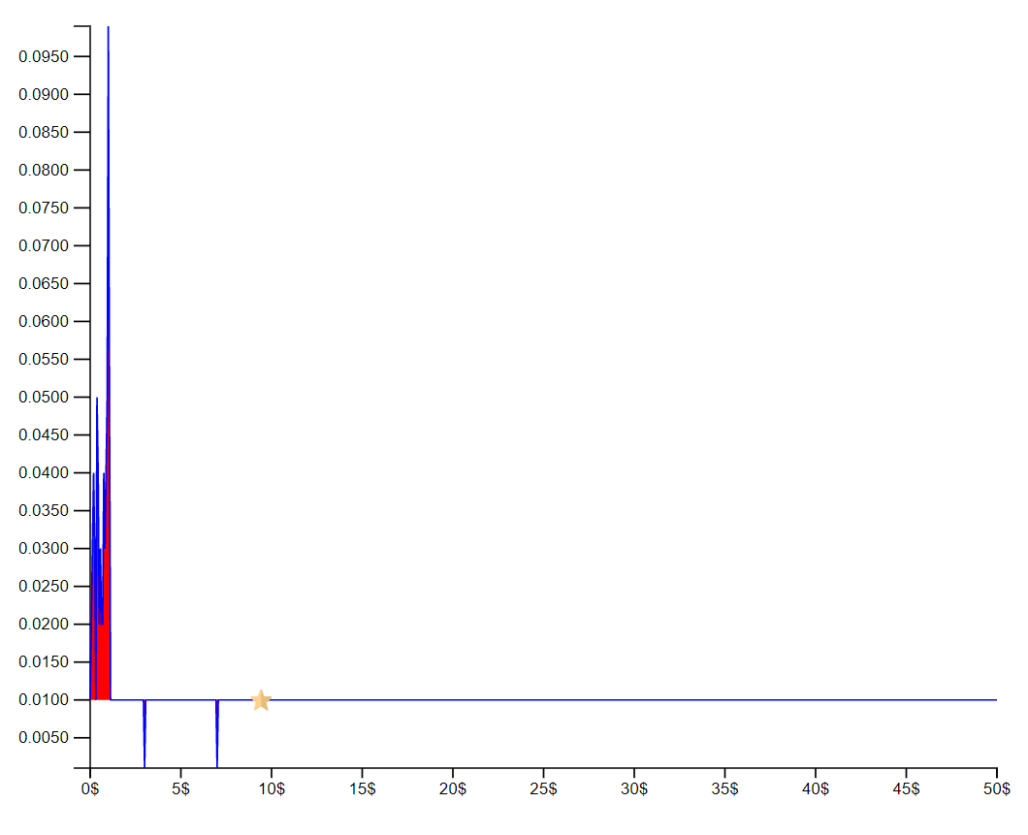

### Customization of tick format

##### Code snippets

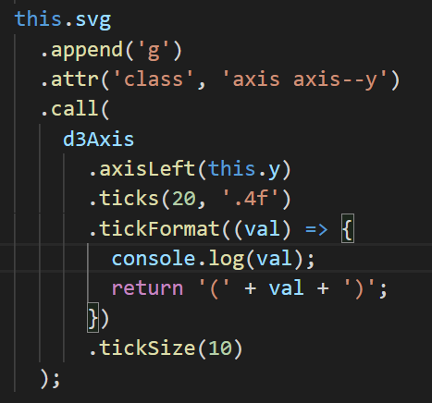

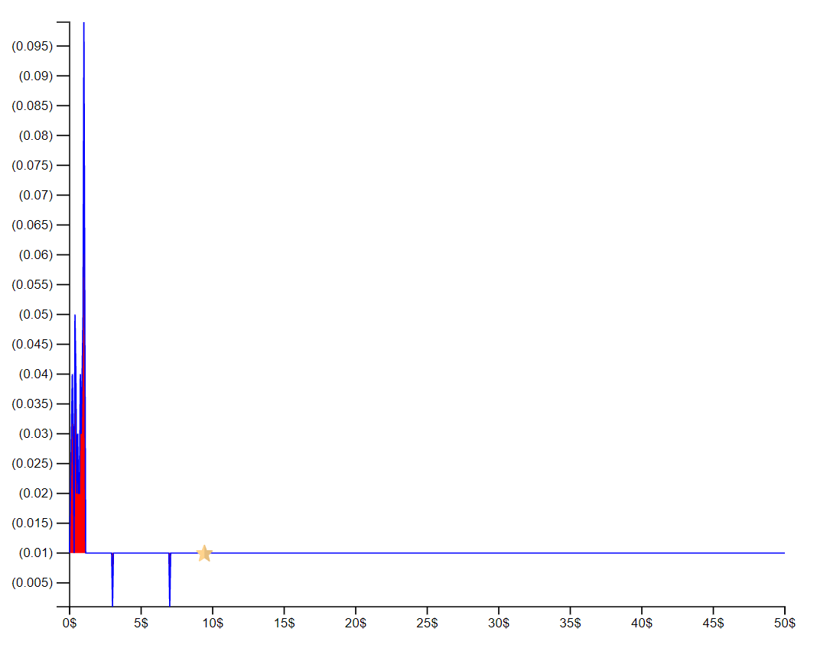

## Exporting chart as PNG

### Code Snippet

* Set up the export function,

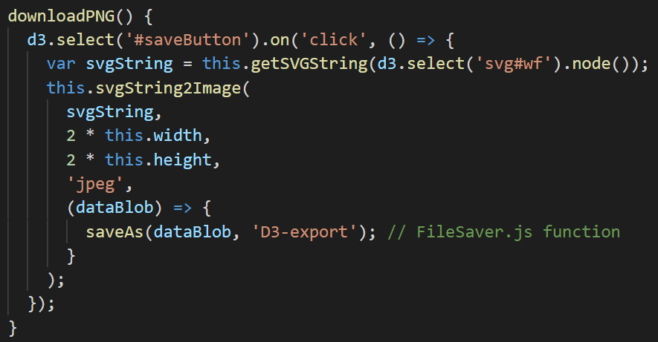

* Get the chart root node as String SVG,

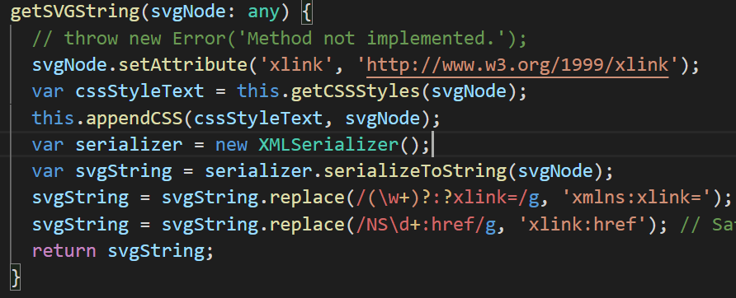

* Export the stream to a file using file-saver,

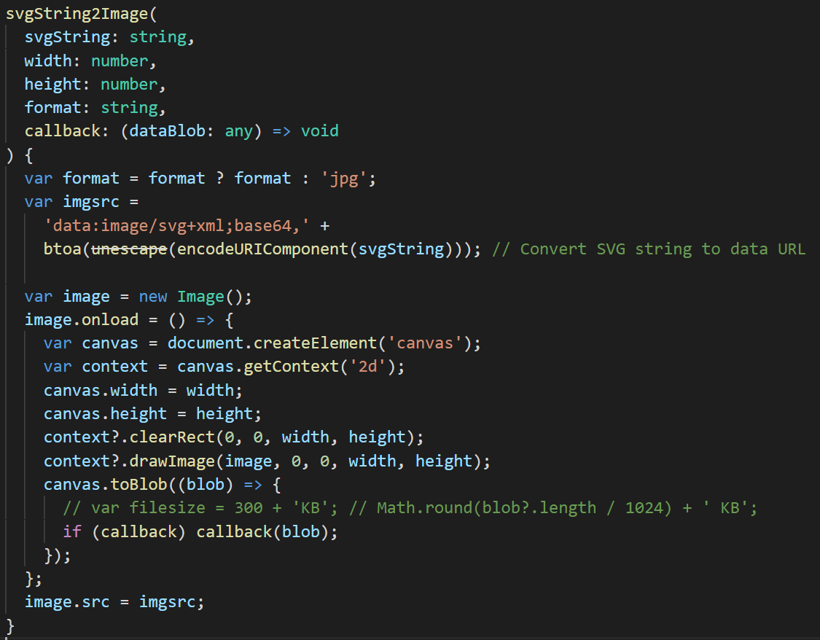

# Conclusion

* These are the following features achieved,
  + Responsiveness of the d3 charts.
  + Axis manipulations.
  + Export chart as PNG.

# Resources

* <https://github.com/BentlyNevada-bh/spike-plots-d3js.git>
* <https://d3js.org/>
* <https://www.geeksforgeeks.org/d3-js-axis-ticks-function/>
* <https://observablehq.com/@d3/scale-ticks>
* <https://jsfiddle.net/ramseyfeng/xm7x47gm/>
* <https://jsfiddle.net/ksav/4kco9azw/>
* <https://jsfiddle.net/speedymcs/o160fb10/>
* <http://jsfiddle.net/robdodson/KWRxW/>
* <http://bl.ocks.org/Rokotyan/0556f8facbaf344507cdc45dc3622177>
* <https://gist.github.com/Rokotyan/0556f8facbaf344507cdc45dc3622177>
* <https://www.demo2s.com/javascript/javascript-d3-js-save-svg-to-png-image.html>