<https://github.com/chinni-bh/d3-poc-cursors>

<https://observablehq.com/@sergeyobodovskiy/interactive-line-chart>

Note:

Think in terms of SVG styling, not the HTML styles

//some Random 27th value of the waveform

    console.log(WaveformData[27].x_value);

    //to get the scale value from waveform data point

    console.log(this.x(WaveformData[27].x_value));

    //to get the waveform data point form scale value(approximate vlaue)

    console.log(this.x.invert(this.x(WaveformData[27].x_value)));

    //to get the nearest index of waveform data based on the passed value

    //bisectCenter() - 1st arg: Array of x-values, 2nd arg: approx. value.

    console.log(

      d3.bisectCenter(this.X, this.x.invert(this.x(WaveformData[27].x_value)))

    );

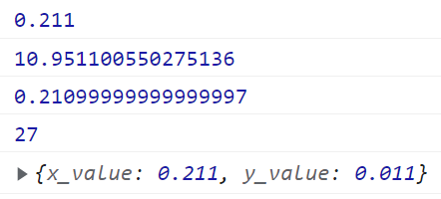

# Note:

To the index based on the click event,

this.x.invert(d3.pointer(event)[0]-49)

d3.bisectCenter(X, this.x.invert(d3.pointer(event)[0]-49));

X-represents the complete x-values in the data