Summary

The goal of this project is to create a similar site/service to https://www.casinotopsonline.com/. The design and layout of the site may be altered in order to make the new site unique and different, but it will hold vastly similar features and functionality. The project will have a focus of being user-friendly and fast, with a sleek design that is both desktop and mobile friendly.

Added Functionality

The user reviews on casino services will follow the format laid out on Casino Review where users can give positives and negatives and a star rating based out of 10. The user star ratings will not effect the actual star rating of the casino, as this will be controlled by admin.

There will also be a “follow casino” feature which will alert users of changes to the casino. This will be sent to them as a message on their dashboard.

Pricing/Deadlines

The total cost of this project will be $10,000, paid in three increments with an intended project estimated completion date of June 27th. Payments will be scheduled as follows:

3/17/17 – $3,333.33
4/27/17 – $3,333.33
5/27/17 – $3,333.33

Features/Functionality

Home Page

- Reel of the top rated casinos with play buttons that will follow a given href
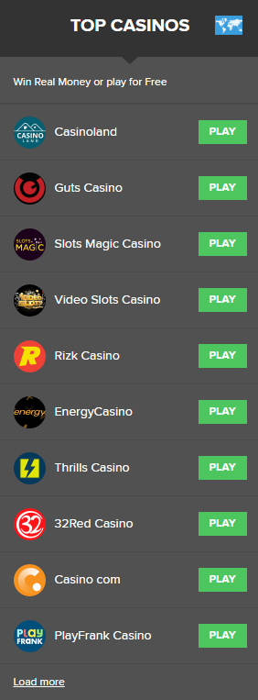
- Category reel that will take users to pages of reviews for different types of games (aka blackjack, video slots, poker, etc)

- Thumbnail section with the latest articles add to the site by admin

- Section for displaying the latest bonus offers added to the site by admin
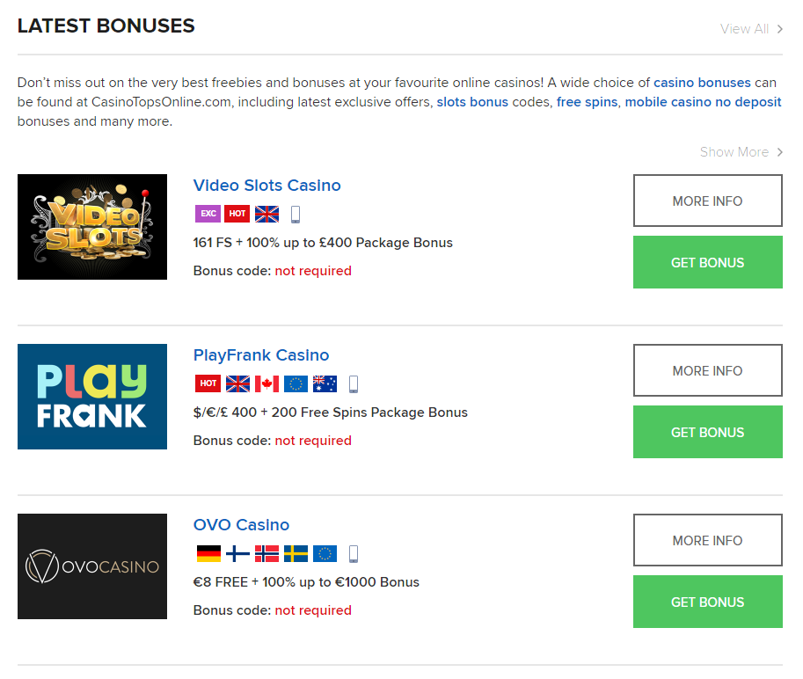
- Section for displaying latest free slot games added to the site by admin
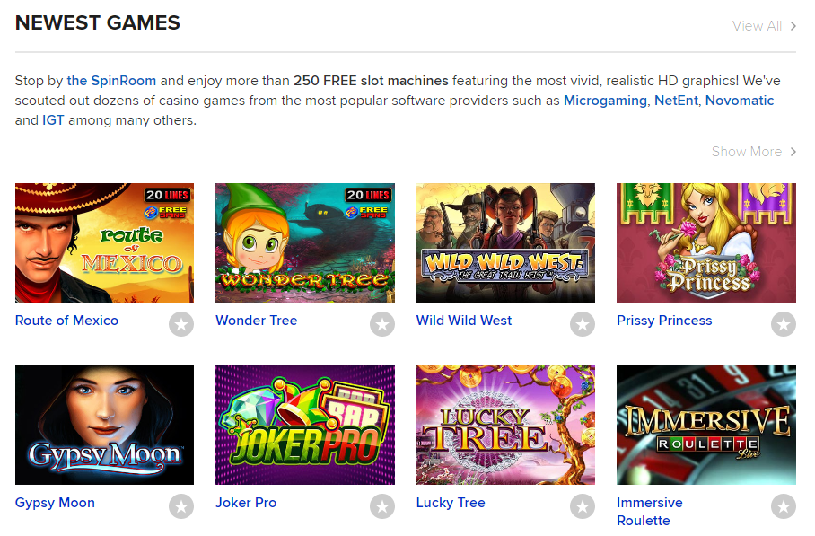
- Section for displaying the highest rated casinos for different categories (aka by region, casino type, games offered)
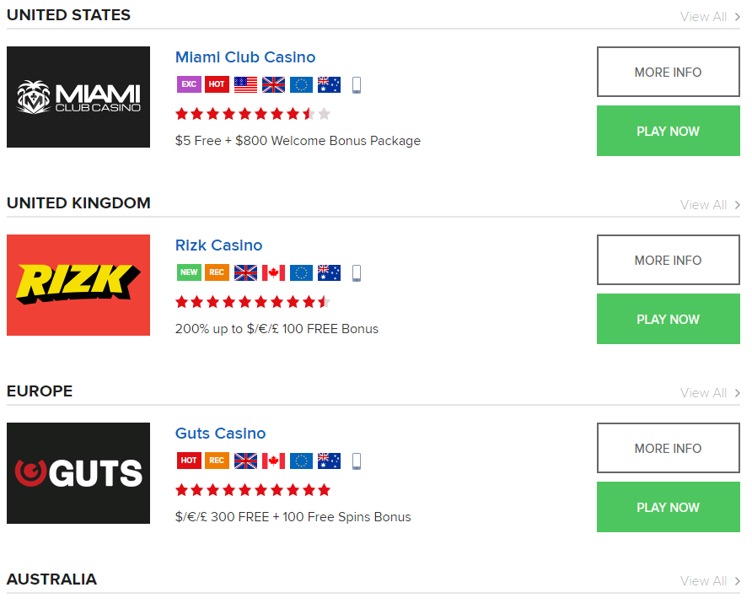
- Section for subscribing to the site, which will send them newsletters whenever a new article is added to the website



Other Pages

- Leaderboard pages for top rated casinos in different categories
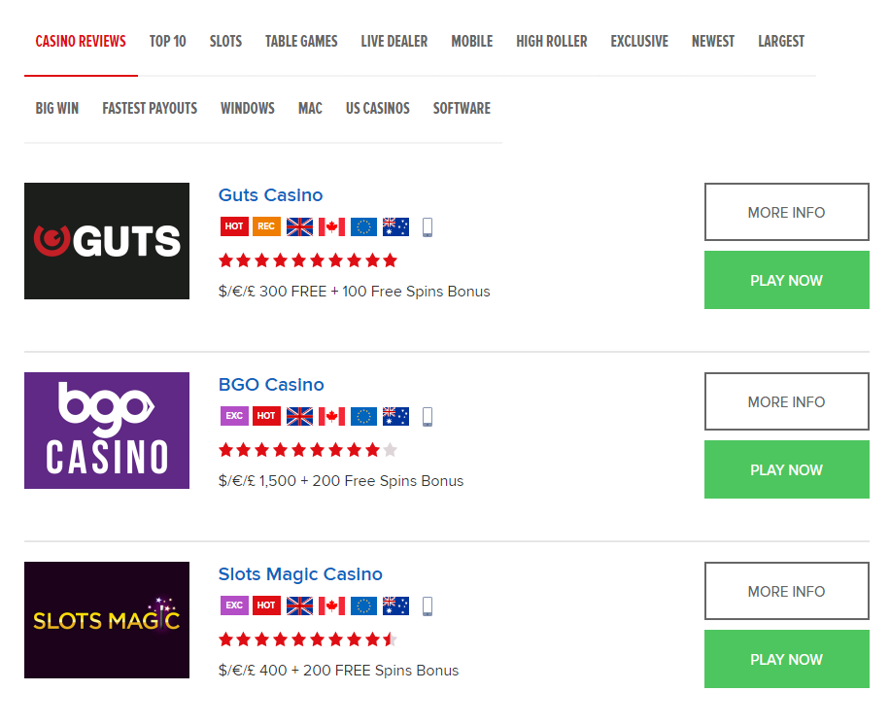
- Casino pages that will host a description, star rating, user reviews, and other useful information
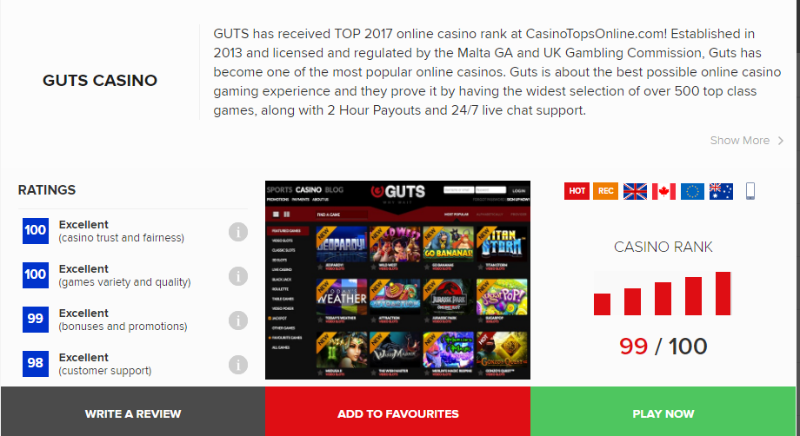
- Slots pages that will give users access to free slot games added by admin
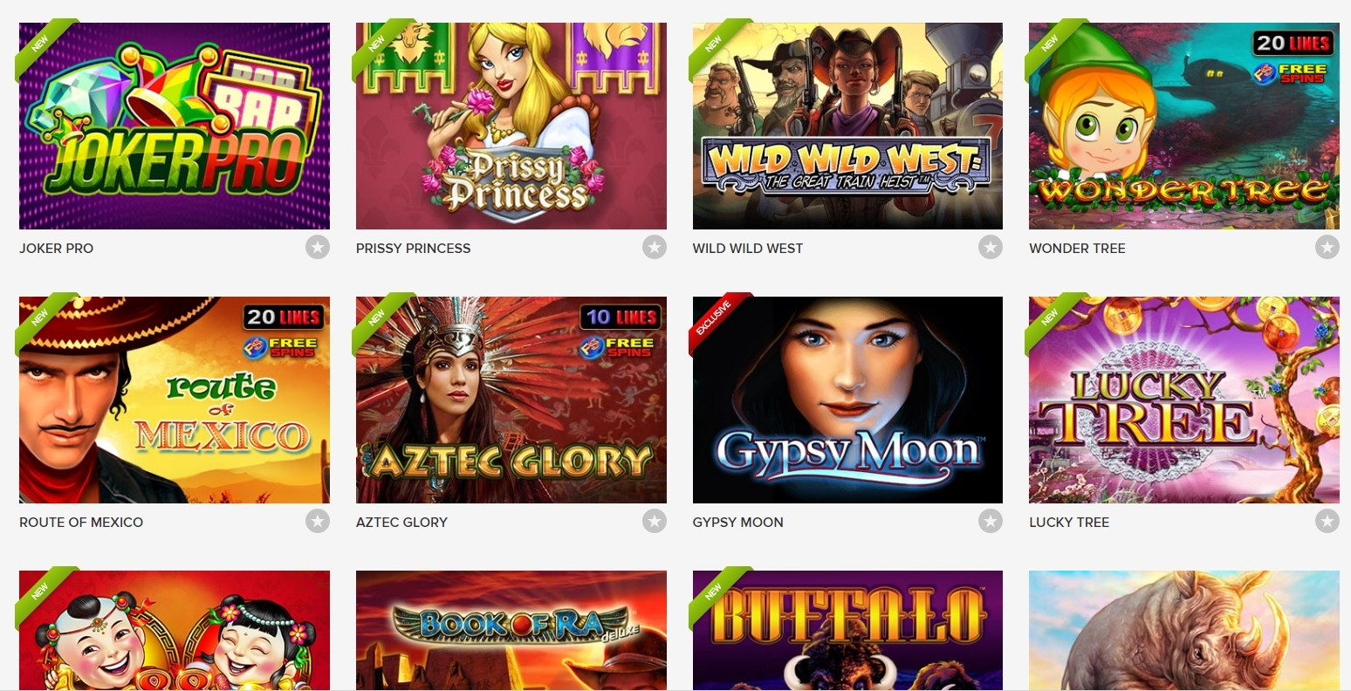
- Login system/User Dashboard with Facebook API functionality for registering/logging in
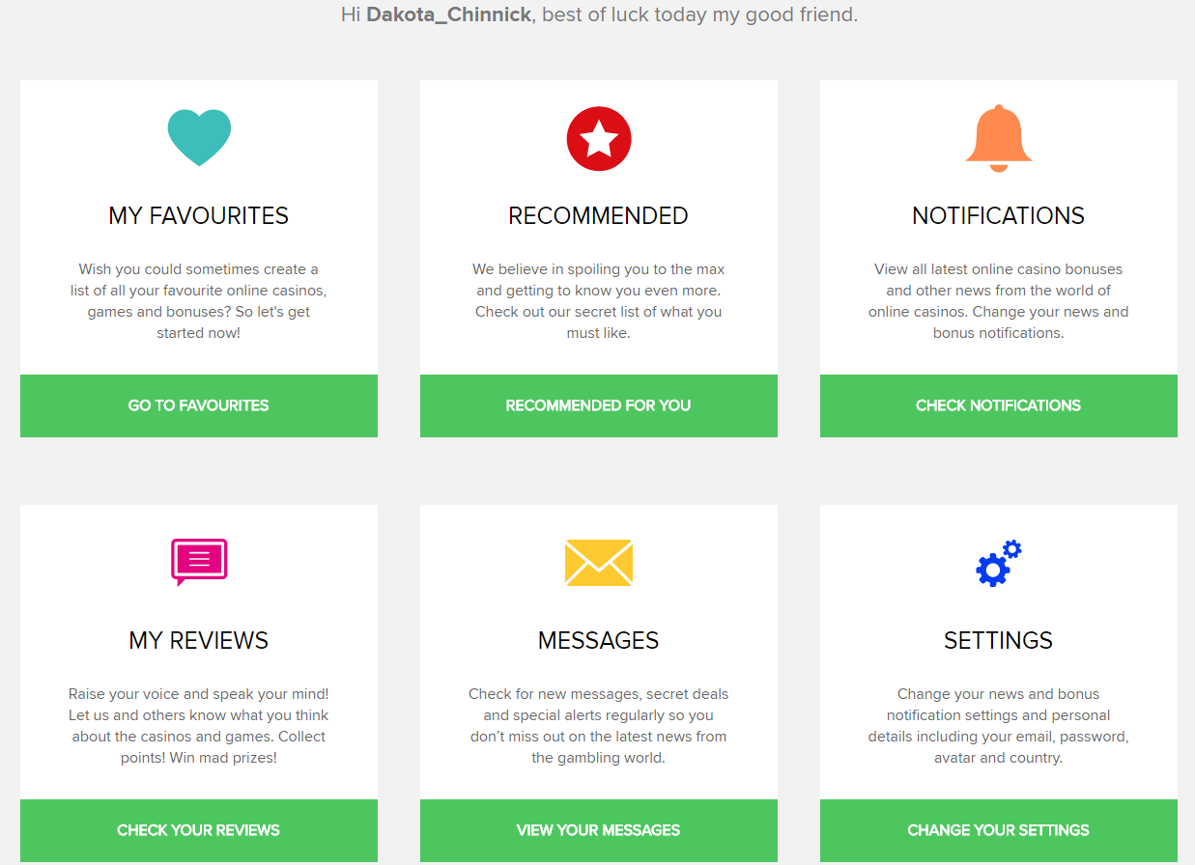
- Bonuses search page that will allow users to search through site bonuses based off certain filters
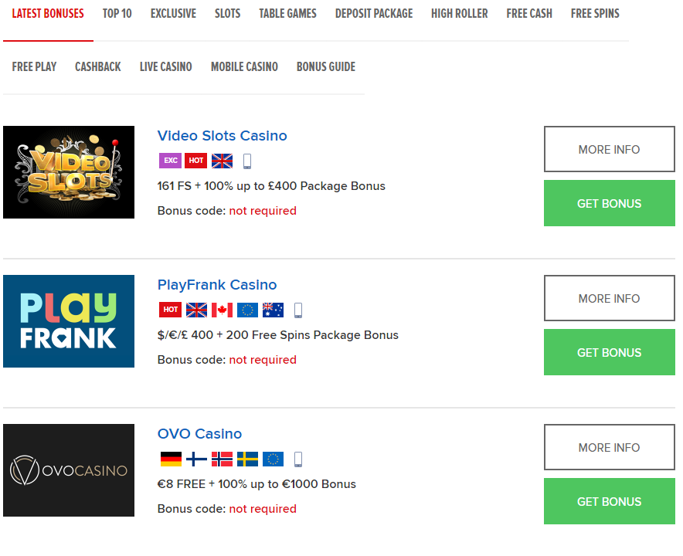

Website Content Developer Not Responsible For

Developer will not be responsible for the content on the website, such as casino review articles, slot games, and bonus descriptions. He will also not be responsible for thumbnail images.

Website Admin Submissions

Website content will be submitted in the same markdown format that we used for the Jekyll project, where there will be a template that the admin can add stuff in such as categories, image filepath, article content, bonus amounts, etc. Files will be named by submission date.

