JOINS
JOIN: A join is an operation that combines rows from two or more tables based on a related column between them. Joins are used to retrieve data from multiple tables by linking them together using a common key or column.
Types of Joins:
1) Inner Join :An inner join combines data from two or more tables based on a specified condition, known as the join condition. The result of an inner join includes only the rows where the join condition is met in all participating tables. It essentially filters out non-matching rows and returns only the rows that have matching values in both tables.
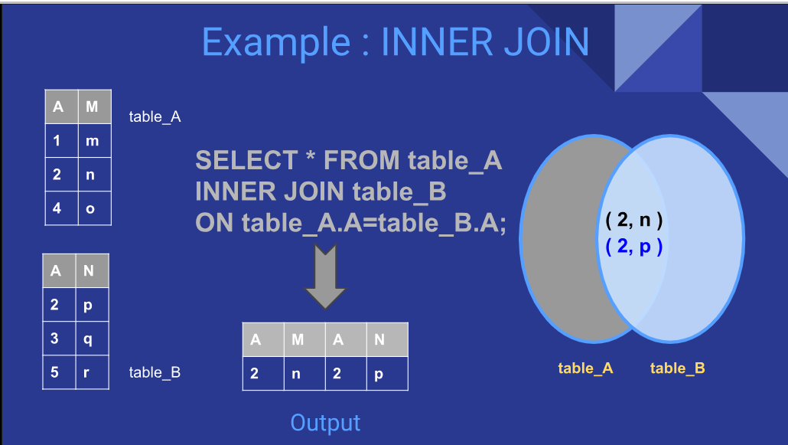
Syntax: SELECT columns FROMtable1
INNER JOIN table2
ONtable1.column = table2.column; --TheONclause specifies the join condition, where you define how the tables are related.
Give me a list of all movies along with their language names,but only if the movie has a valid language in the language table
SELECT f.title, l.name AS language
FROM sakila.film f
INNER JOIN sakila. language l ON f.language_id = l.language_id;
Here: f.title → we are picking the movie title from the film table (we call it f).
--l.name AS language → we are picking the language name from the language table (we call it l) and giving it a column name language.
--INNER JOIN sakila.language l → we are joining the language table, and calling it l.
--ON f.language_id = l.language_id → the “matching rule”: match the language_id in the film table with language_id in the language table.

2) OuterJoin: Outer join combines the data from two or more tables based on a specific condition, just like inner joins. Outer joins also include rows that do not have matching values in both tables. They are particularly useful when you want to include from one table even though there is no corresponding match in the other table
Types: There are three types of outer joins: left outer join,
right outer join, and
full outer join

LEFT JOIN: retrieves all records from the left table and the matched records from the right table. If there are no matches, the result is NULL on the right side. This is particularly useful for finding unmatched records in a dataset or ensuring that all records from one table are included in the result, regardless of their presence in the other table.
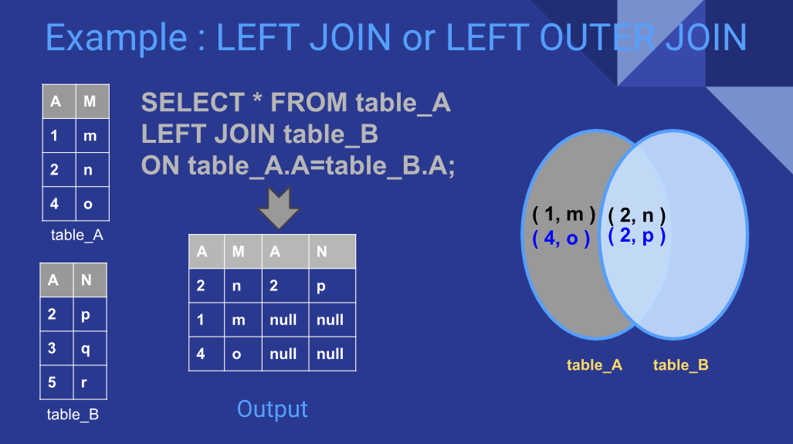
Left Join: Syntax: SELECT * FROM table1
LEFT [ OUTER ] JOIN table2
ON table1.column_name=table2.column_name; --Specifies the condition to match rows between the tables.
Key Points: All rows from the left table: The LEFT JOIN returns all rows from the left table, regardless of whether there are matching rows in the right table.
->NULL values for unmatched rows: If there are no matching rows in the right table, the result will contain NULL for the columns from the right table.
EX: SELECT f.title, c.name AS category
FROM sakila.film f ---left table
LEFT JOIN sakila.film_category fc ON f.film_id = fc.film_id ----This joins the film_category table, which tells us which film belongs to which category.
------------------------------------------------------------------------------------------------------------------------------------------------------------------
RIGHT JOIN: The SQL RIGHT JOIN, joins two tables and fetches rows based on a condition, which is matching in both the tables ( before and after the JOIN clause mentioned in the syntax below) , and the unmatched rows will also be available from the table written after the JOIN clause ( mentioned in the syntax below ).
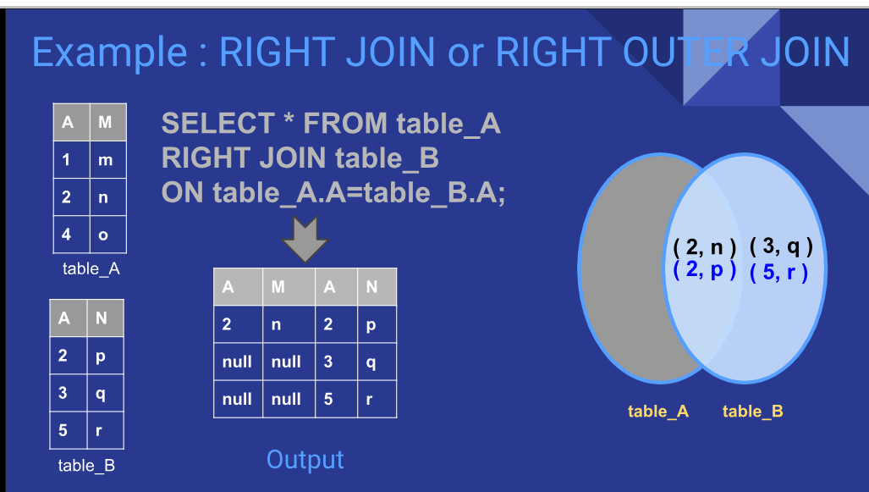
Syntax: SELECT *FROM table1
RIGHT [ OUTER ] JOIN table2
ON table1.column_name=table2.column_name;
Full outer Join: (LEFT JOIN + RIGHT JOIN + UNION):
used to combine rows from two or more tables based on a related column between them. Unlike INNER JOINs which return only matched rows, and LEFT/RIGHT JOINs which return matched rows plus all rows from one table, a FULL OUTER JOIN returns all rows from both tables
includes:
- All matched rows from both tables.
- All unmatched rows from the left table with NULLs for the right table columns.
- All unmatched rows from the right table with NULLs for the left table columns.
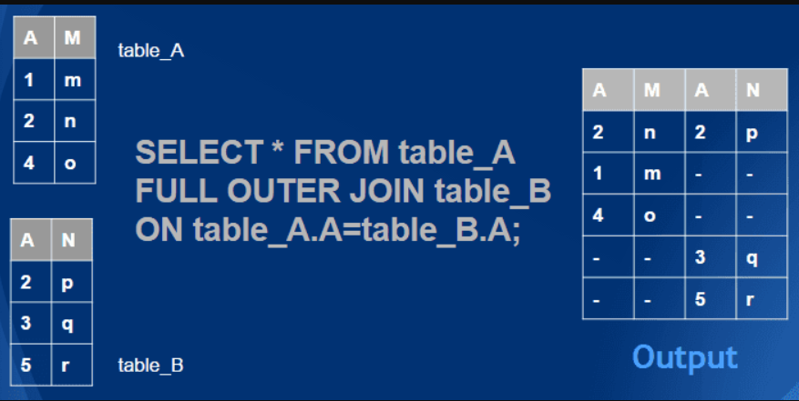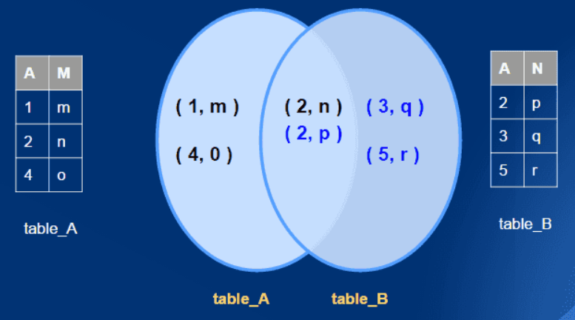
Union: It is used to combine the result set of two or more statements.
-> Every select statement with union must have the same number of columns .
-> the colkulmns must have similar data types .
-> the columns in every select statement must also be in the same order.
Ex: # List all actors and the films they’ve acted in (even if unmatched on either side
---
SELECT a.actor_id, a.first_name, fa.film_id
FROM sakila.actor a --Take all rows from the left table (actor) and match with the right table (film_actor).
LEFT JOIN sakila.film_actor fa ON a.actor_id = fa.actor_id -----| If there’s no match, still keep the left table row, and fill the right side with NULL
UNION --UNION combines the two results and film_id
FROM sakila.actor are moves duplicates .This way, we get all actors and films together, like a FULL OUTER JOIN.
SELECT a.actor_id, a.first_name, fa.
RIGHT JOIN sakila.film_actor fa ON a.actor_id = fa.actor_id;

Ex: #List all customers and all rentals, including those without each other
--LEFT JOIN → all customers + matching rentals
--RIGHT JOIN → all rentals + matching customers
--UNION → everything together

SELECT c.customer_id, r.rental_id
FROM sakila.customer c |-->left join: Take all customers (c) and match them with rentals (r).
LEFT JOIN sakila.rental r ON c.customer_id = r.customer_id -----| If a customer didn’t rent anything, still show them, but rental_id will be NULL.
UNION
SELECT c.customer_id, r.rental_id
FROM sakila.customer c
RIGHT JOIN sakila.rental r ON c.customer_id = r.customer_id;
-----------------------------------------------------------------------------------------------------------------------------------------------------------------
Self Join: A self join is a join in which a table is joined with itself ,especially when the table has a FOREIGN KEY which references its own PRIMARY KEY. To join a table itself means that each row of the table is combined with itself and with every other row of the table. This allows the table to establish a relationship between its rows, such as an employee-supervisor relationship within an organisation's employee table.
Syntax: SELECT a.column_name, b.column_name...
FROM table1 a, table1 b
WHERE a.common_filed = b.common_field;
Example: Consider an Employees table that contains information about employees and their managers
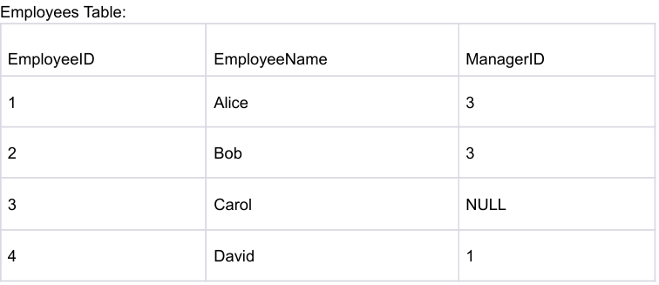
Self Join Query:
SELECT e1.EmployeeName AS Employee, e2.EmployeeName AS Manager
FROM Employees AS e1
JOIN Employees AS e2 ON e1.ManagerID = e2.EmployeeID;
Result: Employee Manager
Alice Bob
Carol Carol
David Alice
--In this example, the self join is performed on the Employees table to find the relationship between employees and their managers. The join condition connects the ManagerID column in the e1 alias (representing employees) with the EmployeeID column in the e2 alias (representing managers)
---
1. Create the staff_demo table
CREATE TABLE sakila.staff_demo (
staff_id INT PRIMARY KEY, --Each staff has a unique ID number (primary key)
first_name VARCHAR(50), store_id INT --which store the staff works in.
);
--------------
-- 2. Insert sample data
INSERT INTO sakila.staff_demo (staff_id, first_name, store_id) VALUES --Adds data into your table.
(1, 'Alice', 1),
(2, 'Bob', 1),
(3, 'Charlie', 2),
(4, 'Diana', 2),
(5, 'Ethan', 1);
----------------
-- 3. Run a self join: find staff pairs working in the same store
SELECT --Show the staff pair (staff_1 and staff_2) and their store.
s1.staff_id AS staff_1_id,
s1.first_name AS staff_1_name,
s2.staff_id AS staff_2_id,
s2.first_name AS staff_2_name,
s1.store_id
FROM sakila.staff_demo s1
JOIN sakila.staff_demo s2
ON s1.store_id = s2.store_id ---Only match rows where both staff are in the same store.
AND s1.staff_id <> s2.staff_id --Make sure we don’t pair someone with themselves.
ORDER BY s1.store_id, s1.staff_id; --Sort the results first by store, then by staff_1 ID.

