INDUSTRIAL TRAINING
An Industrial Training report submitted for partial fulfillment of requirements for the award of
DIPLOMA
IN
COMPUTER ENGINEERING

SUBMITTED BY

A.MOUNIKA TRIPURA SUNDARI 23404-CM-010



DEPARTMENT OF COMPUTER ENGINEERING

ADITYA COLLEGE OF ENGINEERING AND TECHNOLOGIES
(Polytechnic-249)
(Approved by AICTE, Affiliated to SBTET)
ADITYA NAGAR, ADB ROAD, SURAMPALEM-533437 www.aec.edu.in

(2023-2026)

ADITYA COLLEGE OF ENGINEERING AND TECHNOLOGIES
(Polytechnic-249)
(Approved by AICTE, Affiliated to SBTET)

DEPARTMENT
OF
COMPUTER ENGINEERING

CERTIFICATE

This is to certify that the industrial training report being submitted by A.MOUNIKA TRIPURA SUNDARI bearing roll no.23404-CM-010 in partial fulfilment for the award of the Diploma in Computer Engineering. It is record of
Bonafide work carried out by me under the esteemed guidance and supervision of
Ms. L.KARTHIKEYA REDDY.

L.KARTHIKEYA REDDY | P.SUNEETHA SRI
TRANING GUIDE | HEAD OF THE DEPT.
LECTURER | COMPUTER ENGINEERING

EXTERNAL EXAMINER

ACKNOWLEDGEMENT

I would like to take this opportunity to express my profound sense of gratitude to Principal Mr. S.T.V.S KUMAR, Aditya Engineering College (Polytechnic-404) for his refining comments and critical judgments of the industrial training.

I have great pleasure in expressing my deep sense of gratitude to our Head of the Department Mrs. P. SUNEETHA, Department of computer Engineering, Aditya Engineering College (polytechnic-404) for providing all necessary support for successful completion of our training.

I would like to express my special thanks of gratitude to my trainer Mr. JVR RAMAKRISHNA, who gave me the golden opportunity to do this Industrial Training in CAD DESK IT DESK PVT LTD which helped me in learn so many new things, Knowledge and Hands- on experience.

I wish to convey my sincere gratitude to my guid. Mr.L.KARTHIKEYA REDDY Department of Computer Engineering, Aditya College OF Engineering (polytechnic-249), Surampalem. We are highly Indebted to her for her guidance, timely suggestions at every stage and encouragement to complete this training successfully.

I thank all the staff members of our department & the college administration and all my friends who helped me directly and indirectly in carrying out this training successfully.

Sincerely,
A.MOUNIKA TRIPURA SUNDARI
23404-CM-010

ABSTRACT
The “Fraud Guard – Credit Card Fraud Detection System” is a smart web application developed to identify fraudulent credit card transactions using Machine Learning techniques. The system analyzes transaction details such as merchant name, amount, category, and location to determine whether a transaction is safe or fraudulent. It provides real-time fraud analysis and helps users monitor suspicious activities effectively. The application includes secure login authentication, transaction analysis, dashboard monitoring, and transaction history tracking. A Random Forest Machine Learning model is used to improve fraud prediction accuracy. The system is built using React for frontend development and Supabase for database management. This project helps banks and users reduce financial losses caused by online payment frauds. The application analyzes transaction details such as merchant name, transaction amount, category, and location to determine whether a transaction is safe or fraudulent. The system uses the Random Forest Algorithm for fraud prediction and provides features like secure login, dashboard monitoring, transaction analysis, and transaction history management.
INDEX

S.NO Topic Name Page NO
- Introduction to HTML 1-7
HTML
Basic HTML Document
Basic Tags
Heading Tags
Paragraph Tag
HTML Anchor Tag
HTML Image Tag
Presentation Formatting Tags
HTML Table Tag And Form Tag
- CSS 8-11
Introduction to CSS
Types of Stylesheets
CSS Selectors
CSS Background
Properties CSS
Box Model CSS Position property Z- index Property CSS Overflow Property Opacity and Box-Shadow 3 BOOTSTRAP 12-14
Introduction to Bootstrap
Bootstrap CDN & offline link inserting
Bootstrap Grid system
Bootstrap images
Bootstrap Tabel
Bootstrap Model
Bootstrap Alert

4 JAVASCRIPT 15-17

Introduction to JavaScript
JavaScript Variables
JavaScript Operators
JavaScript Functions
JavaScript Arrays
JavaScript Objects
JavaScript DOM
Manipulation JavaScript
Events
JavaScript Form Validation
5 JQuery 18-19
Introduction to jQuery jQuery Selectors jQuery Events
jQuery Effects

6 React JS
ReactJs React
Render Html
React Events
React lists
React Forms
ReactRouterReact
CSS styling React Sass
styling

7 Python 22-23
Introduction to python
Applications of
Python Variables
& Data Types
Conditional
Statements Loops
Input &
Output
Key
Features
Functions

8 Software Engineering 24-28
Introduction to Software
Engineering Software Development
Life Cycle (SDLC) Software Testing
Life Cycle (STLC)

9 Django 29-30
Introduction to Django
Django MVT
Architecture
Creating a Simple Django Project
Creating a Django
App DJango
Template
Advantages
10 Java 31-32
Introduction to Java Syntax Looping
Statement
OOPs
Concept

11 GIT AND GITHUB 33-34
Introduction to
Git Key
Features of Git
CommonGit Commands
Introduction to GitHub
Difference Between Git and GitHub
How Git and GitHub Work Together
Benefits of Using Git & GitHubs

- SQLite Database 35-36
Introduction to SQLITE Data Storage
commands
SQLite with Python
Limitations of SQlite
- Project- Fraud Guard 37-43
- Conclusion 44

1. INTRODUCTION TO HTML

1. HTML
HTML (Hyper Text Markup Language) is the standard language used to create and design web pages. It structures the content on the web by using various tags and elements. HTML defines how text, images, links, videos, and other multimedia are displayed in a browser.
Example Code
<!DOCTYPE html>

<html>

<head>

<title>HTML Introduction</title>

</head>

<body>

<h1>Hello, World!</h1>

<p>This is my first HTML page.</p>

</body>

</html>

Output:

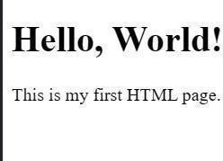

2. Basic HTML Document

An HTML document is the foundation of every web page. It uses a series of tags to structure and display content in a browser.
Tag | Description
<!DOCTYPE html> | Declares that the document type is HTML5.
<html> | Root element that wraps all the content of the page.
<head> | Contains metadata like the title, styles, and scripts.
<title> | Defines the title of the web page shown in the browser tab.
<body> | Contains the visible content of the web page.
Example Structure

<!DOCTYPE html>

<html>

<head>

<title>My Webpage</title>

</head>

<body>

<h2>Welcome!</h2>

<p>This is a simple webpage.</p>

</body>

</html>

Output:

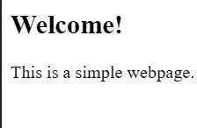

3. Basic Tags in HTML

Definition
• Basic HTML tags are used to structure and format content on web pages. Important Basic Tags
Tag | Purpose
<h1> ... <h6> | Headings
<p> | Paragraph
<br> | Line break
<hr> | Horizontal line
<strong> | Bold text
<em> | Italic text

4. Heading Tags
HTML provides heading tags to define headings and subheadings on a web page.
There are six levels of heading tags in HTML, ranging from <h1> to <h6>.

5. Paragraph Tag
The paragraph tag (<p>) in HTML is used to define blocks of text as paragraphs Example:
<p>This is the first paragraph.</p>
<p>This is another paragraph with separate spacing.</p>

6. HTMLAnchor Tag
The HTML anchor tag is used to create hyperlinks in a webpage. It allows users to navigate from one page to another or to different sections within the same page.
Syntax:

<a href="https://www.google.com">Visit Google</a>
Attribute | Description
href | Specifies the URL of the page the link goes to.
target | Specifies where to open the linked document (_blank, _self, _parent, _top).
title | Provides additional information about the link (appears as a tooltip).
download | Allows users to download the linked file.
name | Used to create bookmarks within the page.

7. HTML Image Tag
The HTML <img> tag is used to embed images into a webpage. It helps display pictures, logos, diagrams, and other graphical elements to make web pages visually appealing and informative.
Syntax:

<img src="flower.jpg" alt="Beautiful Flower">

8. Presentation Formatting Tags
Presentation tags in HTML are used to control the appearance (style or formatting) of text and elements in a webpage. These tags define how the content looks—such as bold, italic, underlined, or centered—rather than its structure or meaning.

Tag | Description
<b> | Displays text in bold style.
<i> | Displays text in italic style.
<u> | Underlines the text.
<big> | Increases the font size of text.
<small> | Decreases the font size of text.
<sub> | Displays text as subscript (below baseline).
<sup> | Displays text as superscript (above baseline).
<strike> | Adds a line through the text (deprecated).
<center> | Centers the content horizontally on the page (deprecated).

9. HTMLTable Tag
In HTML, the table tags are used to display data in a tabular (row and column) format.

Important Tags

Tag | Description
<table> | Table container
<tr> | Table row
<td> | Table data
<th> | Table header

Example
<table border="1">
<tr>
<th>Name</th><th>Age</th>
</tr>
<tr>
<td>BALA</td><td>20</td>
</tr>
<tr>
<td>SAI</td><td>21</td>
</tr> </table>
Output:

Name | Age
Raghu | 18
Ram | 19

10. HTML Form Tag

Definition
• Forms collect input from users (login, signup, feedback forms).

Important Tags

Tag | Usage
<form> | Form container
<input> | Text fields, buttons
<textarea> | Multi-line input
<button> | Button
<select> / <option> | Dropdown

11. HTML Background Image
Used to set background image for webpage using CSS.

Example
<body style="background-image: url('bg.jpg');">

<h2>Welcome Page</h2>

</body>

Or inside CSS block:
<style> body{ background-image: url('bg.jpg'); background-size: cover; background-repeat: no-repeat;
}

</style>

2. CSS

1. Introduction to CSS
CSS (Cascading Style Sheets) is a stylesheet language used to control the look and layout of web pages. It describes how HTML elements should be displayed on the screen, paper, or in other media.
Example
<p style="color: blue; font-size: 20px;">Hello CSS!</p>

2. Types of StyleSheets

Definition
CSS can be applied to HTML in three ways:

1. Inline CSS
Inline CSS is written directly inside the HTML element using the style attribute.

<p style="color: red;">Inline CSS Example</p>

2. Internal CSS
Internal CSS is defined inside the <style> tag within the <head> section.

<head> <style> h1 { color: blue; }
</style> </head>

3. External CSS
External CSS is written in a separate .css file and linked to the HTML document using the <link> tag.

index.html
<link rel="stylesheet" href="style.css">
<h1>External CSS Example</h1>
style.css h1 { color: green; }

3. CSS Selectors
CSS Selectors are patterns used to select and style HTML elements. They tell the browser which elements to apply the CSS rules to the html elements.Selectors are one of the most important parts of CSS because they define the connection between HTML and styling.

Types Of Selectors

Selector | Description | Example
Element | Targets a specific HTML tag | p {}
ID | Unique element | #header {}
Class | Multiple elements | .btn {}
Universal | All elements | * {}
Grouping | Many selectors | h1, h2 {}

4. CSS Background Properties
Used to set background style of elements & pages.

Common Properties

Property | Usage
background-color | Set background color
background-image | Set image
background-repeat | Repeat control
background-size | Fit image

Example
body { background-color: lightblue; background-image: url("bg.jpg"); background-repeat: no-repeat; background-size: cover;
}

5. CSS Box Model
The CSS Box Model describes how elements are displayed as boxes.

• Each box has:
- Content
- Padding
- Border
- Margin Example

div { margin: 10px;
padding: 20px; border: 2px solid black;
}

6. CSS Position Property
Position property controls how elements are positioned.

Type | Meaning
static | Default
relative | Move from original position
absolute | Positioned relative to parent
fixed | Stays fixed during scroll
sticky | Sticks on scroll

7. Z-Index Property
- Controls stacking order of overlapping elements.
- Higher value appears above lower value.
Example
.box1 { position: absolute; z-index: 1; }

8. CSS Overflow Property

Controls how content behaves when it overflows the element box.

Types

Value | Meaning
visible | Default
hidden | Cuts overflow
scroll | Adds scrollbars
auto | Scroll only if needed

Example

div {
width: | 100px;
height: | 100px;
overflow: scroll;
}

9. Opacity & Box-Shadow

Opacity : Controls transparency of element

Box-Shadow : Adds shadow around element

3. BOOTSTRAP

1. Introduction to Bootstrap
Bootstrap is a popular front-end framework used to design responsive, mobile-first websites quickly. It provides ready-made CSS styles and JavaScript components such as buttons, forms, tables, navigation bars, and modals.

Features
- Responsive grid layout
- Predefined CSS utility classes
- Reusable UI components
- Built-in JavaScript plugins
2. Bootstrap CDN & Offline Linking

CDN Method (Online)
- Loads Bootstrap directly from the internet.
- No download required; fast and easy.

<link

href="https://cdn.jsdelivr.net/npm/bootstrap@5.3.2/dist/css/bootstrap.min.css" rel="stylesheet">

<script

src="https://cdn.jsdelivr.net/npm/bootstrap@5.3.2/dist/js/bootstrap.bundle.min.js"> </script>

Offline Method
- Download Bootstrap → place in project folder.
- Works without internet.

<link rel="stylesheet" href="bootstrap/css/bootstrap.min.css">
<script src="bootstrap/js/bootstrap.bundle.min.js"></script>

3. Bootstrap Grid System
Bootstrap uses a 12-column responsive grid system to create flexible layouts. It adjusts automatically for mobile, tablet, and desktop screens.
Common breakpoints: col-sm, col-md, col-lg, col-xl.

4. Bootstrap Images
Bootstrap provides classes that make images responsive and visually appealing.

Common Classes
- .img-fluid → responsive image
- .img-thumbnail → border + padding
- .rounded, .rounded-circle → rounded shapes
- .float-start, .float-end, .mx-auto → alignment

Example
<img src="photo.jpg" class="img-fluid rounded-circle" width="200">

5. Bootstrap Tables
Bootstrap improves the look of tables using built-in styles like borders, stripes, hover effects, and dark themes.

Common Table Classes
- .table → basic Bootstrap table
- .table-striped → zebra-striping
- .table-bordered → cell borders
- .table-hover → hover highlight
- .table-dark → dark theme
- .table-responsive → scrollable on small screens

6. Bootstrap Modal
A modal is a popup box used for showing information, alerts, or forms without leaving the current page.

Key Features
- Includes header, body, and footer
- Can open via button or JavaScript
- Used for alerts, login forms, confirmations

7. Bootstrap Alerts
Alerts are used to display messages, warnings, errors, or success notifications.

Common Alert Classes
- .alert-primary → general info
- .alert-success → success
- .alert-danger → error
- .alert-warning → warning
- .alert-info → information

4. JavaScript

Introduction
JavaScript is a powerful scripting language used to make web pages interactive and dynamic. It runs directly in the browser and can update content, validate forms, create animations, and handle user actions without reloading the page.
Key Features:
- Supports event handling and validation
- Enables dynamic content updates
- Works on both client and server side (with Node.js)

Basic Example
<script> document.write("Welcome to
JavaScript!");
</script>

Output: Welcome to JavaScript!

JavaScript Variables
Variables are containers that store data values. In JavaScript, variables can be declared using var, let, or const.

Types of Variable Keywords

Keyword | Scope | Re-assignment | Modern Use
var | Function Scope | Allowed | Old (Avoid)
let | Block Scope | Allowed | Recommended

JavaScript Operators
Operators are symbols used to perform operations.

Types
- Arithmetic (+ - * / %)
- Comparison (== === != > <)
- Logical (&& || !)
- Assignment (= += -=)
- Ternary (condition ? true:false)

JavaScript Functions
Functions are reusable blocks of code that perform a certain task.

Syntax function greet() { console.log("Good Morning!");
} greet();

JavaScript Arrays
A JavaScript Array is a collection used to store multiple values in a single variable.
Arrays can hold different data types like numbers, strings, or objects.

Common Methods

- push() – add element
- pop() – remove last element
- sort() – sort array
- length – array size

JavaScript Objects
Objects store data in key:value format.

JavaScript DOM Manipulation
DOM means Document Object Model, used to interact with HTML elements.
- Select & Change Element
- document.getElementById("title").innerHTML = "Welcome!";
- Change Style document.getElementById("box").style.color = "blue";

JavaScript Events
Interaction triggers such as click, key press, hover, submit, etc.

Example
<button onclick="alert('Clicked!')">Click Me</button>

JavaScript Form Validation
Used to check input data before submission.

5. JQUERY

Of jQuery
jQueryis afast and lightweight JavaScript library designed to simplify HTMLdocument traversal,
event handling, animations, and AJAX interactions. It makes JavaScript coding shorter and easier.
Key Features:
- Simplifies HTML and CSS manipulation
- Supports animations and effects
- Provides AJAX support for dynamic web pages
- Works across all major browsers

jQuery Selectors
jQuery Selectors are used to select and manipulate HTML elements easily. They use a simple
syntax similar to CSS selectors to target elements based on their tag, id, class, or attributes.

Common jQuery Selectors:
- $("tag") – Selects all elements with the given tag
- $("#id") – Selects an element by its ID
- $(".class") – Selects all elements with the given class
- $("*") – Selects all elements

jQuery Events
jQuery Events are actions or occurrences that happen in the browser, such as clicking a button,
loading a page, or typing in a textbox
Syntax: $(selector).method(function)

Common jQuery Event Methods:
- click() – Triggered when an element is clicked
- dblclick() – Triggered on double-click
- mouseenter() / mouseleave() – When the mouse enters or leaves an element
- keydown() / keyup() – When a key is pressed or released
- submit() – When a form is submitted

jQuery Effects

jQuery Effects are used to create visual animations and transitions on web pages. They make websites more interactive and engaging by allowing elements to show, hide, fade, or slide smoothly.

Common jQuery Effects:

- show() – Displays hidden elements
- hide() – Hides visible elements
- toggle() – Toggles between show and hide
- fadeIn() / fadeOut() / fadeToggle() – Fades elements in or out
- slideDown() / slideUp() / slideToggle() – Slides elements vertically

6. ReactJS

to ReactJS
React JS is a popular JavaScript library used for building user interfaces (UIs), especially for single- page applications (SPAs). It was developed by Facebook to make front-end development faster and more efficient.

Key Features:
- Component-Based: UI is divided into reusable, independent components.

- Virtual DOM: Enhances performance by updating only changed elements.

- JSX (JavaScript XML): Allows writing HTML within JavaScript.

- Unidirectional Data Flow: Data flows in one direction, making apps predictable.

React Render HTML
In React JS, rendering means displaying HTML content on the web page. React uses the ReactDOM.render() method to render elements or components into the DOM.
Syntax:
ReactDOM.render(element, container);

- element → The React element or component to display
- container → The HTML element where it will be rendered

React Events
React Events are actions that occur as a result of user interaction, such as clicking a button, typing text, or submitting a form.
- onClick – When an element is clicked

- onChange – When input value changes

- onSubmit – When a form is submitted
- onMouseOver – When the mouse moves over an element

- onKeyDown – When a key is pressed

React Lists

In React, lists are used to display a collection of similar items, such as names, numbers, or products. Lists are usually created by using the JavaScript map() function, which loops through an array and returns JSX elements.
Each item in a list should have a unique key prop to help React identify and efficiently update elements.

React Forms

React Forms are used to collect and manage user input like text, email, passwords, etc. Unlike HTML forms, React uses state to control and handle form data dynamically, making it easy to track changes and perform validation.

React Router

React Router is a powerful library used for navigation and routing in React applications. It allows users to move between different components or pages without reloading the entire page, making the app feel faster and smoother.
Key Features:

- Enables multiple page views in a single-page app
- Uses dynamic routing based on URL changes
- Provides components like <BrowserRouter>, <Routes>, and <Route>
- Supports navigation using <Link> and useNavigate()

React CSS Styling

React supports multiple styling methods:

1. Inline CSS

2. External CSS File React Sass Styling
Sass (Syntactically Awesome Stylesheet) is a CSS pre-processor that adds extra features like variables, nesting, mixins, and reduces repetitive CSS.

7. PYTHON

to Python
Python is a powerful, high-level, general-purpose programming language developed by Guido van Rossum in 1991. It is known for its simple syntax, readability, and versatile application in web development, data science, AI, automation, and more.

Key Features
- Interpreted Language – Executes code line by line.
- Portable and Cross-Platform – Runs on Windows, macOS, Linux, etc.
- Extensive Libraries – Has built-in modules and external packages (like NumPy, Pandas).

Applications of Python
- Web development (Django, Flask)
- Machine Learning & AI (TensorFlow, Scikit-Learn)
- Data Science & Analytics (Pandas, NumPy)
- Game Development
- Automation / Scripting
- Cybersecurity & Networking Variables & Data Types name = "RAGHU" age = 18 pi =3.14
is_student = True

Input & Output
name = input("Enter your name:")
print("Welcome", name)

Conditional Statements
x = 10 if x > 5: print("Greater") else:
print("Smaller")

Loops
for i in range(1,6): print(i)

Functions
def greet():
print("Hello Python")
greet()

List Example
fruits =["apple","banana","mango"]
print(fruits[1])

Dictionary Example

student = {"name":"Surya","age":21} print(student["name"])

8. SOFTWARE ENGNINEERING

1. Introduction to Software Engineering

Software Engineering is the disciplined process of designing, developing, testing, and maintaining software systems.

2. Key Principles of Software Engineering

- Modularity
Dividing software into small, independent modules that can be developed, tested, and maintained easily.
- Abstraction
Showing only necessary features and hiding internal implementation details to reduce complexity.
- Encapsulation
Wrapping data and related functions into a single unit (class/object) and protecting internal data from outside interference.
- Reusability
Using existing components or modules in new applications to save time, effort, and cost.
- Maintenance
Regularly updating software to fix bugs, improve performance, add new features, and strengthen security.

3. Software Development Life Cycle (SDLC)

SDLC is a step-by-step, structured process used to build high-quality software. It defines all stages ensuring the final product meets user requirements at minimal cost.
Purpose of SDLC

- Provides a clear development plan

- Ensures organized workflow

- Delivers reliable, functional software
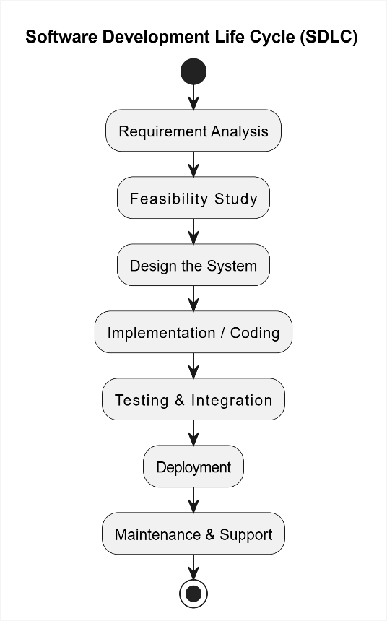

Common SDLC Models

- Waterfall Model

- V-Model

- Spiral Model

- Agile Model

- Iterative Model

4. Software Testing Life Cycle (STLC)

STLC is the structured process of testing software to ensure its quality, correctness, and reliability.
It runs parallel to SDLC and ensures that every defect is identified and resolved before release.

Phases of STLC

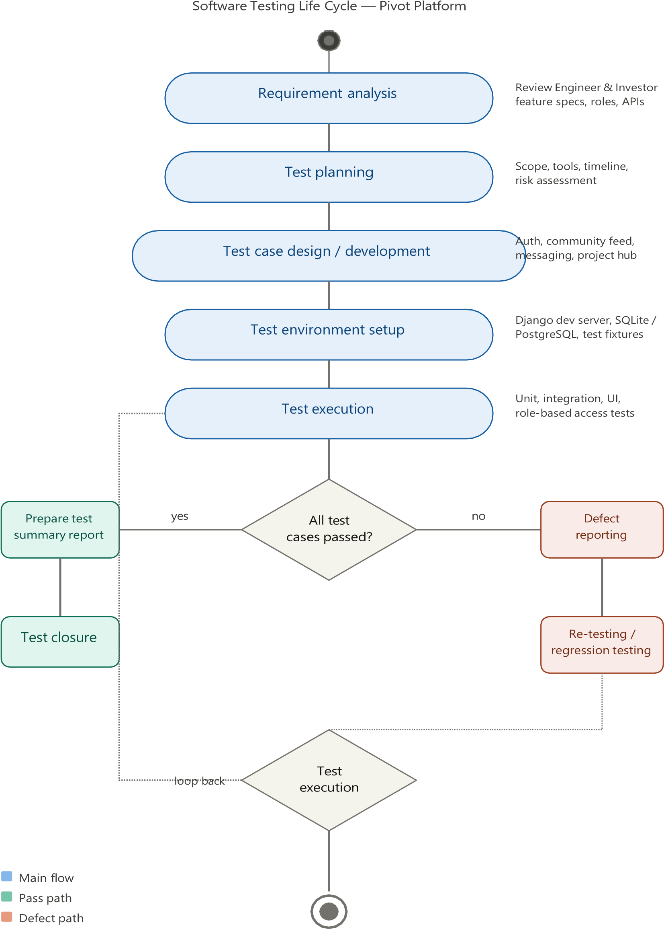

Requirement Analysis

- Understand what needs to be tested

- Identify functional and non-functional requirements
- Identify testable and unclear areas

- Prepare requirement traceability matrix

2. Test Planning

- Create the overall testing strategy

- Estimate effort, cost, and resources

- Identify testing tools

- Assign roles and responsibilities

3. Test Case Development

- Write detailed test cases
- Prepare test data

- Review and finalize test cases

4. Test Environment Setup

- Configure hardware, software, and network

- Install test tools and frameworks

- Ensure environment is stable and ready for test execution

5. Test Execution

- Execute test cases

- Compare actual results with expected results

- Log defects and report issues

- Re-test after bug fixes

6. Test Closure

- Prepare test summary report

- Evaluate test coverage

- Document lessons learned

- Confirm deliverables are completed

9. DJANGO
Introduction:
Django is a high-level Python web framework used for developing secure, scalable, and maintainable web applications quickly and efficiently. It was created to help developers build web applications faster, with less code.
Pivot Platform — class diagram
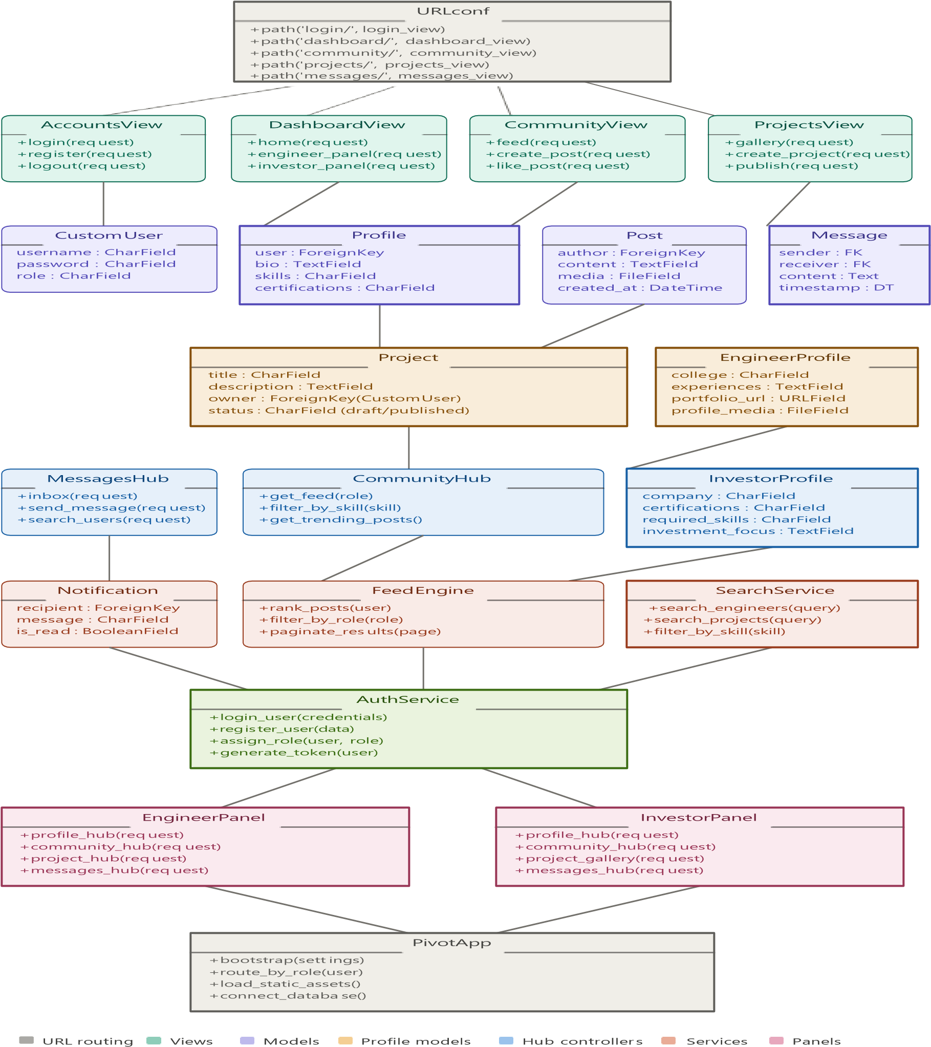

Key Features of Django
- Rapid Development: Simplifies web app creation by providing prebuilt components.
- Security: Protects against SQL injection, XSS, and CSRF attacks.
- Scalability: Handles heavy traffic efficiently with database optimization.

Django Architecture (MVT Pattern)
Django’s MVT (Model–View–Template) architecture separates the business logic, data handling, and user interface.

Workflow:
- The user sends a request through a URL.
- The View processes the request using the Model.
- The Template displays the data back to the user.

Django Template System
Templates are used to separate the presentation layer (HTML) from the logic.
They use dynamic placeholders like {{ variable }} to display values.

Advantages of Using Django
- Built-in Admin Interface: Saves development time.

- ORM (Object Relational Mapper): Simplifies database operations.

- Community Support: Large and active developer community.

- Scalable Framework: Used by companies like Instagram, Pinterest, and Spotify.

10. JAVA

Introduction to Java
Java is a high-level, object-oriented, and platform-independent programming language developed by James Gosling at Sun Microsystems in 1995 (now owned by Oracle). It is widely used for building desktop, web, and mobile applications.
Java follows the principle of —Write Once, Run Anywhere (WORA)”, meaning that code written in Java can run on any device that has a Java Virtual Machine (JVM).

Features of Java
- Simple: Easy to learn and syntactically similar to C and C++ but without complex features like pointers.
- Object-Oriented: Everything in Java revolves around objects and classes.
- Platform Independent: It is compiled into bytecode, runs on any platform.

Syntax and Basic Structure of a Java Program
Every Java program must contain a class definition, and inside that class, a method named main() serves as the entry point of execution. Program Example: Basic Structure class HelloWorld { public static void main(String[] args) {
System.out.println("Welcome to Java Programming!");

}
}

Output:
Welcome to Java Programming!

Looping Statements in Java

Looping statements allow repeated execution of a block of code as long as a condition is true. They are fundamental for automating repetitive tasks.

Types of Loops in Java
- for Loop
- while Loop
- do-while Loop

Object-Oriented Programming (OOP) Concepts
Java is fundamentally based on Object-Oriented Programming (OOP). It organizes code into classes and objects, promoting reusability and modularity.

Major OOP Principles:
- Class
- Object
- Encapsulation
- Inheritance
- Polymorphism
- Abstraction

11. GIT & GITHUB

Git – Introduction
Git is a distributed version control system (VCS) that allows developers to track changes in their code, manage versions, and work collaboratively without losing previous work. It stores the entire project history and enables multiple people to work simultaneously.

Key Features of Git
- Distributed System: Every developer has a local copy of the entire repository.
- Branching & Merging: Allows creating separate branches for new features and merging them easily.
- Speed & Efficiency: Very fast operations like committing, branching, and merging.
- Data Integrity: Uses SHA-1 checksum to protect code from corruption.

Common Git Commands
- git init → Creates a new repository
- git clone <url> → Downloads a repository
- git add . → Stages changes
- git commit -m "message" → Saves changes
- git push → Uploads changes
- git pull → Fetches updates

GitHub – Introduction
GitHub is a cloud-based platform used to host Git repositories. It enables developers to store code online, collaborate with others, and manage projects efficiently. GitHub works on top of Git, providing a user-friendly interface.

Key Features of GitHub
- Remote Repository Hosting
- Collaboration Tools: Pull requests, code reviews, issues, and discussions
- Project Management: Kanban boards, milestones, labels
- Open-Source Community: Millions of public repositories
- Security: Code scanning, branch protection, access control

Difference Between Git and GitHub

Git | GitHub
A version control system installed on your system. | Cloud platform that hosts Git repositories.
Works offline. | Requires internet to access remote repos.
Tracks version history locally. | Provides collaboration, issue tracking, CI/CD, etc.
No GUI by default. | Provides web interface and desktop app.

How Git and GitHub Work Together
- Git tracks project changes locally.
- GitHub stores the project online as a remote repository.
- Developers push code to GitHub and pull updates from it.

Benefits of Using Git & GitHub
- Better teamwork and collaboration
- Easy tracking of who changed what and when
- Secure backup of code on the cloud
- Faster development with branches
- Helpful for open-source contribution and portfolio building

12. SQLITE DATABASE

Introduction to SQLite
SQLite is a lightweight, fast, and self-contained database management system that stores data in a single file on the device. Unlike other databases, it doesn’t require a separate server process, making it ideal for embedded systems, mobile apps, and small applications.
It is an open-source, relational database that uses SQL (Structured Query Language) to manage and manipulate data.

SQLite Architecture and Data Storage
SQLite stores the entire database (tables, indexes, and data) in a single file. It follows a client-side architecture, meaning all SQL operations happen inside the application using the SQLite library.
Structure Overview:
- Database File: Contains all tables and records.
- SQLite Engine: Processes SQL queries.
- API Interface: Allows languages like Python, C, and Java to communicate with the database.
Flow Diagram:
Application → SQLite Engine → Database File (.db)

- Reliable for embedded and standalone projects.

Basic SQLite Commands
Below are commonly used SQL commands supported by SQLite.

Command | Purpose
CREATE TABLE | Creates a new table.
INSERT INTO | Inserts records into a table.
SELECT | Retrieves data from one or more tables.
UPDATE | Modifies existing data.
DELETE | Removes data from a table.

SQLite supports most SQL92 standard features but omits unnecessary server functions.

Using SQLite with Python
Python’s sqlite3 module provides an interface to work with SQLite databases programmatically.

Limitations of SQLite
While SQLite is efficient for small projects, it has a few limitation
- Not suitable for large-scale enterprise systems.
- Lacks user management and access control.
- Limited concurrent write operations.
- No built-in network access (used locally only).
13. PROJECT

Credit card fraud detection system
FraudGuard – Credit Card Fraud Detection System is a smart web-based application developed to identify fraudulent credit card transactions using Machine Learning techniques. In today’s digital era, online payments and card transactions are increasing rapidly in banking, shopping, ticket booking, food delivery, and many other services. Along with the growth of digital payments, cyber frauds and unauthorized transactions are also increasing day by day. These fraudulent activities may lead to huge financial losses for both customers and financial institutions.
The main aim of FraudGuard is to analyze transaction details such as merchant name, transaction amount, category, and location to determine whether a transaction is safe or fraudulent. The system uses a Machine Learning algorithm called Random Forest to improve fraud prediction accuracy and provide quick analysis results.
FraudGuard provides a secure login system, dashboard monitoring, transaction analysis, and transaction history management through a simple and user-friendly interface. The dashboard displays important statistics like total transactions, fraud detected count, safe transactions, fraud rate, and transaction volume. Users can also check individual transactions and view their complete transaction history.
The project is developed using modern technologies such as React JS for frontend development, Supabase for backend and database management, and Machine Learning techniques for fraud prediction. The system helps reduce manual work, improves transaction security, and minimizes financial risks caused by online fraud activities.
Modules Description
- User Authentication Module
This module allows users to register and log in securely. Only authorized users can access the application.
Functions:
  - User Registration
  - User Login
  - Password Validation
  - Secure Authentication
- Dashboard Module
The dashboard displays important transaction statistics and fraud details.
Features:
- Total Transactions
- Fraud Detected Count
- Safe Transactions
- Fraud Rate
- Transaction Volume
This module helps users monitor transaction activities easily.
- Fraud Detection Module
This is the main module of the project. Users enter transaction details such as merchant name, amount, category, and location. The Machine Learning model analyzes the data and predicts whether the transaction is fraudulent or safe.
Input Details:
  - Merchant Name
  - Transaction Amount
  - Category
  - Location
  - Card Details
Output:
  - Fraud Transaction
  - Safe Transaction
  - Risk Percentage
- Transaction History Module
This module stores all analyzed transactions and allows users to view previous transaction records.
Features:
  - Search Transactions
  - Filter Fraud/Safe Transactions
  - View Transaction Details
  - Transaction Status Tracking
- Database Management Module
This module manages user data and transaction records using Supabase Database.
Functions:
  - Store Transaction Data
  - Update Records
  - Retrieve History
  - Maintain User Information

System analysis
Hardware requirements:
The hardware requirements used for developing the FraudGuard – Credit Card Fraud Detection System are shown below
Component | Minimum Requirement | Recommended  Requirement
Processor | Intel Core i3 | Intel Core i5 or  Above
RAM | 4 GB | 8 GB or More
Hard Disk Space | 20 GB Free Space | 50 GB Free Space
Monitor | Standard Display Monitor | HD Display Monitor
Keyboard | Standard Keyboard | Standard Keyboard
Mouse | Optical Mouse | Optical Mouse
Graphics | Basic Graphics Support | Dedicated Graphics
Internet  Connection | Required | High-Speed Internet

Software requirements:
The software requirements used for developing the FraudGuard – Credit Card Fraud Detection System are shown below:

Software Component | Used Technology
Operating System | Windows 10 / macOS
Frontend Technology | React JS
Styling Technology | CSS / Tailwind CSS
Scripting Language | JavaScript
Backend Technology | Node.js
Database | Supabase
Machine Learning Algorithm | Random Forest
Code Editor | Visual Studio Code
Web Browser | Google Chrome

Use Case Diagram:
In this project, the main actor is the User who interacts with various modules such as Login Page, Dashboard, Fraud Check Page, and Transaction History Page. The user can register and log into the system to access fraud detection features. The system allows users to enter transaction details, analyze transactions using Machine Learning techniques, view fraud prediction results, and access previous transaction history. The user can also navigate through these modules using the navigation menu provided in the application.
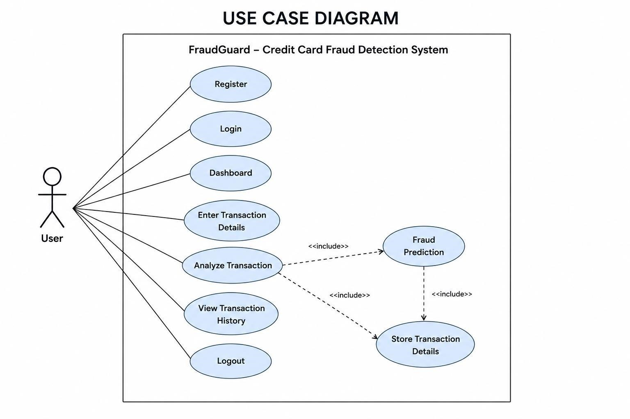
Sequence Diagram:
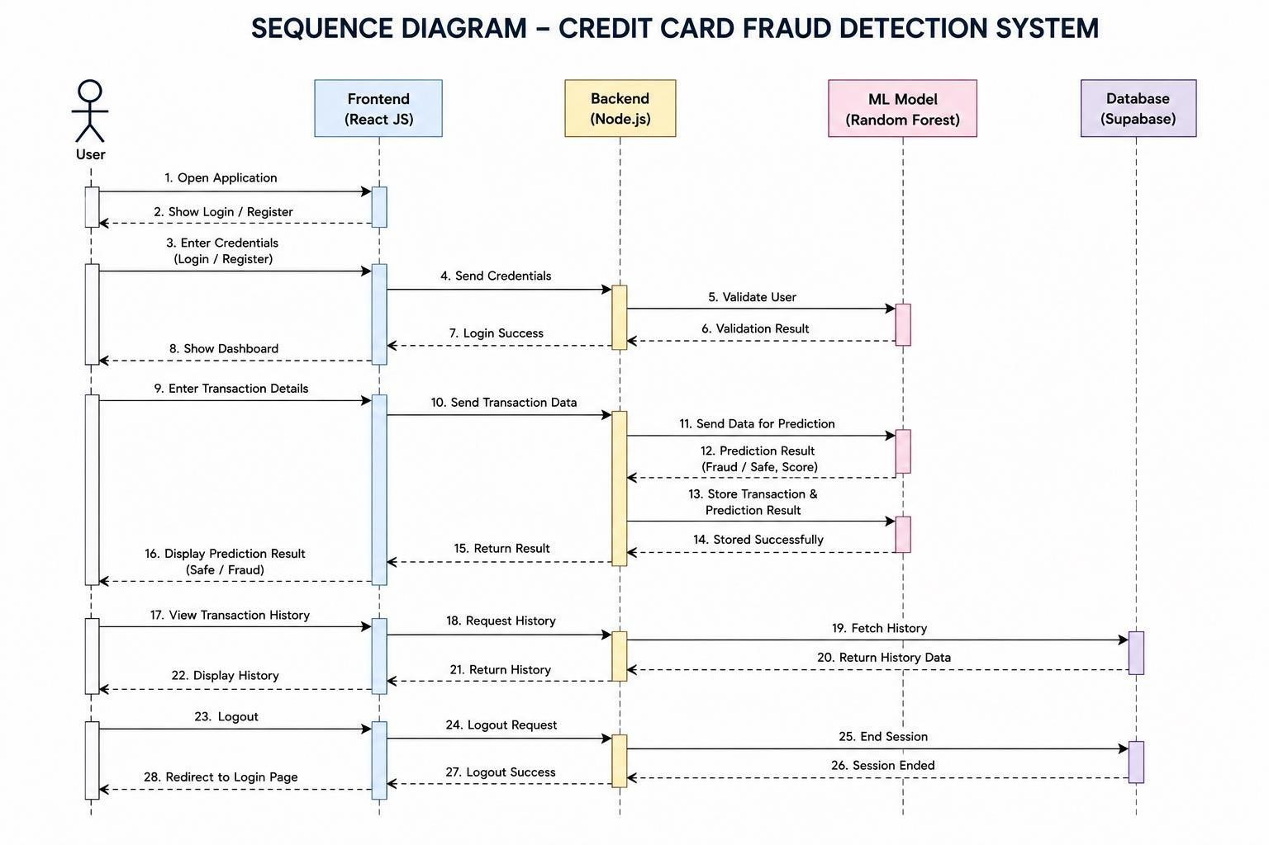
Flow Chart:
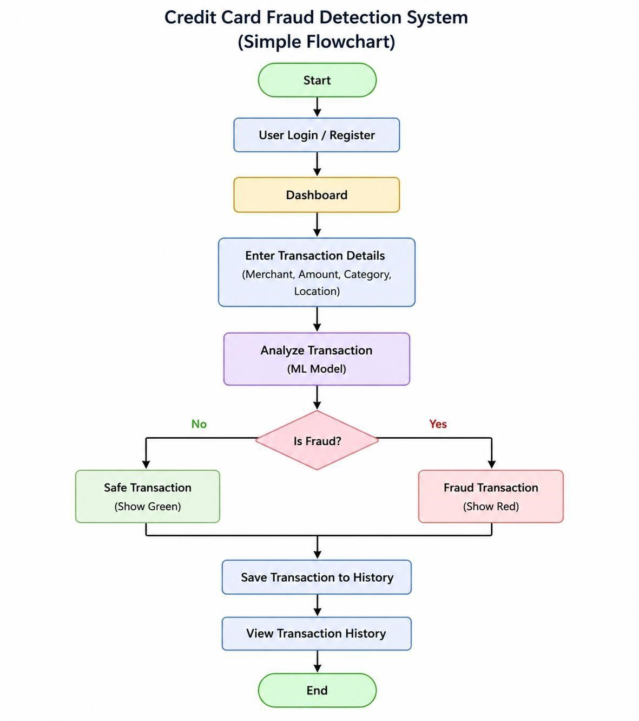
Code implementation
Frontend code (React js):
import { useState } from 'react'; export default function FraudCheck() {
const [merchant, setMerchant] = useState(''); const [amount, setAmount] = useState(''); const [category, setCategory] = useState(''); const [location, setLocation] = useState(''); const [result, setResult] = useState('');
const [risk, setRisk] = useState('');

const analyzeTransaction = () => { if (
amount > 5000 || category === 'Gambling'
) { setResult('Fraud Transaction'); setRisk('High Risk');
} else { setResult('Safe Transaction'); setRisk('Low Risk');
}
};

return (
<div className="container">
<h1>FraudGuard - Credit Card Fraud Detection</h1>

<input type="text" placeholder="Merchant Name" value={merchant}
onChange={(e) => setMerchant(e.target.value)}
/>

<input type="number" placeholder="Transaction Amount" value={amount}
onChange={(e) => setAmount(e.target.value)}
/>

<input type="text" placeholder="Transaction Category" value={category}
onChange={(e) => setCategory(e.target.value)}
/>

<input type="text" placeholder="Location" value={location}
onChange={(e) => setLocation(e.target.value)}
/>

<button onClick={analyzeTransaction}>
Analyze Transaction
</button>

<div className="result-section">
<h2>Result: {result}</h2>
<h3>Risk Level: {risk}</h3>
</div>
</div>
);
}
Backend code (Node.js+subabase):
import express from 'express';
import { createClient } from '@supabase/supabase-js';
const app = express();
app.use(express.json());

const supabaseUrl = 'YOUR_SUPABASE_URL';
const supabaseKey = 'YOUR_SUPABASE_ANON_KEY';

const supabase = createClient(
supabaseUrl, supabaseKey
);

app.post('/analyze', async (req, res) => {

const { merchant, amount, category, location
} = req.body;

let status = 'Safe'; let risk = 'Low';
if (
amount > 5000 || category === 'Gambling' ) { status = 'Fraud'; risk = 'High';
}

const { data, error } = await supabase
.from('transactions')
.insert([
{ merchant, amount, category, location, status, risk
}
]);

if (error) {
return res.status(500).json({
message: 'Database Error'
});
}

res.json({ merchant, amount, category, location, status, risk
});
});
app.listen(3000, () => {
console.log(
'FraudGuard Server Running on Port 3000'
); });

Login Page:

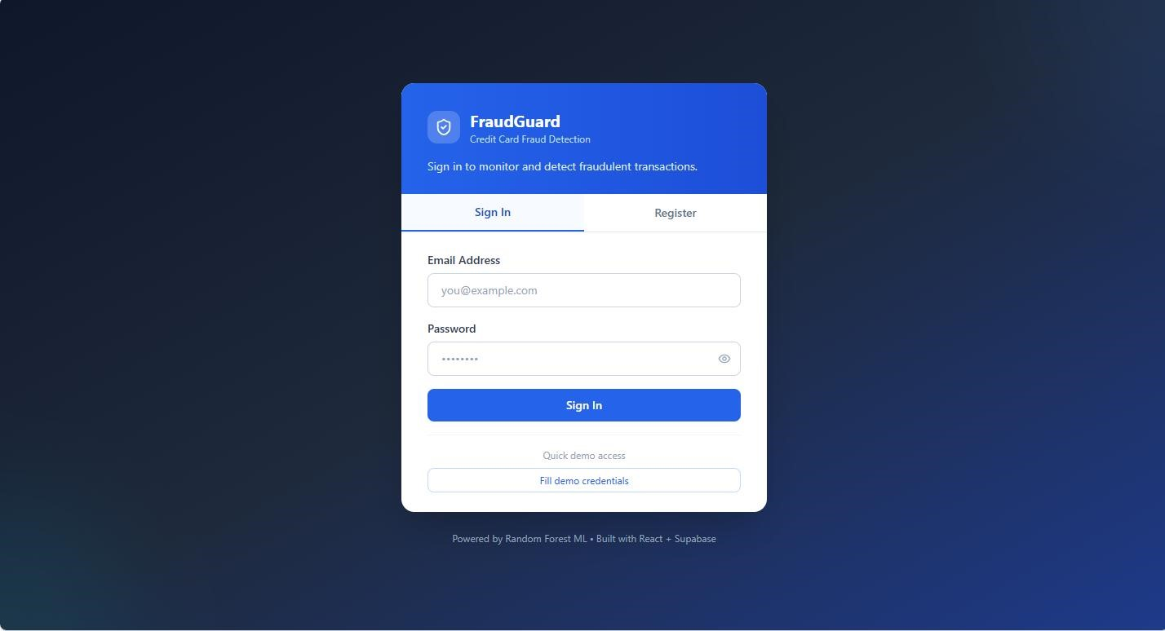

Dashboard page:
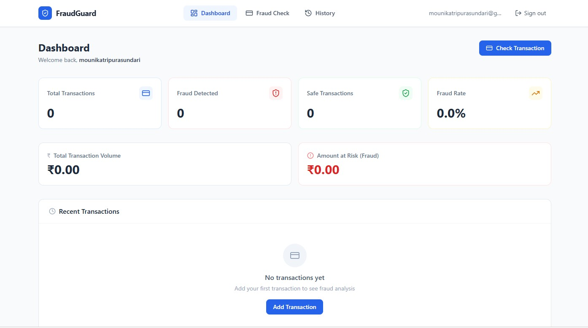

Fraud Check page:

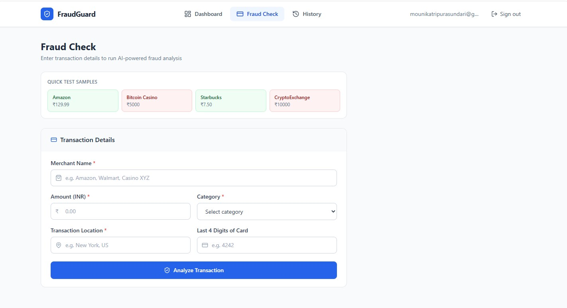

History page:

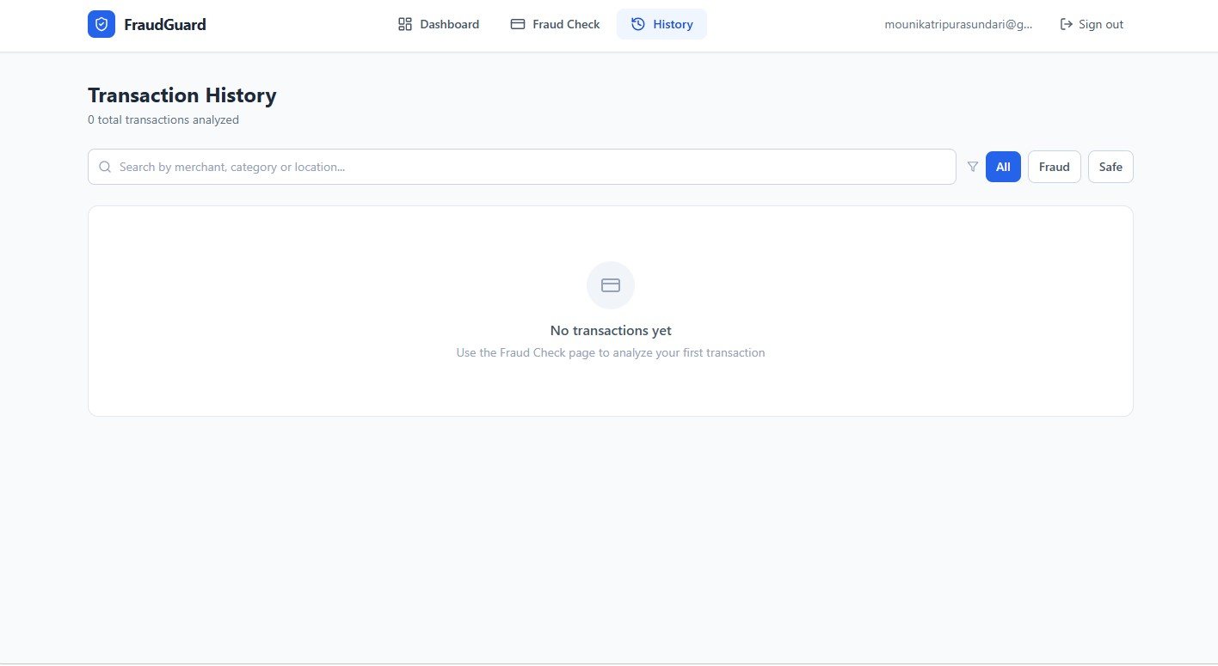

14. CONCLUSION

The Fraud Guard – Credit Card Fraud Detection System is developed to identify fraudulent credit card transactions using Machine Learning techniques by analyzing transaction details such as merchant name, amount, category, and location to determine whether a transaction is safe or fraudulent. The system provides features such as secure login, dashboard monitoring, transaction analysis, and transaction history management through a simple and user-friendly interface. The project helps improve transaction security, reduce financial risks, and minimize fraud-related losses. The Random Forest Algorithm improves fraud prediction accuracy and helps in quick detection of suspicious activities, demonstrating how Machine Learning and modern web technologies can be combined to develop an efficient fraud detection system for real-world financial applications.

