Execution of java program in linux:

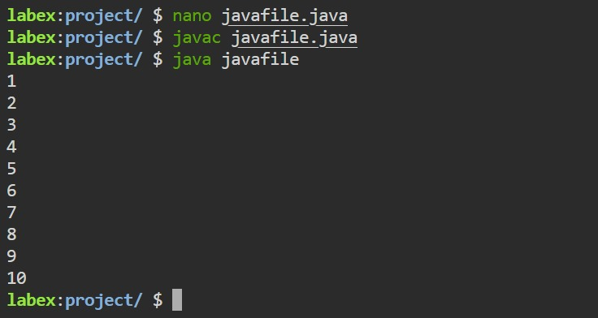

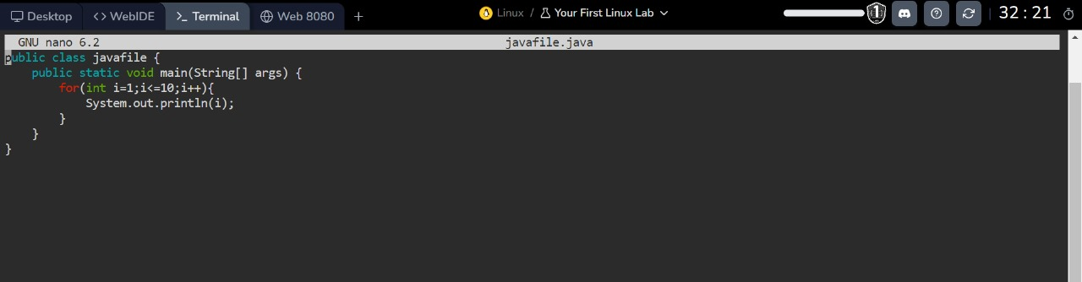

Execution of sheel program in linux:

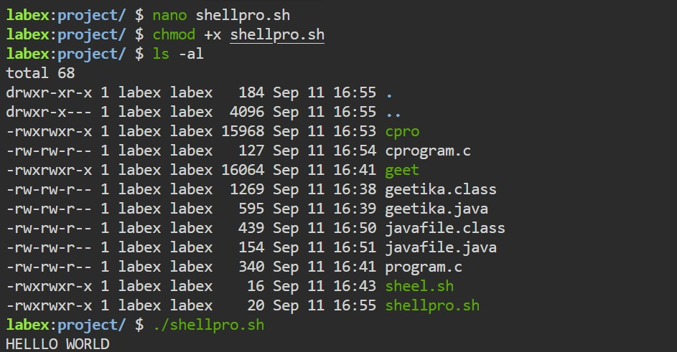

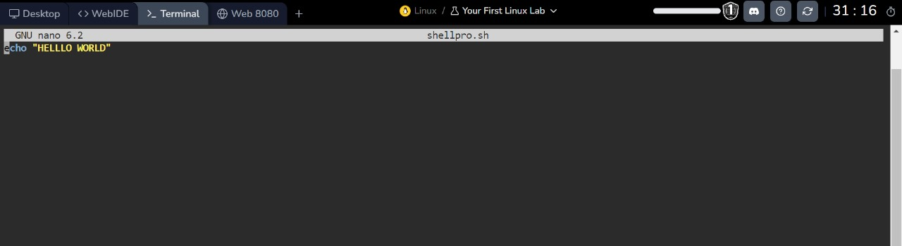

Execution of C program in linux:

